In the “Right” Place at the Right Time: Impacts of Compensation from Prison Labor on Reincarceration

**Matias Axelrod\***

[**[Most Recent Draft]**](https://github.com/matiasaxelrod/CV2024)

Abstract: I explore the role of mandatory savings from higher-paying *correctional industry*(CI) prison labor assignments in reducing recidivism. Using unique administrative data from the Arizona Department of Corrections, Rehabilitation and Reentry (ADCRR) and exploiting cross-prison variation in the availability of these assignments over time, I find that higher levels of mandatory savings significantly reduce the probability of recidivism and that these effects are largest in the first six months after release. On average, a $1,000 increase in mandatory savings decreases the probability of reincarceration within six months by 0.8 (↓4.3%) and 0.9 (↓6.4%) percentage points, for men and women respectively. Investigating potential mechanisms behind this result suggests substantial heterogeneity (differences in treatment response between subgroups) and nonlinearity (diminishing marginal returns in recidivism reduction for increases in mandatory savings) in the relationship between mandatory savings from prison labor and recidivism.

*Axelrod: Michigan State University (email: [axelrod6@msu.edu](mailto:axelrod6@msu.edu)). This research was supported by MSU’s University Enrichment Fellowship and University of Michigan’s Criminal Justice Administrative Records System (CJARS) Fellowship. I thank Stacy Dickert-Conlin, Todd Elder, Ajin Lee and Deyanira Nevarez-Martinez for their extensive feedback and support. I also thank the Arizona Department of Corrections, Rehabilitation, and Reentry’s Research Division for excellent research assistance and cooperation, in particular Danielle Haverkate and Laura Phrasavath, as well as Michael Dolny and Joshua Connolly. I also thank Amanda Agan, Soren Anderson, Bocar Ba, Ben Bushong, Michael Conlin, Jon Eguia, Neil Filosa, Graham Gardner, Michael Mueller-Smith, Elisabeth Perlman, Grace Phillips, and Jeffrey Wooldridge for their suggestions and encouragement at various stages of the project as well as seminar participants at SEA ’23. Any remaining errors are mine.

**I. Introduction**

Over the past decade, an average of 600,000 inmates are released from state prisons every year in the United States. Of these releasees, 6 in 10 will be arrested within three years and 45% will be re-incarcerated in five[1]. The societal costs of incarceration and by extension recidivism, are hard to understate. On average, state and local governments in the United States spend 2.5% of their yearly budgets on the operation of correctional facilities alone, with the average yearly cost of incarcerating an inmate totaling $33,274 in 2015. Indirect costs are substantial as well—using a “movers” design, Finlay, Mueller-Smith, and Street (2023) find that children who move into counties with higher exposure to criminal justice involvement grow up to have significantly higher crime rates, lower employment and earnings, and greater likelihood of death before age 26. Given that recidivism in the U.S. is characterized by a minority of offenders repeatedly cycling through the criminal justice system (Rhodes et al. 2016), evidence-based interventions that interrupt this cycle are necessary to mitigate the economic burdens of incarceration overall.

One class of interventions that is nearly ubiquitous in U.S. correctional facilities is prison labor. According to the most recent census from the Bureau of Justice Statistics, 99.7 percent of state and federal prisoners were held at a facility that had some type of work program.[2] In their most recent survey of prisoners, they estimate that over two-thirds have mandatory work assignments.[3] Despite their prominence, relatively little is known about whether and how these prison work programs impact inmates’ ability to desist from crime after release (i.e. recidivism). This paper addresses a substantial gap in the prison program evaluation literature by being the first to directly examine how compensation from selective, higher-paying prison work assignments impacts inmates’ ability to delay or prevent recidivism. These special work assignments—called *correctional industries* (CI)—generally pay much more than the default work assignments, although there is significant variation between jobs and states[4]. Inmates working CI assignments earn wages that are then subject to various deductions[5], with a portion placed into a mandatory savings account that is disbursed to the inmate upon release. In Arizona, between forty and twenty percent of inmates’ earnings from CI are placed into this savings account.

In this study, I explore the role of mandatory savings[6] from CI assignments in reducing recidivism. Using unique administrative data from the Arizona Department of Corrections, Rehabilitation and Reentry (ADCRR) and exploiting cross-prison variation in the availability of these assignments over time, I find that higher levels of mandatory savings significantly reduce the probability of recidivism and that these effects are largest in the first six months after release. For the average inmate in the study, a $1,000 increase in mandatory savings decreases the probability of reincarceration within six months by 0.8 (↓4.3%) and 0.9 (↓6.4%) percentage points, for men and women respectively. Investigating potential mechanisms behind this result suggests substantial heterogeneity (differences in treatment response between subgroups) and nonlinearity (diminishing marginal returns in recidivism reduction for increases in mandatory savings) in the relationship between mandatory savings from prison labor and recidivism.

Following the seminal theoretical works on the returns to crime of Becker (1968) and Ehrlich (1973), the conceptual reasoning for why increased savings from prison labor may lead to lower recidivism manifests through its effects on the expected benefits from continuing to desist from crime. Given that the average prisoner in the study accumulates mandatory savings between $2,062 and $2,422,[7] prisoners released with larger amounts of mandatory savings can more readily afford the high initial costs of “restarting” civilian life (e.g. down payment for a car, security deposit for housing, paying off debts accrued due to incarceration). Access to consistent housing and transportation in turn, can increase the likelihood of obtaining legal employment, thereby increasing the value of desistance relative to reengaging in criminal activity. A theoretical ambiguity arises however, since inmates’ mandatory savings could instead be used to simply invest in resuming criminal activity. This leaves the net result of mandatory savings on recidivism an open empirical question.

Using intimate knowledge of the Arizona Correctional Industry’s (ACI) assignment process, as well as variation in mandatory savings induced by the limited availability of correctional industry assignments, I estimate the causal impact of higher inmate mandatory savings from prison labor on recidivism. Because inmates are required to save anywhere from 20% to 40%[8] of their earnings for release, there is a minimum level of prison labor compensation for each inmate that is not confounded by endogenous savings behavior. This study exclusively compares inmates assigned to the ACI “Labor Contracts” (ACIL) program, all of which are contracts with private outside firms paying $2 per hour or more. These are the highest-paying prison work assignments in Arizona and are the only ones with a mandatory savings requirement.[9] Identifying variation in levels of mandatory savings comes from fluctuations in ACIL assignment availability over time and across Arizona's 15 prison complexes, conditional on a rich set of covariates that includes the internal metrics correctional officers use when making assignment decisions. I conduct several robustness checks to indirectly assess the plausibility of the conditional exogeneity assumption, such as comparing estimates from inmates assigned to jobs known to be very selective, testing for the sorting of inmates to prisons with better prospects for CI assignments, and exploiting time periods during which certain prisons had no CI assignments to assess the validity of internal metrics used by correctional officers when making assignment decisions.

The remainder of the paper is organized as follows: Section II discusses the related literature and predictions of the model that are tested in the study, Section III discusses the data and institutional details, Section IV presents the empirical strategy and main results, Section V concludes.

**II: Model and Related Literature**

**A. Becker-Ehrlich Model of the Returns to Crime**

Borrowing the theoretical exposition from Doleac (2023), an individual considering whether to commit a crime faces the following payoffs:

where,

and

is the perceived payoff (monetary or psychic) from committing a crime

is the perceived payoff (monetary or psychic) from a noncriminal outside option

is noncriminal capital

is criminal capital

measures attitudes and preferences over legal and illegal behavior

measures risk preferences and/or discounting

is the perceived cost of punishment (monetary or psychic)

is the perceived probability of punishment

The model suggests that mandatory savings could delay recidivism by directly substituting for illegal income , or by investing in noncriminal capital and making the legal option more attractive. Examples of investments in include complements to legal employment: a down-payment on a used car, or a security deposit for housing[10]. Yet another possibility is that inmates that accumulate higher savings from prison labor also pick up hard skills that are more relevant in the legal job market.

If direct substitution of illegal income is the main channel, one would expect the average impacts of savings on recidivism to be mostly transitory— having the greatest effects in the first few months after release and rapidly depreciating thereafter. One testable implication of the Becker-Ehrlich model would be differential impacts of mandatory savings on recidivism resulting from crimes that are and are not likely to be financially motivated (Ludwig and Schnepel, 2024). This distinction stems from the observation that violent crimes like rape and homicide are generally not profit-driven, while property and arguably many drug crimes are. If the effects are instead driven by investments in , either via work complements or hard skills, one might expect the reductions in recidivism to be longer-lasting and to differ depending on the industry of the ACIL assignment. I investigate these possibilities by allowing savings’ effects on recidivism to differ by ACIL industry as well as comparing estimates for individuals recidivating for a violent versus a non-violent felony conviction in section IV.

**B. Related Literature**

This study builds upon and extends the literature on the impacts of CI prison labor programs on post-release outcomes. In a national study, Smith et al. (2006) find that inmates who participated in Prison Industrial Enhancement (PIE)[11] work programs were seven percentage points less likely to be arrested in the first year post-release compared to a propensity score matched sample of non-PIE participants, but find no difference in reoffending for other CI participants. Using the same empirical strategy, Cox (2016) finds that PIE participants were not able to hold onto jobs significantly longer than non-participants after release, adding that differences in recidivism rates were not large enough to explain this fact. In California, Hess and Turner (2021) find lower rates of various measures of reoffending when comparing CI inmates who participated for at least six months to a matched sample of inmates on a CI waitlist. However, they do not distinguish between PIE inmates who make a gross hourly wage of at least $10 and all other CI inmates who gross between $0.35 and $1.00 per hour[12]. Additionally, several studies using similar matching strategies of CI inmates in different settings fail to reject significant differences in measures of reoffending (Richmond, 2014; Duwe and McNeeley, 2017). This study represents a major contribution to the literature in that it is the first to examine how differences in compensation from prison labor assignments impact recidivism rates, which may account for some of the conflicting estimates from different studies.

This study builds upon the current understanding of how CI assignments impact recidivism rates in several ways. First, while national evaluations may be desirable from a statistical power perspective, the differences between states in eligibility criteria[13] for prison labor programs complicates the interpretation of causal estimates. Because each state has discretion in how to operate their CI programs, estimated treatment effects of CI on recidivism may instead reflect differences in how these programs are implemented across states (Nur and Nguyen, 2023). By restricting the study to just Arizona, I can hold these eligibility criteria and institutional details constant. Second, all of these studies use participation in CI as their treatment variable of interest. However, economic theory and results from Cox (2016) and Smith et al. (2006) suggest that variation in compensation and length of participation are salient factors in determining subsequent effects on recidivism. Using participation indicators in this context masks the heterogeneity of treatment on the intensive margin, making the policy implications of these estimates unclear. By exploring heterogeneity in treatment using variation in mandatory savings, this study contributes to a better understanding of which aspects of these prison labor programs are driving reductions in recidivism. Third, the extant literature on the efficacy of prison labor programs in reducing recidivism rely on strong distributional independence assumptions for identification that are unlikely to hold in their respective settings. Matching inmates assigned to correctional industries to those who were not despite being eligible, does not contend with the issue of *why* they were not assigned. The richness of this data and cooperation from ADCRR present a unique opportunity for this study to comprehensively investigate how selection mechanisms and treatment heterogeneity factor into the estimation of the average partial effects of mandatory savings on recidivism. Finally, [dynamics].

**III. Setting and Data**

1. **Prison Labor and Arizona Correctional Industries (ACI)**

In Arizona, 95 percent[14] of inmates released after 2007 participated in at least one work assignment during their sentence. The vast majority of these involve labor related to the upkeep of the prison itself, which are called *institutional work assignments*: landscaping, janitorial services, laundry, commissary, or kitchen duty for example. Some of these institutional work assignments involve more specialized skills or occur as part of a vocational training program: appliance repair, car repair, building maintenance, construction, or HVAC for example. Despite the breadth of these assignments, they share a common payscale of $0.10 to $0.50 per hour[15]. Inmates’ earnings are deposited into a spendable account they can use to purchase various items or phone calls within the prison.

This study focuses instead on a special class of prison work assignments offered by the Arizona Correctional Industries Labor Contracts (ACIL) program. These work assignments pay significantly more than any other job in prison because they produce goods and services sold in the free market. Hourly wages for almost all[16] ACIL assignments range from $2.00 to $6.00 per hour, depending on the assignment, and most have payscales that increment fixed amounts depending on how long the inmate has been employed in that assignment. Arizona state law stipulates that any inmate earning an hourly wage of $2.00 or more must have a portion of their earnings placed in a savings account that cannot be accessed by the inmate until release. Because all ACIL assignments must pay at least $2.00 per hour, this means that inmates assigned to ACIL are the only ones with mandatory savings accounts.

The sample in this study consists of all inmates in Arizona prisons initially assigned to an ACIL work assignment between September, 2007 and February, 2020. Additionally, all inmates in the study were released at least one month prior to March 20, 2020. I chose this date as the right-censoring date since it corresponds to the first day pandemic lockdowns were announced in Arizona. These criteria yield a sample of 10,567 inmate-spells, with 10,214 unique inmates[17]. An inmate-spell is a continuous stay in prison during which an inmate was assigned to an ACIL assignment.

All ACIL contracts are negotiated between an outside private firm and ADCRR. Because prison laborers are not legally considered employees[18], firms can avoid substantial labor and overhead costs[19] by contracting them. However, only certain goods made using prison labor are allowed to be sold on the free market, which limits the types of firms that can contract prison labor. Of the 10,567 ACIL inmate-spells in the study, 48.5% (5,121) involved agriculture. Examples include harvesting and processing eggs, wiring up tomato plants, and sorting agricultural produce. 23.8% (2,510) involved manufacturing jobs; examples include canning green chiles, wood furniture assembly, and building aluminum trailers[20]. 13.4% (1,416) involved call centers for Business-to-Business telemarketing services. The remaining 14.4% (1,520) involved miscellaneous types of labor or repair services. Primary examples include car washing/detailing, landscaping, sorting recycling, and large truck repair[21].

Because ACIL contracts are with private firms, the number and types of positions available vary substantially across prisons and over time depending on the needs of each business[22], as shown in Figures 1 and 2. 61 distinct ACIL contracts were active at some point during the sample period, employing approximately 1,094 total inmates on an average day across 13 different prison complexes[23]. Despite accounting for roughly 15% of the general prison population, female inmates represent 22% of the study population and are all held at Arizona’s only women’s-only prison complex, Perryville. Because the ACIL jobs offered vary depending on the prison complex, male and female inmates are never competing for the same assignments. To account for potentially substantial differences in selection mechanisms and job types between the male (8,258 inmate-spells) and female (2,309 inmate-spells) subsamples, I model their recidivism responses to changes in mandatory savings separately.

Figure 1

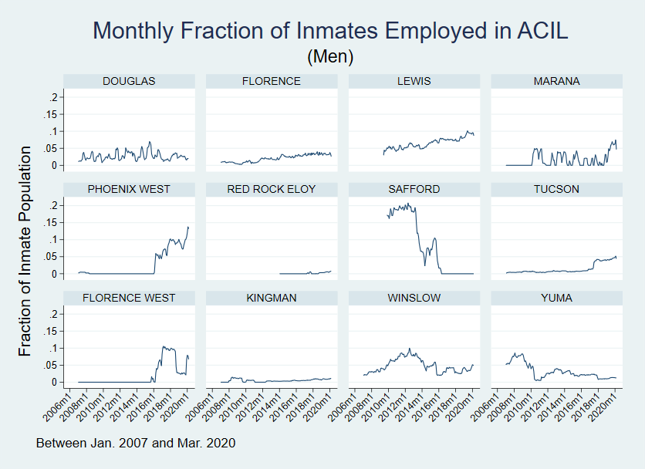

Source: Author’s calculations from ADCRR-provided data.

Note: Facilities “LEWIS” and “SAFFORD” switched to a different coding scheme in July 2008 which resolved ambiguity in determining ACIL assignments. Facility “RED ROCK ELOY” opened in January 2014. Monthly fraction is calculated as the number of inmates at a facility employed for at least one day each month in an ACIL assignment divided by the average daily number of inmates held at that facility each month.

Figure 2

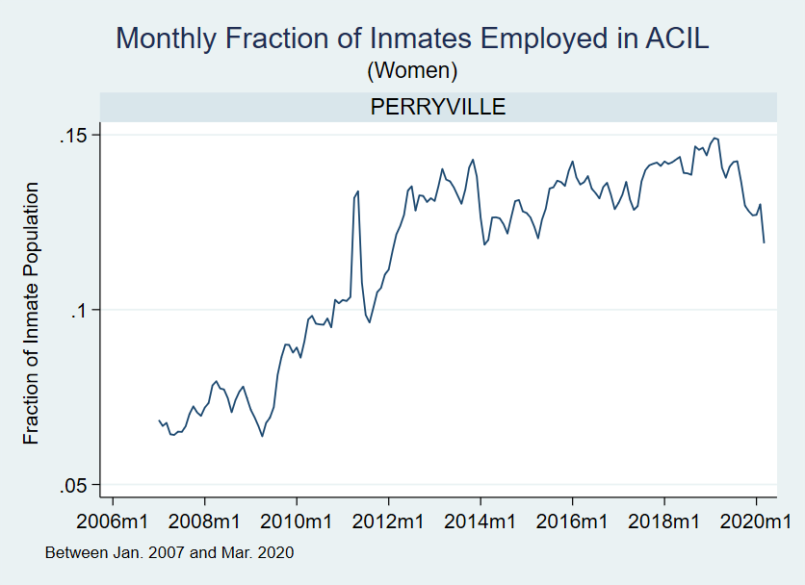

Note: All female inmates are held at “PERRYVILLE”. Monthly fraction is calculated as the number of inmates at a facility employed for at least one day each month in an ACIL assignment divided by the average daily number of inmates held at that facility each month.

1. **How Inmates are Assigned to ACIL: Eligibility and Prioritization**

Participation in ACIL is voluntary and subject to eligibility requirements. The eligibility requirements for ACIL are fairly similar to those used by other states in their correctional industries programs (Smith et al. 2006; Cox 2015). To be considered for an ACIL assignment the inmate must[24]:

1. Have a GED, or be enrolled in GED preparation program. If no GED program slots are available, the inmate may be provisionally assigned to ACIL until then.
2. Have satisfactory work evaluations during the last 12 months.
3. Have no disciplinary violations in the last 6 months.
4. Have no scheduling conflicts with major programs they are currently participating in.
5. Have no refusal or removal from mandatory work assignments or programs ever during current incarceration.
6. Be a legal U.S. resident.

These eligibility criteria result in a highly selected study sample that is observably different from the general prison population. For this reason, I focus exclusively on inmates that received an ACIL assignment. Doing so precludes confounded comparisons of ACIL participants to those who were never assigned for reasons unobservable to the econometrician—inmates that were plausibly more likely to recidivate anyway. While this still leaves open the possibility that inmates with lower mandatory savings selected into such levels for similar reasons, I argue that details of the ACIL assignment process as well as exogenous fluctuations in the number of ACIL assignments available significantly mitigate the extent to which such selection happens in practice.

Conditional on eligibility, ADCRR staff indicate that they prioritize assigning inmates that are perceived as being at an *elevated* risk of recidivating. They quantify this risk using an inmate’s aptly-named “recidivism risk score”, which is an integer ranging from 1 to 14 with larger scores indicating higher risk. An inmate’s recidivism risk score is first calculated at prison intake using their criminal history, socioeconomic characteristics, salient medical conditions, and impressions from the correctional officer’s interview with the inmate.[25] This score can be periodically updated throughout an inmate’s sentence to reflect new information but is mostly not done.[26] Information gathered on the inmate’s behavior during their sentence is generally reflected in their internal risk score and number of disciplinary infractions. An inmate’s internal risk score is an integer ranging from 1 to 5 with a larger score indicating higher perceived risk to other inmates and corrections staff. In practice, it is a composite score that decreases gradually over the course of an inmate’s sentence and can only increase during a spell if the inmate is found guilty of a disciplinary infraction.[27] Inmates must have an internal risk score of 3 or lower to be considered for an ACIL assignment.[28]

The restrictive eligibility criteria coupled with ADCRR’s stated practice of prioritizing high-risk inmates both present favorable conditions for consistently estimating causal effects of mandatory savings on recidivism. The eligibility criteria ensure that all inmates in the sample are at least somewhat comparable in terms of their levels of motivation and work ethic, by virtue of having passed the selection process to get assigned to ACIL in the first place. Provided that higher recidivism risk scores are predictive of an inmate’s ex-ante higher potential to recidivate and that this prioritization manifests in higher mandatory savings, this selection process should bias the analysis against finding protective effects of mandatory savings on recidivism, resulting in a lower-bound of effects in absolute terms.

Figure 3[29] compares the distributions of recidivism risk scores between people never assigned to ACIL and those in the study. While I cannot condition on ACIL eligibility for the non-ACIL participants[30], the higher fraction of ACIL inmates with medium-low to high levels of recidivism risk (2 to 6) relative to the non-ACIL population is consistent with ADCRR’s stated practice of prioritizing higher risk inmates. The diminishing percentage of ACIL participants with recidivism risk scores higher than 7 may indicate that these especially high-risk inmates are prioritized for other rehabilitative programs or that they are less likely to be eligible for ACIL assignments.

Apart from the recidivism risk score, correctional officers also use an inmate’s ACI “Good Fit” score when making ACIL assignment decisions. The ACI score, which ranges from zero to five, is initially determined at the same time as the recidivism risk score. Nearly all inmates assigned to ACIL have their ACI score set to zero once assigned, presumably to better keep track of inmates that are deemed a “good fit” for ACIL assignments but haven’t had the chance to participate. To simplify comparisons between the study and non-study sample, I plot their histograms of the highest ACI score received during their sentence in Figure 4.[31]

Figure 3

Note: Figure 3 compares the distributions of maximum recidivism risk scores received by Non-ACIL and ACIL inmate-spells over the course of their sentences. Non-ACIL inmate-spells are the 149,447 male inmate-spells incarcerated in an ADCRR facility at any point through the sample period that never participated in an ACIL assignment during their sentence. ACIL inmate-spells are the 8,226 male inmate-spells that ever participated in an ACIL assignment over the study period.

Figure 4

Note: Figure 4 compares the distributions of maximum ACI scores received by Non-ACIL and ACIL inmate-spells over the course of their sentences. Non-ACIL inmate-spells are the 149,447 male inmate-spells incarcerated in an ADCRR facility at any point through the sample period that never participated in an ACIL assignment during their sentence. ACIL inmate-spells are the 8,226 male inmate-spells that ever participated in an ACIL assignment over the study period.

Figure 4 shows that roughly a third of inmate-spells never assigned to ACIL were considered to be a good candidate for ACIL at some point during their sentence (i.e. had a score strictly larger than zero). Conversely, almost 30% of inmate-spells assigned to ACIL were not considered by correctional officers to have been good candidates for ACIL (i.e. had a score of zero). The existence of both categories of inmates (score greater than zero but never assigned versus score equal to 0 but assigned nevertheless) is consistent with correctional officers being constrained by ACIL assignment availability in getting “better” inmates assigned to ACIL. One possibility is that many “zeroes” get assigned to ACIL to satisfy fluctuations in the needs of ACIL contracts on a temporary basis (e.g. harvesting season or need to fulfill a large order).

1. **Measuring Mandatory Savings**

Measuring mandatory savings requires combining multiple sources of administrative data from ADCRR. Using their banking data, I have exact amounts of mandatory savings inmates were released with if they were released after December 1st, 2019, which amounts to 165 inmate-spells in the study period. Because the number of overlapping spells is relatively small, I impute mandatory savings for all inmate-spells in the study using the procedure described below and use the 165 inmate-spells that overlap as a spot-check for the calculations.

I use program participation data to get participation start and end dates for inmates’ ACIL work assignments. Then, assuming a 40-hour work week, I compute the total number of hours worked in their respective ACIL assignments. ADCRR staff indicate that there are no “part-time” ACIL assignments, so the 40-hour work week assumption is reasonable.

I use payscale data for each ACIL assignment and each fiscal year the contract is active to determine hourly wages. These payscales are the result of negotiations between ADCRR and the firm contracting the labor. Hourly wages will increment depending on how long the inmate has worked the assignment up to some prespecified maximum hourly wage, although some[32] pay a flat rate regardless of tenure. Using the hours from the previous step, I calculate how many hours they spent in each step of the payscale to get their total earnings from that ACIL assignment[33].

After calculating total earnings from each ACIL assignment, I then apply the mandatory deductions in the order listed in Figure 6. These exact deductions are statutorily mandated[34] by the Arizona legislature; a legislative history search revealed that this deduction schedule remained unchanged over the course of the sample period. Deductions one through six are taken from the total ACIL earnings calculated in the previous step[35]. The inmate’s spendable balance can be used freely to purchase goods from the inmate store or healthcare fees. Any other uses of funds in their spendable balance are subject to approval by corrections staff. Funds in the inmate’s mandatory savings account are generally inaccessible until they are released, although they can submit a written request to the prison warden in exceptional circumstances.[36][37]

The only deduction that is unobservable from the data is the “Court Ordered Child Support” deduction, which I ignore when calculating mandatory savings. Back-of-the-envelope calculations using typical hourly wages in the study sample indicate that omitting the child support deduction when it is actually being taken would result in my mandatory savings estimate being anywhere from two to four times its actual value. When comparing my mandatory savings estimates to those in the banking data for the 165 inmate-spells that overlap, I find that I generally overestimate mandatory savings by approximately $350 on average. Figure 5 shows the distribution of these discrepancies. In exchanges with ADCRR staff I found that while ACIL contracts are for 40-hour work weeks, logistical issues or onboarding in certain weeks can result in fewer hours, which may help explain the smaller discrepancies. The larger discrepancies and the mass of inmates overestimated by more than $2,000 are likely due to some combination of unobserved withdrawals or child support deductions[38].

If this multiplicative measurement error (i.e. omitted child support deduction) is independent of the “true” value of mandatory savings and other covariates, then overestimating mandatory savings should dilute per-dollar effects of mandatory savings on recidivism, leading to attenuated effect estimates. An alternative to modelling this measurement error directly is to give the estimated effects in section IV an intention-to-treat (ITT) interpretation. This interpretation is motivated by the channels discussed in Section II. Namely, that higher amounts of mandatory savings can be used to pay off debts accrued during incarceration (i.e. child support arrears) or assist in maintaining strained social ties (i.e. helping immediate family with bills) while incarcerated. In this sense, the mandatory savings amounts I estimate do capture an inmate’s “assigned” dose-level regardless of whether portions of it were used before being released (Newell, 1992).

Figure 5

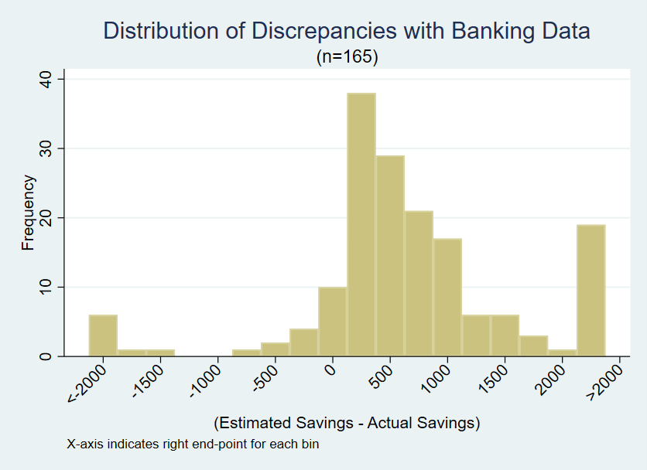

Source: Author’s Calculations from ADCRR-provided transaction data for inmates released after

December 1, 2019.

Figure 6

|  |  |  |
| --- | --- | --- |
| **Deduction** | **Amount** | **Note** |
| **1.** Initial to Spendable | $0.50 per hour worked |  |
| **2.** Alcohol Abuse Treatment Fund | $0.50 per hour worked | Inmates with DUI conviction only |
| **3.** Transition Fees | 5% of total earnings | DUI inmates exempt |
| **4.** Room and Board | 30% of total earnings |  |
| **5.** Court Ordered Child Support | 30% of total earnings | If applicable |
| **6.** Additional to Spendable | 10% of balance remaining after above deductions |  |
| **7.** Balance to Mandatory Savings | Remaining balance after above deductions |  |

Source: ADCRR D.O. 905 – Inmate Trust Account/Money System

Note: Figure 6 lists the order and amounts deducted from ACIL gross earnings.

The largest deduction in Figure 6 that applies to all[39] ACIL inmates is the room and board deduction, which is intended to offset the costs of incarcerating the inmate. The average inmate-spell in the study is released with $2,251 in mandatory savings and paid an average of $1,167 in room and board fees over the course of their sentence. Table 2 shows summary statistics for compensation for women and men. The deduction schedule in Figure 6 implies that inmates will pay an amount equal to approximately half of their mandatory savings in fees for room and board, depending on their hourly wage and whether they are serving a sentence for a DUI.

Figure 7 shows that the distribution of estimated mandatory savings for men is less skewed-left relative to women. Figures 8 and 9 show that the higher average mandatory savings for women is mostly explained by greater consistency in working more hours as well as higher maximum hourly wages in their pay-scales. Since the female and male samples are modeled separately however, the variation in estimated mandatory savings is almost entirely coming from hours worked due to scant variation in hourly wages conditional on gender.

Figure 7

Note: Figure 7 plots the overlaid histograms of estimated savings in 2017 dollars on a log-scale of the male (shaded green) and female (shaded red) subsamples.

Figure 8

Note: Figure 8 plots the overlaid histograms of estimated total hours worked in ACIL assignments on a log-scale of the male (shaded green) and female (shaded red) subsamples.

Figure 9

Note: An ACIL inmate-spell’s maximum hourly wage is defined as the highest hourly wage possible shown in the pay-scale data for the assignment. If an inmate-spell is associated with two or more distinct ACIL assignments, the pay-scale used corresponds to the assignment with the greatest estimated hours worked.

**D. Measuring Recidivism**

The primary measures of recidivism in this study are indicators for whether an inmate was reincarcerated or absconded supervision[40], whichever happens first, within a certain number of months from their release, ranging from 1 to 36 months. Reincarceration is a common measure of recidivism (e.g. Yang 2017, Agan and Makowsky 2021, Rose and Shem-Tov 2021). I also consider indicators for whether an inmate was reincarcerated for a technical violation of community supervision versus a new felony conviction.

Because Arizona is a Truth-in-Sentencing (TIS) state, inmates serving sentences for crimes committed on or after January 1, 1994 are required to spend at least 85% of their sentence incarcerated.[41] The remaining 15% of their sentence may be served in community supervision, which supplanted the previous parole system but functions much the same. Inmates in community supervision are released from prison but must regularly report to a correctional officer in charge of their case. They may also be subject to random drug testing, required to attend outpatient or residential treatment programs, pay fees related to their supervision, or search for and maintain employment. Violating the terms of their community supervision, absconding, or being convicted of a new felony can result in the offender being reincarcerated to serve out the remainder of their sentence.

Figure 10

In addition to admission and release dates, the data from ADCRR shows the date an inmate absconded if they were released into community supervision. Because recorded instances of an inmate absconding always result in eventual reincarceration, I take the absconding date to be the date they recidivated. Figure 10 plots the unconditional recidivism rates for men and women in the study, ranging from 1 to 36 months.

Figure 10 also shows that women in the study consistently have lower recidivism rates then men, a finding that has been observed in other settings.[42] Despite these mean differences in recidivism rates, the dynamics of how this recidivism risk evolves over time-from-release are similar between male and female cohorts. For the female sample, 513 inmate-spells end with reincarceration within 36 months. Of those 513, 303 had already terminated within 6 months of release. Of the 2,782 male inmate-spells that ended in reincarceration within 36 months, 1,471 had already terminated within 6 months of release. Figure 11 visualizes this intuition by plotting the monthly hazard rates defined as the probability of recidivating in month conditional on not having recidivated any month prior. Men are consistently at a higher risk of recidivating in any given month relative to women, however both samples experience their highest risk in the first year post-release.[43]

Figure 11

With the administrative ADCRR data I categorize recidivism events as one of two types of events: technical violations and new convictions. Technical violations occur when an offender violates one of the terms of their community supervision, with absconding supervision being a special case.[44] Of the 3,295 recidivism events observed in the study (i.e. within 36 months of release), 63% (2,076) are due to technical violations and the remaining are due to new felony convictions. This composition of recidivism events is similar to statistics reported by other state prison systems.[45]

**IV. Empirical Strategy and Results**

1. **Model and Sample Construction**

Separately for male and female inmates, I estimate 36 linear probability models (LPM) via OLS of the following form:

where is an indicator for whether inmate recidivated within months, conditional on being observed for at least that long. is the total mandatory savings (in thousands) inmate is released from prison with, is a flexible vector of conditioning variables centered at their respective sample means, is a vector containing an intercept, binary controls, and year-released dummies for inmate , and an idiosyncratic error term. The target parameter of interest in this study is the Average Partial Effect (APE) of savings on the probability of recidivating by month after release:

Where the expectation is taken over the distribution of covariates **.**  Chen, Martin and Wooldridge (2023) show that the OLS estimates from a sufficiently flexible linear model like equation (1) are consistent for the if, in addition to savings being conditionally exogenous, *all* predicted values from the estimated models from equation (1) fall in the unit interval. The concerns about identification of the resulting from model inflexibility, like those described by Chen, Martin and Wooldridge (2023), are fundamentally separate from concerns over confounding variation in savings. In future drafts, I will address the model flexibility issues using methods developed in their study and focus on providing suggestive evidence for conditional exogeneity of savings in the next section. Additionally, using recent developments in the double-debiased machine learning literature (Semenova and Chernozhukov, 2021), I plan to estimate an average dose response function of mandatory savings on recidivism probability under stronger exogeneity assumptions.

For to be consistent for the causal effect of increasing an average inmate’s mandatory savings by one thousand dollars, I need that mandatory savings be conditionally exogenous with respect to unobserved determinants of recidivism , conditional on covariates which include demographic controls (e.g. age at release and race), measures of criminal history (e.g. indicators for crime category and number of prior spells), internal metrics used by prison staff (e.g. recidivism risk scores, number of disciplinary infractions, and ACI scores) and other potential confounders (e.g. indicators for year released and alternative program participation).

**B. Supportive Evidence of Conditional Exogeneity**

The amount of mandatory savings an ACIL inmate accumulates over their sentence is roughly[46] a function of the hourly wage and hours worked in their assignment. As Table 2 shows, variation in mandatory savings is almost entirely explained by variation in the latter, because the range of hourly wages is severely limited. Variation in hours worked is driven by three factors: (i) ACIL contracts’ entry and exit over time and across prisons, (ii) alternative programs[47] an inmate may be required to participate in, (iii) how much time inmates have remaining in their sentence once assigned. For ease of exposition, I restrict attention to the male subsample (8,258 inmate-spells) although a similar rationale applies to the female subsample (2,309), once I exclude one ACIL assignment in particular.[48]

ADCRR has 13 different men’s-only active prison facilities across the state over the sample period, 12 of which had at least one active ACIL contract during the sample period.[49] Figure 1 demonstrates that while most facilities have at least one active contract throughout the sample period, several have significant spans of time with zero ACIL contracts. ACIL assignment availability fluctuates based on the needs of the business that contracted the labor. Key examples of this are ACIL jobs in agriculture, which are associated with 44% of inmate-spells in the sample. These jobs usually involve harvesting, processing, or maintaining crops and as such, are seasonal in nature. These exogenous shocks to ACIL assignment availability-and consequentially, mandatory savings- are part of what drive the estimation of causal effects conditional on covariates.

While this leaves open the possibility of inmates being endogenously sorted to prison facilities with more consistent ACIL assignments, ADCRR staff deny this practice and allege that inmates are assigned to different facilities based on their risk profile subject to capacity constraints for each facility. To test this, I regress the monthly fractions of inmates employed in ACIL at a given facility (shown in Figure 1) on covariates at the facility-month level one would expect to be associated with sorting “better” inmates to facilities with better ACIL assignment prospects. Figure 12 displays the results of the following regression estimated by POLS:

where is the fraction of inmates that worked at least one day in an ACIL job at prison facility in month of the study period. is a vector of mean characteristics of the *entire* inmate population at a prison facility for a given month as well as a constant. For example, “Not Prioritized ACI” is defined as an indicator that equals one when an inmate has an ACI score of zero during a given facility-month (since I can observe if and when they change for an inmate). The corresponding mean characteristic inis then just the fraction of inmates with an ACI score of zero at facility in month . The other characteristics are calculated in a similar way.

If inmates are systematically sorted into certain facilities based upon their perceived (by correctional officers) aptitude for ACIL contracts, one would expect correlates of that aptitude (i.e. lower recidivism risk or higher ACI scores) to be predictive of the fraction of inmates employed in ACIL at a facility in a given month . Figure 12 shows that none of these covariates manage to achieve significance at the 5% level and are collectively poor predictors of variation in . Even setting aside statistical significance, the magnitudes of the point estimates are small. The coefficient on Not Prioritized ACI is -0.12, which implies that a one percentage point increase in inmates with an ACI score of zero is associated with a 0.12 percentage point decline in the fraction of inmates that worked at least one day in an ACIL assignment at facility during month . I plan to do a future robustness check where I restrict to the day when an inmate is transferred to a new facility, and regress of the destination facility on individual inmate’s characteristics to capture the sorting decision more directly.

Figure 12

Note: Figure 12 plots coefficients from a pooled OLS regression of the fraction of inmates who worked at least one day in an ACIL assignment at the prison-month level. Low Internal Risk is defined as the fraction of inmates with an IR score of 1 or 2. Low Recidivism Risk is defined as the fraction of inmates with a recidivism risk score of 1 or 2. Low Custody is defined as the fraction of inmates that are eligible to be held in a minimum-security facility. Not Prioritized ACI is defined as the fraction of inmates with an ACI score of zero. %GED is defined as the fraction of inmates with a GED. %Drug through %Property are the fractions of inmates serving time for a conviction in each respective crime category, which are not mutually exclusive. Private Prison indicates whether facility f is operated by a private firm contracted by ADCRR. Standard errors are clustered at the facility level.

**Prioritization of Higher Risk Inmates for ACIL Assignments**

Correspondence with ADCRR staff and internal documentation[50] indicate that rather than a match of skills, ACIL-eligible inmates are prioritized for assignments according to their recidivism risk score, ACI score, and how much time the inmate has until release. An inmate’s recidivism risk score is composite score ranging from 1 to 14 that factors in their criminal record, employment history, substance abuse history, education, and the correctional officer’s discretion during an interview with the inmate[51]. These scores are determined within the first few months of an inmate’s sentence and rarely change over its course. According to internal documentation, ACIL-eligible inmates with *higher* recidivism risk scores and *less* time remaining in their sentence are prioritized when an ACIL vacancy arises, provided it does not conflict with any other rehabilitative programs[52] the inmate is participating in.

Figure 13

Note: Figure 13 plots coefficients from an OLS regression of estimated savings (2017 dollars, in thousands) on indicators for recidivism risk scores in the male sample and an intercept (Baseline). An inmate-spell’s recidivism risk score is the highest recidivism risk score received during that spell. 95% Confidence Intervals given by line segments extending from point estimates.

Figure 14

Note: Figure 14 plots average estimated mandatory savings over ACI scores associated with inmate spells. An inmate spell’s ACI score is defined as the maximum ACI score they received during the spell.

Figure 13 shows that on average, ACIL inmate-spells with higher recidivism risk scores end up with slightly larger amounts of mandatory savings by the time they are released. A joint F-test rejects equality of coefficients 2-6+ (p=0.0239). However as Figure 14 shows, the prioritization of certain inmates for ACIL assignments is far more pronounced for inmates with higher ACI scores. Average savings for ACI scores of 1-5 are statistically indistinguishable from each other at the 10% level despite strongly rejecting their collective difference from the baseline mean (ACI score=0). This reinforces the credibility of the conditional exogeneity assumption by demonstrating that despite the best efforts of correctional officers to prioritize certain inmates for ACIL assignments, variation in the timing and location of ACIL contract availability significantly mitigate how much that selection can impact resulting mandatory savings levels.

In a future robustness check, I investigate whether recidivism risk scores have predictive power of ex-ante potential to recidivate. Doing so requires a suitable “control” group of prisoners that may have been a “good fit” for ACIL but were never assigned due to exogenous reasons. I use the lengthy periods with no active ACIL contracts at the Phoenix West, Florence West, and Safford prisons to test this hypothesis. These facilities are good candidates for control comparisons since they have ACIL-eligible prison populations with good overlap in observable characteristics [show comparison of means here] with the study sample. Phoenix West and Florence West are small private prisons primarily for inmates with DUI convictions, while Safford is a large public prison that has difficulty maintaining ACIL contracts due to its remote location.

**C. Summary Statistics of Data Employed**

Table 1 (Appendix) shows summary statistics for the male and female ACIL inmate-spells. On average, male offenders are roughly 53% White non-Latino, have more than one previous incarceration spell, 40 years old at the time of release, and roughly 3 out 4 are non-violent offenders. Their average sentence length is 4.07 years (median: 3.31) and roughly 70% are released into community supervision. The female subsample is similar, with 61% identifying as White non-Latino and 37 years old on average at the time of release. However, their sentences are somewhat shorter on average at 2.98 years (median: 2.43) and most of them have no prior incarceration spells. A greater fraction of them (87.7% vs 75.8%) are also non-violent offenders.

**D. Effects of Mandatory Savings on Recidivism**

Figure 15 plots the coefficient from the linear projection of a recidivism indicator for whether inmate recidivated by month on the estimated mandatory savings they left prison with, measured in thousands of 2017 dollars. Each coefficient can be interpreted as the average change in the probability of recidivating within months of release for a $1,000 increase in mandatory savings. Because the outcomes are “nested”[53], one should interpret the change in estimates from one month to the next as evidence of a persisting effect over time rather than their nominal values. One can see that this association persists until roughly 6 months after release. Table 4 (Appendix) shows the estimated for selected months under the “No” columns. A $1,000 increase in mandatory savings is associated with a 1.1 percentage point *reduction* in the probability of recidivating within 6 months of release, which is a 6% reduction over the mean.

Figure 16 shows the ’s from the more flexible model from equation (1), which includes demographic controls, number of disciplinary violations during their sentence, whether they participated in vocational training or a release program, their ACI and recidivism risk scores, year-released indicators, crime categories (i.e. Drug, Property, Violent or DUI offenses) and measures of severity (i.e. felony class), age at release, sentence length, and number of prior incarceration spells. Additionally, it includes an interaction term allowing the slope of savings to vary depending on the industry their primary ACIL assignment was associated with. Including these controls yields smaller estimates of the average effect of a $1,000 increase, despite exhibiting similar dynamics to Figure 15 – dropping to a 0.8 percentage point reduction in the probability of recidivating within 6 months of release, which is a 4.25% reduction over the mean. Table 5 (Appendix) shows a qualitatively similar pattern in the estimates for the female subsample as well as point estimates and percent changes that are larger in magnitude relative to the male subsample.

Despite the flexibility of the model generating estimates in Figure 16, they may still mask significant heterogeneity across ACIL jobs associated with different industries. Investigating this heterogeneity is important due to plausibly different skill sets required in different types of ACIL jobs and their relevance in getting steady work post-release. Another restrictive feature of the model is that it inherently assumes constant “linear” effects of additional mandatory savings on the probability of recidivating. In later subsections, I investigate these dimensions of heterogeneity by restricting to the 6-month recidivism outcome and estimating separate models for different ACIL industries and adding a quadratic term to allow for the to be a function of mandatory savings.

Figure 15

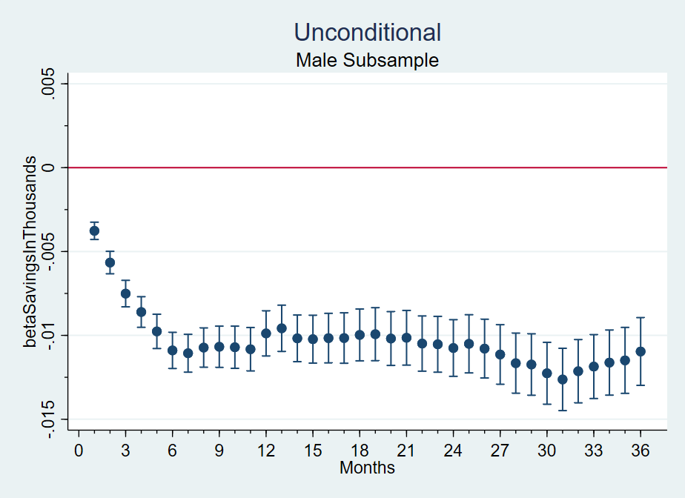

Note: Figure 15 plots the coefficient on savings from a linear projection of indicators for ever recidivating within j months, ranging from 1 to 36. Standard errors are clustered at the individual level.

Figure 16

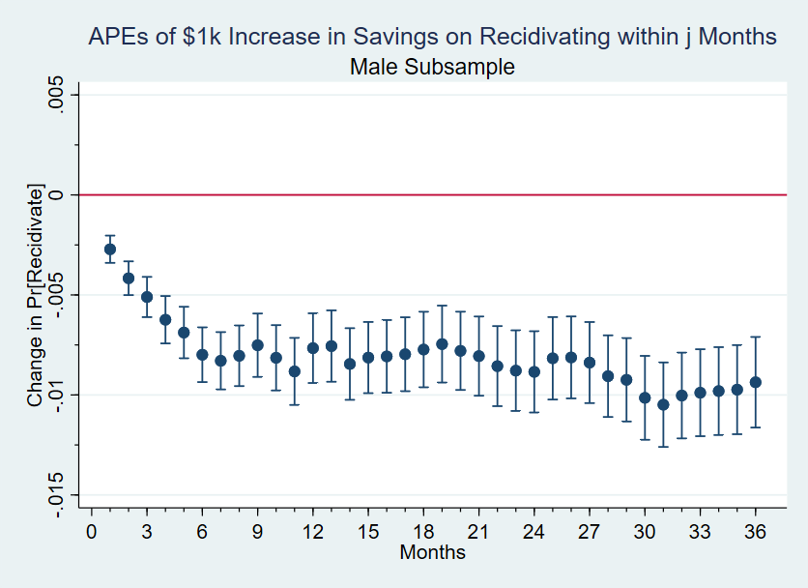

Note: Figure 16 displays the average partial effects of a $1,000 increase in mandatory savings on the probability of recidivating separately for months 1-36. Standard errors are clustered at the individual level.

**E. Effects for Violent v.s. Non-Violent Offenders**

If compensation rather than selection is driving effects, the economic theory discussed in Section II would suggest that impacts should be more pronounced in reducing recidivism precisely for individuals committing crimes that are plausibly financially-motivated. In particular, the theory suggests that recidivism for commiting violent crimes should be relatively unaffected by higher savings levels, since financial security is unlikely to be a salient factor for most violent crimes.[54]

Table 6 (Appendix) presents OLS estimates of and using the same controls as Section IV D on alternative outcomes for the male subsample.[55] I fail to reject null effects of mandatory savings on the probability of committing a new violent offense within 6 or 36 months, even at the 10% level. In contrast, effects on committing a new drug felony within 6 months of release are significant at the 5% level, implying a 3.4% decrease over the mean for a $1,000 increase in savings. However, the drug-felony effects fail to achieve significance at the 36-month mark. Aggregating to any non-violent felony conviction, effects are significant at the 1% level for the 6-month mark, implying a 4.8% reduction over the mean. At both the 6 and 36-month marks, the estimated effects on recidivating due to any technical violation are significant at the 1% level, with a 3.84% decrease over the mean for the 6-month mark and a 1.97% decrease for the 36-month mark.

In table 7 (Appendix) I conduct the same analysis on the female subsample, which reveals similar patterns with a few key distinctions. The first is that both drug-felony and property-felony effects are significant at the 1% level at the 6-month mark -- implying 9.3% and 10.4% reductions over the mean respectively. These effects represent larger relative changes over the mean compared to the male subsample, owing partially to the lower rates of criminal recidivism for women overall. Nevertheless, the corresponding female subsample estimates for drug- and property-felony effects at the 36-month mark are indistinguishable from zero, as with the male subsample. Another key distinction in the female subsample is that effects on violent felony convictions are significant at the 10% level and fairly noisy. While this could be interpreted as a sign of residual confounding, lack of statistical power is a more likely explanation considering that the female violent-felony recidivism outcome is one of the rarest outcomes in Table 7, second only to DUIs. Out of the 2,214 female inmate-spells under observation at the 6-month mark, 7 had ended with a new violent felony conviction and 2 had ended with a new DUI.

Figure 17

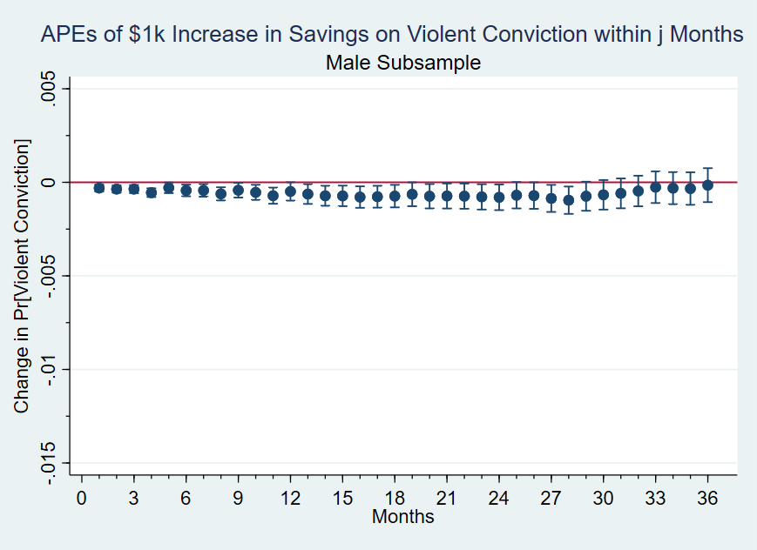

Note: Figure 17 shows the average partial effects of a $1,000 increase in mandatory savings on the probability of being convicted of a new violent felony separately for 1-36 months. Bars indicate 95% confidence intervals and standard errors are clustered at the individual level.

Figures 17 and 18[56] show that a similar pattern to Tables 6 and 7 holds for the other months as well. Of the 36 model estimates shown in Figure 17, only 6 manage to eke out significance at the 5% level. In contrast, all 36 model estimates in Figure 18 are significant and roughly 4 times larger in magnitude on average.

Figure 18

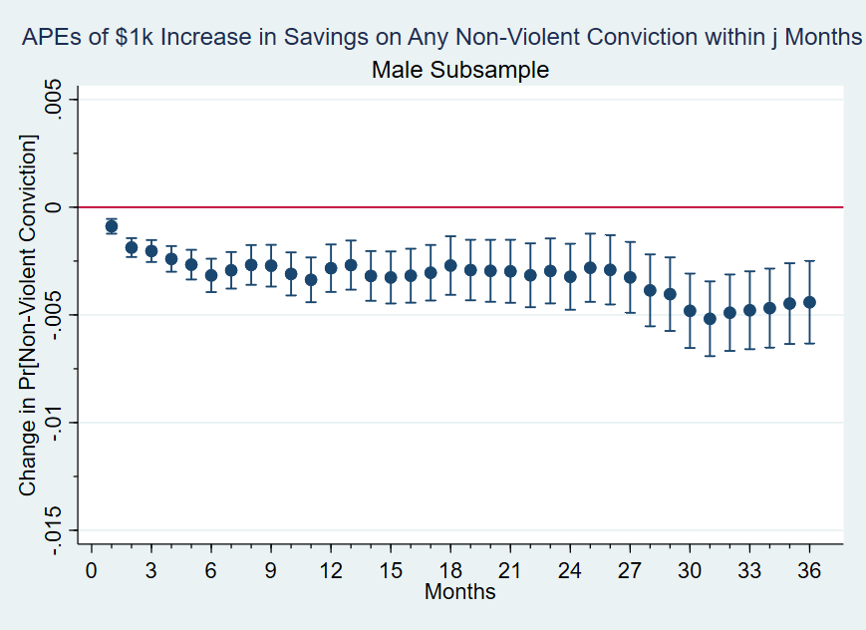

Note: Figure 18 shows the average partial effects of a $1,000 increase in mandatory savings on the probability of being convicted of any new non-violent felony separately for 1-36 months. Bars indicate 95% confidence intervals and standard errors are clustered at the individual level.

Failing to reject null effects for violent felony convictions is consistent with the intuition that financial considerations are unlikely to impact decisions to engage in violent behavior for the recently released. However, also failing to reject null effects for property crimes is seemingly inconsistent with theoretical predictions from the economic model. Statistical power may be an issue considering that recidivating due to any new felony conviction is rare relative to recidivating due to a technical violation. An alternative explanation for this pattern would be that the probability of detection differs systematically between property and drug crimes. Within 6 months of release most offenders are still under community supervision, which usually includes random drug testing. In this sense, the drug-related felony outcome is less prone to measurement error than the property-related felony outcome, which may explain the attenuation of effect estimates for property crimes. I leave exploration of these potential alternatives to future work.

**V. Conclusion**

In this study I estimate the impacts of higher savings from prison labor on the probability of reincarceration. I justify the unconfoundedness assumption by demonstrating plausibly exogenous sources of variation in mandatory savings using rich administrative data from ADCRR. I find that a $1,000 increase in mandatory savings reduces the probability of recidivating within 6 months by 0.8 percentage points, a 4.25% reduction over the mean. To my knowledge, this study is the first to use measures of compensation from prison labor assignments as a treatment variable. Further, this extension helps reconcile conflicting estimates on the effect of CI participation in previous studies. Comparing estimates between violent and non-violent recidivists reveals significant treatment effect heterogeneity that is consistent with workhorse economic theories of crime; failing to reject null effects for violent crime while finding a statistically significant 0.1 percentage point reduction in conviction for drug-related felonies, a 3.42% reduction over the mean at 6 months. These results build upon a growing literature in the economics of crime on the relationship between financial precarity and the propensity to desist from criminal activity.

# References

Agan, A. Y., & Makowsky, M. D. (2021). The Minimum Wage, EITC, and Criminal Recidivism. *Journal of Human Resources*.

American Civil Liberties Union; Global Human Rights Clinic - University of Chicago Law School. (2022). *Captive Labor.*

Arizona Department of Corrections, Rehabilitation, and Reentry. (2022). Department Order 903: Inmate Work Activities. Arizona, United States of America.

Becker, G. (1968). Crime and Punishment: An Economic Approach. *Journal of Political Economy*.

Carson, E. A. (2020). *Prisoners in 2019.* Bureau of Justice Statistics.

Cox, R. (2016). The Effect of Private Sector Work Opportunities in Prison on Labor Market Outcomes of the Formerly Incarcerated. *Journal of Labor Research*.

D.J., N. (1992). Intention-to-treat analysis: implications for quantitative and qualitative research. *International journal of epidemiology*.

Doleac, J. (2023). Encouraging Desistance from Crime. *Journal of Economic Literature*.

Durose, M. R., & Leonardo Antenangeli, P. (2021). *Recidivism of Prisoners Released in 34 States in 2012: A 5-Year Follow-Up Period (2012–2017).* Bureau of Justice Statistics.

Duwe, G., & McNeeley, S. (2017). The Effects of Prison Labor on Institutional Misconduct, Postprison Employment, and Recidivism. *Corrections*.

Ehrlich, I. (1973). Participation in Illegitimate Activities: A Theoretical and Empirical Investigation. *Journal of Political Economy*.

Finlay, K., Mueller-Smith, M., & Street, B. (2023). Children's Indirect Exposure to the U.S. Justice System: Evidence From Longitudinal Links between Survey and Administrative Data. *The Quarterly Journal of Economics*.

Hess, J., & Turner, S. F. (2021). *The Effect of Prison Industry on Recidivism: An Evaluation of California Prison Industry Authority.* Center for Evidence-Based Corrections; University of California, Irvine.

Horrace, W., & Oaxaca, R. (2006). Results on the bias and inconsistency of ordinary least squares for the linear probability model. *Economics Letters*.

J., N. D. (1992). Intention-to-treat analysis: implications for quantitative and qualitative research. *International journal of epidemiology*.

Ludwig, J., & Schnepel, K. (2024). Does nothing stop a bullet like a job? The effects of income on crime. *Annual Review of Criminology. Submitted.*

Maruscha, L., & E. B. (2021). *Census of State and Federal Adult Correctional Facilities, 2019 - Statistical Tables.* Bureau of Justice Statistics.

Nur, A. V., & Nguyen, H. (2023). Prison Work and Vocational Programs: A Systematic Review and Analysis of Moderators of Program Success. *Justice Quarterly*.

Rhodes, W., Gaes, G., Luallen, J., Kling, R., Rich, T., & Shively, M. (2016). Following incarceration, most released offenders never return to prison. *Crime & Delinquency*.

Richmond, K. (2014). Impact of Federal Prison Industries Employment on the Recidivism Outcomes of Female Inmates. *Justice Quarterly*.

Rose, E. K., & Shem-Tov, Y. (2021). How Does Incarceration Affect Reoffending? Estimating the Dose-Response Function. *Journal of Political Economy*.

Semenova, V., & Chernozhukov, V. (2021). Debiased machine learning of conditional average treatment effects and other causal functions. *The Econometrics Journal*.

Smith, C. J., Bechtel, J., Patrick, A., Smith, R. R., & Wilson-Gentry, L. (2006). *Correctional Industries Preparing Inmates for Re-entry: Recidivism & Post-release Employment.*

The Council of State Governments - Justice Center. (2018). *Confined and Costly.*

Wooldridge, J. M. (2010). *Econometric Analysis of Cross-Section and Panel Data.*

Yang, C. S. (2017). Does Public Assistance Reduce Recidivism? *American Economic Review*.

**Appendix: Tables**

**Table 1: Summary Statistics of Analyzed Sample**

|  |  |  |
| --- | --- | --- |
| Summary Statistics: Demographics, Criminal History, and Internal Metrics | | |
|  | Full Analytic Sample | |
|  | Men | Women |
| Mean |  |  |
| % Drug Conviction | 0.43 | 0.56 |
| % Property Conviction | 0.42 | 0.46 |
| % Violent Conviction | 0.19 | 0.09 |
| % DUI Conviction | 0.09 | 0.05 |
| % Black | 0.14 | 0.07 |
| % Latino | 0.26 | 0.25 |
| % Native | 0.05 | 0.05 |
| Has GED | 0.83 | 0.79 |
| Age at Release (Years) | 40.55 | 38.38 |
| Some College | 0.17 | 0.13 |
| % Participated Academic Education | 0.30 | 0.43 |
| % Participated Vocational Training | 0.36 | 0.34 |
| % Participated Substance Abuse Treatment | 0.16 | 0.10 |
| # of Prior Prison Spells | 1.57 | 0.95 |
| Sentence Length (Years) | 4.07 | 2.98 |
| # of Disciplinary Infractions in Current Spell | 0.45 | 0.16 |
| Median |  |  |
| Age at Release (Years) | 40.12 | 37.36 |
| # of Prior Prison Spells | 1.00 | 0.00 |
| Sentence Length (Years) | 3.31 | 2.43 |
| # of Disciplinary Infractions in Current Spell | 0.00 | 0.00 |
| Factor-variable percent |  |  |
| Internal Risk Score=1 | 35.46% | 45.56% |
| Internal Risk Score=2 | 43.34% | 52.62% |
| Internal Risk Score=3 | 21.11% | 1.82% |
| Internal Risk Score=4 | 0.10% | 0.00% |
| Recidivism Risk Score=0 | 0.04% | 0.00% |
| Recidivism Risk Score=1 | 31.13% | 36.68% |
| Recidivism Risk Score=2 | 19.64% | 14.60% |
| Recidivism Risk Score=3 | 14.35% | 25.42% |
| Recidivism Risk Score=4 | 9.35% | 6.54% |
| Recidivism Risk Score=5 | 14.50% | 16.63% |
| Recidivism Risk Score=6 | 7.85% | 0.13% |
| Recidivism Risk Score=7 | 2.89% | 0.00% |
| Recidivism Risk Score=8 | 0.25% | 0.00% |
| # of Inmate Spells | 8,258 | 2,309 |
| Note: Internal Risk and Recidivism Risk Scores used for calculations are their values at the time of assignment. For simplicity, all statistics are calculated at the inmate spell level. | | |

|  |  |  |  |  |  |  |  |  |  |  |  |  |
| --- | --- | --- | --- | --- | --- | --- | --- | --- | --- | --- | --- | --- |
|  | **10th percentile** | | **25th percentile** | | **Median** | | **75th percentile** | | **90th percentile** | | **Mean** | |
|  | **Men** | **Women** | **Men** | **Women** | **Men** | **Women** | **Men** | **Women** | **Men** | **Women** | **Men** | **Women** |
| Starting Hourly Wage | 2.00 | 3.00 | 2.00 | 3.00 | 2.00 | 3.00 | 3.00 | 3.00 | 3.00 | 3.00 | 2.51 | 3.04 |
| Maximum Hourly Wage | 3.00 | 4.00 | 3.00 | 4.00 | 3.00 | 4.00 | 4.00 | 4.00 | 4.00 | 4.00 | 3.32 | 3.93 |
| # of Weeks Assigned | 2.29 | 2.57 | 6.71 | 8.00 | 19.43 | 21.43 | 48.71 | 47.86 | 92.57 | 84.43 | 35.91 | 34.75 |
| Total Mandatory Savings from Assignment | 100.29 | 142.07 | 300.86 | 468.00 | 906.75 | 1299.54 | 2562.30 | 3196.61 | 5507.36 | 6329.70 | 2062.32 | 2422.03 |
| Fraction of Mandatory Savings from Assignment | 0.92 | 1.00 | 1.00 | 1.00 | 1.00 | 1.00 | 1.00 | 1.00 | 1.00 | 1.00 | 0.97 | 0.98 |
| # of ACIL Assignments During Spell | 1.00 | 1.00 | 1.00 | 1.00 | 1.00 | 1.00 | 1.00 | 1.00 | 2.00 | 1.00 | 1.15 | 1.10 |
| Observations | 8,258 | 2,309 | 8,258 | 2,309 | 8,258 | 2,309 | 8,258 | 2,309 | 8,258 | 2,309 | 8,258 | 2,309 |
| **Note**: All statistics are calculated using ACIL assignment where inmate earned largest share of mandatory savings. | | | | | | | | | | | | |

**Table 2: Summary Statistics for Estimated Mandatory Savings**

|  |  |  |
| --- | --- | --- |
| **Table 3: Recidivism Rates and Sample Sizes for Selected Months** | | |
|  | **Men** | **Women** |
| 1 Month | 0.05 | 0.04 |
|  | **8,258** | **2,309** |
|  |  |  |
| 2 Months | 0.08 | 0.06 |
|  | **8,217** | **2,289** |
|  |  |  |
| 3 Months | 0.11 | 0.08 |
|  | **8,168** | **2,271** |
|  |  |  |
| 4 Months | 0.14 | 0.11 |
|  | **8,125** | **2,253** |
|  |  |  |
| 5 Months | 0.16 | 0.12 |
|  | **8,063** | **2,234** |
|  |  |  |
| 6 Months | 0.18 | 0.14 |
|  | **8,000** | **2,214** |
|  |  |  |
| 9 Months | 0.23 | 0.17 |
|  | **7,802** | **2,144** |
|  |  |  |
| 12 Months | 0.26 | 0.19 |
|  | **7,613** | **2,081** |
|  |  |  |
| 18 Months | 0.30 | 0.22 |
|  | **7,279** | **1,948** |
|  |  |  |
| 24 Months | 0.34 | 0.25 |
|  | **6,950** | **1,810** |
|  |  |  |
| 30 Months | 0.39 | 0.28 |
|  | **6,610** | **1,703** |
|  |  |  |
| 36 Months | 0.42 | 0.31 |
|  | **6,294** | **1,585** |

**Note:** Fractions are calculated as number of inmate spells that had a recidivism or absconding event within specified window divided by number of inmate spells still under observation which is in bold underneath.

**Table 4: OLS Estimates of Mandatory Savings on Recidivism for Selected Months (Men)**

|  |  |  |  |  |  |  |  |  |  |  |  |  |
| --- | --- | --- | --- | --- | --- | --- | --- | --- | --- | --- | --- | --- |
| Men | | | | | | | | | | | | |
|  | 2 Months | | 4 Months | | 6 Months | | 12 Months | | 24 Months | | 36 Months | |
|  | Controls | | Controls | | Controls | | Controls | | Controls | | Controls | |
|  | No | Yes | No | Yes | No | Yes | No | Yes | No | Yes | No | Yes |
| Mandatory savings (in thousands) | -0.006*** | -0.004*** | -0.009*** | -0.006*** | -0.011*** | -0.008*** | -0.010*** | -0.009*** | -0.011*** | -0.010*** | -0.011*** | -0.010*** |
|  | (0.001) | (0.001) | (0.001) | (0.001) | (0.001) | (0.001) | (0.001) | (0.002) | (0.002) | (0.002) | (0.002) | (0.002) |
| Effect in percentages | -7.20 | -4.88 | -6.50 | -4.74 | -6.07 | -4.25 | -4.03 | -3.46 | -3.13 | -2.85 | -2.48 | -2.29 |
| Dependent variable mean | 0.081 | 0.081 | 0.135 | 0.135 | 0.183 | 0.183 | 0.255 | 0.255 | 0.339 | 0.339 | 0.424 | 0.424 |
| Unique inmates | 7,948 | 7,948 | 7,859 | 7,859 | 7,741 | 7,741 | 7,376 | 7,376 | 6,755 | 6,755 | 6,131 | 6,131 |
| Total inmate spells | 8,217 | 8,217 | 8,125 | 8,125 | 8,000 | 8,000 | 7,613 | 7,613 | 6,950 | 6,950 | 6,294 | 6,294 |
| *** p<.01, ** p<.05, * p<.1 Note: This table presents OLS estimates for the effect of a one thousand dollar increase in mandatory savings on reincarceration or absconding, whichever happens first, within 2, 4, 6, 12, 24, and 36 months from release. Controls include indicators for race, ethnicity, number of prior spells of incarceration, years of education, indicators for crime type, felony class, indicators for year released and NAICS code associated with work assignment, sentence length, recidivism risk score, internal risk score, and number of disciplinary infractions. Standard errors (in parentheses) are clustered at the individual level. Number of observations decrease for longer time horizons as more of the sample is right-censored. | | | | | | | | | | | | |

|  |  |  |  |  |  |  |  |  |  |  |  |  |
| --- | --- | --- | --- | --- | --- | --- | --- | --- | --- | --- | --- | --- |
| Women | | | | | | | | | | | | |
|  | 2 Months | | 4 Months | | 6 Months | | 12 Months | | 24 Months | | 36 Months | |
|  | Controls | | Controls | | Controls | | Controls | | Controls | | Controls | |
|  | No | Yes | No | Yes | No | Yes | No | Yes | No | Yes | No | Yes |
| Mandatory savings (in thousands) | -0.007*** | -0.006*** | -0.011*** | -0.009*** | -0.012*** | -0.009*** | -0.011*** | -0.009*** | -0.013*** | -0.010*** | -0.014*** | -0.010*** |
|  | (0.001) | (0.001) | (0.002) | (0.002) | (0.002) | (0.002) | (0.002) | (0.003) | (0.003) | (0.003) | (0.004) | (0.004) |
| Effect in percentages | -11.69 | -9.65 | -10.40 | -8.08 | -8.86 | -6.38 | -5.69 | -4.70 | -5.33 | -4.09 | -4.52 | -3.31 |
| Dependent variable mean | 0.061 | 0.061 | 0.106 | 0.106 | 0.137 | 0.137 | 0.190 | 0.190 | 0.247 | 0.247 | 0.313 | 0.313 |
| Unique inmates | 2,211 | 2,211 | 2,177 | 2,177 | 2,144 | 2,144 | 2,016 | 2,016 | 1,763 | 1,763 | 1,546 | 1,546 |
| Total inmate spells | 2,289 | 2,289 | 2,253 | 2,253 | 2,214 | 2,214 | 2,081 | 2,081 | 1,810 | 1,810 | 1,585 | 1,585 |
| *** p<.01, ** p<.05, * p<.1 Note: This table presents OLS estimates for the effect of a one thousand dollar increase in mandatory savings on reincarceration or absconding, whichever happens first, within 2, 4, 6, 12, 24, and 36 months from release. Controls include indicators for race, ethnicity, number of prior spells of incarceration, years of education, indicators for crime type, felony class, indicators for year released and NAICS code associated with work assignment, sentence length, recidivism risk score, internal risk score, and number of disciplinary infractions. Standard errors (in parentheses) are clustered at the individual level. Number of observations decrease for longer time horizons as more of the sample is right-censored. | | | | | | | | | | | | |

**Table 5: OLS Estimates of Mandatory Savings on Recidivism for Selected Months (Women)**

**Table 6: OLS Estimates of Mandatory Savings on Alternative Outcomes for Selected Months (Men)**

|  |  |  |  |  |  |  |  |  |  |  |  |  |
| --- | --- | --- | --- | --- | --- | --- | --- | --- | --- | --- | --- | --- |
| Men | | | | | | | | | | | | |
|  | Drug | | DUI | | Property | | Violent | | Any Non-Violent Felony | | Any Technical Violation | |
|  | Months | | Months | | Months | | Months | | Months | | Months | |
|  | 6 | 36 | 6 | 36 | 6 | 36 | 6 | 36 | 6 | 36 | 6 | 36 |
| Mandatory savings (in thousands) | **-0.0013\*\*** | **-0.0013** | **-0.0002\*\*** | **-0.0002** | **-0.0004** | **0.0000** | **-0.0004** | **-0.0002** | **-0.0032\*\*\*** | **-0.0044\*\*** | **-0.0063\*\*\*** | **-0.0054\*\*\*** |
|  | (0.00061) | (0.00149) | (0.00013) | (0.00052) | (0.00053) | (0.00143) | (0.00031) | (0.00091) | (0.00077) | (0.00192) | (0.00129) | (0.00199) |
| Effect in percentages | -3.42% | -1.09% | -7.63% | -1.63% | -1.85% | -0.03% | -4.18% | -0.40% | -4.8% | -2.0% | -3.84% | -1.97% |
| Dependent variable mean | 0.037 | 0.122 | 0.003 | 0.012 | 0.024 | 0.089 | 0.010 | 0.038 | 0.067 | 0.22 | 0.165 | 0.272 |
| Total inmate spells | 8,000 | 6,328 | 8,000 | 6,328 | 8,000 | 6,328 | 8,000 | 6,328 | 8,000 | 6,328 | 8,000 | 6,328 |
| *** p<.01, ** p<.05, * p<.1 Note: This table presents OLS estimates for the average partial effects of a one thousand dollar increase in mandatory savings on alternative outcomes occurring within 6 and 36 months after release. Controls for all columns are identical to those in Tables 4 and 5. Column (1) “Drug” is an indicator for whether an inmate has been reincarcerated for a new drug-related felony charge within 6 or 36 months of release and zero otherwise. Columns “DUI”, “Property”, and “Violent” are defined similarly. Column “Any Non-Violent Felony” is an indicator for whether an inmate has been reincarcerated for any new felony conviction that is not categorized as “Violent”. “Any Technical Violation” is an indicator for whether an inmate has been reincarcerated for absconding or otherwise violating terms of their community supervision. Standard errors (in parentheses) are clustered at the individual level. Number of observations decrease for longer time horizons as more of the sample is right-censored. | | | | | | | | | | | | |

**Table 7: OLS Estimates of Mandatory Savings on Alternative Outcomes for Selected Months (Women)**

|  |  |  |  |  |  |  |  |  |  |  |  |  |
| --- | --- | --- | --- | --- | --- | --- | --- | --- | --- | --- | --- | --- |
|  | Drug | | DUI | | Property | | Violent | | Any Non-Violent Felony | | Any Technical Violation | |
|  | Months | | Months | | Months | | Months | | Months | | Months | |
|  | 6 | 36 | 6 | 36 | 6 | 36 | 6 | 36 | 6 | 36 | 6 | 36 |
| Mandatory savings (in thousands) | **-0.0026\*\*\*** | **-0.0022** | **-0.0001** | **-0.0007** | **-0.0011\*\*** | **-0.0016** | **-0.0004\*** | **-0.0014\*** | **-0.0043\*\*\*** | **-0.0056\*\*** | **-0.0073\*\*\*** | **-0.0088\*\*** |
|  | (0.00092) | (0.00228) | (0.00009) | (0.00047) | (0.00044) | (0.00168) | (0.00025) | (0.00078) | (0.00107) | (0.00266) | (0.00195) | (0.00342) |
| Effect in percentages | -9.30% | -2.48% | -5.82% | -13.16% | -10.39% | -2.95% | -13.69% | -11.92% | -11.7% | -4.1% | -5.85% | -3.91% |
| Dependent variable mean | 0.028 | 0.091 | 0.001 | 0.006 | 0.010 | 0.053 | 0.003 | 0.012 | 0.037 | 0.137 | 0.125 | 0.225 |
| Total inmate spells | 2,214 | 1,590 | 2,214 | 1,590 | 2,214 | 1,590 | 2,214 | 1,590 | 2,214 | 1,590 | 2,214 | 1,590 |
| *** p<.01, ** p<.05, * p<.1 Note: This table presents OLS estimates for the average partial effects of a one thousand dollar increase in mandatory savings on alternative outcomes occurring within 6 and 36 months after release. Controls for all columns are identical to those in Tables 4 and 5. Column (1) “Drug” is an indicator for whether an inmate has been reincarcerated for a new drug-related felony charge within 6 or 36 months of release and zero otherwise. Columns “DUI”, “Property”, and “Violent” are defined similarly. Column “Any Non-Violent Felony” is an indicator for whether an inmate has been reincarcerated for any new felony conviction that is not categorized as “Violent”. “Any Technical Violation” is an indicator for whether an inmate has been reincarcerated for absconding or otherwise violating terms of their community supervision. Standard errors (in parentheses) are clustered at the individual level. Number of observations decrease for longer time horizons as more of the sample is right-censored. | | | | | | | | | | | | |

**Empirical Appendix: Graphs**

**A1: Number of ACIL assignees each day (Women’s Only)**

**A2: Number of ACIL assignees each day (Men’s Only)**

**B1: Recidivism Risk Score Histograms for Female Subsample**

**B2: ACI “Good Fit” Score Histograms for Female Subsample**

**C1: Average Partial Effects on Violent Felony Conviction for Female Subsample**

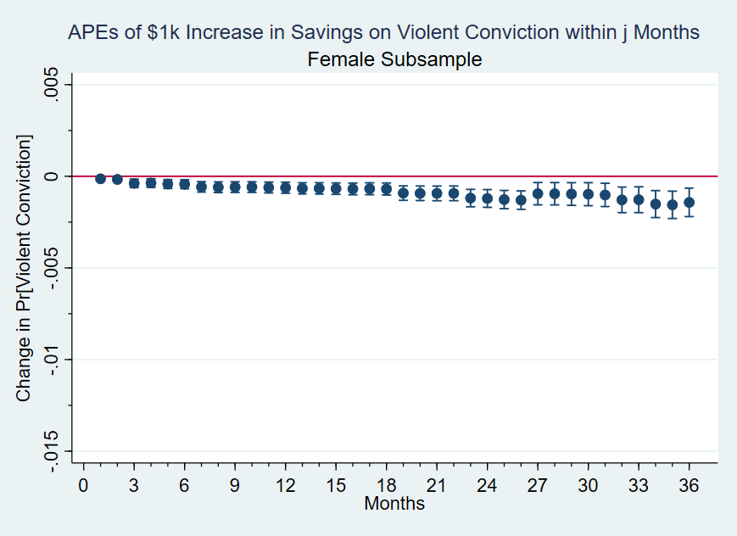

**C2: Average Partial Effects on Any Non-Violent Conviction for Female Subsample**

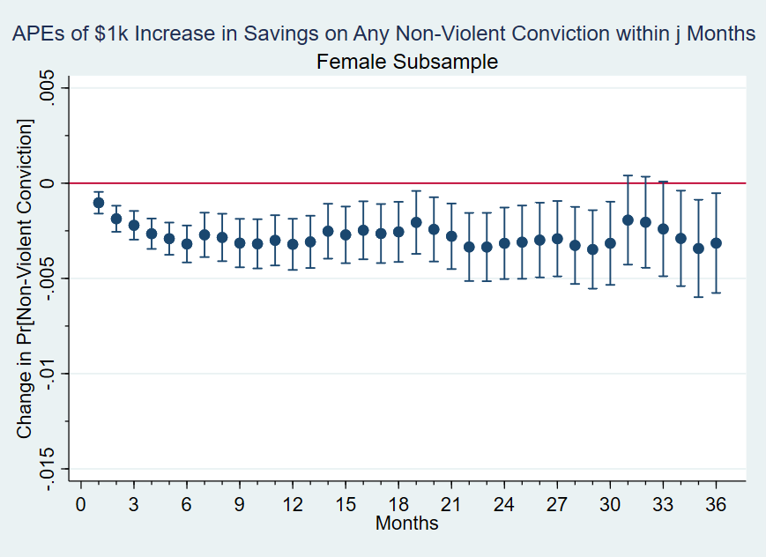

1. Bureau of Justice Statistics, Recidivism of Prisoners Released in 2012
2. Bureau of Justice Statistics, Census of State and Federal Adult Correctional Facilities, 2019
3. Bureau of Justice Statistics, Survey of Prison Inmates, 2016
4. *Captive Labor*, ACLU and GHRC 2022
5. Varies significantly between states but most common deductions are for Room and Board, Victim’s Compensation or Court-Ordered Restitution, and Child Support.
6. I will refer to this as savings or mandatory savings interchangeably. Inmates do not have a dedicated “discretionary” savings account in prison.
7. Male and female subsamples, respectively. Median mandatory savings are $907 and $1,300, respectively. Figures are rounded to the nearest dollar.
8. This figure depends on a variety of factors, see Table 1.
9. ADCRR D.O. 903 *Inmate Work Activities*
10. A related channel is the impact that savings could have on paying off debt accrued while in prison. Between 66 and 92 percent of people who have been incarcerated have child support arrears—roughly twice the rate of child support debt compared to parents who have never been incarcerated (McLeod and Gottlieb, 2018). Because these debts can result in wage garnishments, released inmates with significant arrears face a higher effective marginal tax rate for formal employment. To the extent that savings can help pay off those debts, it may have the secondary effect of ameliorating this disincentive to work in the formal economy.
11. PIE assignments are a subset of CI assignments contracted with private firms that must comply with additional federal regulations and must pay the prevailing market wage for that labor. These types of assignments employ less than one percent of inmates in work programs across the U.S. (ACLU, 2022). 99 inmate-spells in this study—roughly one percent--involved a PIE assignment.
12. Cal. Code Regs. Tit. 15, § 8006
13. Examples include differences in education requirements (e.g. whether a GED is required) and criminal history requirements (e.g. whether violent offenders can participate).
14. Author’s calculation. The remaining 5% either had medical conditions that exempted them from the requirement or were not incarcerated long enough to be assigned.
15. Their hourly wages can fluctuate due to poor performance evaluations, disciplinary infractions, or ADCRR budget shortfalls.
16. The only exception being Prison Industry Enhancement (PIE) jobs, which are also privately contracted but satisfy additional criteria. 42 male inmate-spells in the study (0.37%) were employed in a PIE assignment that paid $8.00-$11.00 per hour.
17. 341 inmates have two spells where they are assigned to ACIL, and 6 inmates have three spells.
18. *Hale v. Arizona*, 993 F.2d 1387 (9th Cir. 1993)
19. No paid vacation/sick days, not subject to any provisions in Fair Labor Standards Act or Occupational Safety and Health Act.
20. All the PIECP jobs in the sample (42 inmate-spells) were for building aluminum trailers. 55 inmate-spells were also assigned to a job for building aluminum trailers before it became a PIECP job, so were paid $3-$4/hour instead of PIECP rate.
21. Approximately 90% of inmate-spells involve an assignment to a single ACIL job. For inmate-spells with multiple ACIL jobs, I associate them with the one where they earned the majority of their mandatory savings when doing industry tabulations.
22. According to ADCRR staff, inmates are generally not moved to different prisons for the sake of ACIL contracts, which is consistent with inmate movement data. Overcrowding and security considerations are the predominant reasons for transferring inmates between prisons.
23. An additional two prison complexes exist in Arizona but had no ACIL contracts during the sample period. ADCRR staff indicate that one of those complexes mostly housed higher security risk inmates, which limits their ability to participate in “off-site” assignments which might explain the lack of ACIL contracts there. The other facility is privately operated and mostly holds inmates from Idaho and the U.S. Marshall Service, so it is possible ACI prioritizes acquiring contracts for in-state inmates.
24. ADCRR D.O. 903 *Inmate Work Activities*
25. ADCRR’s Inmate Classification Technical Manual repeatedly emphasizes the importance of correctional officer discretion in making final score determinations.
26. 80% of non-ACIL inmate-spells during the study period have no change in their recidivism risk score. 77.2% of ACIL inmate spells during the study period have no change in their recidivism risk score.
27. ADCRR *Inmate Classification Technical Manual: Appendix 5*
28. ADCRR *Inmate Work Activities Technical Manual: Table 2*
29. Recidivism Risk Score Distributions for Women in Appendix
30. The eligibility requirement, “Satisfactory Work Evaluations for the past six months” is not included in this dataset.
31. Most changes in ACI score over a sentence happen once an inmate is assigned to ACIL, their score is set to zero.
32. 2,243 (19.3%) inmate-spells have an ACIL assignment that pays a flat rate.
33. If an inmate has multiple ACIL assignments during an incarceration spell, this process is repeated and the results are added up.
34. A.R.S. §31-254
35. If the mandatory deductions exceed 100%, they are taken in the order listed until no balance remains.
36. Most examples of approved withdrawals from mandatory savings in banking data are to assist immediate family members with rent or utility payments. Withdrawals are rare and the checks must be made payable directly to the company or entity seeking payment, rather than the immediate family member.
37. The most recent pull of the data (9/27/2024) includes indicators for whether inmates have a court-ordered child support deduction. This new data will be incorporated in future drafts and should address concerns about measurement error of treatment variable.
38. The handful of negative outliers are almost all inmates that worked for a chicken ranch ACIL contract in December 2019. It is possible that they may have worked overtime, which ADCRR requires be compensated at one and a half the hourly rate for ACIL contracts, which would explain the underestimate of savings.
39. Inmates with PIE jobs have a slightly different deduction schedule which is in Table A1 in the Appendix. The main differences are the absence of deduction 6 and a flat 20% is sent to their spendable account instead of deduction 1. Additionally, PIE inmates have some wages withheld for tax purposes.
40. An inmate absconds if they fail to report to their supervising officer or their whereabouts are otherwise unknown while they are still under community supervision, which is Arizona’s version of parole.
41. This contrasts with the previous system and non-TIS states, where inmates could generally go before a parole board and plead their case for an early release. Only two inmate-spells in the sample had a release under the previous system.
42. Bureau of Justice Statistics, Recidivism of Females Released from State Prison, 2012-2017
43. Whether this duration dependence reflects changes in predisposition to criminal activity over time versus changes in probability of detection of criminal activity over time is investigated in future work.
44. Aside from absconding, the reason for the technical violation is not in the data.
45. The Council of State Governments, Justice Center – *Confined and Costly (2018)*
46. Once deductions described in Figure 6 are accounted for.
47. The most common examples are Substance Abuse and Sex Offender Treatment
48. It is a business-to-business telemarketing assignment unique to the women’s only prison and the longest-standing ACIL contract in the ADCRR; being continuously active for over 20 years. While there are other telemarketing ACIL contracts with different firms during the sample period, staff indicate that it is unique in that it trains inmates on marketing tactics and customer service. Inmates are routinely evaluated on performance metrics and are often reassigned if they cannot meet quotas. Alternatively, they may be demoted to another ACIL job contracted by the same firm that strictly pays $2 per hour, rather than the $3 -$6 per hour payscale in the previous job. Staff indicate that no other ACIL contracts employ that degree of selectivity, which is corroborated by there being no other ACIL contracts in the data with alternative lower-paying versions.
49. The one that did not, named Eyman, is where most of the highest-security designated inmates are held as well as the sex-offenders unit. These classes of inmates are restricted in their ability to leave the prison complex. This explains the lack of ACIL contracts because most of them require inmates to leave the prison complex during the day.
50. D.O. 903 *Inmate Work Activities*
51. D.O. 811 *Individual Inmate Assessments and Reviews*
52. Examples include Substance Abuse Treatment, GED Acquisition, Vocational Training, and Sex Offender Treatment.
53. In a discrete-time hazard model, the probability of recidivating within months of release is where is month of failure.
54. A relevant distinction often made in the criminology literature is that of “instrumental” versus “expressive” violent crime. The former is reserved for cases where the violent nature of the crime was a means to an end (e.g. to steal someone’s wallet), whereas the latter refers to cases where the primary goal is to hurt the victim. Miethe et al. (2004) comb through over 20 years of FBI murder data and find that 23% could be plausibly considered as “instrumental”.
55. Heterogeneity results for 6 and 36 months for female subsample in Table 7.
56. The corresponding female subsample graphs to Figures 17 and 18 exhibit qualitatively similar patterns and are in the Empirical Appendices C1 and C2, respectively.