NorthBridge Bank
Retail Banking Growth & Retention Strategy
PHASE 5
Model Explainability & Validation
Model Card, SHAP Analysis & Baseline Comparison
Churn Prediction Model v1.0

Prepared by: Senior Analytics Team
Classification: CONFIDENTIAL

SECTION 1 PURPOSE & SCOPE

Purpose & Scope
Phase 4 delivered a production churn prediction model (XGBoost) but stopped short of two things a model needs before deployment in a regulated banking context: a documented comparison against a transparent baseline, and a clear account of which individual features drive each prediction. Phase 5 closes both gaps.
This document serves as a model card for the churn prediction system: it documents what the model does, how it compares to a simpler alternative, why it makes the predictions it makes, and where its limits are. The intended audience is twofold — technical reviewers validating the modeling approach, and business stakeholders who need to trust and act on model outputs without auditing the code themselves.

What This Phase Adds
- A logistic regression baseline, trained on the identical feature set and train/test split as the Phase 4 XGBoost model, to test whether the added complexity of gradient boosting is actually earning its keep.
- SHAP (SHapley Additive exPlanations) values applied to the XGBoost model, giving both a global view of feature importance and individual, per-customer explanations.
- Two worked examples — a high-risk and a low-risk customer — showing exactly which factors pushed the model toward each prediction.
- A documented model card summarizing intended use, performance characteristics, and known limitations.

SECTION 2 MODEL COMPARISON

Logistic Regression vs. XGBoost
Both models were trained on the identical 46-feature set built in Phase 3/4 (demographics, product holdings, transaction behavior, digital engagement, satisfaction) using the same 75/25 train-test split and the same class-imbalance handling approach (class_weight='balanced' for logistic regression, scale_pos_weight for XGBoost).

2.1 Performance Comparison
Metric | Logistic Regression | XGBoost | Winner
AUC-ROC | 0.730 | 0.708 | Logistic Regression
Average Precision | 0.227 | 0.213 | Logistic Regression
Precision (at optimal threshold) | 23.3% | 19.8% | Logistic Regression
Recall (at optimal threshold) | 63.4% | 67.5% | XGBoost
F1 Score (at optimal threshold) | 0.341 | 0.306 | Logistic Regression
Training Time | Fast (seconds) | ~8-12x slower | Logistic Regression
Interpretability | High — coefficients directly readable | Medium — requires SHAP | Logistic Regression

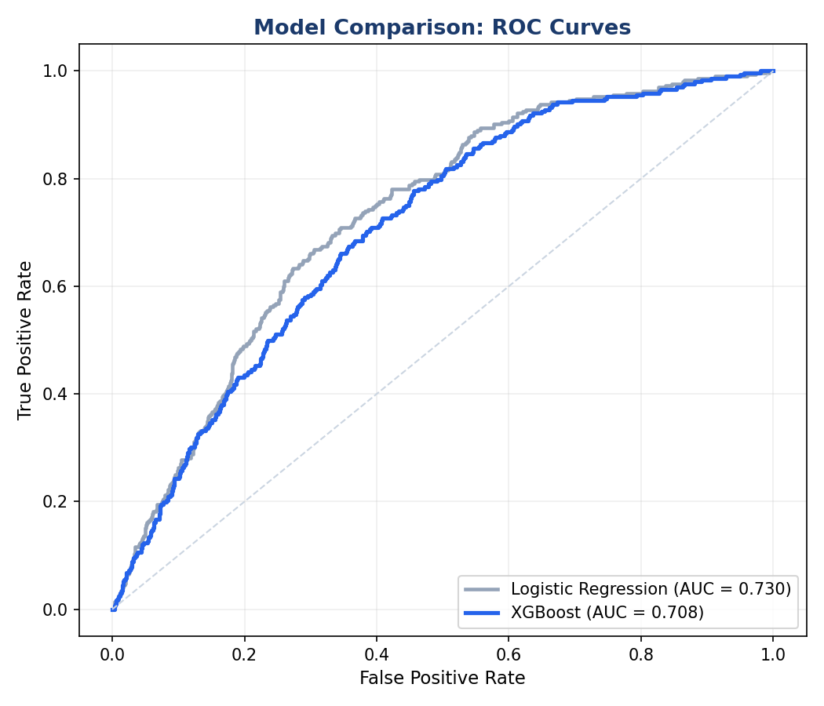
Figure 1. ROC curve comparison. Logistic regression edges out XGBoost across nearly the entire curve.

2.2 Honest Read of the Results
This comparison produced a result worth stating plainly rather than burying: the simpler model performs marginally better on every headline metric except recall. This is not the outcome a consulting narrative typically wants to report, but it is the correct and useful finding.
- The dataset's churn signal is largely linear and monotonic — low balance, low deposits, no direct deposit, few products each independently push risk up, with limited interaction effects between them. Logistic regression is well-suited to exactly this kind of structure.
- XGBoost's strength is capturing non-linear interactions and threshold effects. Where those don't exist in the underlying data-generating process, the extra model capacity adds variance without adding signal.
- XGBoost does win on recall (67.5% vs 63.4%), meaning it catches more true churners at its own optimal threshold — relevant if the cost of missing a churner outweighs the cost of a false alarm.
- Practical recommendation: deploy logistic regression as the primary scoring model for its interpretability, auditability, and slightly better precision/AUC — both important in a regulated banking context where adverse-action explanations may be required. Retain XGBoost as a secondary/ensemble signal where recall matters more, such as flagging the Critical-risk tier for manual review.

SECTION 3 LOGISTIC REGRESSION COEFFICIENTS

What Drives the Baseline Model
Because all features were standardized before fitting, the coefficients below are directly comparable in magnitude. A negative coefficient means higher values of that feature reduce predicted churn probability; positive means higher values increase it.
Feature | Coefficient | Interpretation
Avg Monthly Deposits | -0.730 | Strongest protective factor — higher deposit activity sharply reduces churn risk
Avg Monthly Spend | -0.498 | Active spenders are meaningfully less likely to churn
Monthly Revenue | +0.420 | Counterintuitive — likely reflects high-fee, low-relationship accounts (e.g., overdraft-driven revenue)
Has Investment Account | -0.235 | Investment relationships are a meaningful retention anchor
Has Credit Card | -0.116 | Modest protective effect from active credit relationship
Total Balance | -0.112 | Confirms Phase 3 finding — balance depth protects against churn
Has Mortgage | -0.111 | Mortgage holders are structurally less likely to leave
Avg eTransfers | +0.108 | Higher e-Transfer volume slightly increases churn — possibly indicates funds moving to other institutions

The Monthly Revenue and Avg eTransfers coefficients are worth flagging as candidates for follow-up investigation rather than taking at face value. Monthly Revenue correlates with Total Balance and Avg Monthly Deposits, so its positive sign may be a multicollinearity artifact rather than a genuine independent effect — standard caution applies when interpreting individual coefficients in a model with correlated inputs.

SECTION 4 SHAP EXPLAINABILITY

SHAP Analysis — Explaining the XGBoost Model
SHAP (SHapley Additive exPlanations) values decompose each individual prediction into the contribution of each feature, grounded in cooperative game theory. Unlike XGBoost's built-in feature importance (which only shows global, aggregate impact), SHAP shows both the direction and magnitude of each feature's effect for every single customer — answering not just 'what matters' but 'what matters for this customer, and why.'

4.1 Global Feature Impact
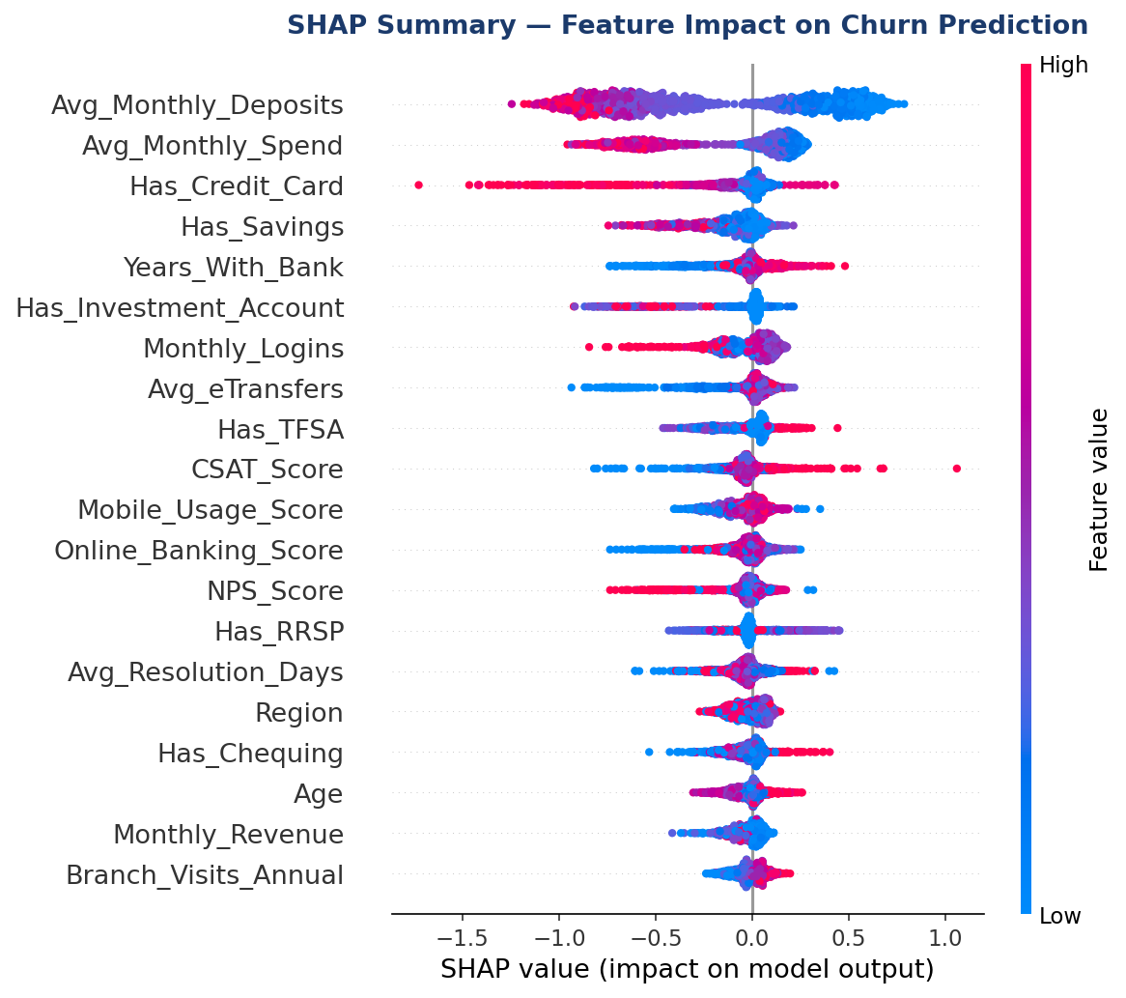
Figure 2. SHAP summary plot. Each dot is one customer. Position shows the SHAP value (impact on churn prediction); color shows whether that customer's feature value was high (red) or low (blue).
Reading this plot: for Avg_Monthly_Deposits, blue dots (low deposits) cluster on the right (positive SHAP, pushing toward churn) while red dots (high deposits) cluster on the left (negative SHAP, pushing toward retention). This is the clearest and most consistent signal in the entire model — and it corroborates, rather than overrides, the deposit-behavior finding from the Phase 4 feature importance chart.

4.2 Importance Ranking
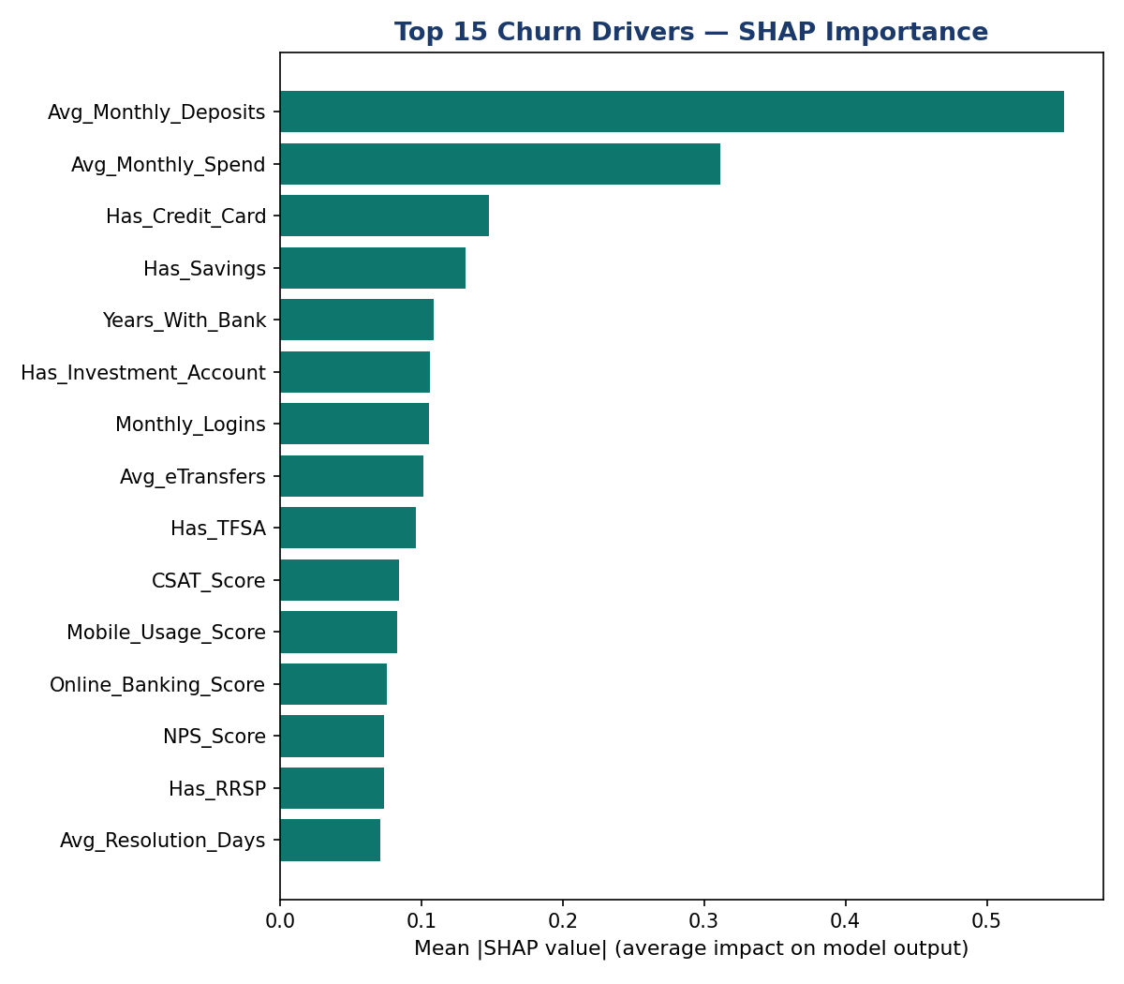
Figure 3. Top 15 features ranked by mean absolute SHAP value across the test set.
SHAP importance broadly agrees with the XGBoost native feature importance from Phase 4, with one useful refinement: SHAP surfaces Has_Credit_Card and Has_Savings as more influential than the native importance metric suggested, and demotes Avg_eTransfers slightly. This is expected — native gain-based importance can overweight features used in many small splits, while SHAP averages actual marginal contribution across all predictions.

SECTION 5 INDIVIDUAL CUSTOMER EXPLANATIONS

Two Worked Examples
The value of SHAP is most concrete at the individual level. Below are two real customers from the test set: one the model flags as high risk, one as low risk. These are the kind of explanations a retention advisor or compliance reviewer could use to understand — and defend — a specific model output.

5.1 High-Risk Customer
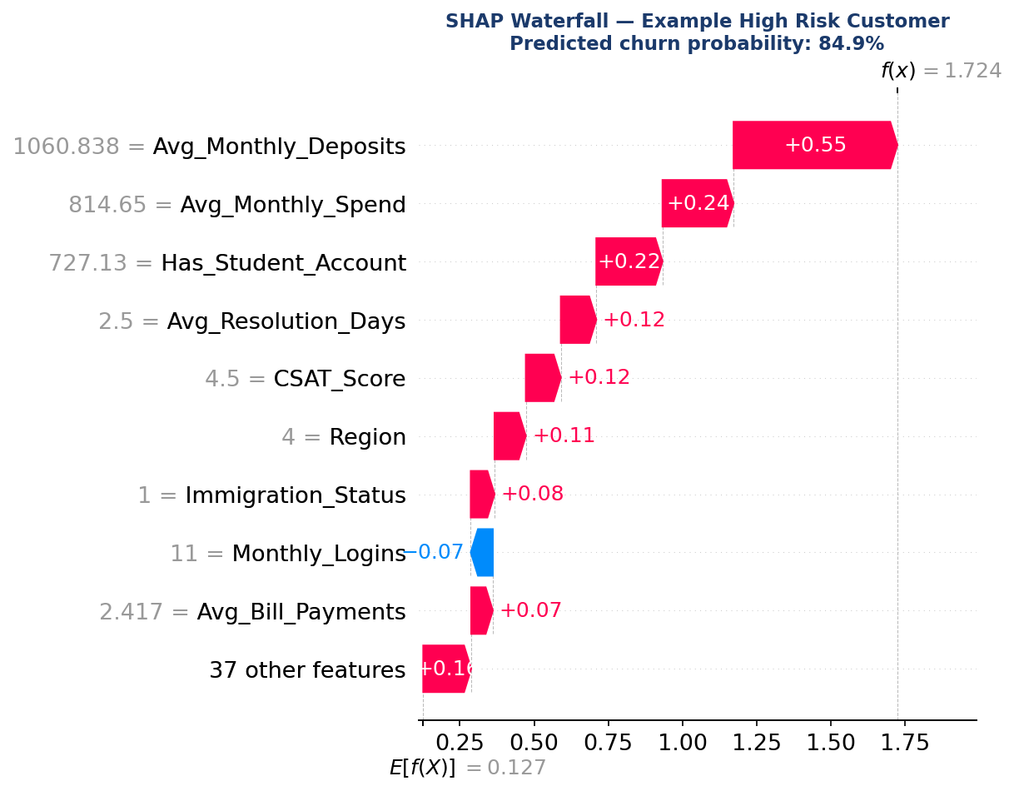
Figure 4. SHAP waterfall for a customer predicted at 84.9% churn probability.
This customer's predicted risk is driven primarily by very high monthly deposits and spend relative to a Student Account profile — an unusual combination that suggests the model has identified a customer whose transaction volume has outgrown their current account type, with no product mix to absorb it. The Region and Immigration_Status contributions are smaller but consistent with the elevated-risk subgroups identified in Phase 3. Low Monthly_Logins is the one factor pulling slightly toward retention, but it is outweighed by the deposit and account-type signals.

5.2 Low-Risk Customer
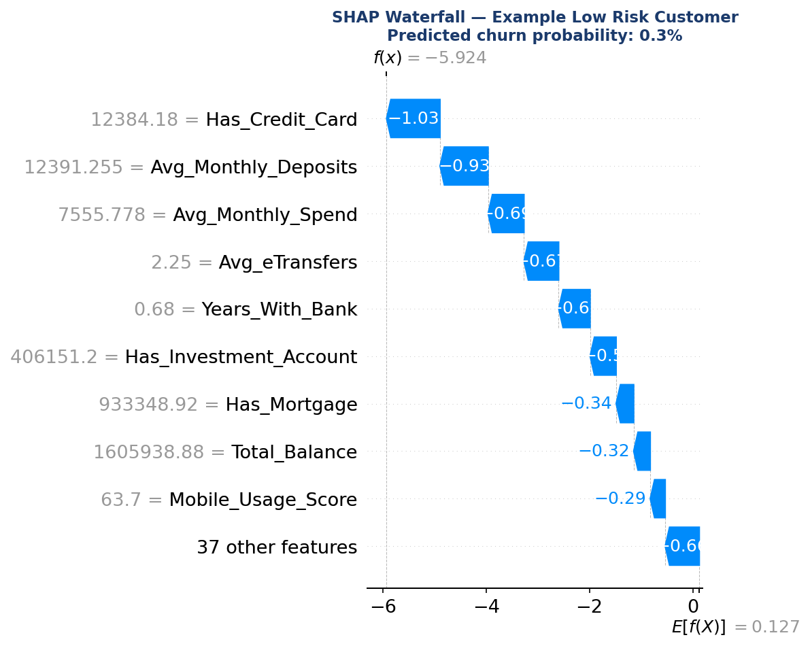
Figure 5. SHAP waterfall for a customer predicted at 0.3% churn probability.
This customer's low risk is overwhelmingly explained by deep product and balance relationships: a credit card, high deposit and spend volume, an investment account, a mortgage, and over $1.6M in total balance. No single factor dominates — instead, nearly every feature contributes a small negative (protective) push, which is the signature of a genuinely embedded, multi-product relationship rather than a single retention lever.

5.3 Practical Use
- For Critical-risk customers flagged by the model, an advisor can pull the individual SHAP explanation before the outreach call — turning 'the model says you're at risk' into 'your deposit activity has dropped and you don't yet hold an investment product, here's what we can offer.'
- For adverse-action or regulatory inquiries, SHAP explanations provide a defensible, feature-level account of why a customer was or was not flagged — which a black-box probability score alone cannot provide.
- For product strategy, aggregating SHAP values by segment (a natural Phase 6 extension) could reveal whether the same features matter differently for Students versus Affluent customers, refining the segment-specific recommendations from Phase 4.

SECTION 6 MODEL CARD

Model Card Summary
A condensed reference for anyone evaluating whether to deploy, retrain, or retire this model.

Field | Detail
Model Name | NorthBridge Churn Prediction Model v1.0
Model Type | Primary: Logistic Regression (recommended for deployment). Secondary: XGBoost Classifier (recall-oriented use cases).
Intended Use | Monthly batch scoring of the active customer base to identify churn risk tier (Low/Medium/High/Critical) and route High/Critical customers to proactive retention outreach.
Training Data | 10,000 synthetic GTA retail banking customers, calibrated to Toronto CMA demographic signals (Phase 2). Not real customer data.
Features | 46 features spanning demographics, product holdings, transaction behavior, digital engagement, branch interaction, and satisfaction.
Target | Binary churn flag (11.68% base rate in training data).
Performance | AUC-ROC 0.730 (logistic) / 0.708 (XGBoost). Both models show moderate, not strong, discriminative power — appropriate for prioritization, not for fully automated decisions.
Known Limitations | Trained on synthetic data with rule-based churn generation, so real-world performance will differ. Average Precision (~0.21-0.23) is low in absolute terms, reflecting the low base rate — most flagged customers will not actually churn. Some coefficients (e.g., Monthly Revenue) may reflect multicollinearity rather than causal effects.
Fairness Considerations | Immigration_Status and Region are included as features. Both correlate with the Newcomer segment's elevated churn rate (Phase 3) for legitimate behavioral reasons (onboarding friction, shallow initial relationships) — but any deployment should monitor for disparate treatment in how risk scores translate into differential offers or service levels across these groups.
Recommended Refresh Cadence | Retrain quarterly, or immediately if the customer mix or product lineup changes materially.
Owner | Senior Analytics Team

Phase 6 Candidates (Not Yet Scoped)
- Fairness audit: disaggregated performance metrics (precision/recall) by segment, region, and immigration status to check for differential model behavior.
- Calibration analysis: confirm that a customer scored at 60% predicted churn probability actually churns close to 60% of the time, not just that the ranking is correct.
- Cost-sensitive threshold tuning: incorporate the actual cost of a retention offer versus the CLV of a saved customer (from Phase 3) to set the decision threshold by expected value rather than F1 score alone.

