NorthBridge Bank
Retail Banking Growth & Retention Strategy
PHASE 6
Model Risk & Calibration Review
Fairness Audit, Calibration Analysis & Cost-Sensitive Threshold Design
Churn Prediction Model v1.0

Prepared by: Senior Analytics Team
Classification: CONFIDENTIAL

SECTION 1 EXECUTIVE SUMMARY

Executive Summary
Phase 5 documented the churn model's overall performance and produced individual SHAP explanations, but stopped short of asking whether the model behaves consistently across customer groups, whether its probability outputs can be trusted at face value, and what decision threshold actually maximizes business value rather than a generic statistical score. This review answers all three questions, and the answer to the first one is not comfortable.

FINDING 1 — MATERIAL FAIRNESS GAP, DO NOT DEPLOY AS-IS
At its current decision threshold, the model flags 95.7% of International Students and 92.2% of Refugees as high churn risk, versus 16.2% of Canadian-Born customers — a 5.9x disparate impact ratio. Before any production use, this requires either a segment-aware threshold strategy or a retrained model, and a documented business justification for any difference in how risk scores translate into customer treatment.

Summary of Findings
- Fairness: the model's flagging rate varies by a factor of nearly 6x across immigration status groups — far more than the underlying churn rate varies (3.4x). The model is not just detecting real risk differences; it is amplifying them.
- Calibration: both models are systematically overconfident. A customer scored at 70% predicted churn probability actually churns about 22-24% of the time. Predicted probabilities should not be read as literal likelihoods without a calibration correction.
- Cost-sensitive thresholding: given the CLV-to-outreach-cost ratio in this portfolio, a naive expected-cost-minimizing threshold pushes toward contacting nearly the entire customer base — which is not operationally realistic and signals that threshold tuning alone cannot solve the targeting problem. A capacity constraint must be layered on top.

SECTION 2 FAIRNESS AUDIT

Disaggregated Performance by Customer Group
Aggregate accuracy metrics (Phase 4-5) can hide large differences in how a model treats different groups of customers. This audit reruns the Phase 5 logistic regression model's predictions, broken out by Segment, Region, and Immigration Status, using the same test set and the same F1-optimal threshold (0.58) established in Phase 5.

2.1 By Immigration Status
This is the dimension with the clearest fairness signal, and the one most directly tied to a protected-adjacent characteristic.
Group | N | Actual Churn | Flagged Rate | Recall | Precision
Canadian Born | 831 | 8.4% | 16.2% | 44.3% | 23.0%
Permanent Resident | 828 | 7.6% | 16.3% | 41.3% | 19.3%
Temporary Resident | 399 | 12.8% | 26.6% | 45.1% | 21.7%
Refugee | 142 | 21.1% | 92.2% | 93.3% | 21.4%
International Student | 300 | 26.0% | 95.7% | 98.7% | 26.8%

Note that actual churn rate varies from 7.6% to 26.0% across these groups — a 3.4x range. The model's flagged rate varies from 16.2% to 95.7% — a 5.9x range. The model is not just calibrated to a real underlying risk difference; it is over-amplifying that difference, most likely because Immigration_Status and correlated features (Region, tenure, product depth) are being weighted more heavily than the actual churn-rate gap justifies.

2.2 By Customer Segment
Segment-level results echo the Phase 3-4 narrative but reveal an operationally important pattern: the model essentially flags almost nobody in low-churn segments and almost everybody in high-churn segments, rather than discriminating within each group.
Segment | N | Actual Churn | Flagged Rate | Recall
Affluent Customers | 211 | 1.4% | 0.0% | 0.0%
Families | 656 | 2.7% | 0.0% | 0.0%
Young Professionals | 802 | 9.5% | 1.6% | 0.0%
Newcomers to Canada | 537 | 22.7% | 90.9% | 91.8%
Students | 294 | 24.8% | 99.7% | 100.0%

OPERATIONAL IMPLICATION
At the current threshold, the model provides essentially zero ranking value within the Affluent, Families, and Young Professionals segments — it simply doesn't flag them, regardless of individual risk variation. All of the model's discriminative power is concentrated in deciding which Students and Newcomers to flag, and even there it leans toward flagging nearly everyone. This means the R2 recommendation from Phase 4 (“deploy churn risk scoring for proactive outreach”) needs segment-specific thresholds, not one global cutoff, or it will miss every at-risk Affluent and Family customer while overwhelming advisors with Student and Newcomer contacts.

2.3 Recommended Remediation
- Adopt segment-specific decision thresholds rather than one global cutoff — calibrated so that each segment's flagged rate is proportional to its actual churn rate, not driven by aggregate score distribution.
- Re-audit Region and Immigration_Status as features: consider whether they add genuine predictive signal beyond what is already captured by tenure, product count, and direct deposit status, or whether they are acting as a proxy that amplifies disparity without adding accuracy.
- Before any deployment that ties model output to differential customer treatment (e.g., faster service, different offers), document a business justification for the disparity and have it reviewed by compliance, consistent with fair lending principles even though this is not a credit decisioning model.

SECTION 3 CALIBRATION ANALYSIS

Are the Probabilities Trustworthy?
AUC measures whether the model ranks churners above non-churners correctly. It says nothing about whether a predicted probability of 70% means the customer actually has a 70% chance of churning. That second property — calibration — matters whenever predicted probabilities are used directly in a calculation, such as expected-value retention targeting or reporting a 'risk score' to a relationship manager.

3.1 Calibration Curve
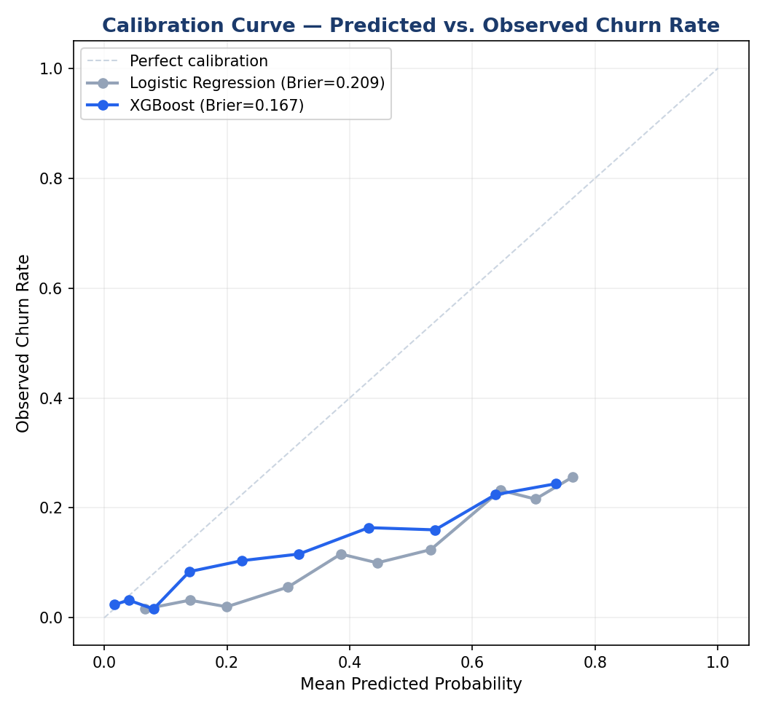
Figure 1. Calibration curve for both models. Points below the diagonal indicate overconfidence — the model predicts higher churn probability than is actually observed.
Both models sit consistently below the diagonal across the full probability range, meaning both are overconfident: a customer the model scores at 50%+ actually churns at roughly half that rate. Interestingly, XGBoost (Brier score 0.167) is meaningfully better calibrated than logistic regression (Brier score 0.209), despite having a slightly lower AUC in the Phase 5 comparison. This is a useful nuance the headline AUC numbers alone do not capture.

3.2 Practical Consequence
If a business process were to read the model's predicted probability literally — for example, 'only escalate to a senior advisor if predicted churn probability exceeds 70%' — it would be working against a number that overstates true risk by roughly 3x at that point on the curve. Any process built on this model should either (a) use score-based ranking and risk tiers, as Phase 4-5 do, rather than literal probability thresholds, or (b) apply a calibration correction (e.g., Platt scaling or isotonic regression) before using the raw probability in a calculation.
- Risk tier assignment (Low/Medium/High/Critical): SAFE to use as-is, since tiers only depend on rank-ordering, not the literal probability value.
- Expected-value calculations (e.g., the cost-sensitive threshold analysis in Section 4): SHOULD use calibrated probabilities — using raw, overconfident probabilities would overstate the expected number of saves from a retention campaign.
- Any external reporting of a numeric 'risk score' as a probability: SHOULD be relabeled as a relative risk index rather than a probability until a calibration correction is applied.

SECTION 4 COST-SENSITIVE THRESHOLD DESIGN

Setting the Threshold by Business Value, Not F1 Score
Phase 4-5 selected decision thresholds by maximizing F1 score — a reasonable default with no business context, but not actually the right objective. The real question is: at what threshold does the expected cost of contacting a customer who wouldn't have churned anyway, balanced against the expected cost of missing a customer who would have, hit its minimum?

4.1 Cost Assumptions
These assumptions are stated explicitly so they can be challenged and updated as real operational data becomes available — they should not be treated as ground truth.
Assumption | Value | Source
Average 5-year CLV | $39,565 | Phase 3 portfolio average
Retention offer cost | $150 | Phase 4, R1 direct deposit incentive
Save rate if contacted | 20% | Phase 4, R2 stated target
Cost of a false positive | $150 | = retention offer cost (wasted on a non-churner)
Cost of a false negative | $7,913 | = avg CLV x save rate (value of a contact never made)

The roughly 53:1 ratio between false-negative cost and false-positive cost is the central driver of everything that follows. When the cost of missing a churner is that much larger than the cost of an unnecessary outreach call, a pure expected-cost-minimizing model will always lean toward over-flagging.

4.2 Result
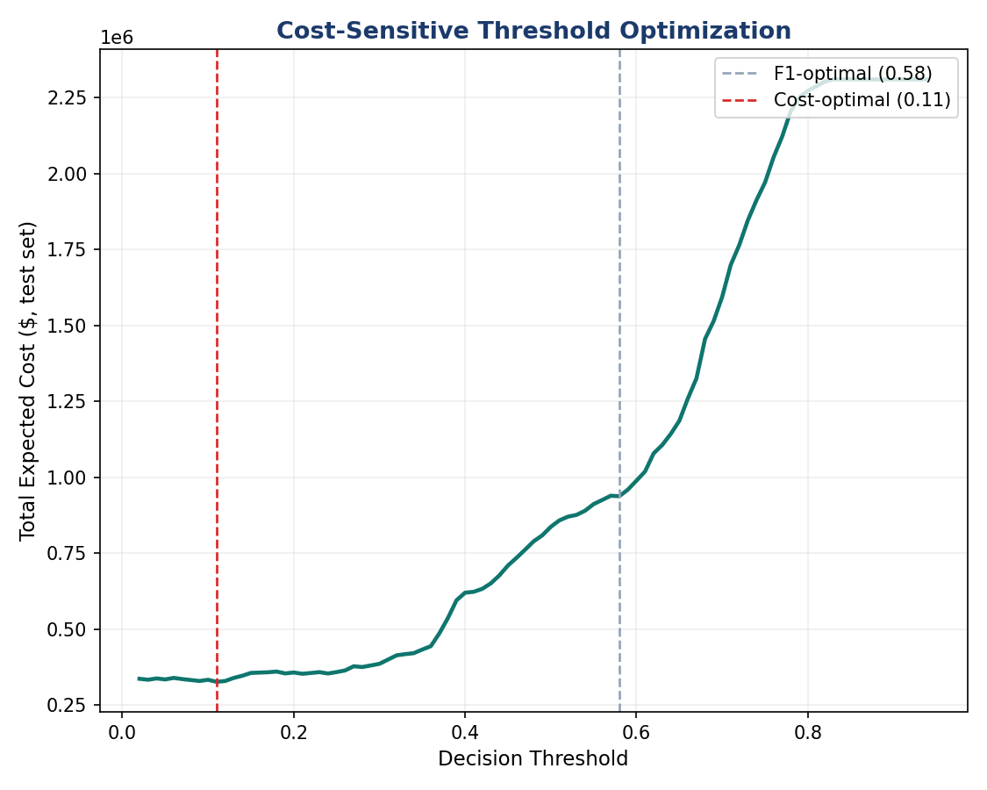
Figure 2. Total expected cost across the test set as a function of decision threshold.
Threshold Strategy | Threshold | False Positives / False Negatives | Expected Cost (test set)
F1-optimal (Phase 5) | 0.58 | 609 / 107 | $938,042
Cost-optimal | 0.11 | 1,967 / 4 | $326,702

READ THIS RESULT CAREFULLY — IT IS NOT DIRECTLY ACTIONABLE
The cost-optimal threshold of 0.11 implies flagging roughly 79% of the test set (1,967 of 2,500 customers) as high-risk. That is not a targeted retention list — it is most of the customer base. This happens because, given the stated CLV-to-outreach-cost ratio, the model is mathematically correct that almost any contact is worth making in expectation. But no retention team has capacity to call 79% of the customer base every month. This is a textbook case where pure cost minimization needs a capacity constraint layered on top, not a threshold chosen in isolation.

4.3 Recommended Approach: Capacity-Constrained Targeting
Rather than picking a single threshold, the practical recommendation is to rank all customers by predicted churn probability (using the calibrated score) multiplied by their individual CLV, and contact as many as the retention team's actual monthly capacity allows, starting from the top of that ranked list. This converts the threshold question into a budget question, which matches how the business actually operates.
- Score = Predicted_Churn_Probability x Customer_CLV_5yr — this prioritizes high-value, high-risk customers over low-value, high-risk customers, which a flat probability threshold does not do.
- If the retention team can realistically make 300 proactive contacts per month, target the top 300 customers by this combined score, not everyone above an arbitrary probability cutoff.
- Revisit the underlying cost assumptions (especially the 20% save rate) with real campaign data after the Phase 4 R1/R2 pilots run for one full quarter, and recompute this analysis with actuals rather than estimates.

SECTION 5 SUMMARY & RECOMMENDATIONS

What This Means for Deployment
Risk Area | Finding | Required Action Before Production Use
Fairness | 5.9x disparate flagging rate by immigration status; segment-level scoring has near-zero discrimination within low-churn segments | Segment-specific thresholds; compliance review of Immigration_Status/Region as features
Calibration | Both models overconfident by roughly 2-3x at mid-to-high probability ranges; XGBoost better calibrated than logistic regression | Apply calibration correction before using raw probabilities in any expected-value calculation
Threshold Design | Pure cost-minimization recommends flagging ~79% of customers — not operationally feasible | Replace single threshold with capacity-constrained, CLV-weighted ranking

Overall Recommendation
The churn model remains valuable for relative risk ranking and the SHAP-based individual explanations from Phase 5 remain accurate and useful. However, this review found that the model is not yet ready for unmodified production deployment: the fairness gap is large enough to warrant remediation before go-live, the probability outputs require a calibration correction before being used in financial calculations, and the threshold strategy needs to shift from a single global cutoff to capacity-constrained, CLV-weighted targeting. These are normal findings for a first-pass model risk review, not a reason to discard the model — they are the specific, scoped engineering work needed before the Phase 4 recommendations (R1, R2) can be deployed responsibly.

