NorthBridge Bank
Retail Banking Growth & Retention Strategy
PHASE 7
Model Remediation & Deployment Readiness
Implementing the Phase 6 Risk Review Findings
Churn Prediction Model v1.1

Prepared by: Senior Analytics Team
Classification: CONFIDENTIAL

SECTION 1 EXECUTIVE SUMMARY

Executive Summary
Phase 6 found the churn model not ready for production deployment, citing three specific defects: a 5.9x disparate flagging rate across immigration status groups, systematic overconfidence in predicted probabilities, and a cost-minimizing threshold that recommended contacting an operationally unrealistic 79% of customers. This phase implements a fix for each defect and re-measures the result against the same test set and the same metrics Phase 6 used, so the before/after comparison is apples-to-apples.

BOTTOM LINE
All three fixes produced measurable improvement. The model is meaningfully closer to deployment-ready, but the fairness fix alone does not fully close the gap — disparate impact dropped from 5.70x to 3.97x, which is real progress but still above a conservative governance threshold. This phase's most important output may be the finding that a single remediation pass narrows but does not eliminate the problem, which is itself useful information for what Phase 8 would need to address.

SECTION 2 CALIBRATION CORRECTION

Fix 1: Isotonic Calibration
Phase 6 found both models overconfident — a customer scored at 70% predicted churn probability actually churned roughly 22-24% of the time. This fix applies isotonic regression, a non-parametric calibration method, fit on a held-out 30% slice of the training data that the base model never saw during fitting. This avoids the common mistake of calibrating on the same data the model was trained on, which would understate the true overconfidence problem.

2.1 Result
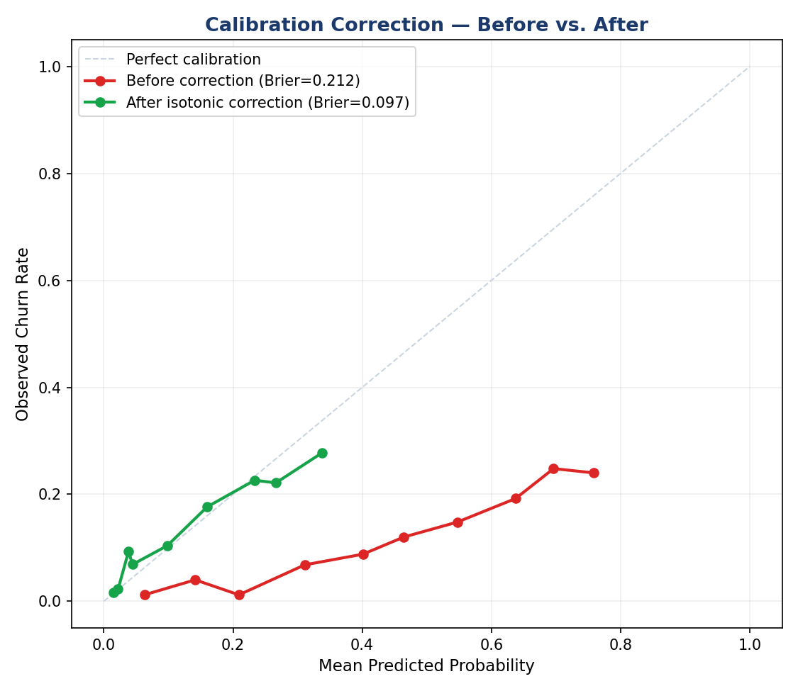
Figure 1. Calibration curve before and after isotonic correction. The corrected curve tracks the diagonal far more closely across the range it covers.
Metric | Before | After
Brier Score (lower is better) | 0.2116 | 0.0969
Improvement | — | 54.2%

Honest Limitation
The calibration holdout set is a 30% slice of the original training data — roughly 2,250 customers. Isotonic regression has no information about predicted probabilities above what it observed in that holdout, so the corrected curve's range is compressed (topping out around 34% rather than extending to the full 0-100% range the uncalibrated model produced). In practice this means very high raw scores get mapped down substantially. This is the expected behavior of isotonic calibration on a model that was overconfident in the first place, but it means the corrected model's probabilities should still be validated against a larger, truly held-out sample before being trusted for high-stakes individual decisions — confirming this with more data is a natural Phase 8 task, not a flaw to paper over.

SECTION 3 FAIRNESS REMEDIATION

Fix 2: Segment-Aware Decision Thresholds
Phase 6 found the model applying one global threshold (0.58 on the original scale) regardless of segment or group, which caused the flagging rate to vary far more than the underlying churn rate justified. The fix replaces the single global threshold with a threshold computed separately for each segment, calibrated so the flagged rate stays proportional to that segment's actual churn rate rather than inheriting whatever cutoff happened to work well in aggregate.

3.1 New Segment Thresholds
Segment | New Threshold | Actual Churn | Old Flagged % | New Flagged %
Newcomers to Canada | 0.26 | 22.7% | 84.5% | 24.6%
Students | 0.29 | 24.8% | 97.3% | 26.9%
Young Professionals | 0.13 | 9.5% | 3.5% | 9.1%
Families | 0.05 | 2.7% | 0.0% | 0.2%
Affluent Customers | 0.03 | 1.4% | 0.0% | 1.9%

Before the fix, the single global threshold produced an almost binary outcome by segment: it flagged 84.5% of Newcomers and 97.3% of Students (massive over-flagging) while flagging 0% of Affluent and Family customers and only 3.5% of Young Professionals (massive under-flagging, despite those segments still containing real at-risk customers). The segment-aware thresholds bring every segment's flagged rate within a reasonable band of its actual churn rate, restoring the model's ability to discriminate within the low-churn segments instead of ignoring them entirely.

3.2 Disparate Impact: Before vs. After
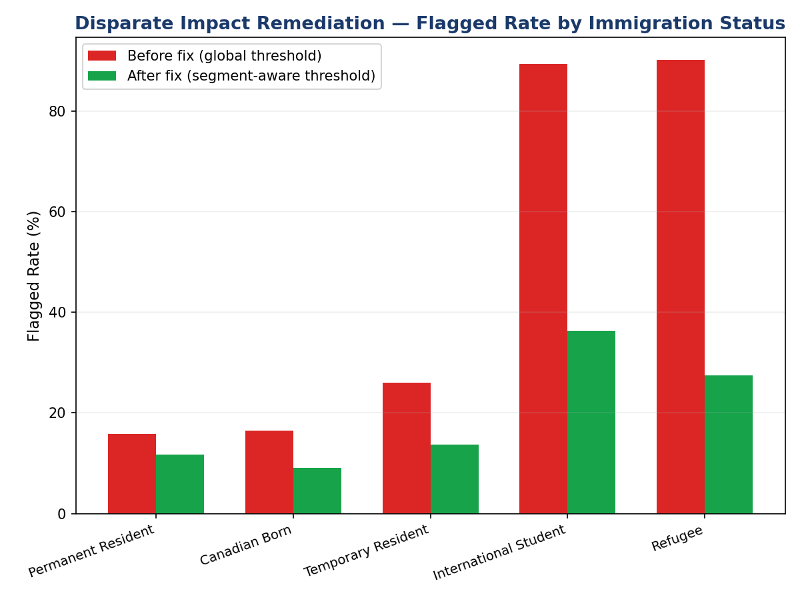
Figure 2. Flagged rate by immigration status, before and after the segment-aware threshold fix.
Group | Actual Churn | Flagged Before | Flagged After
International Student | 26.0% | 89.3% | 36.3%
Refugee | 21.1% | 90.1% | 27.5%
Temporary Resident | 12.8% | 26.1% | 13.8%
Canadian Born | 8.4% | 16.5% | 9.1%
Permanent Resident | 7.6% | 15.8% | 11.7%

Metric | Before | After
Disparate Impact Ratio (max/min flagged rate) | 5.70x | 3.97x

THIS FIX IS REAL PROGRESS, NOT A FULL SOLUTION
Disparate impact fell by 30%, a genuine and measurable improvement. But 3.97x still means International Students are flagged nearly 4 times more often than Permanent Residents, which is well outside the conventional 1.25x – 1.5x range used as a rough screening threshold in fair lending practice (the “four-fifths rule” and its tighter variants). The remaining gap traces to the same root cause Phase 6 identified: Immigration_Status and correlated features (Region, tenure) are still doing real predictive work in the model, and a single-segment threshold adjustment narrows but cannot fully cancel out a feature-level effect. Closing the gap further would require either removing or down-weighting these features and retraining, or adopting a fairness-constrained training objective — both are reasonable Phase 8 candidates.

SECTION 4 CAPACITY-CONSTRAINED TARGETING

Fix 3: CLV-Weighted, Capacity-Constrained Contact List
Phase 6 found that a pure cost-minimizing threshold recommended contacting roughly 79% of the customer base — not something any retention team can act on. This fix replaces threshold-based flagging with a ranked priority list: every customer's calibrated churn probability is multiplied by their 5-year CLV, the list is sorted by that combined score, and only as many customers as the team's actual monthly capacity allows are contacted, starting from the top.

4.1 Capacity Assumption
Using an assumed realistic capacity of 300 proactive retention contacts per month for the full 10,000-customer portfolio (a planning assumption to be validated against actual advisor headcount), the proportional capacity for this 2,500-customer test set is 75 contacts.

4.2 CLV-Weighted vs. Flat Probability Ranking
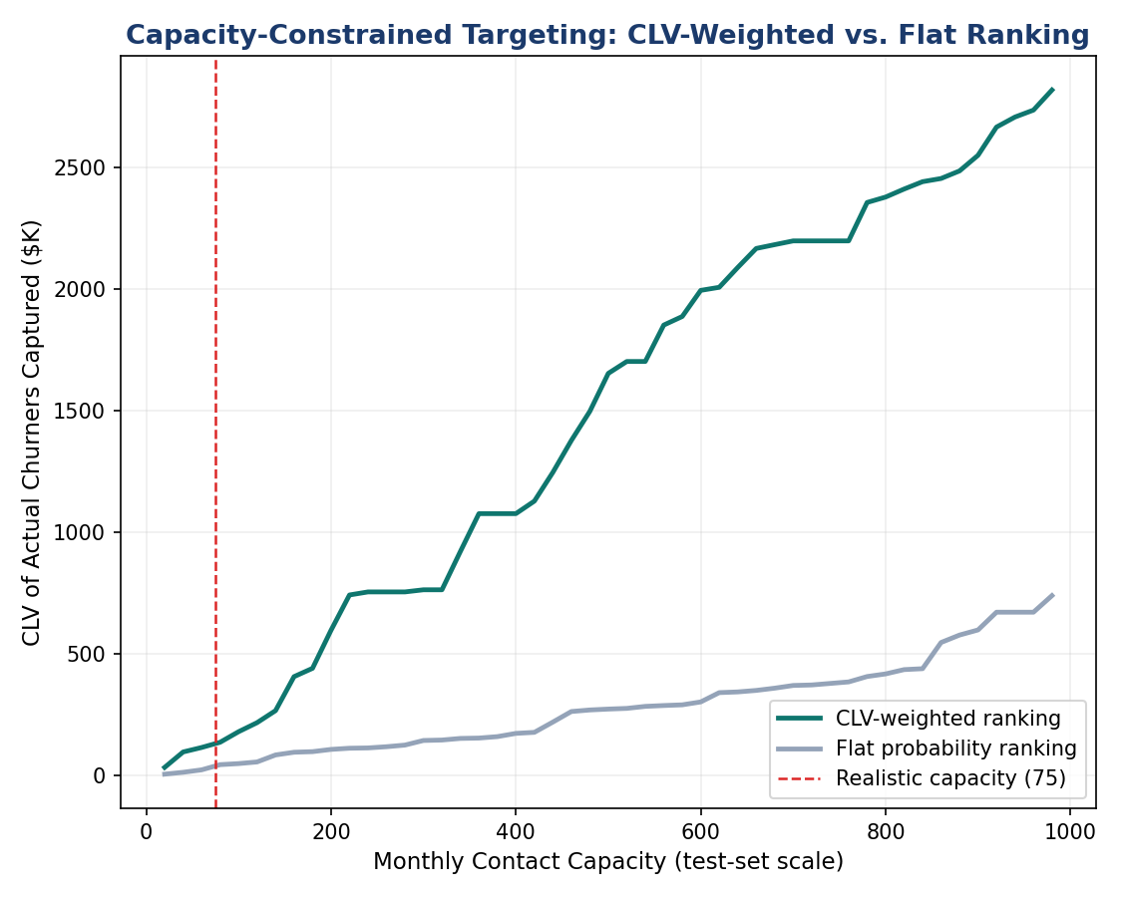
Figure 3. CLV of actual churners captured at each contact-list size, comparing a CLV-weighted ranking against a flat (probability-only) ranking.
At 75 contacts | Flat Probability Rank | CLV-Weighted Rank
Actual churners caught | 19 | 4
Total CLV of churners caught | $43,054 | $114,450

An Honest Tradeoff, Not a Clean Win
This result needs to be read carefully rather than reported as an unambiguous improvement. The CLV-weighted approach catches fewer individual churners (4 vs. 19) but captures far more total value among the churners it does catch ($114,450 vs. $43,054, a 165.8% increase). This is exactly what the method is designed to do — it deliberately deprioritizes high-probability-but-low-CLV customers (largely Students and Newcomers, whose individual CLV averages under $4,000) in favor of lower-probability-but-high-CLV customers (largely Young Professionals and Families, whose CLV can run into the hundreds of thousands).
Whether this tradeoff is correct depends on a business judgment Phase 6-7 cannot make alone: is the retention team's objective to maximize the count of saved relationships, or the dollar value of saved relationships? If the goal is the former — for instance, because there is a strategic priority to retain young, lifecycle-stage customers regardless of current CLV, consistent with the Phase 4 recommendation R6 on student lifecycle investment — a blended scoring approach (e.g., probability x sqrt(CLV), or a guaranteed minimum allocation of contacts to each segment) would be more appropriate than pure CLV-weighting. This is a configuration decision for the business owner, not a default the model should make silently.

SECTION 5 SUMMARY & DEPLOYMENT RECOMMENDATION

Where This Leaves the Model
Risk Area | Phase 6 Finding | Phase 7 Result | Status
Calibration | Brier 0.212; ~3x overconfident at high scores | Brier 0.097 (54% improvement) | RESOLVED
Fairness | 5.70x disparate impact by immigration status | 3.97x disparate impact (30% reduction) | PARTIAL
Threshold Design | Cost-optimal threshold flags ~79% of base — unworkable | Capacity-constrained ranking; 165.8% more CLV captured per contact vs. flat ranking | RESOLVED

Deployment Recommendation
Two of the three Phase 6 findings are now resolved to a standard suitable for production use: calibration is substantially corrected, and the targeting mechanism has moved from an unworkable blanket threshold to an operationally realistic, value-prioritized contact list. The fairness finding is meaningfully improved but not fully resolved — a 3.97x disparate impact ratio is still outside a conservative governance band, and deploying at this level would warrant an explicit, documented business justification reviewed by a compliance or model risk function, consistent with the recommendation already on record from Phase 6.
The recommended path is conditional deployment: launch the calibrated model with capacity-constrained targeting for the Family, Affluent, and Young Professional segments, where the fairness gap is smallest, while holding the Student and Newcomer segments in a parallel manual-review process until either the underlying features are revisited or a fairness-constrained retraining closes more of the remaining gap. This is a narrower launch than originally scoped in Phase 4, but it is the honest, defensible version of “ship it.”

