**Fall 2021 RIS Lab I project sheet**

1. Launched the uuv_gazebo/rexrov_default.launch and inspected the nodes, topics, services it launches and the message/service types they use to communicate.

a. Short report describing these nodes, topics, services and messages including screenshots of rqt or the terminal output from which you collected this information.

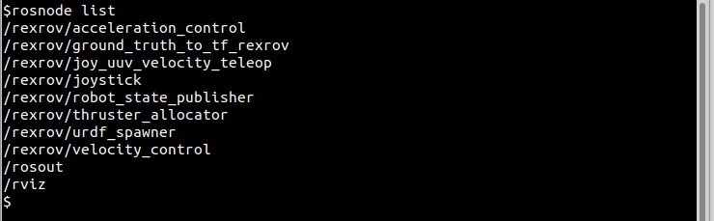

**List of Nodes:-**

* /rexrov/acceleration_control
* /rexrov/ground_truth_to_tf_rexrov
* /rexrov/joy_uuv_velocity_teleop
* /rexrov/joystick
* /rexrov/robot_state_publisher
* /rexrov/thruster_allocator
* /rexrov/urdf_spawner
* /rexrov/velocity_control
* /rosout
* /rviz

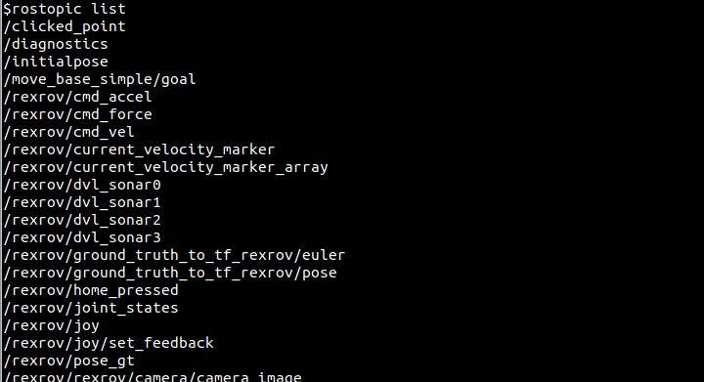

**List of Topics:-**

* /clicked_point (geometry_msgs/PointStamped)
* /diagnostics (diagnostic_msgs/DiagnosticArray)
* /initialpose (geometry_msgs/PoseWithCovarianceStamped)
* /move_base_simple/goal (geometry_msgs/PoseStamped)
* /rexrov/cmd_accel (geometry_msgs/Accel)
* /rexrov/cmd_force (geometry_msgs/Accel)
* /rexrov/cmd_vel (geometry_msgs/Twist)
* /rexrov/current_velocity_marker (visualization_msgs/Marker)
* /rexrov/current_velocity_marker_array (visualization_msgs/MarkerArray)
* /rexrov/dvl_sonar0 (sensor_msgs/Range)
* /rexrov/dvl_sonar1 (sensor_msgs/Range)
* /rexrov/dvl_sonar2 (sensor_msgs/Range)
* /rexrov/dvl_sonar3 (sensor_msgs/Range)
* /rexrov/ground_truth_to_tf_rexrov/euler (geometry_msgs/Vector3Stamped)
* /rexrov/ground_truth_to_tf_rexrov/pose (geometry_msgs/PoseStamped)
* /rexrov/home_pressed (std_msgs/Bool)
* /rexrov/joint_states (sensor_msgs/JointState)
* /rexrov/joy (sensor_msgs/Joy)
* /rexrov/joy/set_feedback (sensor_msgs/JoyFeedbackArray)
* /rexrov/pose_gt (nav_msgs/Odometry)
* /rexrov/rexrov/camera/camera_image (sensor_msgs/Image)
* /rexrov/thruster_manager/input (geometry_msgs/Wrench)
* /rexrov/thruster_manager/input_stamped (geometry_msgs/WrenchStamped)
* /rexrov/thrusters/0/input (uuv_gazebo_ros_plugins_msgs/FloatStamped)
* /rexrov/thrusters/1/input (uuv_gazebo_ros_plugins_msgs/FloatStamped)
* /rexrov/thrusters/2/input (uuv_gazebo_ros_plugins_msgs/FloatStamped)
* /rexrov/thrusters/3/input (uuv_gazebo_ros_plugins_msgs/FloatStamped)
* /rexrov/thrusters/4/input (uuv_gazebo_ros_plugins_msgs/FloatStamped)
* /rexrov/thrusters/5/input (uuv_gazebo_ros_plugins_msgs/FloatStamped)
* /rexrov/thrusters/6/input (uuv_gazebo_ros_plugins_msgs/FloatStamped)
* /rexrov/thrusters/7/input (uuv_gazebo_ros_plugins_msgs/FloatStamped)
* /rexrov/velocity_control/parameter_descriptions (dynamic_reconfigure/ConfigDescription)
* /rexrov/velocity_control/parameter_updates (dynamic_reconfigure/Config)
* /rosout (rosgraph_msgs/Log)
* /rosout_agg (rosgraph_msgs/Log)
* /tf (tf2_msgs/TFMessage)
* /tf_static (tf2_msgs/TFMessage)

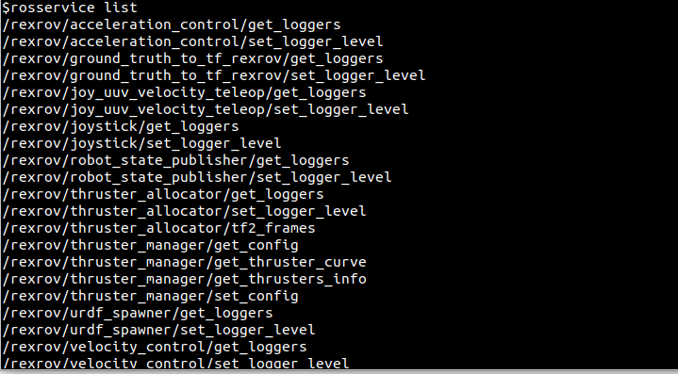

**List of Services:-**

* /rexrov/acceleration_control/get_loggers (roscpp/GetLoggers)
* /rexrov/acceleration_control/set_logger_level (roscpp/SetLoggerLevel)
* /rexrov/ground_truth_to_tf_rexrov/get_loggers (roscpp/GetLoggers)
* /rexrov/ground_truth_to_tf_rexrov/set_logger_level (roscpp/SetLoggerLevel)
* /rexrov/joy_uuv_velocity_teleop/get_loggers (roscpp/GetLoggers)
* /rexrov/joy_uuv_velocity_teleop/set_logger_level (roscpp/SetLoggerLevel)
* /rexrov/joystick/get_loggers (roscpp/GetLoggers)
* /rexrov/joystick/set_logger_level (roscpp/SetLoggerLevel)
* /rexrov/robot_state_publisher/get_loggers (roscpp/GetLoggers)
* /rexrov/robot_state_publisher/set_logger_level (roscpp/SetLoggerLevel)
* /rexrov/thruster_allocator/get_loggers (roscpp/GetLoggers)
* /rexrov/thruster_allocator/set_logger_level (roscpp/SetLoggerLevel)
* /rexrov/thruster_allocator/tf2_frames (tf2_msgs/FrameGraph)
* /rexrov/thruster_manager/get_config (uuv_thruster_manager/GetThrusterManagerConfig)
* /rexrov/thruster_manager/get_thruster_curve (uuv_thruster_manager/GetThrusterCurve)
* /rexrov/thruster_manager/get_thrusters_info (uuv_thruster_manager/ThrusterManagerInfo)
* /rexrov/thruster_manager/set_config (uuv_thruster_manager/SetThrusterManagerConfig)
* /rexrov/urdf_spawner/get_loggers (roscpp/GetLoggers)
* /rexrov/urdf_spawner/set_logger_level (roscpp/SetLoggerLevel)
* /rexrov/velocity_control/get_loggers (roscpp/GetLoggers)
* /rexrov/velocity_control/set_logger_level (roscpp/SetLoggerLevel)
* /rexrov/velocity_control/set_parameters (dynamic_reconfigure/Reconfigure)
* /rosout/get_loggers (roscpp/GetLoggers)
* /rosout/set_logger_level (roscpp/SetLoggerLevel)
* /rviz/get_loggers (roscpp/GetLoggers)
* /rviz/load_config (rviz/SendFilePath)
* /rviz/reload_shaders (/rviz/reload_shaders)
* /rviz/save_config (rviz/SendFilePath)
* /rviz/set_logger_level (roscpp/SetLoggerLevel)

**Determine the message/service type of topics/services**

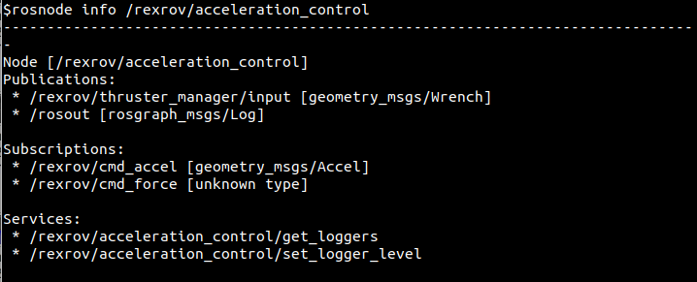

**b. Commands to retrieve this information and write down what these commands do**

**rosnode list**

**rostopic list**

**rosservice list**

**rosnode info <node_name>**

**rostopic info <topic_name>**

**rosservice info <service_name>**

**2. Controlling the robot using teleop_twist_keyboard**

a. launch file

uuv_gazebo/launch/rexrov_underwater_world.launch contains the rexrov_default.launch, empty_underwater_world and teleop twist node to control the simulated ROV. Also added the comments.

b. rosbag file

bags/cmd_vel_rosbag.bag contains the cmd_vel topic data, when the ROV was moving around. Also played the rosbag and it moved the ROV.

RQT Graph

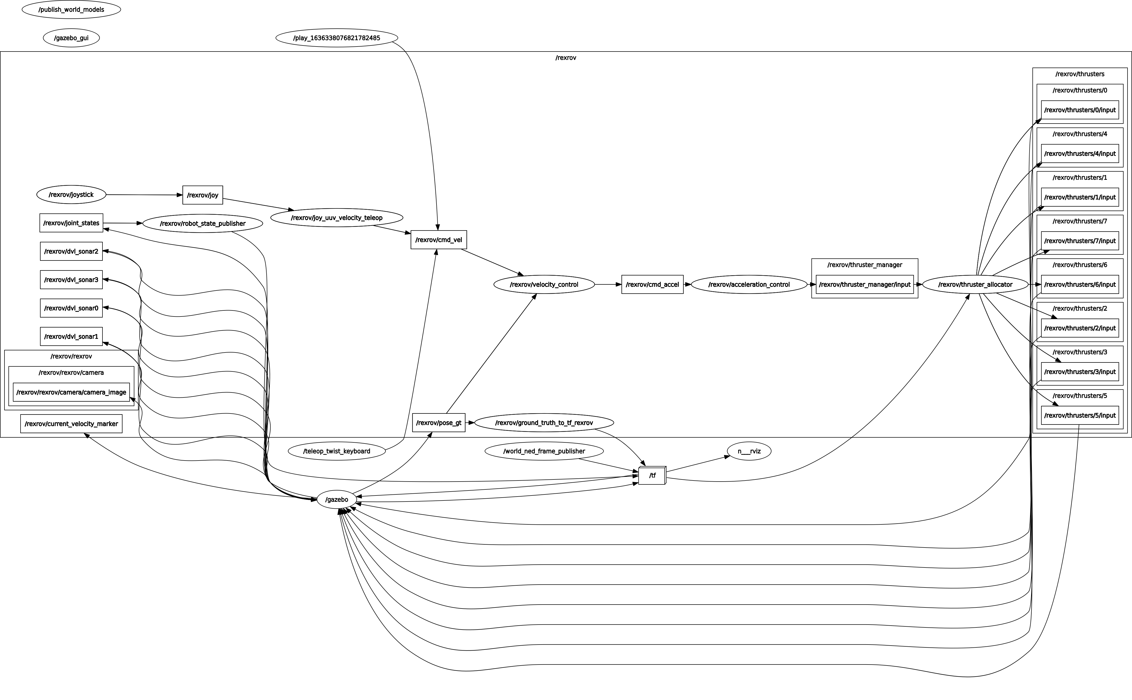

**3. Forces and Torque Output**

Downloaded the rexrov_wrench_control.launch file

a. created the node similar to teleop twist keyboard

uuv_simulator/uuv_control/uuv_thruster_manager/scripts/wrench_control.py

b. uuv_gazebo/rexrov_wrench_control.launch is the launch file which launches AUV and my node.

**4. Custom URDF**

a. my_rov/urdf/my_rov.urdf created a custom rov urdf

b. the thruster positioning at the back left and right to move the robot forward/backward/left/right etc.

c. my_rov/scripts/thruster_control.py is the node that takes the forces and torques as input and publishes thrust commands for the ROV and uses the service for this conversion.

Created a launch file my_rov/launch/thruster_control.launch which executes the thurster_control node

d.

I. my_rov/launch/my_rov_underwater_world.launch is the launch file which load the robot into the empty_underwater_world.launch in gazebo

ii. uuv_simulator/uuv_control/uuv_thruster_manager/scripts/wrench_control.py started the exercise 3 node to publish force/torque data

iii. my_rov/launch/thruster_control.launch is used to execute my_rov/scripts/thruster_control.py node to publish the commands to the vehicle.

Combined all the required nodes in the launch file my_rov/launch/my_rov_underwater_world.launch