Insights of WeRateDogs

**Introduction**

This report will describe insights and display meaningful visualizations produced from my wrangled data.

WeRateDogs is a popular twitter account were everyone can rate their own dogs by posting a tweet. Among others, its unique rating system and of course Brend helped to establish an impressive community of 8.1 million followers.

There were 3 insights in my analysis with 2 visualizations.

**Average rated dog breed**

Each tweet represents a rating of a dog. The rating is normally between 0 and 10 but as there are a lot of good dogs the rating exceeds the denominator 10.

With this insight, I wanted to look up which twitter breed type receives in average the highest rating. With this we can assume that one breed gets regularly higher ratings than other dog breeds. In the plot below, it is visible that the highest rating dogs receive were where the breed name is missing. A more precise investigation could be done with the breed names from the data set image predictions.

Anyways, for the dog breeds which are tagged is the highest rating for doggo and close after puppo. Pupper receives the lowest ratings.

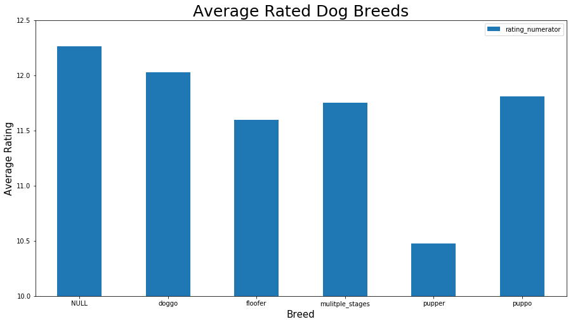

**Most frequent dogs**

In this insight I wanted to investigate which dog breed is the most frequent tweeted. In the pie chart it is visible that in almost every 5th tweet a golden retriever was rated. In the chart are only dogs represented, that occur more than 15 times.

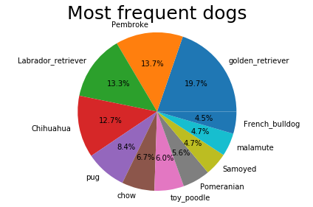

**Highest/lowest image prediction confidence for dogs**

The image prediction dataset contains for each tweet a prediction what dog breed is displayed in the image. Additionally, there is another column with the prediction confidence of the prediction.

With this insight I wanted to investigate what is the highest and lowest possible prediction confidence where the dog is correctly predicted.

The highest prediction confidence was for the dog breed Komodor dog.

|  |  |
| --- | --- |
| Highest prediction | |
| **Komodor** | 0. 972531 |

The lowest prediction confidence was for the dog breed Scottish Deerhound dog.

|  |  |
| --- | --- |
| Lowest prediction | |
| **Scottish_deerhound** | 0.182365 |

**Conclusion**

The insights represent the gathered data good and one can get a general view.