# iNVESTIGACIÓN

## Simple FOC:

<https://docs.simplefoc.com/>

## Texas Instruments:

<https://e2e.ti.com/support/motor-drivers-group/motor-drivers/f/motor-drivers-forum/1014955/faq-current-sensing-in-sensorless-brushless-dc-bldc-motor-systems>

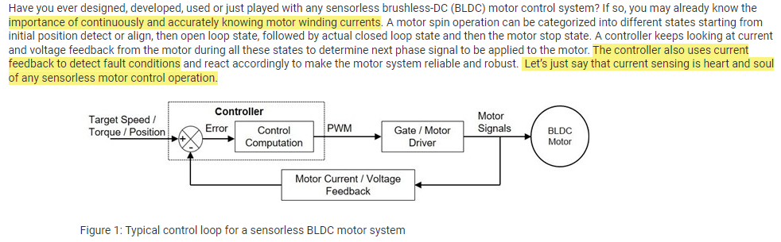

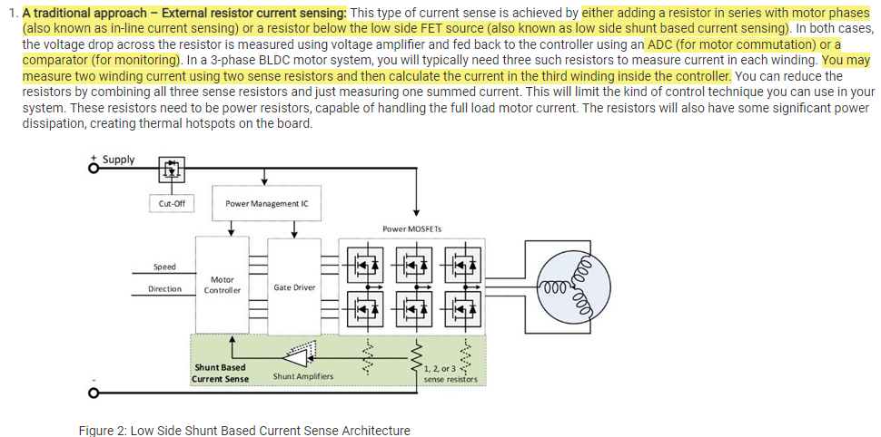

Onsemi:

<https://www.onsemi.cn/company/news-media/blog/industrial/en-us/field-oriented-control-foc-for-3-phase-motors>

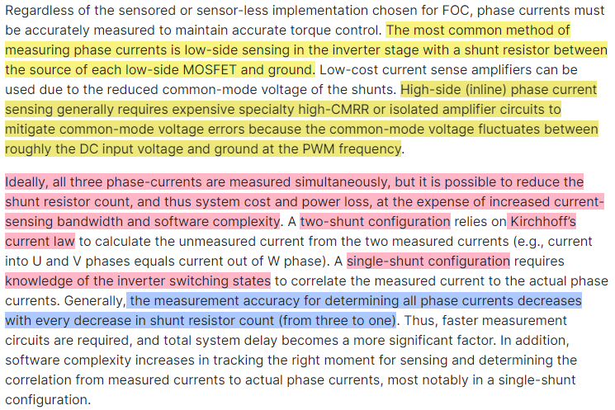

## POWER ELECTRONICS NEWS:

<https://www.powerelectronicsnews.com/current-sensing-in-brushless-motor-drives/>

## Factor de rechcazo al modo común

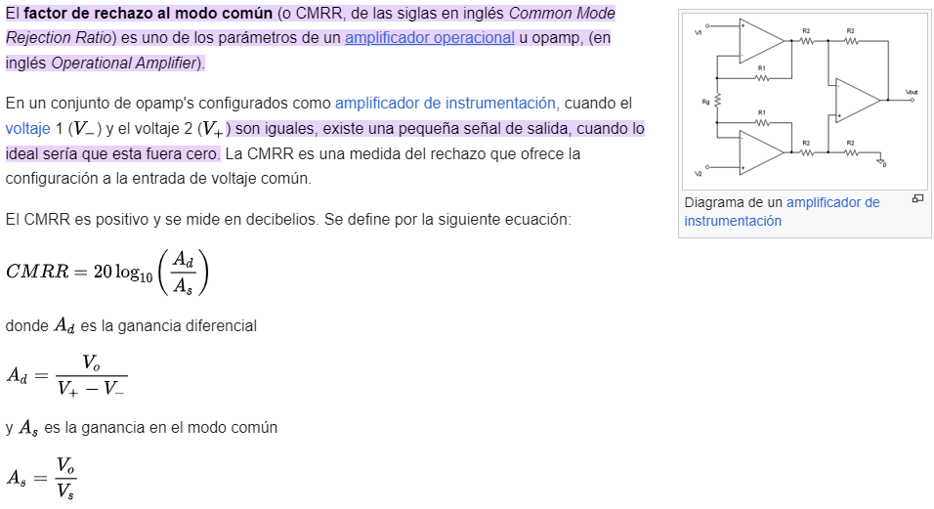

## TI:

<https://e2e.ti.com/support/microcontrollers/c2000-microcontrollers-group/c2000/f/c2000-microcontrollers-forum/752600/tms320f2806-inline-vs-low-side-current-sensing-for-foc-algorithms>

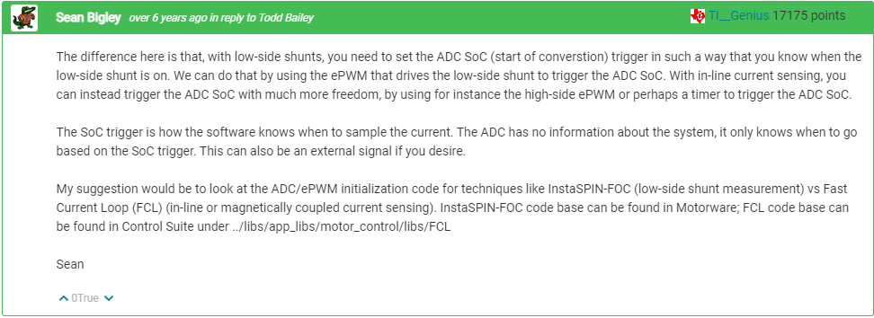

## Microchip

<https://www.microchip.com/en-us/about/media-center/blog/2019/high-side-versus-low-side-current-sensinghttps://www.microchip.com/en-us/about/media-center/blog/2019/high-side-versus-low-side-current-sensing>

## MAX40056:

<https://www.electronicproducts.com/how-to-implement-an-accurate-and-rugged-motor-control-sensing-system/>

## Simple BLDC driver:

<https://hackaday.io/project/188219-a-simple-bldc-driver-module-for-beginners>