Raport z planowania akwizycji satelitarnych
Projekt SatPlan
ID projektu: PROJECT-PROJEKT-SATPLAN
Autor: nie podano
Instytucja: Wojskowa Akademia Techniczna
Wygenerowano UTC: 2026-07-17T08:32:45.995830+00:00
Wersja aplikacji: 0.13.0

1. Podsumowanie
metric | value | unit
Satelity | 6 | szt.
Zlecenia | 1 | szt.
Okna dostępu | 76 | szt.
Okazje akwizycyjne | 76 | szt.
Wykonalne okazje | 72 | szt.
Wersje harmonogramu | 2 | szt.
Algorytm | GREEDY
Funkcja celu | 83.423 | pkt
Zrealizowane zlecenia | 1 | szt.
Akwizycje w planie | 2 | szt.
Stopień realizacji | 100 | %
Algorytm GREEDY wybrał 2 akwizycji i w pełni zrealizował 1 z 1 aktywnych zleceń. Stopień realizacji wyniósł 100.0%, a wartość funkcji celu 83.423.

Uwagi kompletności
- Bieżąca sesja nie zawiera benchmarku algorytmów.
- Bieżąca sesja nie zawiera walidacji okien względem STK.

2. Metodyka
Dostępność geometryczną wyznaczono na podstawie publicznych elementów orbitalnych OMM/GP i propagacji SGP4. Okazje optyczne oceniono z użyciem prognozy zachmurzenia Open-Meteo, natomiast harmonogram zbudowano algorytmem Greedy lub CP-SAT z uwzględnieniem zasobów i przeorientowań.

3. System satelitarny
satellite_id | name | sensor_type | altitude_km | inclination_deg | memory_capacity_mb | max_acquisitions_per_day
SAR-01 | ICEYE public slot 01 | SAR | 570 | 97.7 | 256000 | 30
SAR-02 | ICEYE public slot 02 | SAR | 570 | 97.7 | 256000 | 30
SAR-03 | ICEYE public slot 03 | SAR | 570 | 97.7 | 256000 | 30
SAR-04 | ICEYE public slot 04 | SAR | 570 | 97.7 | 256000 | 30
EO-01 | Pléiades Neo public slot 01 | OPTICAL | 620 | 97.9 | 512000 | 40
EO-02 | Pléiades Neo public slot 02 | OPTICAL | 620 | 97.9 | 512000 | 40

4. Zlecenia obserwacyjne
request_id | name | mode | sensor_types | priority | mandatory | earliest_start_utc | latest_end_utc
REQ-CUSTOM-001 | WAT | DUAL_OPTIONAL | SAR | OPTICAL | 7 | False | 2026-07-16T08:31:00+00:00 | 2026-07-18T08:31:00+00:00

5. Okna dostępu i okazje

5.1. Okna dostępu
window_id | satellite_id | sensor_type | mode_name | start_utc | end_utc | duration_s | coverage_ratio
ACCESS-CUSTOM-001-EO-01-OPT-PLEIADES-NEO-PAN-001 | EO-01 | OPTICAL | Pléiades Neo Panchromatic | 2026-07-16T09:11:45+00:00 | 2026-07-16T09:13:15+00:00 | 90 | 1
ACCESS-CUSTOM-001-EO-01-OPT-PLEIADES-NEO-PANSHARPENED-001 | EO-01 | OPTICAL | Pléiades Neo Pansharpened | 2026-07-16T09:11:45+00:00 | 2026-07-16T09:13:15+00:00 | 90 | 1
ACCESS-CUSTOM-001-EO-02-OPT-PLEIADES-NEO-PAN-001 | EO-02 | OPTICAL | Pléiades Neo Panchromatic | 2026-07-16T09:59:15+00:00 | 2026-07-16T10:02:15+00:00 | 180 | 1
ACCESS-CUSTOM-001-EO-02-OPT-PLEIADES-NEO-PANSHARPENED-001 | EO-02 | OPTICAL | Pléiades Neo Pansharpened | 2026-07-16T09:59:15+00:00 | 2026-07-16T10:02:15+00:00 | 180 | 1
ACCESS-CUSTOM-001-SAR-04-SAR-ICEYE-DWELL-001 | SAR-04 | SAR | ICEYE Dwell | 2026-07-16T12:18:45+00:00 | 2026-07-16T12:20:15+00:00 | 90 | 1
ACCESS-CUSTOM-001-SAR-04-SAR-ICEYE-DWELL-FINE-001 | SAR-04 | SAR | ICEYE Dwell Fine | 2026-07-16T12:18:45+00:00 | 2026-07-16T12:20:15+00:00 | 90 | 1
ACCESS-CUSTOM-001-SAR-04-SAR-ICEYE-SLEA-001 | SAR-04 | SAR | ICEYE Spot Extended Area | 2026-07-16T12:18:45+00:00 | 2026-07-16T12:20:15+00:00 | 90 | 1
ACCESS-CUSTOM-001-SAR-04-SAR-ICEYE-SPOT-001 | SAR-04 | SAR | ICEYE Spot | 2026-07-16T12:18:45+00:00 | 2026-07-16T12:20:15+00:00 | 90 | 1
ACCESS-CUSTOM-001-SAR-04-SAR-ICEYE-SPOT-FINE-001 | SAR-04 | SAR | ICEYE Spot Fine | 2026-07-16T12:18:45+00:00 | 2026-07-16T12:20:15+00:00 | 90 | 1
ACCESS-CUSTOM-001-SAR-04-SAR-ICEYE-DWELL-PRECISE-001 | SAR-04 | SAR | ICEYE Dwell Precise | 2026-07-16T12:19:15+00:00 | 2026-07-16T12:19:45+00:00 | 30 | 1
ACCESS-CUSTOM-001-SAR-03-SAR-ICEYE-DWELL-001 | SAR-03 | SAR | ICEYE Dwell | 2026-07-16T12:23:45+00:00 | 2026-07-16T12:25:45+00:00 | 120 | 1
ACCESS-CUSTOM-001-SAR-03-SAR-ICEYE-DWELL-FINE-001 | SAR-03 | SAR | ICEYE Dwell Fine | 2026-07-16T12:23:45+00:00 | 2026-07-16T12:25:45+00:00 | 120 | 1
ACCESS-CUSTOM-001-SAR-03-SAR-ICEYE-SLEA-001 | SAR-03 | SAR | ICEYE Spot Extended Area | 2026-07-16T12:23:45+00:00 | 2026-07-16T12:25:45+00:00 | 120 | 1
ACCESS-CUSTOM-001-SAR-03-SAR-ICEYE-SPOT-001 | SAR-03 | SAR | ICEYE Spot | 2026-07-16T12:23:45+00:00 | 2026-07-16T12:25:45+00:00 | 120 | 1
ACCESS-CUSTOM-001-SAR-03-SAR-ICEYE-SPOT-FINE-001 | SAR-03 | SAR | ICEYE Spot Fine | 2026-07-16T12:23:45+00:00 | 2026-07-16T12:25:45+00:00 | 120 | 1
ACCESS-CUSTOM-001-SAR-03-SAR-ICEYE-DWELL-PRECISE-001 | SAR-03 | SAR | ICEYE Dwell Precise | 2026-07-16T12:24:15+00:00 | 2026-07-16T12:25:15+00:00 | 60 | 1
ACCESS-CUSTOM-001-SAR-01-SAR-ICEYE-DWELL-001 | SAR-01 | SAR | ICEYE Dwell | 2026-07-16T21:39:15+00:00 | 2026-07-16T21:41:15+00:00 | 120 | 1
ACCESS-CUSTOM-001-SAR-01-SAR-ICEYE-DWELL-FINE-001 | SAR-01 | SAR | ICEYE Dwell Fine | 2026-07-16T21:39:15+00:00 | 2026-07-16T21:41:15+00:00 | 120 | 1
ACCESS-CUSTOM-001-SAR-01-SAR-ICEYE-SLEA-001 | SAR-01 | SAR | ICEYE Spot Extended Area | 2026-07-16T21:39:15+00:00 | 2026-07-16T21:41:15+00:00 | 120 | 1
ACCESS-CUSTOM-001-SAR-01-SAR-ICEYE-SPOT-001 | SAR-01 | SAR | ICEYE Spot | 2026-07-16T21:39:15+00:00 | 2026-07-16T21:41:15+00:00 | 120 | 1
ACCESS-CUSTOM-001-SAR-01-SAR-ICEYE-SPOT-FINE-001 | SAR-01 | SAR | ICEYE Spot Fine | 2026-07-16T21:39:15+00:00 | 2026-07-16T21:41:15+00:00 | 120 | 1
ACCESS-CUSTOM-001-SAR-01-SAR-ICEYE-DWELL-PRECISE-001 | SAR-01 | SAR | ICEYE Dwell Precise | 2026-07-16T21:39:45+00:00 | 2026-07-16T21:40:45+00:00 | 60 | 1
ACCESS-CUSTOM-001-SAR-01-SAR-ICEYE-DWELL-002 | SAR-01 | SAR | ICEYE Dwell | 2026-07-17T08:35:15+00:00 | 2026-07-17T08:35:45+00:00 | 30 | 1
ACCESS-CUSTOM-001-SAR-01-SAR-ICEYE-DWELL-FINE-002 | SAR-01 | SAR | ICEYE Dwell Fine | 2026-07-17T08:35:15+00:00 | 2026-07-17T08:35:45+00:00 | 30 | 1
ACCESS-CUSTOM-001-SAR-01-SAR-ICEYE-SLEA-002 | SAR-01 | SAR | ICEYE Spot Extended Area | 2026-07-17T08:35:15+00:00 | 2026-07-17T08:35:45+00:00 | 30 | 1
Tabela skrócona: pokazano 25 z 76 wierszy. Pełny zbiór znajduje się w results.xlsx i plikach CSV.

5.2. Okazje akwizycyjne
opportunity_id | request_id | satellite_id | sensor_type | start_utc | quality_score | coverage_ratio | is_feasible
OPP-PUBLIC-CUSTOM-001-EO-01-OPT-PLEIADES-NEO-PAN-001 | REQ-CUSTOM-001 | EO-01 | OPTICAL | 2026-07-16T09:12:27.500000Z | 0.395406 | 1 | False
OPP-PUBLIC-CUSTOM-001-EO-01-OPT-PLEIADES-NEO-PANSHARPENED-001 | REQ-CUSTOM-001 | EO-01 | OPTICAL | 2026-07-16T09:12:27.500000Z | 0.403476 | 1 | False
OPP-PUBLIC-CUSTOM-001-EO-02-OPT-PLEIADES-NEO-PAN-001 | REQ-CUSTOM-001 | EO-02 | OPTICAL | 2026-07-16T10:00:27.500000Z | 0.0760286 | 1 | False
OPP-PUBLIC-CUSTOM-001-EO-02-OPT-PLEIADES-NEO-PANSHARPENED-001 | REQ-CUSTOM-001 | EO-02 | OPTICAL | 2026-07-16T10:00:27.500000Z | 0.0775802 | 1 | False
OPP-PUBLIC-CUSTOM-001-SAR-04-SAR-ICEYE-DWELL-001 | REQ-CUSTOM-001 | SAR-04 | SAR | 2026-07-16T12:19:17.500000Z | 0.636915 | 1 | True
OPP-PUBLIC-CUSTOM-001-SAR-04-SAR-ICEYE-DWELL-FINE-001 | REQ-CUSTOM-001 | SAR-04 | SAR | 2026-07-16T12:19:17.500000Z | 0.657028 | 1 | True
OPP-PUBLIC-CUSTOM-001-SAR-04-SAR-ICEYE-DWELL-PRECISE-001 | REQ-CUSTOM-001 | SAR-04 | SAR | 2026-07-16T12:19:17.500000Z | 0.670437 | 1 | True
OPP-PUBLIC-CUSTOM-001-SAR-04-SAR-ICEYE-SPOT-FINE-001 | REQ-CUSTOM-001 | SAR-04 | SAR | 2026-07-16T12:19:22.500000Z | 0.650323 | 1 | True
OPP-PUBLIC-CUSTOM-001-SAR-04-SAR-ICEYE-SLEA-001 | REQ-CUSTOM-001 | SAR-04 | SAR | 2026-07-16T12:19:25Z | 0.603393 | 1 | True
OPP-PUBLIC-CUSTOM-001-SAR-04-SAR-ICEYE-SPOT-001 | REQ-CUSTOM-001 | SAR-04 | SAR | 2026-07-16T12:19:25Z | 0.616802 | 1 | True
OPP-PUBLIC-CUSTOM-001-SAR-03-SAR-ICEYE-DWELL-001 | REQ-CUSTOM-001 | SAR-03 | SAR | 2026-07-16T12:24:17.500000Z | 0.673434 | 1 | True
OPP-PUBLIC-CUSTOM-001-SAR-03-SAR-ICEYE-DWELL-FINE-001 | REQ-CUSTOM-001 | SAR-03 | SAR | 2026-07-16T12:24:17.500000Z | 0.694701 | 1 | True
OPP-PUBLIC-CUSTOM-001-SAR-03-SAR-ICEYE-SPOT-FINE-001 | REQ-CUSTOM-001 | SAR-03 | SAR | 2026-07-16T12:24:22.500000Z | 0.687612 | 1 | True
OPP-PUBLIC-CUSTOM-001-SAR-03-SAR-ICEYE-SLEA-001 | REQ-CUSTOM-001 | SAR-03 | SAR | 2026-07-16T12:24:25Z | 0.63799 | 1 | True
OPP-PUBLIC-CUSTOM-001-SAR-03-SAR-ICEYE-SPOT-001 | REQ-CUSTOM-001 | SAR-03 | SAR | 2026-07-16T12:24:25Z | 0.652168 | 1 | True
OPP-PUBLIC-CUSTOM-001-SAR-03-SAR-ICEYE-DWELL-PRECISE-001 | REQ-CUSTOM-001 | SAR-03 | SAR | 2026-07-16T12:24:47.500000Z | 0.718915 | 1 | True
OPP-PUBLIC-CUSTOM-001-SAR-01-SAR-ICEYE-DWELL-PRECISE-001 | REQ-CUSTOM-001 | SAR-01 | SAR | 2026-07-16T21:39:47.500000Z | 0.71667 | 1 | True
OPP-PUBLIC-CUSTOM-001-SAR-01-SAR-ICEYE-DWELL-001 | REQ-CUSTOM-001 | SAR-01 | SAR | 2026-07-16T21:40:17.500000Z | 0.675084 | 1 | True
OPP-PUBLIC-CUSTOM-001-SAR-01-SAR-ICEYE-DWELL-FINE-001 | REQ-CUSTOM-001 | SAR-01 | SAR | 2026-07-16T21:40:17.500000Z | 0.696403 | 1 | True
OPP-PUBLIC-CUSTOM-001-SAR-01-SAR-ICEYE-SPOT-FINE-001 | REQ-CUSTOM-001 | SAR-01 | SAR | 2026-07-16T21:40:22.500000Z | 0.689297 | 1 | True
OPP-PUBLIC-CUSTOM-001-SAR-01-SAR-ICEYE-SLEA-001 | REQ-CUSTOM-001 | SAR-01 | SAR | 2026-07-16T21:40:25Z | 0.639554 | 1 | True
OPP-PUBLIC-CUSTOM-001-SAR-01-SAR-ICEYE-SPOT-001 | REQ-CUSTOM-001 | SAR-01 | SAR | 2026-07-16T21:40:25Z | 0.653766 | 1 | True
OPP-PUBLIC-CUSTOM-001-SAR-01-SAR-ICEYE-DWELL-002 | REQ-CUSTOM-001 | SAR-01 | SAR | 2026-07-17T08:35:17.500000Z | 0.630967 | 1 | True
OPP-PUBLIC-CUSTOM-001-SAR-01-SAR-ICEYE-DWELL-FINE-002 | REQ-CUSTOM-001 | SAR-01 | SAR | 2026-07-17T08:35:17.500000Z | 0.650893 | 1 | True
OPP-PUBLIC-CUSTOM-001-SAR-01-SAR-ICEYE-SPOT-FINE-002 | REQ-CUSTOM-001 | SAR-01 | SAR | 2026-07-17T08:35:22.500000Z | 0.644251 | 1 | True
Tabela skrócona: pokazano 25 z 76 wierszy. Pełny zbiór znajduje się w results.xlsx i plikach CSV.

6. Harmonogram
Algorytm GREEDY wybrał 2 akwizycji i w pełni zrealizował 1 z 1 aktywnych zleceń. Stopień realizacji wyniósł 100.0%, a wartość funkcji celu 83.423.
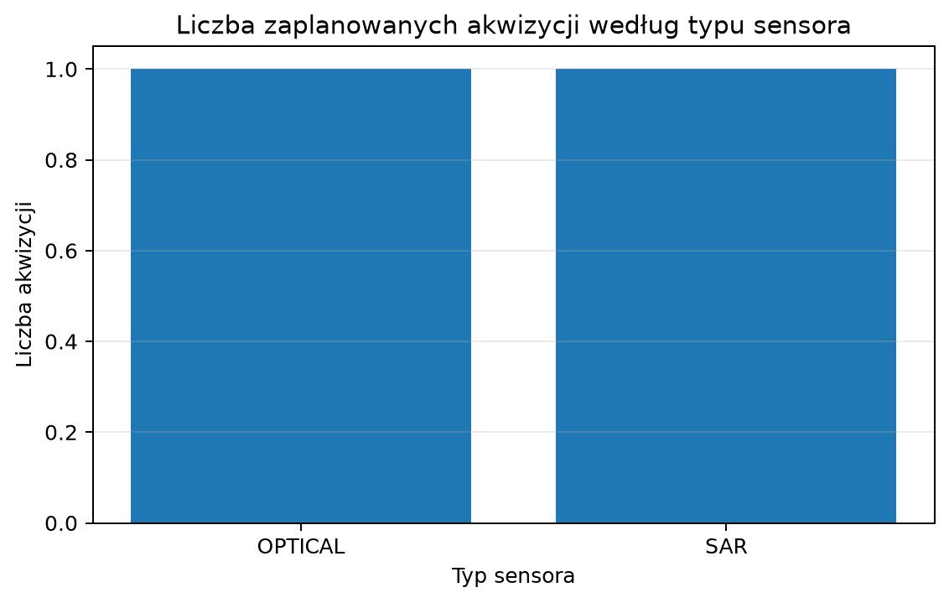
Rysunek 1. Struktura harmonogramu według typu sensora.
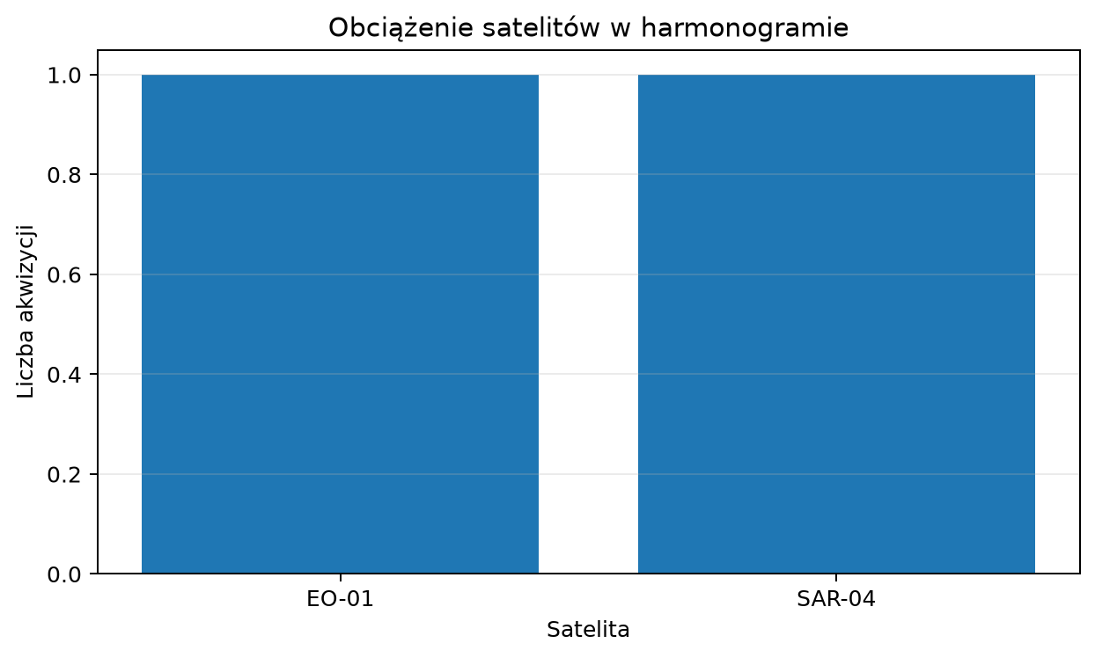
Rysunek 2. Liczba akwizycji przypisana do satelitów.
entry_id | request_id | satellite_id | sensor_type | mode_id | start_utc | end_utc | estimated_data_volume_mb
ENTRY-PUBLIC-CUSTOM-001-EO-01-OPT-PLEIADES-NEO-PANSHARPENED-002 | REQ-CUSTOM-001 | EO-01 | OPTICAL | MODE-OPT-PLEIADES-NEO-PANSHARPENED | 2026-07-17T09:30:57.500000Z | 2026-07-17T09:31:02.500000Z | 750
ENTRY-PUBLIC-CUSTOM-001-SAR-04-SAR-ICEYE-DWELL-PRECISE-002 | REQ-CUSTOM-001 | SAR-04 | SAR | MODE-SAR-ICEYE-DWELL-PRECISE | 2026-07-17T12:27:47.500000Z | 2026-07-17T12:28:12.500000Z | 3000

6.1. Diagnostyka zleceń
request_id | request_mode | priority | is_mandatory | fulfillment_status | scheduled_entry_count | scheduled_sensor_types | reason_codes
REQ-CUSTOM-001 | DUAL_OPTIONAL | 7 | False | FULLY_SATISFIED | 2 | OPTICAL | SAR

6.2. Wykorzystanie satelitów
satellite_id | sensor_type | scheduled_acquisitions | imaging_utilization_ratio | memory_utilization_ratio | acquisition_utilization_ratio | generated_data_mb
EO-01 | OPTICAL | 1 | 0.001389 | 0.047679 | 0.025 | 750
EO-02 | OPTICAL | 0 | 0 | 0.034467 | 0 | 0
SAR-01 | SAR | 0 | 0 | 0.045956 | 0 | 0
SAR-02 | SAR | 0 | 0 | 0.036765 | 0 | 0
SAR-03 | SAR | 0 | 0 | 0.055147 | 0 | 0
SAR-04 | SAR | 1 | 0.006944 | 0.036765 | 0.033333 | 3000

7. Walidacja względem STK
Brak zaimportowanych wyników walidacji STK.
Brak danych.

7.1. Próbki AER
Brak danych.

8. Benchmark Greedy i CP-SAT
Brak wyników benchmarku w bieżącej sesji.
Brak danych.

9. Historia harmonogramów
event_type | algorithm | solver_status | objective_value | fully_satisfied_requests | total_acquisitions | recorded_at_utc
INITIAL_PLANNING | GREEDY | NOT_APPLICABLE | 83.4227 | 1 | 2 | 2026-07-17T08:32:05.502114+00:00
WEATHER_REPLANNING | GREEDY | NOT_APPLICABLE | 83.4227 | 1 | 2 | 2026-07-17T08:32:27.865974+00:00

10. Ograniczenia i interpretacja
Wyniki należy interpretować jako ocenę modelu planistycznego opartego na danych publicznych. Nie stanowią potwierdzenia operacyjnej dostępności satelitów ani gwarancji taskingu operatora.
- Publiczne OMM/GP oraz propagacja SGP4 nie są precyzyjnymi efemerydami operatora.
- Profile ICEYE i Pléiades Neo są publicznym modelem badawczym, nie pełną specyfikacją operacyjną.
- Prognoza zachmurzenia wpływa wyłącznie na okazje optyczne; SAR pozostaje niezależny od chmur.
- Geometria footprintu i pokrycia AOI jest uproszczona względem narzędzi operatorskich.
- Wynik harmonogramowania zależy od przyjętych wag funkcji celu i limitów zasobów.

