Correlation: 0.8068949

Call:
lm(formula = dist ~ speed, data = cars)

Residuals:
Min 1Q Median 3Q Max
-29.069 -9.525 -2.272 9.215 43.201

Coefficients:
Estimate Std. Error t value Pr(>|t|)
(Intercept) -17.5791 6.7584 -2.601 0.0123 *
speed 3.9324 0.4155 9.464 1.49e-12 ***
---
Signif. codes: 0 ‘***’ 0.001 ‘**’ 0.01 ‘*’ 0.05 ‘.’ 0.1 ‘ ’ 1

Residual standard error: 15.38 on 48 degrees of freedom
Multiple R-squared: 0.6511, Adjusted R-squared: 0.6438
F-statistic: 89.57 on 1 and 48 DF, p-value: 1.49e-12

Residausl: Nisu simetricni toliko sto znaci da neke predvidene tocke su jako udaljene od onih pravih.

Odbacujemo H0(H0:koeficijenit su 0) jer su Pr(>|t|) I p-value mali brojevi tojest. manji od .0.05. Temeljem toga Distance ovisi o Speed-u

Estimate: Porsjek za zaustavljanje je 17.5791, a potrebna udaljenot za zaustavljanje se za svaki 1 brzine povecava za 3.9324

Std. Error: Udaljenost zaustavjanaj auta varira za 0.4155.

Residaul standard error: Pototak pogreske iznosi Residual standard error\Estimate = 89.5%
R-squared I Adjusted R-squared: 65.11% variance u dist se moze objasniti sa previdenim speed.

F-statistic: s ozbirom na velicinu podatak I injenicu da je 89.57 nogo veci od 1odbacujemo H0( Speed I dist su medusobno neovisne varijable).

Analysis of Variance Table

Response: dist
Df Sum Sq Mean Sq F value Pr(>F)
speed 1 21186 21185.5 89.567 1.49e-12 ***
Residuals 48 11354 236.5
---
Signif. codes: 0 ‘***’ 0.001 ‘**’ 0.01 ‘*’ 0.05 ‘.’ 0.1 ‘ ’ 1

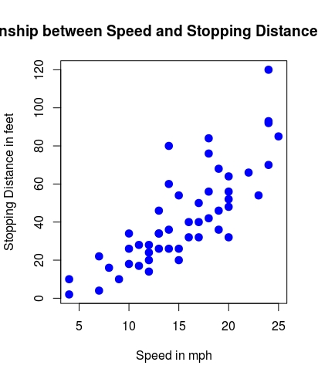

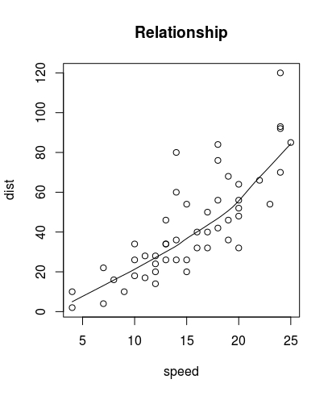

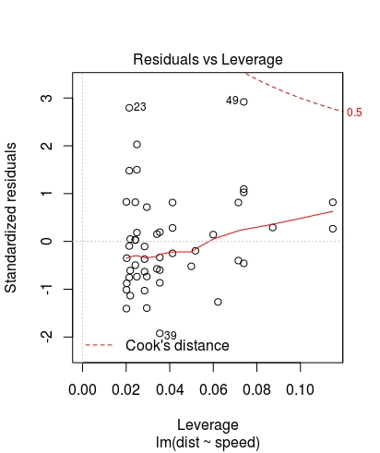

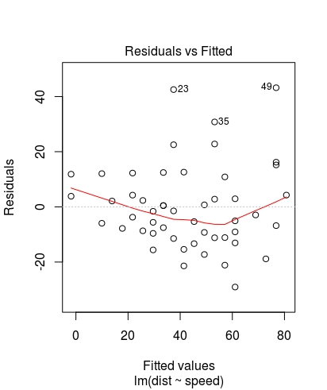

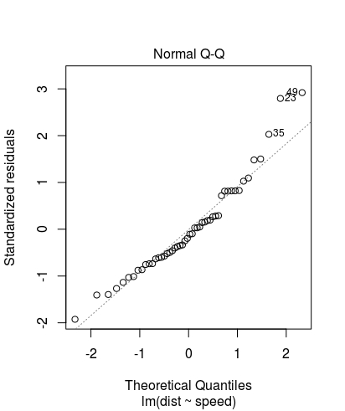

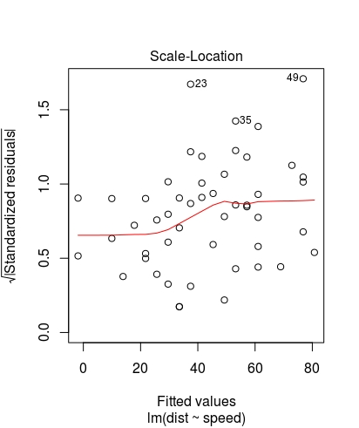

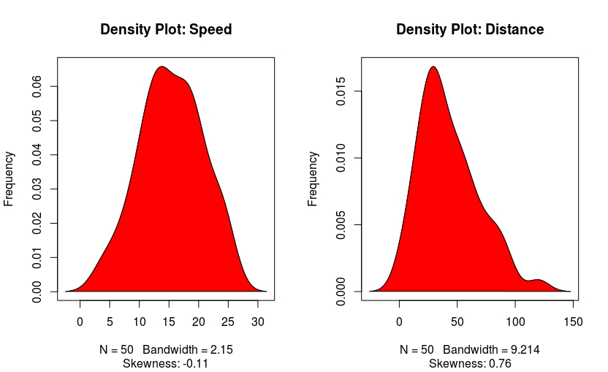

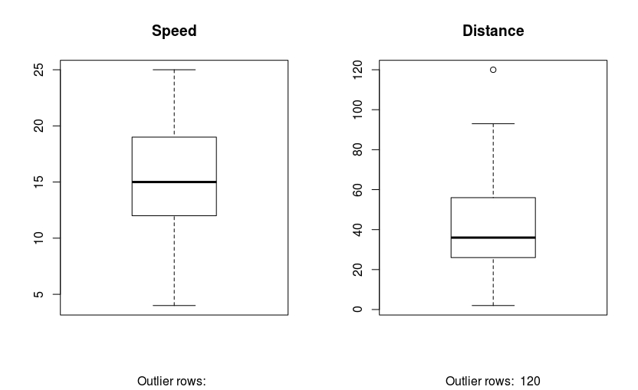

2: Training: 80% Test 20%

Call:
lm(formula = dist ~ speed, data = trainingdata)

Residuals:
Min 1Q Median 3Q Max
-23.350 -10.771 -2.137 9.255 42.231

Coefficients:
Estimate Std. Error t value Pr(>|t|)
(Intercept) -22.657 7.999 -2.833 0.00735 **
speed 4.316 0.487 8.863 8.73e-11 ***
---
Signif. codes: 0 ‘***’ 0.001 ‘**’ 0.01 ‘*’ 0.05 ‘.’ 0.1 ‘ ’ 1

Residual standard error: 15.84 on 38 degrees of freedom
Multiple R-squared: 0.674, Adjusted R-squared: 0.6654
F-statistic: 78.56 on 1 and 38 DF, p-value: 8.734e-11

Analysis of Variance Table

Response: dist
Df Sum Sq Mean Sq F value Pr(>F)
speed 1 19702.5 19702.5 78.56 8.734e-11 ***
Residuals 38 9530.2 250.8
---
Signif. codes: 0 ‘***’ 0.001 ‘**’ 0.01 ‘*’ 0.05 ‘.’ 0.1 ‘ ’ 1
>

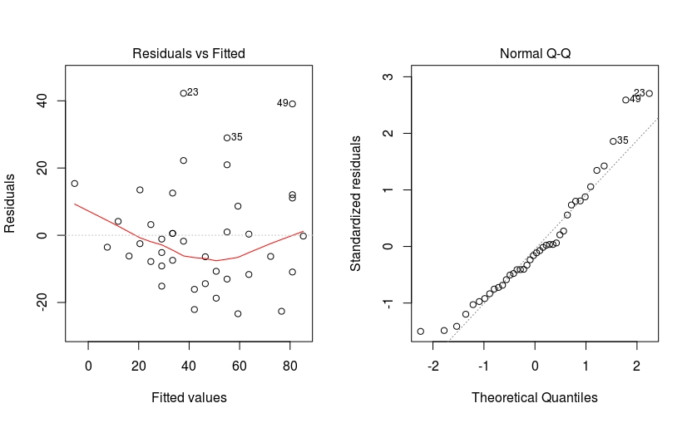
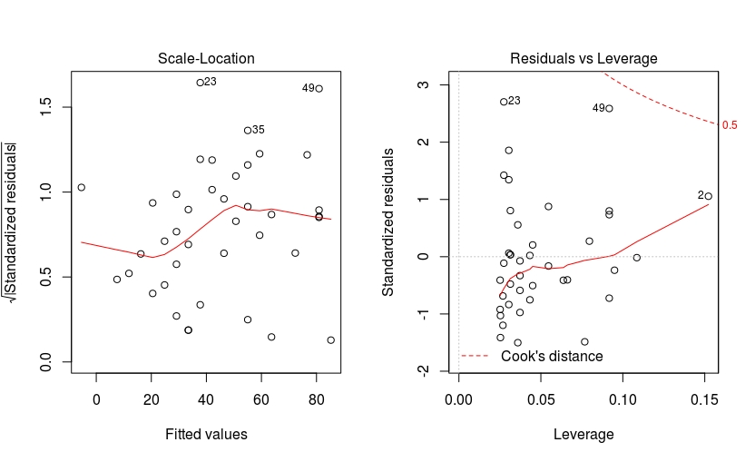
Residuals vs fitted: pokazuje nellinearnost. Rekao bi da nema nelinearnosti
Norma Q-Q: s obzirom da tocke se pojavljuju s liejve trane znaci da imamo dugi desni rep.
Scale-Locaton: Da li je varijanca jednako rapsoredena,. Moraju biti jednak orasporseni sa jedne I druge strane . Cini se da nisu.
Residuals vs Levarage: nemamo otuliere koji utjecu na nasu predikciju

