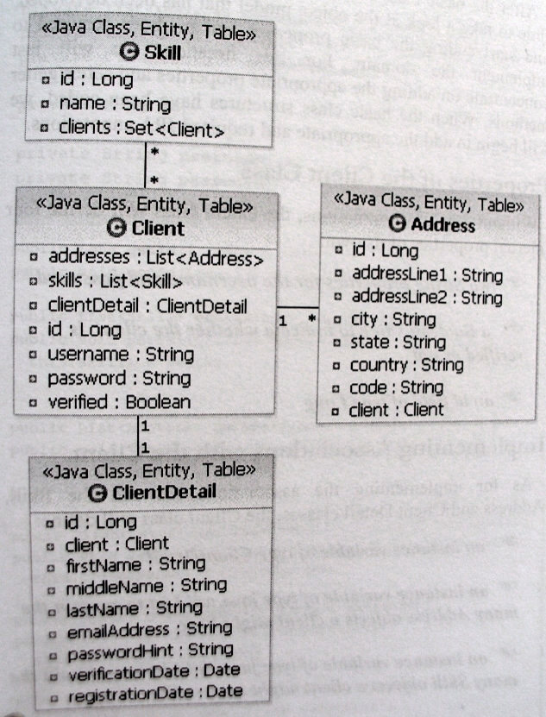
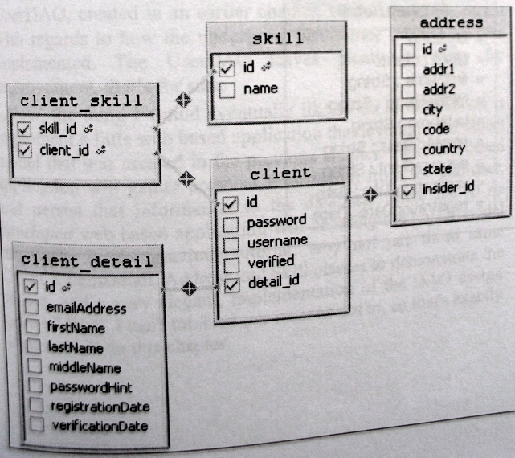

Wszystkie poniższe relacje są relacjami typu bidirectional.

- Jeden do jednego:

@Entity
@Table(name="client", schema="examscam")
public class Client implements Serializable{

private Long id;
private ClientDetail clientDetail;

@OneToOne(cascade = CascadeType.ALL, fetch = FetchType.LAZY)
@JoinColumn(name = "detail_id")
public ClientDetail getClientDetail() {
return clientDetail;
}

@Id
@GeneratedValue
@Column(name = "id")
public Long getId() {
return id;

…

@Entity
@Table(name="client_detail", schema="examscam")
public class ClientDetail {

private Client client;

@OneToOne(cascade= CascadeType.ALL, fetch= FetchType.LAZY)
@JoinColumn(name="detailId")
public Client getClient() {
return client;
}
…

- Jeden do wielu:

@Entity
@Table(name="client", schema="examscam")
public class Client implements Serializable{

private List<Address> addresses = new Vector<Address>();

@OneToMany(mappedBy="client", fetch= FetchType.EAGER,
cascade= {CascadeType.ALL}, orphanRemoval=true)
public List<Address> getAddresses() {
return addresses;
}

public void addAddress(Address address) {
address.setClient(this);
addresses.add(address);
}
…

@Entity
@Table(name="address")
public class Address implements Serializable {

private Client client;

@ManyToOne()
@JoinColumn(name="client_id")
public Client getClient() {
return client;
}
...

- Wiele do wielu

@Entity
@Table(name="client", schema="examscam")
public class Client implements Serializable{

private List<Skill> skills = new Vector<Skill>();

@ManyToMany(cascade= CascadeType.PERSIST)
@JoinTable(name="client_skill",
joinColumns={@JoinColumn(name="client_id")},
inverseJoinColumns={@JoinColumn(name="skill_id")})
public List<Skill> getSkills() {
return skills;
}
…

@Entity
@Table(name="skill", schema="examscam")
public class Skill implements Serializable {

private Set<Client> clients;

@ManyToMany(cascade= CascadeType.PERSIST)
@JoinTable(name="client_skill",
joinColumns={@JoinColumn(name="skill_id")},
inverseJoinColumns={@JoinColumn(name="client_id")})
public Set<Client> getClients() {
return clients;
}

