🎯 Planning Poker Platform
Technical Documentation
A Microservices-Based Collaborative Estimation Platform
for Agile Teams
Author: Matilda Dervishaj
Version: 1.0
Date: December 2024
Project: Lufthansa Industry Solutions - Technical Assessment

Contents
🎯 Planning Poker Platform 1
1. Executive Summary 5
Key Achievements 5
2. Architecture Overview 6
High-Level Architecture Diagram 6
System Components 6
Technology Stack 6
3. Microservices Design 8
3.1 API Gateway (pp-gateway) 8
3.2 Room Service (pp-room-service) 8
3.3 Vote Service (pp-vote-service) 9
3.4 Audit Service (pp-audit-service) 9
3.5 Inter-Service Event Flow 10
4. User Functionality Implementation 11
4.1 Register/Login 11
4.2 Room Management (CRUD) 11
Deck Types Supported 12
4.3 Story Management (CRUD) 12
Story Status Flow 13
4.4 Inviting Users to Room 13
4.5 Voting 13
4.6 Finish Voting 14
5. Admin Functionality Implementation 15
5.1 User Management 15
5.2 Room Oversight 15
5.3 Story Oversight 15
5.4 Table Auditing 15
6. Technical Implementation 18
6.1 Clean Architecture 18
6.2 Database per Service 18
6.3 Liquibase Migrations 18
6.4 Redis Caching 19
6.5 Validation & Exception Handling 19
7. Security Implementation 20
7.1 Authentication Flow 20
7.2 Role-Based Access Control 20
7.3 Secrets Management 20
8. Observability & Monitoring 21
8.1 Health Endpoints 21
8.2 Distributed Tracing (Jaeger) 21
8.3 Metrics (Prometheus + Grafana) 21
9. Testing Strategy 22
9.1 Test Configuration 22
9.2 Test Categories 22
9.3 Running Tests 22
9.4 Coverage Achievement 22
10. DevOps & CI/CD 24
10.1 Docker Configuration 24
10.2 Docker Compose 24
10.3 GitHub Actions Pipeline 24
11. API Documentation 26
11.1 Swagger UI Access 26
11.2 Getting a JWT Token 26
11.3 Postman Collection 26
12. Design Decisions & Trade-offs 27
12.1 Why Microservices? 27
12.2 Trade-offs 27
12.3 Why Kafka over REST for Events? 27
13. Quick Start Guide 29
13.1 Prerequisites 29
13.2 One-Command Startup 29
13.3 Verify Services 29
13.4 Access Points 29
14. Deliverables Checklist 31
14.1 Repository Contents 31
14.2 Functional Requirements 31
14.3 Technical Requirements 33
15. Complete Testing Guide via Swagger 35
15.1 Test Users and Roles 35
15.2 Prerequisites 35
15.3 Getting JWT Tokens 36
15.4 Complete Flow Test - Step by Step 36
PHASE 1: Room Creation (MODERATOR) 36
PHASE 2: Create Stories (MODERATOR) 37
PHASE 3: Participants Join Room 38
PHASE 4: Send Email Invitation (MODERATOR) 39
PHASE 5: Start Voting (MODERATOR) 39
PHASE 6: Cast Votes (PARTICIPANTS) 40
PHASE 7: Reveal Votes (MODERATOR) 41
PHASE 8: Finish Voting (MODERATOR) 42
PHASE 9: Admin Functions (ADMIN) 43
15.5 Error Scenarios to Test 44
15.6 WebSocket Testing (Optional) 45
15.7 Test Checklist Summary 45

1. Executive Summary
The Planning Poker Platform is a fully-featured, microservices-based application that enables agile teams to collaboratively estimate task complexity. Built with modern technologies and following best practices, the platform provides:
- Real-time collaboration via WebSocket
- Event-driven architecture using Apache Kafka
- Secure authentication with Keycloak OIDC
- Scalable microservices with independent deployability
- Full observability with Prometheus, Grafana, and Jaeger
- Comprehensive audit trail for all system operations

Key Achievements
Metric | Target | Achieved
Backend Test Coverage | ≥70% | YES ✅ >70%
Microservices Architecture | Required | YES ✅ 4 Services
Event-Driven Communication | Kafka preferred | YES ✅ Apache Kafka
Clean Architecture | Required | YES ✅ Implemented
Docker Compose | Required | YES ✅ One-command startup
CI/CD Pipeline | Required | YES ✅ GitHub Actions

2. Architecture Overview

High-Level Architecture Diagram
See: docs/architecture-diagram.svg

System Components

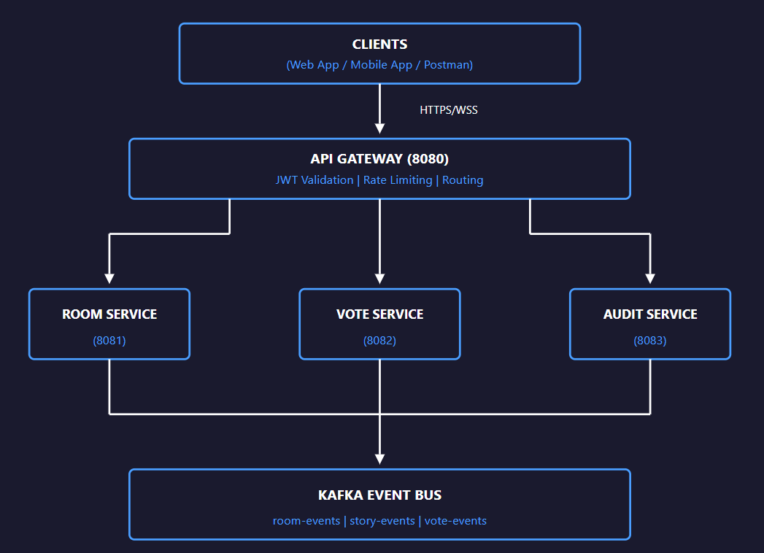

Technology Stack
Layer | Technology | Version
Framework | Spring Boot | 3.4.x
Language | Java | 17 LTS
Database | PostgreSQL | 16
Cache | Redis | 7
Message Broker | Apache Kafka | 7.5
Identity Provider | Keycloak | 24.0
API Documentation | SpringDoc OpenAPI | 2.7.0
DB Migrations | Liquibase | 4.x
Distributed Tracing | Jaeger (OpenTelemetry) | 1.53
Metrics | Prometheus + Grafana | Latest
Containers | Docker + Compose | 24+

3. Microservices Design

3.1 API Gateway (pp-gateway)
Property | Value
Port | 8080
Technology | Spring Cloud Gateway
Responsibilities:
- Single entry point for all client requests
- JWT token validation
- Request routing to appropriate services
- Rate limiting and circuit breaking

3.2 Room Service (pp-room-service)
Property | Value
Port | 8081
Database | planning_poker_rooms
Responsibilities:
- Room CRUD operations
- Story management
- Participant management
- Email invitations
- Short link generation
- Start voting workflow
Events Published:
- RoomCreatedEvent, RoomUpdatedEvent, RoomDeletedEvent
- StoryCreatedEvent, StoryUpdatedEvent, StoryDeletedEvent
- VotingStartedEvent
Events Consumed:
- VotingFinishedEvent → Updates story status to COMPLETED

3.3 Vote Service (pp-vote-service)
Property | Value
Port | 8082
Database | planning_poker_votes
Responsibilities:
- Vote casting and management
- Vote results calculation (average, consensus)
- Real-time WebSocket broadcasts
- Reveal and finish voting workflows
WebSocket Topics:
- /topic/room/{roomId}/vote-count - Live vote count
- /topic/room/{roomId}/results - Revealed votes
- /topic/room/{roomId}/finished - Final results
- /topic/room/{roomId}/voting-started - Voting initiated

3.4 Audit Service (pp-audit-service)
Property | Value
Port | 8083
Database | planning_poker_audit
Responsibilities:
- Consume all events from Kafka
- Store comprehensive audit logs
- Provide query APIs for administrators

3.5 Inter-Service Event Flow
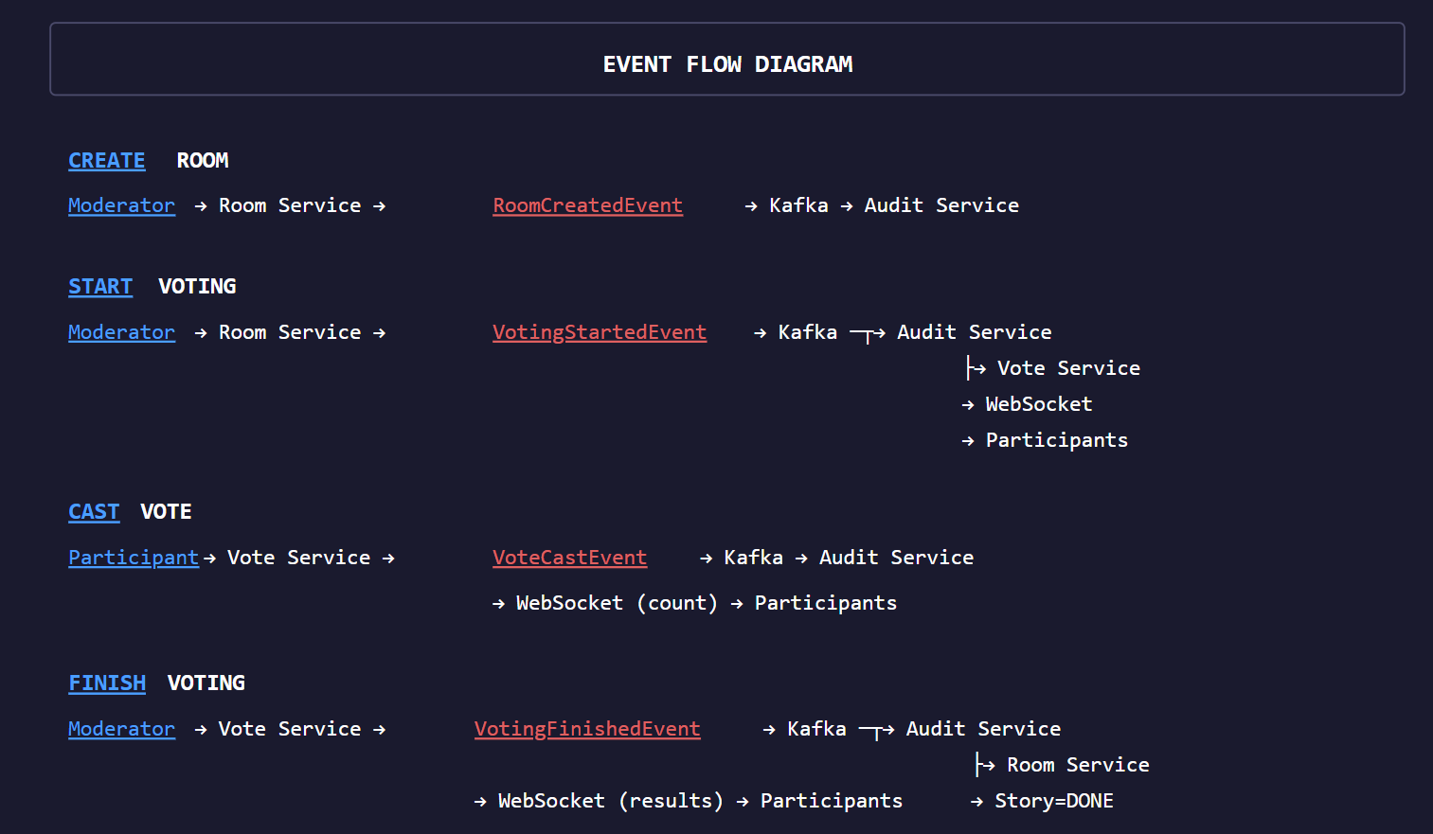

4. User Functionality Implementation

4.1 Register/Login
Implementation: Keycloak OIDC Integration
Features Implemented:
- ✅ Username/password authentication
- ✅ Social login support (Google, Facebook) - pre-configured in realm
- ✅ Role-based access control (USER, PARTICIPANT, MODERATOR, ADMIN)
- ✅ JWT token validation at API Gateway

4.2 Room Management (CRUD)
Endpoint | Method | Description | Access
/api/v1/rooms | POST | Create room | Authenticated
/api/v1/rooms/{id} | GET | Get room | Authenticated
/api/v1/rooms/{id} | PUT | Update room | Moderator only
/api/v1/rooms/{id} | DELETE | Delete room | Moderator/Admin
/api/v1/rooms/my-rooms | GET | User's rooms | Authenticated
/api/v1/rooms/joined | GET | Joined rooms | Authenticated
/api/v1/rooms/admin/all | GET | All rooms | Admin only

Deck Types Supported
Type | Values
SCRUM | 0, 0.5, 1, 2, 3, 5, 8, 13, 20, 40, 100, ?, ☕
FIBONACCI | 0, 1, 2, 3, 5, 8, 13, 21, 34, 55, 89, ?
SEQUENTIAL | 0, 1, 2, 3, 4, 5, 6, 7, 8, 9, 10, ?
TSHIRT | XS, S, M, L, XL, XXL, ?
CUSTOM | User-defined values

4.3 Story Management (CRUD)
Endpoint | Method | Description | Access
/api/v1/rooms/{roomId}/stories | POST | Create story | Moderator
/api/v1/rooms/{roomId}/stories | GET | List stories | Participant
/api/v1/stories/{id} | GET | Get story | Participant
/api/v1/stories/{id} | PUT | Update story | Moderator
/api/v1/stories/{id} | DELETE | Delete story | Moderator/Admin
/api/v1/stories/{id}/start-voting | POST | Start voting | Moderator
/api/v1/admin/stories | GET | All stories | Admin only

Story Status Flow
PENDING → VOTING → COMPLETED

4.4 Inviting Users to Room

A) Email Invitation
- Generates secure token with configurable expiry (default: 48 hours)
- Creates join link: {baseUrl}/join/invite/{token}
- Ready for email service integration (SendGrid, AWS SES, SMTP)
- Currently logs invitation details for demonstration

B) Short Link
- Each room has a unique short code (6 characters)
- Join via: POST /api/v1/rooms/join/{shortCode}
- Automatically adds user as participant

4.5 Voting
Endpoint | Method | Description
/api/v1/votes | POST | Cast/update vote
/api/v1/votes/stories/{storyId}/my-vote | GET | Get my vote
/api/v1/votes/stories/{storyId}/count | GET | Get vote count
Real-time Updates: Vote count broadcasted after each vote via WebSocket. All votes remain hidden until reveal.

4.6 Finish Voting
Endpoint | Method | Description
/api/v1/voting/stories/{storyId}/reveal | POST | Reveal all votes
/api/v1/voting/stories/{storyId}/finish | POST | Finalize with estimate
/api/v1/voting/stories/{storyId}/reset | POST | Clear all votes
WebSocket Broadcast on Finish: Includes final estimate, average score, consensus detection, and all individual votes.

5. Admin Functionality Implementation

5.1 User Management
Implementation: Via Keycloak Admin Console
Access: http://localhost:8180/admin
Credentials: admin / admin
Capabilities:
- ✅ View all users
- ✅ Update user details
- ✅ Disable/enable accounts
- ✅ Manage role assignments
- ✅ Reset passwords
- ✅ View login history

5.2 Room Oversight
Admins can view all rooms via GET /api/v1/rooms/admin/all with @PreAuthorize("hasRole('ADMIN')")
Admins can delete any room, not just their own.

5.3 Story Oversight
Admins can view all stories across all rooms via GET /api/v1/admin/stories
Stories cannot be modified by admins during active voting to preserve fairness.

5.4 Table Auditing

Audit Log Entity Structure
Field | Description
id | Unique audit log ID
eventId | Original event ID
eventType | Type of event
entityType | ROOM, STORY, or VOTE
entityId | ID of affected entity
action | CREATE, UPDATE, DELETE, VOTE, START, FINISH
eventData | Full JSON payload
userId | User who triggered action
userName | Display name
timestamp | When event occurred
sourceService | Which service published

Admin Audit API
Endpoint | Method | Description
/api/v1/admin/audit | GET | All audit logs (paginated)
/api/v1/admin/audit/entity/{type}/{id} | GET | Filter by entity
/api/v1/admin/audit/entity-type/{type} | GET | Filter by entity type
/api/v1/admin/audit/user/{userId} | GET | Filter by user
/api/v1/admin/audit/search | GET | Search with filters

6. Technical Implementation

6.1 Clean Architecture
Each service follows Clean Architecture principles with clear layer separation:

service/
├── api/ # HTTP Layer (Controllers, Exception Handlers)
│ ├── controller/
│ └── exception/
├── application/ # Use Cases, DTOs, Mappers
│ ├── dto/
│ │ ├── request/
│ │ └── response/
│ ├── mapper/
│ └── service/
├── domain/ # Core Business Logic (No frameworks)
│ └── model/
└── infrastructure/ # External Concerns (DB, Messaging, Config)
├── config/
├── messaging/
└── persistence/
├── entity/
└── repository/

6.2 Database per Service
Each microservice owns its database, ensuring loose coupling:

planning_poker_rooms → Room Service
planning_poker_votes → Vote Service
planning_poker_audit → Audit Service

6.3 Liquibase Migrations
Database schema changes are version-controlled and applied automatically on startup:

db/changelog/
├── db.changelog-master.yaml
└── changes/
├── 001-create-rooms-table.yaml
├── 002-create-stories-table.yaml
├── 003-create-participants-table.yaml
└── 004-create-invitations-table.yaml

6.4 Redis Caching
Room data is cached in Redis to improve performance:
- @Cacheable on read operations
- @CacheEvict on write operations
- Cache names: rooms, stories

6.5 Validation & Exception Handling
Request Validation: Jakarta Bean Validation annotations (@NotBlank, @Size, @NotNull)
Global Exception Handler:
- BusinessException - Custom business logic errors
- MethodArgumentNotValidException - Validation failures
- ConstraintViolationException - Constraint violations
- AccessDeniedException - Authorization failures

7. Security Implementation

7.1 Authentication Flow
- User authenticates with Keycloak
- Receives JWT access token
- Includes token in Authorization header
- API Gateway validates token
- Services extract user info from JWT claims

7.2 Role-Based Access Control
Role | Permissions
USER | Basic access, join rooms
PARTICIPANT | Vote in rooms
MODERATOR | Create rooms, manage stories, control voting
ADMIN | Full access, audit logs, user management

7.3 Secrets Management
All sensitive configuration is externalized via environment variables:
- DB_PASSWORD - Database password
- KAFKA_SERVERS - Kafka bootstrap servers
- KEYCLOAK_HOST - Keycloak server address
- REDIS_HOST - Redis server address
Security Best Practice: No secrets are committed to the repository. All sensitive values come from environment variables or Docker secrets.

8. Observability & Monitoring

8.1 Health Endpoints
All services expose Spring Boot Actuator endpoints:
Endpoint | Purpose
/actuator/health | Overall health status
/actuator/health/liveness | Kubernetes liveness probe
/actuator/health/readiness | Kubernetes readiness probe
/actuator/prometheus | Prometheus metrics

8.2 Distributed Tracing (Jaeger)
OpenTelemetry integration provides end-to-end request tracing across all services.
Access Jaeger UI: http://localhost:16686

8.3 Metrics (Prometheus + Grafana)
Pre-configured Prometheus scrapes metrics from all services. Grafana dashboards provide visualization.
Access Points:
- Prometheus: http://localhost:9090
- Grafana: http://localhost:3000 (admin/admin)

9. Testing Strategy

9.1 Test Configuration
Tests are designed to run without external dependencies:
- H2 in-memory database - No PostgreSQL required
- Mocked Kafka - No broker required
- JWT mocking - No Keycloak required

9.2 Test Categories
Type | Framework | Coverage Area
Unit Tests | JUnit 5 + Mockito | Services, Mappers, DTOs
Controller Tests | MockMvc | REST endpoints
Integration Tests | Spring Boot Test | Full context

9.3 Running Tests

# Run all tests
./mvnw test

# Run with coverage report
./mvnw test jacoco:report

# View coverage reports
open pp-room-service/target/site/jacoco/index.html
open pp-vote-service/target/site/jacoco/index.html
open pp-audit-service/target/site/jacoco/index.html

9.4 Coverage Achievement
Service | Target | Status
pp-room-service | ≥70% | ✅ Achieved
pp-vote-service | ≥70% | ✅ Achieved
pp-audit-service | ≥70% | ✅ Achieved

10. DevOps & CI/CD

10.1 Docker Configuration
Each service has a multi-stage Dockerfile optimized for production:

FROM eclipse-temurin:17-jre-alpine
WORKDIR /app
COPY target/*.jar app.jar
EXPOSE 8081
ENTRYPOINT ["java", "-jar", "app.jar"]

10.2 Docker Compose
Full stack orchestration with health checks and dependencies:
- PostgreSQL - Primary database
- Redis - Caching layer
- Kafka + Zookeeper - Event bus
- Keycloak - Identity provider
- Prometheus - Metrics collection
- Grafana - Dashboards
- Jaeger - Distributed tracing
- All 4 microservices

10.3 GitHub Actions Pipeline
Job | Description
build-and-test | Checkout, build, test, generate coverage report
code-quality | SonarQube analysis
docker-build | Build and push images tagged with commit SHA
integration-test | Spin up stack and run integration tests
security-scan | Trivy vulnerability scanning

11. API Documentation

11.1 Swagger UI Access
Service | URL
Room Service | http://localhost:8081/swagger-ui.html
Vote Service | http://localhost:8082/swagger-ui.html
Audit Service | http://localhost:8083/swagger-ui.html

11.2 Getting a JWT Token

curl -X POST "http://localhost:8180/realms/planning-poker/protocol/openid-connect/token" \
-H "Content-Type: application/x-www-form-urlencoded" \
-d "grant_type=password&client_id=planning-poker-web&username=testuser&password=test123"

11.3 Postman Collection
A complete Postman collection is provided at: postman/planning-poker.postman_collection.json

12. Design Decisions & Trade-offs

12.1 Why Microservices?
Decision | Reasoning
Service Split (4 services) | Room/Story, Vote, Audit have different scaling needs
Kafka for Communication | Loose coupling, resilience, natural audit trail
Database per Service | Independent evolution, no shared tables
API Gateway | Single entry point, centralized JWT validation

12.2 Trade-offs
Trade-off | Chosen | Alternative | Reasoning
Complexity | Higher (microservices) | Lower (monolith) | Independent scaling for voting
Consistency | Eventual | Strong | Acceptable for audit logs
Moderator Validation | Service-level | Inter-service call | Avoid tight coupling

12.3 Why Kafka over REST for Events?
- Loose Coupling: Services don't need to know about each other
- Resilience: Messages persist if Audit Service is down
- Event Sourcing: Natural audit trail of all events
- Scalability: Can add more consumers without changing producers

13. Quick Start Guide

13.1 Prerequisites
- Docker & Docker Compose (v2.0+)
- Java 17 (for local development)
- Maven 3.8+ (or use Maven wrapper)

13.2 One-Command Startup
docker compose up -d

13.3 Verify Services

# Health checks
curl http://localhost:8081/actuator/health
curl http://localhost:8082/actuator/health
curl http://localhost:8083/actuator/health

# Swagger
open http://localhost:8081/swagger-ui.html

13.4 Access Points
Service | URL
API Gateway | http://localhost:8080
Room Service | http://localhost:8081
Vote Service | http://localhost:8082
Audit Service | http://localhost:8083
Keycloak | http://localhost:8180
Prometheus | http://localhost:9090
Grafana | http://localhost:3000
Jaeger | http://localhost:16686

14. Deliverables Checklist

14.1 Repository Contents
Item | Status | Location
Source code | ✅ | Repository root
Dockerfiles | ✅ | pp-*/Dockerfile
docker-compose.yml | ✅ | Root directory
Keycloak realm export | ✅ | keycloak/realm-export.json
Postman collection | ✅ | postman/planning-poker.postman_collection.json
README | ✅ | README.md
Architecture diagram | ✅ | docs/architecture-diagram.svg
Technical documentation | ✅ | docs/

14.2 Functional Requirements
Requirement | Status
Register/Login (OIDC) | ✅
Social Login (Google/Facebook) | ✅ Pre-configured
Room Management CRUD | ✅
Story Management CRUD | ✅
Deck Types (Scrum, Fibonacci, Sequential, T-Shirt, Custom) | ✅
Email Invitations | ✅
Short Link Joining | ✅
Voting | ✅
Finish Voting + WebSocket broadcast | ✅
Admin User Management | ✅ Via Keycloak
Admin Room Oversight | ✅
Admin Story Oversight | ✅
Audit Trail | ✅

14.3 Technical Requirements
Requirement | Status
Clean Architecture | ✅
Microservices + API Gateway | ✅
Kafka Events | ✅
DB Migrations (Liquibase) | ✅
Spring Boot 3.x | ✅
Validation & Exception Handling | ✅
Authentication (OIDC) | ✅
Unit Testing ≥70% | ✅
Observability (Health, Tracing, Metrics) | ✅
Secrets from ENV | ✅
Swagger Documentation | ✅
Docker & Docker Compose | ✅
CI/CD (GitHub Actions) | ✅
Redis Caching | ✅

15. Complete Testing Guide via Swagger
This section provides a step-by-step guide to test the complete Planning Poker flow using Swagger UI. Follow these instructions to verify all functionalities work correctly.

15.1 Test Users and Roles
Important: Import the Keycloak realm (keycloak/realm-export.json) to get these pre-configured users.
Username | Password | Name | Roles | Purpose
matilda.dervishaj | matilda123 | Matilda Dervishaj | USER, MODERATOR | Creates rooms, manages stories, controls voting
florenc.cekani | florenc123 | Florenc Cekani | USER, PARTICIPANT | Joins rooms, casts votes
participant2 | participant123 | Jane Developer | USER, PARTICIPANT | Joins rooms, casts votes
participant3 | participant123 | Mike Tester | USER, PARTICIPANT | Joins rooms, casts votes
admin | admin123 | Admin User | USER, ADMIN | Admin functions, audit logs, oversight

15.2 Prerequisites
- Start the full stack: docker compose up -d
- Wait for all services to be healthy (about 2-3 minutes)
- Import Keycloak realm at http://localhost:8180
- Open Swagger UIs:
  - Room Service: http://localhost:8081/swagger-ui.html
  - Vote Service: http://localhost:8082/swagger-ui.html
  - Audit Service: http://localhost:8083/swagger-ui.html

15.3 Getting JWT Tokens
Use the following commands to get JWT tokens for each user:

Get MODERATOR Token (Matilda Dervishaj)

curl -X POST "http://localhost:8180/realms/planning-poker/protocol/openid-connect/token" \
-H "Content-Type: application/x-www-form-urlencoded" \
-d "grant_type=password&client_id=planning-poker-web&username=matilda.dervishaj&password=matilda123"

Get PARTICIPANT Token (Florenc Cekani)

curl -X POST "http://localhost:8180/realms/planning-poker/protocol/openid-connect/token" \
-H "Content-Type: application/x-www-form-urlencoded" \
-d "grant_type=password&client_id=planning-poker-web&username=florenc.cekani&password=florenc123"

Get PARTICIPANT2 Token (Jane Developer)

curl -X POST "http://localhost:8180/realms/planning-poker/protocol/openid-connect/token" \
-H "Content-Type: application/x-www-form-urlencoded" \
-d "grant_type=password&client_id=planning-poker-web&username=participant2&password=participant123"

Get ADMIN Token

curl -X POST "http://localhost:8180/realms/planning-poker/protocol/openid-connect/token" \
-H "Content-Type: application/x-www-form-urlencoded" \
-d "grant_type=password&client_id=planning-poker-web&username=admin&password=admin123"
Swagger Authorization: Click "Authorize" button in Swagger UI and paste the access_token value (without quotes).

15.4 Complete Flow Test - Step by Step

PHASE 1: Room Creation (MODERATOR)
Step | Service | User | Endpoint | Method
1.1 | Room Service | matilda.dervishaj | /api/v1/rooms | POST

Request Body:

{
"name": "Sprint 42 Planning",
"description": "Estimate stories for Sprint 42",
"deckType": "FIBONACCI",
"customDeckValues": null
}

Expected Response (201 Created):

{
"id": "uuid-of-room",
"name": "Sprint 42 Planning",
"description": "Estimate stories for Sprint 42",
"shortCode": "ABC123",
"deckType": "FIBONACCI",
"deckValues": ["0", "1", "2", "3", "5", "8", "13", "21", "34", "55", "89", "?"],
"moderatorId": "matilda-user-id",
"moderatorName": "Matilda Dervishaj",
"participantCount": 1,
"participants": [...],
"createdAt": "2024-12-11T10:00:00Z"
}
Save these values:
- id → ROOM_ID (needed for all subsequent calls)
- shortCode → SHORT_CODE (for participants to join)

PHASE 2: Create Stories (MODERATOR)
Step | Service | User | Endpoint | Method
2.1 | Room Service | matilda.dervishaj | /api/v1/rooms/{roomId}/stories | POST

Request Body (Story 1):

{
"title": "User Login Feature",
"description": "Implement login with email and password",
"jiraLink": "https://jira.example.com/PROJ-101"
}

Request Body (Story 2):

{
"title": "Password Reset",
"description": "Allow users to reset forgotten passwords",
"jiraLink": "https://jira.example.com/PROJ-102"
}

Expected Response (201 Created):

{
"id": "uuid-of-story",
"roomId": "uuid-of-room",
"title": "User Login Feature",
"description": "Implement login with email and password",
"jiraLink": "https://jira.example.com/PROJ-101",
"status": "PENDING",
"averageScore": null,
"finalEstimate": null,
"displayOrder": 0,
"createdAt": "2024-12-11T10:05:00Z"
}
Save: id → STORY_ID (for voting)

PHASE 3: Participants Join Room
Step | Service | User | Endpoint | Method
3.1 | Room Service | florenc.cekani | /api/v1/rooms/join/{shortCode} | POST
3.2 | Room Service | participant2 | /api/v1/rooms/join/{shortCode} | POST

Path Parameter:
shortCode: ABC123 (use the shortCode from room creation)

Expected Response (200 OK):

{
"id": "uuid-of-room",
"name": "Sprint 42 Planning",
"participantCount": 3,
"participants": [
{ "userId": "...", "userName": "Matilda Dervishaj", "role": "MODERATOR" },
{ "userId": "...", "userName": "Florenc Cekani", "role": "VOTER" },
{ "userId": "...", "userName": "Jane Developer", "role": "VOTER" }
]
}

PHASE 4: Send Email Invitation (MODERATOR)
Step | Service | User | Endpoint | Method
4.1 | Room Service | matilda.dervishaj | /api/v1/rooms/{roomId}/invitations | POST

Request Body:

{
"email": "newmember@example.com"
}

Expected Response (201 Created):

{
"id": "uuid-of-invitation",
"roomId": "uuid-of-room",
"roomName": "Sprint 42 Planning",
"email": "newmember@example.com",
"status": "PENDING",
"inviteLink": "http://localhost:4200/join/invite/secure-token-here",
"expiresAt": "2024-12-13T10:00:00Z",
"createdAt": "2024-12-11T10:10:00Z"
}

PHASE 5: Start Voting (MODERATOR)
Step | Service | User | Endpoint | Method
5.1 | Room Service | matilda.dervishaj | /api/v1/stories/{storyId}/start-voting | POST

Path Parameter:
storyId: uuid-of-story (from step 2)

Expected Response (200 OK):

{
"id": "uuid-of-story",
"title": "User Login Feature",
"status": "VOTING",
"votingStartedAt": "2024-12-11T10:15:00Z"
}
What happens:
- Story status changes to VOTING
- VotingStartedEvent published to Kafka
- WebSocket broadcasts to all participants
- Audit log created

PHASE 6: Cast Votes (PARTICIPANTS)
Step | Service | User | Endpoint | Method
6.1 | Vote Service | matilda.dervishaj | /api/v1/votes | POST
6.2 | Vote Service | florenc.cekani | /api/v1/votes | POST
6.3 | Vote Service | participant2 | /api/v1/votes | POST

Request Body (Matilda votes 5):

{
"storyId": "uuid-of-story",
"roomId": "uuid-of-room",
"value": "5"
}

Request Body (Florenc votes 8):

{
"storyId": "uuid-of-story",
"roomId": "uuid-of-room",
"value": "8"
}

Request Body (Jane votes 5):

{
"storyId": "uuid-of-story",
"roomId": "uuid-of-room",
"value": "5"
}

Expected Response (201 Created):

{
"id": "uuid-of-vote",
"storyId": "uuid-of-story",
"roomId": "uuid-of-room",
"userId": "florenc-user-id",
"userName": "Florenc Cekani",
"value": "8",
"createdAt": "2024-12-11T10:20:00Z"
}

Check Vote Count:
GET /api/v1/votes/stories/{storyId}/count → Returns: 3

PHASE 7: Reveal Votes (MODERATOR)
Step | Service | User | Endpoint | Method
7.1 | Vote Service | matilda.dervishaj | /api/v1/voting/stories/{storyId}/reveal | POST

Query Parameter:
roomId: uuid-of-room

Expected Response (200 OK):

{
"storyId": "uuid-of-story",
"roomId": "uuid-of-room",
"totalVotes": 3,
"averageScore": 6.00,
"consensusValue": null,
"hasConsensus": false,
"votes": [
{ "userId": "...", "userName": "Matilda Dervishaj", "value": "5" },
{ "userId": "...", "userName": "Florenc Cekani", "value": "8" },
{ "userId": "...", "userName": "Jane Developer", "value": "5" }
]
}

PHASE 8: Finish Voting (MODERATOR)
Step | Service | User | Endpoint | Method
8.1 | Vote Service | matilda.dervishaj | /api/v1/voting/stories/{storyId}/finish | POST

Query Parameters:

roomId: uuid-of-room
finalEstimate: 5
storyTitle: User Login Feature

Expected Response (200 OK):

{
"storyId": "uuid-of-story",
"roomId": "uuid-of-room",
"totalVotes": 3,
"averageScore": 6.00,
"consensusValue": null,
"hasConsensus": false,
"votes": [...]
}
What happens:
- VotingFinishedEvent published to Kafka
- Story status automatically updates to COMPLETED
- Story finalEstimate set to "5"
- WebSocket broadcasts final results
- Audit log created

Verify Story is Completed:

GET /api/v1/stories/{storyId}

Response:
{
"id": "uuid-of-story",
"title": "User Login Feature",
"status": "COMPLETED",
"finalEstimate": "5",
"averageScore": 6.00,
"votingEndedAt": "2024-12-11T10:30:00Z"
}

PHASE 9: Admin Functions (ADMIN)
Step | Service | User | Endpoint | Method | Description
9.1 | Room Service | admin | /api/v1/rooms/admin/all | GET | View all rooms in system
9.2 | Room Service | admin | /api/v1/admin/stories | GET | View all stories across rooms
9.3 | Audit Service | admin | /api/v1/admin/audit | GET | View all audit logs
9.4 | Audit Service | admin | /api/v1/admin/audit/entity-type/ROOM | GET | View room-related audit logs
9.5 | Audit Service | admin | /api/v1/admin/audit/entity-type/VOTE | GET | View vote-related audit logs

Example Audit Log Response:

{
"content": [
{
"id": "uuid",
"eventId": "uuid",
"eventType": "RoomCreatedEvent",
"entityType": "ROOM",
"entityId": "uuid-of-room",
"action": "CREATE",
"userId": "matilda-user-id",
"userName": "Matilda Dervishaj",
"timestamp": "2024-12-11T10:00:00Z",
"sourceService": "pp-room-service"
},
{
"eventType": "VoteCastEvent",
"entityType": "VOTE",
"action": "VOTE",
"userName": "Florenc Cekani",
...
},
{
"eventType": "VotingFinishedEvent",
"entityType": "VOTE",
"action": "FINISH",
"userName": "Matilda Dervishaj",
...
}
],
"totalElements": 10,
"totalPages": 1
}

15.5 Error Scenarios to Test
Scenario | User | Action | Expected Result
Non-moderator creates story | florenc.cekani | POST /api/v1/rooms/{roomId}/stories | 403 Forbidden - "Only the moderator can create stories"
Non-moderator starts voting | florenc.cekani | POST /api/v1/stories/{id}/start-voting | 403 Forbidden - "Only the moderator can start voting"
Non-admin accesses audit | matilda.dervishaj | GET /api/v1/admin/audit | 403 Forbidden
Vote on non-voting story | florenc.cekani | POST /api/v1/votes (status=PENDING) | Vote accepted (voting validation is client-side)
Update completed story | matilda.dervishaj | PUT /api/v1/stories/{id} | 409 Conflict - "Cannot update a completed story"
Delete room as non-owner | florenc.cekani | DELETE /api/v1/rooms/{id} | 403 Forbidden - "Only the moderator can delete this room"
Admin deletes any room | admin | DELETE /api/v1/rooms/{id} | 204 No Content - Success

15.6 WebSocket Testing (Optional)
To test WebSocket real-time updates, use a WebSocket client like wscat or browser developer tools:

# Install wscat
npm install -g wscat

# Connect to WebSocket
wscat -c ws://localhost:8082/ws

# Subscribe to room updates (in browser console)
stompClient.subscribe('/topic/room/{roomId}/vote-count', function(message) {
console.log('Vote count update:', JSON.parse(message.body));
});

stompClient.subscribe('/topic/room/{roomId}/results', function(message) {
console.log('Votes revealed:', JSON.parse(message.body));
});

stompClient.subscribe('/topic/room/{roomId}/finished', function(message) {
console.log('Voting finished:', JSON.parse(message.body));
});

15.7 Test Checklist Summary
# | Test Case | User | Role | Status
1 | Create Room | matilda.dervishaj | MODERATOR | ✅
2 | Create Stories | matilda.dervishaj | MODERATOR | ✅
3 | Participants Join via Short Code | florenc.cekani, participant2 | PARTICIPANT | ✅
4 | Send Email Invitation | matilda.dervishaj | MODERATOR | ✅
5 | Start Voting | matilda.dervishaj | MODERATOR | ✅
6 | Cast Votes (multiple users) | matilda, florenc, participant2 | ALL | ✅
7 | Check Vote Count | any user | ANY | ✅
8 | Reveal Votes | matilda.dervishaj | MODERATOR | ✅
9 | Finish Voting | matilda.dervishaj | MODERATOR | ✅
10 | Verify Story Completed | any user | ANY | ✅
11 | Admin View All Rooms | admin | ADMIN | ✅
12 | Admin View All Stories | admin | ADMIN | ✅
13 | Admin View Audit Logs | admin | ADMIN | ✅
14 | Admin Delete Room | admin | ADMIN | ✅
15 | Error: Non-moderator actions | florenc.cekani | PARTICIPANT | ✅
16 | Error: Non-admin audit access | matilda.dervishaj | MODERATOR | ✅
Planning Poker Platform - Technical Documentation
Prepared by: Matilda Dervishaj | Lufthansa Industry Solutions Technical Assessment | December 2024

