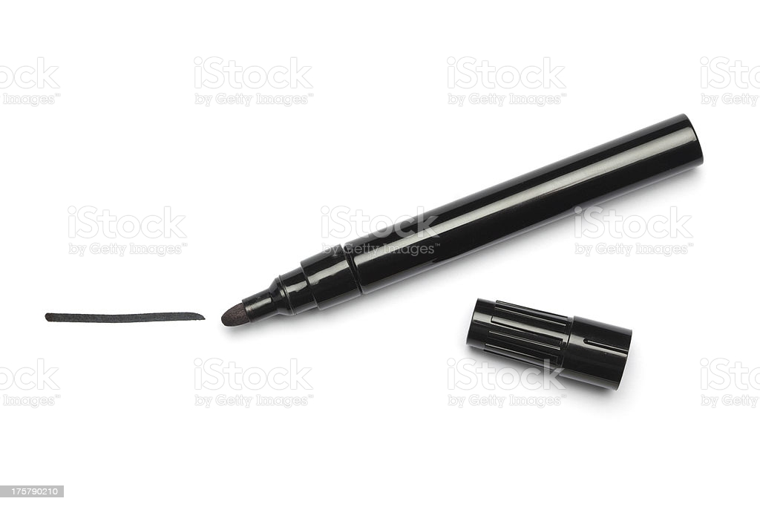

<https://media.istockphoto.com/photos/black-pen-and-line-picture-id175790210>

Pixabay, 2020-10-20

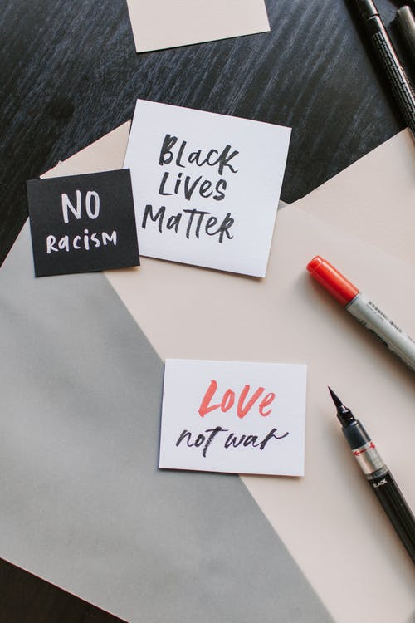

<https://images.pexels.com/photos/4668353/pexels-photo-4668353.jpeg?auto=compress&cs=tinysrgb&dpr=2&h=650&w=940>

Pexels 2020-10-20

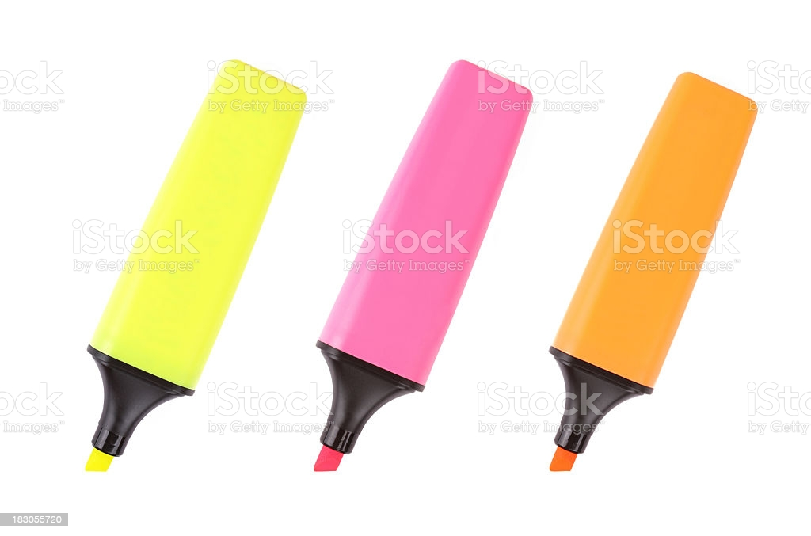

<https://media.istockphoto.com/photos/yellow-pink-and-orange-highlighters-picture-id183055720>

Pixabay 2020-10-20

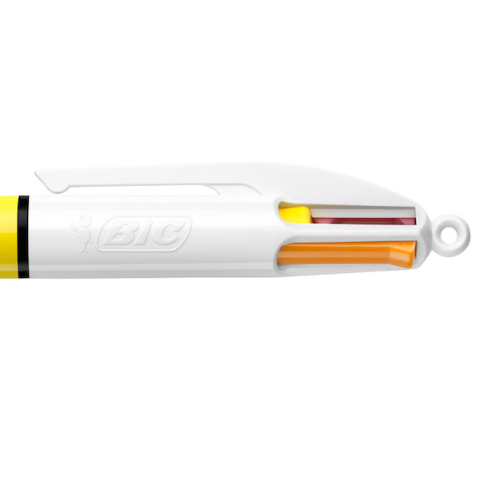

<https://www.cultpens.com/imgs/products/cp/600x600_fitPad/BC64340~BIC-4-Colour-Multipen-Sun_DTL2_P2.jpg>

Cultpens 2020-10-20

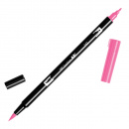

Penstore 2020-10-20

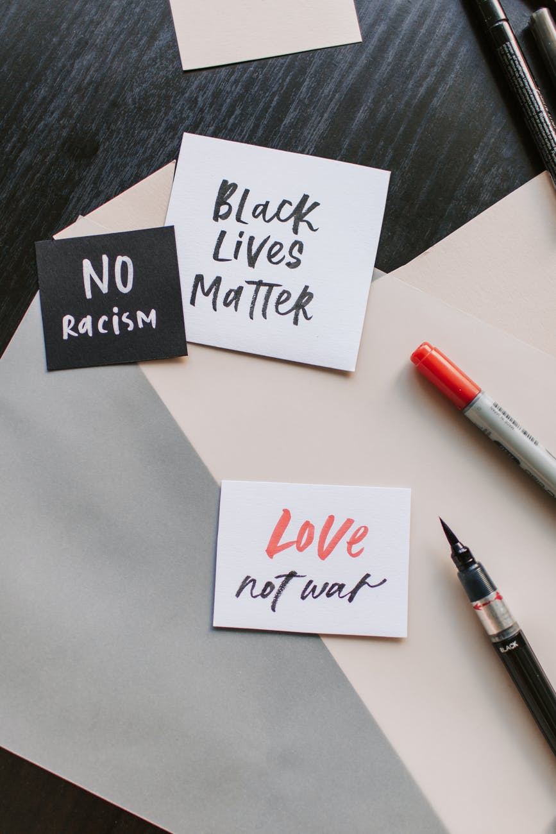

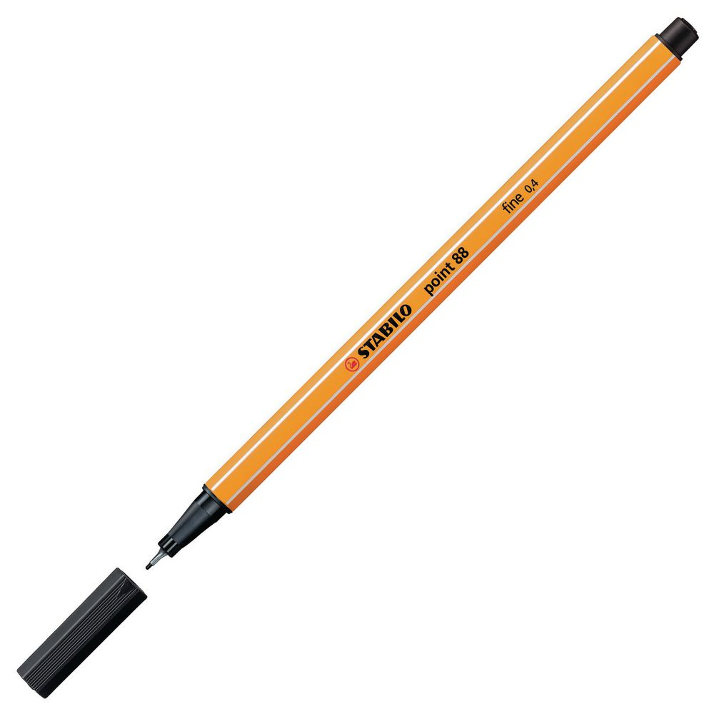

<https://www.staples.se/content/images/product/883387_1_xnl.jpg>

Hämtad 2/11-2020

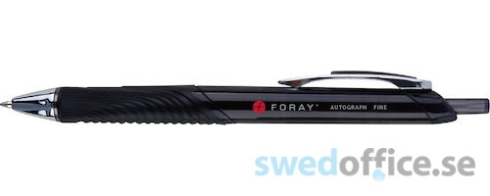

<https://www.swedoffice.se/images/products/large/2204084.jpg>

hämtad 2/11-2020



<https://cdn.pixabay.com/photo/2016/02/19/11/31/graffiti-wall-1209761__480.jpg>

hämtad 2/11-2020



<https://cdn.pixabay.com/photo/2018/02/06/22/43/painting-3135875__480.jpg>

hämtad 2/11-2020

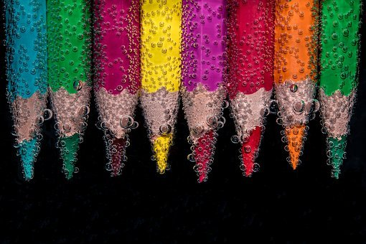

<https://cdn.pixabay.com/photo/2017/03/12/13/41/beaded-2137080__480.jpg>

hämtad 2/11-2020

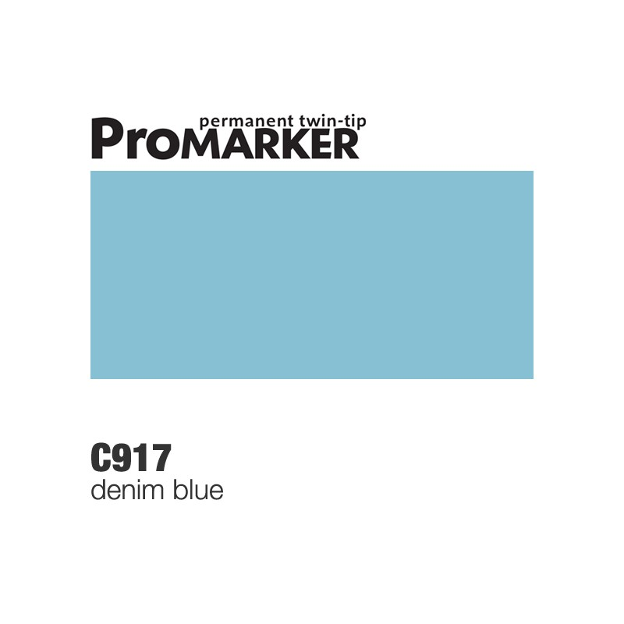

<https://shopcdn2.textalk.se/shop/26067/art67/h1719/95211719-origpic-0a220f.jpg>

hämtad 2/11-2020

PoscaLogga – utklippt från Poscas egna hemsida 3/11-2020

StabiloLogga – utklippt från Stabilos egna hemsida 3/11-2020



<https://www.google.com/url?sa=i&url=https%3A%2F%2Fwww.sharpie.com%2F&psig=AOvVaw3KclBxJDZ7kz1EZg7a1ceV&ust=1604491264103000&source=images&cd=vfe&ved=0CAIQjRxqFwoTCICKifGp5uwCFQAAAAAdAAAAABAF>

Hämtad 3/11-2020



<https://www.pilotnordic.com/>

Hämtad 3/11-2020

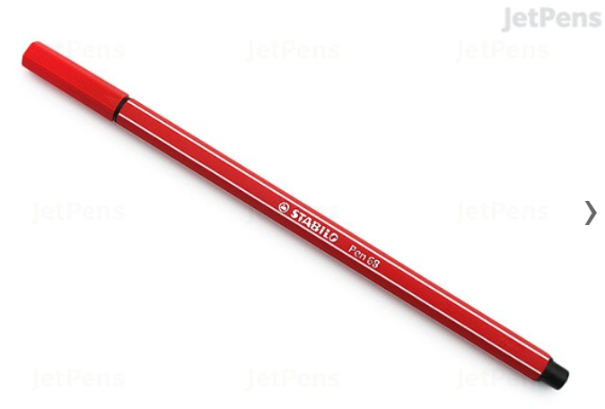

<https://www.jetpens.com/Stabilo-Pen-68-Marker-1.0-mm-Neon-Red/pd/17609>

Hämtad 6/11-2020

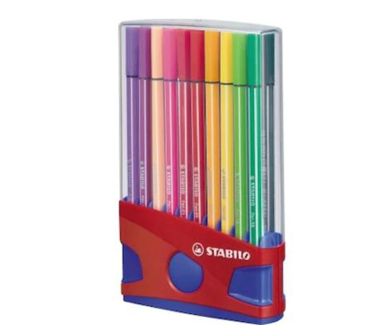

<https://cdon.se/hushallsapparater/stabilo-fiberspetspenna-stabilo-pen-68-colorparade-6820-04-olikfargat-sorterade-1-mm-20-st-pack-20-s-p46258414>

Hämtad 6/11-2020

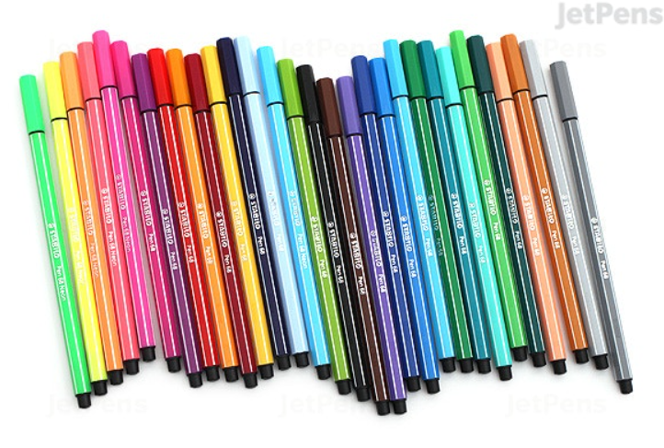

<https://www.jetpens.com/Stabilo-Pen-68-Marker-1.0-mm-30-Color-Set/pd/16387>  
Hämtad 6/11-2020

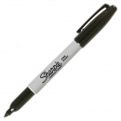

<https://penstore.se/sharpie/fine-marker>

Hämtad 6/11-2020

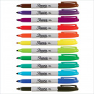

<https://penstore.se/sharpie/fine-marker-12-set>

Hämtad 6/11-2020

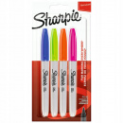

<https://penstore.se/sharpie/fine-marker-4-pack-fun>

Hämtad 6/11-2020