**REVISION HISTORY**

| **Date** | **Version** | **Description** | **Author** |
| --- | --- | --- | --- |
| 11.10.2023 | 1.0 | Had our first meeting, decided on our software idea and planned the project development | Arda Onur, Meriç Okçu, Kaan İşmen, Buğra Bedir Durmuş |
| 14.10.2023 | 1.1 | Our project's requirements have been established, each member has been given a responsibility, and the group has begun working on the documentation using Google Documents. | Arda Onur, Meriç Okçu, Kaan İşmen, Buğra Bedir Durmuş, Ömer Özmeteler |
| 14.10.2023 | 1.2 | Activities and responsibilities have been discussed. | Arda Onur, Meriç Okçu, Kaan İşmen, Buğra Bedir Durmuş, Ömer Özmeteler |
| 14.10.2023 | 1.3 | Workstation part had been updated | Arda Onur, Meriç Okçu, Kaan İşmen, Buğra Bedir Durmuş, Ömer Özmeteler |
| 15.10.2023 | 1.4 | Document overview has been added. | Arda Onur |
| 15.10.2023 | 1.5 | Gantt chart has been added. | Arda Onur, Meriç Okçu, Kaan İşmen, Buğra Bedir Durmuş, Ömer Özmeteler |
| 17.10.2023 | 1.6 | Risk Assessment has been added. | Meriç Okçu, Kaan İşmen |
| 17.10.2023 | 1.7 | Risk Analysis has been added | Meriç Okçu, Kaan İşmen |
| 23.10.2023 | 1.8 | Gantt chart has been updated. | Buğra Bedir Durmuş |
| 24.10.2023 | 1.9 | Coding section had been updated | Arda Onur |

**TABLE OF CONTENTS**

**Revision History 1**

**1** **Identification 3**

***1.1*** ***Document overview 3***

***1.2*** ***Abbreviations 3***

1.2.1 Abbreviations 3

***1.3*** ***References 3***

1.3.1 Project References 3

**2** **Software Development Activities 3**

***2.1*** ***Software development process 3***

2.1.1 Overview of process phases 3

2.1.2 Technical documentation 4

2.1.3 Deliverables 4

***2.2*** ***Software development tools 4***

2.2.1 Workstation 4

2.2.2 Requirements management and documentation 4

2.2.3 Software Design 4

2.2.4 Coding and automated tests 4

2.2.5 Configuration management 4

***2.3*** ***Software development rules and standards 4***

**3** **Responsibilities 5**

***3.1*** ***Activities and responsibilities 5***

**4** **Risk Assessment 5**

***4.1*** ***Risk Analysis 5***

***4.2*** ***Risk Planning 5***

1. **Identification**
   1. ***Document overview***

This document contains the software development plan of software AVEC.

This project is a web-based Java e-commerce application powered by Spring framework and microservices. In this project, individuals or companies open accounts in their own

names and sell or purchase their own product(s) through these accounts

* 1. ***Abbreviations***

***1.2.1* Abbreviations**

AVEC : Avielent E-Commerce

* 1. ***References***

***1.3.1* Project References**

| **#** | **Document Identifier** | **Document Title** |
| --- | --- | --- |
|  |  |  |

1. **Software Development Activities**

The section lists and describes the software development activities of AVEC software development projects.

* 1. ***Software development process***

This is a course project, which adopts the waterfall model as the software development process.

* + 1. **Overview of process phases**

The software development process for the project will be composed of the following phases:

* Planning
* Requirements Analysis
* Design
* Implementation
* Testing and Analysis

These phases will follow each other sequentially, where each phase starts just after the completion of the previous one. The following Gantt chart depicts the planned start date and duration for the phases.

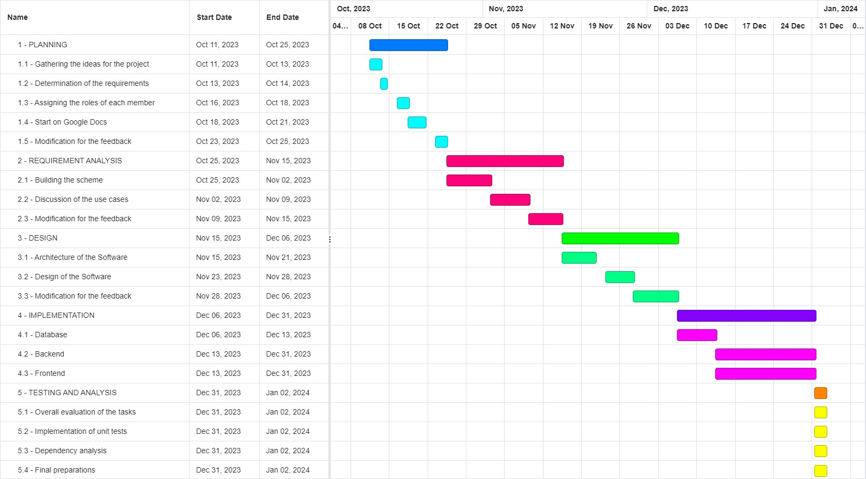

* + 1. **Technical documentation**

The following documentation is produced during the software development phases:

* Software specification: SRS, STP
* Software detailed conception: SDD
* Software tests phases : STR
* Software analysis: SAR
  + 1. **Deliverables**

The following items will be delivered at the end of the process:

* Technical documentation as outlined in Section 2.1.2
* Software and its configuration files
  1. ***Software development tools***
     1. **Workstation**  
          
        Custom-built

● Intel(R) Core(TM) i7-4790 CPU @ 3.60GHz, 3601 Mhz, 4 Core

● 2 TB HDD, 120 GB SSD

● NVIDIA GeForce GTX 1070 Ti

● 16 GB 2x8 3200 Mhz Vengeance on board Memory  
● Windows 11 Home  
  
MacBook Pro 2021

● Apple M1 chip

● 512 GB PCIe-based SSD

● AMD Radeon Pro 5500M

● 16 GB GDDR6 VRAM

MacBook Pro 2023

● Apple M2 Pro Chip

● 512 GB PCIe-based SSD

● AMD Radeon Pro 5500M

● 16 GB GDDR6 VRAM

Asus TUF Gaming A15 FA506II-BQ018

● AMD Ryzen 7 4800H

● 512 GB SSD

● NVIDIA GeForce GTX 1650Ti

● 16 GB 2x8 RAM

Monster Tulpar T7 V20.1

● Intel Core i7-9750H CPU

● 512 GB SSD

● NVIDIA GeForce GTX 1660Ti

● 16 GB 2x8 RAM

* + 1. **Requirements management and documentation**
* Microsoft Word
* Microsoft Excel
* Google Documents
  + 1. **Software Design**

Argo UML open source tool will be used for software design.

* + 1. **Coding and automated tests**
* Java
* JUnit
* MySQL Database
* Spring Framework (Spring Cloud, Spring Data)
* Hibernate
* Maven
* Thymeleaf
* Html
* Css
* Javascript

### 2.2.5 Configuration management

GitHub[1] will be used for software configuration management and tracking issues regarding the software development. A public repository will be created for this purpose.

* 1. ***Software development rules and standards***

UML[1] will be used for software design documentation.

GitHub: We'll utilize GitHub as a platform for hosting code so that we can all work at once. Additionally, showcasing our own work will be useful. A team of developers will also implement the project's revised version there.

Database schema and UML diagram creation is free online using Lucidchart. In order to visualize relationships and tasks, the UML diagram tool automatically generates UML diagrams online with a sequence markup editor.

[Code conventions for the Java ™ Programming Language](https://www.oracle.com/java/technologies/javase/codeconventions-contents.html)

[MySQL 8.0.21 Source Code Documentation](https://dev.mysql.com/doc/dev/mysql-server/latest/PAGE_CODING_GUIDELINES.html)

1. **Responsibilities**
   1. ***Activities and responsibilities***

| **Activity** | **Responsibility** | **Comment** |
| --- | --- | --- |
| Project management | Arda Onur |  |
| Configuration tools management | Kaan İşmen, Meriç Okçu Arda Onur, Buğra Bedir Durmuş, Ömer Özmeteler |  |
| Setting up the Development tools | Kaan İşmen, Meriç Okçu Arda Onur, Buğra Bedir Durmuş, Ömer Özmeteler |  |
| Database design | Kaan İşmen, Meriç Okçu , Arda Onur, Buğra Bedir Durmuş, Ömer Özmeteler |  |
| Front-end Design | Kaan İşmen, Meriç Okçu ,Arda Onur, Buğra Bedir Durmuş, Ömer Özmeteler |  |

1. **Risk Assessment**
   1. Risk Analysis

| Risk | Probability | Effects |
| --- | --- | --- |
| Key workers are ill and unavailable at a critical time. | High | Tolerable |
| The miscalculation about the required time to develop the software. | Medium | Serious |
| Underestimating the effort to be spent on software | Medium | Serious |
| A team member is missing for one or more meetings | Medium | Tolerable |
| The database of the system is unable to process the necessary number of transactions per second. | Low | Insignificant |
| Having a disagreement between members of the team | Low | Serious |

* 1. ***Risk Planning***

| Risk | Indicators | Actions |
| --- | --- | --- |
| Key workers are ill and unavailable at a critical time. | Since the climate change, people can not anticipate the weather temperature and they might not be able to dress up properly for the weather condition so it may be common to get sick. | Other group members will try to compensate for the personnel’s absence. After the personnel’s returnal, the team will walk through the changes that have been done in order to keep the personnel informed. |
| Wrong required time calculation for developing the software. | According to the gantt table, the plans and the timings aren’t going as planned. | The team has to work more efficiently and effectively in order to keep up with the original timeline. |
| The size of effort that needs to be put into software is underestimated by the team | Some ideas are easier to think about rather than demonstrating them. | We can ask for help from our professors in their available time. |
| A team member is missing for one or more meetings | Experiencing overwhelming stress as a result of a heavy academic workload, health issues, and balancing internships during the academic semester. | The tasks of the absent team member can be evenly split among the remaining team members in order to proceed with the least damage. |
| The database of the system is unable to process the necessary number of transactions per second. | Every system has a different capacity. Since every team member doesn’t have the same system, the database might not work on someone’s system while working perfectly on someone else’s. | The team member who has the lower capacity system will switch tasks with one of their teammates. |
| Having a disagreement between members of the team | Any team member might have a different idea rather than the project standards and tries to apply their idea without the consent of the other team members. | A thorough meeting will be required with all of the team members in order to discuss and evaluate the idea. |

1. http://www.github.com