A Project Report on
News24x7
Submitted To:
HEMCHANDRACHARYA NORTH GUJARAT UNIVERSITY
For Partial Fulfillment towards the Award of Degree Of
Bachelor of Computer Applications (BCA)
September - 2025
Submitted by:

Matin Abbassi (Roll No 45)
Pravin Kumar (Roll No 32)
Utkarsh (Roll No 28)



D.L. PATEL INSTITUTE OF MANAGEMENT & TECHNOLOGY BCA COLLEGE
VIDHYANAGARI, HIMATNAGAR

D.L. PATEL INSTITUTE OF MANAGEMENT & TECHNOLOGY BCA COLLEGE
VIDHYANAGARI, HIMATNAGAR


C E R T I F I C A T E

This is to certify that the project entitled News24x7 Submitted by Matin Abbassi (Roll No 45), Pravin Kumar (Roll No 32) & Utkarsh (Roll No 28) towards the partial fulfillment of the requirement for the award of the degree of BCA of Hemchandracharya North Gujarat University is a record of the work carried out by them under my guidance and supervision. The work submitted, in my opinion, has reached to a level required for being accepted for the examination.

Internal Guide I/C Principal
Mr. Yash Joshi Dr. Vishal R. Trivedi
I/C Principal D.L.P.I.M.T. - BCA
College Vidhyanagari, Himatnagar

Examiner Sign
I N D E X

SR. NO. | DESCRIPTION | PAGE NO.
1. | DECLARATION | 2
2. | ACKNOWLEDGEMENT | 5
3. | PREFACE | 6
4. | INTRODUCTION TO PROJECT | 7
5. | PROJECT PROFILE | 8
6. | SYSTEM ANALYSIS  6.1 EXISTING SYSTEM  6.2 PROPOSED SYSTEM  6.3 FEASIBILITY STUDY | 14
7. | SYSTEM DESIGN  7.1 FLOW CHART  7.2 E-R DIAGRAM  7.3 DATA FLOW DIAGRAM | 17
8. | DATA DICTIONARY | 35
9. | INTERFACE DESIGN (ADMIN & USER SIDE SCREEN SHOTS) | 48
10. | FUTURE ENHANCEMENT | 56
11. | BIBLIOGRAPHY & WEBLIOGRAPHY | 57

Declaration

Project Overview

- Project Title: News24x7 - Modern News Aggregation Platform

- Technology Stack: Django, MySQL, HTML/CSS/JavaScript, Bootstrap, jQuery, slick slider, fancy box, chart s, Sun editor

- Project Duration: 3 Months

- Project Type: Web Application Development

Team Structure & Roles

- Developed by: Matin

- Content written by: Pravin

- Documentation by: Utkarsh

Project Features

User Features

- Login & Registration: To securely authenticate users, create a unique identity on the platform, and enable personalized experiences.

- User Profile: To provide a centralized hub for users to manage their identity, preferences, and activity on the platform.

- Bookmark: To allow users to save content for later consumption, creating a personalized reading list.

- Follow & Like: Stay connected with your favorite topics and show your support.

- Topics Following: Personalize your news feed by choosing the categories you care about most.

- Comments on News: Share your opinions and join discussions with other readers.

- Report News: Help improve the platform by reporting false or inappropriate content.

- Language Options: Access news in Hindi and Gujarati for wider reach.

Admin & Staff Features

- Admin Panel: To be the one and only control center for all administrative tasks.

- WYSIWYG Editor: for Content Creation: To allow admins and staff to write and format news articles and pages easily, without needing to know any code.

- Internal Messaging System (Admin & Staff Only): To provide a private channel for the website team to communicate and coordinate. Regular users cannot see or access these messages.

- Comprehensive Statistics & Reporting: To make informed decisions by understanding how the website is performing.

Acknowledgement

We are thrilled to present our project titled "News24x7" as a part of our Bachelor of Computer Applications (BCA) curriculum. Its successful completion would not have been possible without the support and guidance of several individuals, to whom we would like to express our sincere gratitude.

First and foremost, we wish to express our profound gratitude to our project guide, MR SR Vandan Upadhyaya, Faculty of the Computer Science Department at D.L. Patel Institute of Management & Technology B.C.A. & M.C.A College, Vidhyanagar. Their unwavering support, invaluable guidance, and insightful feedback at every stage were instrumental in shaping this project. Their patience and motivation kept us on track, especially when we encountered challenges.

We are also thankful to our Head of Department, I/C Principle Prof. Dr. Vishal R. Trivedi, and the entire faculty and staff of the Computer Science department for providing us with the necessary resources and a conducive environment for learning and innovation.

Our heartfelt thanks go to our lab assistants and the college staff for their timely technical support during the development and testing phases of our project.

We are incredibly grateful for the seamless collaboration and relentless effort of our team members, Matin, Pravin & Utkarsh. Their dedication, hard work, and constructive discussions were the backbone of this project. It was a truly enriching experience to work together and combine our skills to achieve this goal.

Lastly, we would be remiss if we did not thank our families and friends for their constant encouragement, unwavering belief in our abilities, and for providing us with the moral support needed to complete this work.

Preface

This project report entitled “News24x4” has been prepared in partial fulfillment of the requirements for the Bachelor of Computer Applications (B.C.A.) program.

The main objective of this project is to design and develop a dynamic news website that delivers updated information to users in an efficient and interactive way. Through this work, we have been able to bridge the gap between theoretical concepts and practical implementation.

During the development process, we enhanced our skills in web technologies, database management, and software development methodologies. Moreover, this project has helped us understand the importance of teamwork, time management, and problem-solving in real-world applications.

We sincerely hope that this project will serve as a useful reference for students and learners in the field of computer applications.

Introduction To Project

The rapid growth of the internet has transformed the way people access and share information. News websites have become one of the most popular platforms for delivering real-time updates, covering diverse areas such as politics, sports, entertainment, technology, and world affairs. Unlike traditional newspapers, online news portals provide users with instant access, interactive features, and personalized experiences.

Our project, “News24x4”, is a web-based news portal designed to meet the increasing demand for fast, reliable, and user-friendly news platforms. It allows users to browse the latest articles, bookmark important content, follow updates, and actively engage through comments. The system is built to ensure smooth navigation, easy content management, and secure user interaction.

The project has been developed using Django framework as the backend, with HTML, CSS, and JavaScript for the frontend, and a robust database system for managing user data and content. By integrating these technologies, the platform provides both efficiency and scalability.

This project has not only given us the opportunity to explore modern web technologies but also helped us understand the end-to-end software development life cycle. It serves as a practical application of concepts learned during the B.C.A. course and demonstrates how technology can be used to simplify the process of information sharing.

Project Profile

Project Title: News24x7

Project Type: Web-based Application

Technology Used:
Frontend:
- HTML
- CSS
- JavaScript
- Bootstrap
- jQuery
- slick slider
- Fancy box
- chart JS

Backend:
- Python
- Django,
- Django REST framework
- python weather
- Google trans
- django-background-tasks

Database: MySQL team members roles

The project “News24x4” is an online news portal designed to deliver real time news and information to users in a simple, effective, and interactive way. It enables readers to explore news articles across various categories such as politics, sports, entertainment, technology, and world news.

The system provides features such as bookmarking articles, following updates, and adding comments, which enhance user engagement. Admins can easily upload, edit, and manage content, ensuring the website remains dynamic and up to date.

Objectives of the Project:

- To design a reliable and user-friendly online news platform.

- To allow users to access news articles anytime, anywhere.

- To implement interactive features like bookmarking, commenting, and following.

- To ensure secure user authentication and data management.

- To provide an efficient backend system for managing content dynamically.

Scope of the Project:

The project has been developed for educational purposes, but it can be expanded into a fully functional commercial news portal. With additional features like live notifications, multimedia content, and AI-driven recommendations, the platform can cater to a large user base in the future.

Thus, the “News24x4” project provides both information access and interactivity, combining technology and usability to create an effective news delivery platform.

System Analysis

Existing System

In the existing news websites or portals, most systems provide static content with limited interactivity. Users can only read the news but have minimal options to engage or customize the content. Many platforms also lack efficient content management and user-friendly navigation.

Limitations of Existing System:

- Content updates are often manual and delayed.
- No options for bookmarking or following favorite news categories.
- Commenting and interactive features are limited or absent.
- Websites may not be fully responsive across devices.
- Lack of real-time notifications or alerts.

Proposed System

The proposed system, “News24x7”, is a dynamic and interactive news portal that aims to improve user experience and content management. Users can register, bookmark articles, follow topics, and comment on news posts. Administrators can easily manage news content, categories, and user interactions through a secure backend system.

Features of Proposed System:

- Dynamic news content management using Django framework.
- User registration and secure login system.
- Bookmarking, following, and commenting functionality.
- Responsive design for desktop and mobile devices.
- Real-time content updates and notifications.

Feasibility Study

Technical Feasibility:

- The system uses open-source technologies: Django, Python, HTML, CSS, JavaScript, and MySQL.

- Required hardware and software resources are available and easy to implement.

Operational Feasibility:

- The system is user-friendly for both users and administrators.

- Minimal training is required for effective use of the system.

Conclusion:

The proposed “News24x7” system is technically, economically, and operationally feasible. It addresses the limitations of existing systems and provides a modern, interactive, and efficient news platform.

Hardware Requirements

- Processor: A modern dual-core or quad-core processor is generally sufficient.

- RAM: 4GB to 8GB of RAM is typically adequate for a smooth development experience, especially when running a local development server and potentially other tools like a text editor or IDE.

- Storage: A solid-state drive (SSD) is highly recommended for faster boot times and application loading, even a modest 256GB SSD would be fine.

- Operating System: Django runs on Windows, macOS, and various Linux distributions.

System Analysis

6.1 Existing System

In the existing news websites or portals, most systems provide static content with limited interactivity. Users can only read the news but have minimal options to engage or customize the content. Many platforms also lack efficient content management and user-friendly navigation.

Limitations of Existing System:
- Content updates are often manual and delayed.
- No options for bookmarking or following favorite news categories.
- Commenting and interactive features are limited or absent.
- Websites may not be fully responsive across devices.
- Lack of real-time notifications or alerts.

6.2 Proposed System

The proposed system, “News24x7”, is a dynamic and interactive news portal that aims to improve user experience and content management. Users can register, bookmark articles, follow topics, and comment on news posts. Administrators can easily manage news content, categories, and user interactions through a secure backend system.

Features of Proposed System:

- Dynamic news content management using Django framework.
- User registration and secure login system.
- Bookmarking, following, and commenting functionality.
- Responsive design for desktop and mobile devices.
- Real-time content updates and notifications.

Conclusion:

The proposed “News24x7” system is technically, economically, and operationally feasible. It addresses the limitations of existing systems and provides a modern, interactive, and efficient news platform.

6.3 Feasibility Study

Technical Feasibility:

- The system uses open-source technologies: Django, Python, HTML, CSS, JavaScript, and MySQL.
- Required hardware and software resources are available and easy to implement.

Economic Feasibility:

- The project can be developed at minimal cost using free technologies.
- Development can be completed within the allocated time and budget.

Operational Feasibility:

- The system is user-friendly for both users and administrators.
- Minimal training is required for effective use of the system.

SYSTEM DESIGN

Flow Chart

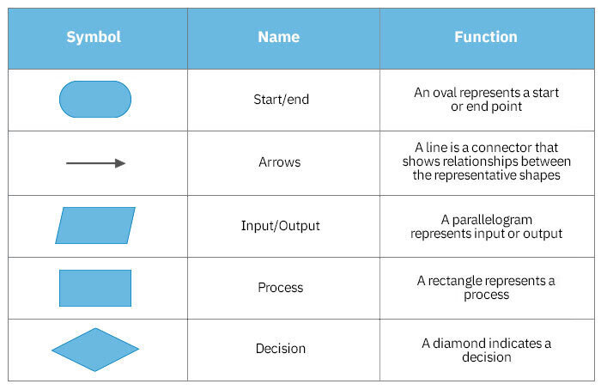

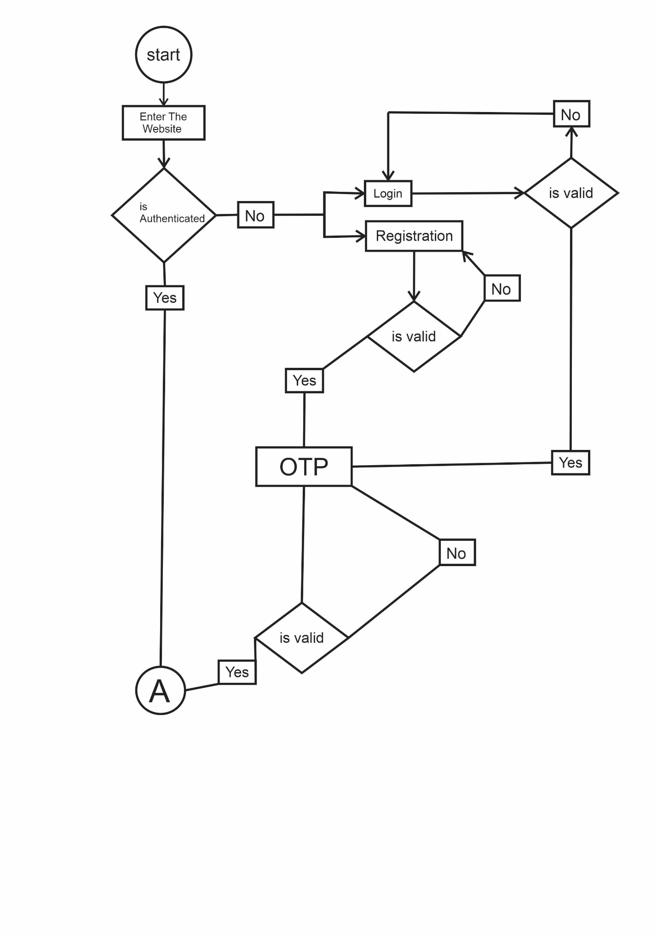

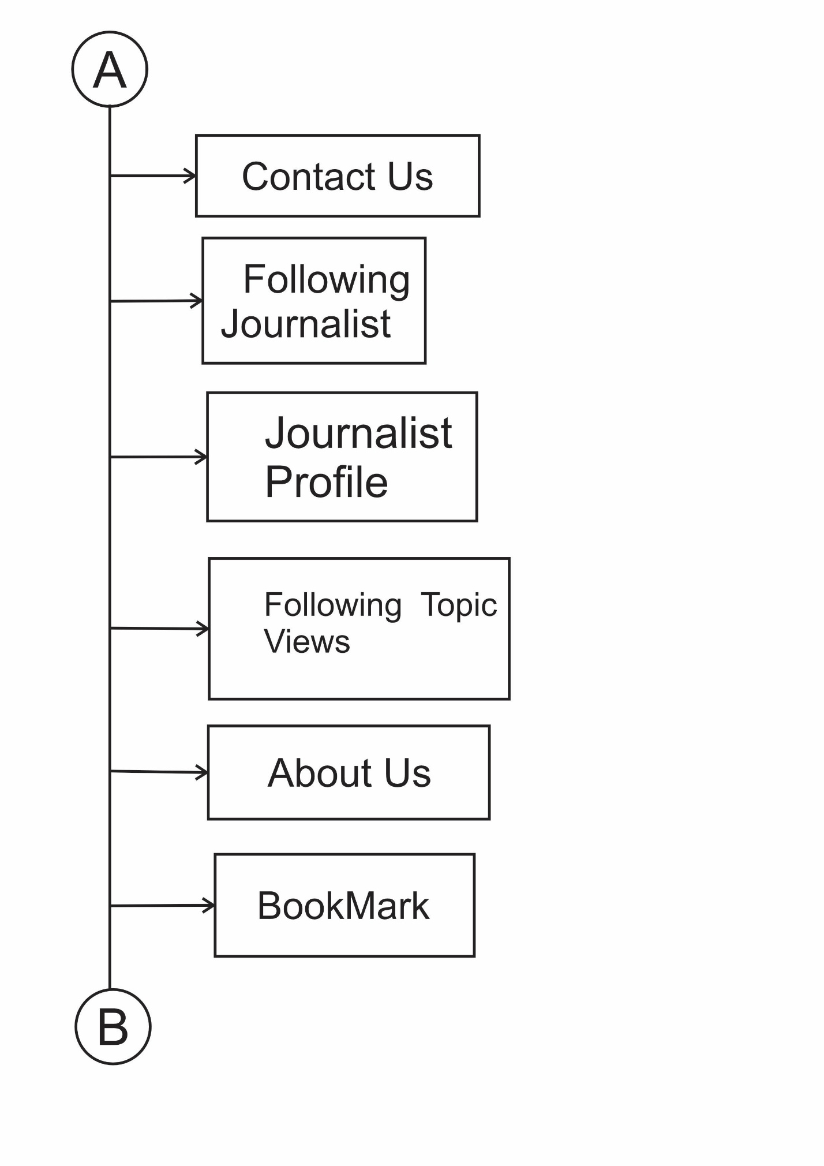
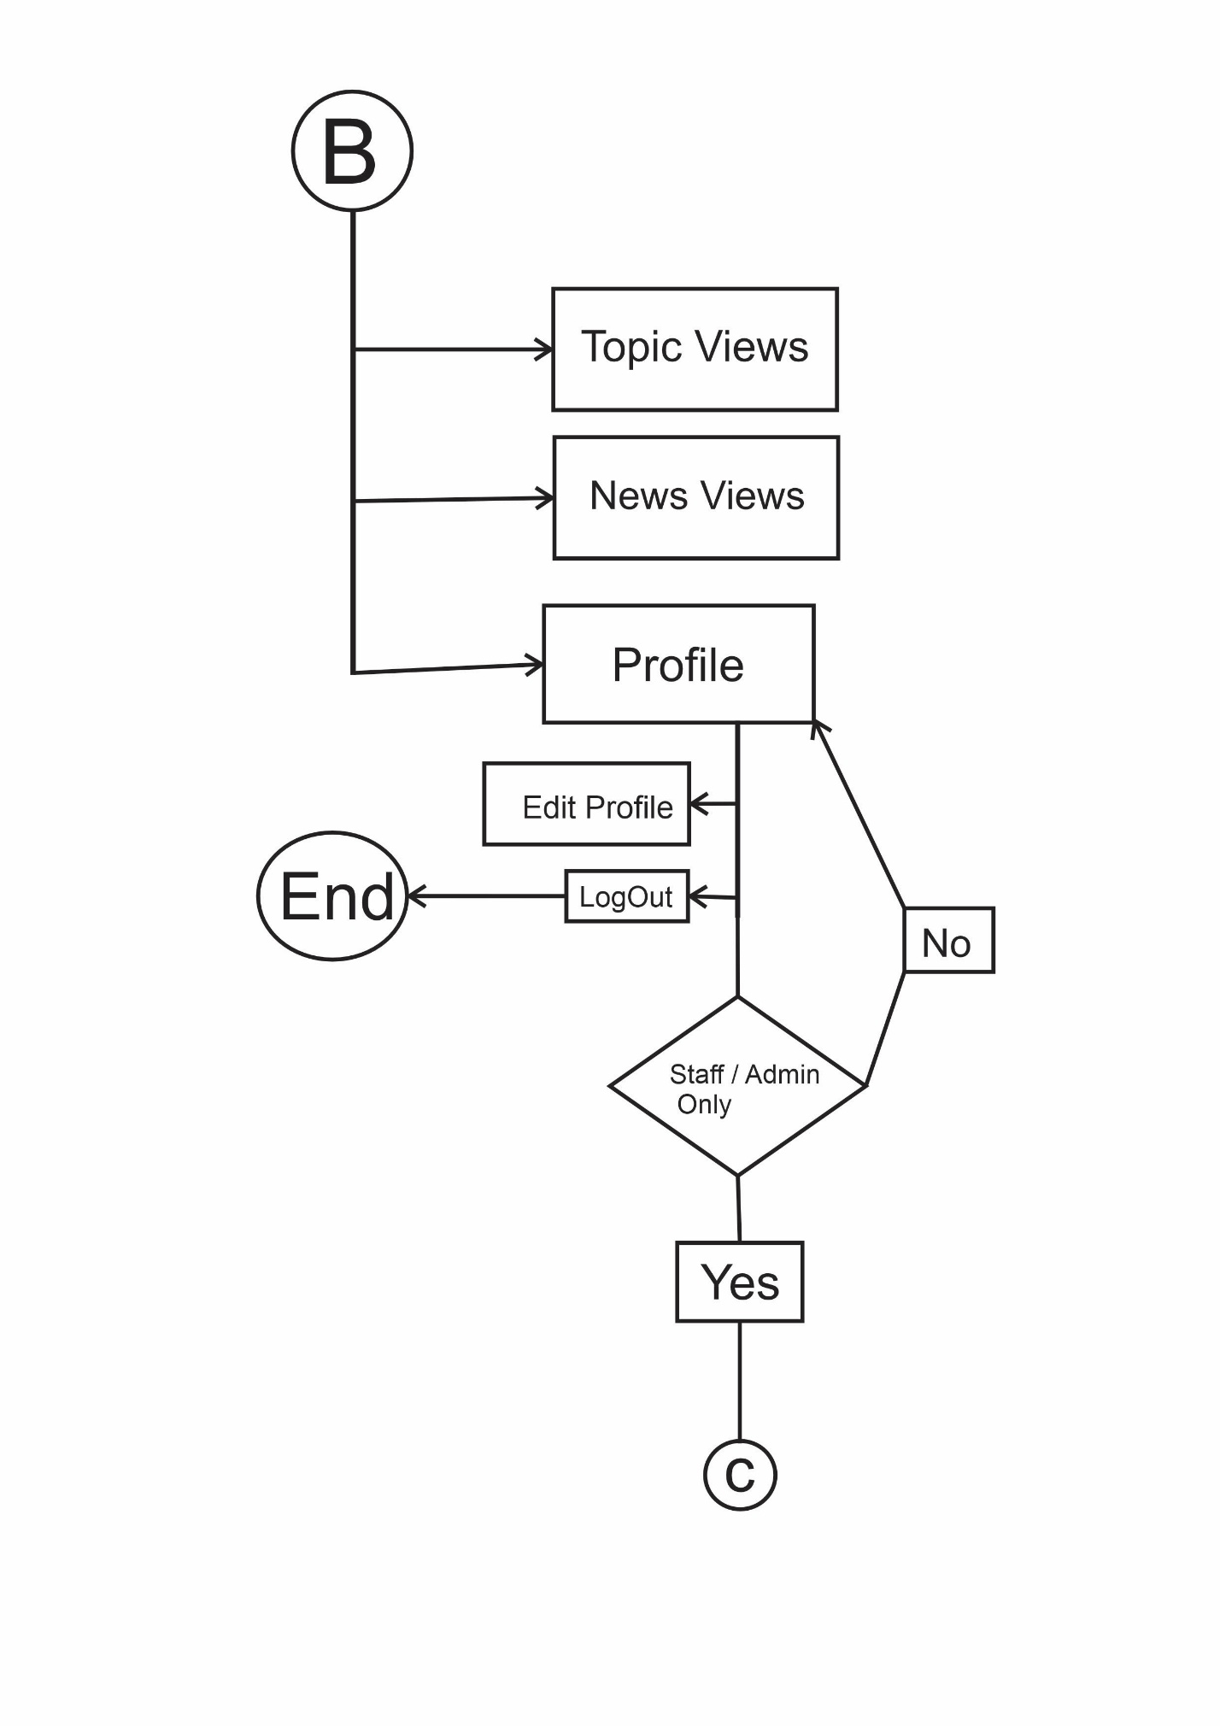

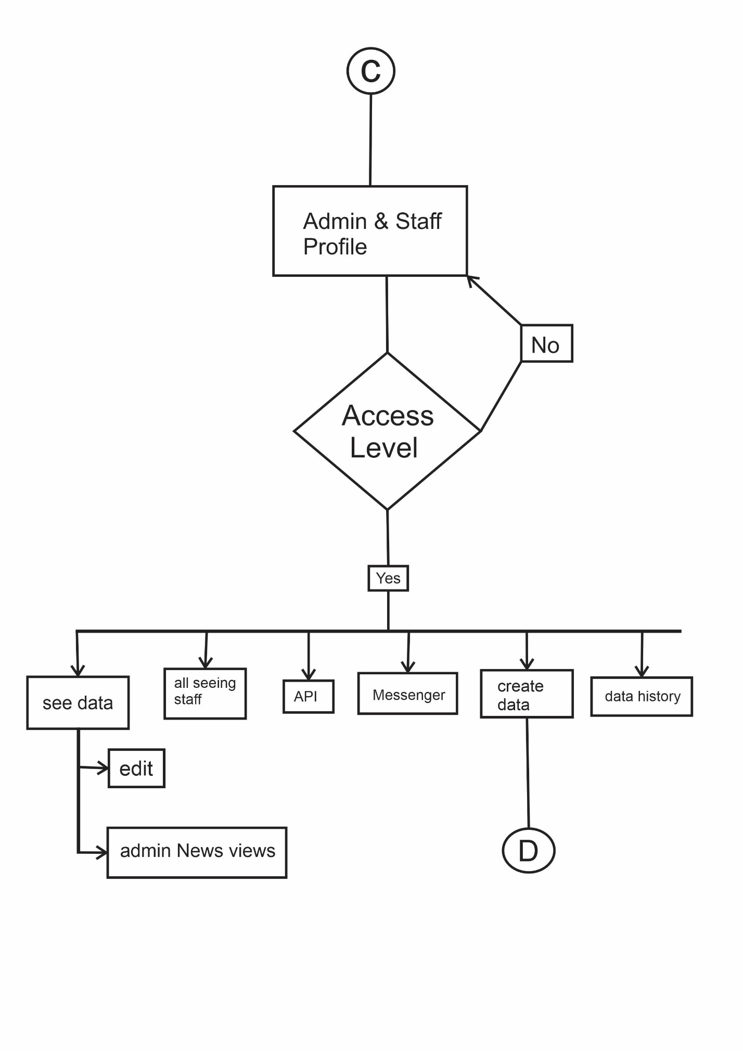

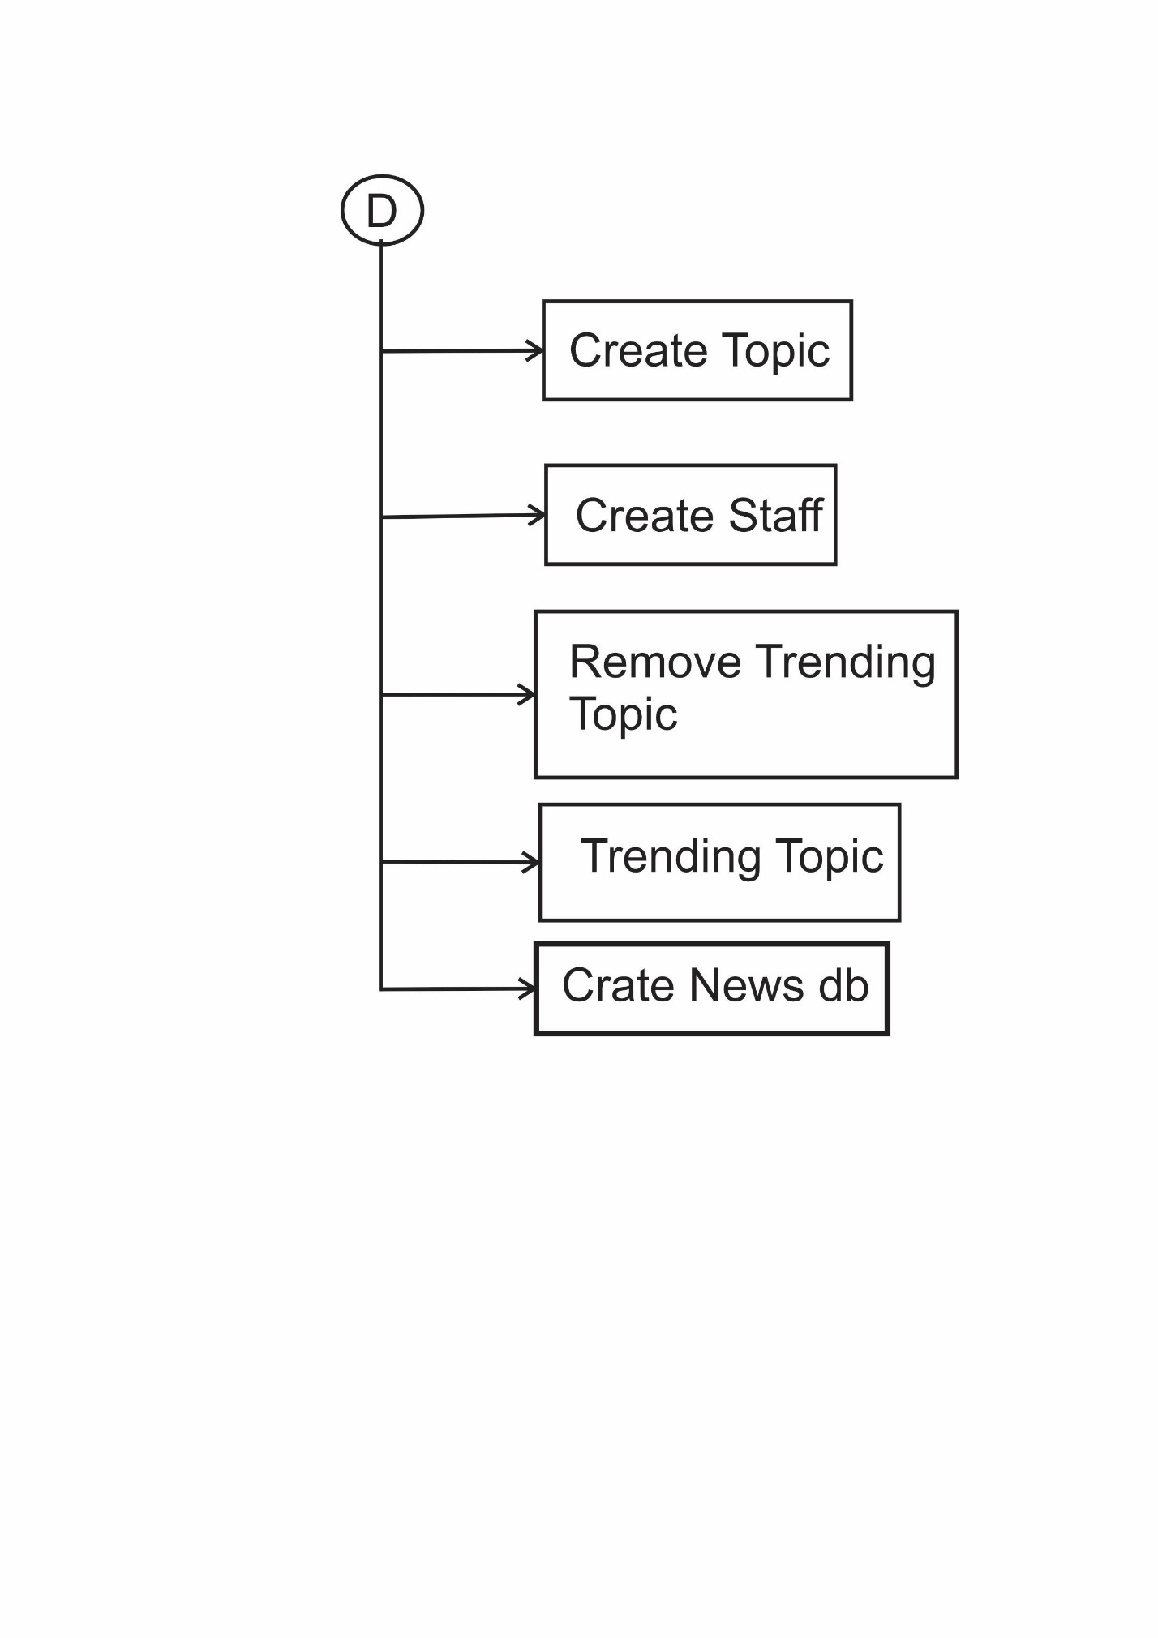

E-R DIAGRAM

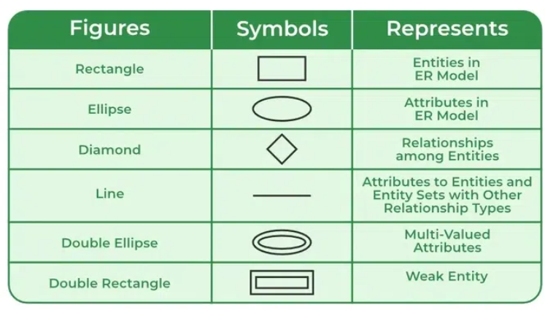

User Management

- auth_user: Base user accounts (id, username, email, password)

- UserOTP: Email verification system (OTP, expiration timestamps)

- UserInfo: Extended user profiles (gender, address, language preferences)

Staff Management

- StaffMember: Employee records with roles (Journalist, Writer, Editor, Manager, CEO, Admin)

- Office: Physical office locations and details

News Content
- News: Core news articles with multimedia support (text, images, videos)

- Topic: News categorization system

Engagement & Workflow

- newsLike: User like tracking

- NewsView: Article view analytics (including anonymous views)

- NewsStatus: Publication workflow tracking (draft → published)

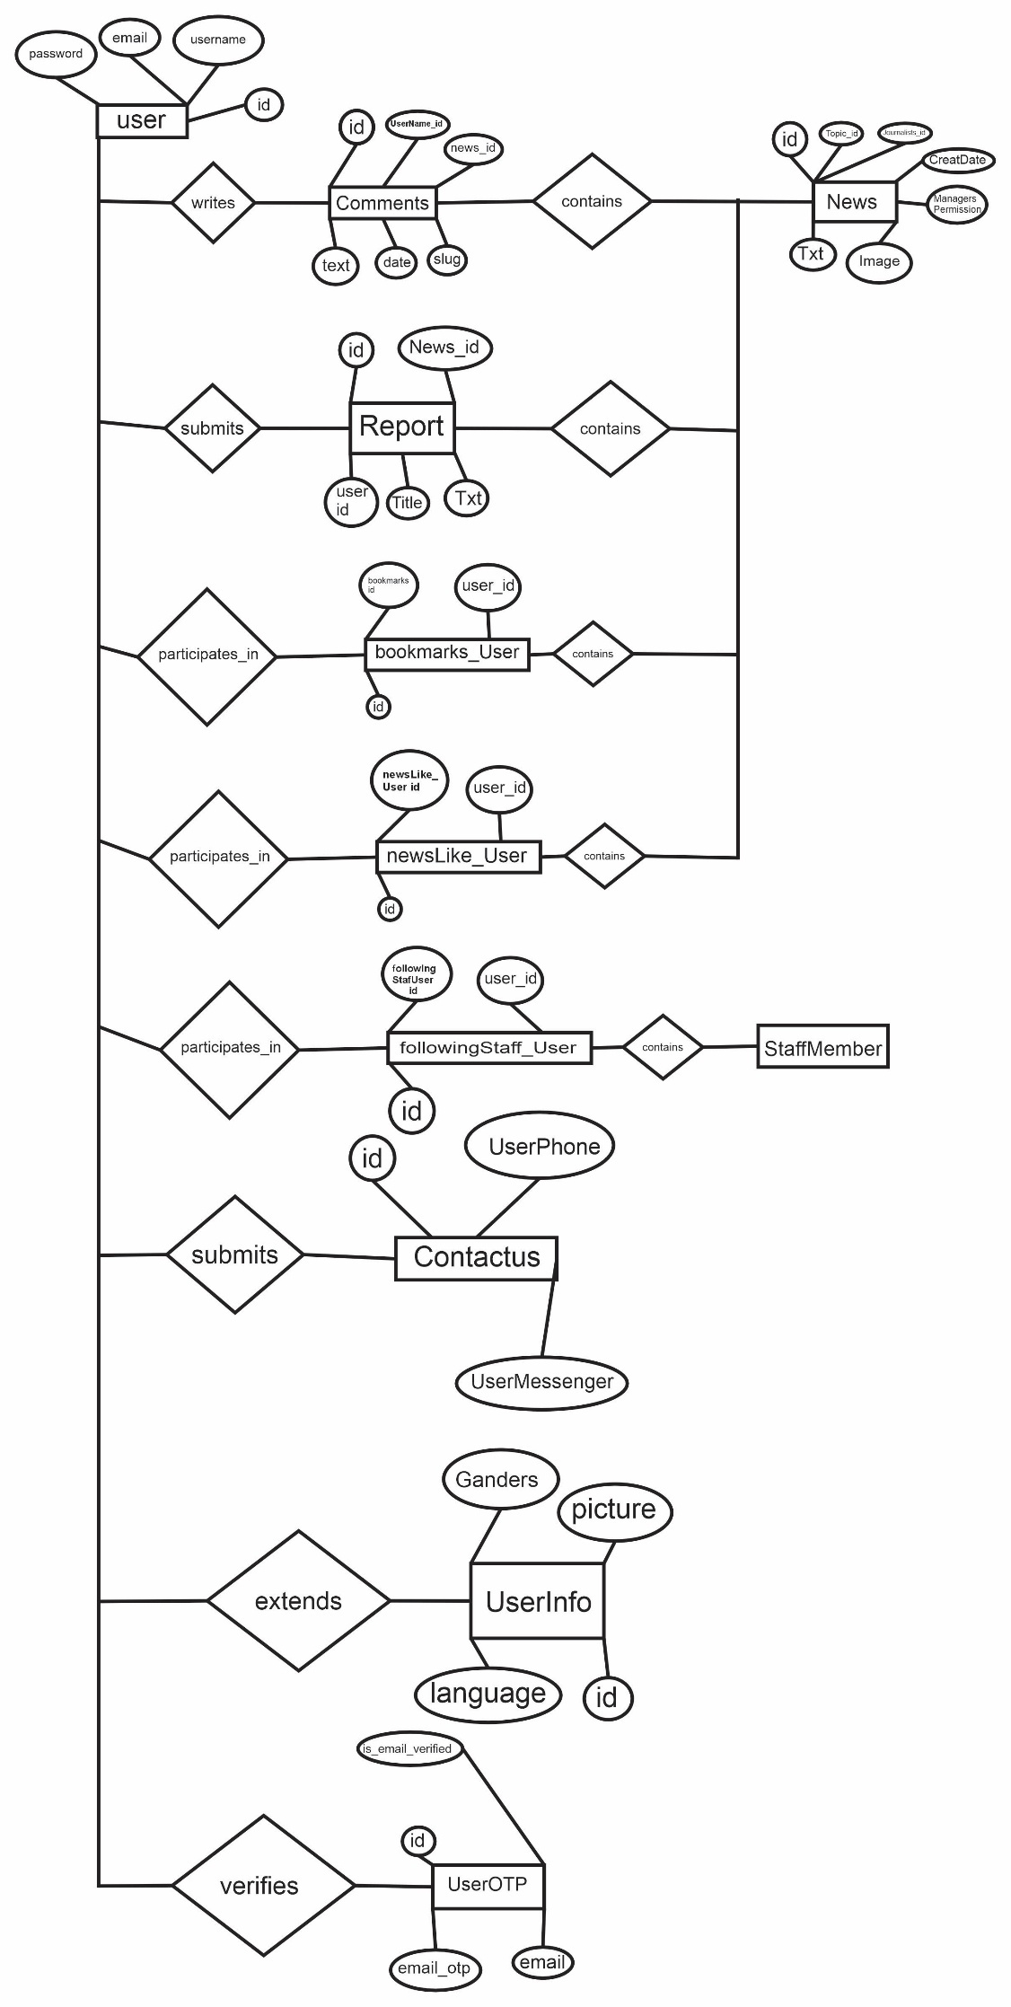
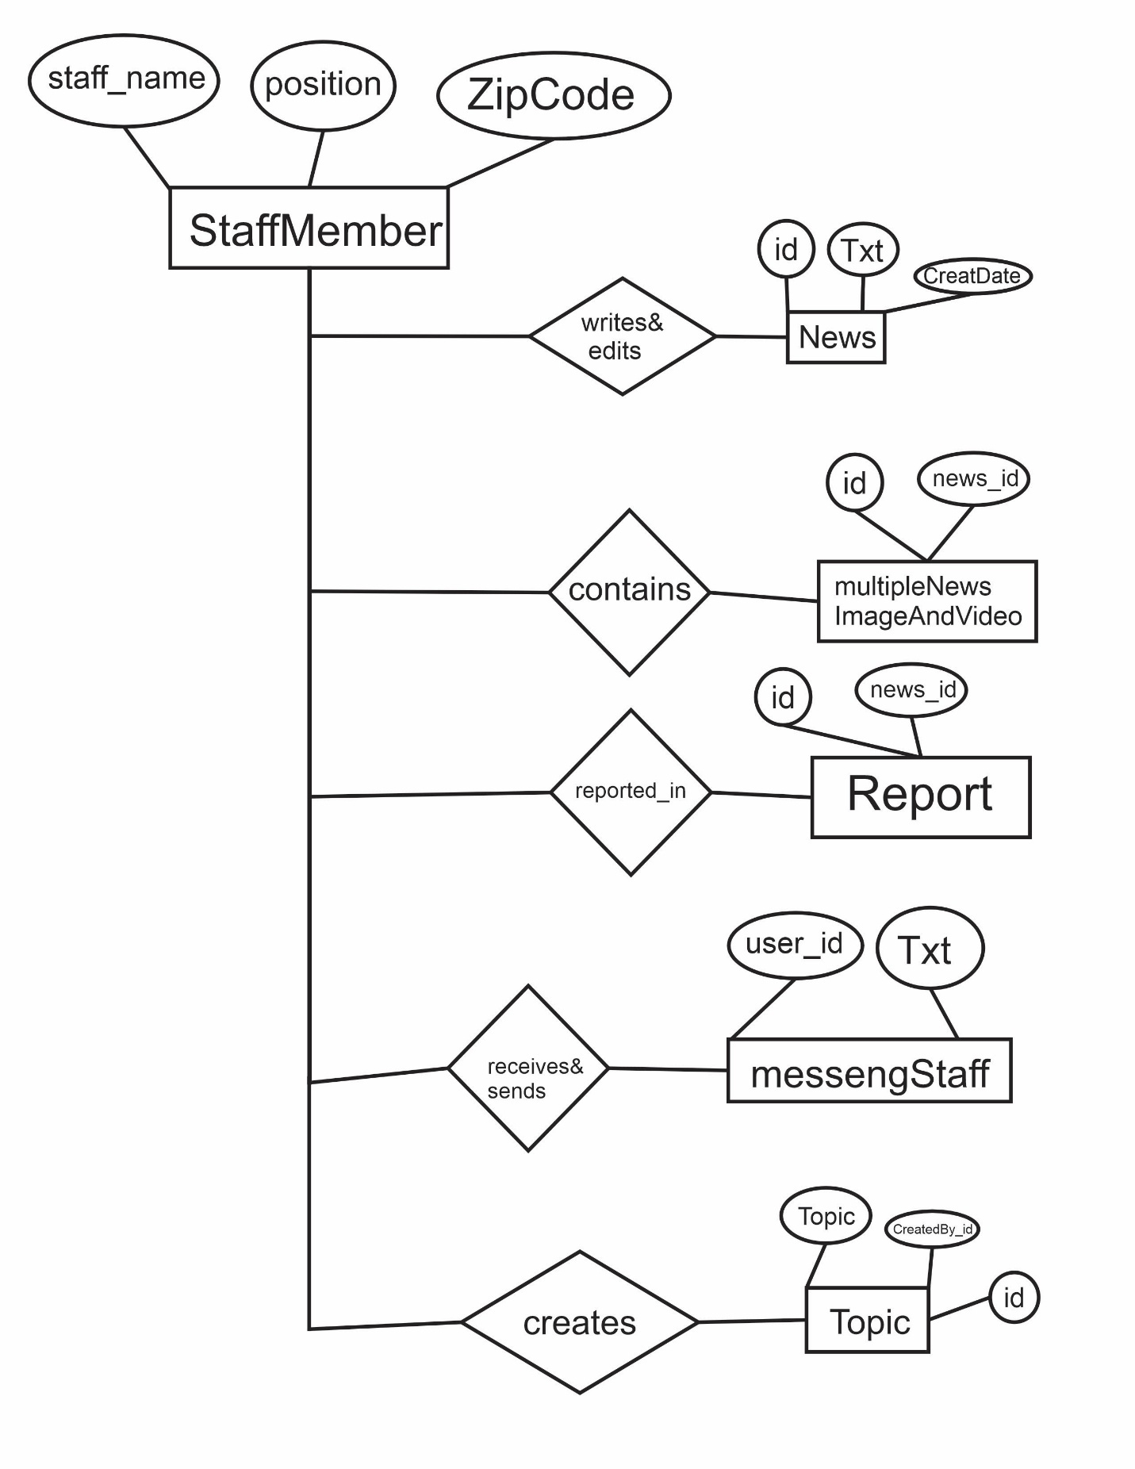

Data Flow Diagram

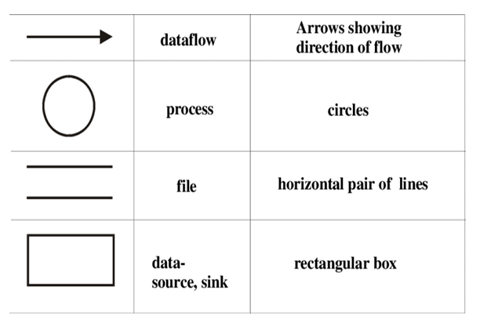

DFD LEVEL 0

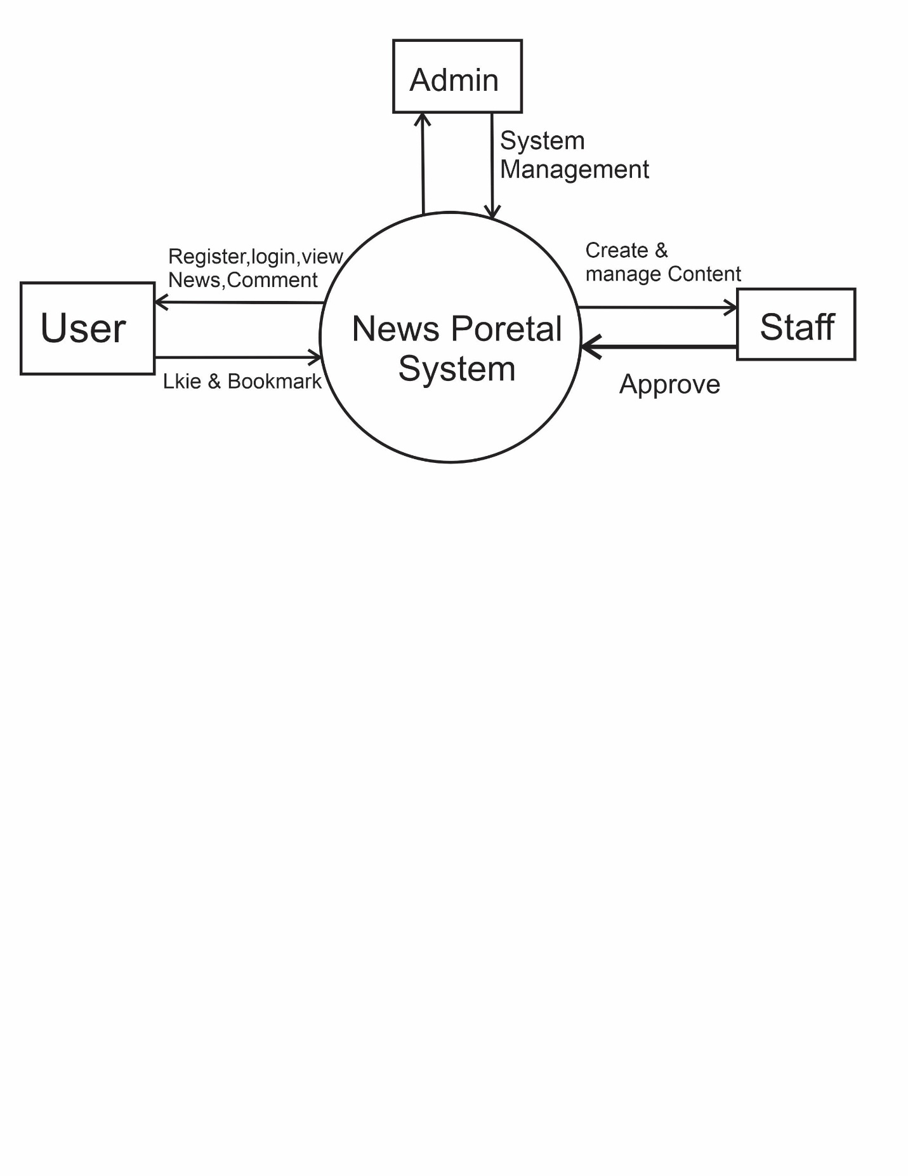

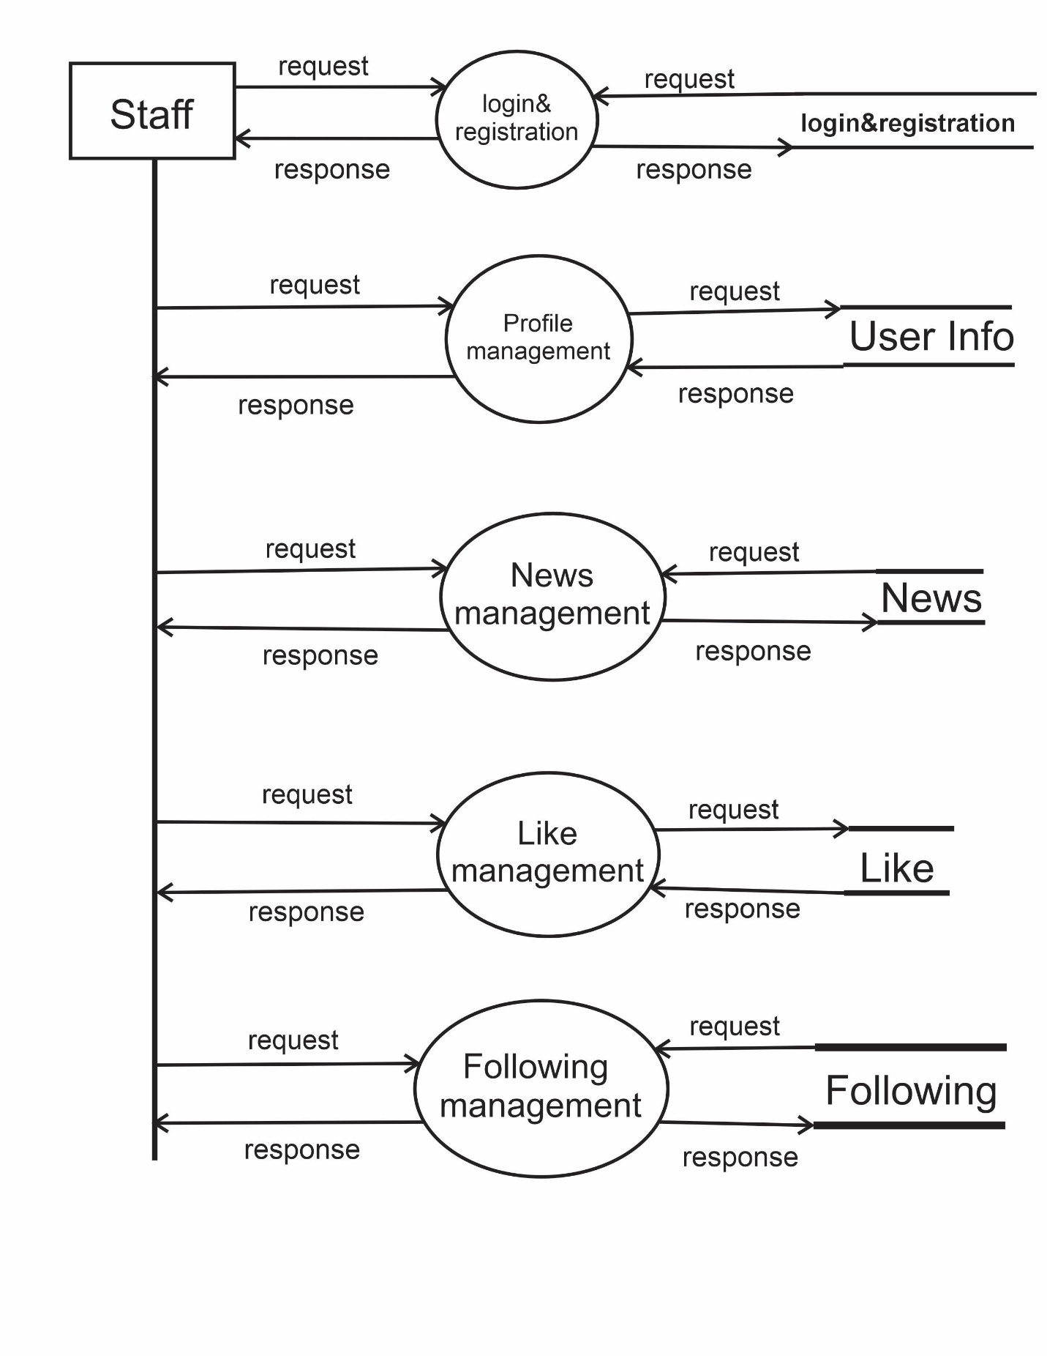DFD LEVEL 1
User

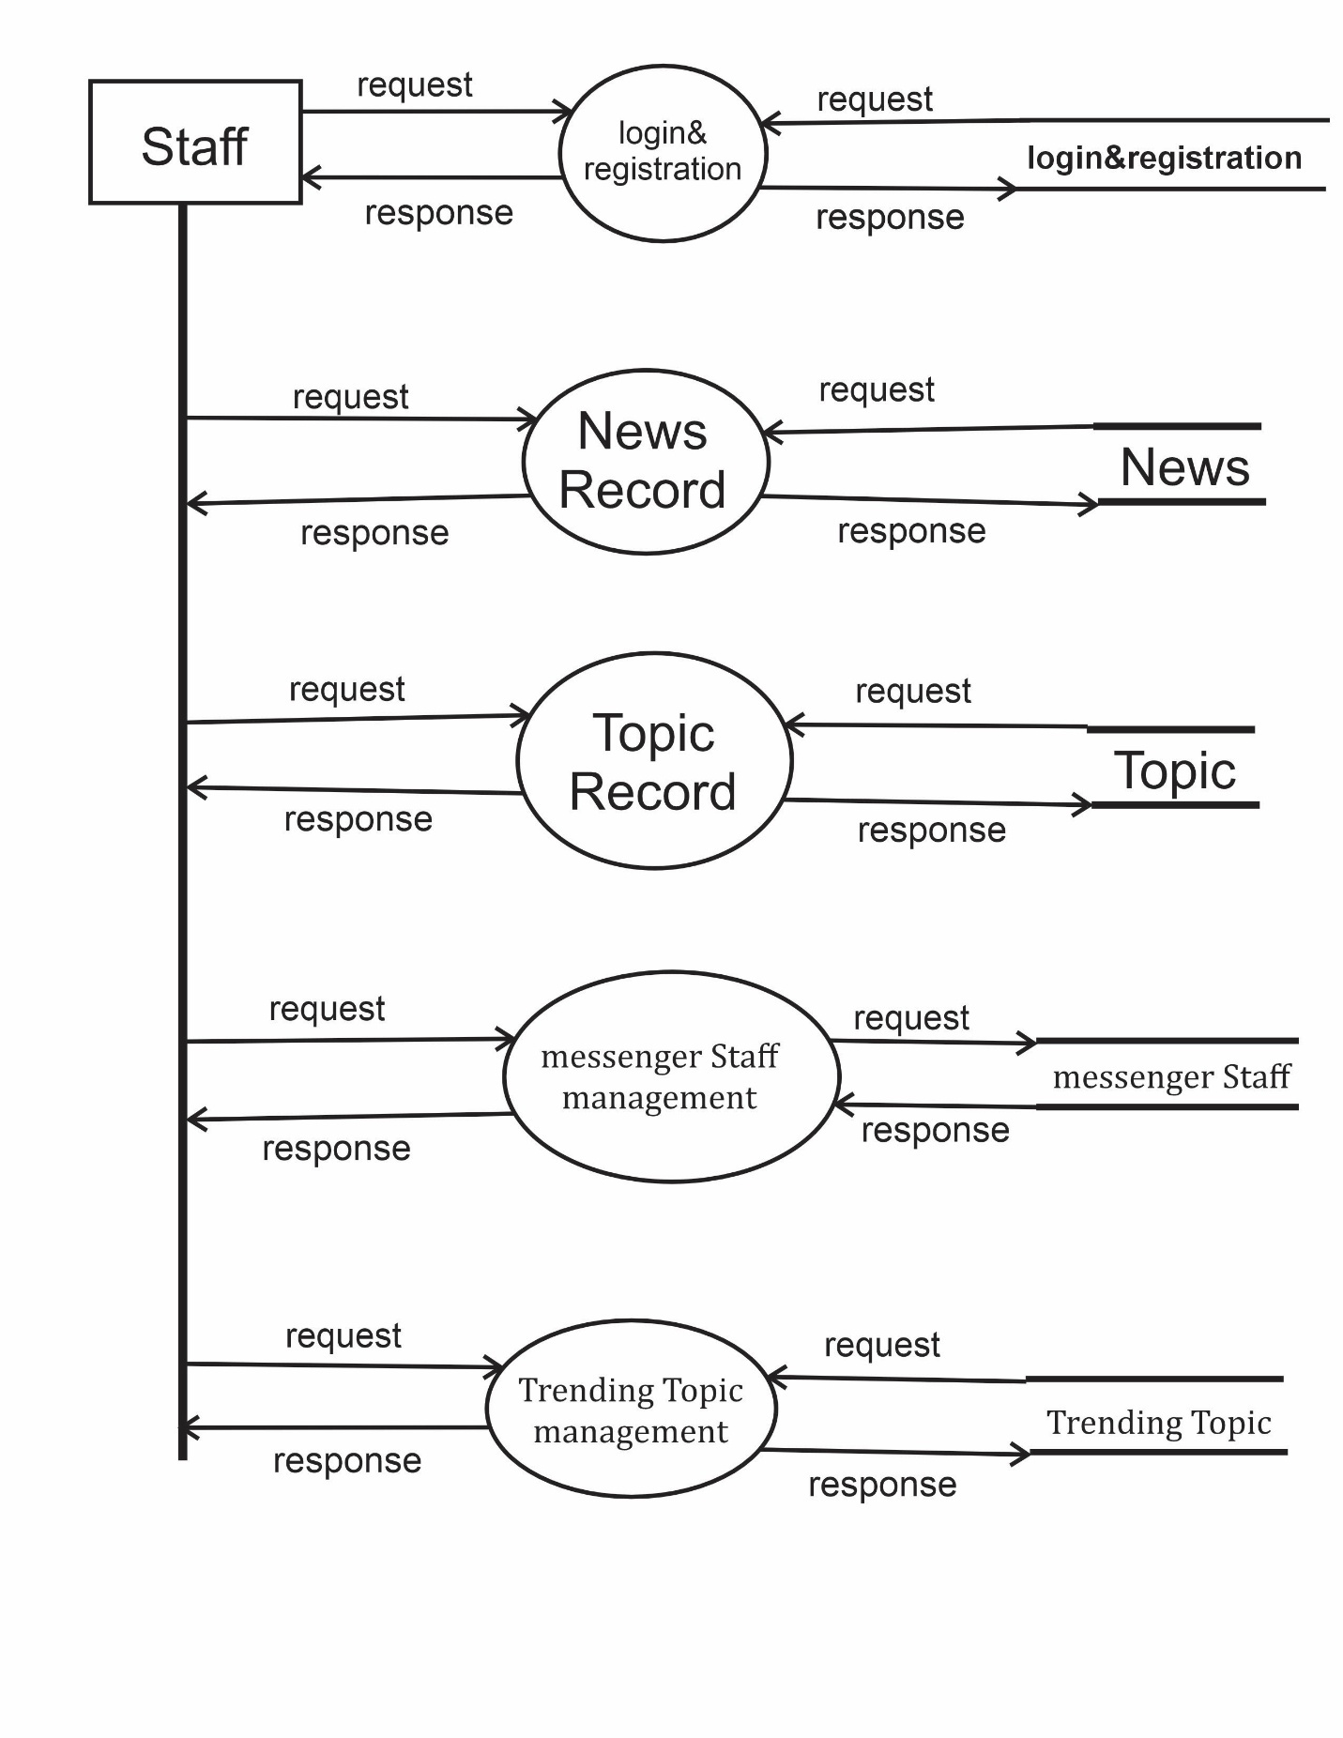

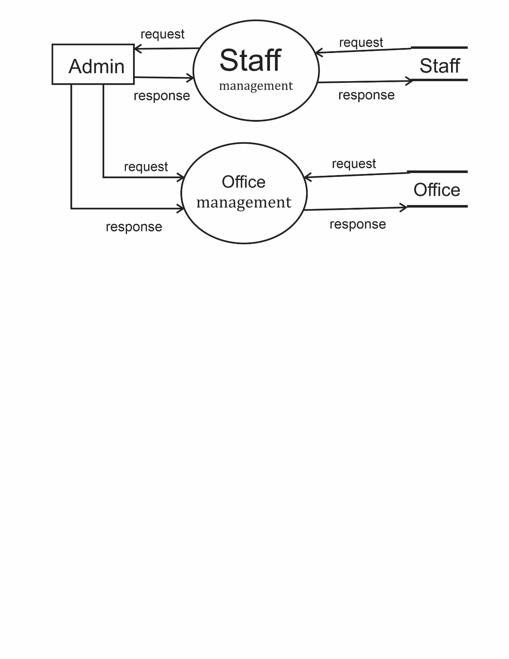

DFD LEVEL 2

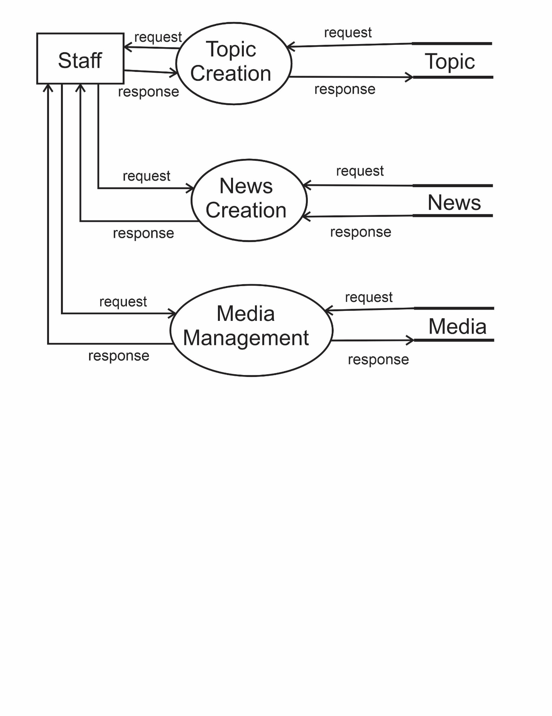

Data Dictionary

(1) Table: UserOTP
Column Name | Data Type | Constraints | Description
id | INT | PRIMARY KEY, AUTO_INCREMENT | Unique identifier for OTP record
email | VARCHAR(254) | UNIQUE, NOT NULL | User's email address
is_email_verified | BOOLEAN | DEFAULT FALSE | Whether email has been verified
email_otp | VARCHAR(6) | NULL | 6-digit OTP code for verification

(2) Table: UserInfo

Column Name | Data Type | Constraints | Description
id | INT | PRIMARY KEY, AUTO_INCREMENT | Unique identifier for user info
UserName_id | INT | UNIQUE, NOT NULL, FOREIGN KEY (auth_user.id) | Reference to main user account
Ganders | VARCHAR(15) | CHECK (Male, Other, Female) | User's gender (note: typo in column name)
address | VARCHAR(150) | NULL | User's physical address
picture | VARCHAR(100) | NULL | Profile picture file path
language | VARCHAR(100) | DEFAULT 'English', CHECK (English, Hindi, Gujarati) | User's preferred language

(3) Table: Contactus

Column Name | Data Type | Constraints | Description
id | INT | PRIMARY KEY, AUTO_INCREMENT | Unique contact record identifier
UserChoice | VARCHAR(25) | NOT NULL | Reason for contact/category
UserEmail | VARCHAR(254) | NOT NULL | Contact email address
UserFullName | VARCHAR(200) | NOT NULL | Contact person's full name
UserPhone | VARCHAR(30) | NOT NULL | Contact phone number
UserMessenger | TEXT | NOT NULL | Message content
Date | DATETIME | DEFAULT CURRENT_TIMESTAMP | Submission timestamp

(4) Table: Office

Column Name | Data Type | Constraints | Description
id | INT | PRIMARY KEY, AUTO_INCREMENT | Unique office identifier
address | VARCHAR(200) | UNIQUE, NOT NULL | Office physical address
manger | VARCHAR(100) | NOT NULL | Office manager name (note: typo)

(5) Table: StaffMember

Column Name | Data Type | Constraints | Description
id | INT | PRIMARY KEY, AUTO_INCREMENT | Unique staff identifier
user_id | INT | UNIQUE, NOT NULL, FOREIGN KEY (auth_user.id) | Associated user account
staff_name | VARCHAR(200) | NOT NULL | Staff member's full name
Office_id | INT | NOT NULL, FOREIGN KEY (Office.id) | Associated office
position | VARCHAR(100) | CHECK (none, Admin, CEO, Manager, ...) | Staff position/role
DateOfBirth | DATE | NOT NULL | Staff birth date
PhoneNumber | VARCHAR(100) | NOT NULL | Contact phone number
ZipCode | VARCHAR(15) | NOT NULL | Postal zip code
OneAddress | TEXT | NOT NULL | Primary address
TwoAddress | TEXT | NULL | Secondary address
picture | VARCHAR(100) | NOT NULL | Staff profile picture
JoinDate | DATE | NOT NULL | Employment start date
LeaveDate | DATE | NULL | Employment end date (if applicable)
aboutme | TEXT | NULL | Staff biography/description

(6) Table: Topic

Column Name | Data Type | Constraints | Description
id | INT | PRIMARY KEY, AUTO_INCREMENT | Unique topic identifier
Topic | VARCHAR(20) | UNIQUE, NOT NULL | Topic name
Date | DATE | DEFAULT CURRENT_DATE | Topic creation date
CreatedBy_id | INT | NOT NULL, FOREIGN KEY (StaffMember.id) | Staff who created the topic

(7) Table: News

Column Name | Data Type | Constraints | Description
id | INT | PRIMARY KEY, AUTO_INCREMENT | Unique news identifier
Topic_id | INT | NULL, FOREIGN KEY (Topic.id) | News topic/category
Journalists_id | INT | NULL, FOREIGN KEY (StaffMember.id) | Journalist staff member
Writers_id | INT | NULL, FOREIGN KEY (StaffMember.id) | Writer staff member
Editors_id | INT | NULL, FOREIGN KEY (StaffMember.id) | Editor staff member
NewsTitle | VARCHAR(250) | NULL | News article title
Txt | LONGTEXT | NULL | News article content
Image | VARCHAR(100) | NULL | Primary image file path
Video | VARCHAR(100) | NULL | Video file path
CreatDate | DATE | DEFAULT CURRENT_DATE | Creation date
onlyvideo | BOOLEAN | DEFAULT FALSE | Whether content is video-only
JournalistsPermission | BOOLEAN | NULL | Journalist approval status
WritersPermission | BOOLEAN | NULL | Writer approval status
EditorsPermission | BOOLEAN | NULL | Editor approval status
ManagersPermission | BOOLEAN | NULL | Manager approval status
slug | VARCHAR(255) | NULL | URL-friendly identifier

(8) Table: Report

Column Name | Data Type | Constraints | Description
id | INT | PRIMARY KEY, AUTO_INCREMENT | Unique report identifier
News_id | INT | NOT NULL, FOREIGN KEY (News.id) | Reported news article
user_id | INT | UNIQUE, NOT NULL, FOREIGN KEY (auth_user.id) | User who submitted report
Title | VARCHAR(75) | NOT NULL | Report title
Txt | TEXT | NOT NULL | Report details
slug | VARCHAR(255) | NULL | URL-friendly identifier

(9) Table: newsLike

Column Name | Data Type | Constraints | Description
id | INT | PRIMARY KEY, AUTO_INCREMENT | Unique like identifier
News_id | INT | UNIQUE, NOT NULL, FOREIGN KEY (News.id) | Liked news article

(10) Table: newsLike_User

Column Name | Data Type | Constraints | Description
id | INT | PRIMARY KEY, AUTO_INCREMENT | Unique relationship identifier
newslike_id | INT | NOT NULL, FOREIGN KEY (newsLike.id) | Reference to like record
user_id | INT | NOT NULL, FOREIGN KEY (auth_user.id) | User who liked the news

(11) Table: FollowingNewsTopic_User

Column Name | Data Type | Constraints | Description
id | INT | PRIMARY KEY, AUTO_INCREMENT | Unique relationship identifier
followingnewstopic_id | INT | NOT NULL, FOREIGN KEY (FollowingNewsTopic.id) | Reference to follow record
user_id | INT | NOT NULL, FOREIGN KEY (auth_user.id) | User following the topic

(12) Table: Comments

Column Name | Data Type | Constraints | Description
id | INT | PRIMARY KEY, AUTO_INCREMENT | Unique comment identifier
UserName_id | INT | NOT NULL, FOREIGN KEY (auth_user.id) | User who commented
news_id | INT | NOT NULL, FOREIGN KEY (News.id) | News article being commented on
text | TEXT | NOT NULL | Comment content
date | DATE | DEFAULT CURRENT_DATE | Comment date
slug | VARCHAR(255) | NULL | URL-friendly identifier

(13) Table: multipleNewsImageAndVideo

Column Name | Data Type | Constraints | Description
id | INT | PRIMARY KEY, AUTO_INCREMENT | Unique media identifier
news_id | INT | NOT NULL, FOREIGN KEY (News.id) | Associated news article
image | VARCHAR(100) | NULL | Additional image file path
video | VARCHAR(100) | NULL | Additional video file path

(14) Table: TrendingTopic

Column Name | Data Type | Constraints | Description
id | INT | PRIMARY KEY, AUTO_INCREMENT | Unique trending record identifier
NewsTopic_id | INT | UNIQUE, NOT NULL, FOREIGN KEY (Topic.id) | Trending topic
Date | DATETIME | DEFAULT CURRENT_TIMESTAMP | When trend was recorded

(15) Table: bookmarks

Column Name | Data Type | Constraints | Description
id | INT | PRIMARY KEY, AUTO_INCREMENT | Unique bookmark identifier
News_id | INT | UNIQUE, NOT NULL, FOREIGN KEY (News.id) | Bookmarked news article

(16) Table: bookmarks_User

Column Name | Data Type | Constraints | Description
id | INT | PRIMARY KEY, AUTO_INCREMENT | Unique relationship identifier
bookmarks_id | INT | NOT NULL, FOREIGN KEY (bookmarks.id) | Reference to bookmark record
user_id | INT | NOT NULL, FOREIGN KEY (auth_user.id) | User who bookmarked the news

(17) Table: followingStaff_User

Column Name | Data Type | Constraints | Description
id | INT | PRIMARY KEY, AUTO_INCREMENT | Unique relationship identifier
followingstaff_id | INT | NOT NULL, FOREIGN KEY (followingStaff.id) | Reference to follow record
user_id | INT | NOT NULL, FOREIGN KEY (auth_user.id) | User following the staff

(18) Table: messengStaff

Column Name | Data Type | Constraints | Description
id | INT | PRIMARY KEY, AUTO_INCREMENT | Unique message identifier
user_id | INT | NOT NULL, FOREIGN KEY (StaffMember.id) | Sending staff member
OthrtUserName_id | INT | NOT NULL, FOREIGN KEY (StaffMember.id) | Receiving staff member
Txt | TEXT | NOT NULL | Message content
date | DATETIME | DEFAULT CURRENT_TIMESTAMP | Message timestamp

(19) Table: NewsGujarati

Column Name | Data Type | Constraints | Description
id | INT | PRIMARY KEY, AUTO_INCREMENT | Unique translation identifier
News_id | INT | UNIQUE, NOT NULL, FOREIGN KEY (News.id) | Original news article
Topic_id | INT | NOT NULL, FOREIGN KEY (TopicGujarati.id) | Gujarati topic reference
title | VARCHAR(200) | NOT NULL | Gujarati news title
text | TEXT | NULL | Gujarati news content
Date | DATE | DEFAULT CURRENT_DATE | Translation date

(20) Table: NewsHindi

Column Name | Data Type | Constraints | Description
id | INT | PRIMARY KEY, AUTO_INCREMENT | Unique translation identifier
News_id | INT | UNIQUE, NOT NULL, FOREIGN KEY (News.id) | Original news article
Topic_id | INT | NOT NULL, FOREIGN KEY (TopicHindi.id) | Hindi topic reference
title | VARCHAR(200) | NOT NULL | Hindi news title
text | TEXT | NULL | Hindi news content
Date | DATE | DEFAULT CURRENT_DATE | Translation date

Interface Design

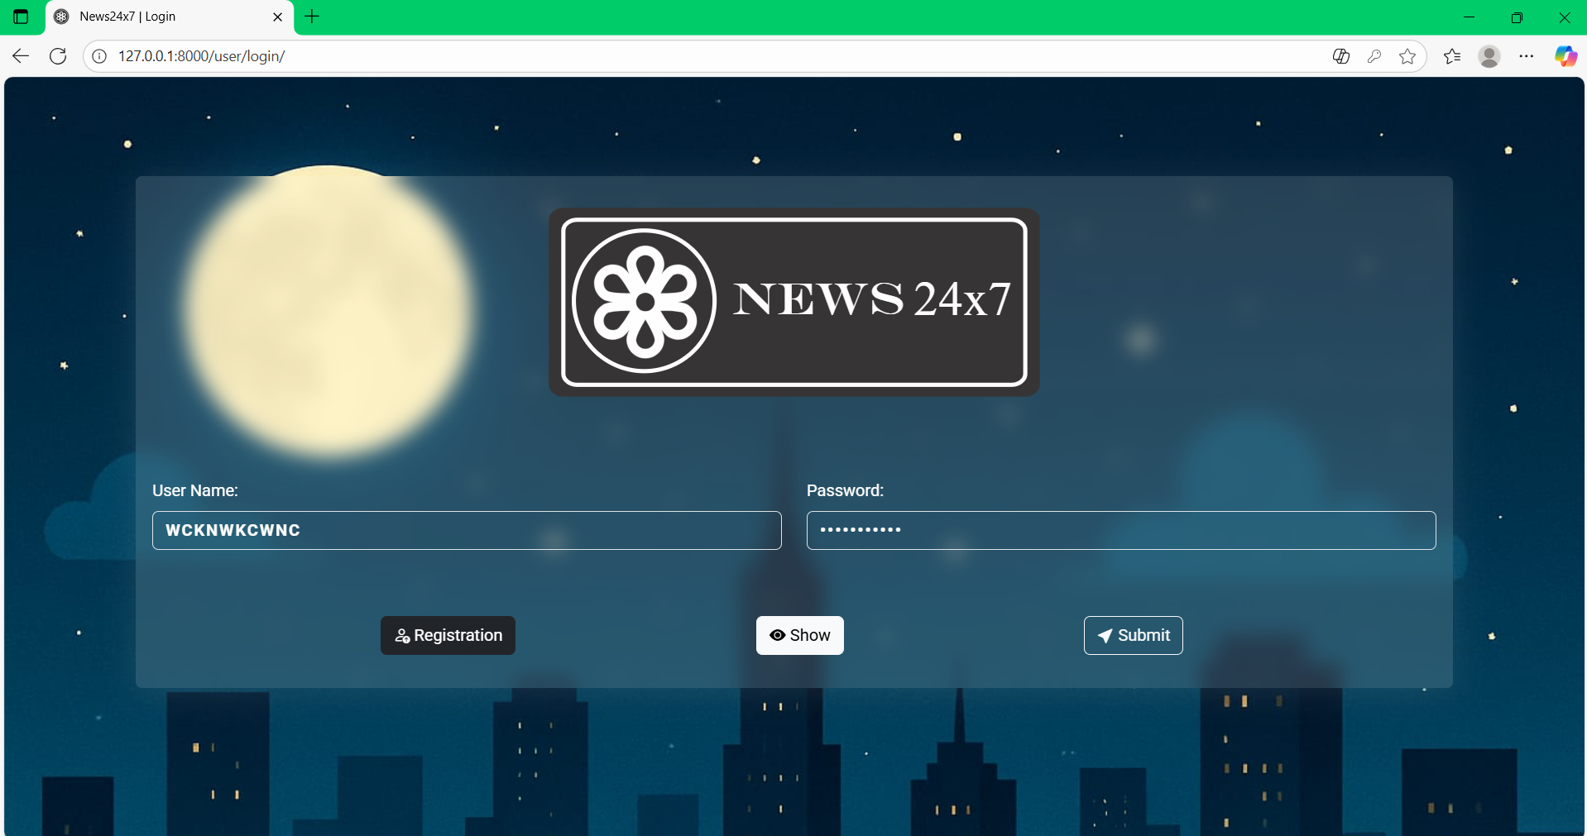

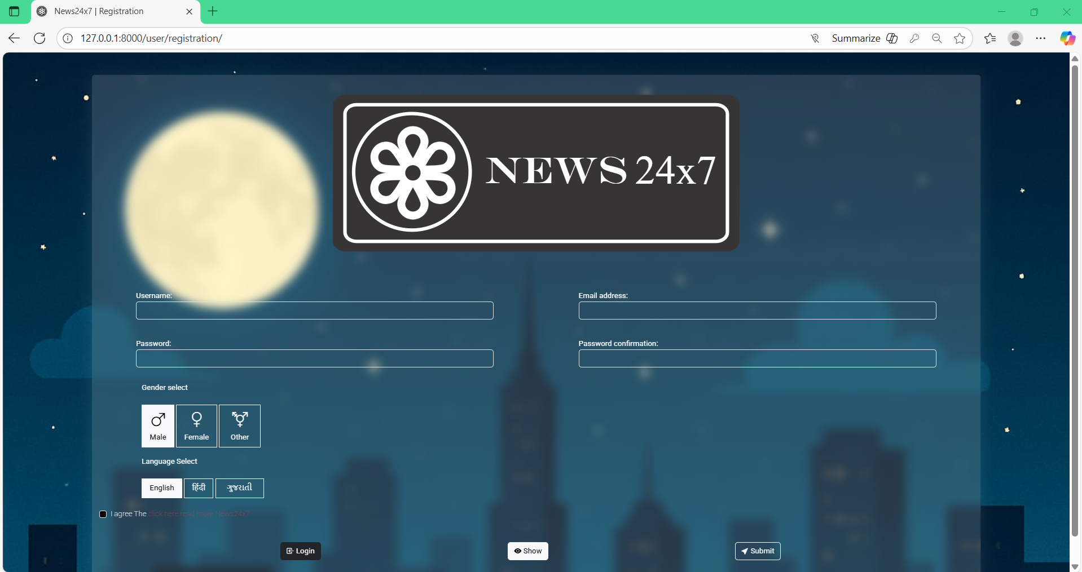

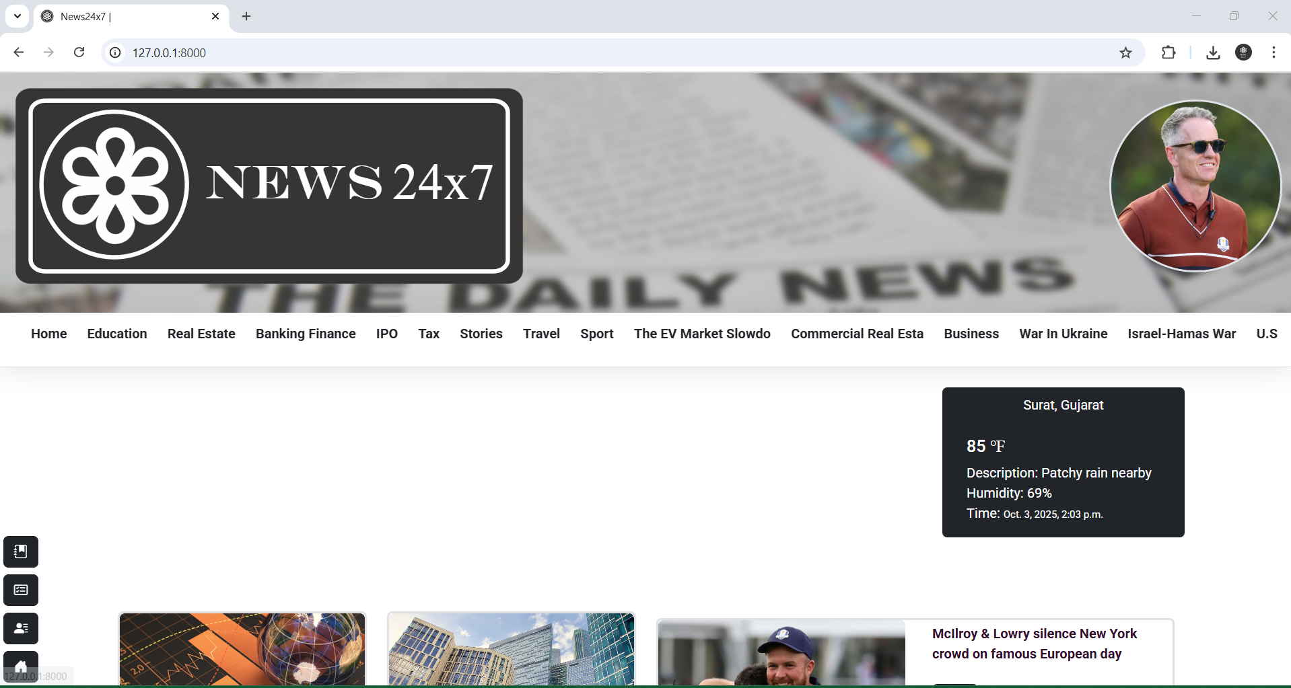

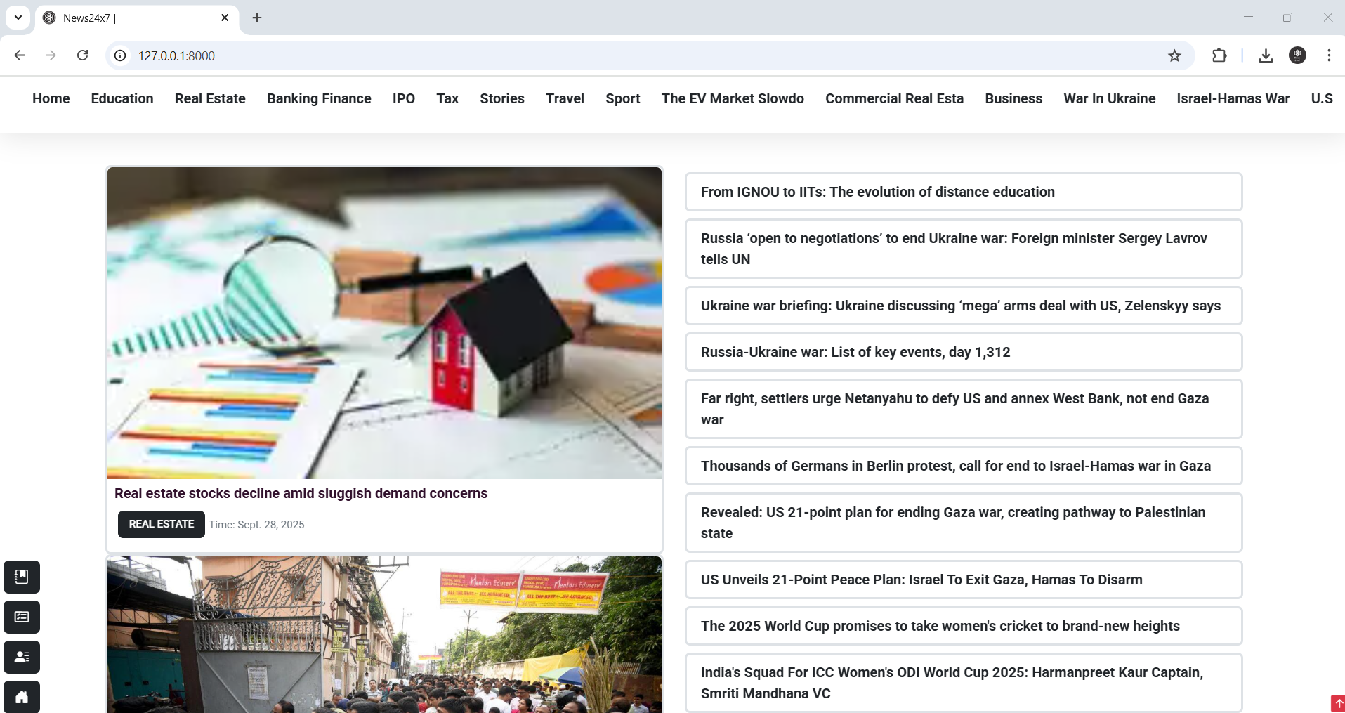

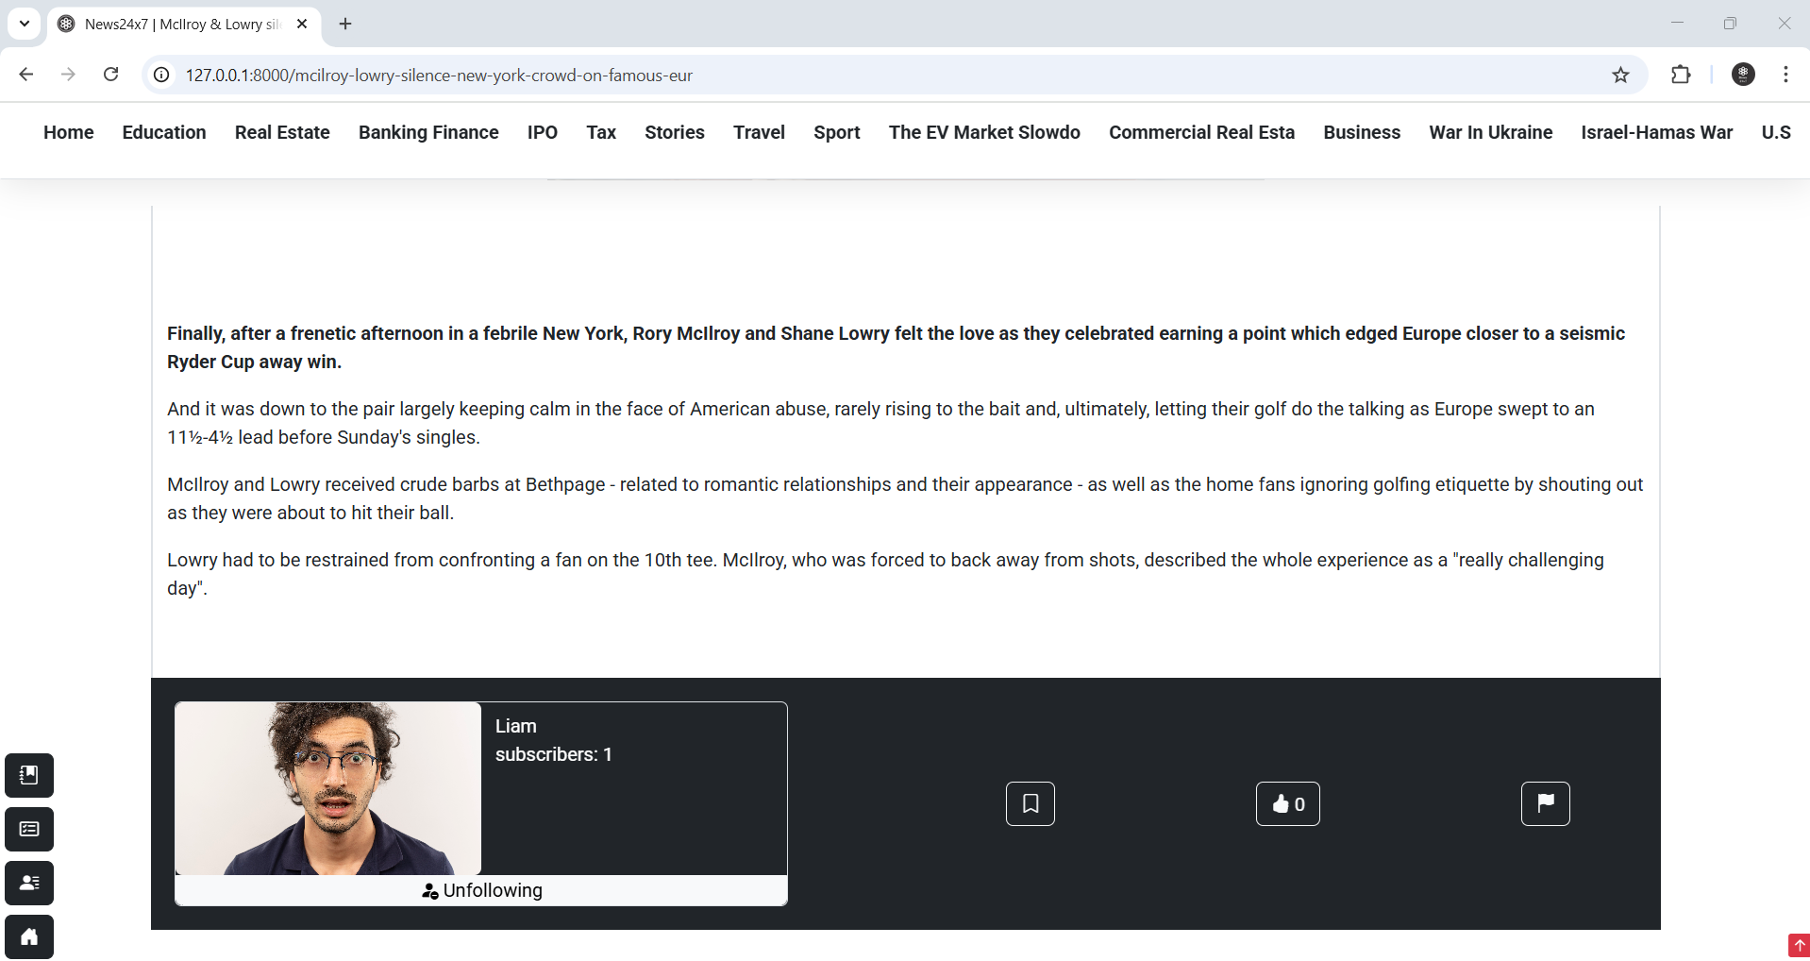

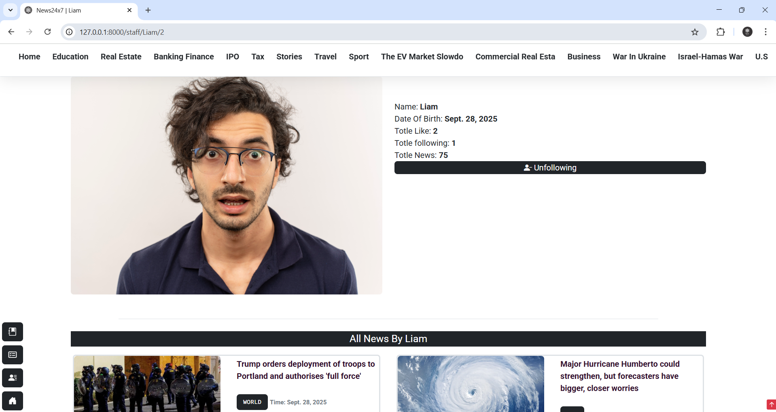

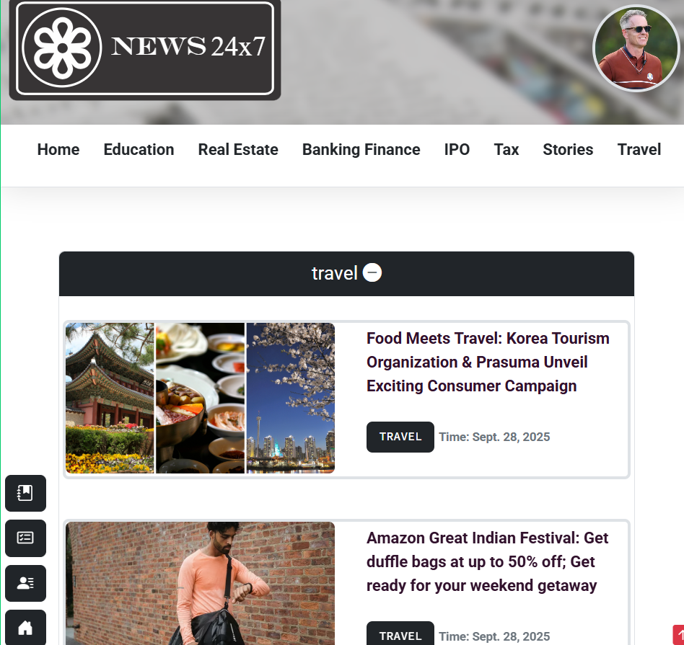

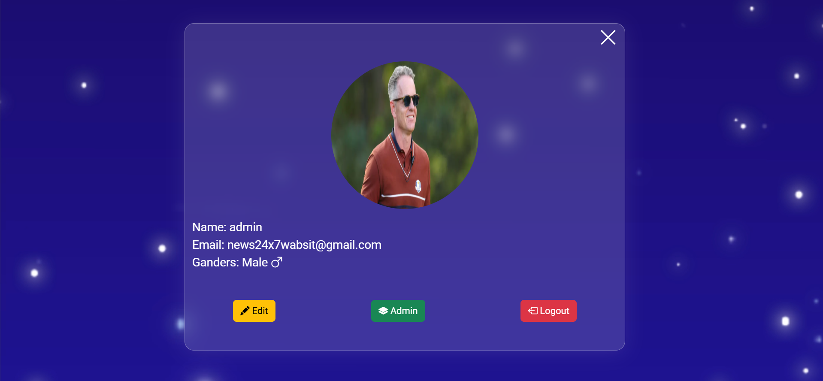

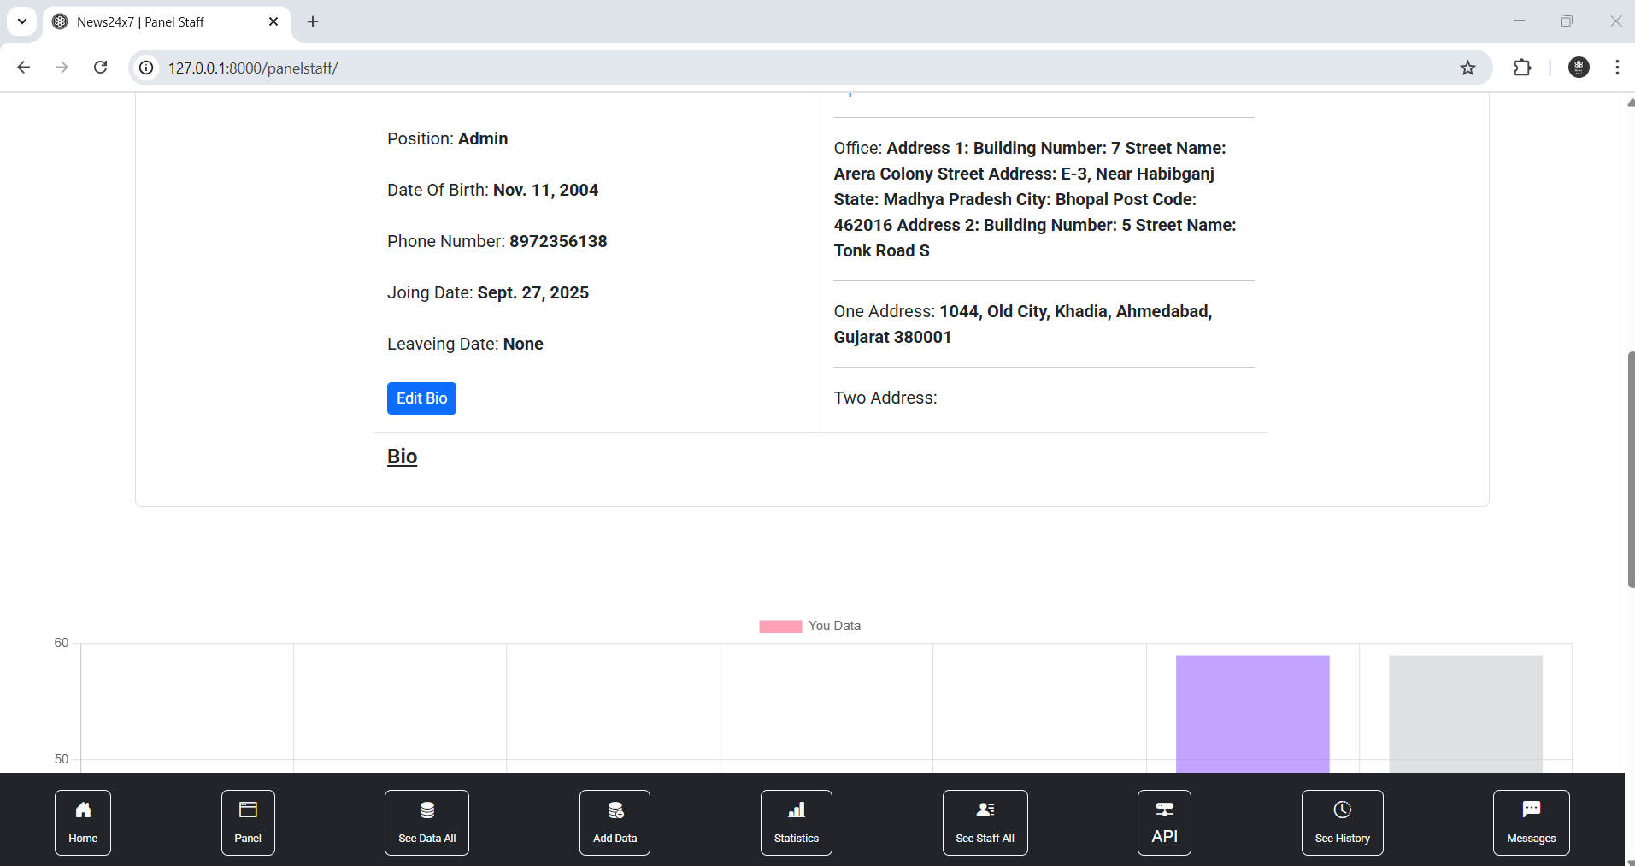

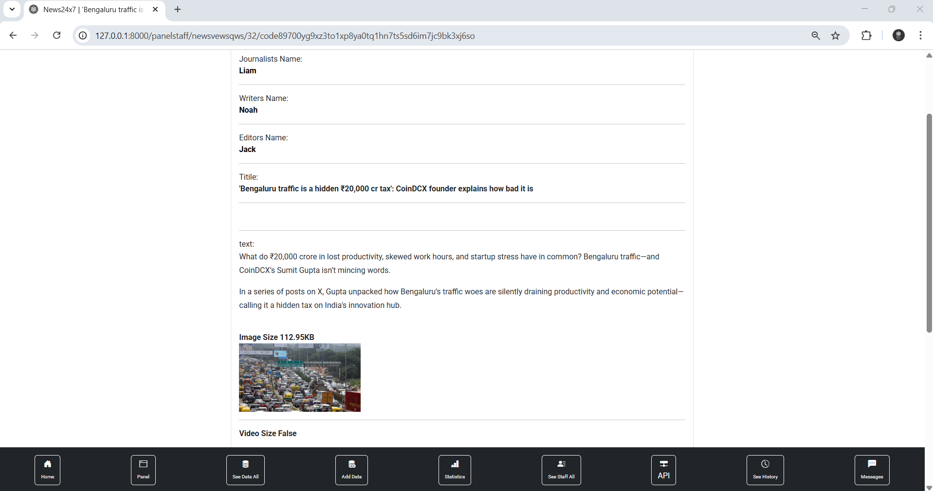

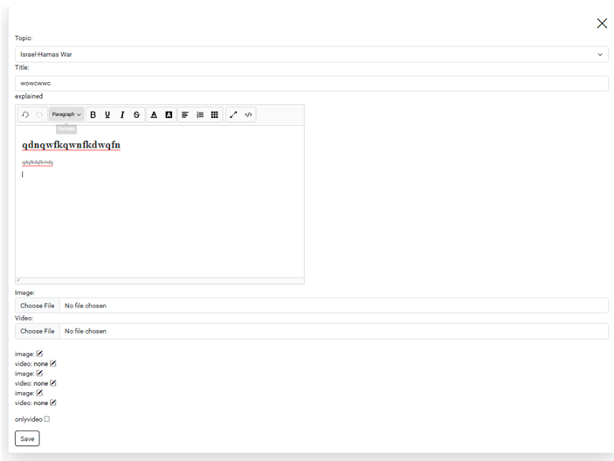

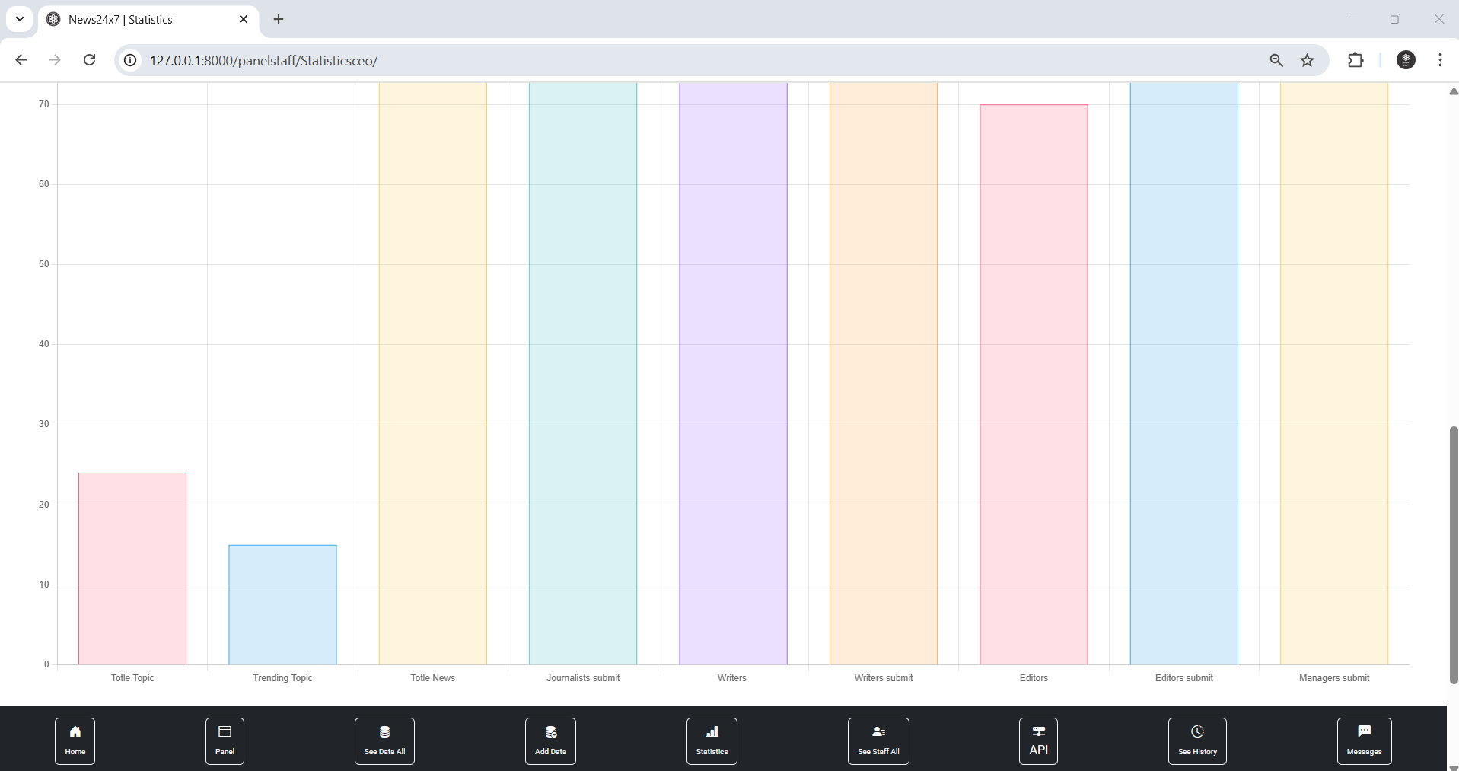

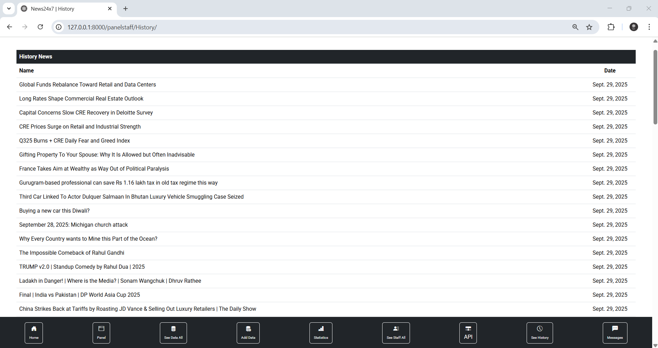

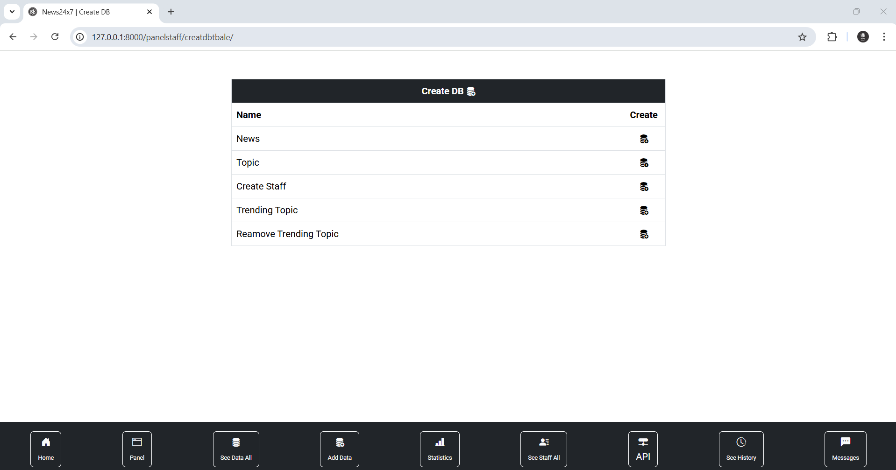

Future Enhancement

- Bookmark News – Users can save news articles for future reading by bookmarking them.

- Follow & Like – Readers can follow their favorite topics or staff members and like news content to show engagement.

- Topics Following – Users can subscribe to specific categories/topics and receive updates accordingly.

- Language Options – News content is available in multiple languages (English, Hindi, Gujarati), ensuring accessibility to a wider audience.

- Login & Registration – Secure user authentication system for registered users with profile management.

- Comments on News – Readers can express their views and interact by posting comments on articles.

- Report News – Users can report inappropriate or false news to maintain the authenticity of the platform.

- WYSIWYG Editor (What You See Is What You Get) – Admins and staff can add or edit news content using a rich text editor with formatting options.

- Statistics – The system provides insights and analytics such as the most viewed, most liked, and trending topics.

- Messenger for Staff Members – An internal messaging system is available exclusively for staff members to communicate and collaborate.

Bibliography

- GeeksforGeeks, "Page Title," GeeksforGeeks. [Online]. Available: https://www.geeksforgeeks.org/.

- W3Schools, "Page Title," W3Schools. [Online]. Available: https://www.w3schools.com/.

- JavaTpoint, "Page Title," JavaTpoint. [Online]. Available: https://www.javatpoint.com/

- CodeWithHarry, "Video Title," YouTube. [Online]. Available: https://www.youtube.com/@CodeWithHarry.

