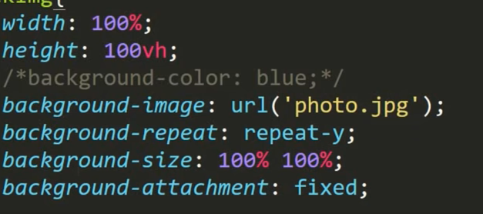

Background-size is used to put image in center.

Background- attachment: fixed makes background image fixed while scrolling. Paralax website

Text

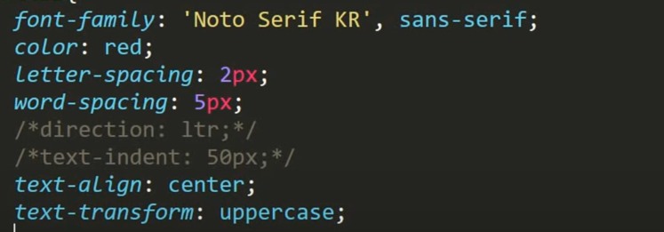

Link

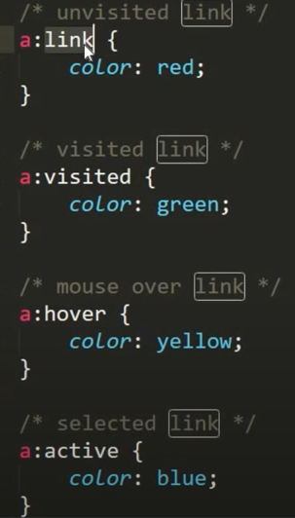

for responsive image

object-fit: cover;

Border

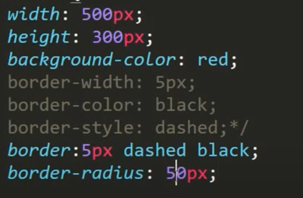

Overflow: visible, hidden, scroll, auto

Overflow-x overflow-y

Position: relative absolute fixed sticky

z-index: max value shows on top

float: left right

line-height

display: inline, block, inline-block, none

cursor

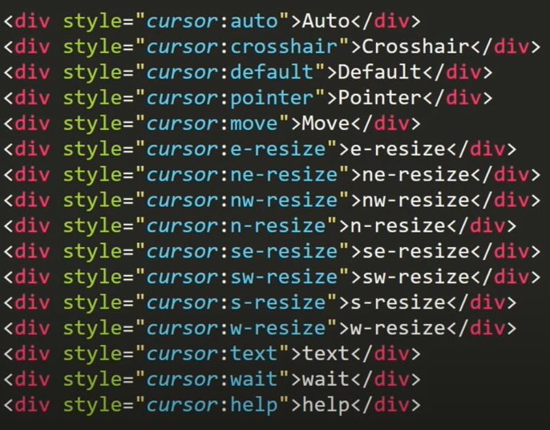

Grid

Display: grid

Fr= fractional unit. 1fr takes all remaining space

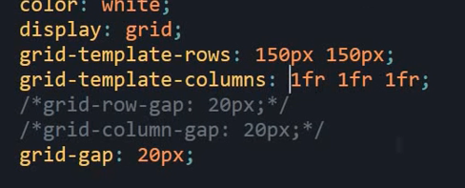



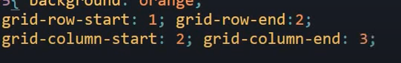



For row to be from first to last then,

Grid-row: 1/-1;

Defined grid is explicit grid and undefined grid is implicit grid.

For implicit grid:



Span

Grid-column: 1/ span3

For fixed width:

Min-content max-content

Minmax()

For responsive grid:



Fit is better than fill

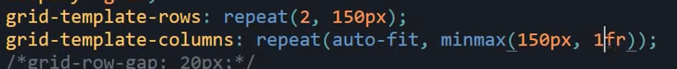

Use 1fr

For sidebar:





Horizontal offset, vertical offset, blur, spread, color

For transparent text:

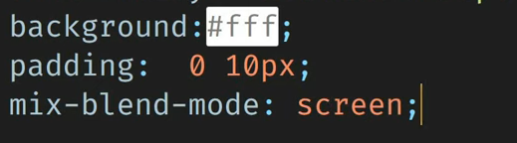

Flex:

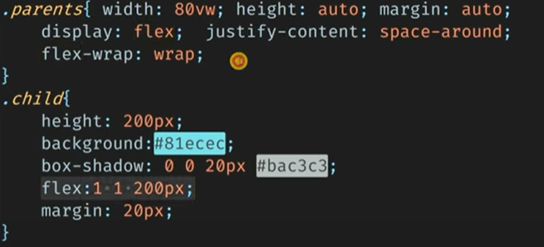

Text with background image: 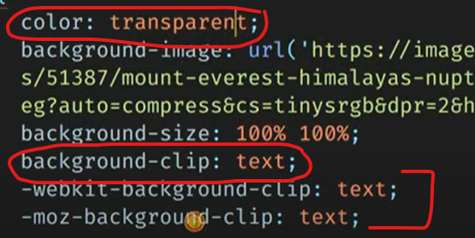

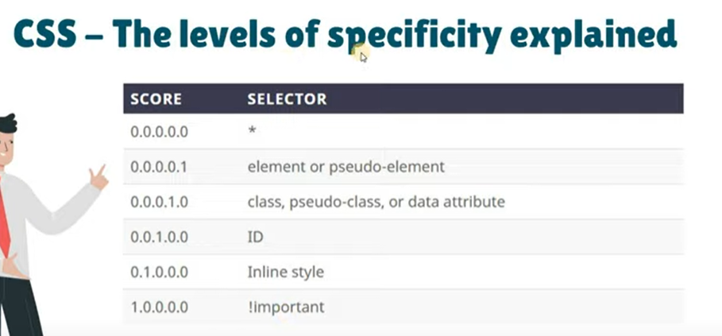

rem

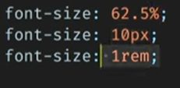

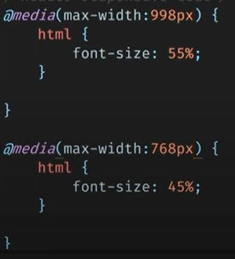

npm init

npm install node-sass --save-dev

"scripts": {

    "compile:sass" : "node-sass sass/contact.scss css/contact.css"

  },

For auto compile

"scripts": {

    "compile:sass" : "node-sass sass/contact.scss css/contact.css -w"

  },

npm run compile:sass

for common code: mixin and include

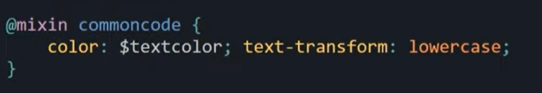



Value pass:

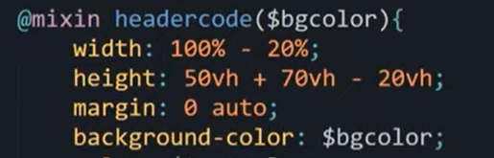



To import partial file:

