Action:
What to do
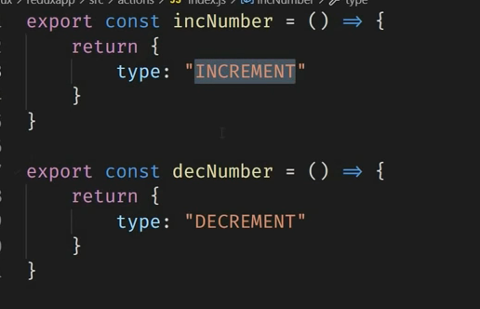
Payload ni herna parcha
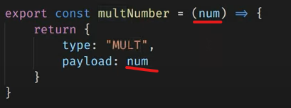

Reducer:
How to do
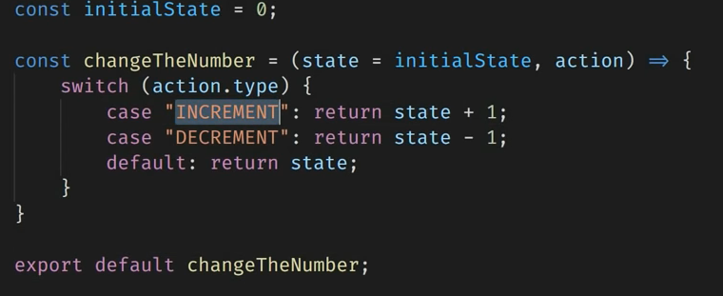
Root reducer:
multiple reducers kept in single reducer.
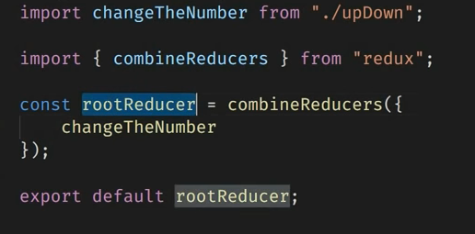

Store:
root reducer is stored in store
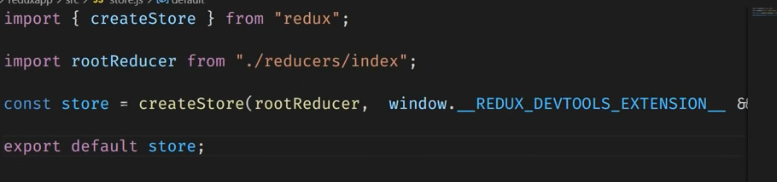
Add this on store:
window.__REDUX_DEVTOOLS_EXTENSION__ && window.__REDUX_DEVTOOLS_EXTENSION__()

Provider:
provider is used to pass state from store
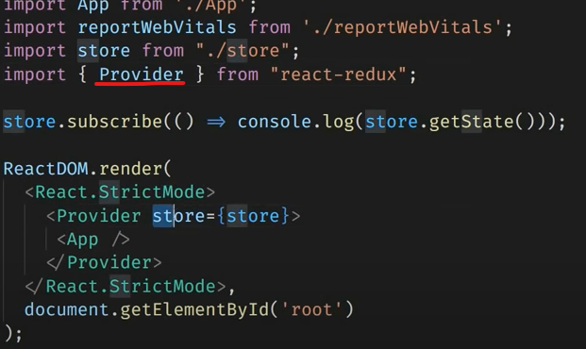

useSelector and useDispatch:
useSelector: to get data from store.
useDispatch: to call/trigger function
