System Manual

1. Architecture Overview

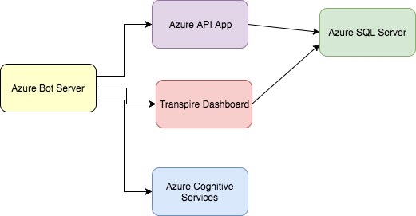

1. Configuration and Const Analysis

All services are hosted on Microsoft Azure Cloud. Their configurations and cost analysis is outlined in this section. The cost is predicted for the current PoC/Prototype configuration and would increase if the services were scaled up.

* Azure Cognitive Services which is used to get a subscription key for LUIS

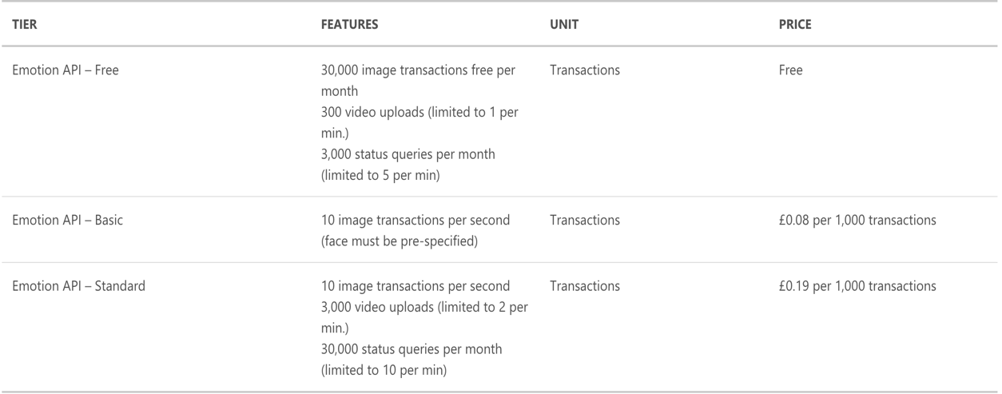

* Azure bot services which is used to host the bot on one of the Microsoft bot servers which is free to use and you only pay for the resources you consume.
* Azure API app which is used to host Nuffield custom API

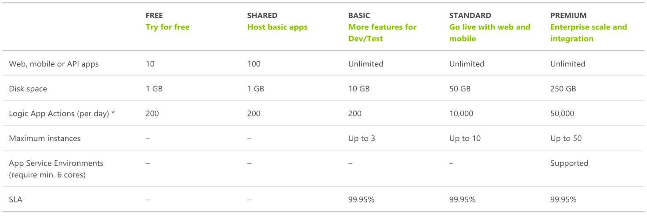

* Azure SQL server which is used for Azure SQL Database for Nuffield Custom Database

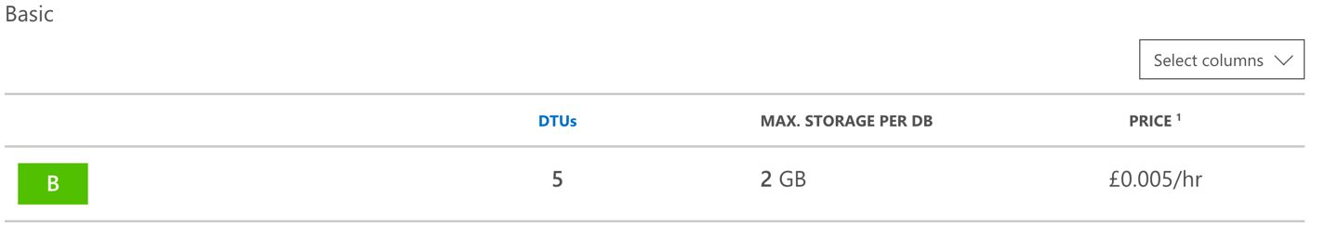

1. After the deployment of the bot on azure, you can click on the channels tab to publish the bot to any platform that you want.

