User Manual for Nuffield Bot

1. Search for NuffieldHealthBot in skype or facebook messenger.
2. Add the bot to your contacts.
3. To start the conversation, you can say hi, hello, hey, etc and it would come up with the introduction message.

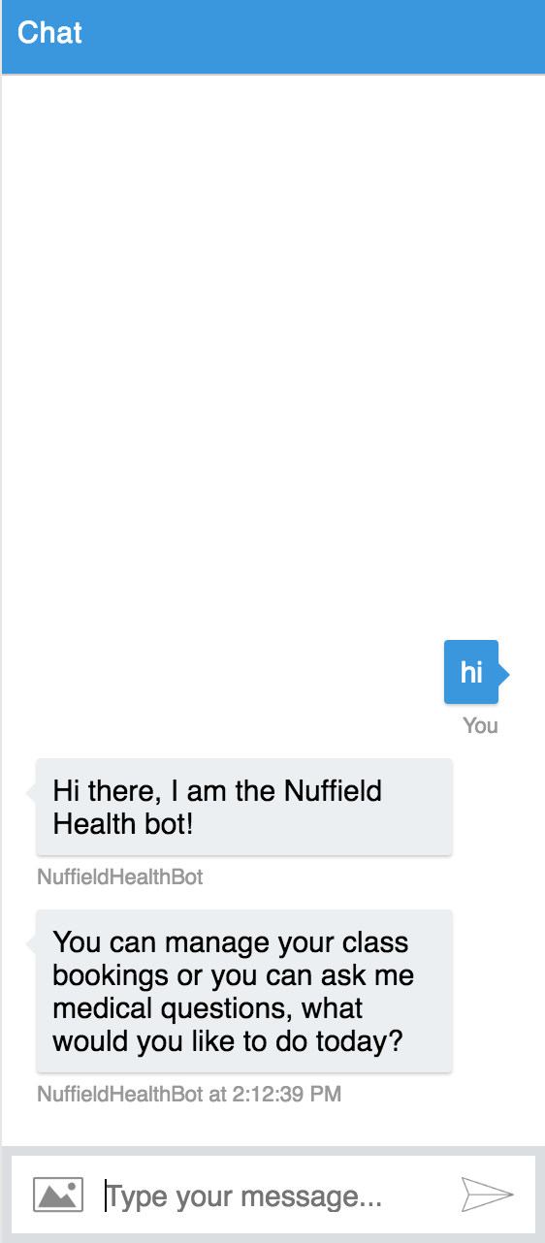

1. You can book classes by saying “I want to book a class”, the bot will then ask for the name of the class and the date of the class you want to book. Alternatively, you can provide all the info on the go, for example: “I want to book a Yoga class for next Monday”.

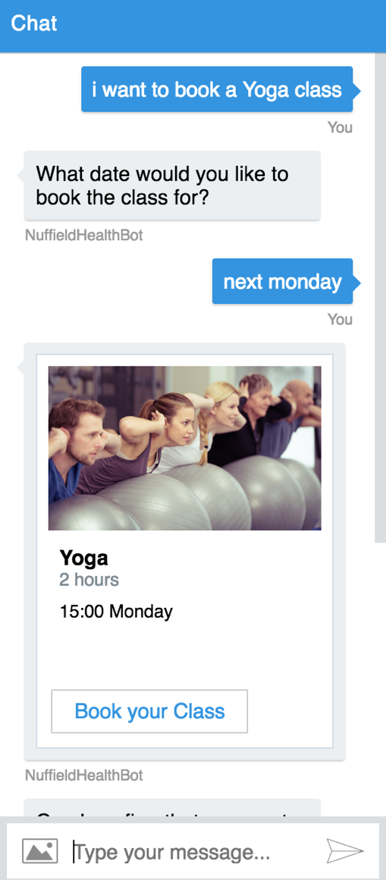

1. You can also view available classes by specifying the date you want to view classes for. For example, you can say: “I want to view available classes for tomorrow”

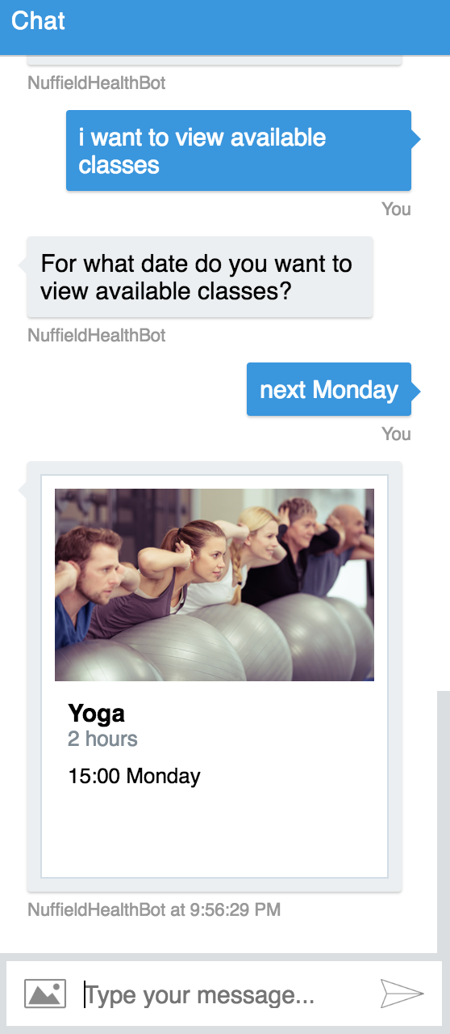

1. You can view your active bookings, by saying for example “I want to view my active bookings” or any similar sentence.

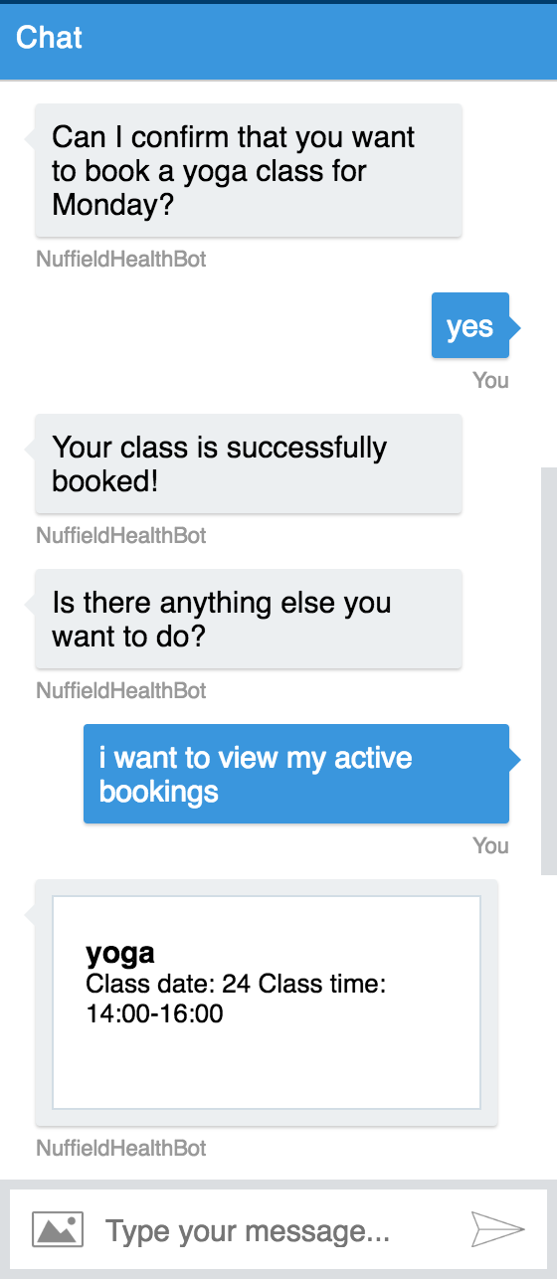

1. You can cancel your classes by specifying the name and the date of the class you want to cancel. For example, “I want to cancel my yoga class for next Monday”.
2. 