**Magento 2 Biddyut Shipping Module Document**

## New Module Install

#php bin/magento setup:upgrade --keep-generated or

#php bin/magento setup:upgrade

#php bin/magento indexer:reindex

#php bin/magento cache:flush

#php bin/magento cache:clean

#sudo chmod 777 -R generated/* var/* pub/*

#rm var/cache/* generated/code/* var/view_preprocessed/* var/page_cache/* pub/static/frontend/* pub/static/adminhtml/* -R

*** Magento 2.2.3 Need to Update temando vendor module , plz check

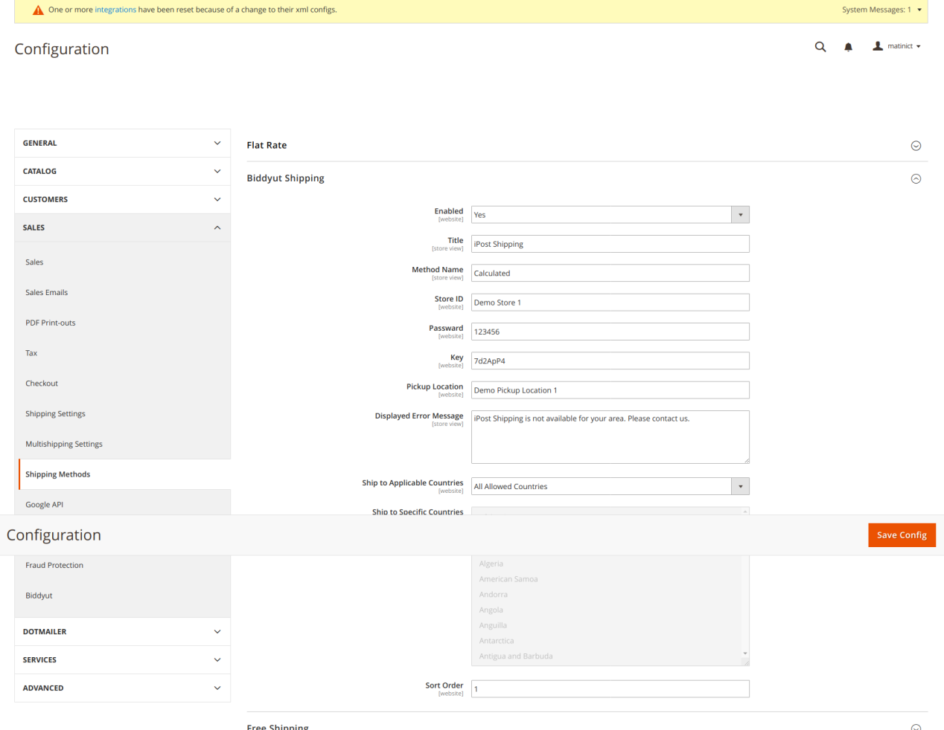

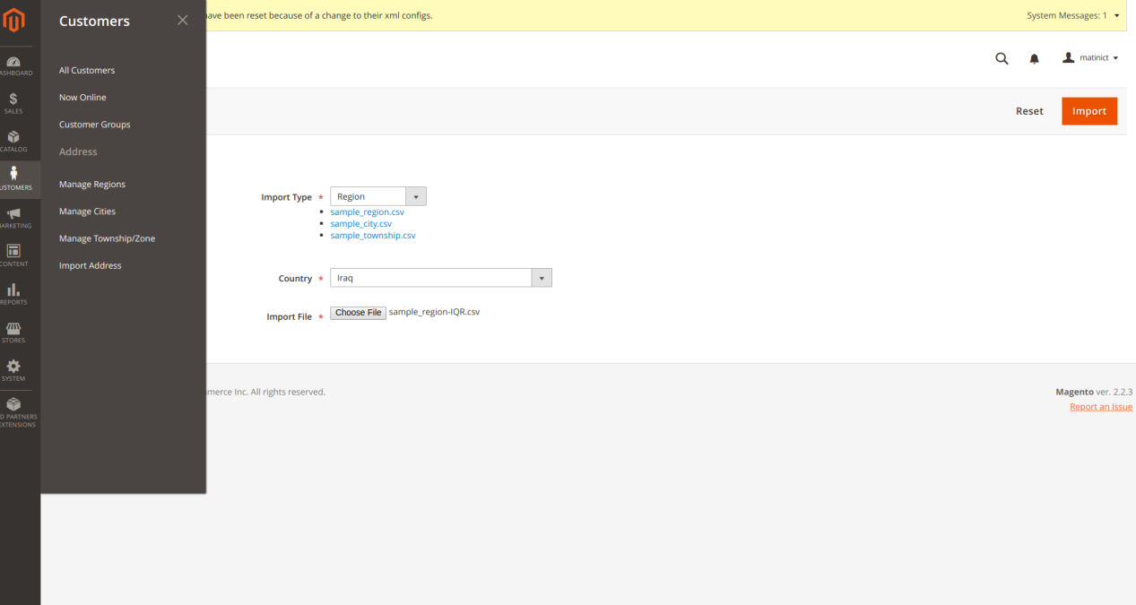

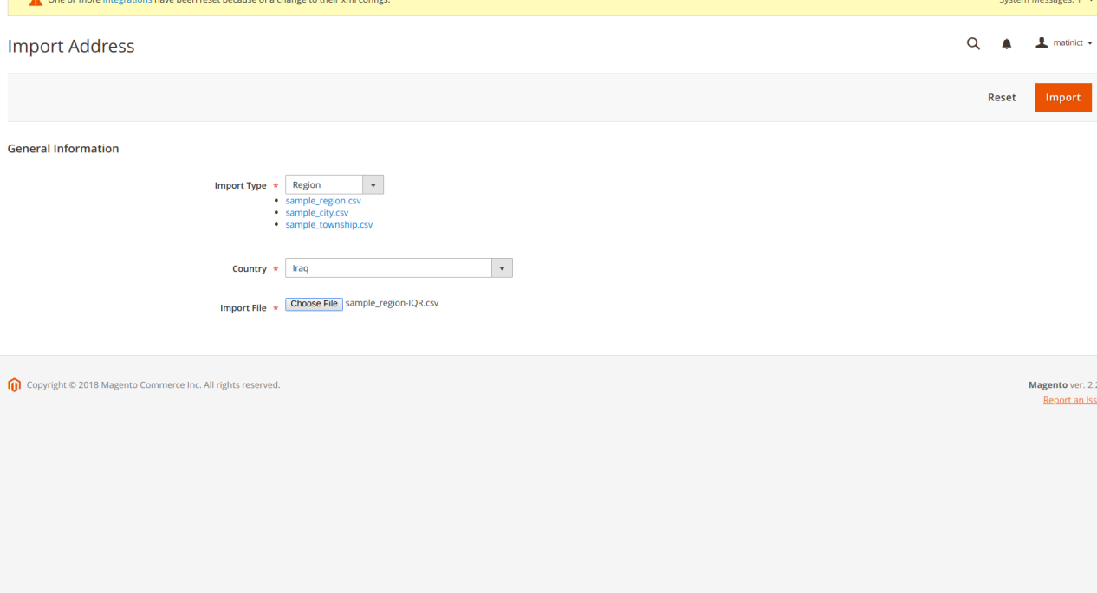

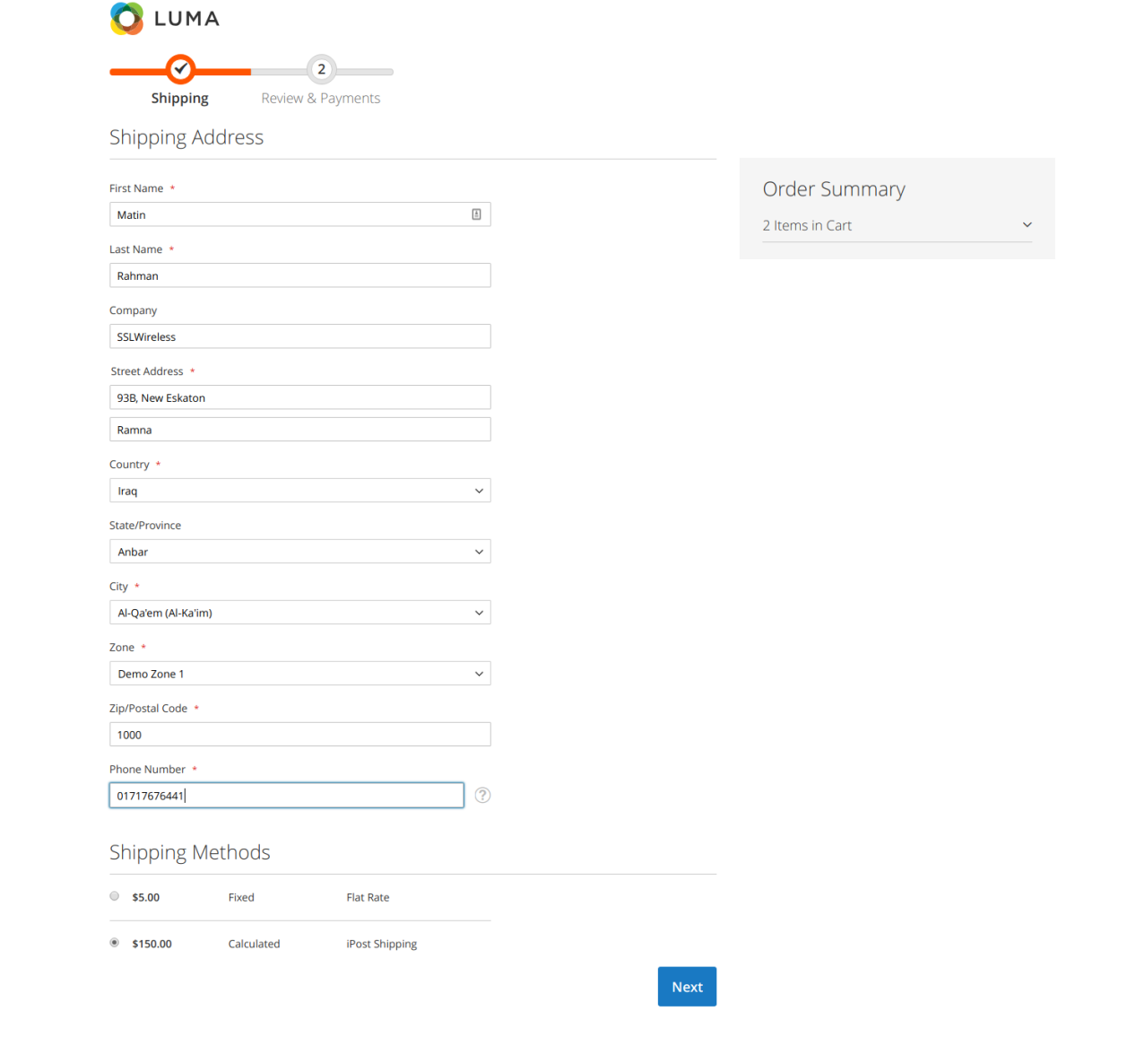

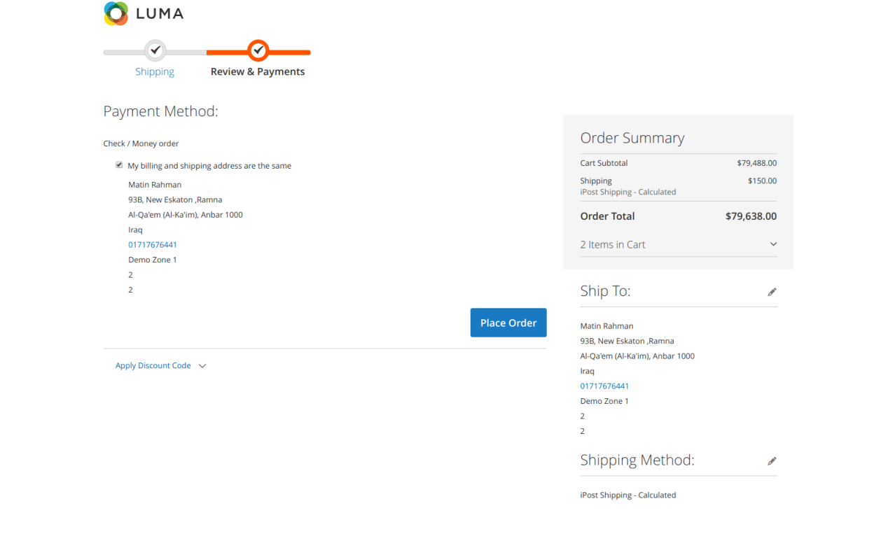

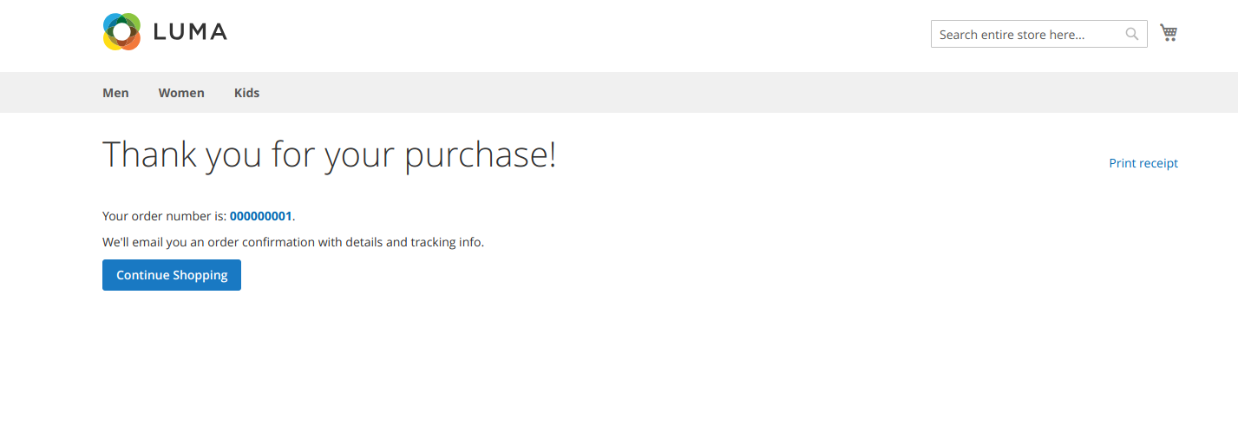

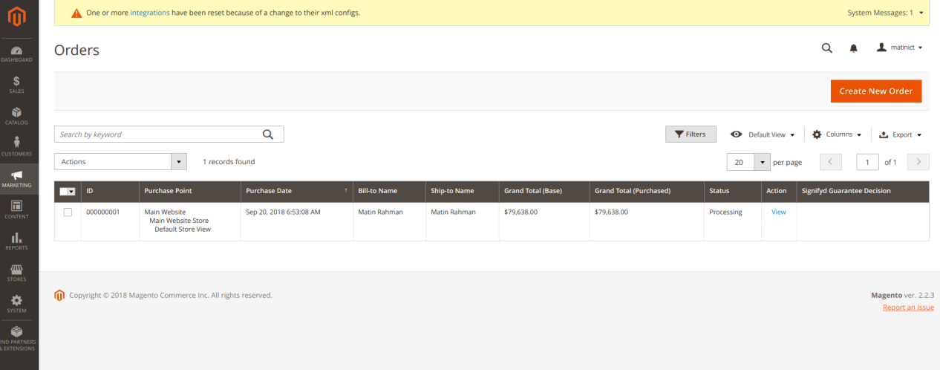

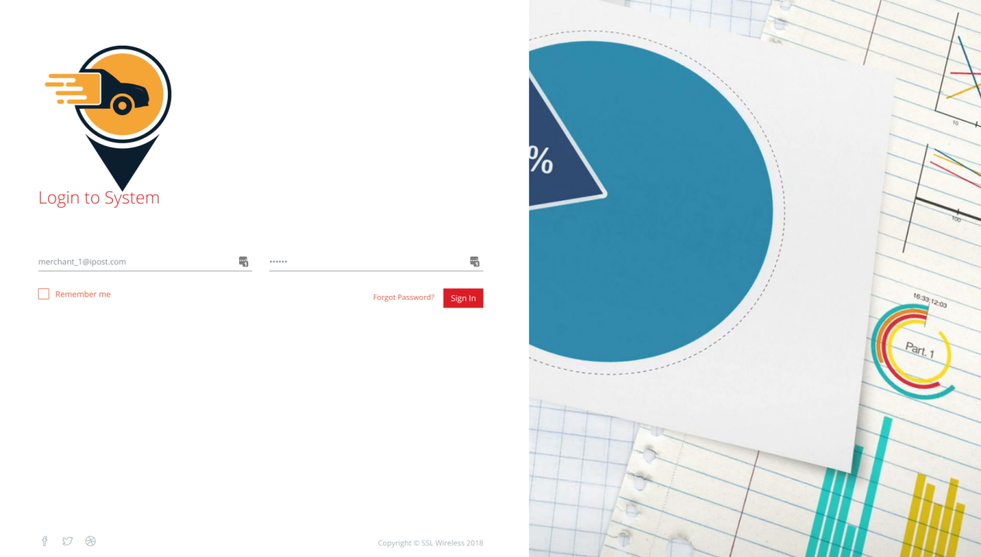

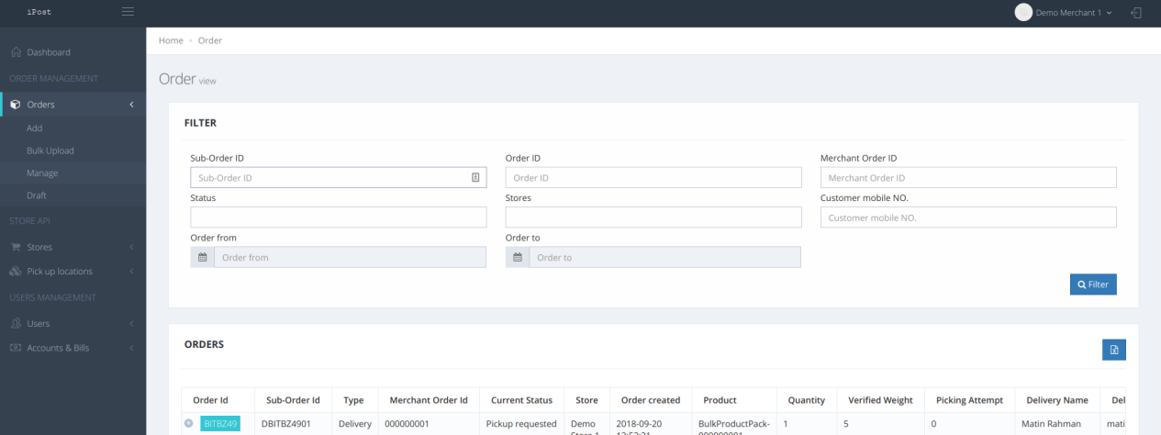

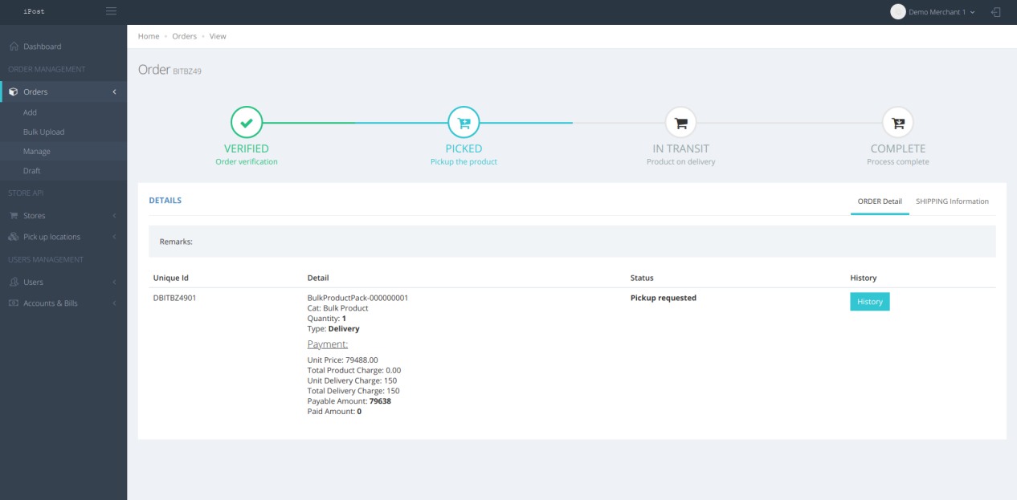

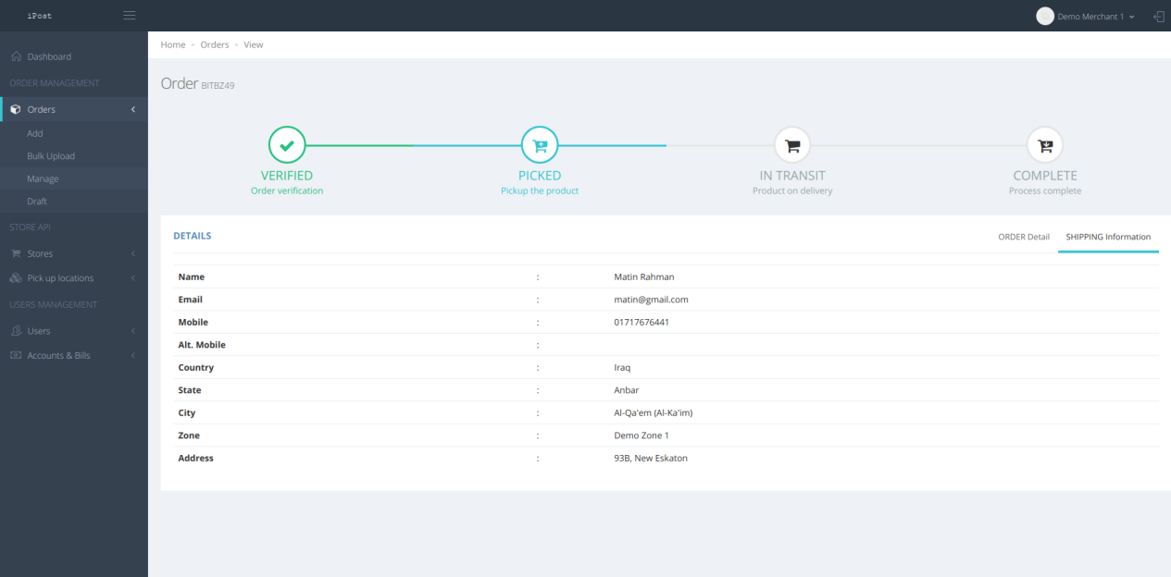

Issue:

*** Magento 2.2.3 Need to Update temando vendor module , plz check

Vendor/temando/module-shipping-m2/etc/events.xml updated as below:

<config xmlns:xsi="http://www.w3.org/2001/XMLSchema-instance" xsi:noNamespaceSchemaLocation="urn:magento:framework:Event/etc/events.xsd">

<event name="sales_quote_address_save_before">

<observer name="temando_persist_checkout_fields" instance="Temando\Shipping\Observer\SaveCheckoutFieldsObserverBefore"/>

</event>

<event name="sales_quote_address_save_after">

<observer name="temando_persist_checkout_fields" instance="Temando\Shipping\Observer\SaveCheckoutFieldsObserver"/>

</event>

<event name="sales_quote_address_load_after">

<observer name="temando_load_checkout_fields" instance="Temando\Shipping\Observer\LoadCheckoutFieldsObserver"/>

</event>

<event name="sales_order_save_after">

<observer name="temando_manifest_order" instance="Temando\Shipping\Observer\ManifestOrderObserver"/>

</event>

<event name="sales_quote_address_collect_totals_before">

<observer name="temando_load_checkout_fields" instance="Temando\Shipping\Observer\LoadCheckoutFieldsObserver"/>

</event>

</config>

Vendor/temando/module-shipping-m2/Observer/SaveCheckoutFieldsObserverBefore.php updated as below:

<?php

/**

* Refer to LICENSE.txt distributed with the Temando Shipping module for notice of license

*/

namespace Temando\Shipping\Observer;

use Magento\Framework\Event\Observer;

use Magento\Framework\Event\ObserverInterface;

use Magento\Framework\Exception\NoSuchEntityException;

use Temando\Shipping\Api\Data\Checkout\AddressInterface;

use Temando\Shipping\Api\Data\Checkout\AddressInterfaceFactory;

use Temando\Shipping\Model\ResourceModel\Repository\AddressRepositoryInterface;

/**

* Save checkout fields with quote shipping address.

*

* @package Temando\Shipping\Observer

* @author Christoph Aßmann <christoph.assmann@netresearch.de>

* @license http://opensource.org/licenses/osl-3.0.php Open Software License (OSL 3.0)

* @link http://www.temando.com/

*/

class SaveCheckoutFieldsObserverBefore implements ObserverInterface

{

/**

* @var AddressRepositoryInterface

*/

private $addressRepository;

/**

* @var AddressInterfaceFactory

*/

private $addressFactory;

/**

* SaveCheckoutFieldsObserver constructor.

* @param AddressRepositoryInterface $addressRepository

* @param AddressInterfaceFactory $addressFactory

*/

public function __construct(

AddressRepositoryInterface $addressRepository,

AddressInterfaceFactory $addressFactory

) {

$this->addressRepository = $addressRepository;

$this->addressFactory = $addressFactory;

}

/**

* @param Observer $observer

* @return void

*/

public function execute(Observer $observer)

{

if($address = $observer->getEvent()->getQuoteAddress()){

if($attributes = $address->getExtensionAttributes()){

$checkoutFields = $attributes->getCheckoutFields();

if(is_null($checkoutFields)){

$attributes->setCheckoutFields(array());

}

}

}

// /** @var \Magento\Quote\Api\Data\AddressInterface|\Magento\Quote\Model\Quote\Address $quoteAddress */

// $quoteAddress = $observer->getData('quote_address');

// if ($quoteAddress->getAddressType() !== \Magento\Quote\Model\Quote\Address::ADDRESS_TYPE_SHIPPING) {

// return;

// }

//

// if (!$quoteAddress->getExtensionAttributes()) {

// return;

// }

//

// // persist checkout fields

// try {

// $checkoutAddress = $this->addressRepository->getByQuoteAddressId($quoteAddress->getId());

// } catch (NoSuchEntityException $e) {

// $checkoutAddress = $this->addressFactory->create(['data' => [

// AddressInterface::SHIPPING_ADDRESS_ID => $quoteAddress->getId(),

// ]]);

// }

//

// $extensionAttributes = $quoteAddress->getExtensionAttributes();

// $checkoutAddress->setServiceSelection($extensionAttributes->getCheckoutFields());

// $this->addressRepository->save($checkoutAddress);

}

}

# ## magento2-Biddyut- Sslwireless_Biddyut

# ##magento2-address-Sslwireless_Address

============

Make city and township as dropdown

The module is working with magento 2.1.x, if you are using magento 2.2.x, you need rename 2 files

app\code\Sslwireless\Address\view\base\ui_component\customer_form_22.xml

app\code\Sslwireless\Address\view\frontend\templates\address\edit22.phtml

After installed, pls go to admin > customer > import address and use my sample csv in data folder to import. The order to import is regions > cities > townships (if you dont use township, you can ignore it)

Address template configuration (Stores > Configuration > Customer Configuration > Address template) - use this or change element sort order depend on your purpose

Text

{{depend prefix}}{{var prefix}} {{/depend}}{{var firstname}} {{depend middlename}}{{var middlename}} {{/depend}}{{var lastname}}{{depend suffix}} {{var suffix}}{{/depend}}

{{depend company}}{{var company}}{{/depend}}

{{if street1}}{{var street1}}

{{/if}}

{{depend street2}}{{var street2}}{{/depend}}

{{depend street3}}{{var street3}}{{/depend}}

{{depend street4}}{{var street4}}{{/depend}}

{{if city}}{{var city}}, {{/if}}{{if township}}{{var township}}, {{/if}}{{if region}}{{var region}}, {{/if}}{{if postcode}}{{var postcode}}{{/if}}

{{var country}}

{{depend telephone}}T: {{var telephone}}{{/depend}}

{{depend fax}}F: {{var fax}}{{/depend}}

{{depend vat_id}}VAT: {{var vat_id}}{{/depend}}

==================================

Text One Line

{{depend prefix}}{{var prefix}} {{/depend}}{{var firstname}} {{depend middlename}}{{var middlename}} {{/depend}}{{var lastname}}{{depend suffix}} {{var suffix}}{{/depend}}, {{var street}}, {{var city}}, {{var township}}, {{var region}}, {{var postcode}}, {{var country}}

==================================

HTML

{{depend prefix}}{{var prefix}} {{/depend}}{{var firstname}} {{depend middlename}}{{var middlename}} {{/depend}}{{var lastname}}{{depend suffix}} {{var suffix}}{{/depend}}{{depend firstname}}<br />{{/depend}}

{{depend company}}{{var company}}<br />{{/depend}}

{{if street1}}{{var street1}}<br />{{/if}}

{{depend street2}}{{var street2}}<br />{{/depend}}

{{depend street3}}{{var street3}}<br />{{/depend}}

{{depend street4}}{{var street4}}<br />{{/depend}}

{{if city}}{{var city}}, {{/if}}{{if township}}{{var township}}, {{/if}}{{if region}}{{var region}}, {{/if}}{{if postcode}}{{var postcode}}{{/if}}<br />

{{var country}}<br />

{{depend telephone}}T: <a href="tel:{{var telephone}}">{{var telephone}}</a>{{/depend}}

{{depend fax}}<br />F: {{var fax}}{{/depend}}

{{depend vat_id}}<br />VAT: {{var vat_id}}{{/depend}}

==================================

PDF

{{depend prefix}}{{var prefix}} {{/depend}}{{var firstname}} {{depend middlename}}{{var middlename}} {{/depend}}{{var lastname}}{{depend suffix}} {{var suffix}}{{/depend}}|

{{depend company}}{{var company}}|{{/depend}}

{{if street1}}{{var street1}}|{{/if}}

{{depend street2}}{{var street2}}|{{/depend}}

{{depend street3}}{{var street3}}|{{/depend}}

{{depend street4}}{{var street4}}|{{/depend}}

{{if city}}{{var city}}, {{/if}}{{if township}}{{var township}}, {{/if}}{{if region}}{{var region}}, {{/if}}{{if postcode}}{{var postcode}}{{/if}}|

{{var country}}|

{{depend telephone}}T: {{var telephone}}|{{/depend}}

{{depend fax}}F: {{var fax}}|{{/depend}}|

{{depend vat_id}}VAT: {{var vat_id}}{{/depend}}|

==================================

**Here is sql command to remove the module**DELETE FROM eav_attribute WHERE attribute_code = 'city_id';  
DELETE FROM eav_attribute WHERE attribute_code = 'township_id';  
DELETE FROM eav_attribute WHERE attribute_code = 'township';  
DROP TABLE IF EXISTS directory_region_city;  
DROP TABLE IF EXISTS directory_region_city_name;  
DROP TABLE IF EXISTS directory_city_township;  
DROP TABLE IF EXISTS directory_city_township_name;  
ALTER TABLE customer_address_entity DROP COLUMN city_id;  
ALTER TABLE customer_address_entity DROP COLUMN township;  
ALTER TABLE customer_address_entity DROP COLUMN township_id;

ALTER TABLE quote_address DROP COLUMN city_id;  
ALTER TABLE quote_address DROP COLUMN township;  
ALTER TABLE quote_address DROP COLUMN township_id;

ALTER TABLE sales_order_address DROP COLUMN city_id;  
ALTER TABLE sales_order_address DROP COLUMN township;  
ALTER TABLE sales_order_address DROP COLUMN township_id;