End User Documentation:

* Enter <http://www.onlinetryon.com/basic/web/> in your browser. ASIN Analyzer form will be appeared.

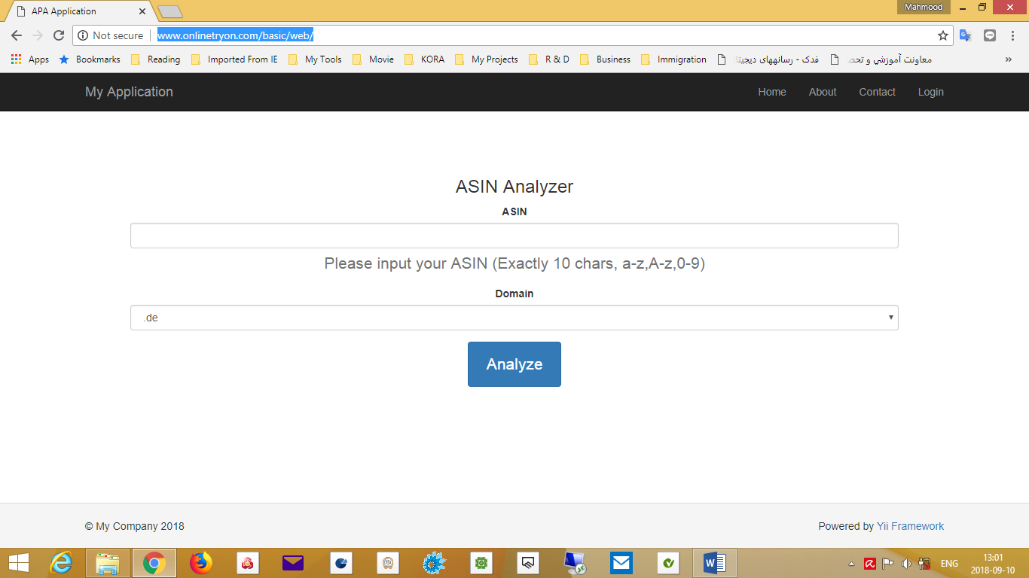

* Enter **ASIN code** as required, including exactly 10 characters from numbers and letters
* Select your desired domain from the combo box and click **Analyze**
* If your ASIN code is not approved, the alert message will be displayed

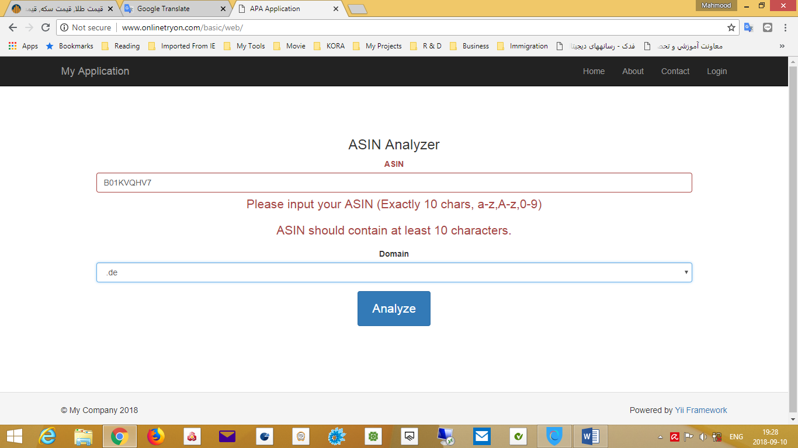

* The result will be displayed in the following table

