Braukaiser
articles

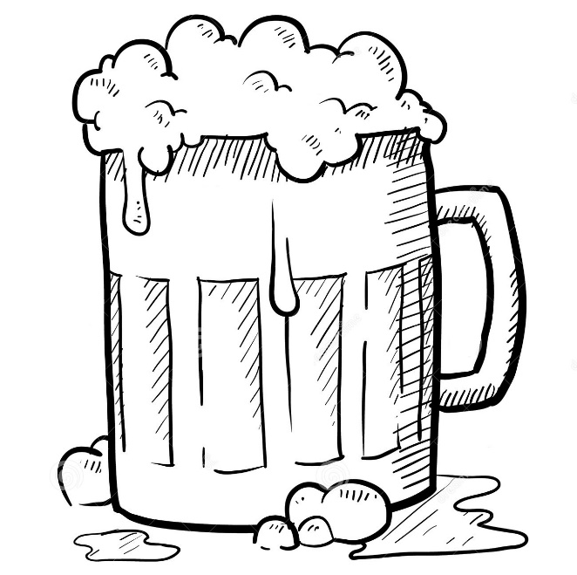
Braukaiser.com

1
Preparation



2
Brewing science
Basics



3
Ingredients



4
Wort production



5
Boiling & wort transfer



6
Fermentation



7
Bottling & Serving



8
Recipes



