Clase 7

Diccionario de datos:
https://www.nyc.gov/assets/tlc/downloads/pdf/data_dictionary_trip_records_yellow.pdf

1. En Hive, crear la siguiente tabla (externa) en la base de datos tripdata:

airport_trips(tpep_pickup_datetetime, airport_fee, payment_type, tolls_amount,
total_amount)

CREATE EXTERNAL TABLE airport_trips (tpep_pickup_datetime date, airport_fee float, payment_type int, tolls_amount float, total_amount float)
ROW FORMAT DELIMITED
FIELDS TERMINATED BY ','
LOCATION '/tables/external/airport_trips';

2. En Hive, mostrar el esquema de airport_trips

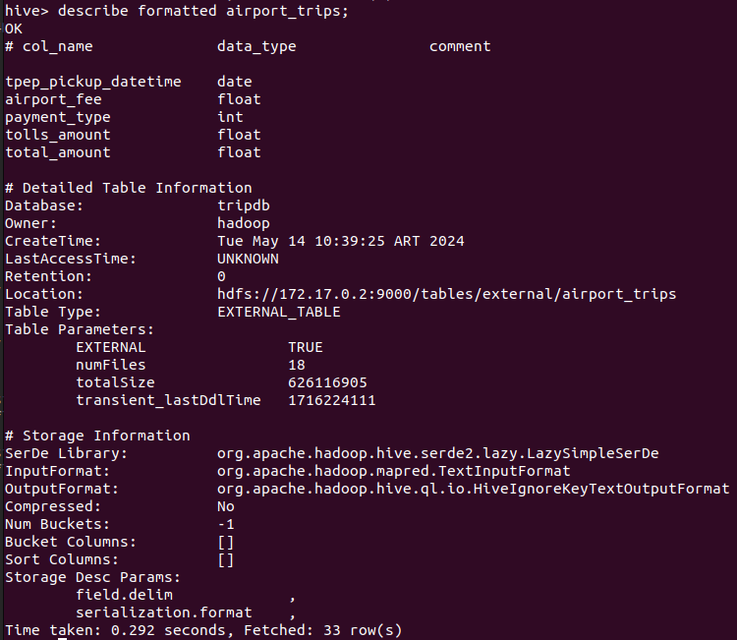
3. Crear un archivo .bash que permita descargar los archivos mencionados abajo e ingestarlos en HDFS:

wget -O /home/hadoop/landing/Yellow_tripdata_2021-01.parquet https://edvaibucket.blob.core.windows.net/data-engineer-edvai/yellow_tripdata_2021-01.parquet\?sp\=r\&st\=2023-11-06T12:52:39Z\&se\=2025-11-06T20:52:39Z\&sv\=2022-11-02\&sr\=c\&sig\=J4Ddi2c7Ep23OhQLPisbYaerlH472iigPwc1%2FkG80EM%3D

/home/hadoop/hadoop/bin/hdfs dfs -put -f /home/hadoop/landing/Yellow_tripdata_2021-01.parquet /ingest/airflow

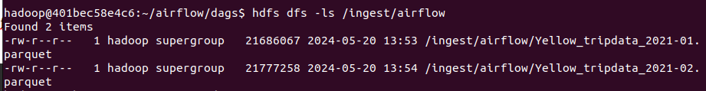
4. Crear un archivo .py que permita, mediante Spark, crear un data frame uniendo los
viajes del mes 01 y mes 02 del año 2021 y luego Insertar en la tabla airport_trips los
viajes que tuvieron como inicio o destino aeropuertos, que hayan pagado con dinero.

from pyspark.context import SparkContext
from pyspark.sql.session import SparkSession
from pyspark.sql import HiveContext

sc = SparkContext('local')
spark = SparkSession(sc)
hc = HiveContext(sc)

df01 = spark.read.option("header","true").parquet("hdfs://172.17.0.2:9000/ingest/airflow/Yellow_tripdata_2021-01.parquet")

df02 = spark.read.option("header","true").parquet("hdfs://172.17.0.2:9000/ingest/airflow/Yellow_tripdata_2021-02.parquet")

total_trips_df = df01.unionAll(df02)

total_trips_filtered_df = total_trips_df.filter("RatecodeID = 2 AND payment_type = 2")

final_total_trips_df = total_trips_filtered_df.select(total_trips_filtered_df.tpep_pickup_datetime.cast("date"), total_trips_filtered_df.airport_fee.cast("float"), total_trips_filtered_df.payment_type.cast("int"), total_trips_filtered_df.tolls_amount.cast("float"), total_trips_filtered_df.total_amount.cast("float"))

#final_total_trips_df.show(10)

final_total_trips_df.createOrReplaceTempView("airport_trips_view")

hc.sql("insert into tripdb.airport_trips select * from airport_trips_view;")

5. Realizar un proceso automático en Airflow que orqueste los archivos creados en los puntos 3 y 4. Correrlo y mostrar una captura de pantalla (del DAG y del resultado en la base de datos)

from datetime import timedelta
from airflow import DAG
from airflow.operators.bash import BashOperator
from airflow.operators.dummy import DummyOperator
from airflow.utils.dates import days_ago

args = {
'owner': 'airflow',
}

with DAG(
dag_id='ingest-transform-practice',
default_args=args,
schedule_interval='0 0 * * *',
start_date=days_ago(2),
dagrun_timeout=timedelta(minutes=60),
tags=['ingest', 'transform'],
params={"example_key": "example_value"},
) as dag:

finaliza_proceso = DummyOperator(
task_id='finaliza_proceso',
)
ingest = BashOperator(
task_id='ingest',
bash_command='/usr/bin/sh /home/hadoop/scripts/practica_airflow/ingest.sh ',
)
transform = BashOperator(
task_id='transform',
bash_command='ssh hadoop@172.17.0.2 /home/hadoop/spark/bin/spark-submit --files /home/hadoop/hive/conf/hive-site.xml /home/hadoop/scripts/practica_airflow/transformation.py ',
)

ingest >> transform >> finaliza_proceso

if __name__ == "__main__":
dag.cli()

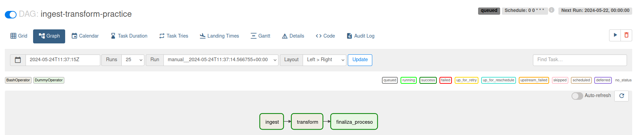
Luego de ejecutarse el dag, en hive ya se han cargado los datos a la tabla airport_trips

hive> show databases;
OK
default
f1
tripdb
Time taken: 0.891 seconds, Fetched: 3 row(s)

hive> use tripdb;
OK
Time taken: 0.041 seconds

hive> show tables;
OK
airport_trips
congestion
distance
passenger
payments
tolls
Time taken: 0.088 seconds, Fetched: 6 row(s)

hive> select * from airport_trips limit 10;

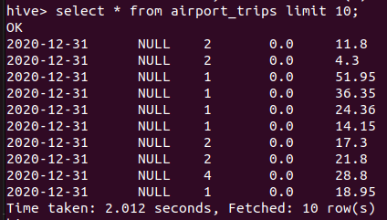
Clase 8

Diccionario de datos:
https://www.kaggle.com/datasets/rohanrao/formula-1-world-championship-1950-2020?se
lect=results.csv

1. Crear la siguientes tablas externas en la base de datos f1 en hive:

a. driver_results (driver_forename, driver_surname, driver_nationality, points)
b. constructor_results (constructorRef, cons_name, cons_nationality, url, points)

create external table driver_results(
driver_forename string,
driver_surename string,
driver_nationality string,
point int)
COMMENT 'Driver Results'
ROW FORMAT DELIMITED
FIELDS TERMINATED BY ','
LOCATION '/tables/external/f1/';

create external table constructor_results(
constructor_ref string,
cons_name string,
cons_nationality string,
url string,
points int)
comment 'Constructor Results'
row format delimited
fields terminated by ','
location '/tables/external/f1/';

2. En Hive, mostrar el esquema de driver_results y constructor_results

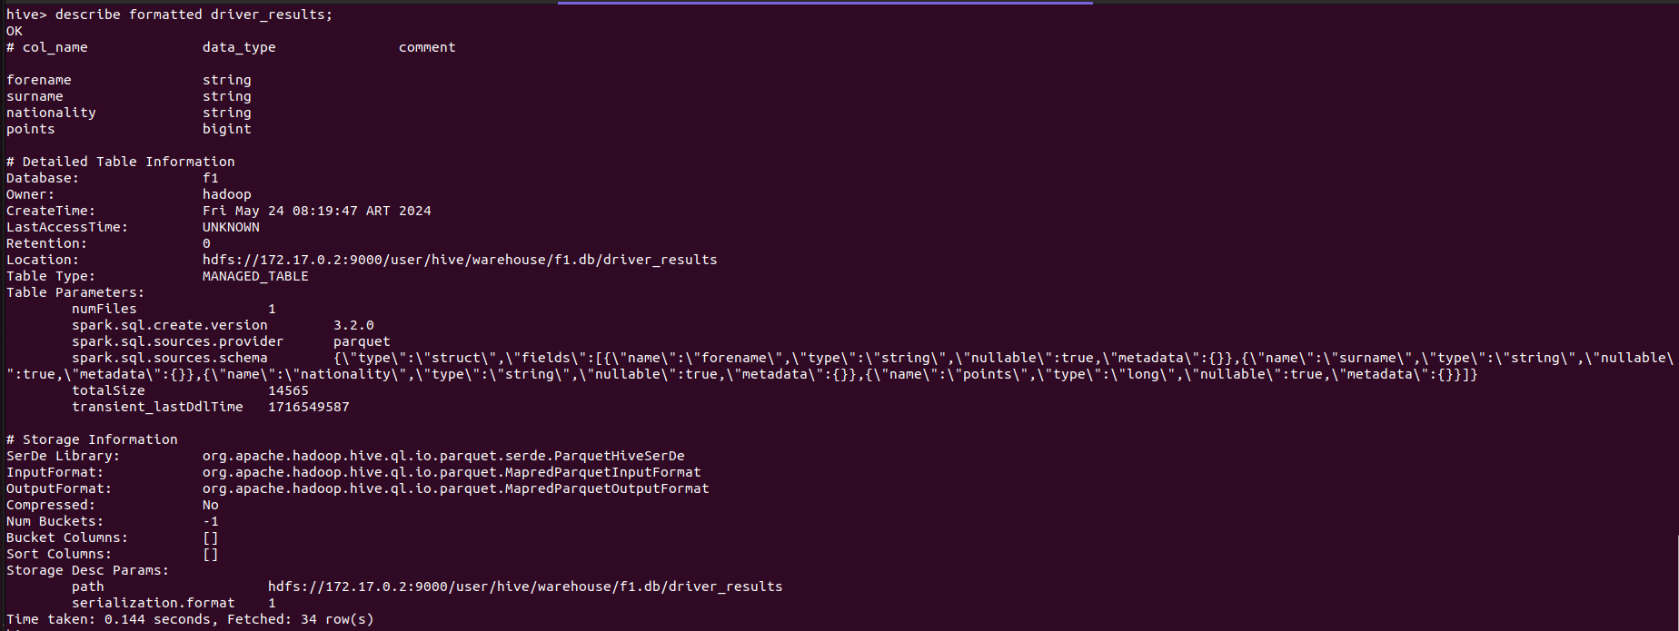
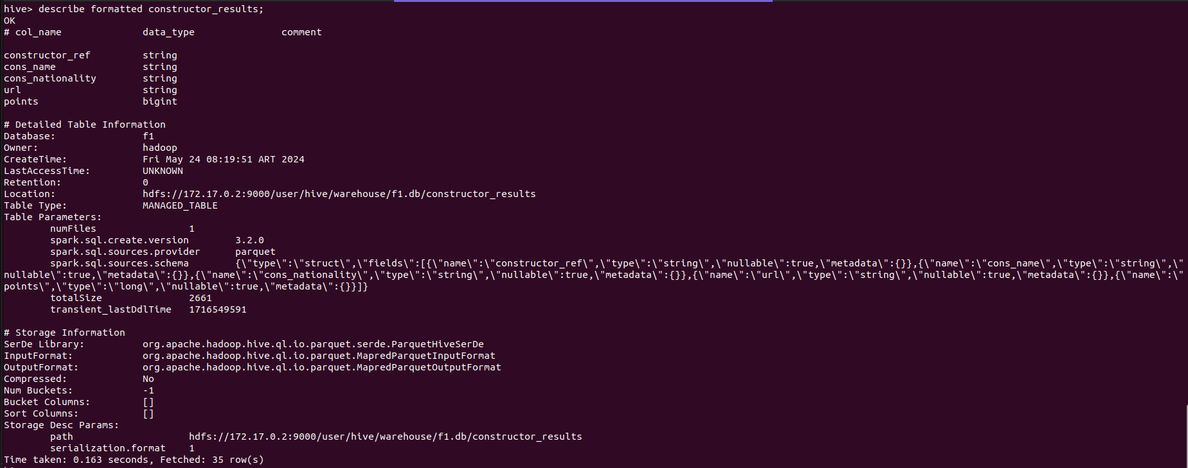
3. Crear un archivo .bash que permita descargar los archivos mencionados

wget -O /home/hadoop/landing/results.csv https://dataengineerpublic.blob.core.windows.net/data-engineer/f1/results.csv
hdfs dfs -put /home/hadoop/landing/results.csv /ingest/f1

wget -O /home/hadoop/landing/drivers.csv https://dataengineerpublic.blob.core.windows.net/data-engineer/f1/drivers.csv
hdfs dfs -put /home/hadoop/landing/drivers.csv /ingest/f1

wget -O /home/hadoop/landing/constructors.csv https://dataengineerpublic.blob.core.windows.net/data-engineer/f1/constructors.csv
hdfs dfs -put /home/hadoop/landing/constructors.csv /ingest/f1

wget -O /home/hadoop/landing/races.csv https://dataengineerpublic.blob.core.windows.net/data-engineer/f1/races.csv
hdfs dfs -put /home/hadoop/landing/races.csv /ingest/f1

4. Generar un archivo .py que permita, mediante Spark:

a. insertar en la tabla driver_results los corredores con mayor cantidad de puntos en la historia.

b. insertar en la tabla constructor_result quienes obtuvieron más puntos en el Spanish Grand Prix en el año 1991

from pyspark.sql.session import SparkSession

spark = SparkSession.builder \
.appName("CSV to Hive") \
.config("spark.sql.catalog.Implementation", "hive") \
.enableHiveSupport() \
.getOrCreate()

df_results = spark.read.option("header", "true").csv("hdfs://172.17.0.2:9000/ingest/f1/results.csv")
df_drivers = spark.read.option("header", "true").csv("hdfs://172.17.0.2:9000/ingest/f1/drivers.csv")
df_constructors = spark.read.option("header", "true").csv("hdfs://172.17.0.2:9000/ingest/f1/constructors.csv")
df_races = spark.read.option("header", "true").csv("hdfs://172.17.0.2:9000/ingest/f1/races.csv")

df_results.createOrReplaceTempView("vw_results")
df_drivers.createOrReplaceTempView("vw_drivers")
df_constructors.createOrReplaceTempView("vw_constructors")
df_races.createOrReplaceTempView("vw_races")

df_driver_results = spark.sql( \
"SELECT \
cast(d.forename as string), \
cast(d.surname as string), \
cast(d.nationality as string), \
sum(cast(r.points as int)) points \
FROM \
vw_results r, \
vw_drivers d \
WHERE \
r.driverId = d.driverId \
GROUP BY \
d.driverId, d.forename, d.surname, d.nationality \
ORDER BY \
points DESC" \
)

df_constructor_results = spark.sql( \
"SELECT \
cast(c.constructorRef as string) constructor_ref, \
cast(c.name as string) cons_name, \
cast(c.nationality as string) cons_nationality, \
cast(c.url as string) url, \
sum(cast(r.points as int)) points \
FROM \
vw_results r, \
vw_constructors c, \
vw_races ra \
WHERE \
r.constructorId = c.constructorId \
AND r.raceId = ra.raceId \
AND ra.year = '1991' \
GROUP BY \
c.constructorId, constructor_ref, cons_name, cons_nationality, c.url \
ORDER BY \
points DESC" \
)

df_driver_results.write.mode("overwrite").saveAsTable("f1.driver_results")
df_constructor_results.write.mode("overwrite").saveAsTable("f1.constructor_results")

5. Realizar un proceso automático en Airflow que orqueste los archivos creados en los
puntos 3 y 4. Correrlo y mostrar una captura de pantalla (del DAG y del resultado en la
base de datos)

from datetime import timedelta
from airflow import DAG
from airflow.operators.bash import BashOperator
from airflow.operators.dummy import DummyOperator
from airflow.utils.dates import days_ago

args = {
'owner': 'airflow',
}

with DAG(
dag_id='f1-etl',
default_args=args,
schedule_interval='0 0 * * *',
start_date=days_ago(2),
dagrun_timeout=timedelta(minutes=60),
tags=['ingest', 'transform'],
params={"example_key": "example_value"},

) as dag:

finaliza_proceso = DummyOperator(
task_id='finaliza_proceso',
)
ingest = BashOperator(
task_id='ingest',
bash_command='/usr/bin/sh /home/hadoop/scripts/practica_airflow/clase8/ingest.sh ',
)
transform = BashOperator(
task_id='transform',
bash_command='ssh hadoop@172.17.0.2 /home/hadoop/spark/bin/spark-submit --files /home/hadoop/hive/conf/hive-site.xml /home/hadoop/scripts/practica_airflow/f1-transformation2.py ',
)

ingest >> transform >> finaliza_proceso

if __name__ == "__main__":
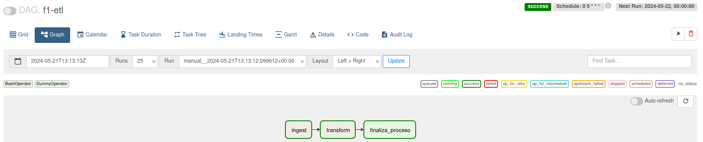
dag.cli()

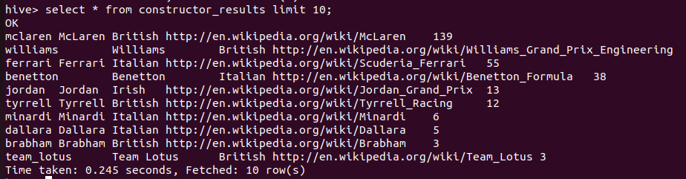

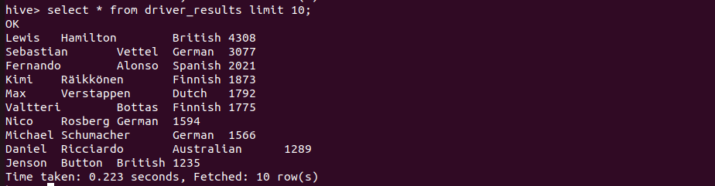
BONUS: GroupTask
En lugar de la tarea de ingest anterior que contenía todas las sentencias para la descarga y puesta en hdfs de los archivos, se separó por dos task group donde en una se ejecutan los comandos para los archivos de conductores y constructores, mientras que en el otro grupo se ejecutan las tareas para los archivos de carreras y resultados.
with TaskGroup("ingest") as ingest:

inicializa_ingest = EmptyOperator(task_id='inicializa_ingest',)

finaliza_ingest = EmptyOperator(task_id='finaliza_ingest',)

with TaskGroup("ingest_actors") as ingest_actors:

ingestDrivers = BashOperator(
task_id='ingest-drivers',
bash_command='/usr/bin/sh/home/hadoop/scripts/practica_airflow/clase8/ingest-drivers.sh ',
)

ingestConstructors = BashOperator(
task_id='ingest-constructors',
bash_command='/usr/bin/sh/home/hadoop/scripts/practica_airflow/clase8/ingest-constructors.sh ',
)

with TaskGroup("ingest_metrics") as ingest_metrics:

ingestResults = BashOperator(
task_id='ingest-results',
bash_command='/usr/bin/sh/home/hadoop/scripts/practica_airflow/clase8/ingest-results.sh ',
)

ingestRaces = BashOperator(
task_id='ingest-races',
bash_command='/usr/bin/sh/home/hadoop/scripts/practica_airflow/clase8/ingest-races.sh ',
)

inicializa_ingest >> [ingest_actors, ingest_metrics] >> finaliza_ingest

inicializa_proceso >> ingest >> transform >> finaliza_proceso

