Práctica Hive - Spark

1. Crear las tablas payments, passenger, distance, tolls y congestion en Hive:

CREATE TABLE payments (VendorID int, tpep_pickup_datetime date, payment_type int, total_amount float)
COMMENT 'Payments'
ROW FORMAT DELIMITED
FIELDS TERMINATED BY ',';

CREATE TABLE tolls (tpep_pickup_datetime date, passenger_count int, tolls_amount float, total_amount float)
COMMENT 'Tolls'
ROW FORMAT DELIMITED
FIELDS TERMINATED BY ',';

CREATE TABLE passenger (tpep_pickup_datetime date, passenger_count int, total_amount float)
COMMENT 'Passenger'
ROW FORMAT DELIMITED
FIELDS TERMINATED BY ',';

CREATE TABLE congestion (tpep_pickup_datetime date, passenger_count int, congestion_surcharge float, total_amount float )
COMMENT 'Congestion'
ROW FORMAT DELIMITED
FIELDS TERMINATED BY ',';

CREATE TABLE distance (tpep_pickup_datetime date, passenger_count int, trip_distance float, total_amount float )
COMMENT 'Distance'
ROW FORMAT DELIMITED
FIELDS TERMINATED BY ',';

Para ver los resultados en la terminal se utiliza use tripdb y show tables.

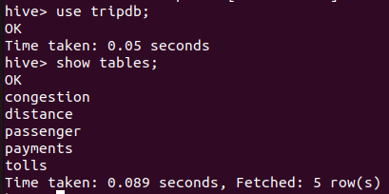

2. En Hive hacer un ‘describe’ de las tablas passengers y distance:
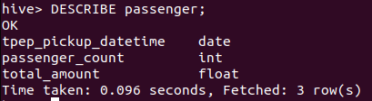
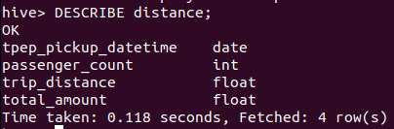
3. Hacer ingest del file ‘Yellow_tripdata_2021-01.csv’.

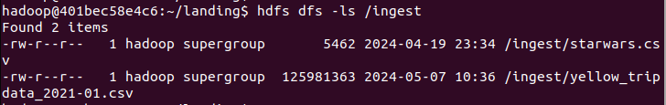
Para los isguientes ejercicios se debe usar Pyspark. Si se desea practicar más también se puede repetir los mismos en SQL.

4. Inserción de tablas mediante Pyspark con dataframes:

# Carga del csv alojado en hdfs en el dataframe df.
df = spark.read.option("header", "true").csv("/ingest/yellow_tripdata_2021-01.csv")
df.show(1)

# Para la tabla payments:
df_payments = df.select(df.VendorID.cast("int"), df.tpep_pickup_datetime.cast("date"), df.payment_type.cast("int"), df.total_amount.cast("float"))
df_payments.write.insertInto("tripdb.payments")

# Para la tabla passenger:
df_passenger = df.select(df.tpep_pickup_datetime.cast("date"), df.passenger_count.cast("int"), df.total_amout.cast("float"))
df_passenger.write.insertInto("tripdb.passenger")

# Para la tabla tolls
df_tolls = df.select(df.tpep_pickup_datetime.cast("date"), df.passenger_count.cast("int"), df.tolls_amount.cast("float"), df.total_amount.cast("float"))
df_tolls.write.insertInto("tripdb.tolls")

# Para la tabla congestion:
df_congestion = df.select(df.tpep_pickup_datetime.cast("date"), df.passenger_count.cast("int"), df.congestion_surcharge.cast("float"), df.total_amount.cast("float"))
df_congestion.write.insertInto("tripdb.congestion")

# Para la tabla distance:
df_distance = df.select(df.tpep_pickup_datetime.cast("date"), df.passenger_count.cast("int"), df.trip_distance.cast("float"), df.total_amount.cast("float")) df_distance.write.insertInto("tripdb.distance")

Resultados en Hive:

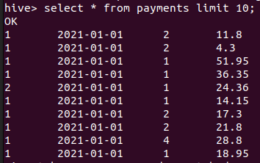
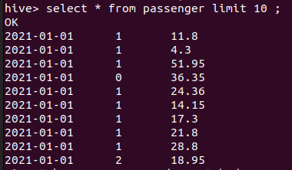

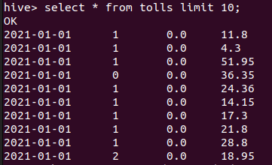
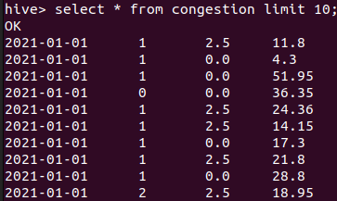

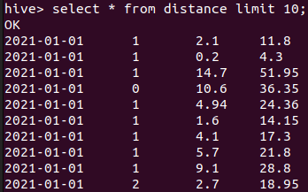

5. Inserción de tablas mediante Pyspark con SQL:

Dropeamos la database
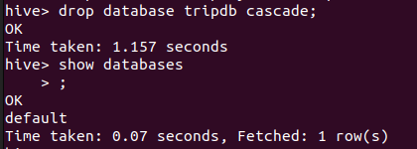

Ahora se crea nuevamente con los comandos de Hive que se escribieron al principio.

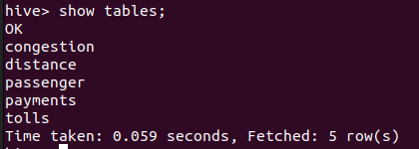

Código para crear las tablas con SQL:

# Carga inicial del documento en hdfs a un dataframe llamado df
df = spark.read.option("header", "true").csv("/ingest/yellow_tripdata_2021-01.csv")
df.createOrReplaceTempView("vs_df")

# Carga de la tabla payments
df_payments = spark.sql("select cast(VendorID as int), cast(tpep_pickup_datetime as date), cast(payment_type as int), cast(total_amount as float) from vs_df")
df_payments.createOrReplaceTempView("vs_payments_load")
spark.sql("insert into tripdb.payments select * from vs_payments_load")

# Carga de la tabla passenger

df_passengers = spark.sql("select cast(tpep_pickup_datetime as date), cast(passenger_count as int), cast(total_amount as float) from vs_df")
df_passengers.createOrReplaceTempView("vs_passengers_load")
spark.sql("insert into tripdb.passenger select * from vs_passengers_load")

# Carga de la tabla tolls

df_tolls = spark.sql("select cast(tpep_pickup_datetime as date), cast(passenger_count as int), cast(tolls_amount as float), cast(total_amount as float) from vs_df")
df_tolls.createOrReplaceTempView("vs_tolls_load")
spark.sql("insert into tripdb.tolls select * from vs_tolls_load")

# Carga de la tabla congestion

df_congestion = spark.sql("select cast(tpep_pickup_datetime as date), cast(passenger_count as int), cast(congestion_surcharge as float), cast(total_amount as float) from vs_df")
df_congestion.createOrReplaceTempView("vs_congestion_load")
spark.sql("insert into tripdb.congestion select * from vs_congestion_load")

# Carga de la tabla distance

df_distance = spark.sql("select cast(tpep_pickup_datetime as date), cast(passenger_count as int), cast(trip_distance as float), cast(total_amount as float) from vs_df")
df_distance.createOrReplaceTempView("vs_distance_load")
spark.sql("insert into tripdb.distance select* from vs_distance_load")

Los resultados en Hive son los mismos que llenando las tablas sin sentencias SQL:

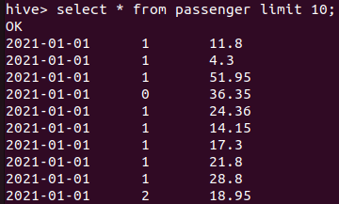
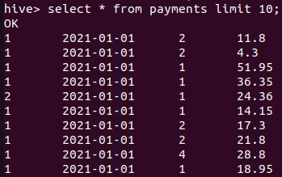

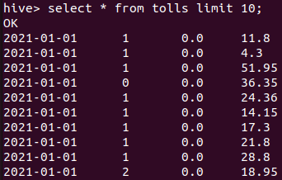
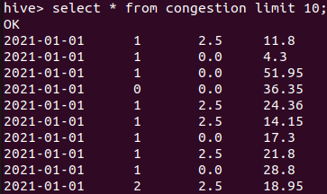

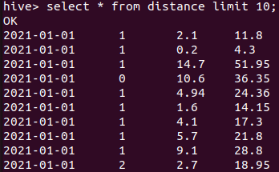

Práctica de transformaciones con Spark y SQL

1. En el container de Nifi crear un .sh que permita descargar el archivo yellow_tripdata_2021-01.parquet.

2. Por medio de Nifi crear un job con dos procesos:
a) GetFile para obtener el archivo del punto 1.
b) PutHDFS para ingestarlo a HDFS.

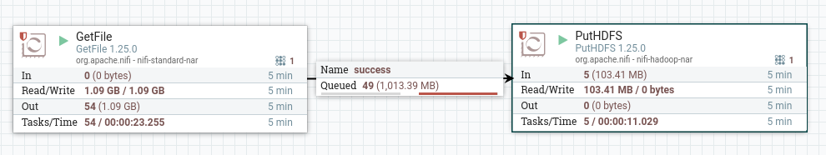
Se puede ver en el contenedor de hadoop hdfs que se cargó el .parquet correctamente.

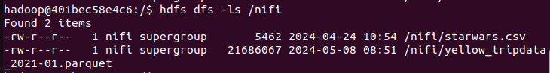
3. Con el archivo ingestado en HDFS/nifi, escribir consultas y agregar captura de pantalla del resultado. Para los ejercicios se puede usar SQL mediante la creación de una vista llamada yellow_tripdata.

df2 = spark.read.parquet("/nifi/yellow_tripdata_2021-01.parquet")
df2.createOrReplaceTempView("yellow_tripdata")

3.1 Mostrar las columnas VendorID int, Tpep_pickup_datetime date, Total_amount double, donde el total_amount < 10 USD.

df_3_1 = spark.sql("select cast(VendorID as int), cast(tpep_pickup_datetime as date), cast(total_amount as float) from yellow_tripdata where total_amount <10")
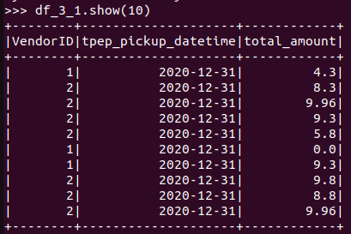

3.2 Mostrar los 10 días que más se recaudó dinero (tpep_pickup_datetime, total_amount).

df_3_2_cast = spark.sql("select cast(tpep_pickup_datetime as date), cast(total_amount as float) from yellow_tripdata")
df_3_2_cast.createOrReplaceTempView("3_2_2_cast")
df_3_2 = spark.sql("select tpep_pickup_datetime, sum(total_amount) as sum_total_amount from 3_2_2_cast group by tpep_pickup_datetime order by sum_total_amount desc")

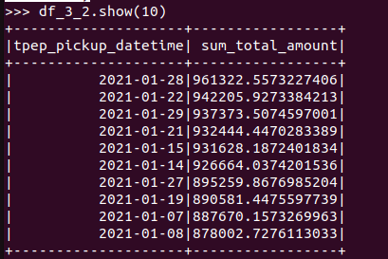

3.3 Mostrar los 10 viajes que menos dinero recaudó en viajes mayores a 10 millas (trip_distance, total amount)

df_3_3_cast = spark.sql("select cast(trip_distance as float), cast(total_amount as float) from yellow_tripdata")
df_3_3_cast.createOrReplaceTempView("3_2_3_cast")
df_3_3 = spark.sql("select trip_distance, total_amount from 3_2_3_cast where trip_distance > 10 order by total_amount asc")

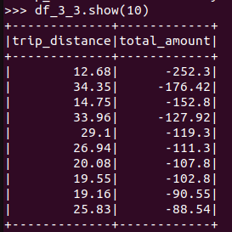

3.4 Mostrar los viajes de más de dos pajeros que hayan pagado con tarjeta de crédito. (trip_distance, tpep_pickup_datetime)

df_3_4_cast = spark.sql("select cast(trip_distance as float), cast(tpep_pickup_datetime as date), cast(passenger_count as int), cast(payment_type as int) from yellow_tripdata")
df_3_4_cast.createOrReplaceTempView("3_2_4_cast")
df_3_4 = spark.sql("select trip_distance, tpep_pickup_datetime from 3_2_4_cast where passenger_count > 2 and payment_type = 1")

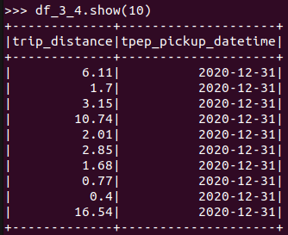

3.5 Mostrar los 7 viajes con mayor propina en distancias mayores a 10 millas (tpep_pickup_datetime, trip_distance, passenger_count, tip_amount)

df_3_5 = spark.sql("select cast(tpep_pickup_datetime as date), cast(trip_distance as float), cast(passenger_count as int), cast (tip_amount as float) from yellow_tripdata where trip_distance > 10 order by tip_amount DESC LIMIT 7")

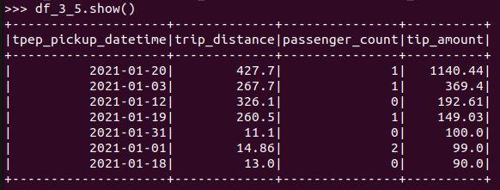
3.6 Mostrar para cada uno de los valores RateCodeID, el monto total y el monto promedio. Excluir los viajes donde RateCodeID es ‘Group ride’

df_3_6 = spark.sql(" SELECT CAST(RateCodeID as int), SUM(total_amount), AVG(total_amount) FROM yellow_tripdata WHERE RateCodeID != 6 GROUP BY RateCodeID")

