**WebEx User Guide**

The following user guide has been put together for the use of the WebEx software when demonstrating Lease-Desk to clients.

**1. Logging on:**

1. Go to <https://lease-desk.webex.com>

2. You will be presented with the following screen;

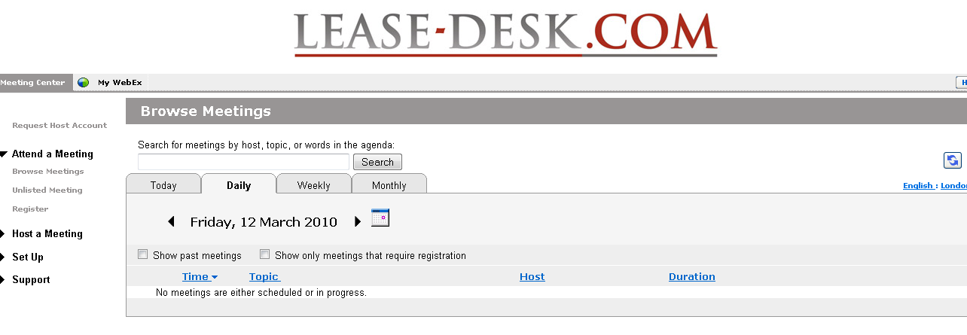

3. Click  on the right hand side.

4. Then enter your login details;

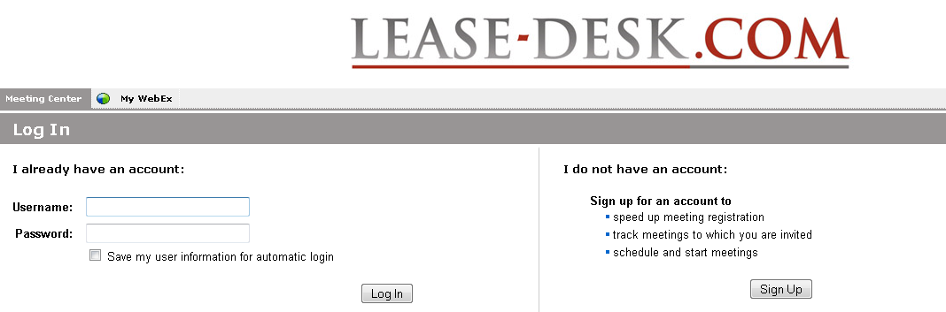

5. You will then be presented with the following pop up:

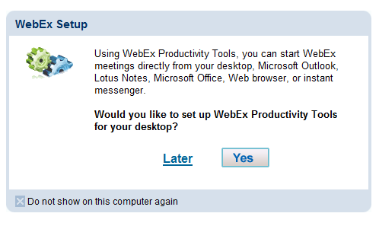

6. Select ‘Yes’ if you want to set up WebEx Productivity Tools for your desktop or ‘Later’ for another time.

7. If you click ‘Yes’ you will receive the following screen;

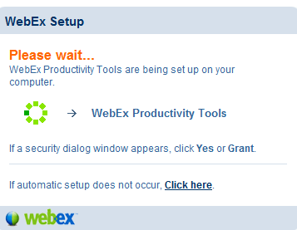

8. Work through the Install Wizard.

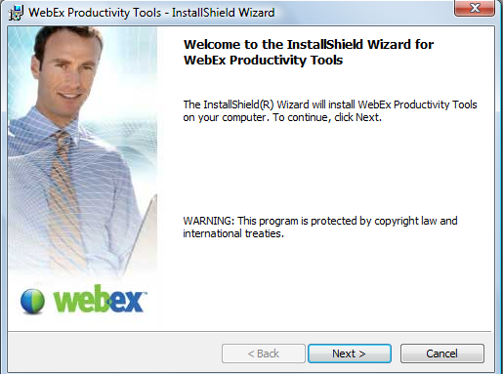

**2. Attend a Meeting:**

**2a. Browse Meetings:**

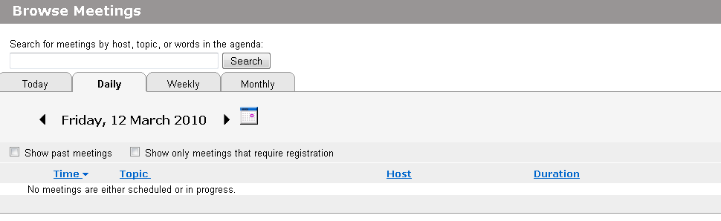

1. Browse for Meetings by clicking on the Calendar or searching by host, topic or words.

1. Search for a meeting from the Calendar. You have the option to change the view to daily, weekly or monthly and can use the search functionality to look for the required meeting.

**2b. Join an Unlisted Meeting:**

1. Click on 

2. You will then be presented with the following screen;

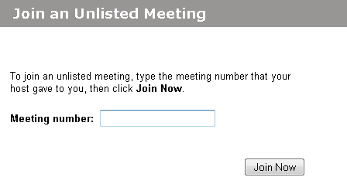

3. Enter the Meeting Number and click on ‘Join Now’.

**2c. Register for meeting:**

1. Click on 

2. You will then be presented with the following screen;

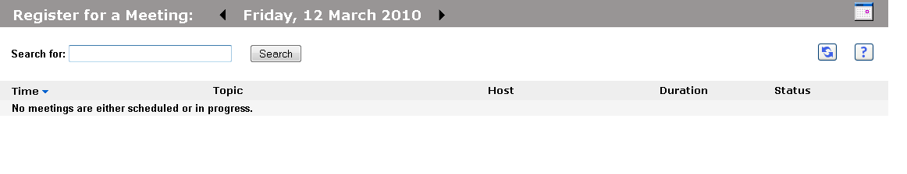

3. Enter the details and click on ‘Search’ (if meeting details known) or click on relevant meeting.

**3. Host a Meeting:**

**3a. Schedule a meeting:**

1. Click on 

2. You will then be presented with the following screen;

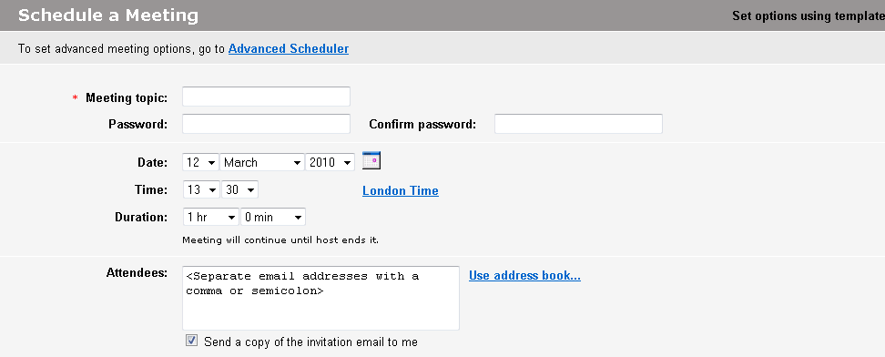

3. Enter a meeting topic

4. You can enter a meeting password if required (for extra security). If you don’t require this option at all you can change it via the system admin page (see full guide for further details).

5. Enter the date, time and duration.

6. Enter Attendees or email the copy of the invitation to yourself and amend it (depending on what is preferred).

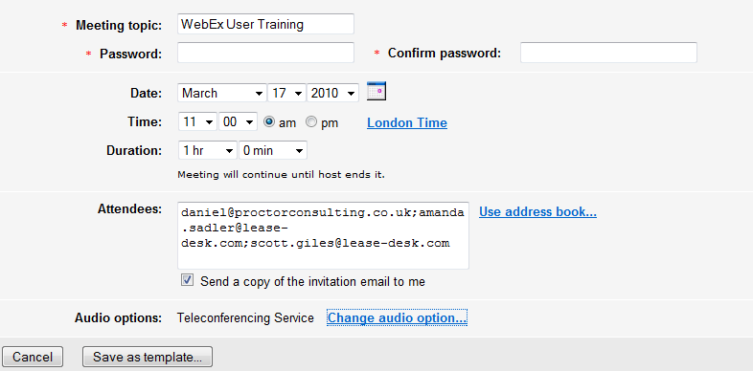

8. Click on 

9. You will then be presented with the following confirmation screen giving you the option of adding to calendar or editing if required. If not, click on ‘OK’.

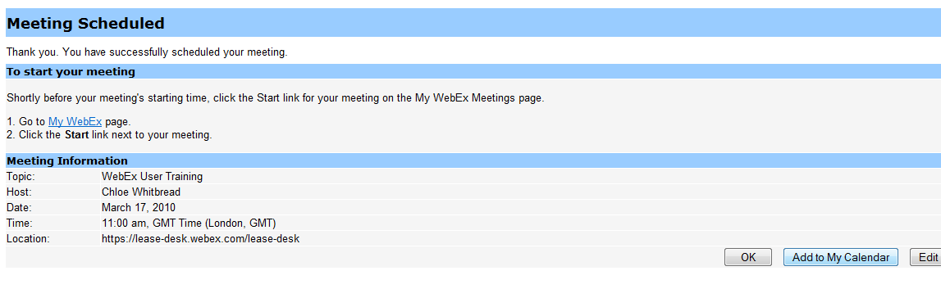

10. You will then receive the following email;

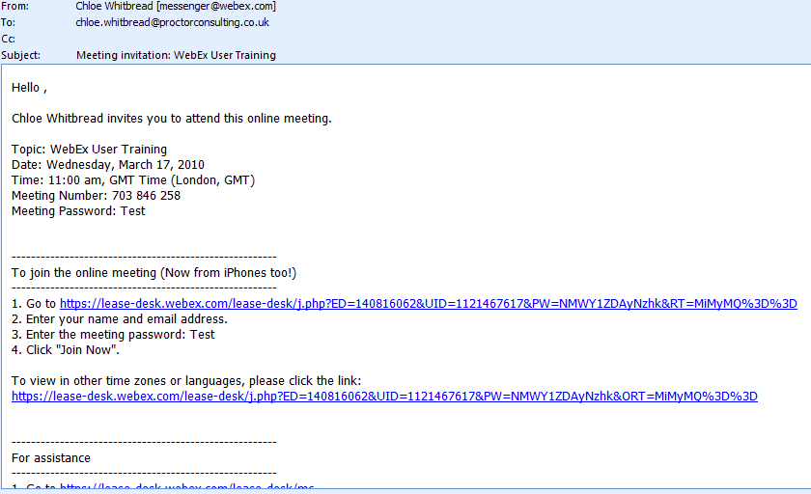

You will also receive a copy you can forward on if required.

**3b. Starting/Schdeuling a Meeting Using One-Click:**

**From Outlook;**

1. Click on  to start a meeting or 

**Note: You can also access other WebEx functionality by selecting the following dropdown menu within Outlook;**

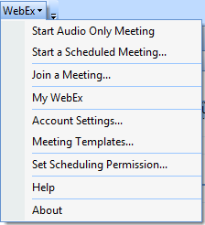

2. You will then be presented with the following screen;

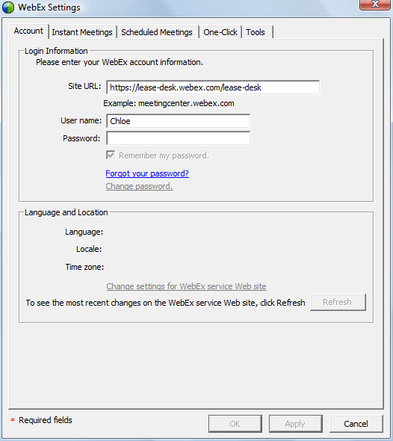

3. Login to WebEx and click on ‘OK’.

**From the Toolbar:**

1. Click on 

2. You will then receive the following pop up;

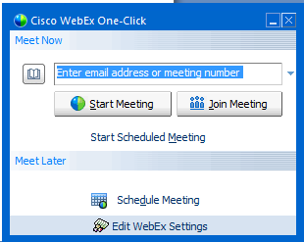

3. Select the option required (Start Meeting, Join Meeting, Schedule Meeting)

**Note: You will need to be logged in to access this functionality**

**From Excel**

1. Click on the following icon within Excel;

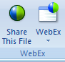

2. Click on ‘WebEx’ which will bring you the following dropdown menu;

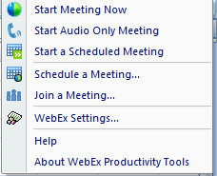

3. Click on ‘Share this File’ which will bring up the following;

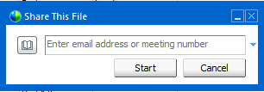

4. Enter the details and then click ‘Start’

**3c. My meetings:**

1. Click on 

2. You will then be presented with the following screen;

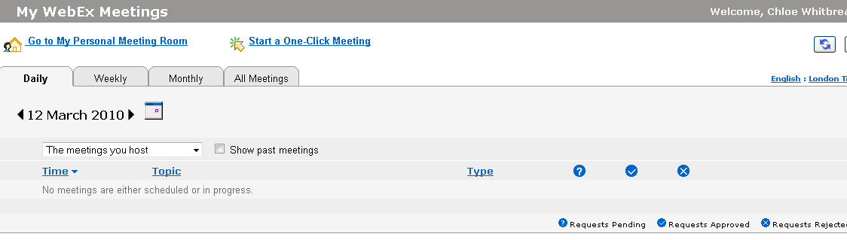

3. Use Calendar to search for meetings that you are hosting.

4. To delete, edit or view a meeting, locate the meeting from your calendar as per below;

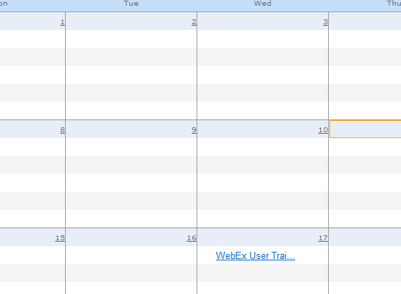

5. Click on the meeting;

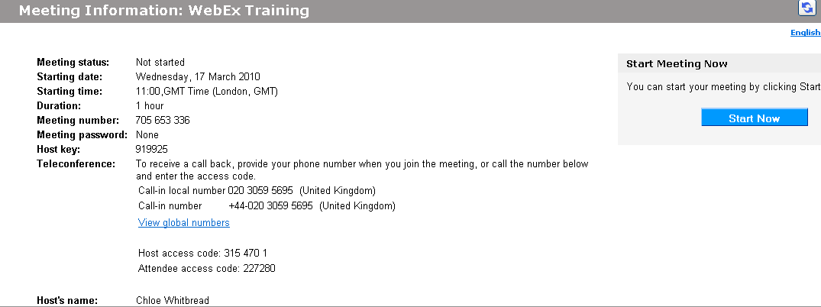

6. Then select the option required, i.e. Edit, Delete, View Agenda etc.

**3d. Oneclick meeting:**

1. Click on 

2. If you have not already set up ‘One-Click Meeting’ (from login screen pop up option), you will then be presented with the following screen;

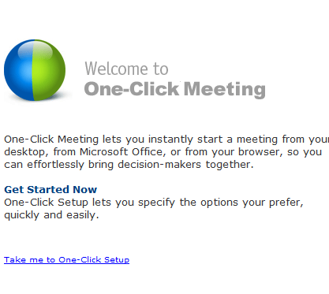

3. Click on  and follow Wizard instructions.

**3e. My recorded meetings:**

1. Click on 

2. You will then be presented with the following screen;

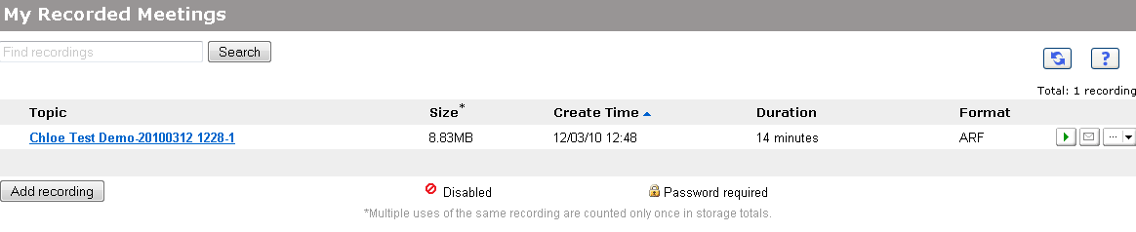

**Please note: Recordings are saved for a maximum of 90 days. If you require longer there is a cost, please contact Premiere Global.**

3. Click on the required recording. You can use various different actions by clicking on the drop down menu as indicated below;

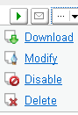

**4. Set up:**

**4a. Meeting Centre:**

1. Click on 

2. You will then be presented with the following screen;

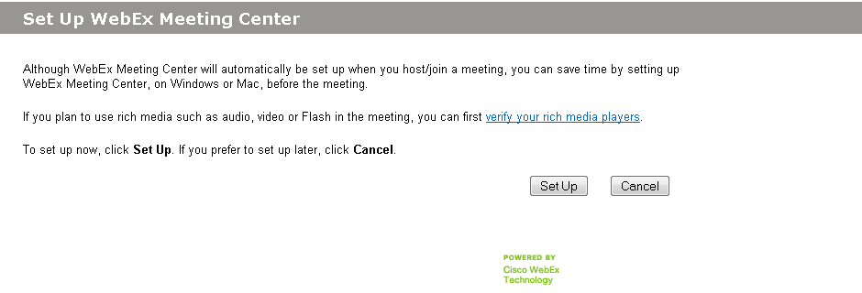

3. Click ‘Set Up’ to continue or ‘Cancel’ if not required.

4. If ‘Set Up’ is selected, upon completion you will then receive the following confirmation message;

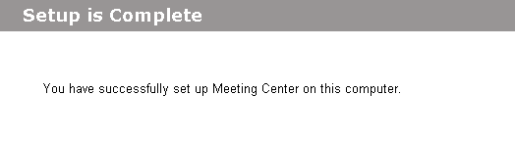

**4b. Preferences:**

1. Click 

2. You will then receive the following screen;

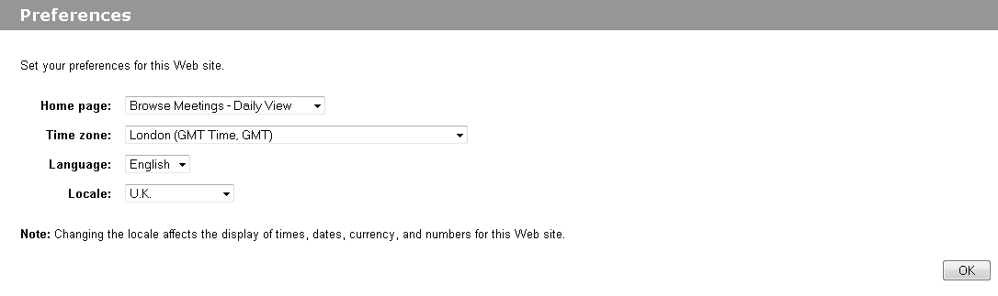

3. Amend the details as required.

**4c. My Profile:**

1. Click 

2. You will then be presented with the following screen;

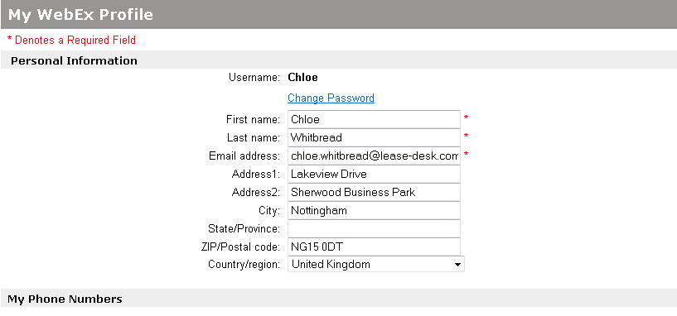

3. Amend the details accordingly. **Note: You can change your password details here.**

**5. Support:**

The Support menu list contains the following information if required:

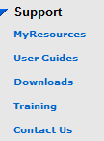

**6. Hosting a Meeting Functionality:**

1. When are logged in to a meeting you are hosting, you will be presented with the following screen;

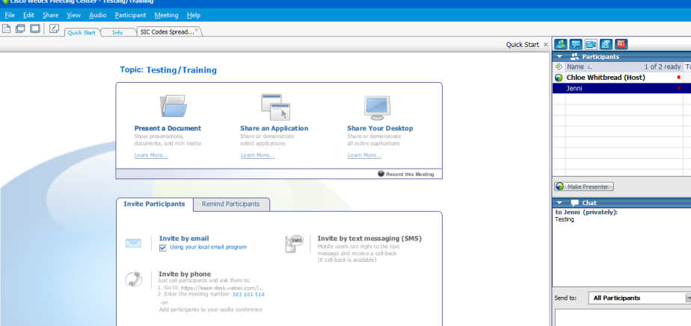

2. This gives you several different options.

**1. Present a Document:** for sharing a document.

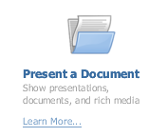

1. Click on the Icon and then open the document required.

2. Once in the document, you can add arrows, draw circles, erase drawings, underline, and add text etc;

*  Add Arrow, or use drop down and select pointer 
*  Add Text, Add Lines or use drop down and select arrows  or 
*  add square or additional shapes using drop down 
*  use pen on doc or dropdown to select pencil 
*  select colour for amendments or use dropdown to alternate 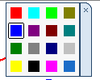
* Click on  then select options from drop down 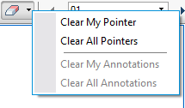

**2. Share an Application:**

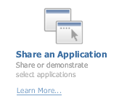

1. Click on the icon and the following appears;

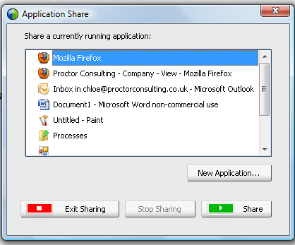

2. Select the Application required. For example for Lease-Desk, go to Firefox and open up the software. **Note: It is worth completing this prior to the meeting starting to save time.**

2. Select one of the following; Exit sharing  or share 

**3. Share Desktop:**

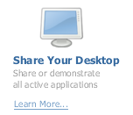

1. Click on the icon to share your whole Desktop

**Note: Please be aware that the customer will be able to see everything therefore it might be worth shutting down emails if certain information should not be seen by the customer.**

2. The following menu will appear on the bottom right hand side of screen;



3. Each option means the following;

 Stop sharing and return

 Temporarily freeze attendee view

Select content to share



 Assign control (don’t assign host but can change presenter)

 Draw on desktop

 Participants

 Chat (brings up chat screen)

 Video (brings up web conferencing)

**4. Recording a Meeting:**

1. Click on the following icon; 

**Please note: You will need to ensure the Recording Software has been downloaded, you can do this from the ‘Resource Centre’ on the left hand menu and click on downloads.**

2. Once recording, it will display the following icon on the right hand side of screen;



**Please note: This can take a few seconds to kick in. In addition as part of the data protection act, users must be notified that the webinar is being recorded.**

**5. Invite people:**

1. You have the option to invite people by email or phone as per below;



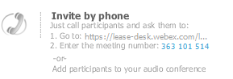

2. Click on the required option which will bring up the relevant pop up screen.

**6. Remind:**

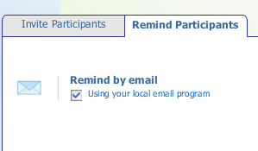

1. You can remind participants about a meeting if they have not logged in.

**7. Participants:**

1. Once logged in you can see how many participants are logged in. You can minimise this or maximise depending on what you wish to view.

**Note: You can remove this if required.**

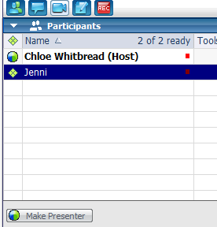

2. Other options available within this screen as chat, video, recording, and notes.

3. To enable chat, click on the following icon; .

4. You have the option to chat to specific individuals or all members as indicated below.

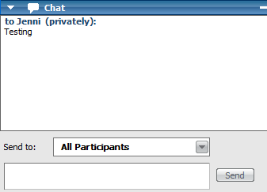 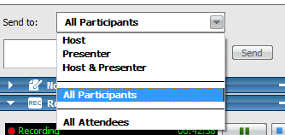

5. To enable video conferencing, click on 

6. To write notes on the webinar, click on 

7. You will then receive the following notes screen for you to write on;

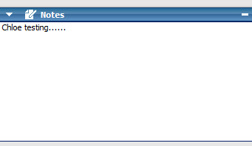

**8a. Changing Presenters:**

1. To give someone the right to be a presenter, click on their name and then right click ‘make a presenter’. The user can then also show all users within the webinar various documents or programmes.

**8b. To end a meeting:**

1. Either exit the screen or go to ‘File’ and select ‘End Meeting’ as per below.

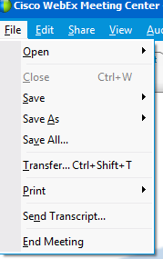

2. You may receive the following pop up menu if there have been any notes or chat messages from the webinar;

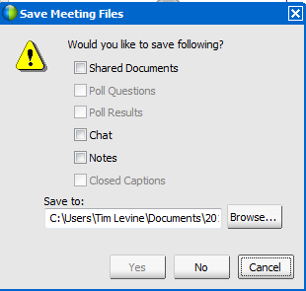

3. You can choose to save any of the information if required.

**9. Share items:**

1. On the top menu, click on ‘Share’ to being up various options available to you.

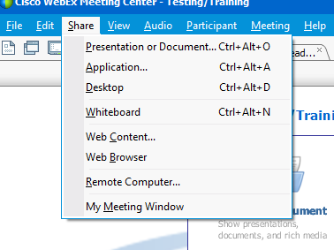

**10. Changing view settings:**

1. Click on ‘View’ on the main toolbar to see available options to you.

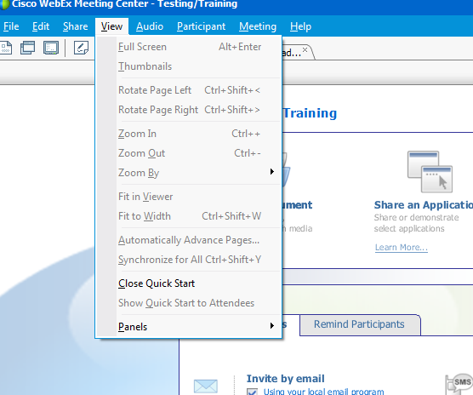

**11. Participant options:**

1. Click on ‘Participant’ to see available options to you (note, many of these are duplications from the icon images anyway).

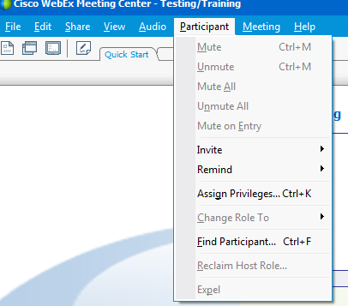

**12. Meeting information:**

1. Click on ‘Meeting’ and then ‘Information’ to view all information, such as total amount of users etc.

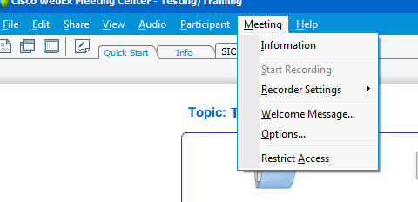

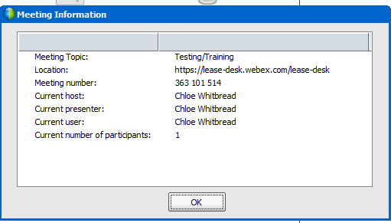

**13. Welcome message:**

1. You can customise the Welcome Message people receive when the log on. Select ‘Welcome Message’ from the ‘Meeting’ menu option as per below;

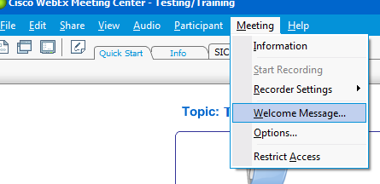

2. You will then be presented with the following screen;

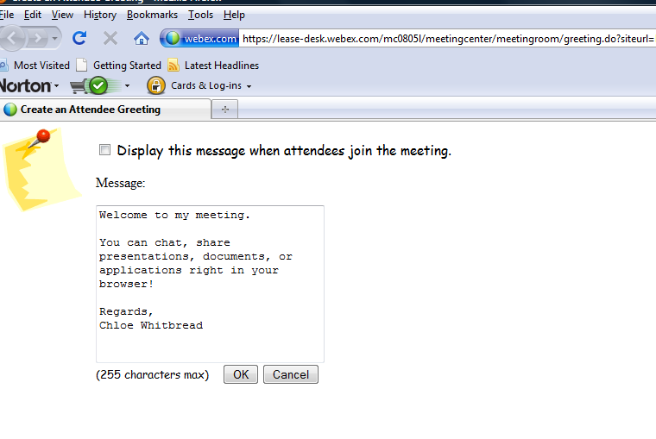

3. Change the message details as required and then click on ‘OK’.

**14. Forgotten User Name/Password & Support:**

If you have forgotten your log in details or require any support and/or assistance, contact Jenni at Premiere Global at the below details and she will be able to help;

|  |
| --- |
| **Jenni Platt** |
| **Key Business Account Manager** |
|  |
| **Premiere Global Services Inc** |
| **17 Godliman Street London - EC4V 5BD** |
|  |
| **Tel:    +44 (0) 207 890 7051** |
| **Mob:  +44 (0) 777 569 6860**  **Fax:**   **+44 (0) 207 106 6703**  **Web:** [**www.premiereglobal.co.uk**](http://www.premiereglobal.co.uk) |