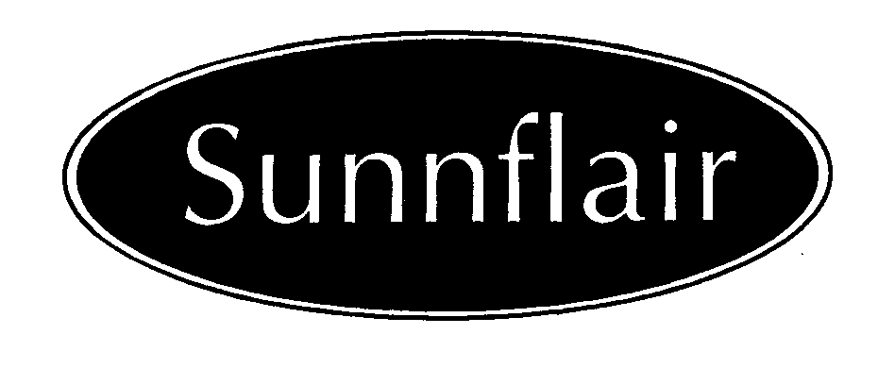
Party Tent

Instructions & Care

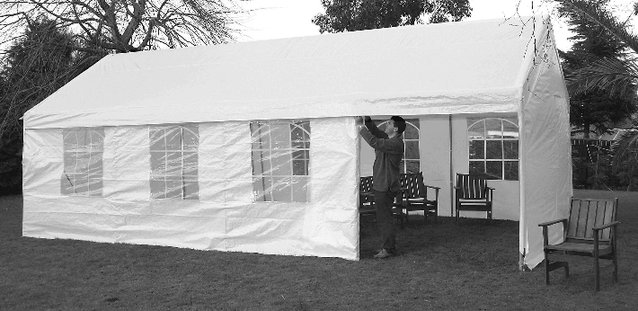

Congratulations on purchasing your new Sunnflair Party Tent. Your Party Tent will give you years of trouble free service and enjoyment if you follow these instructions carefully and look after your Party Tent correctly. Please read the instructions before attempting to pitch your Party Tent and retain them for future reference.

INSURANCE

We highly recommend that your Party Tent be insured against theft, storm and accidental damage. Storm damage, accidental damage and damage through incorrect storage is not covered under the warranty.

IMPORTANT- CHECK YOUR EQUIPMENT

Check the contents of the boxes in advance of using your Party Tent for the first time. We would recommend that you check that you have all the components at least 2 weeks prior to first using the product. Ensure that you are familiar with the pitching of the Party Tent and that all parts are accounted for. You should familiarise yourself with the tent including any limitations it may have for your particular use. A Party Tent is a portable structure, which under most circumstances will provide comfortable shelter against the elements. There are however extremes of weather for which allowance should be made. PLEASE DON’T BLAME THE TENT.

SUITABILITY

Position: Sheltered Lowland/Valley
Weather: Fair/Moderate

Sunnflair Party tents are not guaranteed waterproof. We do however endeavour to make them as weatherproof as possible. Where necessary/possible we have welded the seams but on some seams this is not feasible. It is therefore possible that a small amount of leakage may occur in heavy rain. Treating all sewn seams with a seam sealant, which is available from your supplying dealer, can prevent this.

TIE DOWN KITS

We recommend that all Party Tents be secured using our Tie Down Kits. These are available from your supplying dealer. The fixings supplied with these kits are suitable for most ground types but it may be necessary to purchase additional fixings for some ground types.

Where it is not possible to fix the Party Tent into the ground, alternative arrangements should be made.

ASSEMBLY

Find a level piece of ground on which to pitch your Party Tent. Ensure that you have enough help to lift the Party Tent without straining yourself or the frame.

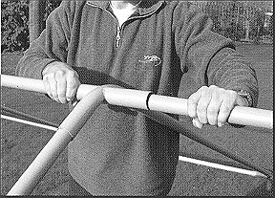
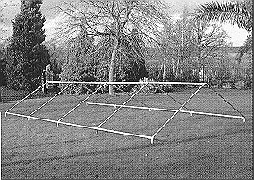
- Lay out the roof frame. Ensure all parts are in their correct positions and then assemble roof frame in the required position. Start with the apex.

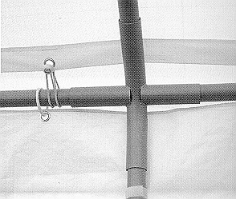
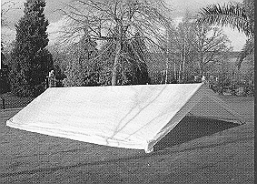
- Lay the roof canvas over the frame and attach using bungees.

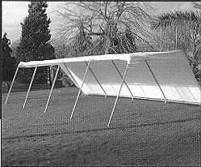

- Using an adequate number of people, lift one side of the Party Tent and insert the legs. Ensure that the holes in the leg poles are placed towards the bottom.

- If you intend to use the end wall panels it is easier to attach these now, before the Party Tent is at full height.

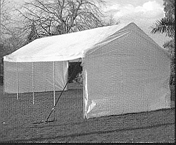
- Lift the other side, of the roof, and attach the legs.

IT IS IMPORTANT THAT YOU TAKE CARE IN WINDY WEATHER. IT MAY BE NECESSARY TO TIE DOWN YOUR PARTY TENT AT ANY STAGE DURING THE ASSEMBLY.

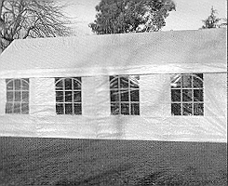
- Attach the sidewalls using the same bungees as the roof for the top fixings.

- Attach the base plates to the bottom of all the legs using the bolts provided. These feet can be pegged down on soft ground or can be semi-permanently attached to a hard standing (fixings not supplied).

- Peg down the bottom of each side and end wall.

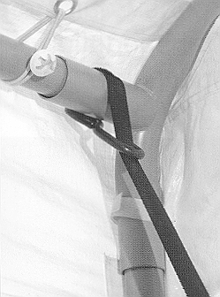
9. Secure with Tie Down Kits as necessary

SECURING

It is very important that this unit is secured against wind. We recommend the use of our tie down kits (optional at extra cost). Although the unit is supplied with four guy lines and attachment points on the roof corners, we recommend that the unit be secured by attaching our tie down kits to the frame.
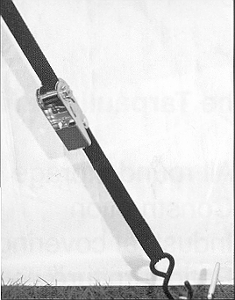
Secure the ratchet tie down around the frame

Attach ratchet tie down to ground using peg and
adjust until tight

On hard standing it will be necessary to make alternative fixing arrangements for holding the tie downs. It is also possible to semi-permanently fix the feet, of the Party Tent, to hard standing (fixings not supplied).

REMOVE THE COVER BEFORE A STORM OR STRONG WINDS.
FIRE PRECAUTIONS - REMEMBER, YOUR PARTY TENT CAN BURN. FOLLOW THESE COMMON SENSE RULES

- Do not place cooking, heating or lighting appliances near the sides or the roof of the Party Tent
- Always observe safety instructions for all appliances
- Keep exits clear/unobstructed
- Do not light fireworks in the Party tent

TAKING DOWN YOUR PARTY TENT

Reverse the assembly instructions. TAKE GREAT CARE IN WINDY CONDITIONS AND ENSURE THAT YOU HAVE ENOUGH HELP TO PREVENT STRAIN ON THE FRAME.

DRY ALL PARTS AT THE EARLIEST OPPORTUNITY. DO NOT PUT AWAY WET.

YOUR PARTY TENT IS NOT COVERED UNDER WARRANTY IF DAMAGE OCCURS DUE TO INCORRECT DISMANTLING, PACKING OR STORAGE

STORAGE

During long periods of inactivity and during the winter months, it is essential that the roof, walls and bungees are stored in a warm dry environment. Failure to do this may result in mildew damage to these parts.

The frame should also be stored in a completely dry environment. A light coating of petroleum jelly will help prevent corrosion.

Please note your Party Tent is not covered under warranty if it is stored incorrectly.

CLEANING

Roof and walls Clean with a soft cloth or brush using mild detergent solution
Frame Brush of dirt and then wash with soapy water. Dry thoroughly.

CARE

- Ultra violet rays from the sun will damage the roof and walls of the Party Tent. Dismantle and store your Party Tent when it is not needed.
- Treat scratches on the frame with a rust treatment as soon as they occur.
- Check and if necessary replace bungees at regular intervals. Spare bungees are available for purchase from your dealer.

WARNING

It may be necessary to take your Party Tent down in windy conditions. Do not leave it unattended for long periods of time. Constantly review the weather conditions and check to make sure it is secure.

SPARE PARTS

Should you damage or lose any parts of your Party Tent, spares are available from your Party Tent dealer. In case of difficulty contact Sunnflair direct. IMPORTANT: For all warranty claims please contact your Party Tent dealer - do not contact Sunnflair. Warranty claims must be processed through your dealer. Sunnflair cannot process a warranty claim for you direct. Please note that storm/weather/accident damage and damage through incorrect dismantle, packing and storage is not covered by the warranty.

IMPORTANT: PLEASE READ CAREFULLY

Because we have no control over the weather, we cannot be held responsible for any damage caused by wind or snow to the tent or by the tent. We strongly recommend that you contact your insurance company and obtain the appropriate cover.

ACCESSORIES

TIE DOWN KITS
Ensure that your Party tent is anchored securely using our tie down kits.

GROUNDBARS
These easy to attach Ground Bar Sets give your Party Tent™ added stability, especially when used on hard standing. They link each leg together, essentially creating a frame around the base to which the bottom of each wall can be attached by bungee, no more flapping walls! This makes the whole structure even more stable. Individual sections can be left out to provide uninterrupted entry and exit points. The Ground Bars can be pegged to soft ground using our Ground Bar Stakes. On hard standing you can apply weights to the Ground Bars to provide more security. This is a “must have” accessory.

GUTTERS
Allow two or more Party Tents™ to be connected together along their lengths. Available in 6, 8, 10 & 12 metre lengths. Create the ideal Party Tent™ to cover your event!

ALL ACCESSORIES ARE AVAILABLE FROM YOUR PARTY TENT DEALER

www.partytent.co.uk

Sunnflair Limited
South Woodham Ferrers, Chelmsford, Essex CM3 5XJ, UK

