Coconut Surveillance is a system that combines phone based notifications from health facilities, a team of surveillance officers using tablets for household followups, and a management team that responds to the data.

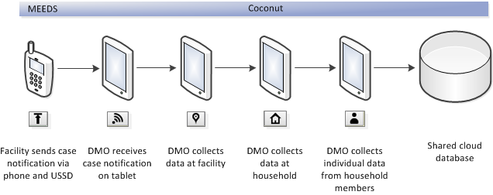

In Coconut Surveillance, there are four kinds of interactions that lead to data being captured. The following sections describe the process in detail.

# Case Notification

The health facility sends a notification that a new malaria case has been detected via their mobile phone. When this notification is received, a SMS is sent to the DMSO for that health facility. This SMS tells the DMSO that they have a new case to followup. They must then get their tablet online (via mobile network or wifi) and press the "Get Data" button. This will download all new case data within that DMSO's district of responsibility and save it as a Case Notification record. The data is as follows:

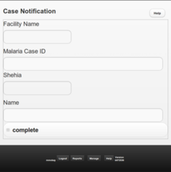

# Facility

(describe what happens when a case is found in)

The DMSO goes to the facility that reported the case. They will then look through the appropriate documents and registers to capture the required data.

Notes:

If a DMSO finds a case that they should have received a notification for, but have not, then they should help the health facility to report the notification immediately. Since the DMSO may not have internet access, and therefore are unable to download the just created notification, they can write down the case details on paper, and then add it to their tablet once it gets online and downloads the data. This will save them from having to visit the facility again.

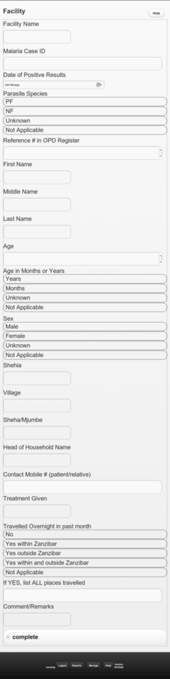

# Household

1. After data is collected from the reporting facility, the DMSO will use the information to find the household here the patient lives. This usually involves calling the patient or going to the house of the Sheha to find the correct household. The following data is collected:

* Reason for visiting household
* Malaria Case ID
* Head of Household Name
* Shehia
* Village
* Sheha/Mjumbe
* Contact Mobile # (patient/relative)
* Household Location
* Number of LLIN
* Number of Sleeping Places (beds/mattresses)
* Number of Household Members with Fever or History of Fever Within Past Week
* Number of Household Members Treated for Malaria Within Past Week
* Index case: If patient is female 15-45 years of age, is she is pregant?
* Index case: Patient's current status
* Index case: Patient's treatment status
* Index case: Slept under LLIN last night?
* Last date of IRS
* complete

Note that the household location is captured using GPS technology. For this to work, the DMSO does not need an internet connection, but they do need a clear path to the sky. So the location should be captured standing outside in a clear area (not covered in trees if possible).

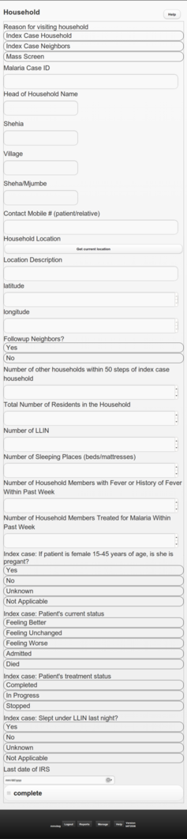

# Household Member

1. Based on the number of household members ans

