Qscintilla documentation
(A learn-by-example guide)

This documentation assumes a basic knowledge of the Python programming language. But even if you are a complete beginner in the language do not get discouraged, the examples should be quite understandable regardless.
All examples will use the Python 3 programming language and the PyQt5 application framework. To change the examples to Python 2 or the PyQt4 is quite simple and in most cases, trivial.
For in-depth information about Qt, PyQt, Scintilla and QScintilla go to the official documentation websites.
Table of Contents
1. Introduction 4
1.1. What is QScintilla? 4
1.2. Some QScintilla features 4
1.3. QScintilla object overview 5
1.3.1. PyQt5.Qsci.QsciScintillaBase 5
1.3.2. PyQt5.Qsci.QsciScintilla 5
1.3.3. PyQt5.Qsci.QsciLexer 5
1.3.4. PyQt5.Qsci.QsciAPIs 6
1.4. PyQt objects used by QScintilla 6
1.4.1. PyQt5.QtWidgets.QApplication 6
1.4.2. PyQt5.QtWidgets.QMainWindow 6
1.4.3. PyQt5.QtWidgets.QWidget 6
1.4.4 PyQt5.QtGui.QFont 6
1.5. QScintilla visual description 8
1.5.1. Editing area 8
1.5.2. Margin area 8
1.5.3. Scroll bar area 9
1.5.4. Autocompletion windows 9
1.5.5. Context menu 10
1.6. QScintilla's default settings 10
1.6.1. Default lexer 10
1.6.2. Default font 10
1.6.3. Default paper 11
1.6.4. Default keyboard shortcuts 11
1.6.5. Default scroll bar behaviour 12
1.6.6. Default margin 12
1.6.7. Default autocompletion behaviour 12
1.6.8. Default mouse behaviour 12
1.6.9. Default encoding 13
2. Installation guide 14
2.1. Windows 14
2.2. GNU/Linux 14
2.3. Mac OS 14
3. QScintilla options 16
3.1. Text wrapping 16
3.1.1. Text wrapping mode 16
3.1.2 Text wrapping visual flags 17
3.1.3 Text wrapping indent mode 18
3.2. End-Of-Line (EOL) options 19
3.2.1. End-Of-Line mode 19
3.2.2. End-Of-Line character/s visibility 19
3.3. Indentation options 20
3.3.1. Indentation character (tabs or spaces) 20
3.3.2. Indentation size 20
3.3.3. Indentation guides 20
3.3.4. Indentation at spaces options 21
3.3.5. Automatic indentation 21
3.4. Caret options (cursor representation) 22
3.4.1. Caret foreground color 22
3.4.2. Caret line visibility 22
3.4.3. Caret line background color 23
3.4.3. Caret width 23
4. Basic examples 24
4.1. Qscintilla's “Hello World” example 24
4.1.1. Code breakdown 24
4.2. Customization example 25
4.2.1. Code breakdown 25
FUTURE CHAPTERS: 29
Creating a Nim programming language lexer 29
X. Appendix: code examples 30
X.1. Hello World 30
X.2. Customization 30

1. Introduction
This chapter assumes you know nothing about QScintilla or PyQt and will guide you step by step to understanding the basics of the PyQt framework and the QScintilla editing component.

1.1. What is QScintilla?
QScintilla is a text editing component for the Qt application framework written in the C++ programming language. It is a wrapper for the Scintilla text editing component created by Neil Hodgson also written in the C++ programming language. The Qt application framework is a set of objects, also referred to as widgets, that help making GUI (Graphical-User-Interface) and other types of applications easier and is cross-platform.
PyQt is a set of Python bindings to the Qt application framework, which also includes bindings to the QScintilla component. So hurray, we can use QScintilla in Python. This introduction chapter will focus solely on the PyQt's QScintilla component, other PyQt components will only be mentioned when they are needed with regards to the QScintilla component.
As PyQt is a wrapper for Qt framework, it cannot be avoided that some parts of Qt will have to be described in order to understand the documentation. Sometimes I will even mention some C++ code, but only when it is absolutely necessary.
The referencing of QScintilla / Scintilla will seem confusing at first but do not get discouraged, just keep in mind that QScintilla component is just the Scintilla text editing component wrapped in a Qt QWidget object so it can be used in the Qt framework, and PyQt's QScintilla component is just the QScintilla component wrapped in Python!
Also later in the document I will use the terms QScintilla, Qscintilla document, editor, object or widget interchangeably. All terms mean the QScintilla editing component.

1.2. Some QScintilla features
- Built-in syntax highlighting for more than 30 programming languages
- Create syntax highlighting for custom purposes
- Text styling: underlining, highlighting, …
- Clickable text (called Hotspots in QScintilla)
- Word wrapping
- Autocompletion functionality and call tips
- Error indicating, bookmarks, … using the margins of the document
- Code folding
- Selecting various font styles and colors
- Mixing font styles in the same document
- Customizing keyboard commands
- Block selection of text
- Zooming text in / out
- UTF-8 support
- Command macros (call sequences of commands with one command)
- Customizing the Caret (the blinking marker that shows where the cursor is located)
- Built-in search and replace functionality
- ...
Plus with Python and the entire PyQt framework at your disposal, you will be able to do much, much more.

1.3. QScintilla object overview
All QScintilla objects are part of the PyQt framework under the PyQt5.Qsci module. The below listed objects will be covered in depth (some more than others) in this documentation.

1.3.1. PyQt5.Qsci.QsciScintillaBase
The base object for text editing. This is a more direct low level wrapper to access all of the underlying Scintilla functionality. It is used when you cannot implement something in the higher level PyQt5.Qsci.QsciScintilla object.

1.3.2. PyQt5.Qsci.QsciScintilla
The high level object for text editing. It is a subclass of the low level PyQt5.Qsci.QsciScintillaBase object, which just means it has access to all of the PyQt5.Qsci.QsciScintillaBase methods and attributes. This object will be used most of the time for all text editing purposes you will need and has a very Qt-like API. When using the name QScintilla, I will always be referring to this object.

1.3.3. PyQt5.Qsci.QsciLexer
The abstract object used for styling text (syntax highlighting) usually in the context of a programming language. This is an abstract object and has to be sub-classed to make a custom lexer. There are many built-in lexers already available such as: QsciLexerPython, QsciLexerRuby, … The lexer needs to be applied to an instance of a PyQt5.Qsci.QsciScintilla object for it to start styling the text.

1.3.4. PyQt5.Qsci.QsciAPIs
The object used for storing the custom autocompletion and call tip information. In a nutshell, you assign it to an instance of the sub-classed PyQt5.Qsci.QsciLexer with autocompletions / call tips enabled, add keywords to it and you get custom autocompletions in the editor.

1.4. PyQt objects used by QScintilla
There are various PyQt objects needed to customize the QScintilla component, while some are needed to initialize the PyQt application.

1.4.1. PyQt5.QtWidgets.QApplication
The QApplication object manages the GUI application's control flow and main settings. It's the object that needs to be initialized and executed to get QScintilla shown on the screen.

1.4.2. PyQt5.QtWidgets.QMainWindow
This object provides the main application window. It should always be used a the main window widget. If you are creating a simple QScintilla editor without any bells and whistles, just create

1.4.3. PyQt5.QtWidgets.QWidget
The QWidget object is the base object of all user interface objects. The QScintilla object and all other GUI object inherit from this object, that is why it is relevant.
From the official Qt 5 documentation:
The widget is the atom of the user interface: it receives mouse, keyboard and other events from the window system, and paints a representation of itself on the screen. Every widget is rectangular, and they are sorted in a Z-order. A widget is clipped by its parent and by the widgets in front of it.
A widget that is not embedded in a parent widget is called a window. Usually, windows have a frame and a title bar, although it is also possible to create windows without such decoration using suitable window flags). In Qt, QMainWindow and the various subclasses of QDialog are the most common window types.

1.4.4 PyQt5.QtGui.QFont
QScintilla uses PyQt's QFont object for describing fonts. The QFont object resides in the PyQt5.QtGui module. The relevant attributes of the QFont object with regards to QScintilla are:
- family: style of the font. Some examples are: Courier, Times, Helvetica, ...
- pointSize: size of the font in points. If it is set to lower than 1, it will default to the system default size
- weight: font thickness from 0 (ultralight) to 99 (extremely black). The predefined values are QFont.Light, QFont.Normal, QFont.DemiBold, QFont.Bold and Qfont.Black.
- italic: tilted text, True or False.
For more detailed information on this object, see the PyQt's web documentation.
You may be wondering how do you change the color of the font, right? This is what styling does, which will be described in a later chapter.

1.5. QScintilla visual description
Here I will describe the parts of the QScintilla component that will be discussed throughout this document, so you will have a clear idea of what goes where. A more detailed look into these parts will follow in a later chapter.

1.5.1. Editing area
This is where all of the editing and styling (coloring, ...) of text happens. Text is edited using the mouse and keyboard, but it may also be manipulated in Python code. The editing area is swhon in the red rectangle in the image below.
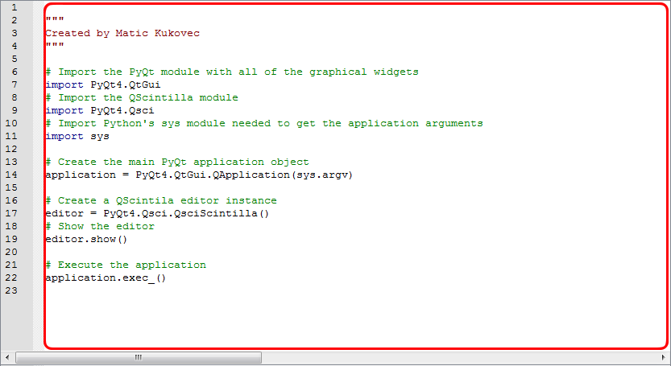

1.5.2. Margin area
This is where the margins of the QScintilla document are located. Margins are the sidebars that can show line numbers, where there is the option for code folding, showing error indicators, showing bookmarks and anything else you can think of. The QScintilla can have up to 7 margins (I think?). The margin area is shown in the image below.
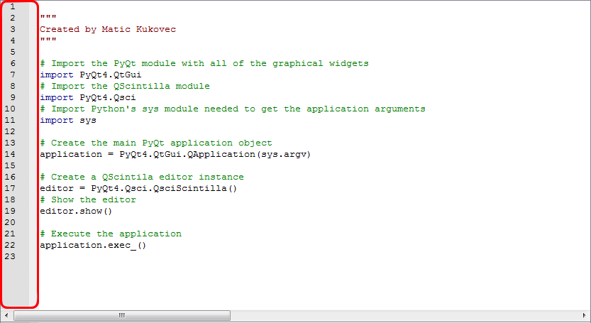

1.5.3. Scroll bar area
This is is the area where the scroll bars are shown. The horizontal vertical bar is always present, while the vertical scroll bars is shown depending on the number of lines in the document and the documents window size. The scroll bar area is shown in the image below.
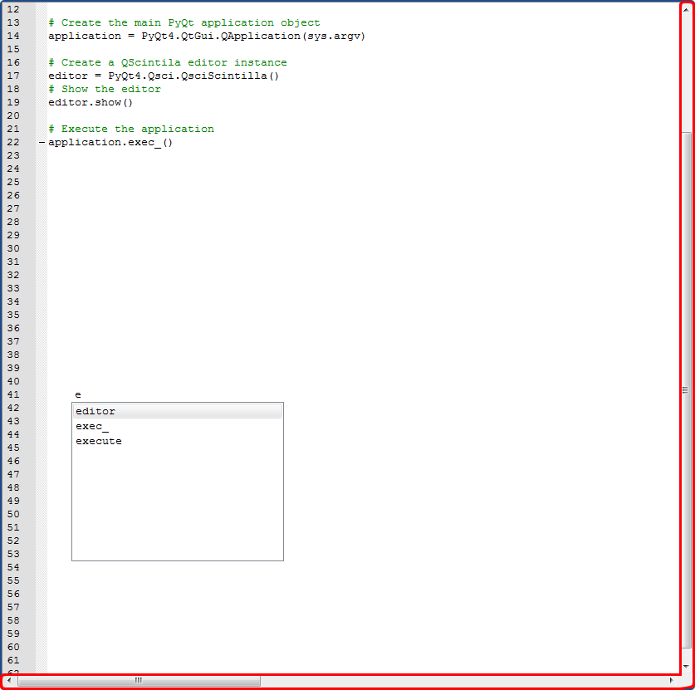

1.5.4. Autocompletion windows
When autocompletions are active in the document, the documentation window show sthe current autocompletion suggestions. By default, autocompletion is not enabled. An example autocompletion window is shown in the image below.
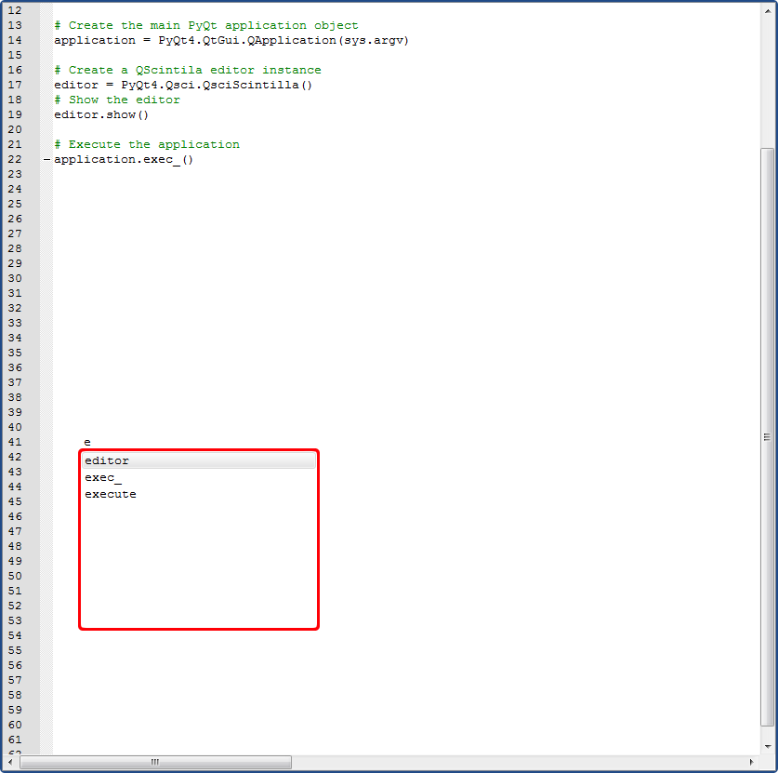

1.5.5. Context menu
By default there is only the right-click context menu that shows some standard editing options in the QScintilla component. Custom context menus can be added in Python code, but they use other parts of the PyQt framework that will not be covered in this documentation. QScintilla's default context menu is shown in the image below.
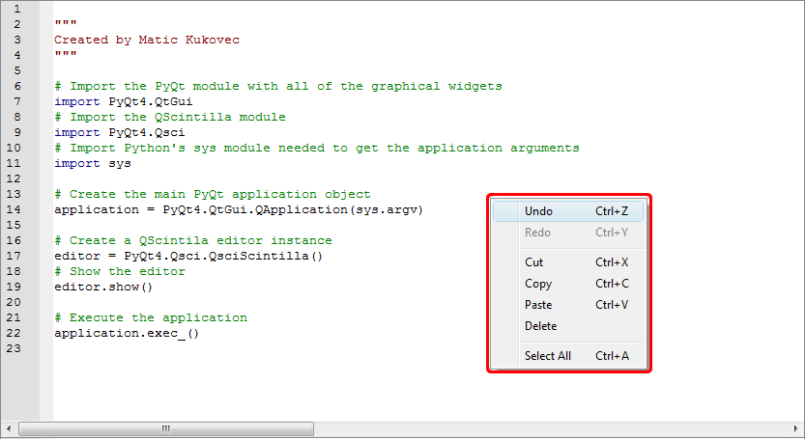

1.6. QScintilla's default settings
Below are QScintilla's default settings. These are the setting when you create an instance of the QScintilla component without setting any of it's options.

1.6.1. Default lexer
By default, there is NO lexer set for the QScintilla editing component when it is first created. Sometimes I will also say that the lexer is disabled, but it means the same thing, that no lexer is set for the editor.

1.6.2. Default font
The default font used by QScintilla when NO lexer is set depends on the operating system you are using. On Windows it is MS Shell Dlg 2, while on GNU/Linux Debian Jesse it is Roboto.
The default font color is black. The size of the font depends on your system's settings. I have not had the opportunity to test on other systems.
When there is a lexer set for the document, it overrides any settings that you have manually set previously. If you are trying to set some font style or color directly and nothing is happening, it means that a lexer is set on the document and is always overriding the changes you are trying to make.

1.6.3. Default paper
In QScintilla the background of the document is called the paper. The paper is the background color of the document. By default the paper is white.
Here it's the same as with the font. If you are trying to set the paper color directly and nothing is happening, it means that a lexer is set on the document and is always overriding the changes you are trying to make.

1.6.4. Default keyboard shortcuts
Below is the list of the default shortcuts used by QScintilla.
(NOTE: FIX ALL OF THE DESCRIPTIONS BELOW)
- 'Down': Move one line down
- 'Down+Shift': Extend selected text one line down
- 'Down+Ctrl': Scroll the view one line down
- 'Down+Alt+Shift': Block extend selection one line down
- 'Up': Move one line up
- 'Up+Shift': Extend selected text one line up
- 'Up+Ctrl': Scroll the view one line up
- 'Up+Alt+Shift': Block extend selection one line up
- '[+Ctrl': Move paragraph up
- '[+Ctrl+Shift': Extend selection one paragraph up
- ']+Ctrl': Move paragraph down
- ']+Ctrl+Shift': Extend selection one paragraph down
- 'Left': SCI_CHARLEFT
- 'Left+Shift': SCI_CHARLEFTEXTEND
- 'Left+Ctrl': SCI_WORDLEFT
- 'Left+Shift+Ctrl': SCI_WORDLEFTEXTEND
- 'Left+Alt+Shift': SCI_CHARLEFTRECTEXTEND
- 'Right': SCI_CHARRIGHT
- 'Right+Shift': SCI_CHARRIGHTEXTEND
- 'Right+Ctrl': SCI_WORDRIGHT
- 'Right+Shift+Ctrl': SCI_WORDRIGHTEXTEND
- 'Right+Alt+Shift': SCI_CHARRIGHTRECTEXTEND
- '/+Ctrl': SCI_WORDPARTLEFT
- '/+Ctrl+Shift': SCI_WORDPARTLEFTEXTEND
- '\\+Ctrl': SCI_WORDPARTRIGHT
- '\\+Ctrl+Shift': SCI_WORDPARTRIGHTEXTEND
- 'Home': SCI_VCHOME
- 'Home+Shift': SCI_VCHOMEEXTEND
- 'Ctrl+Home': SCI_DOCUMENTSTART
- 'Ctrl+End': SCI_DOCUMENTSTARTEXTEND
- 'Home+Alt': SCI_HOMEDISPLAY
- 'Home+Alt+Shift': SCI_VCHOMERECTEXTEND
- 'End': SCI_LINEEND
- 'End+Shift': SCI_LINEENDEXTEND
- 'Ctrl+End': SCI_DOCUMENTEND
- 'Ctrl+Shift+End': SCI_DOCUMENTENDEXTEND
- 'End+Alt': SCI_LINEENDDISPLAY
- 'End+Alt+Shift': SCI_LINEENDRECTEXTEND
- 'PageUp': SCI_PAGEUP
- 'Shift+PageUp': SCI_PAGEUPEXTEND
- 'PageUp+Alt+Shift': SCI_PAGEUPRECTEXTEND
- 'PageDown': SCI_PAGEDOWN
- 'Shift+PageDown': SCI_PAGEDOWNEXTEND
- 'PageDown+Alt+Shift': SCI_PAGEDOWNRECTEXTEND
- 'Delete': SCI_CLEAR
- 'Delete+Shift': SCI_CUT
- 'Ctrl+Delete': SCI_DELWORDRIGHT
- 'Ctrl+Shift+BackSpace': SCI_DELLINERIGHT
- 'Insert': SCI_EDITTOGGLEOVERTYPE
- 'Insert+Shift': SCI_PASTE
- 'Insert+Ctrl': SCI_COPY
- 'Escape': SCI_CANCEL
- 'Backspace': SCI_DELETEBACK
- 'Backspace+Shift': SCI_DELETEBACK
- 'Ctrl+BackSpace': SCI_DELWORDLEFT
- 'Backspace+Alt': SCI_UNDO
- 'Ctrl+Shift+BackSpace': SCI_DELLINELEFT
- 'Ctrl+Z': SCI_UNDO
- 'Ctrl+Y': SCI_REDO
- 'Ctrl+X': SCI_CUT
- 'Ctrl+C': SCI_COPY
- 'Ctrl+V': SCI_PASTE
- 'Ctrl+A': SCI_SELECTALL
- 'Tab': SCI_TAB
- 'Shift+Tab': SCI_BACKTAB
- 'Return': SCI_NEWLINE
- 'Return+Shift': SCI_NEWLINE
- 'Add+Ctrl': SCI_ZOOMIN
- 'Subtract+Ctrl': SCI_ZOOMOUT
- 'Divide+Ctrl': SCI_SETZOOM
- 'Ctrl+L': SCI_LINECUT
- 'Ctrl+Shift+L': SCI_LINEDELETE
- 'Ctrl+Shift+T': SCI_LINECOPY
- 'Ctrl+T': SCI_LINETRANSPOSE
- 'Ctrl+D': SCI_SELECTIONDUPLICATE
- 'U+Ctrl': SCI_LOWERCASE
- 'U+Ctrl+Shift': SCI_UPPERCASE

1.6.5. Default scroll bar behaviour
By default, only the horizontal scroll bar is shown and it has a default starting length. The horizontal scroll bar automatically grows as you enter more text and adjusts itself to the longest line in the document. The vertical scroll bar also shrinks automatically when you delete text form the lines, but it shrinks back to it's default size.
The vertical scroll bar appears only when there are more lines than can be shown in the current QScintilla document. When you add lines the vertical scroll bar grows automatically, while when you delete lines it shrinks automatically.

1.6.6. Default margin
The QScintilla shows one margin by default. It's behaviour is, that it selects the text of the line next to the position where the user has left-clicked on the margin using the mouse.

1.6.7. Default autocompletion behaviour
By default, autocompletion are disabled.

1.6.8. Default mouse behaviour
The default mouse behaviour is text selection with holding the left mouse button and dragging the mouse. Right clicking anywhere in the document shows the contex menu. By default the context menu has the following options: Undo, Redo, Cut, Copy, Paste, Delete and Select All.
When there is text selected in the editor

1.6.9. Default encoding
The default encoding is ASCII. Unknown characters will appear as the questionmark (?) symbol.

2. Installation guide
Note that in this installation guide I mention QScintilla2. QScintilla is at version 2.9.3 at the moment, this is where the 2 comes from.
Installing PyQt5 using pip as described below can be done ONLY with Python3.5 at the moment.

2.1. Windows
Install the latest PyQt5 library for your version of Python 3, this can be done easily using the pip package manager (if you have it installed) with the following command in the windows console:
pip install PyQt5
The other option is to install the Visual Studio version that your Python 3 version was compiled with and compile the from source from their official website. You will also need to download the SIP library source code. Download the source code and follow the instructions in the readme/install files. You'll also need the Qt5 C++ source code.

2.2. GNU/Linux
If you are on Lubuntu, Raspbian or probably most Debian derivatives, install the following libraries using apt-get:
- python3.x (Probably already installed on the system)
- python3-pyqt5
- python3-pyqt5.qsci
Another option is as on Windows using pip with the following command in your favourite terminal:
pip3 install PyQt5
Notice it's pip3 on GNU/Linux as it usually has both Python2 and Python3 installed.
Otherwise you can install PyQt5 and QScintilla2 (you will also need the SIP library) from source from their official website. Download the source code and follow the instructions in the readme/install files. You'll also need the Qt5 C++ source code.

2.3. Mac OS
Install the latest Python3 version and the pip package manager and use the following command in the terminal:
pip install PyQt5
Another thing you can try is using Anaconda Python 3 and it's package manager to install all dependencies. Here is the more information.
I don't know much about Mac's, but you can try using the default Mac package manager to find the PyQt5 and QScintilla2 libraries or install the libraries from source, same as on GNU/Linux.

3. QScintilla options
This chapter will be an in depth description of all QScintilla options.

3.1. Text wrapping
Text wrapping disables or enables multiple types of text wrapping, which means breaking lines that are longer than what the QScintilla editor can show in the editor screen into multiple lines.

3.1.1. Text wrapping mode
Set with method: setWrapMode(wrap_mode)
Queried with method: wrapMode()
wrap_mode parameter options:
- PyQt5.Qsci.QsciScintilla.WrapNone
No wrapping. Lines that exceed the editor's screen width cannot be seen unless you scroll horizonstally using the mouse or with the cursor.
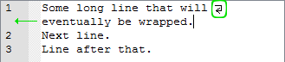
- PyQt5.Qsci.QsciScintilla.WrapWord
Lines are wrapped at words. Example:
Note the line wrap character and that the wrapped line has no line number (if there is a line margin present in the QScintilla editor). The other wrap visualisation options will be shown later.
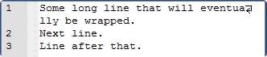
- PyQt5.Qsci.QsciScintilla.WrapCharacter
Lines are wrapped at the character boundaries. Example:
- PyQt5.Qsci.QsciScintilla.WrapWhitespace
Lines are wrapped at the whitespace boundaries. Example:
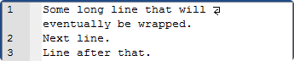

3.1.2 Text wrapping visual flags
These method selects how the text wrapping will be indicated in the QScintilla editor.
Set with method: setWrapVisualFlags(endFlag, startflag, indent)
endFlag parameter options:
- PyQt5.Qsci.QsciScintilla.WrapFlagNone
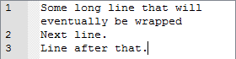
- PyQt5.Qsci.QsciScintilla.WrapFlagByText
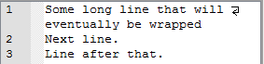
- PyQt5.Qsci.QsciScintilla.WrapFlagByBorder
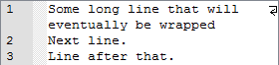
- PyQt5.Qsci.QsciScintilla.WrapFlagInMargin
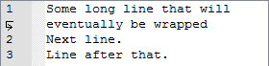
startflag parameter options:
- PyQt5.Qsci.QsciScintilla.WrapFlagNone
- PyQt5.Qsci.QsciScintilla.WrapFlagByText or PyQt5.Qsci.QsciScintilla.WrapFlagByBorder
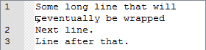
- PyQt5.Qsci.QsciScintilla.WrapFlagInMargin (same effect as the endflag parameter)
indent parameter options:
- This parameter sets the number of spaces each wrapped line is indented by. It has to be an int. It effects can be seen ONLY if setWrapIndentMode is set to PyQt5.Qsci.QsciScintilla.WrapIndentFixed!

3.1.3 Text wrapping indent mode
Selects how wrapped lines are indented.
Set with method: setWrapIndentMode (indent_mode)
indent_mode parameter options:
- PyQt5.Qsci.QsciScintilla.WrapIndentFixed (with setWrapVisualFlags indent parameter set to 4!)
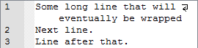
- PyQt5.Qsci.QsciScintilla.WrapIndentSame
Indents the same as the first wrapped line. In the below example, the first line is indented by two whitespaces.
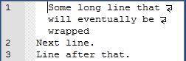
- PyQt5.Qsci.QsciScintilla.WrapIndentIndented
Indents the same as the first wrapped line PLUS one more indentation level. Indentation level is by the setTabWidth method.
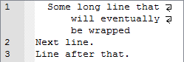

3.2. End-Of-Line (EOL) options
These options effect the End-Of-Line settings like the End-Of-Line character and mode for the QScintilla editor. By default the line endings are invisible but can be made visible with the setEolVisibility method, described below.

3.2.1. End-Of-Line mode
Set with method: setEolMode(eol_mode)
Queried with method: eolMode()
indent_mode parameter options:
- PyQt5.Qsci.QsciScintilla.EolWindows: Carrige-Return + Line-Feed (\r\n)
- PyQt5.Qsci.QsciScintilla.EolUnix: Line-Feed (\n)
- PyQt5.Qsci.QsciScintilla.EolMac: Carrige-Return (\r)

3.2.2. End-Of-Line character/s visibility
This selects the visibility of the EOL character/s in the editor window. By default it is not visible.
Set with method: setEolVisibility(visibility)
Queried with method: eolVisibility()
visibility parameter options:
- False: The EOL character/s is/are NOT visible
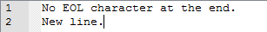

- True: The EOL character/s is/are visible (marked in green in the image below)
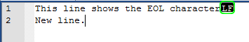

3.3. Indentation options
These options select the indentation character, indentation size, ...

3.3.1. Indentation character (tabs or spaces)
This selects whether the indent/unindent functions use either the TAB ('\t') character or the WHITESPACE (' ') character.
Set with method: setIndentationsUseTabs(use_tabs)
Queried with method: indentationsUseTabs()
use_tabs parameter options:
- False: Indentation uses the whitspace characters
- True: Indentation uses the tab character

3.3.2. Indentation size
Selects the number of space characters to indent by.
This means the number of space characters when indenting with WHITESPACES or the width of the TAB character in spaces when using TABS for indentation.
Set with method: setTabWidth(indentation_size)
Queried with method: tabWidth()
indentation_size parameter options:
- A number greater than zero: Number of space characters to indent by


3.3.3. Indentation guides
QScintilla can show vertical guiding lines at indentation columns as dotted lines. These guides are only visual guides, they do not effect the editor's text.
Set with method: setIndentationGuides (indents)
Queried with method: indentationGuides ()

- False: indentation guides not visible
Example:
- True: indentation guides visible
Example:

3.3.4. Indentation at spaces options
This one is a little confusing to explain without pictures. When indenting at a place in a line where there are ONLY whitespaces/tabs, if this option it set to True, then QScintilla indents and aligns the next NON-whitespace/tab character and the rest of the line to the indentation level and moves the cursor to the NON-whitespace/tab character.
But if set to False, then QScintilla just inserts an indentation, whether whitespaces or tabs.
This sounds confusing, but take a look at the examples shown in the images below.
Set with method: setTabIndents(indents)
Queried with method: tabIndents()
indents parameter options:
- False: Indentation simply inserts an indentation (whitespaces/tab) if indenting in a place in a line where there are only whitespaces to each side of the cursor.
Example:
Before indentation
After indentation (after pressing the TAB key). An indentation (whitespaces/tab) is inserted and the cursor moved the width of the indentation forward.

- True: Indentation indents and aligns the next non-whitespace/tab character to that indentation level and also moves the cursor to that indentation level.
Example:
Before indentation
After indentation (after pressing the TAB key). The next non-whitespace/tab character is aligned to the indentation and the cursor has aligned to the same indentation level.

3.3.5. Automatic indentation
When set to True, automatic indentation moves the cursor to the same indentation as the previous line when adding a new line by either pressing Enter or Return. But when set to False, the cursor will always move to the start of the new line.
NOTE: A lexer can modify this behaviour with it's setAutoIndentStyle method!
Set with method: setAutoIndent(autoindent_on)
Queried with method: autoIndent()
autoindent_on parameter options:

- False: The cursor moves to the start of the line when creating a new line.

- True: The cursor moves to the same indentation as the previous line.

3.4. Caret options (cursor representation)
These option set the way the cursor symbol looks and behaves.

3.4.1. Caret foreground color
This option sets the color of the cursor.
Set with method: setCaretForegroundColor(fg_color)
Queried with method: Not available directly
fg_color parameter options:
- PyQt5.QtGui.QColor: To set the caret color to for example blue, use PyQt5.QtGui.Qcolor("#ff0000ff").

3.4.2. Caret line visibility
This option enables or disables the coloring of the line that the cursor is on.
Set with method: setCaretLineVisible(visibility)
Queried with method: Not available directly
visibility parameter options:
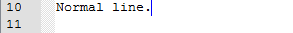
- False: The line the cursor is on is not colored.
- True: The line the cursor is on is indicated with the caret background color.
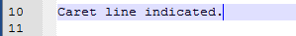

3.4.3. Caret line background color
This option sets the background color of the line that the cursor is on. The caret line visibility option has to be set to True for this option to be visible!
Set with method: setCaretLineBackgroundColor(bg_color)
Queried with method: Not available directly
bg_color parameter options:
- PyQt5.QtGui.QColor: To set the caret color to for example light blue, use PyQt5.QtGui.Qcolor("#1f0000ff").

3.4.3. Caret width
This option sets the caret width in pixels. 0 makes the caret invisible!
Set with method: setCaretWidth(size)
Queried with method: Not available directly
size parameter options:

- Integer: Size of the caret in pixels.

3.5. Autocompletion – Basic
Autocompletion is the functionality of the QScintilla editor to show suggestions for words from an autocompletion source while you are typing characters into the editor. The autocompletion source is selectable. The suggestions are shown in Autocompletion windows, which are described in 1.5.4. Autocompletion windows.
These are the basic options that do not need a lexer to be set for the editor and no API's loaded (lexer/API autocompletion options will be explained in the Advanced chapter).

3.5.1. Autocompletion case sensitivity
Set with method: setAutoCompletionCaseSensitivity(case_sensitivity)
Queried with method: autoCompletionCaseSensitivity()
case_sensitivity parameter options:
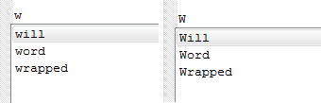
- False: Autocompletion is case IN-sensitive. This means that the letters in the word you are typing do not have to match the case of the words in the autocompletion source. Example (the autocompletion source contains ["will", "wrapped", "Word"]):
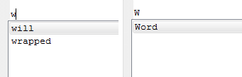
- True: Autocompletion in case sensitive. If you type a word that is in the autocompletion sources but does not match the case of the autocompletion source word, the word will not appear in the suggestion window. Example (the autocompletion source contains ["will", "wrapped", "Word"]):

3.6. Margins
Margins are the sidebars on the right of every QScintilla editor. They are shown in the image in chapter 1.5.2. Margin area.
If margins are not visible, which is the default, means that every margin has a width of 0.
By default margin 0 (the leftmost margin) is the line number margin, margin 1 is used to display non-folding (custom) symbols and margin 2 displays the folding symbols. But you can customize the order of the margins as you wish.
You can have up to 5 margins: 0, 1, 2, 3 and 4.
Margins have customizable type, width, background and foreground color, font type, sensitivity to mouse clicks, ...

3.6.1 Margin types
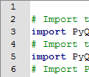
- Line number margin
The line number margin (by default margin 0) is the margin that displays the line numbers. The line margin does not resize automatically when lines are added to the document, so you have to resize it manually with the setMarginWidth function.
An example is shown in the image below:

- Symbol margin
The symbol margin (by default margin 1) can be used for displaying custom symbols (images) on each line of the margin.
Symbol margins have marker masks, which are used to filter which symbols can be shown on which line of the margin. Each symbol is bound to a marker which can be added to a margin. Think of markers as a wrapper around a symbol which you can add to a line number, then the margins determine if the marker can be shown on it using their marker masks. Markers will be explained in more detail in the next chapter.
In the image below is an example of a bookmark symbol on margin 1 in my Ex.Co. editor:
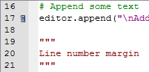
- Folding margin
The folding margin (by default margin 2) displays the folding symbols that are used for folding and unfolding lines that have been styled for folding. In the image below you can see the + and – symbols which are used to fold and unfold lines:
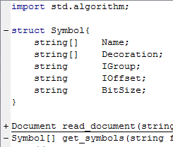
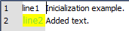
- Text margin
This margin is used for displaying text in the margin lines. The text style (size and family), font and paper color are selectable. In the image below is an example of a text margin with the first line set to the default text and styled green text on a yellow background on the second line:

3.6.2. Choosing a margin's type
Set with method: setMarginType(margin_number, margin_type)
Queried with method: marginType()
margin_number parameter options:
- Integer: Number of the margin
margin_type parameter options:
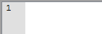
- PyQt5.Qsci.QsciScintilla.NumberMargin: Margin for displaying line numbers
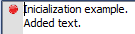
- PyQt5.Qsci.QsciScintilla.SymbolMargin: Margin for displaying custom symbols (images)
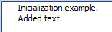
- PyQt5.Qsci.QsciScintilla.SymbolMarginDefaultBackgroundColor: Margin for displaying custom symbols (images) with the background color set to what the default paper color of the editor is. Below is an example of an white editor paper color and a white margin.
NOTE: This margin is NOT affected by the setMarginsBackgroundColor and setMarginsForegroundColor!

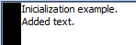
- PyQt5.Qsci.QsciScintilla.SymbolMarginDefaultForegroundColor: Margin for displaying custom symbols (images) with the background color set to what the default font color of the editor is. Below is an example of an editor with black font color and a black margin.
NOTE: This margin is NOT affected by the setMarginsBackgroundColor and setMarginsForegroundColor!
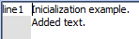
- PyQt5.Qsci.QsciScintilla.TextMargin: Margin for displaying text. The text can be styled, by default it is the same as the editor's default font and paper color.
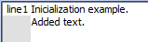
- PyQt5.Qsci.QsciScintilla.TextMarginRightJustified: Margin for displaying text. Same as the standard text margin with the text justified to the right.
- PyQt5.Qsci.QsciScintilla.SymbolMarginColor (NOT AVAILABLE PRE VERSION 2.10): Margin for displaying symbols, but it's background color is set with setMarginBackgroundColor.

3.6.2.1. Special line numbers method
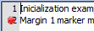
This is a special method which can set the visibility of line numbers on a margin, even if the margin is not the PyQt5.Qsci.QsciScintilla.NumberMargin type. This can either overwrite or combine the contents of the margin. An example of a symbol margin with line numbers visible and overlapping is shown below:
Set with method: setMarginLineNumbers(margin_number, line_numbers_visible)
Queried with method: marginLineNumbers (margin_number)
margin_number parameter options:
- Integer: Selected margin
line_numbers_visible parameter options:
- True: Line numbers visible
- False: Line numbers hidden

3.6.3. Set the number of margins (NOT AVAILABLE PRE VERSION 2.10)
Set with method: setMargins(number_of_margins)
Queried with method: margins()
number_of_margins parameter options:
- Integer: Number of used margins

3.6.4. Margin foreground color
By default the foreground (text) color of every margin is black.
Set with method: setMarginsForegroundColor(color) (ON QScintilla PRE VERSION 2.10 IT'S setMarginForegroundColor)
color parameter options:
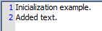
- PyQt5.QtGui.QColor: To change the margin foreground (text) color to blue for example, set it to PyQt5.QtGui.QColor("#0000ffff")

3.6.5. Margin background color
By default the background color of every margin (except for the SymbolMarginDefaultForegroundColor and SymbolMarginDefaultBackgroundColor) is grey.
Set with method: setMarginsBackgroundColor(color) (ON QScintilla PRE VERSION 2.10 IT'S setMarginBackgroundColor)
Queried with method: marginBackgroundColor (DOESN'T SEEM TO WORK IN QScintilla PRE VERSION 2.10)
color parameter options:
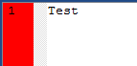
- PyQt5.QtGui.QColor: To change the margin background color to red for example, set it to PyQt5.QtGui.QColor("#ff0000ff")

3.6.6. Margin width
Set with method:
- setMarginWidth(margin_number, int_width)
- setMarginWidth(margin_number, width_string)
Queried with method: marginType(margin_number)
margin_number parameter options:
- Integer: Selected margin

int_width parameter options:
- Integer: Width of the margin in pixels.

width_string parameter options:
- String: A string (for example "0000") which will be used to automatically calculate the needed margin width based on the margin's font's style.

3.6.6. Margin sensitivity to mouse clicks
This option enables or disables mouse click emitting the marginClicked() signal (see PyQt documentation on signals for more details).
Set with method: setMarginSensitivity(margin_number, sensitivity)
Queried with method: marginSensitivity(margin_number)
margin_number parameter options:
- Integer: Selected margin

sensitivity parameter options:
- True: Enables the emitting of the marginClicked() signal
- False: Disables the emitting of the marginClicked() signal

3.6.7. Margin marker mask
A margin's marker mask is 32-bit integer number of which every bit represents the shown/hidden state of the marker (marker = symbol that can be displayed on the margin) on that margin. If a bit is 0 the marker is hidden and if it is 1 it is shown. Examples:
All markers enabled: 0b1111111111111111111111111111111
Marker 0 and 3 disabled: 0b1111111111111111111111111110110
Set with method: setMarginMarkerMask(margin_number, mask)
Queried with method: marginMarkerMask(margin_number)
margin_number parameter options:
- Integer: Selected margin

mask parameter options:
- Integer: A 32-bit integer that will be used as the mask

Example:
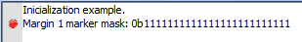
The below image has one margin (margin number 0) with marker number 1 added to it and the marker mask 0b1111111111111111111111111:
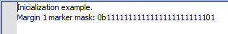
Now we change the margin's marker mask to 0b1111111111111111111111101 and the marker will be hidden:

3.6.8 Markers
Markers are a wrapper around the symbols (images) that you wish to display in a margin. In short, you put an image into a marker and add it to one or more margin's line.
Markers can have custom images or you can choose from a number of built-in symbols.
You can have a total of 32 markers, which is the total number of bits in a marker mask of every margin, but you can assign the same marker multiple times to multiple lines.

3.6.8.1 Defining a marker
There a four ways to define (create) a marker. You can use a built-in symbol, a single ASCII character, a QPixmap or QImage.
Defined with methods:
- markerDefine(builtin_symbol, marker_number)
builtin_symbol parameter options:
  - PyQt5.Qsci.QsciScintilla.MarginSymbol: Built-in symbols, which can be the following
    - PyQt5.Qsci.QsciScintilla.Circle
    - PyQt5.Qsci.QsciScintilla.Rectangle
    - PyQt5.Qsci.QsciScintilla.RightTriangle
    - PyQt5.Qsci.QsciScintilla.SmallRectangle
    - PyQt5.Qsci.QsciScintilla.RightArrow
    - PyQt5.Qsci.QsciScintilla.Invisible
    - PyQt5.Qsci.QsciScintilla.DownTriangle
    - PyQt5.Qsci.QsciScintilla.Minus
    - PyQt5.Qsci.QsciScintilla.Plus
    - PyQt5.Qsci.QsciScintilla.VerticalLine
    - PyQt5.Qsci.QsciScintilla.BottomLeftCorner
    - PyQt5.Qsci.QsciScintilla.LeftSideSplitter
    - PyQt5.Qsci.QsciScintilla.BoxedPlus
    - PyQt5.Qsci.QsciScintilla.BoxedPlusConnected
    - PyQt5.Qsci.QsciScintilla.BoxedMinus
    - PyQt5.Qsci.QsciScintilla.BoxedMinusConnected
    - PyQt5.Qsci.QsciScintilla.RoundedBottomLeftCorner
    - PyQt5.Qsci.QsciScintilla.LeftSideRoundedSplitter
    - PyQt5.Qsci.QsciScintilla.CircledPlus
    - PyQt5.Qsci.QsciScintilla.CircledPlusConnected
    - PyQt5.Qsci.QsciScintilla.CircledMinus
    - PyQt5.Qsci.QsciScintilla.CircledMinusConnected
    - PyQt5.Qsci.QsciScintilla.Background
    - PyQt5.Qsci.QsciScintilla.ThreeDots
    - PyQt5.Qsci.QsciScintilla.ThreeRightArrows
    - PyQt5.Qsci.QsciScintilla.FullRectangle
    - PyQt5.Qsci.QsciScintilla.LeftRectangle
    - PyQt5.Qsci.QsciScintilla.Underline
    - PyQt5.Qsci.QsciScintilla.Bookmark
Below is the image from the official Scintilla documentation displaying all the available built-in markers (as can be seen, the names of the markers differ from the QScintilla names):
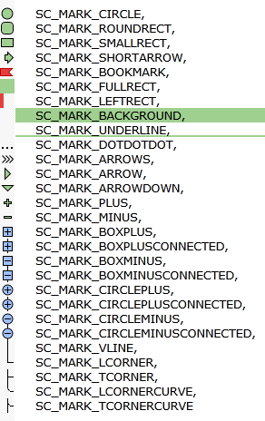
marker_number parameter options:
  - Integer: The number of the marker, which can be 0 – 31. If this value is set to -1, then the first free marker will be used. If the marker number is invalid the method will return -1.
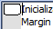
Below is an image showing a marker PyQt5.Qsci.QsciScintilla.Rectangle marker:
- markerDefine(ascii_character, marker_number)
ascii_character parameter options:
  - Char: a – Z ASCII character
marker_number parameter options:
Integer: The number of the marker, which can be 0 – 31. If this value is set to -1, then the first free marker will be used. If the marker number is invalid the method will return -1.
Below is an image of a character marker "T":
- markerDefine(qpixmap_image, marker_number)
qpixmap_image parameter options:
  - PyQt5.QtGui.QPixmap: A custom QPixmap image
marker_number parameter options:
Integer: The number of the marker, which can be 0 – 31. If this value is set to -1, then the first free marker will be used. If the marker number is invalid the method will return -1.
- markerDefine(qimage_image, marker_number)
qpixmap_image parameter options:
  - PyQt5.QtGui.QImage: A custom QImage image
marker_number parameter options:
Integer: The number of the marker, which can be 0 – 31. If this value is set to -1, then the first free marker will be used. If the marker number is invalid the method will return -1.
Return value:
- Integer: The marker number. If the marker number is invalid the method will return -1.

3.6.8.2 Adding a marker to margins
Remeber that markers are added to ALL margins on the specified lines, margin marker masks determine if the marker is visible on a specific margin.
Added with method: markerAdd(line_number, marker_number)
line_number parameter options:
- Integer: Line number which the marker will be added to
marker_number parameter options:
- Integer: The number of the marker, which can be 0 – 31. If the marker number is invalid the method will return -1.
Return value:
- Integer: A handle that is used to track the marker's position. If you assign the same marker to multiple lines, this method will return multiple handles so you can modify each one seperately.

3.6.8.3 Deleting a marker from margins
Like adding a marker to a line, deleting also deletes the marker from ALL margins.
Deleted with method: markerDelete(line_number, marker_number)
line_number parameter options:
- Integer: Line number on which the marker will be deleted. If this parameter is -1, then all markers will be deleted from this line.
marker_number parameter options:
- Integer: The number of the marker, which can be 0 – 31. If the marker number is invalid the method will return -1.

3.6.8.4 Deleting a marker by it's handle
Same as the above method markerDelete, but this method takes the marker handle as the parameter and deletes the marker from the line that it was added to.
Deleted with method: markerDeleteHandle(marker_handle)
marker_handle parameter options:
- Integer: Marker handle of the marker that will be deleted.

3.6.8.5 Deleting all markers
Deleted with method: markerDeleteAll(marker_number)
marker_number parameter options:
- Integer: The number of the marker, which can be 0 – 31. If the marker number is invalid the method will return -1.

3.6.8.6 Get all markers on a line
Returns a integer that represents a 32 bit mask of the markers defined on a line.
Querried with method: markersAtLine (line_number)
line_number parameter options:
- Integer: The line number that you wish to querry
Example:
If there are no markers on the line, the method returns 0b0.
But if there is marker 2 on that line, the method return 0b10.

3.6.8.7 Get line number that a marker is on by the markers handle
This method returns the line number that the marker was added to using the markers handle.
Querried with method: markerLine(marker_handle)
marker_handle parameter options:
- Integer: Marker handle of the marker that will be deleted.
Return value:
- Integer: The line number that the marker is on or -1 if the marker is not present on any line.

3.6.8.7 Find markers
You can search for markers forwards and backwards using a marker mask with these methods.
Search forward with method: markerFindNext (starting_line_number, marker_mask)
starting_line_number parameter options:
- Integer: Starting line number from which the next marker will be searched for.
marker_mask parameter options:
- Integer: A 32 bit mask with the bits that represent the markers to search for set to 1.
Example: To search for markers 1 and 3, set the mask to: 0b1010 (the upper part of the mask are all 0's)
Search backwards with method: markerFindPrevious(starting_line_number, marker_mask)
starting_line_number parameter options:
- Integer: Starting line number from which the next marker will be searched for.
marker_mask parameter options:
- Integer: A 32 bit mask with the bits that represent the markers to search for set to 1.
Example: To search for markers 1 and 3, set the mask to: 0b1010 (the upper part of the mask are all 0's)

4. Basic examples
Below will be the basic learning examples to get you familiarized with how to setup and put the QScintilla editor component on the screen and start editing some text. Most of the parts of the QScintilla visual description chapter will be explained here briefly.
As this is learn-by-example guide, in this chapter the core functionalities will be described in much detail.
For all examples below on GNU/Linux operating systems substitute the executing command “python script_name.py” with “python3 script_name.py” if you have both Python2 and Python3 installed.
ALL THE EXAMPLES SHOULD BE PROVIDED WITH THIS DOCUMENTATION. Otherwise the code examples can be copied into your favourite editor, saved and executed with Python 3.

4.1. Qscintilla's “Hello World” example
So lets start with the mandatory “Hello World” example. The code is in chapter X, link here: X.1. Hello World.
Execute the example file hello_qscintilla.py with Python 3, provided along with this documentation. If you do not have the example files, save the above code to a text file called hello_qscintilla.py and run it using:
python hello_qscintilla.py
A new window should appear with a QScintilla text editing component inside it with the text “Hello World” already entered into the editor's editing area. Click inside the window and type something. You will see that you're already editing text.

4.1.1. Code breakdown
Pretty straightforward code, here are the key points:
- We import all of the needed modules (lines 1 to 6)
- Create a PyQt5.QtWidgets.QApplication object instance (line 10). This is the main object which needs to be initialized and handles things like widget initialization and finalization.
- Create a PyQt5.Qsci.QsciScintilla object instance (line 13). This is our main editing object.
- Show the QScintilla editor widget using the Qwidget's show method (line 16). As QScintilla inherits from the QWidget object, it has all of QWidget's methods. The show method shows the widget and its child widgets on the screen in a new window.
This way of displaying the QScintilla editor on the screen in not recommended! Always use a PyQt5.QtWidgets.QMainWindow as the main widget and set it's central widget to be the editor! That way all events in the editor will be handeled properly. BUT FOR THIS SIMPLE EXAMPLE IT WILL BE OK.
- Next is an example of directly setting the QScintilla editor's text using the setText method (line 18). This method sets the text to the string you enter as the argument AND also resets the undo/redo buffer of the editor. QScintilla has an internal buffer that you that stores all of the text changes until it runs out of memory and cannot store any more. I personally have never reached this limit.
- And lastly we execute the application (line 21). This is called in all PyQt applications, but sometimes with a different style like sys.exit(app.exec_()), so that the application does not run any code after the PyQt application is closed.

4.2. Customization example
Let's show some customizing of various QScintilla settings by modifying the previous example. This example will disable the editor's lexer. Some customization features are only accessible with a lexer, but that will be shown in a later example. The entire code example is in chapter X, link here: X.2. Customization
Run the example customization.py or save the code to a file and execute it with Python 3. There is a lot going on in this example, so each of the sections will be explained in detail in the next paragraph.

4.2.1. Code breakdown
This example will be broken down into separate sections. The sections are devided with docstrings, the triple double-quoted strings at the top of each section.
- Initialization:
Nothing special here, same basic initialization process. The only thing added was the append method, which just adds the parameter string to the editors text.
- General custumizations:
"""
Customization - GENERAL
"""
  - # Disable the lexer
  - editor.setLexer(None)
  - # Set the encoding to UTF-8
  - editor.setUtf8(True)
  - # Set the End-Of-Line character to Unix style ('\n')
  - editor.setEolMode(PyQt5.Qsci.QsciScintilla.EolUnix)
  - # Make End-Of-Line characters visible
  - editor.setEolVisibility(True)
  - # Set the zoom factor, the factor is in points.
  - editor.zoomTo(4)
  - Disabling the lexer is done in line 2. We simply set the lexer to None with the setLexer method. As described in chapter 1.6.1. Default lexer, by default the lexer is disabled, so this step can be skipped.
  - In line 4 we set the editor's encoding to UTF-8 with the setUtf8 method. If the setUtf8 method's parameter is False, the QScintilla editor's encoding will be set to ASCII and will show non-ASCII characters as questionmarks (?). Be careful when changing the encoding from UTF-8 to ASCII at runtime, you will get some interesting squiggles and symbols if you used UTF-8 characters.
  - Line 6 set the End-Of-Line mode for the editor's document with the setEolMode method. This selects how line endings will be interpreted when using the text method. This comes into play when you will be saving or manipulating the editor's text in code. In the above example the line endings are set to Unix mode, which means the Line-Feed (\n) character. All End-Of-Line options are described in 3.2. End-Of-Line (EOL) options .
  - Line 8 we set the End-Of-Line (EOL) character to be visible with the setEolVisibility method. In the below example the EOL character is circled in green:
  - In line 10 we set the zoom factor for the editor with the zoomTo method. This sets the current base font size to the size you set the parameter of the method to. Experiment with different parameters to se the effects. This recalculates all the font sizes in the editor.

- Line wrapping custumizations:
  - """
  - Customization - LINE WRAPPING
  - """
  - # Set the text wrapping mode to word wrap
  - editor.setWrapMode(PyQt5.Qsci.QsciScintilla.WrapWord)
  - # Set the text wrapping mode visual indication
  - editor.setWrapVisualFlags(PyQt5.Qsci.QsciScintilla.WrapFlagByText)
  - # Set the text wrapping to indent the wrapped lines
  - editor.setWrapIndentMode(PyQt5.Qsci.QsciScintilla.WrapIndentSame)
  - Wrapping mode is selected in line 5 with the setWrapMode method. There are 4 wrap modes to choose from, described in 3.1.1. Text wrapping mode. Here we selected to wrap text at word boundaries.
  - Choosing how wrapping is indicated is set in line 7 with setWrapVisualFlags methods.

- Indentation customizations:
These customizations effect the indentation functionality when pressing the Tab / Shift + Tab buttons or using the indent / unindent methods.
  - """
  - Customization - INDENTATION
  - """
  - # Set indentation with spaces instead of tabs
  - editor.setIndentationsUseTabs(False)
  - # Set the tab width to 4 spaces
  - editor.setTabWidth(4)
  - # Set tab indent mode, True indents the with the next
  - # non-whitespace character while False inserts
  - # a tab character
  - editor.setTabIndents(True)
  - # Set autoindentation mode to maintain the indentation
  - # level of the previous line (the editor's lexer HAS
  - # to be disabled)
  - editor.setAutoIndent(True)
  - # Make the backspace jump back to the tab width guides
  - # instead of deleting one character, but only when
  - # there are ONLY whitespaces / tab characters on the
  - # left side of the cursor
  - editor.setBackspaceUnindents(True)
  - # Set indentation guides to be visible
  - editor.setIndentationGuides(True)
  - In line 5 we choose the indentation functionality to use whitespace characters instead of the tab character (\t) with the setIndentationsUseTabs method.
  - Line 7 sets the number of characters the indentation functionality indents / unindents by with the setTabWidth method. In the above example the indentation is increased or decreased by 4 characters when indenting / unindenting (pressing Tab or Shift+Tab). More details in chapter 3.3.2. Indentation size.
  - Line 11 sets the special indentation functionality. When set to False and when the cursor is in set to a whitespace character in a line and then indent is executed (e.g.: by pressing Tab), a Tab character is inserted. For more detailed explanation see chapter 3.3.4. Indentation at spaces options.
  - Line 15 sets smart indentation on with the setAutoIndent method, which means that when inserting a new line character/s by pressing Enter/Return, the new line will be indented to the same indentation level as the previous NON empty line.
  - Line 20 sets the Backspace key functionality with the setBackspaceUnindents method. When set to True, this makes pressing the backspace key unindent to columns aligned to the tab width property. Basicaly when pressing backspace and there are only whitespaces before the cursor position, the cursor will move exactly like as if it was unindenting.
  - Line 22 makes the indentation guides (vertical dots where indentations align) visible if set to True with the setIndentationGuides method.

FUTURE CHAPTERS:

Creating a Nim programming language lexer

Show an example of a Cython compiled lexer

X. Appendix: code examples

X.1. Hello World
# Import the PyQt module with all of the graphical widgets
import PyQt5.QtGui
# Import the QScintilla module
import PyQt5.Qsci
# Import Python's sys module needed to get the application arguments
import sys

# Create the main PyQt application object and give it the
# command line arguments passed to the Python application
application = PyQt5.QtWidgets.QApplication(sys.argv)

# Create a QScintilla editor instance
editor = PyQt5.Qsci.QsciScintilla()
# Put the “Hello World” text into the editing area of the editor
editor.setText("Hello World")
# As the QScintilla object inherits from the QWidget object it has
# the show method which displays the widget on the screen. THIS WAY
# OF DISPLAYING THE EDITOR SHOULD NOT BE USE FOR ANYTHING OTHER THAN
# TESTING PURPOSES! USE THE QMainWindow WIDGET AND SET IT'S CENTRAL
# WIDGET TO BE THE EDITOR, SO THAT THE EVENTS ARE PROPERLY HANDLED!
editor.show()

# Execute the application
application.exec_()

X.2. Customization
"""
Initialization
"""
# Import the PyQt5 module with some of the GUI widgets
import PyQt5.QtWidgets
# Import the QScintilla module
import PyQt5.Qsci
# Import Python's sys module needed to get the
# application arguments
import sys

# Create the main PyQt application object
application = PyQt5.QtWidgets.QApplication(sys.argv)

# Create a QScintila editor instance
editor = PyQt5.Qsci.QsciScintilla()
# Set the initial text
editor.setText("Inicialization example.")
# Append some text
editor.append("\nAdded text.")

"""
Customization - GENERAL
"""
# Disable the lexer
editor.setLexer(None)
# Set the encoding to UTF-8
editor.setUtf8(True)
# Set the End-Of-Line character to Unix style ('\n')
editor.setEolMode(PyQt5.Qsci.QsciScintilla.EolUnix)
# Make End-Of-Line characters visible
editor.setEolVisibility(True)
# Set the zoom factor, the factor is in points.
editor.zoomTo(4)

"""
Customization - LINE WRAPPING
"""
# Set the text wrapping mode to word wrap
editor.setWrapMode(PyQt5.Qsci.QsciScintilla.WrapWord)
# Set the text wrapping mode visual indication
editor.setWrapVisualFlags(PyQt5.Qsci.QsciScintilla.WrapFlagByText)
# Set the text wrapping to indent the wrapped lines
editor.setWrapIndentMode(PyQt5.Qsci.QsciScintilla.WrapIndentSame)

"""
Customization - EDGE MARKER
"""
# Set the edge marker's position and set it to color the background
# when a line goes over the limit of 50 characters
editor.setEdgeMode(PyQt5.Qsci.QsciScintilla.EdgeBackground)
editor.setEdgeColumn(50)
edge_color = caret_fg_color = PyQt5.QtGui.QColor("#ff00ff00")
editor.setEdgeColor(edge_color)
# Add a long line that will display the edge marker coloring
editor.append("\nSome long line that will display the edge marker's functionality.")

"""
Customization - INDENTATION
"""
# Set indentation with spaces instead of tabs
editor.setIndentationsUseTabs(False)
# Set the tab width to 4 spaces
editor.setTabWidth(4)
# Set tab indent mode, see the 3.3.4 chapter in QSciDocs
# for a detailed explanation
editor.setTabIndents(True)
# Set autoindentation mode to maintain the indentation
# level of the previous line (the editor's lexer HAS
# to be disabled)
editor.setAutoIndent(True)
# Make the backspace jump back to the tab width guides
# instead of deleting one character, but only when
# there are ONLY whitespaces on the left side of the
# cursor
editor.setBackspaceUnindents(True)
# Set indentation guides to be visible
editor.setIndentationGuides(True)

"""
Customization - CARET (the blinking cursor indicator)
"""
# Set the caret color to red
caret_fg_color = PyQt5.QtGui.QColor("#ffff0000")
editor.setCaretForegroundColor(caret_fg_color)
# Enable and set the caret line background color to slightly transparent blue
editor.setCaretLineVisible(True)
caret_bg_color = PyQt5.QtGui.QColor("#7f0000ff")
editor.setCaretLineBackgroundColor(caret_bg_color)
# Set the caret width of 4 pixels
editor.setCaretWidth(4)

"""
Customization - AUTOCOMPLETION (Partially usable without a lexer)
"""
# Set the autocompletions to case INsensitive
editor.setAutoCompletionCaseSensitivity(False)
# Set the autocompletion to not replace the word to the right of the cursor
editor.setAutoCompletionReplaceWord(False)
# Set the autocompletion source to be the words in the
# document
editor.setAutoCompletionSource(PyQt5.Qsci.QsciScintilla.AcsDocument)
# Set the autocompletion dialog to appear as soon as 1 character is typed
editor.setAutoCompletionThreshold(1)

# For the QScintilla editor to properly process events we
# need to add it to a QMainWindow object.
main_window = PyQt5.QtWidgets.QMainWindow()
# Set the central widget of the main window to
# be the editor
main_window.setCentralWidget(editor)
# Resize the main window and show it on the screen
main_window.resize(800, 600)
main_window.show()

# Execute the application
application.exec_()

X.3. Margins

# Import the PyQt5 module with some of the GUI widgets
import PyQt5.QtWidgets
# Import the QScintilla module
import PyQt5.Qsci
# Import Python's sys module needed to get the application arguments
import sys

# Create the main PyQt application object
application = PyQt5.QtWidgets.QApplication(sys.argv)

# Create a QScintila editor instance
editor = PyQt5.Qsci.QsciScintilla()
# Set the initial text
editor.setText("Inicialization example.")
# Append some text
editor.append("\nAdded text.")

"""
Line number margin
"""
# Set margin 0 as the line margin (this is the default, so you can skip this step)
editor.setMarginType(0, PyQt5.Qsci.QsciScintilla.NumberMargin)
# Set the width of the line number margin with a string, which sets the width
# to the width of the entered string text. There is also an alternative function
# with the same name which you can use to set the width directly in number of pixels.
editor.setMarginWidth(0, "00")

"""
Symbol margin - Used to display custom symbols
"""
# Set margin 1 as a symbol margin (this is the default, so you can skip this step)
editor.setMarginType(1, PyQt5.Qsci.QsciScintilla.SymbolMargin)
# Set the margin's width
editor.setMarginWidth(1, 20)
# Prepare an image for the marker
image_scale_size = PyQt5.QtCore.QSize(16, 16)
marker_image = PyQt5.QtGui.QPixmap("marker_image.png")
scaled_image = marker_image.scaled(image_scale_size)
# Set the margin mask (mask constant ~SC_MASK_FOLDERS enables all markers!)
# This sets which of the 32 markers will be visible on margin 1
editor.setMarginMarkerMask(
1, ~PyQt5.Qsci.QsciScintillaBase.SC_MASK_FOLDERS
)
# Just for info we display the margin mask, which should be: 0b1111111111111111111111111
# which means all 32 markers are enabled.
print(bin(editor.marginMarkerMask(1)))
# Create and add marker on margin 1
marker = editor.markerDefine(scaled_image, 1)
editor.markerAdd(1, 1)

"""
Symbol margin with the background color set to the editor's default paper (background) color
"""
# Set margin 2 as a symbol margin with customizable background color
editor.setMarginType(2, PyQt5.Qsci.QsciScintilla.SymbolMarginDefaultBackgroundColor)
# Set the margin's width
editor.setMarginWidth(2, "000000")

"""
Symbol margin with the background color set to the editor's default font color
"""
# Set margin 4 as a symbol margin with customizable background color
editor.setMarginType(3, PyQt5.Qsci.QsciScintilla.SymbolMarginDefaultForegroundColor)
# Set the margin's width
editor.setMarginWidth(3, "0000")
# Set the margin mask to display all markers
editor.setMarginMarkerMask(
3, 0b1111111111111111111111111
)
# Add a marker that is built into QScintilla.
# Note that the marker will be displayed on all symbol margins with the
# third marker bit set to '1'!
marker = editor.markerDefine(PyQt5.Qsci.QsciScintilla.Rectangle, 2)
editor.markerAdd(0, 2)

"""
Text margin
"""
# Set margin 5 as a symbol margin with customizable background color
editor.setMarginType(4, PyQt5.Qsci.QsciScintilla.TextMargin)
# Set the margin's width
editor.setMarginWidth(4, "00000")
# Set the margin's text on line 1 font style 0
# Style 0 is taken from the current lexer, I think!
editor.setMarginText(0, "line1", 0)
# Create a new style and set it on line 2 with some text
style = PyQt5.Qsci.QsciStyle(
2, # style (This has to be set to something other than 0, as that is the default)
"new style", # description
PyQt5.QtGui.QColor(0x8a, 0xe2, 0x34, 80), # color (font)
PyQt5.QtGui.QColor(0xff, 0xff, 0xff, 0xff), # paper (background)
PyQt5.QtGui.QFont('Helvetica', 10), # font
eolFill=False, # End-Of-Line Fill
)
editor.setMarginText(1, "line2", style)

# For the QScintilla editor to properly process events we need to add it to
# a QMainWindow object.
main_window = PyQt5.QtWidgets.QMainWindow()
# Set the central widget of the main window to be the editor
main_window.setCentralWidget(editor)
# Resize the main window and show it on the screen
main_window.resize(800, 600)
main_window.show()

# Execute the application
application.exec_()

