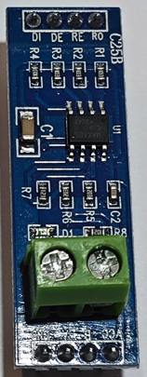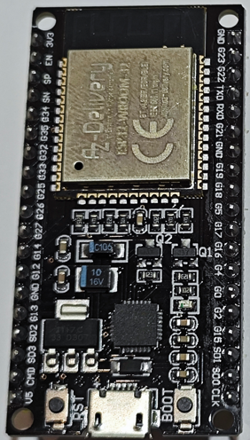 ESP32 MAX485/RS485 Modul



TTL zu RS-485

GND

3.3V

R/W

TX2wiring_nodemcu_rs485

RX2