

**2.0 The Game Map:**

All spaces are in 1 of **3 departments**.

Each department is originally controlled and originally friendly by 1 of the 2 combatants.

France:

* St. Lawrence Dept. (1)
* Louisbourg

British:

* Northern Dept. (2)
* Southern Dept. (3)
* Halifax

**Stacking:**

Unlimited stacking in any space.

For sieges and attrition:

* Inside Fortress = **unlimited**
* Inside Fort = 4 units
* Inside Stockade = 4 units

**3.0 The Playing Pieces**:

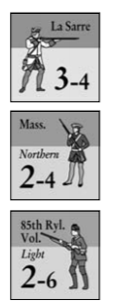

**Drilled Troops =**

* Regulars
* Provincials
* Light infantry

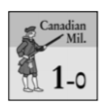

**Militias**



Auxiliaries = Indians, French (Coureurs) & British (Rangers) irregulars.

*The ONLY British leader who can command MOHAWK or Iroquois units is Johnson and he does so at no activation cost.

**Eliminated Units**:

**Regulars and Coureurs** are removed from play when **eliminated**.

**Provincials, Light Infantry, Militia, Indians, and Rangers** **may re-enter** the game by play of the appropriate card.

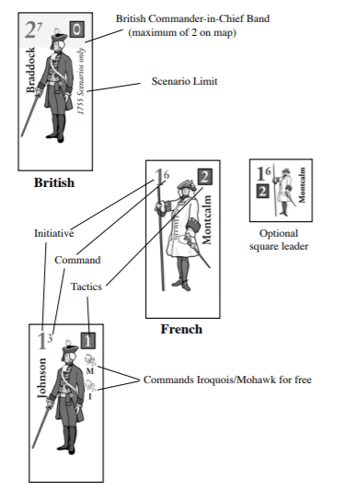

**4.0 Sequence of Play Notes**:

Players may **hold their last card** (use marker).

Indians NOT in a friendly fortification Go Home.

Leaders in wilderness or mountains without troops or fortifications are placed in the nearest friendly fortification.

**5.0 Strategy Cards:**

**Surrender card** always triggers a **reshuffle** (discard, played for op, played for event).

If there aren’t enough cards to refresh both players hands, deal out remaining cards and then reshuffle.

**Card Options**:

* **Activate** leaders/units (5.3)
* **Construct** fort/stockade (5.4)
* **Events** (5.5)

**Activation (5.3)**:

**Individual auxiliary units and/or leaders** moving alone totaling up to the card’s number. Indian units only count as half a unit towards this total, **OR**

1 Drilled Troops unit, regardless of card value, **OR**

**1 Force under 1 leader** with an initiative rating equal to lower than the number value of the card.

Force activation limits are **ignored** for battles, sieges, assaults, and raids.

**Co-Existence**: commanding and subordinate leaders and their force composition need only be defined for the duration of an activation, or at the instant of defending in a Battle, Avoiding Battle (6.8), Intercepting (6.7), and so on.



**5.4 Construction:**

A player may NOT carry out construction with two card plays in a row, even after beginning a new season.

Build **stockades** up to the number of the card value. May only be placed in spaces occupied by friendly, supplied drilled troops or in cultivated spaces that were originally friendly to the placing player (5.41).

**Forts**: construct forts in spaces occupied by friendly, supplied Drilled Troops units.

**A stockade is destroyed** if enemyDrilled Troops units win a battle in the space. The stockade is CAPTURED if enemy Drilled Troops enter an otherwise unoccupied stockage space. In either case award **1 VP**. Forts and fortresses can be captured (8.2). Stockades can also be destroyed in raids (10.31).

At any time during his OWN action phase and at no activation cost, a player may **demolish** any of his own unbesieged forts or stockades anywhere on the map. Forts under construction can be demolished at no cost, otherwise forts cost 1 VP.

**6.0 MOVEMENT:**

A force **may NOT “pick up” units** or leaders as it moves, but **MAY drop off** subordinate units or leaders, which move no further during that Action Phase.

**Land movement (6.2):**

* **Drilled Troops stop** after passing through **wilderness**—UNLESS moving with Auxiliaries.
* **Auxiliaries stop** after passing through an **enemy cultivated space**—UNLESS moving with Drilled Troops.
* **ALL Units stop** when entering a **mountain** space.

***Friendly fortifications eliminate the need to stop in a space***.

Leaders can move 6 spaces.

A force moves at the rate of its slowest unit unless that unit is dropped off.

**Boat movement (6.3) = 9 spaces**. A force or unit moving by boat MAY pass over ONE land connection during its activation if each end is either originally- friendly cultivated space or a friendly fortification (even if besieged, though the force would have to stop upon entering it).

**Naval Movement (6.4)**: friendly port to friendly port—a Force needs 3 value card an individual unit can use any value card.

**Amphibious Landings (6.4.3):** used along the red arrows (to attack a French port). **To make an amphibious move, in addition to the card used to activate movement, the British player must play an amphibious landing card**. Place an amphib marker. ***This marker is removed if the space it is in is occupied by French drilled troops or an unoccupied French fortification.***

* Play of the **Foul Weather event** (between the activating card and the amphibious landing card) blocks the

landing.

**Effects of Amphib Marker:**

* Allows normal British naval movement.
* Maintains British control of Louisbourg.
* Allows British retreat from amphib space to ANY British port.
* Allows placements of reinforcements.

**Moving into Enemy Occupied Spaces (6.5):**

* If the space has enemy units, the moving unit or force must attack. ***Attackers may continue moving after an Overrun Battle (7.82) or if all defenders Avoid Battle (6.82).***
* If the space has an enemy fort or fortress while no enemy units defend outside (8.1) place a Siege “0” marker.
* If the space has an ***unoccupied enemy stockade and the moving unit or force includes auxiliaries without drilled troops, then the auxiliaries must raid***.
* Only a unit or force that includes Drilled Troops may enter an unbesieged enemy fort or fortress space.

**Infiltration (6.6):**

***A LONE auxiliary unit*** (either activated individually or commanded by a leader and moving without any other units) may move by land or boat THROUGH one or more spaces occupied by enemy units or unbesieged enemy fortifications.

**Subject to Interception (6.7)**

**Eliminated if forced back** (either by retreat or the Lake Schooner event) into an enemy occupied space (and may conduct additional infiltrations).

An infiltrating unit may end its movement or KEEP MOVING.

**Interception (6.7):**

Units may intercept enemy units attempting to infiltrate **ADJACENT spaces OR their OWN space.**

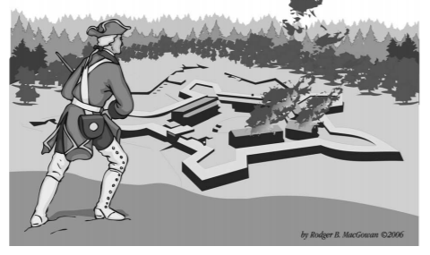

|  |
| --- |
| **Interception Chart:** |
| Include the intercepting leader’s tactics rating (if any): **Roll a 4 or higher**. If successful place the intercepting force in the space with the enemy and conduct a Battle. If interception fails, the enemy keeps moving. |
| *If units intercept into a space where their side has an **unoccupied stockade**, the stockade is NOT captured but remains in place and benefits them in battle.  *If an auxiliary unit is Intercepted while attempting to i**nfiltrate an enemy fort or fortress** it attacks but must retreat no matter if it wins or loses the ensuing battle. Units can retreat inside the fortification PRIOR to the battle.  *Leaders alone may NOT intercept.  *Force activation limits are in effect.  *You do not have to use all available units in a space.  *LONE auxiliary units in a **wilderness or mountain space** may only be intercepted by lone enemy auxiliaries (except against infiltrators in the SAME SPACE). |

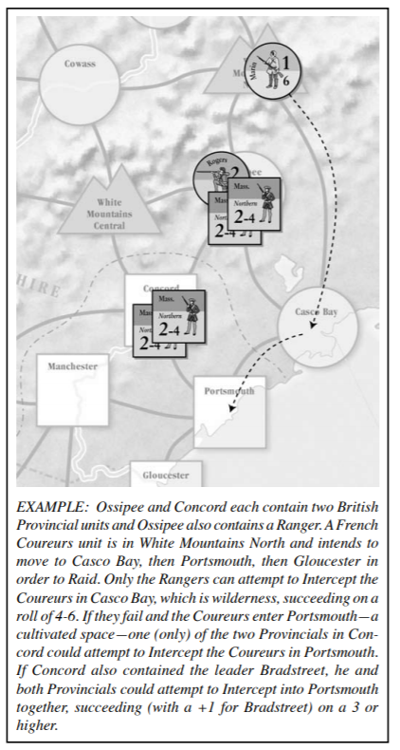

|  |
| --- |
| **Avoiding Battle Chart (6.8)** |
| Any ONE unbesieged force or individual unit in a space about to be attacked may Avoid Battle. Roll a die and add Tactics rating of avoiding commander, if any. ***On a modified roll of 4 or higher, the Avoiding force or unit is placed in a single adjacent space.*** |
| *Need not include all units in a space.  *Force activation limits in effect.  **\*Auxiliaries** automatically avoid attackers in wilderness or mountain spaces if attacker has no auxiliaries.  * British units in an *amphib space may Avoid Battle* directly to any British controlled port.  *If all defending units successfully Avoid, the active force **may continue moving**.  \***Declaration** of “inside” or “outside” is made BEFORE Avoid Battle roll.  *Intercepted and Intercepting units are not allowed to avoid battle. |

**7.0 Battles:**

1. Will militia participate (originally friendly cultivated space)?
   * Exceptions Louisbourg, raids in the department where battle is taking place.
2. Events played
3. Total combat factors and apply DRM
   * Use the tactics rating of the activated leader and, for the non-active player, the tactics rating of the leader with the highest command rating.
   * Ambush loses occur first and then the opposing player fires back with surviving combat strength.
4. Unit step & leader losses inflicted
5. Winner determined and VPS awarded
6. Militia return to their box and the loser retreats

**7.6 Step Loses:**

**At least HALF** (rounded up) of the step loses in a battle MUST **be from Drilled Troops (7.62)**.

A player may not assign **overall losses** from a battle such that some units are eliminated while others remain at full strength unless doing so is fulfilling the Drilled Troop loss requirement (7.63).

Leaders are never removed due to step loses.

Roll of a “natural” 1 or 6 will result in an **enemy leader loss check for EACH enemy leader**. A roll of 1 on a check will eliminate an enemy leader.

**The winner** is the player who inflicts more step losses. Defender wins ties (7.8).

**Winner of the battle gains 1VP** if ***losing side*** had 1 Regular Unit or more than four units of any kind.

**(7.8) Overrun:** If there are no fortifications and the attacker eliminate ***ALL enemy units AND did not suffer ANY step losses himself***, may continue moving as the space had been unoccupied.

**(7.9) Retreat:**

Units outside a fort or fortress can **retreat inside** (8.1).

Units are ***eliminated*** if they cannot meet the following requirements:

* French may not retreat via naval movement (no retreat from Louisbourg).
* Losers may NOT retreat to a space with unbesieged enemy units or fortifications.
* Defenders may not retreat into the space from which the enemy entered.
* Attackers MUST retreat back into the space from which they entered.
* ***Drilled Troops must retreat either to a cultivated space of friendly fortification.***

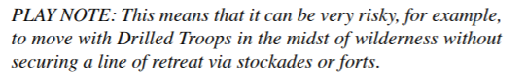

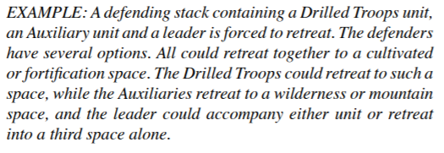

**8.0 Forts, Fortresses, & Sieges:**

No more than **4 units** and any number of leaders defend ***inside a fort***.

ANY number may be inside a fortress.

**8.2 Sieges:**

(8.21) If friendly units are in a space with an enemy fort or fortress (not stockade) **but no enemy units are outside the fortification, then the fort or fortress is besieged.**

Place a “Siege 0” marker on the space. Any space with a siege marker (0, 1, or 2) on it is **“besieged”** (a “siege” space), and any units or leaders inside the fort or fortress are “besieged” units or leaders.

**EXAMPLES:**

**Placement of a Siege 0 marker would occur**:

a) immediately after defenders lose a Battle outside a friendly fort or fortress, or

b) if all units choose to defend inside, or

c) if enemy units move into an otherwise unoccupied fort or fortress space

**NOTE**: **no besieged fortification can** receive replacements (even by event), nor can reinforcements be placed in a besieged space. Small Pox event can still be used however.

See siege table for on player aid for all DRMs.

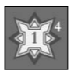

**A siege level of “1” allows for the siege of a fort and a “2” allows for the siege of a fortress.** Assaults occur IMMEDIATLEY once the appropriate siege level is met.

**(8.251)** **If units move into a space** in which the enemy is conducting a siege, friendly units inside the fort or fortress MAY participate in the subsequent Battle even though they were not activated.

**(8.252)** **If the besieged units lose the Battle**, they retreat back inside and remain under siege. Units that entered from an adjacent space may not retreat inside.

**9.0 Assaults:**

**~ 9.12** As in all combat, force activation limits are ignored (all units and leaders participate). If **one force activated by a Campaign event** enters a space where the second activated force is besieging, both may be combined for a subsequent Assault, even though the force that moved would no longer be activated.

**9.14** **An Assault works just like a Battle, with the following differences**:

• **No Militia** take part.

• **Steps must first be lost by both sides from involved Drilled Troops** (even if some Drilled Troop units would be eliminated before non-Drilled Troop units are reduced.)

• No retreat occurs.

• ***No VPs are awarded for the combat itself*** (but are awarded for capture of the fort or fortress [9.22].)

**9.2** **Winner/Loser**: ***The Attacker must cause a HIGHER enemy step loss result to win an Assault***, otherwise the Defender wins. Eliminating all defending units is NOT sufficient to win: ***unoccupied forts and fortresses continued to defend themselves*** on the 0 column of the CRT.

**9.21** If the defender wins, the Siege continues.

**9.22** If the attacker wins, a fortress is captured intact. **A fort is replaced with a Fort Under Construction marker** of the attacker’s nationality (to represent damage to the captured fort). **Units and leaders defending inside are eliminated**. Remove the siege marker and award **2 VPs for a fort and 3 VPs for a fortress.**

**10.0 Raids:**

Successful ***Raids earn VPs, destroy stockades, eliminate Indian units, and block some Militia deployments***.

**10.1 Targets**:

Any active Auxiliaries not stacked with Drilled Troops and ending their activation in any of the following spaces MUST Raid (roll on the Raid Table):

• An originally enemy cultivated space, OR

• An enemy stockade, OR

• A settlement with corresponding enemy Indian unit(s) CURRENTLY on the map (an enemy “allied” settlement).

~ Clarification: All leaders and auxiliaries in a space Raid together with one roll.

**10.12 Active units still Raid after fighting a Battle [5.36]**

**~ 10.13** A force may “drop off” Auxiliary units and subordinate leaders in any spaces through which it passes. ***The dropped-off Auxiliary units Raid***, using the highest Command leader with them, after the force that dropped them off has resolved any battle.

**10.2 Militia Deployment Against Raids**:

If a Raid is against a stockade in an enemy CULTIVATED space, the enemy player MAY place ONE Militia unit from that Department’s Militia Box into the space. He may do so regardless of whether or not Raided markers are present already in that Department (i.e., the 7.3 exception does not block this kind of Militia deployment).

**~ Exception:** Militia may not deploy if the Raiding unit(s) already fought a Battle in the stockade space that Action Phase.

**10.21** If a Militia unit deploys, the Raiding unit(s) must immediately attack it (in the stockade) in a Battle. After the Battle, surviving Militia returns to its Box.

**10.22** If the Raiders win, they carry out the Raid normally. 10.23 If they lose, they retreat normally (they do not Go Home.)

**10.3 Resolving a Raid**:

First, the defending player may play the Blockhouses event.

Then the Raiding player rolls a die on the Raid Table. Use either the “Stockade/Settlement” or “Cultivated” column, depending on the space being Raided (for a stockade or currently enemy allied settlement in cultivated terrain, use the Stockade/Settlement column), and apply any DRMs (also summarized on the Raid Table):

• Add the commanding leader’s Tactics rating.

• Add one if any Raiding units are Rangers.

• Subtract one if the Raid is within an enemy Department whose Militia Box has two or more Militia units in it (reduced or full).

**10.31** Raids result in either Success or Failure and can result in step losses (owner’s choice) or leader losses for the Raiders.

If successful:

• Place a Raided marker,

• Eliminate any stockade in the space,

• Eliminate all unbesieged Indian units, wherever on the map, belonging to the tribe whose settlement has been successfully Raided, and

• Score half a VP during the Remove Raided Markers phase (total rounded up).

**10.32** If a natural “1” is rolled on any Raid—or a natural “6” is rolled on a Raid against a stockade or enemy-allied settlement—roll another die for ***each raiding leader involved***. A roll of “1” kills that leader.

**10.33 Previously-Raided Spaces**:

For additional VPs, you may add Raided markers to spaces that already have them ***ONLY for successfully Raiding stockades or currently enemy-allied settlements***—NOT to an empty cultivated space that already has a Raided marker.

***Auxiliaries ending a move alone in an empty cultivated space with a Raided marker still must roll on the Raid Table and then Go Home***—even though Success will have no effect.

**10.4 Going Home**:

Regardless of the outcome of a Raid, all surviving Raiders immediately redeploy.

**10.41 Indians**. Pick up and place the Indian unit in its home settlement space.

**10.42 Non-Indians:** Coureurs des bois, Rangers, and leaders are immediately placed in the closest friendly, unbesieged fortification (owner’s choice).

**10.421** **“Closest”** is determined by counting connected spaces, regardless of intervening enemy presence or terrain.

**10.422** Any **Indians stacked with a leader** may accompany him to the ***closest fortification.***

**11.1 Who Suffers Attrition:**

During each Winter Attrition Phase, Drilled Troops may suffer step losses. ***All besieged Drilled Troops are subject to Attrition, as are any that do NOT occupy one of the following spaces:***

• An **originally-friendly cultivated space**, OR

• **An unbesieged fort or stockade space with no more than four friendly units of any kind** (leaders do not count), OR

• **An unbesieged fortress**.

11.2 **Attrition Losses** Apply the following losses to each affected stack:

• ~ First**, eliminate half (rounded up)** of the reduced Drilled Troops units (owner’s choice).

• Second, **reduce EVERY full-strength Drilled Troops unit**.

**Exception**: The last friendly step in a space (i.e., a lone, reduced unit) is never removed by Attrition.

**12.0 SUPPLY**

12.1 **General Drilled Troops units (only) must trace a supply line** to an originally-friendly fortress o be fully effective.

British units also can trace to a captured port or to an Amphib space. The supply source must be friendly-controlled and unbesieged.

**12.2 The Supply Line**:

The supply line consists of an unbroken chain of spaces, none of which is occupied by unbesieged enemy fortifications or units***. An enemy fort or fortress that is under siege does NOT block supply.***

**12.21** ***Each space, except the space being supplied***, must have at least one of the following characteristics:

1. Water-connected to each adjacent space in the chain (including the supplied space, if adjacent), OR
2. Cultivated, OR
3. Friendly fortification, OR
4. Amphib.

**12.3 Out-of-Supply Effects**:

Drilled Troops units that cannot trace a supply line have their activities restricted.

They:

• May not build forts or stockades.

• May not roll on the Siege Table (or use the Surrender! event).

• May not be restored to full strength.

***Important: A space is “supplied” the instant a supply line is established.*** Therefore, a player could use a 2-value card to place a stockade that creates a supply line to a second space and immediately place a second stockade there.

**13.0 VICTORY**

**13.1 How to Win**

**13.11 Sudden Death.** Check during each Victory Check Phase (4.0 B.6) to see if any of these conditions prevail:

• If the British control [2.0] all fortresses plus solely occupy Niagara and Ohio Forks, they win regardless of VPs.

• If either side has 11 or more VPs, it wins.

• After 1759, the French win if they have at least as many VPs as the box on the VP Track marked with that year (8 in 1760; 5 in 1761).

