# List for doing a programming project

## 1. Decide on your project

- It will be a fitness app for mobile

## 2. Check online for similar projects

- not done yet

## 3. Choose your language and tools

Mobile application: Object-C

* Differencese to look at <https://stackoverflow.com/questions/2445050/how-different-is-objective-c-from-c>
* Qt c++, Will we try to start with

## 4. List all features and entities

- Add essential and nonessesntial features, start with essential

- 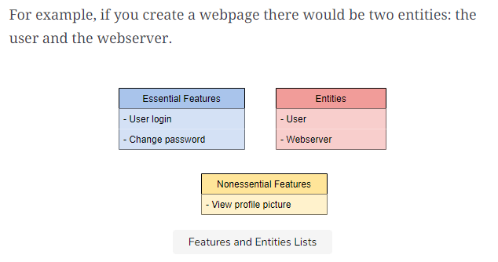

## 5. Map the project architecture

## 6. Mark entities for setup

Means, make a server if we need, and like everything that uses another tool

Brug hashtables

## 7. Add pseudocode to your diagram

## 8. Make a schedule