## PART 3: Configure Image Resizing

In this lab, you will configure Image Resizing for WAP handsets. Image Resizing requires that UAProf is enabled. The UAProf service expects to find a URL in the X-WAP-Profile header. You will enable UAProf if is it is disabled. You will use the Modify Headers feature of Firefox to add the X-WAP-Profile header to outgoing requests.

A Local Device Database is provided which has been created for this example. The following entries have been added:

<enableImageResizing>true</enableImageResizing>

<contentAdaptation enabled="true"> <usableScreenHeight>120</usableScreenHeight>

<usableScreenWidth>125</usableScreenWidth>

</contentAdaptation>

### Task 1: Observe an Image when Image Resizing is Disabled

1. Navigate to the URL <http://static.howstuffworks.com/gif/clock1.jpg>

2. Click on **Images** on the Firefox tool bar. Select **Display Image Dimensions**.

Record the dimensions of the clock1.jpg image: The size is 346x510 pixels

3. Navigate to the URL http://static.howstuffworks.com/gif/clock2.jpg

Record the size of the clock2.jpg image: The size is 480x601 pixels

### Task 2: Enable UAProf & Image Resizing in BMCLI

1. Use BMCLI to determine the settings for UAProf and Image Resizing. View the OSN WAP settings.

cli@csm> **enable**

cli@csm# **osn**

cli@csm(OSN)# **config**

cli@csm(OSN-config)# **show wap**

WAP Configuration

------------------

UAProf enabled : no

UAProf transparency enabled : yes

Type : Proxy

Image resize enabled : yes

Subscriber IP HTTP Header Name : X-Forwarded-For

Subscriber ID HTTP Header Name : X-BMI-SubID

XHTML-MP transcoding enabled : yes

<output omitted>

Is UAProf enabled? No

Is Image Resizing enabled? No

2. Enable UAProf if it is disabled.

cli@csm(OSN-config)# wap

cli@csm(OSN-config-wap)# uaprof enable

cli@csm(OSN-config-wap)# cfg commit

3. Enable Image Resizing if it is disabled.

cli@csm(OSN-config)# wap

cli@csm(OSN-config-wap)# image resize enable

cli@csm(OSN-config-wap)# cfg commit

### Task 3: Import Local Device Database on CSM

1. Use BMCLI on the CSM to import /var/tmp/local-ddb-resize.xml as a Local Device Database.

Which commands did you use?

Answer only

csm # **bmcli**

cli@csm> **enable**

cli@csm# **config**

cli@csm(config)# **deviceDb**

cli@csm(config-deviceDb)# **import deviceDb local /var/tmp/local-ddb-resize.xml**

local device DB has been imported from /var/tmp/local-ddb-resize.xml.

cli@csm(config-deviceDb)# **cfg commit**

Updating application csm

Updating node 10.1.0.1 configuration

### Task 4: Confirm Image Resizing is Enabled for SHARP-TQ-GX25 Handset.

1. Use the ddbadm command to confirm Image Resizing is enabled for the SHARP-TQ-GX25 handset.

* Use the ‘-u’ option and provide the User Agent string as the argument.

Which command did you use?

Answer only

osn # **/opt/bmi/node/bin/.admin/ddbadm -u 'SHARP-TQ-GX25/1.0 Profile/MIDP-2.0 Configuration/CLDC-1.0' | grep resiz**

Enable image resizing : True

### Task 5: Add X-WAP-Profile Header to HTTP Requests

1. Only handsets are eligible for Image Resizing. Handset devices send an X-WAP-Profile header.

Open the **Modify Headers** tool in Firefox to add the X-WAP-Profile header.

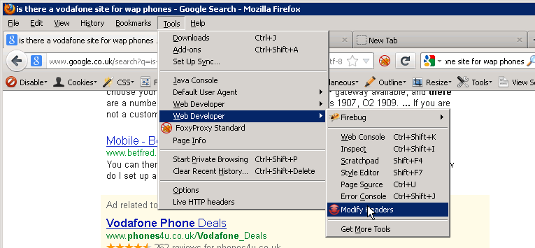

2. Click on the arrow next to “**Select action**” Choose “**Add**”.

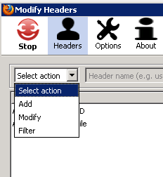

3. Complete the fields for the new header using the information in the table below:

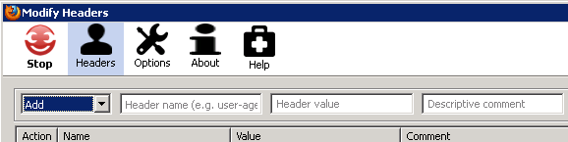

|  |  |
| --- | --- |
| Field | Value |
| **Header** | x-wap-profile |
| **Value** | "http://sharp-mobile.com/UAprof/GX25.xml" |
| **Description** | x-wap-profile header for UAprof |

|  |  |
| --- | --- |
| Note-Icon-small.jpg | The quotes around the header value “<http://sharp-mobile.com/UAprof/GX25.xml>” are required. Be careful to include them. |

4. Check the new header has a green circle showing it is enabled:

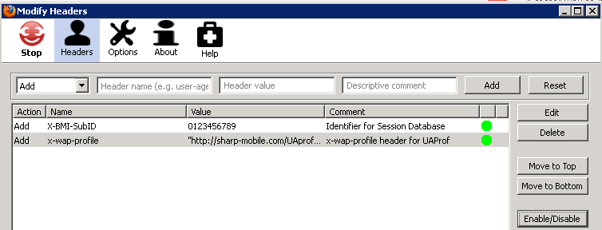

5. Set the User Agent to **SHARP-TQ-GX25** in Firefox:

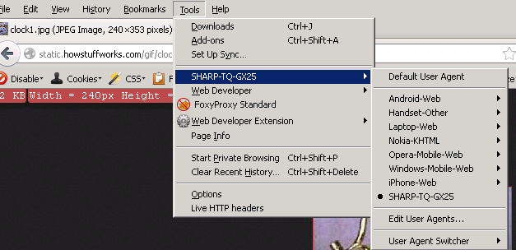

### Task 6: Confirm Image Resizing

1. Navigate to the URL <http://static.howstuffworks.com/gif/clock1.jpg>

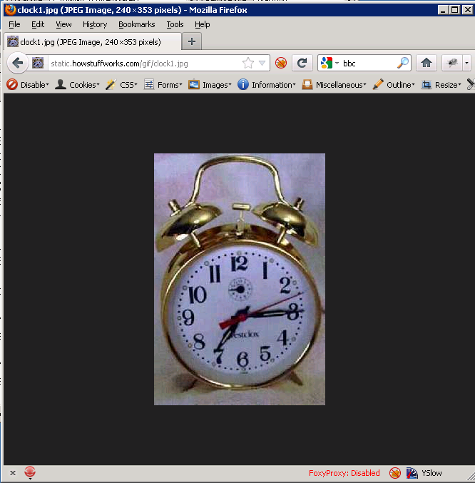

What is the new image size? The size is 240x353 pixels.

2. Examine the corresponding entry in the /opt/bmi/var/log/webgrp/web_access.log file.

How can you confirm that the web proxy applied Image Resizing?   
   
Image Resizing is indicated by optimization flag 13 containing a U

Answer only

Thu Oct 11 13:47:37 2012 p26206 380 -> 0 0/001 172.16.1.102:03762(00000:00000):002 => 80.150.193.146:00080(04101):000 108ms 108ms(r) 75ms(O) 0ms(D) 0ms(L) 1:0ms(R) 0ms(U) 0ms(S) 0ms(C) 0ms(N) 0ms(A) 0ms(s) 21930 -> 12506 42% 0 WC_HIT/200 --j---------U--------- A------F-----N---- n-----b--k1---HL-H!-H-SH-J---L- | -/00000000 | - | - | - | ---- | - | image/jpeg | 0123456789 | SESSION-AC100166-2 | 0123456789 | SHARP-TQ-GX25/1.0 Profile/MIDP-2.0 Configuration/CLDC-1.0 | Sharp GX25 Custom | Handset-Other | 0:0 | GET http://static.howstuffworks.com/gif/clock1.jpg

3. Use the Yaalp utility to confirm that the web proxy has applied Image Resizing.

Which command did you use?   
expand optFlags where url has clock1

Answer only

> **expand optFlags where url has clock1**

optFlags: --j---------U---------

Flag 3: j - Webproxy did JPEG Lossless trans-coding on image object

Flag 13: U - Webproxy did image resizing based on UAProf resource

-----------------------------------------

4. Use the Yaalp utility to confirm that a Local Device Database entry used in processing this request.

What command did you use?   
expand genFlags where url has clock1.jpg

Which Flag shows the Local Device Database was used?   
General flag 16 has a value of L