**Download SonarQube (Community Edition)**

<https://www.sonarqube.org/downloads/>

Extract to your Documents folder

**Download Java SE JDK v11 for 64bit Windows (make sure it's for 64bit windows)**

<https://www.oracle.com/technetwork/java/javase/downloads/jdk11-downloads-5066655.html>

Download C# plugin for SonarQube: <https://docs.sonarqube.org/latest/analysis/languages/csharp/>

Drop the .jar file in the: \extensions\plugins subfolder of your extracted SonarQube files

Delete any older version of the C# plugin in this folder

**Starting SonarQube**

modify the \conf\wrapper.conf to point to your installation of the JDK. On my machine this file is at:

C:\Users\c102116\Documents\SonarCube7.9.1\sonarqube-7.9.1\conf\wrapper.conf

(***Change Java path to suit your installation***)

wrapper.conf contents:

# Path to JVM executable. By default it must be available in PATH.

# Can be an absolute path, for example:

#wrapper.java.command=/path/to/my/jdk/bin/java

wrapper.java.command=C:\Program Files\Java\jdk-12.0.2\bin\java

#

# DO NOT EDIT THE FOLLOWING SECTIONS

#

**Download Sonar Scanner for MS Build**

Download the latest versions of the Sonar Scanner from

<https://github.com/SonarSource/sonar-scanner-msbuild/releases>

Specifically, the following (version numbers may/will vary):

**sonar-scanner-msbuild-4.7.1.2311-net46.zip**

**sonar-scanner-msbuild-4.7.1.2311-netcoreapp2.0.zip**

Extract to the folder shown in the image below (**Folder path and names are important**). For example

See image of directory below.

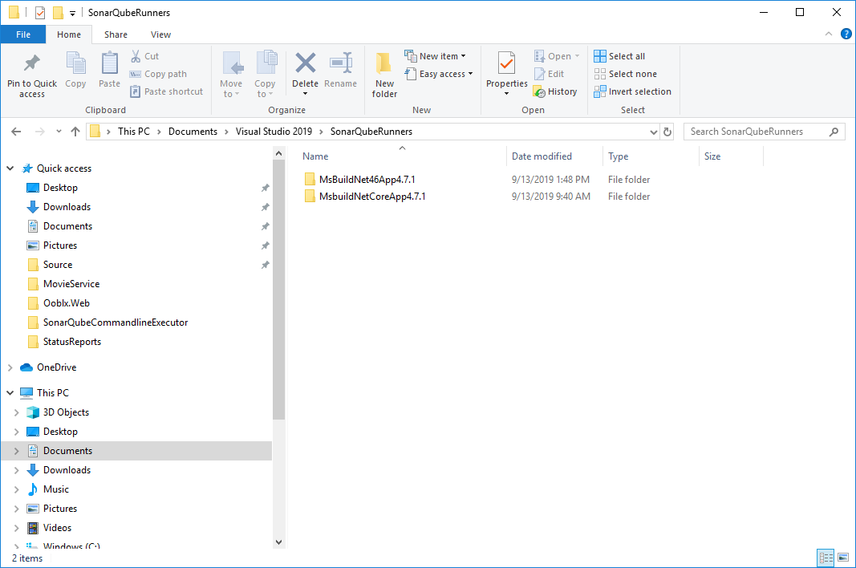

***Note: The names of the folders should be exactly as shown in the image***

Contents of sonar-scanner-msbuild-4.7.1.2311-net46.zip - extract to MsBuildNet46App4.7.1 folder

Contents of sonar-scanner-msbuild-4.7.1.2311-netcoreapp2.0.zip - extract to MsbuildNetCoreApp4.7.1 folder

**Environment Variables**

Under User Variables

Add an Entry (***Change Java path to suit your installation***)

**JAVA_HOME**: C:\Program Files\Java\jdk-12.0.2

Modify your **Path** variable to add the following

C:\Program Files\Java\jdk-12.0.2\bin

C:\Users\c102116\Documents\Visual Studio 2019\SonarQubeRunners\MsBuildNet46App4.7.1

C:\Users\c102116\Documents\Visual Studio 2019\SonarQubeRunners\MsBuildNetCoreApp4.7.1

C:\Users\c102116\Documents\Visual Studio 2019\SonarQubeRunners\MsBuild4.6.2

**Start SonarQube Web server**

**In your SonarQube install folder**

double-click the \bin\windows-x86-64\StartSonar.bat

If the JVM times out, run it once again and it will run the second time.

Once SonarQube starts up successfully browse to the SonarQube site

<http://localhost:9000>

If you see the home page, your installation is good.

**Importing Project Specific SonarQube Rules**

For EDGE the Rules can be Exported from

<https://customersonar-dv1.geico.net/coding_rules#languages=cs>

Using SonarQube with MS SQL Server

***This is an optional feature. If you’re working on EDGE or SALES or other large codebases, then it is recommended that you use MS SQL server rather than the embedded database that SonarQube uses by default.***

You’ll need to do the following to complete this portion:

1. Configure your instance of MS SQL Server to use TCP/IP and listen on port 1433
2. Download the **Microsoft** JDBC Driver
   1. Add paths to the User Environment Variable’s Path
3. Create the Sonar Database in MS SQL Server and configure it correctly
4. Modify the sonar.properties conf file to include Database Connection Information

If you don’t have MS SQL Express or the Developer edition of MS SQL already installed on your PC, then you’ll need to install one of these editions of MS SQL server. SQLExpress is a free download, while you’ll need to download the installation of the Developer edition from your MSDN account.

**SQL Server (2017/2019) Configuration Manager**

Run SQL Server (2017/2019) Configuration Manager with Defend Point (You’ll need Admin permissions). Find the file location of this application and then right-click on the file icon and choose “Run with Defend Point”.

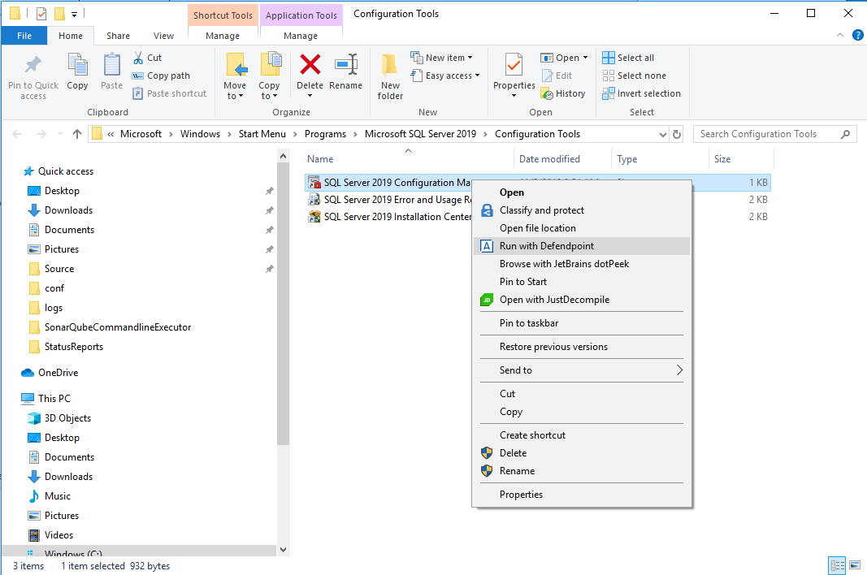

You'll need to enable TCP/IP for the instance is MS SQL you're using (i.e SQLExpress or Developer Edition). The image shows selecting SQLEXPRESS.

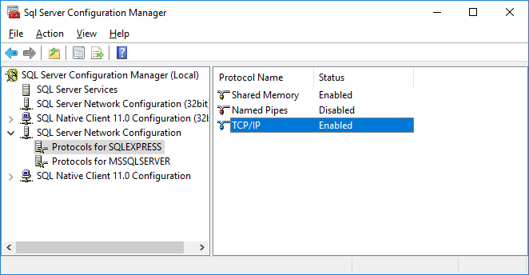

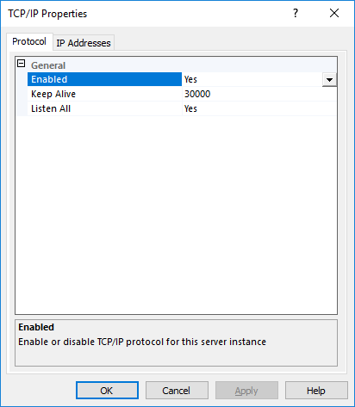

You'll need to set the TCP/IP port to 1433 (All versions of TCP/IP (IPv4, IPv6 etc.)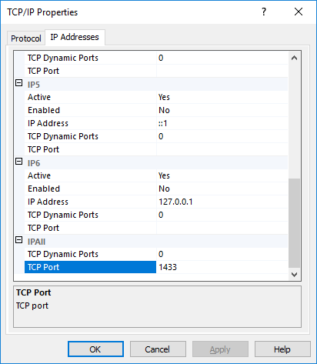

**Create a Database for SonarQube to use and configure it correctly**

Using SQL Server Management Studio, connect to the database instance you plan to use (SQLExpress or the Developer Edition). Select the database node in the tree view on the left and then open a new query window. In a Query window, run the following Script

==========================================

-- Create a DATABASE

USE master;

GO

IF DB_ID ( N'Sonar' ) IS NOT NULL

DROP DATABASE Sonar;

GO

CREATE DATABASE Sonar;

GO

-- Get the current collation

SELECT name, collation_name

FROM sys.databases

WHERE name = 'Sonar'

-- Change the collation to be case-sensitive (CS) and accent-sensitive (AS)

ALTER DATABASE Sonar

COLLATE SQL_Latin1_General_CP1_CS_AS

--READ_COMMITED_SNAPSHOT MUST be set on the SonarQube database

ALTER DATABASE Sonar SET READ_COMMITTED_SNAPSHOT ON WITH ROLLBACK IMMEDIATE;

==========================================

**Download Microsoft JDBC Driver**

https://www.microsoft.com/en-us/download/details.aspx?id=55539

Add the following folders to your User Environment Path. The folder where you installed/unzipped the files. I extracted the zip file to: C:\Users\<ACode>\Documents so I added the following paths

C:\Users\<ACode>\Documents\sqljdbc_6.2\enu

And the "enu\auth\x64" subfolder

C:\Users\<ACode>\Documents\sqljdbc_6.2\enu\auth\x64

**Modify sonar.properties conf file**

Modify the sonar.properties conf file to include Database Connection Information

In file: C:\Users\<ACode>\Documents\SonarCube7.9.1\sonarqube-7.9.1\conf\sonar.properties, find the line that starts with

#sonar.jdbc.url=

Uncomment it (remove the #) and set it to the following:

If you’re using SQLEXPRESS as your database server:

sonar.jdbc.url=jdbc:sqlserver://localhost\\SQLEXPRESS:1433;databaseName=Sonar;integratedSecurity=true

If you’re using the Developer edition of MS SQL Server

sonar.jdbc.url=jdbc:sqlserver://localhost:1433;databaseName=Sonar;integratedSecurity=true

**Getting SonarQube to connect to the database and create the schema it needs**

To get started with this step it is important that your SonarQube webserver/website is shut down. The easiest/sure way to do this is to reboot your machine. You could also kill all Java processes on your machine (there could be multiple processes running, you’ll need to kill all of them).

Once done, open a command prompt and then type/paste in the path to your StartSonar.bat file. Don’t double-click on the file directly, because you’ll need to watch the command line outputs to ensure things are working correctly.

On my machine, the StartSonar.bat file is found at this location:

C:\Users\c102116\Documents\SonarCube7.9.1\sonarqube-7.9.1\bin\windows-x86-64\StartSonar.bat

The JVM may timeout the first time. If that happens, run the StartSonar.bat file again. If there are issues during this step, you can find the log file here:

C:\Users\<ACode>\Documents\SonarCube7.9.1\sonarqube-7.9.1\logs\web.log

It is recommended that you delete the web.log file prior to each time you run the StartSonar.bat file during this process so it is easier to see the issues for each run.

During this step, SonarQube will connect to the database and if all goes well, it will create the schema in the Sonar database on your database server.

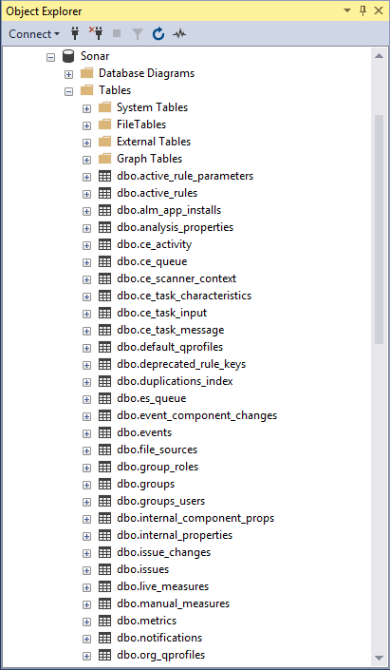

Once all of this is done, your SonarQube website should be up and running and you can now browse to it using <http://localhost:9000>.

You’re done with installing SonarQube!!