Neutrino Physics in Elementary Particle Physics

Mateus Marques

Renata Zukanovich Funchal

Institute of Physics of the University of São Paulo (IFUSP)

mateusmarques2001@usp.br

Objectives

This project concerns the study of neutrino phenomenology through theoretical and computational approaches. As we see in [1], the Standard Model (SM) implies that the mass of the neutrino is zero. However, due to neutrino oscillations [2], this represents a disagreement between the SM and the experiment. Thus, we seek to understand and simulate computationally the oscillation phenomenon in order to compare our results with data from the KamLAND experiment [3].

Materials and Methods

Our approach is based on the hypothesis that the neutrino interacts only in its interaction eigenstateswhile the hamiltonian of its time evolution has different mass eigenstates

While in vacuum and in the ultrarelativistic limit, the hamiltonianis such that

Performing a change of basis to the interaction basis with componentsthrough the Maki-Nakagawa-Sakata mixing matrix[1], adding the interaction potentialand assuming the normal ordering of neutrino masses, we obtain the equation

Using the parameters of the NuFIT group [4], we solve (2) by the Runge-Kutta method in a vacuum and obtain Figure 1, which describes the transition probabilities to the other leptonic flavors.

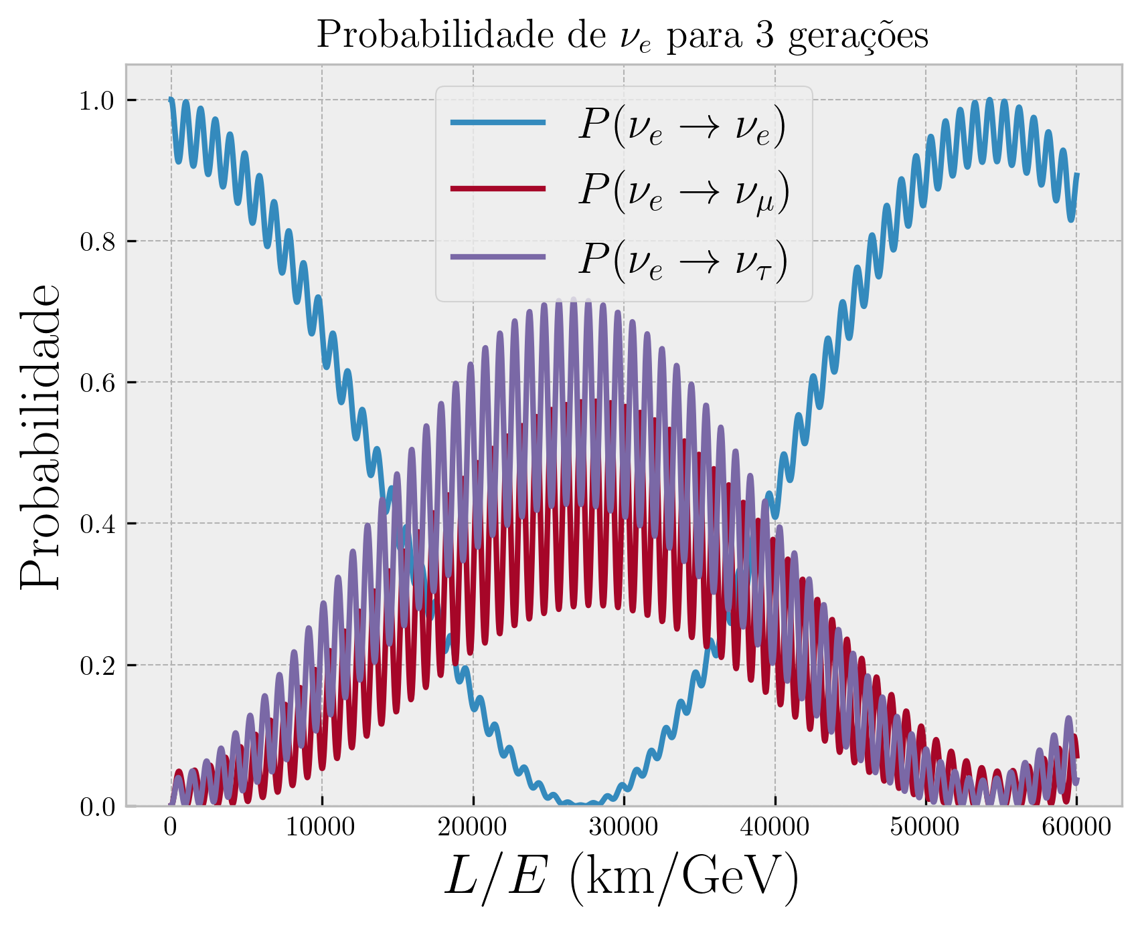
Figure 1: Transition probability for an electron neutrino in vacuum.

Inside the Sun we may only take into account the charged current weak interactions with elastic and coherent scattering [1], which leads to the potential

whereis the Fermi constant andis the solar electron number density.

Results

By (3), we used the data from the solar model BS2005 [5] to interpolateand solve equation (2) for two generationsof neutrinos, obtaining Figure 2:

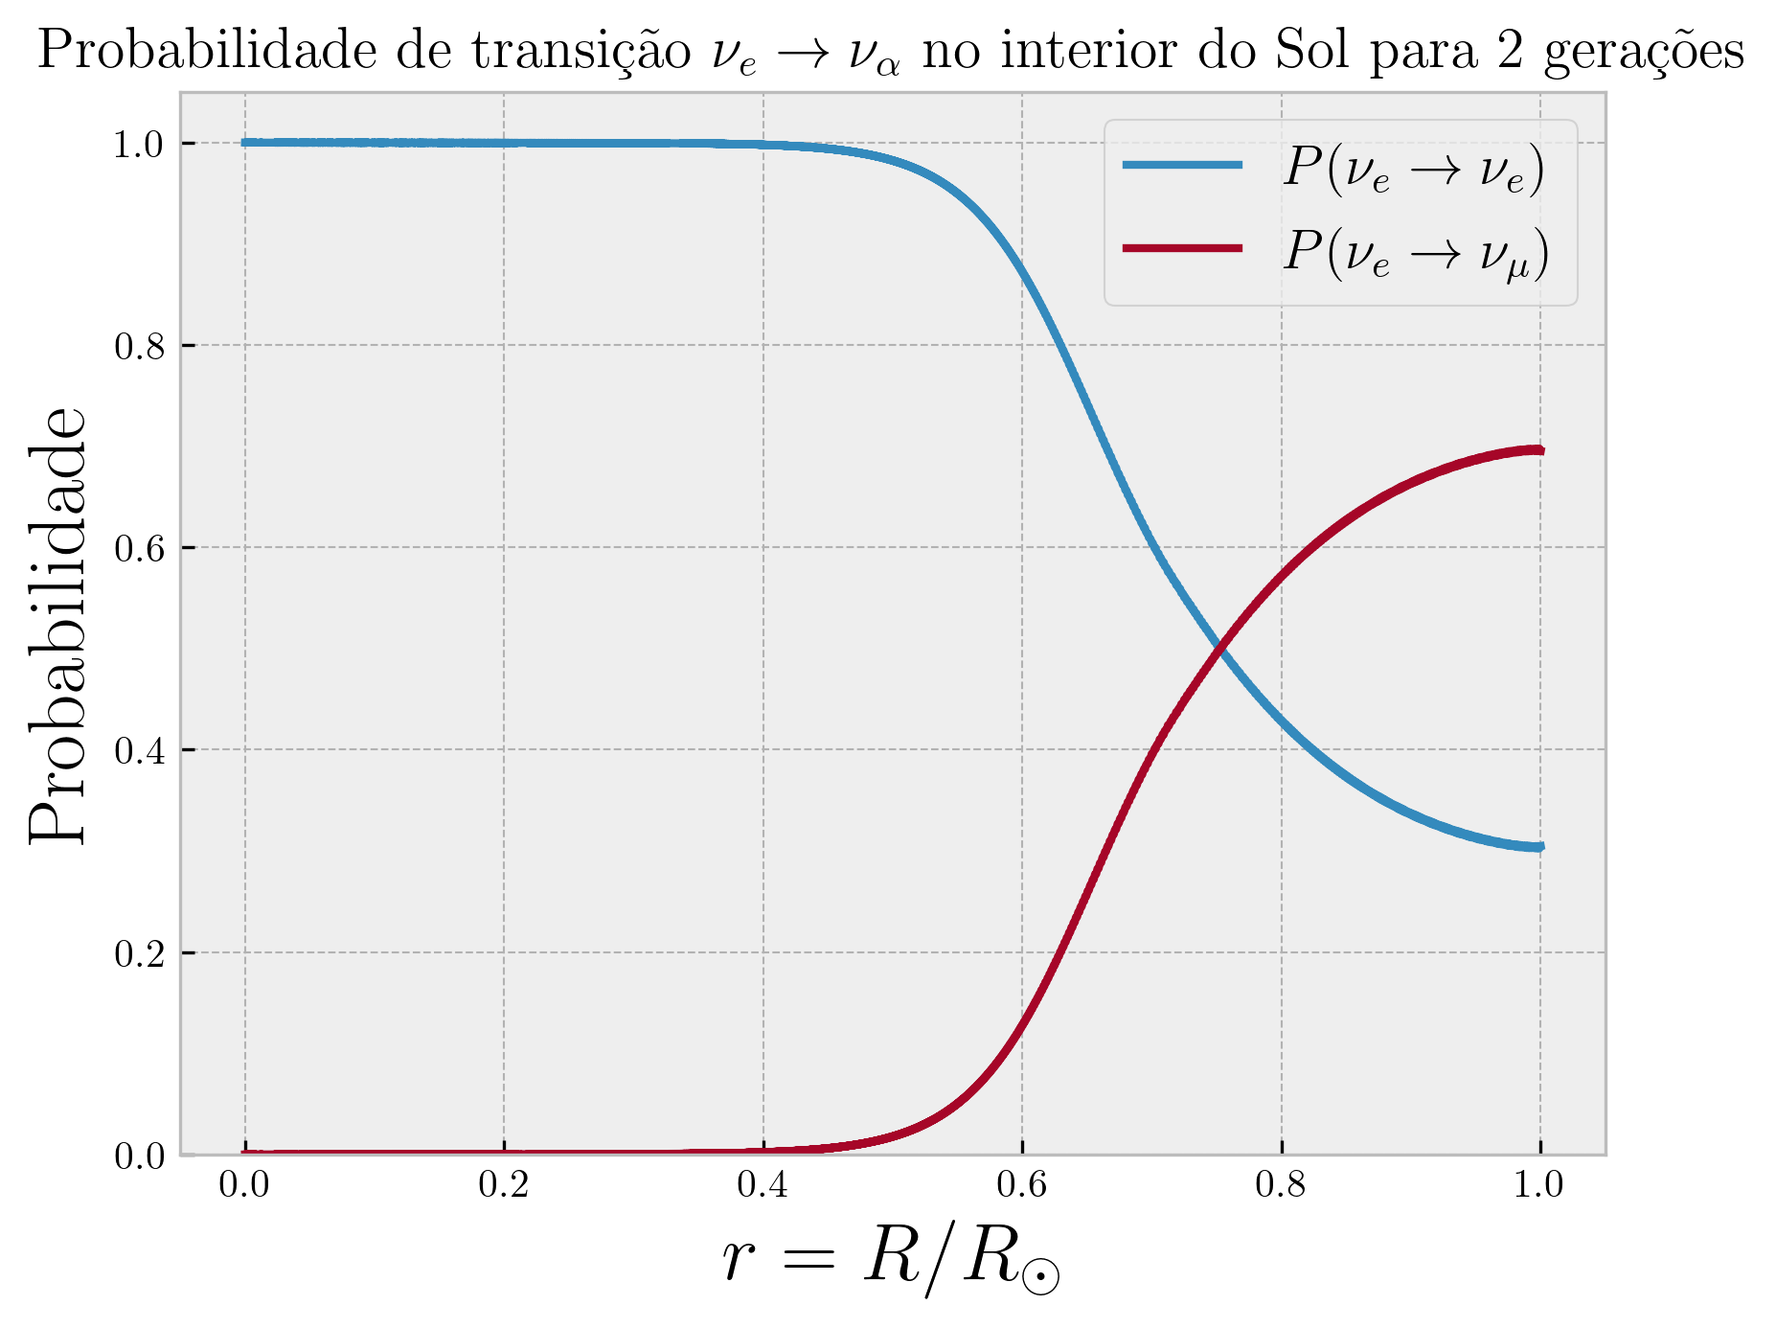
Figure 2: Transition probability (two generations) for an electron neutrino inside the Sun.

Conclusions

In Figure 2, we notice the decay of the transition probability due to the presence of matter, which is called the Mikheyev-Smirnov-Wolfenstein (MSW) effect [6]. This behavior is quite different from Figure 1, being the MSW effect relevant to explain the solar neutrino fluxes arriving at Earth. In the rest of this project, we intend to delve deeper into this analysis, doing numeric simulations with the presence of matter for three generations also taking into account the probability distributions of neutrinos’ energy and point of production. This will allow us to compare our results with the KamLAND experiment.

References

[1] M. C. Gonzalez-Garcia and Y. Nir, “Neutrino masses and mixing: evidence and implications,” Rev. Mod. Phys., vol. 75, pp. 345–402, Mar 2003.

[2] Y. Fukuda, T. Hayakawa, E. Ichihara, et al, “Evidence for oscillation of atmospheric neutrinos,” Phys. Rev. Lett., vol. 81, pp. 1562–1567, Aug 1998.

[3] S. Abe et al. Search for Solar Flare Neutrinos with the KamLAND detector. arXiV:2105.02458, (astro-ph), 5 2021.

[4] NuFIT Collaboration, “NuFIT website http://www.nu-fit.org/,” 2022.

[5] J. N. Bahcall, A. M. Serenelli, and S. Basu, “New solar opacities, abundances, helioseismology, and neutrino fluxes,” The Astrophysical Journal, vol. 621, pp. L85–L88,

Jan 2005.

[6] S. P. Mikheyev and A. Y. Smirnov, “Resonance Amplification of Oscillations in Matter and Spectroscopy of Solar Neutrinos,” Sov. J. Nucl. Phys., vol. 42, pp. 913–917, 1985.

