Dinner and a Show — Site Plan

Jonathan Patten

WDD 130

Overview

Purpose
The Dinner and a Show website serves as the central hub for the podcast and its growing community. It provides easy access to all episodes, host bios, episode guides, and listener resources. The site showcases and markets the podcast to new and returning audiences, turning passive listeners into engaged community members through exclusive content and direct connection with the four hosts.

Audience
Our primary audience is college students who enjoy personality-driven entertainment podcasts. They are active on social media, appreciate authentic conversations, and look for a mix of humor, insight, and community connection. Secondary audiences include fans of individual hosts and listeners who discover the show through Spotify, Apple Podcasts, or word of mouth.

Branding

Website Logo
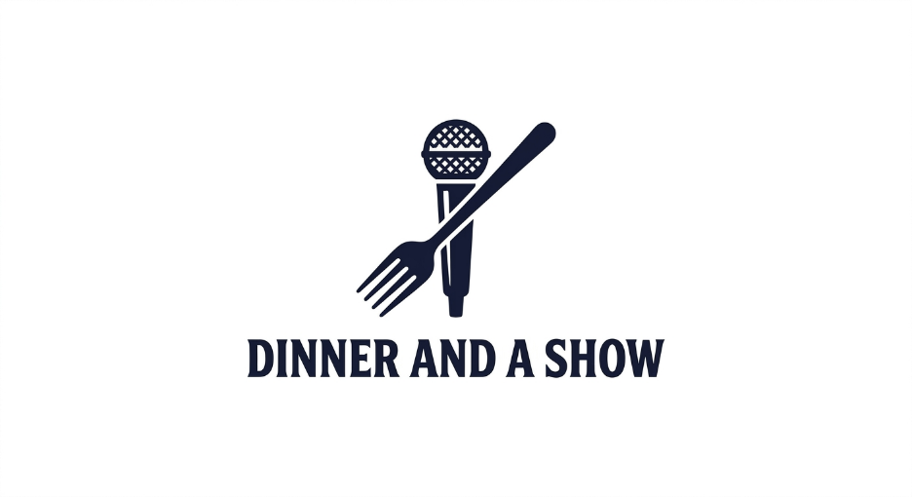

Style Guide

Color Palette
Primary | Secondary | Accent 1 | Accent 2
#1A1A2E | #E94560 | #F5A623 | #F0F0F0

Primary: Deep Navy | Secondary: Vivid Red | Accent 1: Warm Amber | Accent 2: Off-White

Typography

Heading Font: Playfair Display (Serif — bold, editorial feel)

Paragraph Font: Lato (Sans-serif — clean, highly readable)

Navigation
Home Episodes Hosts Blog Community Subscribe

Content

Home Page
Hero section with podcast logo, tagline ('Where Every Episode is a Main Course'), and a featured episode player embed.
Highlight reel: rotating quotes from the podcast's greatest moments (e.g., 'That's the most unhinged thing I've ever heard. — Eva, Ep. 42').
Meet the Hosts: four host profile cards with photo, name, and one-line bio linking to full Host Profiles page.
Latest Episode: auto-updating card showing the most recent episode with title, date, and a 'Listen Now' button.
Subscribe strip: icons and links for Spotify, Apple Podcasts, YouTube, and RSS.

Episodes Page
Full episode library with search, filter by topic or season, and sort by date.
Each episode card includes: title, thumbnail, air date, guest name (if applicable), and short description.
Hosts Page
Individual profile sections for Jonathan, Brayden, Eva, and Linnea.
Each profile: headshot photo, bio, favorite episode picks, fun fact, and links to personal social media (Instagram, Twitter/X, TikTok).
'Host Commentary' feature — short exclusive audio or text commentary clips from each host.

Blog / Articles Page
Behind-the-scenes posts: recording stories, gear, bloopers, and extended discussions from episodes.
Guest spotlight articles expanding on episode topics.
Filterable by author (host name) or topic category.

Community Page
Newsletter signup form with a welcome incentive (e.g., 'Get the Dinner Table Digest — our weekly listener newsletter').
Listener feedback form: submit questions, topic suggestions, or reactions to episodes.
Community discussion board or embedded Discord invite for listener interaction.
Fan highlights section — listener shoutouts and community picks.

Subscribe Page
Dedicated landing page with large, prominent buttons for all major podcast platforms: Spotify, Apple Podcasts, Amazon Music, Google Podcasts, Pocket Casts, RSS.
Short pitch copy explaining what makes the show worth subscribing to.
Embedded social media follow buttons for all four hosts and the main show accounts.

Wireframes

Home
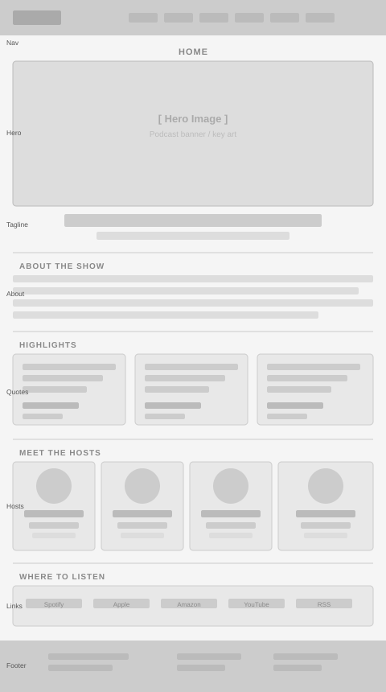

Episodes
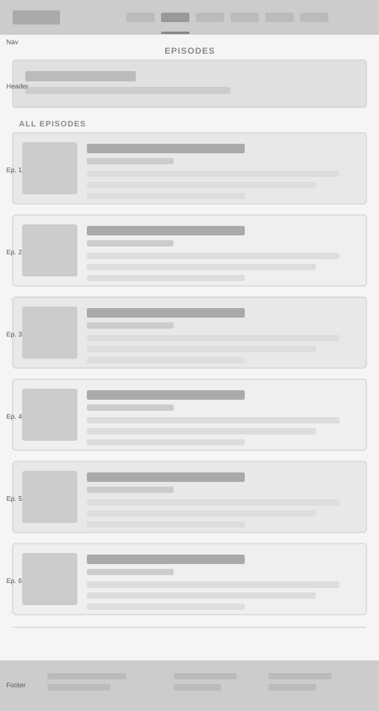

Hosts
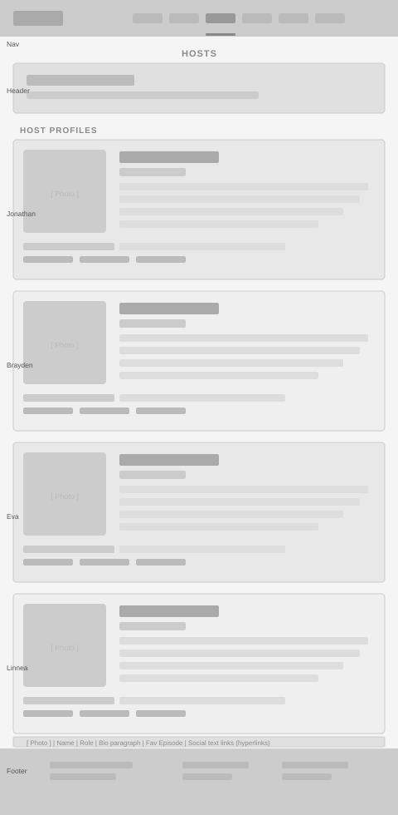

Blog
[Blog / Articles page wireframe — insert mockup image here]

Community
[Community page wireframe — insert mockup image here]

Subscribe
[Subscribe page wireframe — insert mockup image here]

