mathieu ndong
man333@drexel.edu
Spring 2024-Tech Strategy
Subject
Use Google case to show the importance of strategy to managing technological innovation
In 1996, Larry Page and Seygey Brin created a company called “Backrub” as part of a research project while completing their PHD program at Stanford University. Two years later, After Andy Bechtolsheim, co-founder of Sun Microsystems, provides a $100,000 check; Google Inc. was officially founded in a garage in California. Google has evolved from a simple search engine to one of the largest and most influential technology companies in the world. In 2014, the total revenue of the company was 66 billions of dollars. This represented a significant increase from the previous year of 15.4 billion dollars, reflecting Google's continued growth in its core businesses. Indeed, Google is an example of success due to constant innovation and proactive management decisions in a constantly evolving tech world. In this essay, we will discuss the Google Inc, in 2014 Harvard business case to show the importance of strategy to managing technological innovation.
ESSAY
GOOGLE Inc. in 2014
In 2001, Eric Schmidt was appointed CEO of Google which is a significant turning point in the company's history. Schmidt's hiring was pivotal as it brought experienced leadership to the rapidly growing technology company. First, as an experienced executive, Schmidt helped professionalize Google's operations and management, bringing structure and discipline to the company's processes. This included establishing clearer business goals and setting up more formal management practices. The focus was indeed on improving Google Search engine and bringing more revenue from advertising.
Therefore, in January 2004, google launched professional search which ordered results by analyzing a user prior search and clicks. This use of data analytics to optimize the search engine was combined with efforts to attract more advertisers. Indeed, free software were offered to advertisers to enhance paid listing campaigns via Google Analytics.
In line with management’s guidance, Google's strategic direction focus on innovation, long-term vision, and the development of new products and services. In 2003, Google introduced AdSense which is referred as contextual paid listing. This expansion was paramount to improve their revenue. And in 2006, the company bought Youtube for 1.5 billions of dollars. Youtube is a video sharing platform. So the company owned both a video sharing platform and an online advertising platform (Google Ads). The latter allows businesses and marketers to display ads across Google's network, including its search engine results pages, YouTube, and partner websites in the Google Display Network.
Internally, management created a work culture that would boost ingenuity and let people think counterintuitively at work. Indeed, they establish the 70/20/10 rule where employees focus on the core business, projects in relation to the core business and new business respectively. It generates initiative such as Gmail and GoogleNews. Then, they enter the phone and mobile devices market to position themselves in markets outside on their core business. So, they acquired Android Inc. and collaborate with establish phone makers to compete with competitors such as Apple with their iPhone. Finally, they open an office in 2008 in Washington D.C to be close to policy makers in order to stay up to date with legislations as it related to privacy and intellectual property laws. In 2020, the revenue of Google was 182.5 billion dollars. Therefore, their strategy internally and externally remains relevant several years after those decisions.
Some companies such as EMI implement poorly their new businesses and therefore they lose market share over the years due to competitors. Other companies does not focus on internal cultures and find themselves in verge of bankruptcy as it was the case for IBM before Gerstner took over as CEO in April 1993. This is not the case for Google. Trend, Structure and Positioning were keys for Google and they keep maintaining that model with the evolving tech market structure (TSP model).
To conclude, relevant innovations and acquisitions at Google are represented in the figure below (see Appendix). It shows the importance of preserving their strategy of innovating for their core business customers (advertisers, online publishers and users) while trying new businesses to keep growing today in a red ocean such as the tech market.
APPENDIX
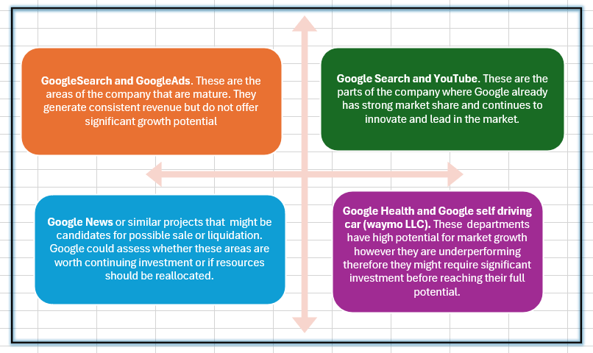

Figure: 2*2 Matrix representing market growth and market share correlation

