mathieu ndong
man333@drexel.edu
Spring 2024-Tech Strategy
Subject
Use Ravian case to demonstrate the differences between strategies for managing incremental innovation and strategies for managing radical innovation. Please first assess whether Ravian’s innovation is incremental or radical.
ESSAY
What Business is Rivian in?
Innovation is a pillar of organizational growth and competitiveness, driving the development of new products and services. However, there are different types of innovations and managing incremental and radical innovation requires distinct strategies due to their unique characteristics and impacts on organizations. Rivian is an American electric vehicle (EV) manufacturer that was founded in 2009 by Robert "RJ" Scaringe. In this essay, we will explore the differences between strategies for managing incremental and radical innovation based on the Rivian’s Harvard business case, highlighting their scope of change, risk and uncertainty, and market impact in the EV business and beyond.
Incremental innovation involves making small improvements to existing products. These changes are evolutionary rather than revolutionary, aiming to enhance existing items. “Skateboards powertrains, last mile delivery vans and electric adventure vehicles” are the main offerings as part of Rivian’s strategy to provide competitive products. Rivian pursue incremental EV innovation to be competitive and maintain relevance in the EV market. Especially, the four motor skateboard power train was a significant advantage for Rivian compared to its competitors within the market. In comparison, Tesla had a configuration that looked “more like an internal combustion engine (ICE) powertrain”. This is a strategy of low risk and high reward (c.f. Appendix). It is emphasized by the choice of working with established large corporations such as Ford and Amazon and taking their time to provide products to the customers. That way the company was able to be financially supported while focusing on delivering a product that meet customers’ needs.
In contrast, radical innovation involves introducing entirely new products that disrupt existing markets or industries. Radical innovations challenge the status quo and require a fundamental shift in thinking. This is the case for self-driving vehicles as they address challenges such as car autonomy, drivers’ rest time and safety. Therefore, developing self-driving cars carries high risks due to technical uncertainties and competitive pressures. However, if successful, breakthroughs in self driving car technology could yield high rewards by providing organization with a competitive edge and new market share which is not the case for Rivian.
Second, the market impact of incremental and radical innovation differs significantly. Incremental innovation tends to have a gradual and evolutionary impact on the market, allowing organizations to maintain their market position and respond to evolving customer needs. When Rivian entered the EV market in 2021, it did not drastically affect the market position of ICE’s car makers or Tesla. However, through the quality of their products and analysis of historical data from competitors such as Tesla; Rivian may have incremental gains in market share and competitive advantages. Indeed, Tesla has built a strong brand and great products however their business model is not profitable as the company lost 775$ million dollars in 2019. Therefore following a low rick and high reward strategy is the best course of action in the EV market.
Elaborating further, the Rivian R1T and R1S represent newer products in the electric vehicle market with high growth potential. While they have generated significant interest and excitement, Rivian's market share in the automotive industry remains relatively low compared to established players such as Tesla or EV manufacturers in China. So, these products require continued investment to capture a larger market share and establish Rivian as a key player in the electric truck and SUV segment.
To conclude, the key differences between strategies for managing incremental and radical innovation lies in the scope of change, market impact and all the risks associated with them. Incremental innovation focuses on building upon existing knowledge, technologies, and capabilities to make gradual improvements. That is Rivian’s strategy in the EV market. While radical innovation such as self-driving vehicle can have a transformative impact on the market, creating new opportunities, reshaping industries, and potentially displacing incumbent players.
Radical innovations possess the potential to revolutionize existing markets and set new benchmarks. In my view, the pioneering company introducing self-driving cars should swiftly transition from radical innovation to competitive product strategies to maintain a leading edge over future contenders. This urgency stems from the formidable barriers to entry within the automotive industry, particularly for traditional internal combustion engine vehicles, which are nearly impregnable. Electric vehicles (EVs) and self-driving cars represent radical innovations that have already demonstrated or hold the promise of success. However, despite their potential, established automotive giants could swiftly enter and challenge new entrants in this burgeoning market segment. Therefore, effective long-term strategy execution is imperative to safeguard against such competition and secure sustained success.

APPENDIX
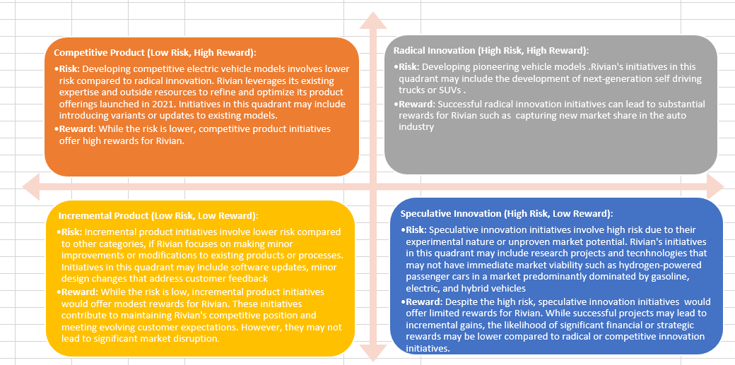

Figure: 2*2 Risk and Reward Matrix.

