



Data in dim_fct_orders

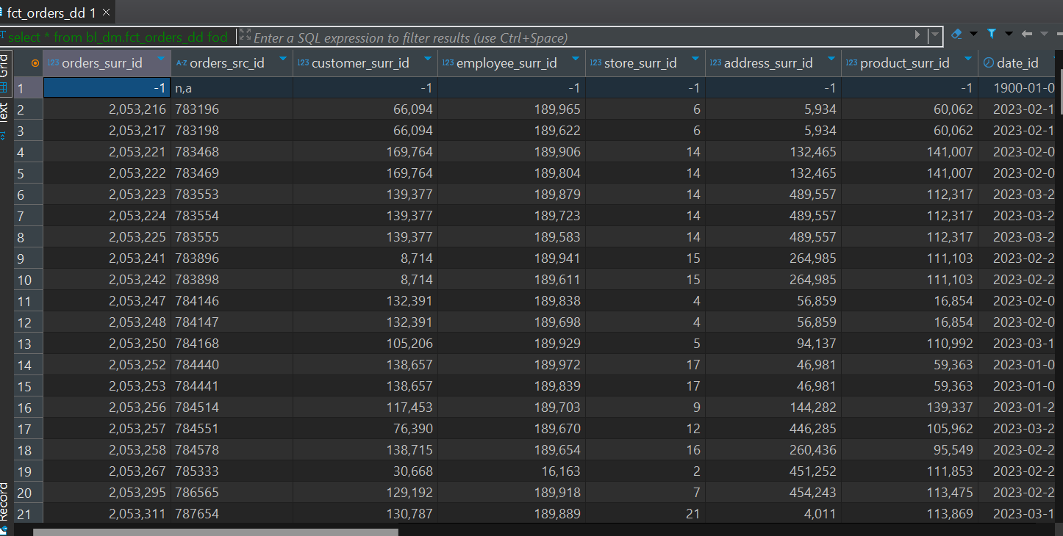

Data in ce_orders:

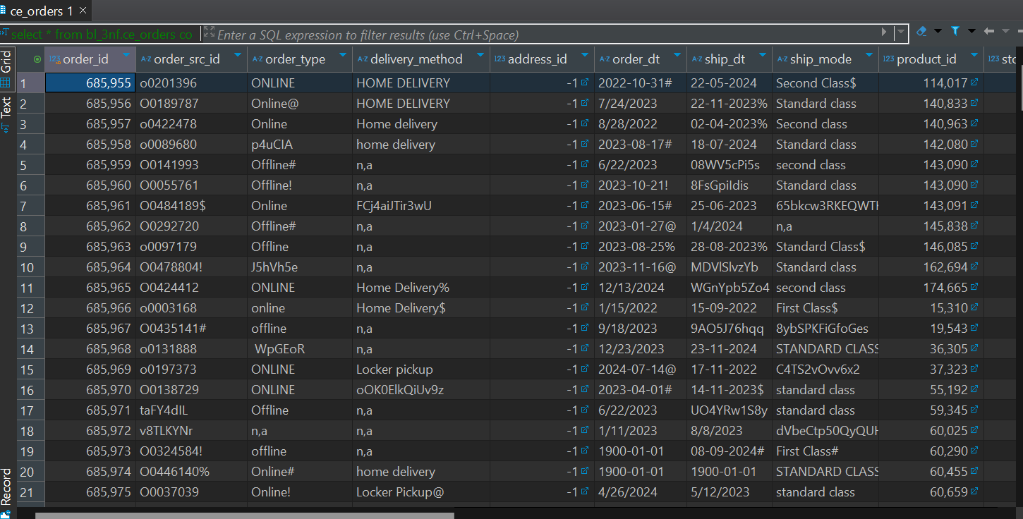

I have created 4 partition tables for dim_fact table and I will show the data there

First partition data:  
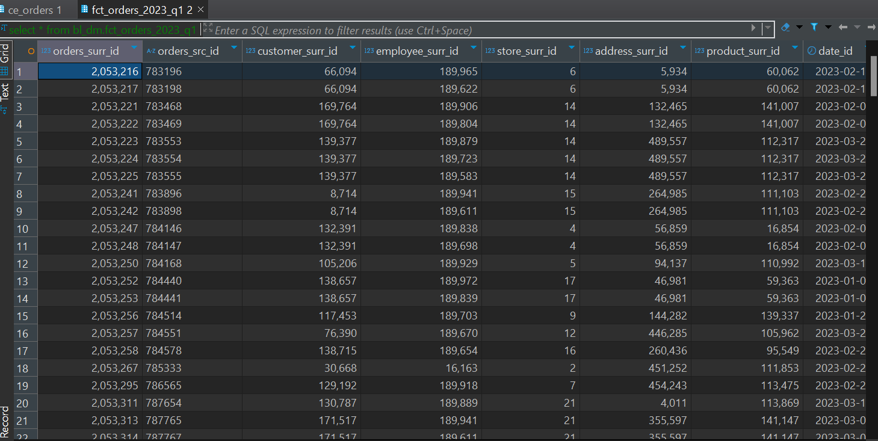

Second partition:

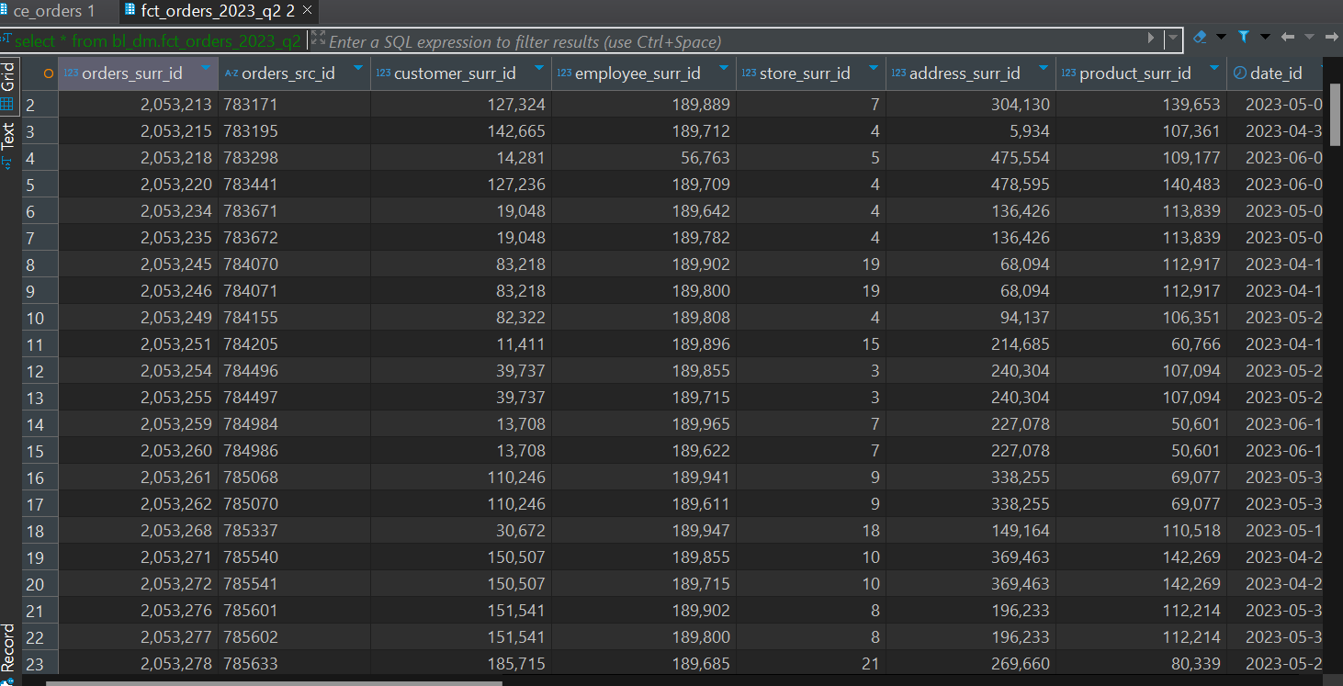

Third partition:

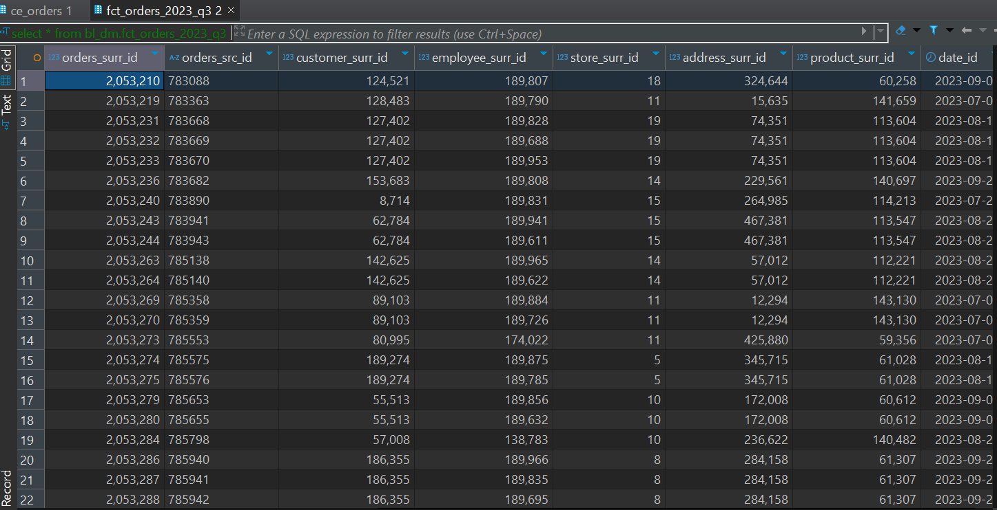

Fourth partition data:

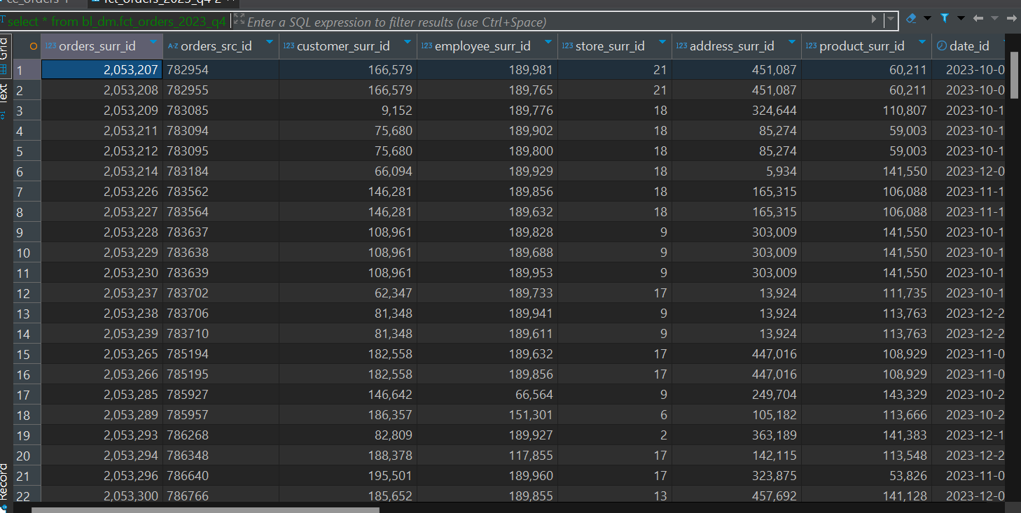

I loaded 3nf fact table from the source data,chose all the columns which were needed and than inserted it in the fact table, using left joins after that I inserted in dimensional layer using 3nf fact tables data as source data for my dimensional fact table, insertion process was the same. I partitioned fact table with event_date. Event_date is the date when this transaction happened. After that I used left join for checkin if event_date was equal to date_id, since my date_id is date type I needed to ensure that I was inserting the data correctly. All other joins logic is same as it was for 3nf fact_table.