I did everything as it was written in the word file. Now I duplicated the columns first_name and last_name here is the screenshot:

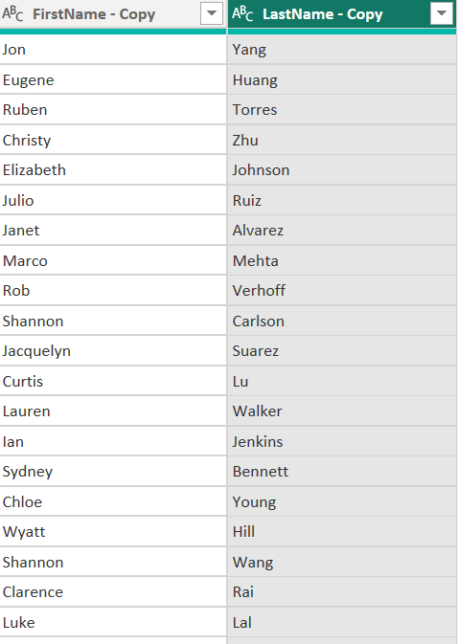

And after merging these 2 columns together we get new full name column:

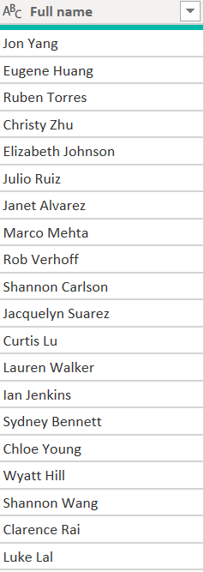

3-Change column type:

* Select ‘DiscountPct’ column in ‘DimPromotion’ table.

Change Data Type to Percentage:

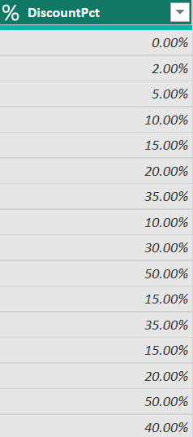

After that I created Promotion days column simply by choosing end_date and start_date and then I went to add column chose ‘Date’ and then substraction days. 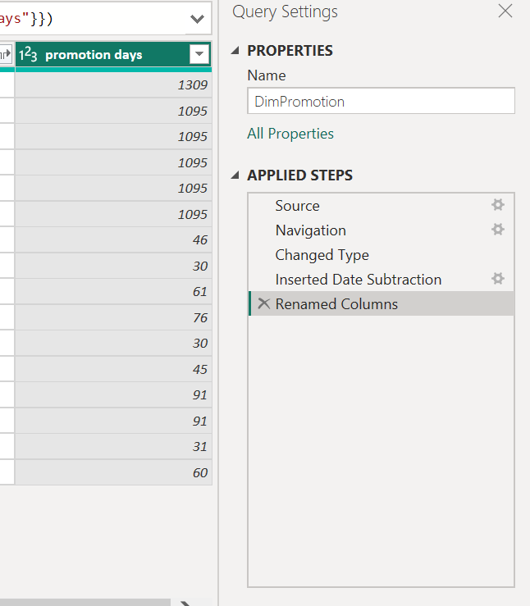

Load additionally ‘**DimProductSubcategory’** and ‘**DimProductCategory’** tables from AdventureWorks:

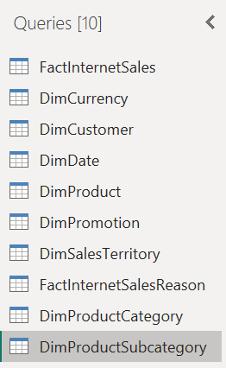

Click on the **View** tab and select options **Column Quality, Column distribution**and**Column profile.**   
Provide a screenshot of the result in your homework.

This is for table dimproductcategory:

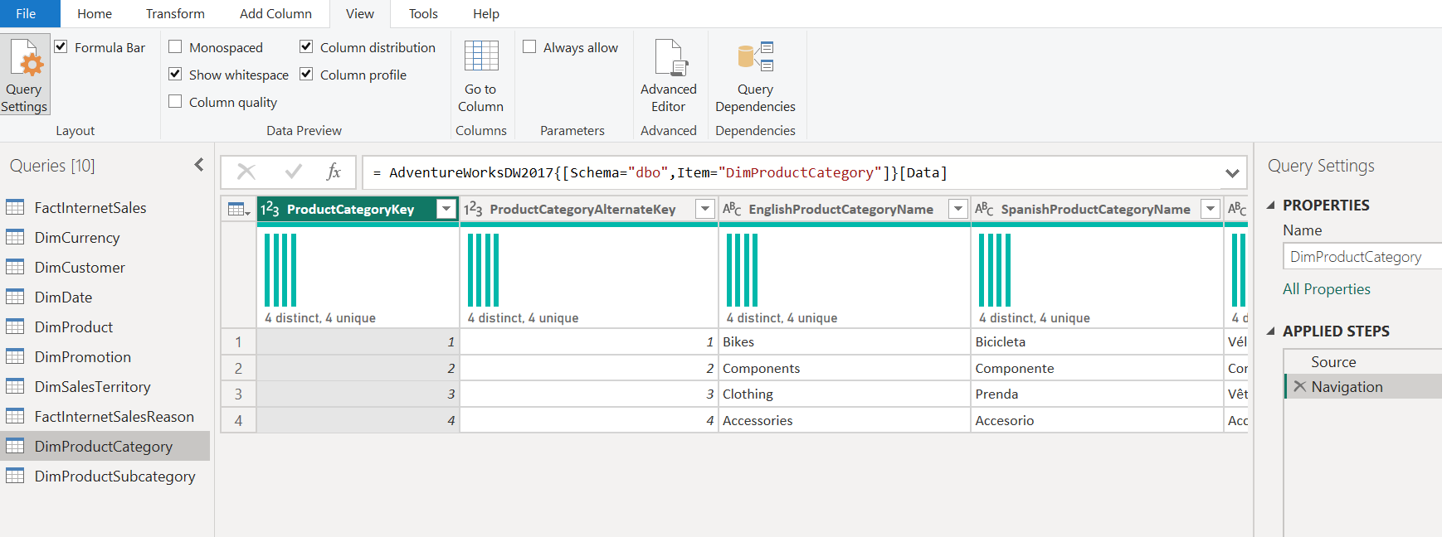

For subcategory:  
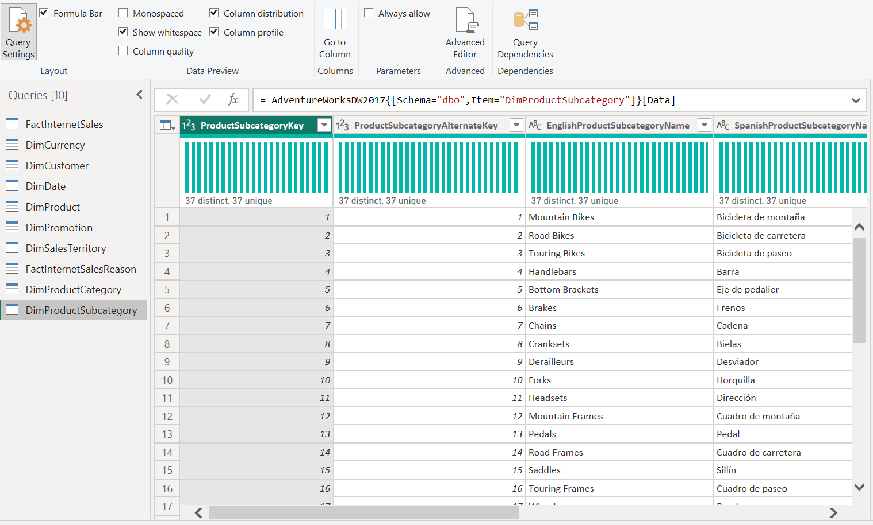

After that we needed to extract year from order_date from the factInternetSales table

Is simply happens like this:

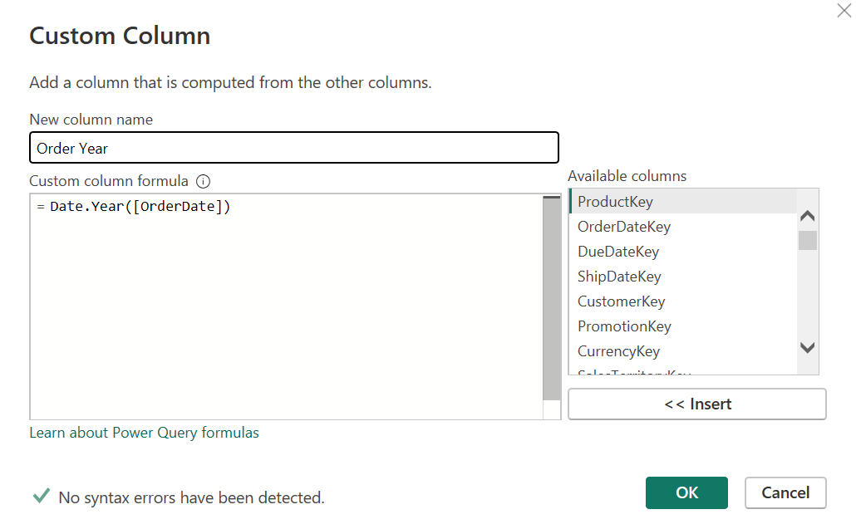

And new column is generated:

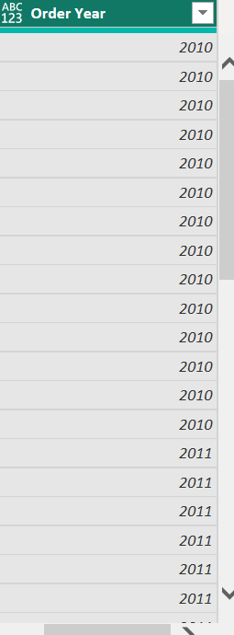

I created new table which was the same as factInternetSales table but after changing the name and removing all other columns other than these four it looks like this:

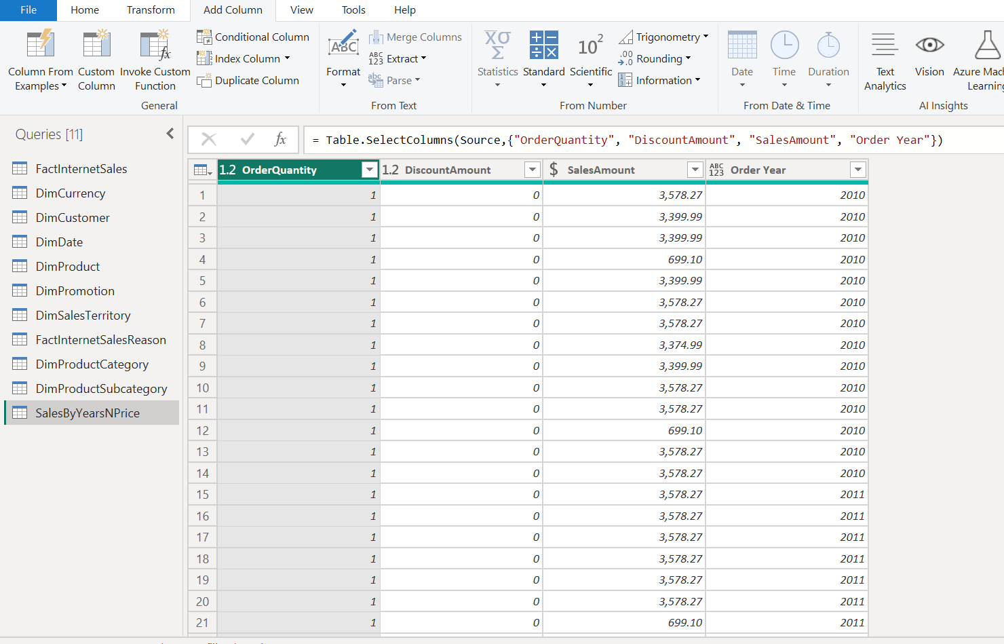

I used order year for pivot column and as I understand it summed up all the sales amount and it is grouped by order year and new table looks like this:

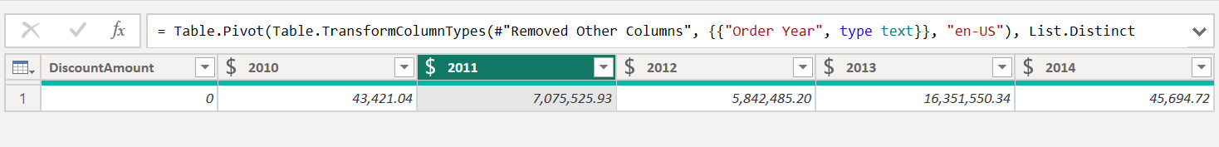

Order quantity is missing but its value was 1.

After creating “SalesByCountry” table and joining it to dimSalesTerritory it looks like this:

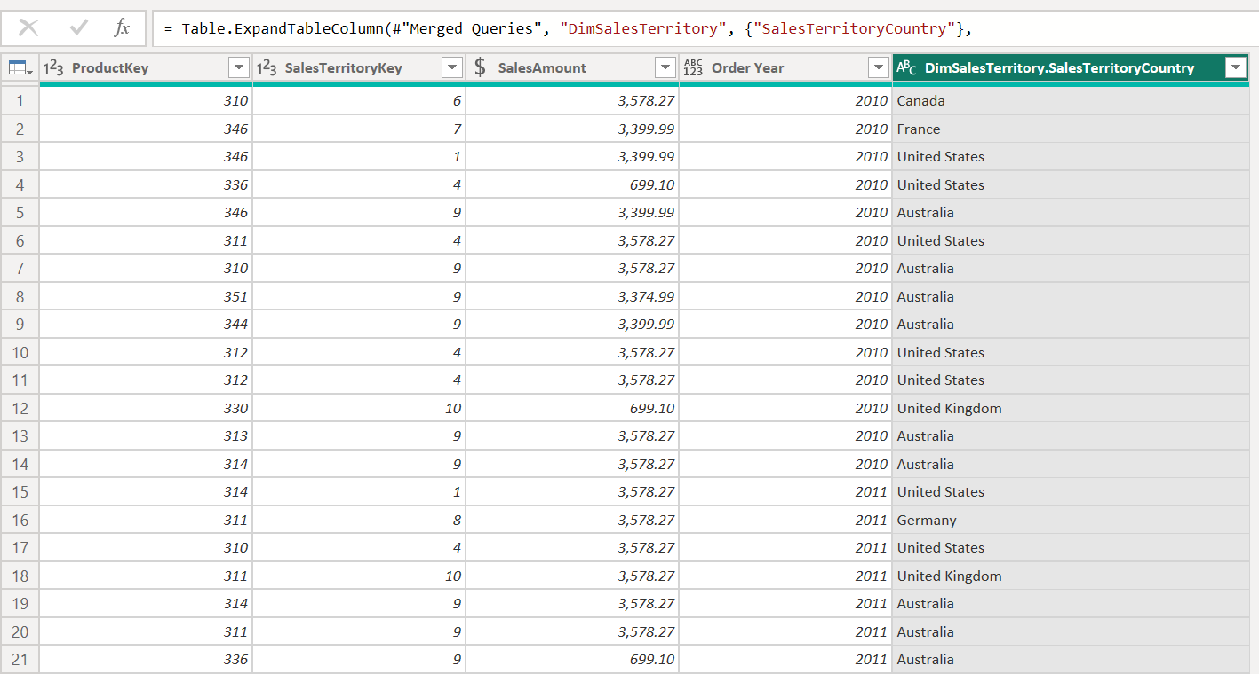

After that we needed to get which are englishProductCategories for that we needed to join dimProductSubcategories and after that dimProductCategores. And final output of the table is like this:

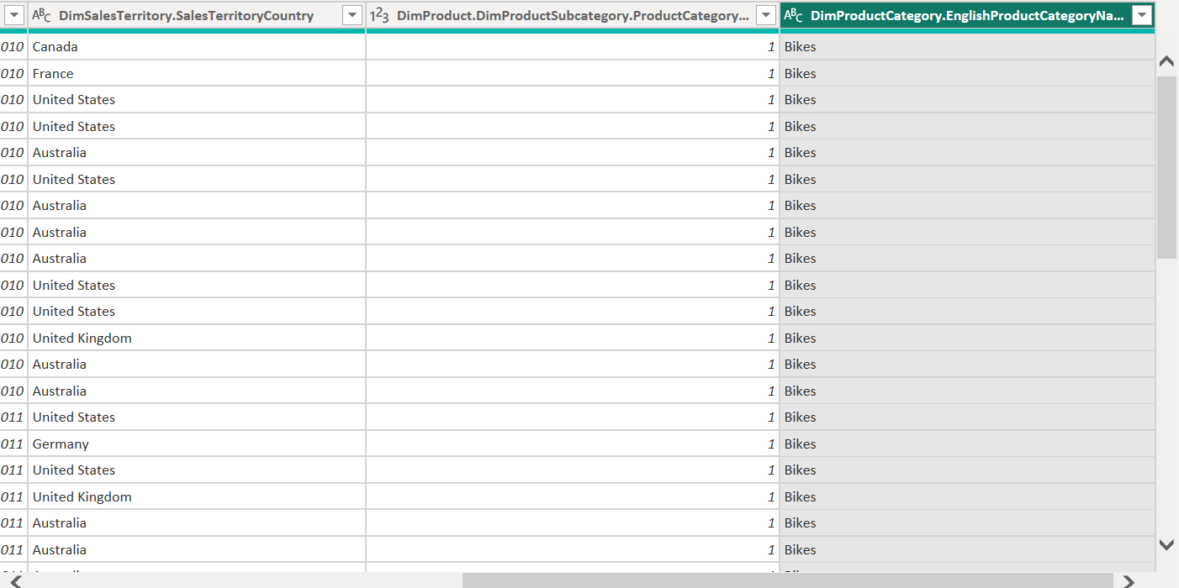

I only show the right hand side of the table since left hand side is unchanged.

New table is grouped by 3 columns order year,territory country and product_categoryname and output is like this: 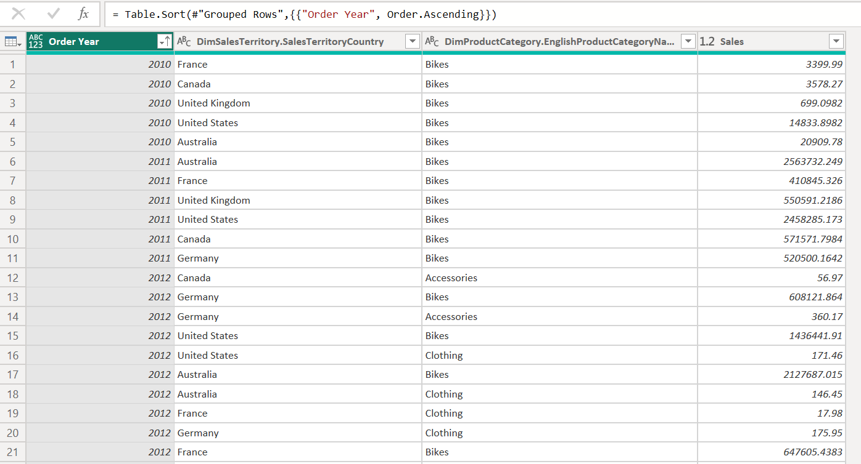

I don’t know what should I explain here.it is simple group by logic and that’s it.

Describe the difference between **Import and Direct query** based on the results.

Only difference as I know between importing and direct quering is that import mode Stores data inside Power BI and direct query mode Data remains in the source.

3-Review the Cardinality, Cross filter direction and Active/Inactive relationships. We are going to work with OrderDate as the main Date for the analysis, so remove other relationships between **FactInternetSales** table and **DimDate** and make the OrderDate connection active.

I deleted all the other relationship between fact and dim_date table only left relationship between order_date and date_key and change it from inactive relationship to active relationship:

