4-step process and denormalizing the model

1-The business process is trackingsalestransactions. Each sale represents an event where a product is sold to a customer, managed by an employee, and occurs at a specific store. This business process generates performance metrics such as salesamount, paymentdetails, and transactioncounts.

2-Grain Statement: One row per individual product sale transaction

STEP 3: IDENTIFY THE DIMENSIONS

Product Dimension-(DIM_PRODUCTS)  
Attributes: PRODUCT_ID, PRODUCT_NAME, CATEGORY_ID, CATEGORY_NAME, PRODUCT_UPDATE_DT.

Customer Dimension (DIM_CUSTOMERS)  
Attributes: CUSTOMER_ID, CUSTOMER_FIRST_NAME, CUSTOMER_LAST_NAME, CUSTOMER_EMAIL, ADDRESS_ID, CITY_ID, COUNTRY_ID, REGION_ID, etc.

Store Dimension (DIM_STORES)  
Attributes: STORE_ID, STORE_ADDRESS_ID, CITY_ID, COUNTRY_ID, REGION_ID, etc.

Employee Dimension (DIM_EMPLOYEES)  
Attributes: EMPLOYEE_ID, EMPLOYEE_FIRST_NAME, EMPLOYEE_LAST_NAME, ADDRESS_ID, CITY_ID, COUNTRY_ID, etc.

4-identify the facts:

Sales Amount**-**The numeric amount of the sale

Payment Details -Identifies how the transaction was completed.

The image of star schema:

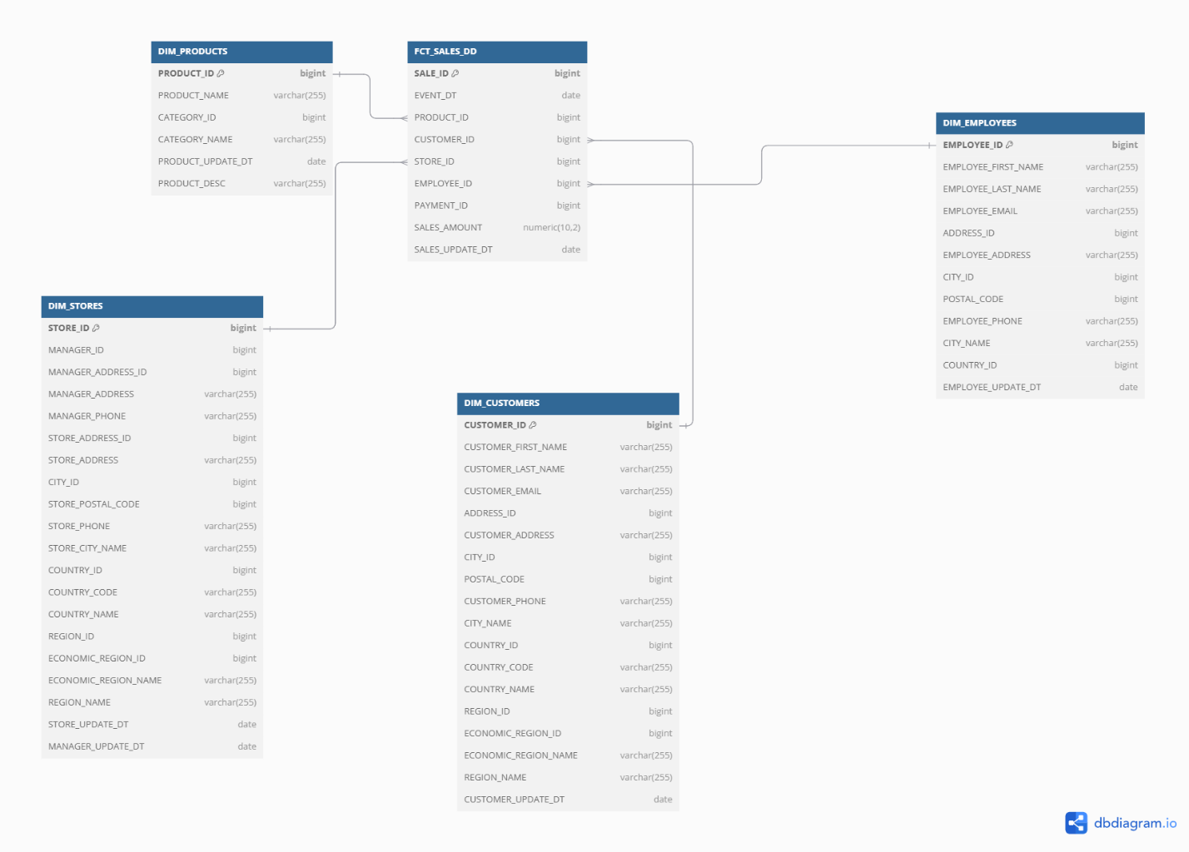

Snowflake schema description-I’m not sure about snowflake schema but my idea was to normalize address, country and city tables. We need them for customers, employee and store tables and because of that I normalized them and used them in these 3 tables. Fact table relationships remain unchanged, connecting to primary dimensions, which now reference sub-dimensions.

Address and location data centralized in DIM_ADDRESSES, DIM_CITIES, DIM_COUNTRIES, DIM_REGIONS, and DIM_ECONOMIC_REGIONS.

Snowflake schema(I hope you can see it clearly):

