After creating table test_index_plan and inserting rows there I wrote task 1.3. its output is this

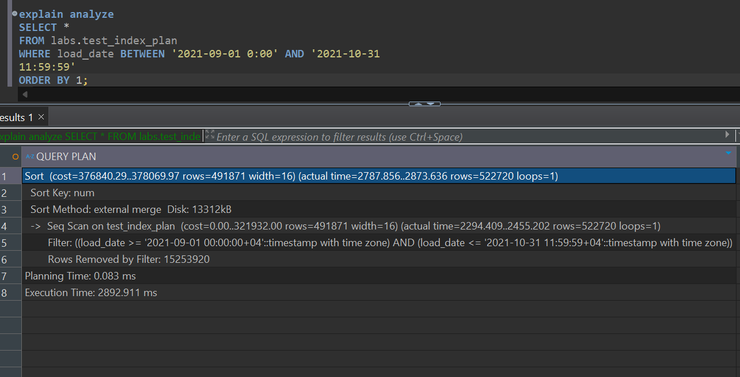

Since we have no index on any column it has to use sequence scan and read all table data and then have to use some sorting algorithm since we have “order by “ clause in the query. after running this query twice nothing changed so that means it still uses the same algorithm.

Explains output:

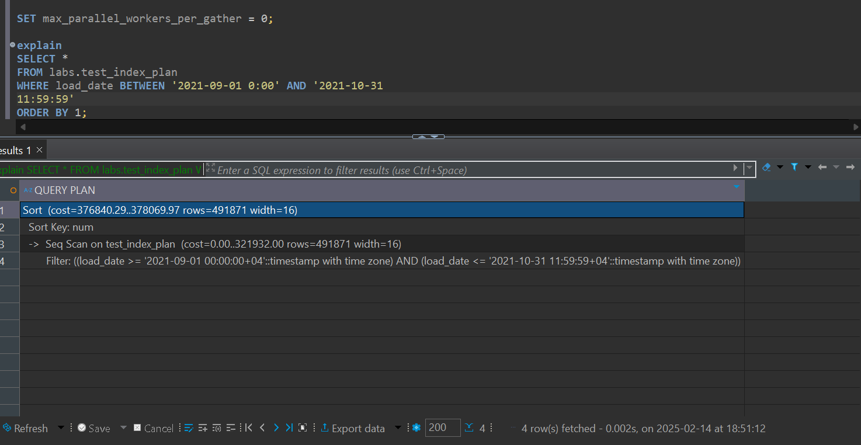

Explain (analayze,buffers):

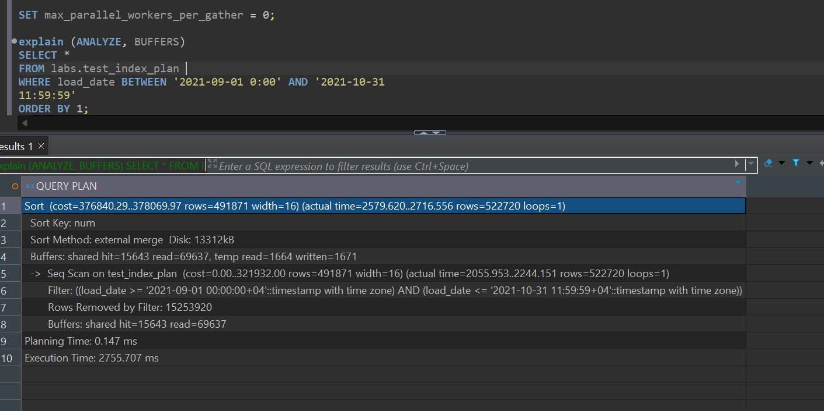

Explain-Displays the estimated execution plan based on statistics.

Explain analyze-Executes the query and provides the actual execution plan with real timing.

Explain(analyze,buffers)- Executes the query, provides actual execution statistics, and includes buffer usage details.

Task 1.2

After creating btree index on column load_date searching algorithm changed from sequence scan to index scan. Since indexes are saved in btree and we also have them filtered in where clause we can see them using index scan and its much convenient for speeding up data retrieval.

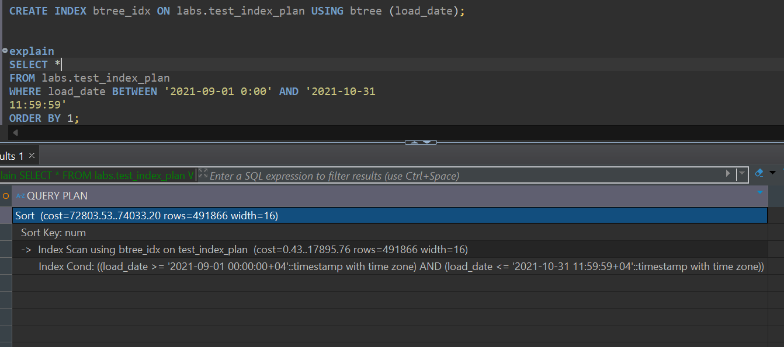

Explain analyze output:

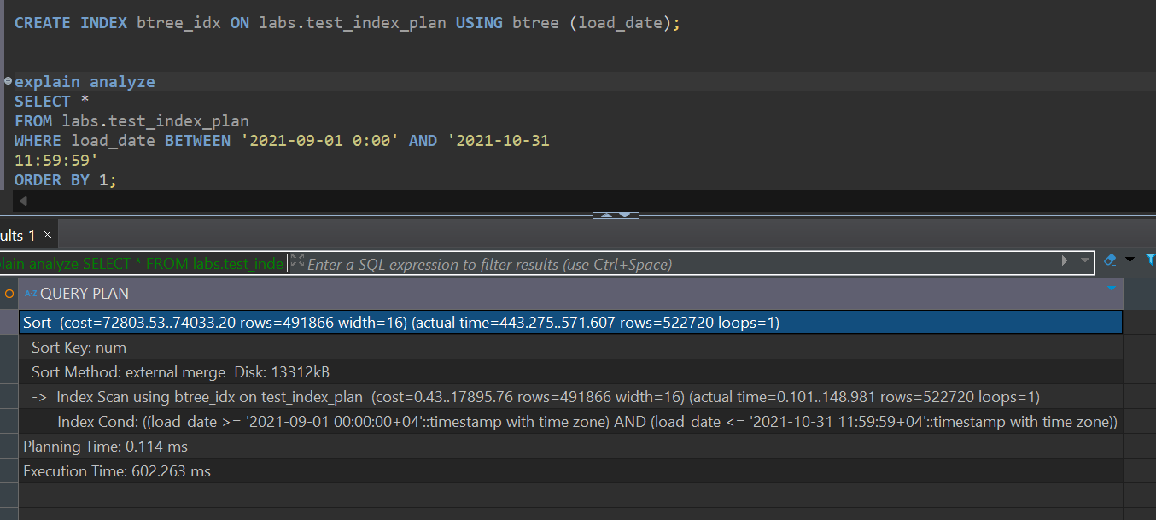

Explain(analyze,buffers):

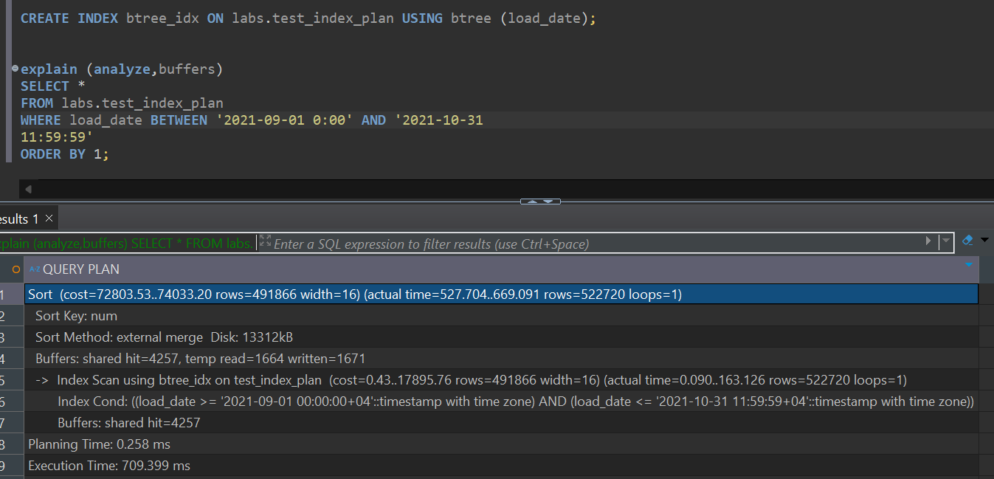

2.3-What can be done to query to use INDEX ONLY SCAN method?

Answer: since ‘index only scan’ has pre-conditions and one of them is that query should be fetching only key columns which are part of the index it is not possible in our example because we are fetching the all the columns. If we replace * with load_date it will use index scan.

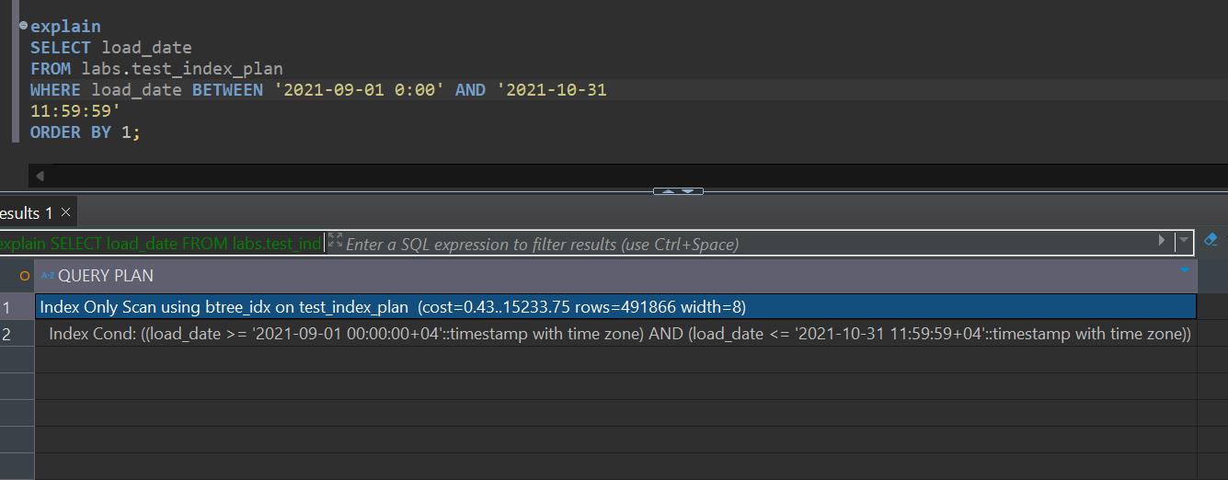

2.4-DROP B-tree Index from test_index_plan table and create BRIN index on test_index_plan table for load_date column. Check the plan of the select (twice at least, is any difference in plans?).

Answer: after using brin index the query is not using index scan anymore it now uses bitmap index scan and bitmap heap scan. Query performance is much better when using brin index compare to btree index.

Explain analyze output:

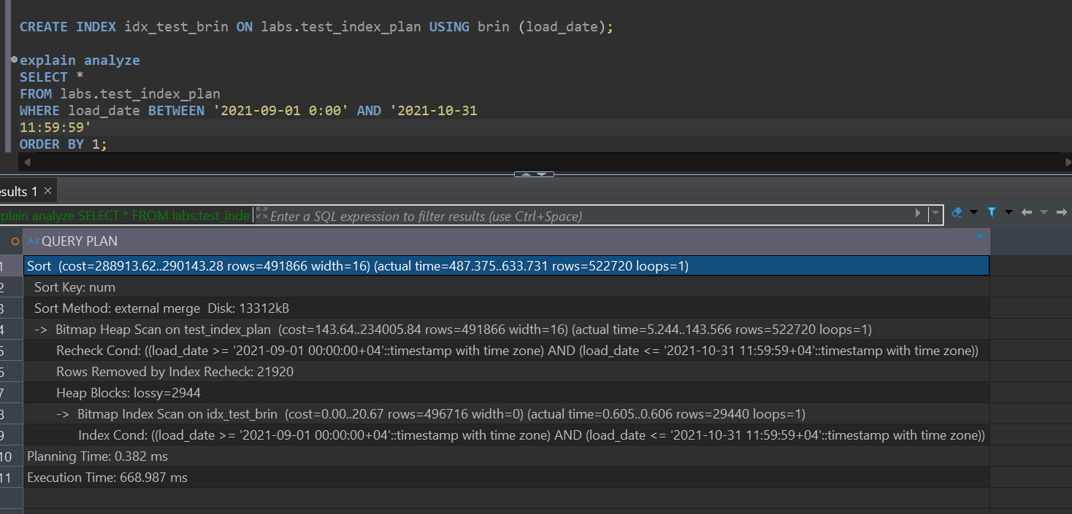

Explain output:

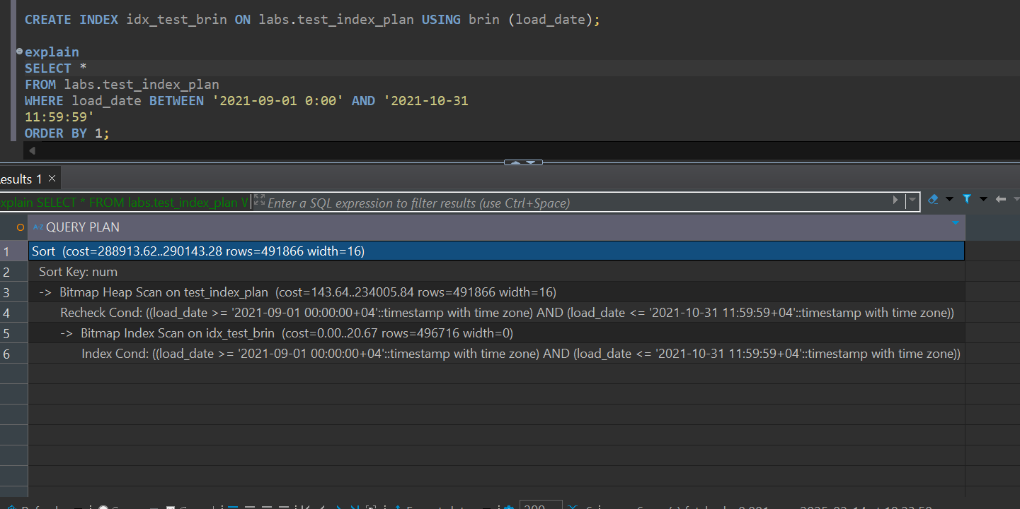

Explain(analyze,buffers):

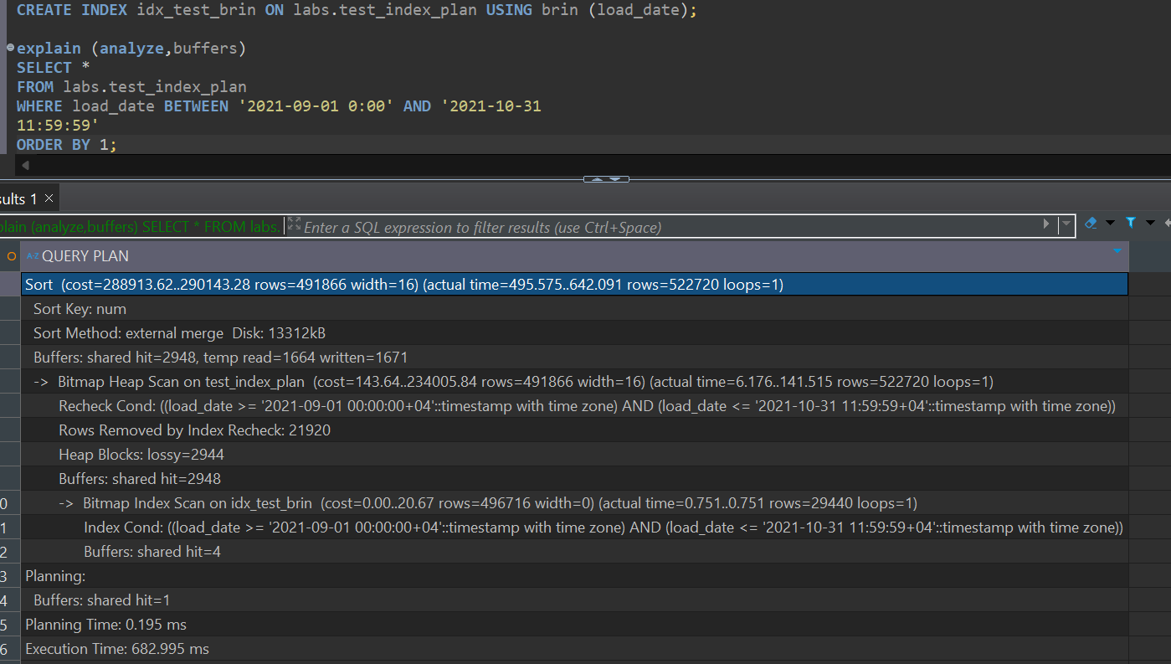

Task 2.1

I have all the explanations of the second task in sql file. I will provide only photos here for you to be sure that files and table are really created.

‘Test_index_plan.csv’ file:

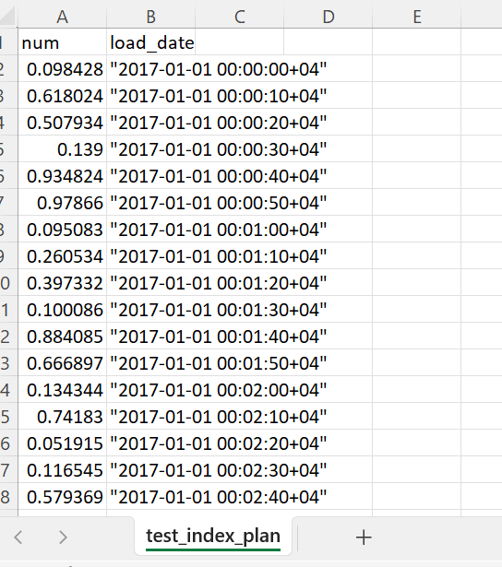

‘test_index_plan_short.csv’ file:

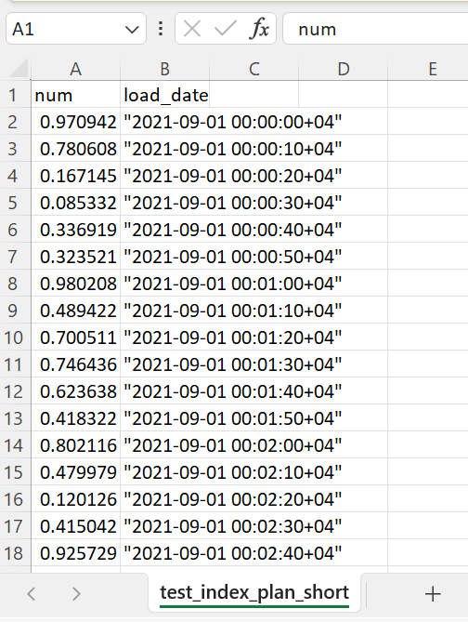

Here is the photo of updated emp table from task 2.3

