SEG800- Workshop 3

Total Mark: | 10 marks
Submission file(s):  (do NOT zip files) | - WS03.pdf (pdf of MTALAB live script)  - Group work declaration and contributions  Please do NOT zip the files for submission.

Please work in groups to complete this lab.
This lab is worth 3% of the total course grade and will be evaluated through your written submission, as well as the lab demo/test. During the lab demo, group members are randomly selected to explain the submitted solution. Group members absent during the lab demo will lose the demo mark.

Learning Objectives
- Evaluate z-transforms of signals and system responses using definition and properties of z-transform.
- Determine the ROC of z-transforms
- Use MATLAB functions to generate and plot the pole-zero plots of signals and systems.

Preparation
- This workshop assumes you have already installed MATLAB and downloaded the DSP Software Package in workshop 1.

- This workshop uses the DSP Student Manual [DSP-SM] available at:
https://media.pearsoncmg.com/ph/esm/ecs_proakis_dsp_5/stu_assets/dsp_student_manual.pdf
Use solutions in Appendix B as reference when needed.

- Review [DSP-SM] Section 3.1 to 3.4.
- Review the functions listed in [DSP-SM] Section 3.5.

- Create a live script in file WS03.mlx. Include text and code to complete this workshop. When asked to prove or calculate analytically, feel free to include a snapshot of your handwritten solutions in a separate document if easier. Please organize your solutions.

Part I: The Z-transform and its properties
Solve the following problems. Include solutions and explanations in your script/ submission.
- [DSP-SM] P3.1
- [DSP-SM] P3.2
- [DSP-SM] P3.3
- [DSP-SM] P3.4

- Include solutions (with explanations) to the following problem:
[DSP] P 3.1 Determine the z-transform of the following signals.
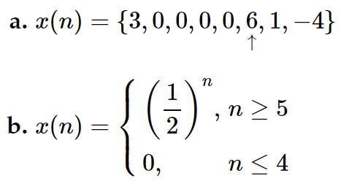

- Include solutions (with explanations) to the following problem:

[DSP] P 3.2 Determine the z-transforms of the following signals and sketch the corresponding pole–zero patterns.
a. $x\left(n\right)=\left(1+n\right) u(n)$
e. $x\left(n\right)= \left(na^{n}\cos{ω_{0}n}\right) u(n)$
h. $x\left(n\right)={\left(\frac{1}{2}\right)}^{n}\left[u\left(n\right)-u(n-10)\right]$

- Include solutions (with explanations) to the following problem:
[DSP] P 3.3 Determine the z-transforms and sketch the ROC of the following signals.
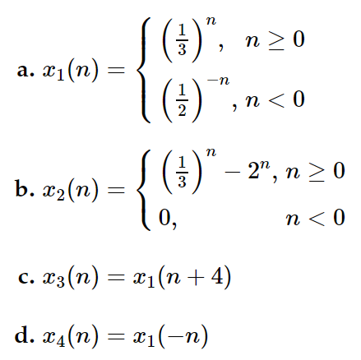

Part II: The inverse z-transform
Solve the following problems. Include solutions and explanations in your script/ submission.
- [DSP-SM] P3.5
- Include analytical solutions (with explanations) to the following problem:
[DSP] P 3.14 Determine the causal signal x(n) if its z-transform X(z) is given by:
a. $X\left(z\right)= \frac{1+3z^{-1}}{1+3z^{-1}+2z^{-2}}$
c. $X\left(z\right)= \frac{z^{-6}+z^{-7}}{1-z^{-1}}$
h. X(z) is specified by a pole-zero pattern in Fig. P3.14. The constat G = ½.

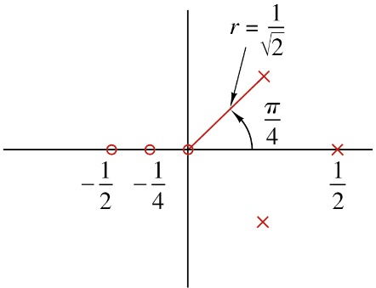
Figure P3.14

Part III: Analysis of LTI Systems
Solve the following problems. Include solutions and explanations in your script/ submission.
- [DSP-SM] P3.7
- [DSP-SM] P3.8
- Include analytical solutions (with explanations) to the following problem:
[DSP] P 3.35 Compute the zero-state response for the following pairs of systems and input signals.
h. $h\left(n\right)= {\left(\frac{1}{2}\right)}^{n}u\left(n\right), x\left(n\right)=(n+1){\left(\frac{1}{4}\right)}^{n}u\left(n\right)$

- Include solutions (with explanations) to the following problem:
[DSP] P 3.37 Compute the response of the system

$$y\left(n\right)=0.7y\left(n-1\right)-0.12y\left(n-2\right)+x\left(n-1\right)+x(n-2)$$

to the input x(n) = n u(n). Is the system stable?

Part IV: Group work
Complete this declaration by adding your names:
We, ------------ (mention your names), declare that the attached assignment is our own work in accordance with the Seneca Academic Policy. We have not copied any part of this assignment, manually or electronically, from any other source including web sites, unless specified as references. We have not distributed our work to other students.

Specify what each member has done towards the completion of this work:
 | Name | Task(s)
1
2
3

Include above in a separate document or in your MATLAB script for submission.

Submission
Run your live script and export to pdf. Include the pdf in your submission.
Please submit the submission file(s) through Blackboard. Only the last submission will be marked. Only one person must submit for the group

