Hello World!

Welcome To Baeldung!

***Welcome To Baeldung***

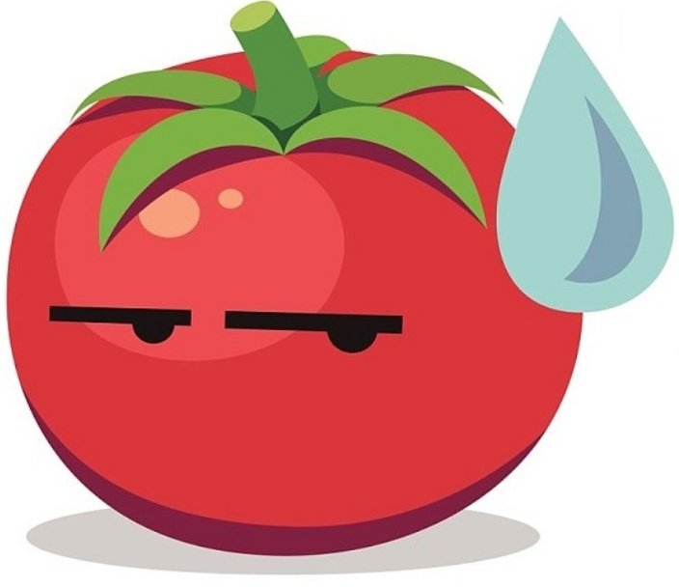

|  |
| --- |
| ***Welcome To Baeldung*** |