Supplementary information: The core seafloor microbiome in the Gulf of Mexico is remarkably consistent and shows evidence of recovery from disturbance caused by major oil spills

Will A. Overholt1, Patrick Schwing2, Kala M. Raz1, David Hastings3, David J. Hollander2, Joel E. Kostka1,4

1School of Biological Sciences, Georgia Institute of Technology, Atlanta GA; 2College of Marine Science, University of South Florida, St. Petersburg, FL; 3Department of Marine Science, Eckerd College, St. Petersburg, FL; 4School of Earth and Atmospheric Sciences, Georgia Institute of Technology, Atlanta, GA

Keywords: biogeography, deep ocean sediment, microbial community, Deepwater Horizon, response and recovery, perturbations

Running title: Deepsea benthic microbial biogeography

Methods

*SSU rRNA Gene Sequencing and Processing*

All samples from 2012-2013 were generated by the Michigan State University sequencing facility. Raw DNA extracts were transferred frozen and were amplified with the original barcoded 515F/806R primers according the Earth Microbiome Project standard protocol (Caporaso et al., 2012; http://www.earthmicrobiome.org/emp-standard-protocols/16s/). A total of 5 MiSeq 2x250 bp runs were performed and demultiplexed sequences were transferred to Georgia Institute of Technology. Samples collected from 2014-2015 were generated in house using the same primer set, however, the Fluidigm Access Array kit was used to barcode the samples post-PCR amplification. Multiplexed samples were pooled at equimolar ratios and paired-end sequenced (2x250 bp) on an Illumina MiSeq following the protocol outlined in by Green and colleagues (Green *et al.*, 2015).

All paired-end reads were merged using PEAR v0.9.6 with default parameters (Zhang et al., 2013) and assembled reads were quality filtered in QIIME using a minimum phred score of 30 (Q=30) (J. Caporaso et al., 2010). Mothur was used to remove sequences less than 250bp or greater than 255bp (Schloss et al., 2009). D*e novo* chimera detection followed by reference based chimera detection against the SILVA gold database was performed with vsearch v1.9.6 (Rognes et al., 2016). Remaining high quality sequences were dereplicated using vsearch v1.9.6 and operational taxonomic units (OTUs) were picked using Swarm v2.1.8 with default parameters (Mahé et al., 2014; Rognes et al., 2016). Overall patterns were similar as determined with uclust_reference and *de novo* based methods, but these would not complete on the full sample set (data not shown, a brief discussion is available here: <http://waoverholt.com/testing_otu_picking/>).

Singletons and OTUs present in less than 10 samples were removed, producing approximately 300,000 OTUs using 47 million reads (75% of initial raw reads). This filtering step does potentially exclude OTU that were locally abundant. However, the most globally abundant OTU that was excluded with this step comprised a maximum of 0 .2% relative sequence abundance in any sample. The most locally abundant OTU that was excluded comprised a maximum of 4.4% relative abundance within a single depth horizon (9-10 cm) at SL1040 only in August 2014 and was observed at 0.001% relative abundance in one other sample (IXW750 in the SGoM). Samples with less than 5000 sequence counts were removed from further analysis. The medium number of QAQC sequences per sample was 82 836 with an interqualtile range of 23 609 to 128 973 (Figure S2). Taxonomic affiliations for each OTU were determined using the SILVA v123 database (Quast et al., 2012). Representative sequences were aligned using the PyNAST implementation in QIIME with the SILVA alignment and a phylogenetic tree for determining phylogenetic diversity metrics was generated with fasttree v2.1.3 (J. G. Caporaso et al., 2010; J. Caporaso et al., 2010; Price et al., 2010). All raw sequences have been uploaded to NCBI under Bioproject PRJNA414249.

*OTU Analysis*

OTU counts were normalized using the metagenomeSeq package in R, scaling by 1000 and without a log-transform (Paulson et al., 2013). Trends were confirmed with rarefaction to 5000 sequences per sample (data not shown). Beta diversity was determined using Bray Curtis dissimilarity implemented in the R package ‘vegan’ (Oksanen et al., 2007; R Core Team, 2014), while weighted and unweighted Unifrac distances were calculated using the implementation found in the R package ‘phyloseq’ (McMurdie and Holmes, 2013). Patterns were consistent and Bray Curtis dissimilarities are shown. Nonmetric multidimensional scaling (NMDS) ordination was generated using the R package ‘vegan’ without transformation and the patterns were indistinguishable to those observed using Principal Coordinates Analysis (PCoA) (Oksanen et al., 2007; R Core Team, 2014). Patterns in Bray Curtis dissimilarity values were tested using multiple linear regressions in R (R Core Team, 2014). The most significant regression used the formula: dissimilarity ~ sediment depth difference * water depth difference * geographic distance * Sampling Year. In this model format, the asterisks indicate that all interaction terms are included in the model, and these are specified in TableS2. Linear regression models were compared using Analysis of Variance (ANOVA), and the percent each variable contributed to the patterns observed was determined with ANOVA (Table S2, Table S3). While all interaction terms were significant, only those that contributed >1% variance were retrained and the model was reconstructed after dropping those terms to reduce its complexity (Table S2; dissimilarity ~ sediment depth difference + water depth difference + geographic distance + sampling year + sed:water). All plots generated use the ggplot2 package in R (R Core Team, 2014; Wickham, 2009).

*Meta-Analysis: Incorporating Impacted Surficial Sediments*

Sequences generated by Mason and colleagues targeted the same region of the 16S rRNA gene, although sequence lengths were substantially shorter (on average 100 bp after Q30 trimming) (Mason et al., 2014). These sequences were incorporated into this study by using our previously identified OTUs as reference sequences and using the QIIME script ‘parallel_pick_otus_uclust_ref.py’. Without chimera checking (as the references were already cleared) we matched 75% of all Mason 16S sequences (20 million reads) to one of our OTUs at 3% sequence difference or less. Since the Mason et al., 2014 study used only surficial sediments (top 1 cm), we restricted our comparison samples to include only depths in the same interval.

*Constructing a Gulf-Wide Model for Microbial Community Composition*

Water depth, sediment depth, latitude, and longitude were chosen as predictor variables and were used as proxies for sediment carbon input, oxygen concentrations, geological regime shifts from E-W and N-S as well as riverine inputs. Latitude, longitude, and water depths were extracted from the NGDC Coastal Relief model (Divins and Metzger, 2008). The Random Forest regression model for each response variable was constructed with 500 trees, a minimum of 5 terminal nodes per tree, and randomly subsampling 1/3 of the response variable (OTU normalized counts) for each node of each tree. Only response variables of which >50% of the variance could be explained by the regression forest were retained.

The effectiveness of the model was evaluated by randomizing the predictor variables 1000 times and comparing the total root mean squared error calculated using:

(1)

where is the predicted OTU relative abundance, is the observed OTU relative abundance, and is the number of OTUs. In this calculation, the OTU abundance from every sample is used, giving one value for the trained model, and one value for each of the 1000 randomized models. The RMSE of the trained model was compared to the randomly constructed models using a Z-test. Additionally, individual sample deviations from the OTU predictions were determined using equation (1). Instead of evaluating the model, this was used to identify samples that were not representative of oligotrophic Gulf of Mexico sediments (e.g. those that differed from baseline).

*Calculating Alpha Diversity Metrics*

Alpha diversity metrics were calculated using the normalized OTU table as described in the methods section. Rarefaction curves were generated using a wrapper function created by B. Hausmannand described here (<https://github.com/joey711/phyloseq/issues/143>). Shannon indices (base e) were determined using the R package ‘vegan’ and the estimated richness was calculated by fitting a zero-truncated negative binomial model by the R package ‘preseqR’ (Deng et al., 2014).

**Results and Discussion**

*Environmental parameters structuring benthic microbial distributions across the Gulf of Mexico, detailed review of previous findings*

The Arctic Ocean is one of the better studied regional ocean basins in regards to biogeographic patterns in microbial community structure (Bienhold et al., 2012; Jacob et al., 2013). The study performed by Jacob and colleagues used spatial variables similar to this study consisting of latitude, longitude, geographic distance, and water depth at the Arctic Long-Term Ecological Research (LTER) site to constrain microbial community variation in 13 surficial sediment samples collected along two transects. Using redundancy analysis, Jacob et al. (2013) found that bacterial community structure significantly varied with water depth and longitude (7% and 3% of the variance, respectively), while geographic distance was not significant. Also in the Arctic, Bienhold et al. (2012) linked microbial community structure and diversity to energy availability in sediments using pyrosequencing on 10 samples and fingerprinting methods on 42 samples. Contrasting with the results from this study and with Jacob et al. (2013), the authors linked changes in community composition primarily with geographic distance (10% of the variation), followed by sediment pigment concentrations (5%). Sediment depth and water depth had low explanatory power (Bienhold et al., 2012). In the southern Atlantic Ocean, a study by Schauer et al. (2010) examined biogeographic patterns in deep marine surficial sediments across 3 basins (Cape, Angola, and Guinea) generating three SSU rRNA clone libraries and analyzing another 51 samples using a fingerprinting method. Their results showed that microbial communities were significantly different between the basins examined and that within a basin there was a spatial effect. In another regional study of surficial benthic microbial communities, the authors sampled 24 surficial sediments in two geographically distinct regions in a 5500 km transect in the Southern Ocean off the coast of Western Antarctica (Learman et al., 2016). This study consisted of SSU rRNA gene amplicons generated from the same primers used in this study and found that microbial community composition was linked to the bioavailability of carbon and nutrient availability. However, this finding was confounded by large physiochemical differences between the distinct regions, that had unique community compositions (Learman et al., 2016).

On a global scale, water depth appears to have less explanatory power than observed in this study, while geographic distance tends to have more power (Bienhold et al., 2016; Danovaro et al., 2016; Zinger et al., 2011). This phenomenon is well documented, poorly understood, and is unlikely to be related to a breakdown in the correlation between water depth and the quality and quantity of carbon inputs (Danovaro et al., 2016 and the refs within). In such a study, Zinger et al. (2011) constrained 22 % of the benthic microbial community variation and found that geographic distance best explained surficial microbial community variation at 6 %, similar in to the results in this study. Zinger et al. (2011) also found that coastal benthic microbial communities varied more than their deep ocean counterparts, which is the opposite of what was observed in this study (Figure S1). This could be due to several reasons, including our shallow samples were mostly retrieved from the same year and sampled more extensively in one geographic region. In a follow-up global-scale study focusing exclusively on deep marine benthic microbial communities (>1000m depths), (Bienhold et al., 2016) observed that microbial communities were less similar with increasing geographic distance, and this distance-decay relationship was greater when one considers water flow paths instead of straight lines between sites. Total organic carbon explained the most variation in microbial community structure (10%) followed by geographic distance (4%), although the sample set consisted of 1-6 samples per ocean region (Bienhold et al., 2016). Using non-sequence based techniques, Danovaro et al. (2016) found that the absolute abundances of bacteria, total archaea, Marine Group I Archaea, and Marine Group II Archaea did not significantly vary within the same ocean basin, however, there were differences between ocean basins. Danovaro et al. (2016) also demonstrated that archaeal and bacterial abundances were partially controlled by the same factors, namely biopolymeric carbon concentrations, and bacterial abundances were primarily influenced by carbon inputs while archaeal abundances were primarily influenced by bottom water temperature.

*Within basin Microbial Biogeography - Organic Matter inputs between NGoM and SGoM*

In this study, significant differences in microbial community composition (p < 2e-16, var. explained = 4%) were observed between the northern and southern Gulf of Mexico, although these differences were small relative to the impacts of overlying water column depth and sediment depth (Figure 2). When comparing the microbial community composition of sediments from similar water depths in each region, community composition in the northern Gulf of Mexico more closely resembled shallower sites in the southern Gulf of Mexico (Figure 4). This effect became more apparent when selecting sediments collected from 1000-1300 m water depths (Figure 4 C). Both southern Gulf microbial community core profiles cluster below (in the direction of increasing water depth profiles) northern Gulf of Mexico sediment profiles collected at similar water depths. This is clearly reflected in the deeper depths of oxygen penetration in the southern Gulf of Mexico and the maintenance of higher oxygen concentrations through the core profile (Figure 4 D). Overall, these data are consistent with greater organic matter deposition in the northern Gulf of Mexico due to the greater carbon and nutrient contributions of the Mississippi River relative to the Grijalva- Usumacinta system (Dunn, 1996). Following a simple adjustment for water depth, the sedimentary microbial communities in these geographically distinct regions with such different quantities of riverine inputs were shown to be remarkably similar.

*The class-level composition of the seafloor microbiome across the Gulf of Mexico*

Shifts in community composition with changes in sediment depth along with water depth were apparent at the class level. In the deep Gulf of Mexico (>1000 m), surficial sediments (0-1 cm) were dominated by Gammaproteobacteria (25.6% ± 4.0, n = 126) followed by Marine Group I Thaumarchaeota (21.0% ± 0.08), Deltaproteobacteria (13.1% ± 3.4), and Alphaproteobacteria (10.2% ± 3.1) (Figure 5). Commonly detected, but at low relative abundances in surficial sediments, were the classes Gemmatimonadetes (2.6% ± 0.63), Phycisphaerae (2.6% ± 0.84), Acidobacteria (2.0% ± 3.9), and Planctomycetacia (2.1% ± 1.5). Microbial communities were strongly stratified with sediment depth. Progressing downcore, class level shifts were apparent with decreasing Gammaproteobacteria (11.3% ± 5.3 at 8-10 cm), Thaumarchaeota (4.5% ± 3.7), and Alphaproteobacteria (6.6% ± 3.5) relative abundances and corresponding increases in Deltaproteobacteria (20.1% ± 5.5), Planctomycetacia (7.2% ± 3.7), and Phycisphaerae (10.1% ± 6.1) groups (Figure 5).

In depth analysis of dominant OTU distributions

*MG-I Archaea*

Using the full dataset, the most abundant MG-I OTU (denovo3, 93% identity to *N. maritimus*)dominated sites sampled at approximately 1000 m water depth (Figures 6, Figure S7), while denovo25 (98% to *N. maritimus*) was abundant in the deepest sites. Conversely, denovo19 and denovo21 (97%, 99% to *N. maritimus* respectively) were most abundant at the shallowest sites. However, all four were abundant in surficial sediments across the entire Gulf and did not have a strong differential response to sediment column depth as was found by Durbin and Teske (2010). Instead of oxygen concentrations dictating the niches of these specific OTU, it may be organic matter quantity and quality that structure the niches, as has been shown in surficial sediments in Antarctica (Learman *et al.*, 2016). While water depth best explains these patterns, there were latitudinal and longitudinal differences in the dominant MG-I OTU (Figures S4, S7). However, these smaller shifts due to spatial variation were also likely driven by organic matter quality and quantity, which vary based on proximity to the Mississippi river delta across the Gulf (Goñi et al., 1997).

*Gammaproteobacteria*

Our most abundant Gammaproteobacteria OTU (denovo1) was 96% similar to the only isolated strain, *Woeseia oceani*, and showed maximum relative abundances just below the oxic-anoxic interface and in deeper water sites, similar to members of the Planctomycetacia group (Figure 6, Figure S8). This *Woeseia*-like group may be respiring nitrate or nitrite coupled with chemoorganoheterotrophy as suggested by others (Dyksma *et al.*, 2016; Mußmann *et al.*, 2017). Unlike denovo1, the remaining dominant Gammaproteobacterial OTU were most abundant in surficial, aerobic sediments of the deep ocean, although their abundances also increased with increasing water depth (Figure 6, S5, S8). Denovo14 and denovo15 were both assigned to the JTB255/*Woeseiaceae* group (95% and 98% similarity to denovo1 respectively). The second most abundant OTU, denovo2, was divergent from the JTB255 group and showed 93% sequence identity to denovo1. The closest BLAST hit was to the isolated strain *Thioprofundum hispidum*, at 94% sequence identity. It was < 95% sequence identity to denovo14 and denovo15, although they exhibit similar distribution patterns. While the phylogenetic identity of denovo2 was less certain, *T. hispidum* was characterized as a chemolithoautotrophic sulfur-oxidizing strain within the Chromatiales order (Mori *et al.*, 2011). With the observed distribution patterns, these 3 OTU (denovo14, 15, 2) were likely utilizing oxygen as a terminal electron acceptor either for chemolithoautotrophic processes observed within *Thioprofundum spp.* coupled with sulfur oxidation or as aerobic chemoorganotrophs as observed in the JTB255/*Woeseiaceae* group (Mori *et al.*, 2011; Mußmann *et al.*, 2017).

*Deltaproteobacteria*

Similar to the Gammaproteobacteria, little overlap was observed between Deltaproteobacterial OTU associated with the shallower sites and those in the deeper sites. In deep ocean sediments, most of the sequences affiliated with Deltaproteobacteria, belong to denovo0. This was the most abundant OTU detected in our dataset, and its relative abundance increased with increasing sediment depth. Interestingly, maximum relative abundance of denovo0 was found at intermediate water column depths (1000 – 1200 m) (Figure 6, S9). Although not closely affiliated to any cultivated strain, denovo0 was most similar to *Syntrophobacter fumaroxidans* at 91% and assigned to the *Syntrophobacteraceae* family by SILVA. The family consists of strictly anaerobic fermentative or sulfate respiring members that are broadly distributed (Kuever, 2014). The other dominant deep ocean sediment Deltaproteobacterial OTU, denovo16 (<90% similarity to denvo0), showed a similar distribution to denovo0, and did not decrease with increasing water depth. Denovo16 showed 91% sequence similarity to *Deferrisoma camini*, a thermophilic strictly anaerobic iron-reducing bacterium,within the uncharacterized and uncultivated NB1-J group. In the shallow sites, denovo89 and denovo50 were very abundant throughout the sediment column (Figure S9). Denovo50 shares 96% identity with *Desulfatiglans aniline*, and was more abundant in the shallow SGoM than the shallow NGoM. Denovo89 was closely affiliated (98% identity) with the deep ocean OTU denovo0, and likely represents a poorly characterized population within the *Syntrophobacteraceae* family.

*Planctomycetacia*

All dominant OTU affiliated with the Planctomycetacia were closely related to *Candidatus* *Scalindua* spp (99-100%). These dominant OTU are likely anaerobic ammonium oxidizing bacteria (anammox), which are chemoautotrophic, ubiquitously found in anoxic systems, and couple the oxidation of ammonium with nitrite as the electron acceptor (Penton *et al.*, 2006; Oshiki *et al.*, 2016). Members from this genus tend to be psychrophilic, and are inhibited by low sulfide concentrations (4-100 µM), which potentially explains their depth limits in our study, although it may also be due to ammonium or nitrite availability (Oshiki *et al.*, 2016). The Planctomycetes were nearly absent in the shallowest sites, and absent in surficial sediments, in agreement with previous studies that indicate ca. *Scalindua* is more abundant in oligotrophic systems (Canion *et al.*, 2014; Learman *et al.*, 2016). All dominant Planctomycetes OTU tended to reach a maximal relative abundance at mid-sediment depths below the oxic-anoxic interface with an overlapping distribution to the *Nitrosopumulis*-like OTUs (Figures 6, S5, S10). Denovo4 tended to be more abundant with increasing water depth, while denovo11 had higher relative abundances in the 600-1200 m water depth range. Previous studies focusing on surficial sediments typically found low Planctomycetacia abundances (Schauer *et al.*, 2010; Bienhold *et al.*, 2016; Learman *et al.*, 2016) while studies that included a larger depth range, or core profiles found higher abundances with depth than at the surface (Zinger *et al.*, 2011; Canion *et al.*, 2014).

*Phycisphaerae*

The dominant Phycisphaerae OTU were only abundant in the deep ocean and different OTU were present in the shallower sites (Figure S11). All increased in relative abundance with increasing sediment depth and were only present below the aerobic to anaerobic transition zone. These OTU were exhibited higher relative abundances in the NGoM than the SGoM, although the same OTUs were detected in both regions (Figures 6, S5, S11). The more abundant OTU, denovo42, was affiliated with an uncharacterized family, MSBL9, with no closely related named strains (< 80% sequence identity). The closest BLAST hits to the NR database were from anaerobic marine sediments with a 100% 16S clone sequence from Gulf of Mexico sediments (Reed *et al.*, 2006).

**Table S1.** List of all sites used in this study.

|  |  |  |  |  |  |  |  |
| --- | --- | --- | --- | --- | --- | --- | --- |
| **Sampling Site** | **Water Depth (m)** | **Latitude** | **Longitude** | **Number of Unique Samplings** | **Number of Years** | **16S Sequences** | **Oxygen Profile** |
| Abkatum | 50 | 19.314270 | -92.208000 | 1 | 1 | Y | Y |
| AC-1 | 490 | 29.474500 | -86.958700 | 1 | 1 | Y | Y |
| AC-2 | 845 | 29.297600 | -86.996800 | 1 | 1 | Y | Y |
| AC-4 | 1732 | 29.000300 | -87.507400 | 1 | 1 | Y | Y |
| AC-5 | 1850 | 28.940100 | -87.582400 | 1 | 1 | Y | Y |
| DSH07 | 400 | 29.255817 | -87.732383 | 1 | 1 | Y | Y |
| DSH08 | 1100 | 29.122783 | -87.867733 | 1 | 1 | Y | Y |
| DSH08 | 1100 | 29.122783 | -87.867733 | 3 | 3 | Y | Y |
| DSH09 | 2290 | 28.636500 | -87.868500 | 2 | 2 | Y | Y |
| DSH10 | 1500 | 28.979050 | -87.891617 | 4 | 4 | Y | Y |
| DWH01 | 1500 | 28.736669 | -88.387161 | 2 | 2 | Y | Y |
| IWX250 | 583 | 19.430680 | -93.094970 | 1 | 1 | Y | Y |
| IXN500 | 1200 | 20.014000 | -92.389000 | 1 | 1 | Y | Y |
| IXTOC | 60 | 19.370080 | -92.317180 | 2 | 1 | Y | Y |
| IXW500 | 1010 | 19.443000 | -93.889000 | 1 | 1 | Y | Y |
| IXW750 | 1470 | 19.458000 | -94.587000 | 1 | 1 | Y | Y |
| LT1 | 16 | 18.808000 | -92.057000 | 1 | 1 | Y | Y |
| LT2 | 21 | 19.061000 | -92.127000 | 1 | 1 | Y | Y |
| MV02 | 541 | 28.494167 | -89.779367 | 2 | 2 | Y | Y |
| PCB06 | 990 | 29.122700 | -87.266217 | 3 | 3 | Y | Y |
| PCB06 | 990 | 29.122700 | -87.266217 | 1 | 1 | Y | Y |
| S35 | 670 | 29.333600 | -87.050200 | 1 | 1 | Y | Y |
| S36 | 1841 | 28.916400 | -87.669100 | 1 | 1 | Y | Y |
| SE02 | 972 | 28.359167 | -86.944267 | 1 | 1 | Y | Y |
| SEEP-A | 1110 | 29.043000 | -87.282400 | 1 | 1 | Y | No |
| SEEP-C | 1116 | 28.990000 | -88.045500 | 1 | 1 | Y | No |
| SL1040 | 50 | 29.196050 | -88.868833 | 3 | 3 | Y | Y |
| SL33-750 | 1300 | 22.415000 | -91.785000 | 1 | 1 | Y | Y |
| SW01 | 1192 | 28.220867 | -89.069500 | 4 | 4 | Y | Y |
| SL26A250 | 500 | 21.199 | -96.851 | 1 | 1 | No | Y |
| SL26A750 | 1500 | 21.37 | -96.559 | 1 | 1 | No | Y |
| IXNW1600 | 3200 | 20.804 | -94.803 | 1 | 1 | No | Y |
| 23-92 | 3700 | 23 | -92 | 1 | 1 | No | Y |
| SL33-200 | 400 | 22.333 | -91.7 | 1 | 1 | No | Y |
| SL31A-1000 | 2200 | 20.718 | -93.137 | 1 | 1 | No | Y |
| IXN1000 | 2200 | 20.345 | -92.137 | 1 | 1 | No | Y |
| IXN750 | 1650 | 20.172 | -92.423 | 1 | 1 | No | Y |
| IXN250 | 800 | 19.912 | -92.342 | 1 | 1 | No | Y |
| IXN100 | 400 | 19.817 | -92.349 | 1 | 1 | No | Y |
| SL31-100 | 200 | 21.038 | -92.46 | 1 | 1 | No | Y |
| Ixtoc 1 | 50 | 19.366 | -92.313 | 1 | 1 | No | Y |
| Abkatun | 50 | 19.913 | -92.206 | 1 | 1 | No | Y |
| LT3 | 50 | 19.36 | -92.28 | 1 | 1 | No | Y |
| IXNW350 | 700 | 19.645 | -92.741 | 1 | 1 | No | Y |
| IXW250 | 580 | 19.429 | -93.094 | 1 | 1 | No | Y |
| SL30A-100 | 200 | 18.936 | -93.36 | 1 | 1 | No | Y |
| SL30-500 | 920 | 19.071 | -94.433 | 1 | 1 | No | Y |
| SL30-250 | 510 | 18.866 | -94.433 | 1 | 1 | No | Y |
| SL30-100 | 200 | 18.7 | -94.433 | 1 | 1 | No | Y |
| SL28-750 | 1500 | 19.324 | -95.594 | 1 | 1 | No | Y |
| SL28-500 | 1000 | 19.224 | -95.696 | 1 | 1 | No | Y |
| SL27-750 | 1500 | 20.12 | -96.133 | 1 | 1 | No | Y |
| SL27-500 | 1000 | 20.085 | -96.233 | 1 | 1 | No | Y |
| SL26-750 | 1533 | 21.37648 | -96.57455 | 1 | 1 | No | Y |
| SL26-500 | 953 | 21.27383 | -96.72933 | 1 | 1 | No | Y |
| SL25-750 | 1603 | 24.15995 | -96.39425 | 1 | 1 | No | Y |
| SL25-500 | 952 | 24.21741 | -96.82131 | 1 | 1 | No | Y |
| PCB06 | 990 | 29.1227 | -87.26622 | 1 | 1 | No | Y |
| PCB03 | 100 | 29.73833 | -86.33833 | 1 | 1 | No | Y |
| SL7150 | 200 | 29.56833 | -86.57833 | 1 | 1 | No | Y |
| MC04 | 400 | 29.30575 | -86.67637 | 1 | 1 | No | Y |
| DSH08 | 1100 | 29.12278 | -87.86773 | 1 | 1 | No | Y |
| DSH07 | 400 | 29.25582 | -87.73238 | 1 | 1 | No | Y |
| SL1040 | 50 | 29.19605 | -88.86883 | 1 | 1 | No | Y |
| DWH01 | 1500 | 28.73667 | -88.38716 | 1 | 1 | No | Y |
| HC01 | 45 | 28.38413 | -90.53097 | 1 | 1 | No | Y |
| MV02 | 541 | 28.49417 | -89.77937 | 1 | 1 | No | Y |
| SW01 | 1192 | 28.22087 | -89.0695 | 1 | 1 | No | Y |
| SW03 | 1196 | 28.57558 | -88.80043 | 1 | 1 | No | Y |
| SE02 | 972 | 28.35917 | -86.94427 | 1 | 1 | No | Y |
| DSH09 | 2290 | 28.6365 | -87.8685 | 1 | 1 | No | Y |
| S36 | 1841 | 28.9164 | -87.6691 | 1 | 1 | No | Y |
| NT800 | 789 | 28.056 | -85.93351 | 1 | 1 | No | Y |
| MC06 | 600 | 29.08355 | -86.91452 | 1 | 1 | No | Y |
| SL8100 | 200 | 29.70167 | -87.19167 | 1 | 1 | No | Y |
| SL1460 | 120 | 29.45648 | -87.45088 | 1 | 1 | No | Y |
| DSH10 | 1500 | 28.97905 | -87.89162 | 1 | 1 | No | Y |
| PCB09 | 1000 | 28.85912 | -87.21468 | 1 | 1 | No | Y |
| SL11150 | 300 | 29.03785 | -88.64423 | 1 | 1 | No | Y |
| MV03 | 800 | 28.39825 | -89.59938 | 1 | 1 | No | Y |
| SL16150 | 200 | 28.63537 | -90.0015 | 1 | 1 | No | Y |

**Table S2. Analysis of variance table for multiple linear regressions used in this study.**

Simplified best fit model.

|  |  |  |  |  |  |  |
| --- | --- | --- | --- | --- | --- | --- |
|  | Df | Sum Sq | Mean Sq | F value | Pr(>F) | Percent Variance Explained |
| water_dif | 1 | 1475.448 | 1.48E+03 | 129176.4 | 0 | 22.09 |
| sed_dif | 1 | 951.5594 | 9.52E+02 | 83309.6 | 0 | 14.25 |
| geo_dist | 1 | 405.9833 | 4.06E+02 | 35544.09 | 0 | 6.08 |
| same_date | 1 | 328.1475 | 3.28E+02 | 28729.52 | 0 | 4.91 |
| water_dif:sed_dif | 1 | 101.5731 | 1.02E+02 | 8892.788 | 0 | 1.52 |
| Residuals | 299145 | 3416.824 | 1.14E-02 | NA | NA | 51.15 |
| Full best fit model |  |  |  |  |  |  |
|  | Df | Sum Sq | Mean Sq | F value | Pr(>F) | Percent Variance Explained |
| water_dif | 1 | 1475.45 | 1.48E+03 | 136850.79 | 0.0E+00 | 22.09 |
| sed_dif | 1 | 951.56 | 9.52E+02 | 88259.06 | 0.0E+00 | 14.25 |
| geo_dist | 1 | 405.98 | 4.06E+02 | 37655.77 | 0.0E+00 | 6.08 |
| same_date | 1 | 328.15 | 3.28E+02 | 30436.35 | 0.0E+00 | 4.91 |
| water_dif:sed_dif | 1 | 101.57 | 1.02E+02 | 9421.11 | 0.0E+00 | 1.52 |
| water_dif:geo_dist | 1 | 0.83 | 8.26E-01 | 76.60 | 2.1E-18 | 0.01 |
| sed_dif:geo_dist | 1 | 16.57 | 1.66E+01 | 1536.90 | 0.0E+00 | 0.25 |
| water_dif:same_date | 1 | 55.50 | 5.55E+01 | 5147.61 | 0.0E+00 | 0.83 |
| sed_dif:same_date | 1 | 6.67 | 6.67E+00 | 618.97 | 1.7E-136 | 0.10 |
| geo_dist:same_date | 1 | 93.49 | 9.35E+01 | 8671.52 | 0.0E+00 | 1.40 |
| water_dif:sed_dif:geo_dist | 1 | 3.11 | 3.11E+00 | 288.75 | 1.0E-64 | 0.05 |
| water_dif:sed_dif:same_date | 1 | 1.31 | 1.31E+00 | 121.58 | 2.9E-28 | 0.02 |
| water_dif:geo_dist:same_date | 1 | 5.82 | 5.82E+00 | 540.25 | 2.1E-119 | 0.09 |
| sed_dif:geo_dist:same_date | 1 | 2.55 | 2.55E+00 | 236.91 | 1.9E-53 | 0.04 |
| water_dif:sed_dif:geo_dist:same_date | 1 | 5.86 | 5.86E+00 | 543.22 | 4.8E-120 | 0.09 |
| Residuals | 299135 | 3225.105 | 1.08E-02 | NA | NA | 48.28 |

**Table S3**. Sequential analysis of variance of multiple linear regression models. Model 5 represents the model that explains the most variance, while model 6 is the simplified model using only terms that explain >1% of the variance. Water = water depth, sed = sediment depth, distance = geographic distance between sites, environment = binary factor representing N of S Gulf of Mexico, date = factor for sampling date (5 sampling timepoints).

|  |  |  |  |  |  |  |
| --- | --- | --- | --- | --- | --- | --- |
|  | Res.Df | RSS | Df | Sum of Sq | F | Pr(>F) |
| 1. water | 299149 | 5204.1 |  |  |  |  |
| 2. water * sed | 299147 | 4150.5 | 2 | 1053.58 | 48860.7 | < 2.2e-16 |
| 3. water * sed * distance | 299143 | 3726 | 4 | 424.51 | 9843.6 | < 2.2e-16 |
| 4. water * sed * environment | 299143 | 3786.5 | 0 | -60.5 |  |  |
| 5. water * sed * distance * date | 299135 | 3225.1 | 8 | 561.39 | 6508.7 | < 2.2e-16 |
| 6. water + sed + distance + date + water:sed | 299145 | 3416.8 | -10 | -191.72 | 1778.2 | < 2.2e-16 |

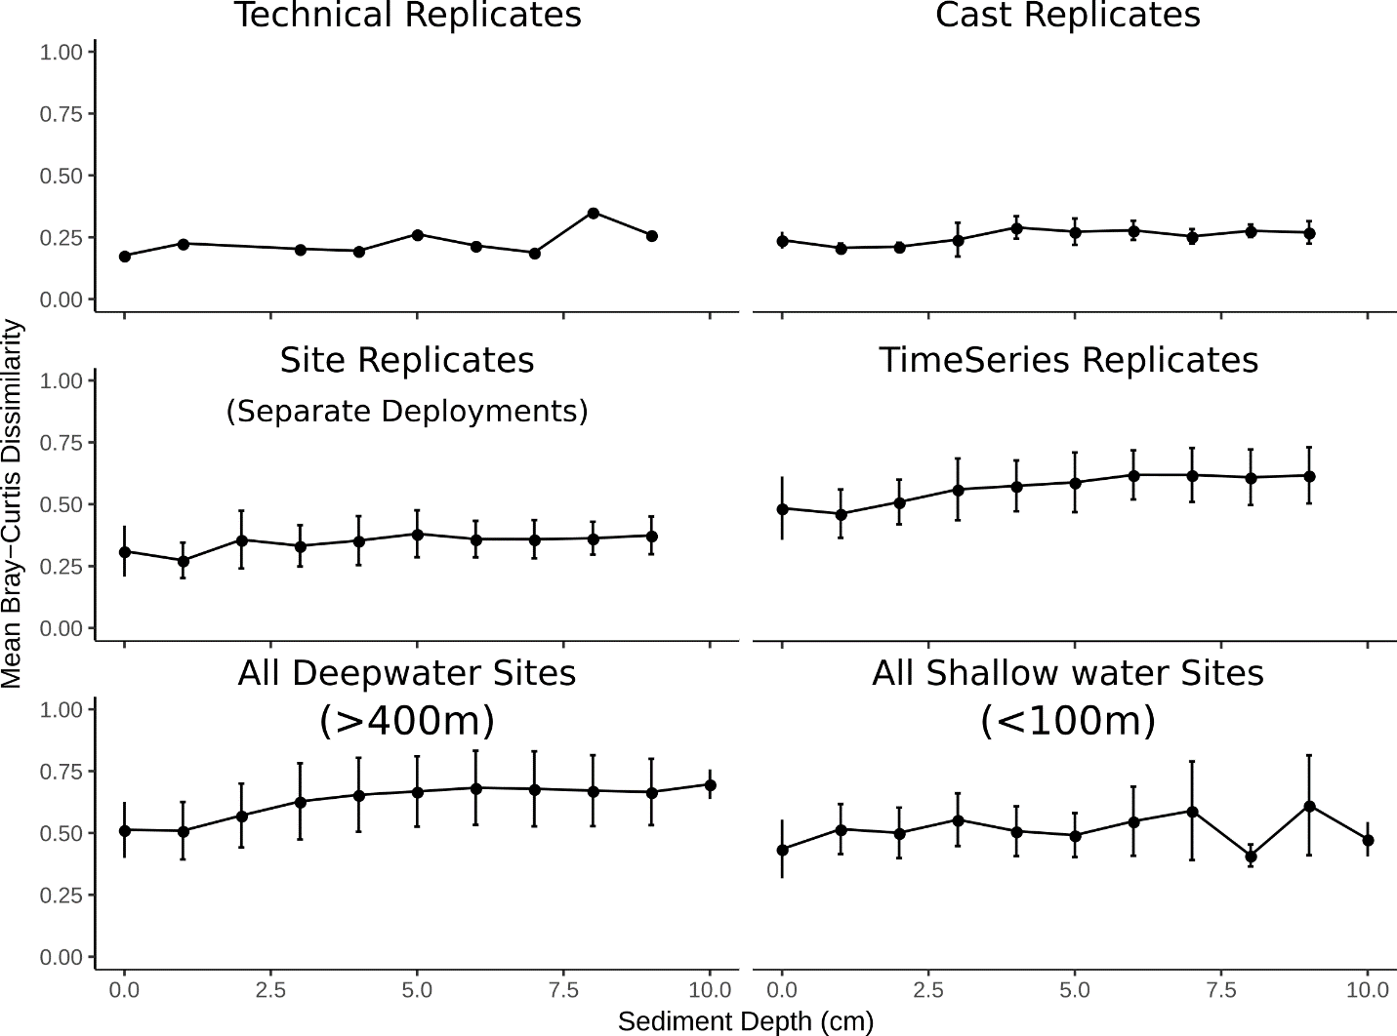

F

E

D

C

B

A

**Figure S1. Changes in microbial community similarity at different levels of replication.** Pairwise Bray-Curtis similarities were calculated for every sample, and samples were binned into 1 cm depth increments to enable cross study comparisons. Error bars represent standard deviation about the mean for each sediment depth bin. (A) The same core (AC-5) depth sections were independently extracted and sequenced in duplicate. (B) For three sites, within 1 multicorer cast, triplicate cores were extruded and depth sections were extracted and sequenced. This represents variation within 1m2 of the seafloor. (C) For 10 sites, triplicate multicore deployments were performed, 1 core from each deployment was extruded, and DNA extraction and sequencing was performed on the sections. This represents community variation of tens to hundreds of square meters on the seafloor. (D) Seven sites were sampled over multiple cruises. (E) All sites sampled at water depths > 400m, representing the deep Gulf of Mexico. (F) All sites sampled at water depths less than 100m, representing the shallow Gulf of Mexico.

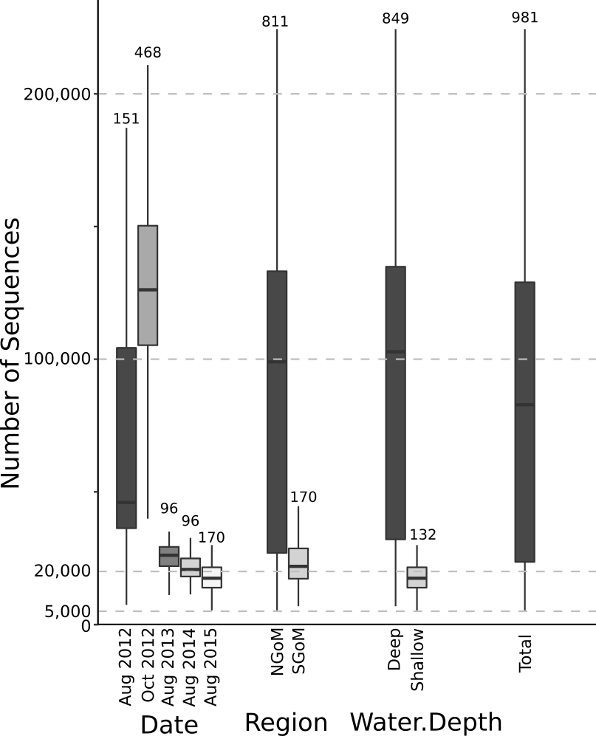

**Figure S2. Number of QAQC sequences per sample.** The number of samples within each group is shown above each boxplot. Only samples with at least 5,000 sequences were retained for analysis and medium number of sequences within each of these groups is >17,000. The boxes bound the interquartile range, and the whiskers represent the full range.

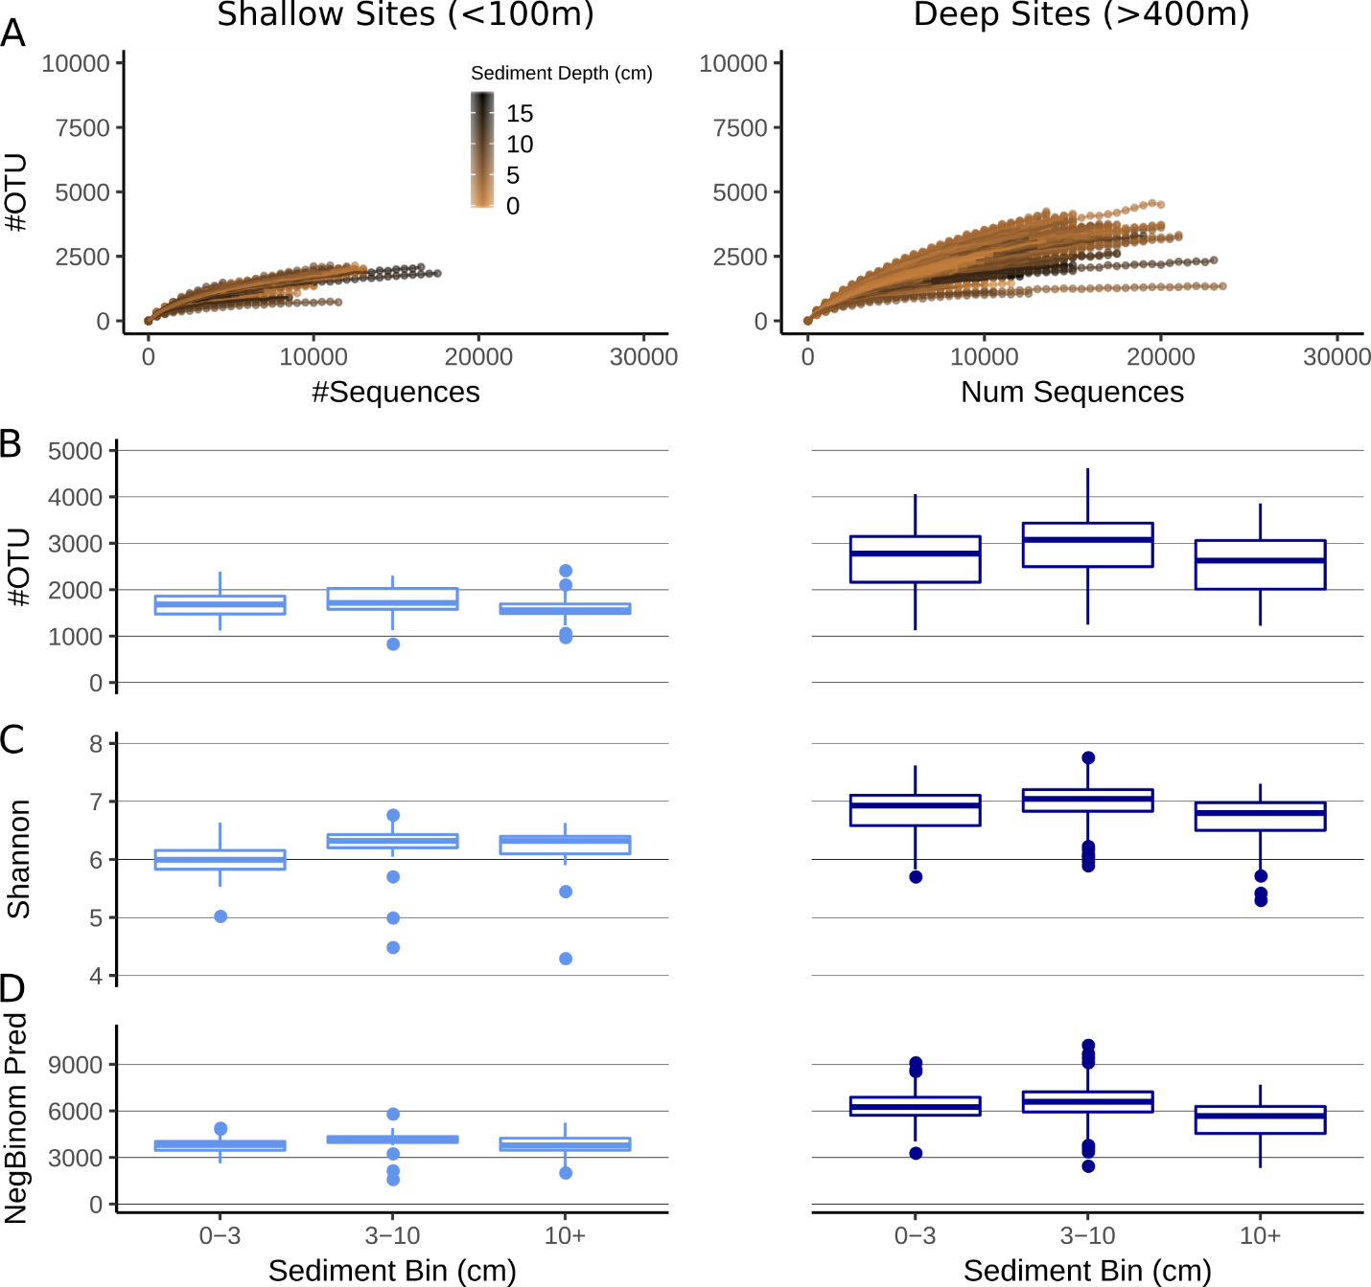

**Figure S3. Microbial alpha diversity metrics from the Gulf of Mexico.** The normalized OTU table that was used for all beta-diversity analyses (Figure 2) was also used here. There are no sites >100 m and <400 m water depth (all samples are included in this figure).(A) Rarefaction curves generated by subsampling at 500 depth intervals, samples are colored based on depth within the sediment (not significant). (B) Observed number of OTUs, (C) Shannon diversity calculated using base e, (D) Estimated number of OTUs using a zero-truncated negative binomial model.

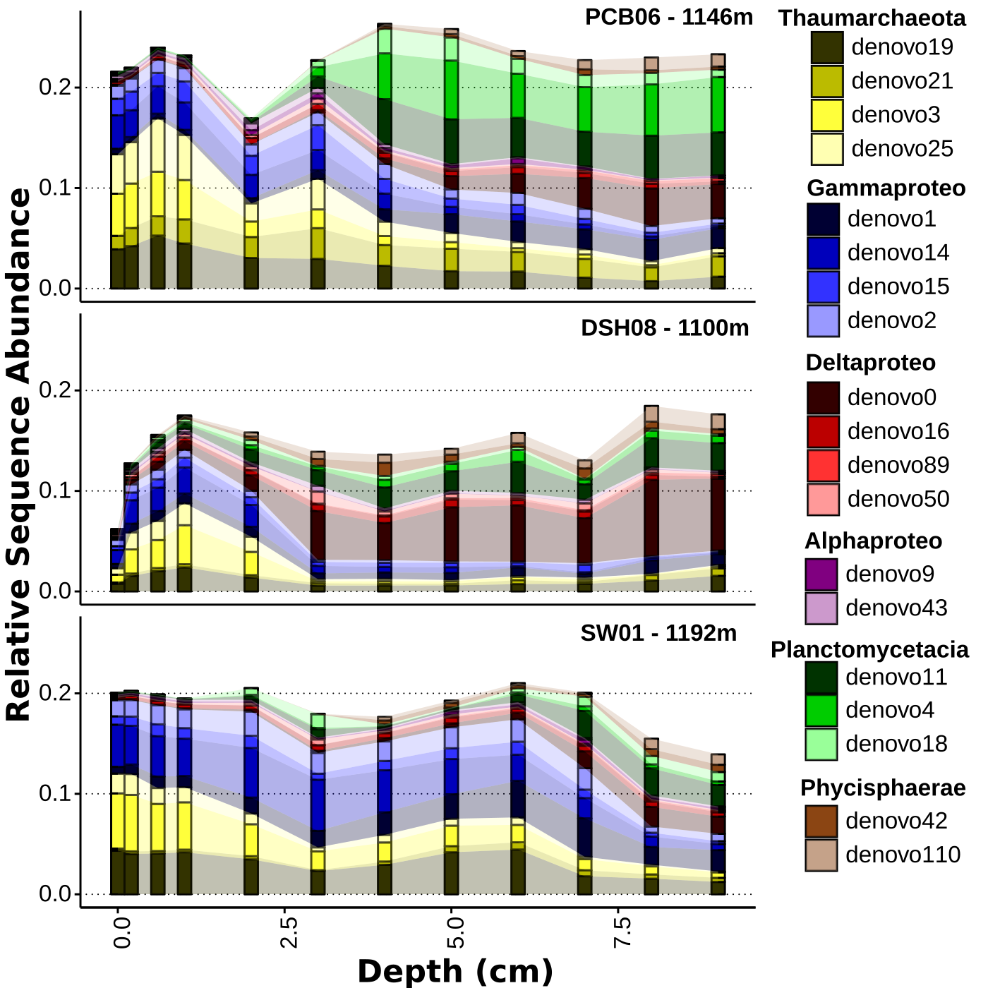

**Figure S4. Core profiles representing an East to West transect sampled at approximately 1100m water depth in the Northern Gulf of Mexico showing population (OTU) level distributions.** Core profiles are arranged from the eastern most site at the top to the western most site on the bottom.

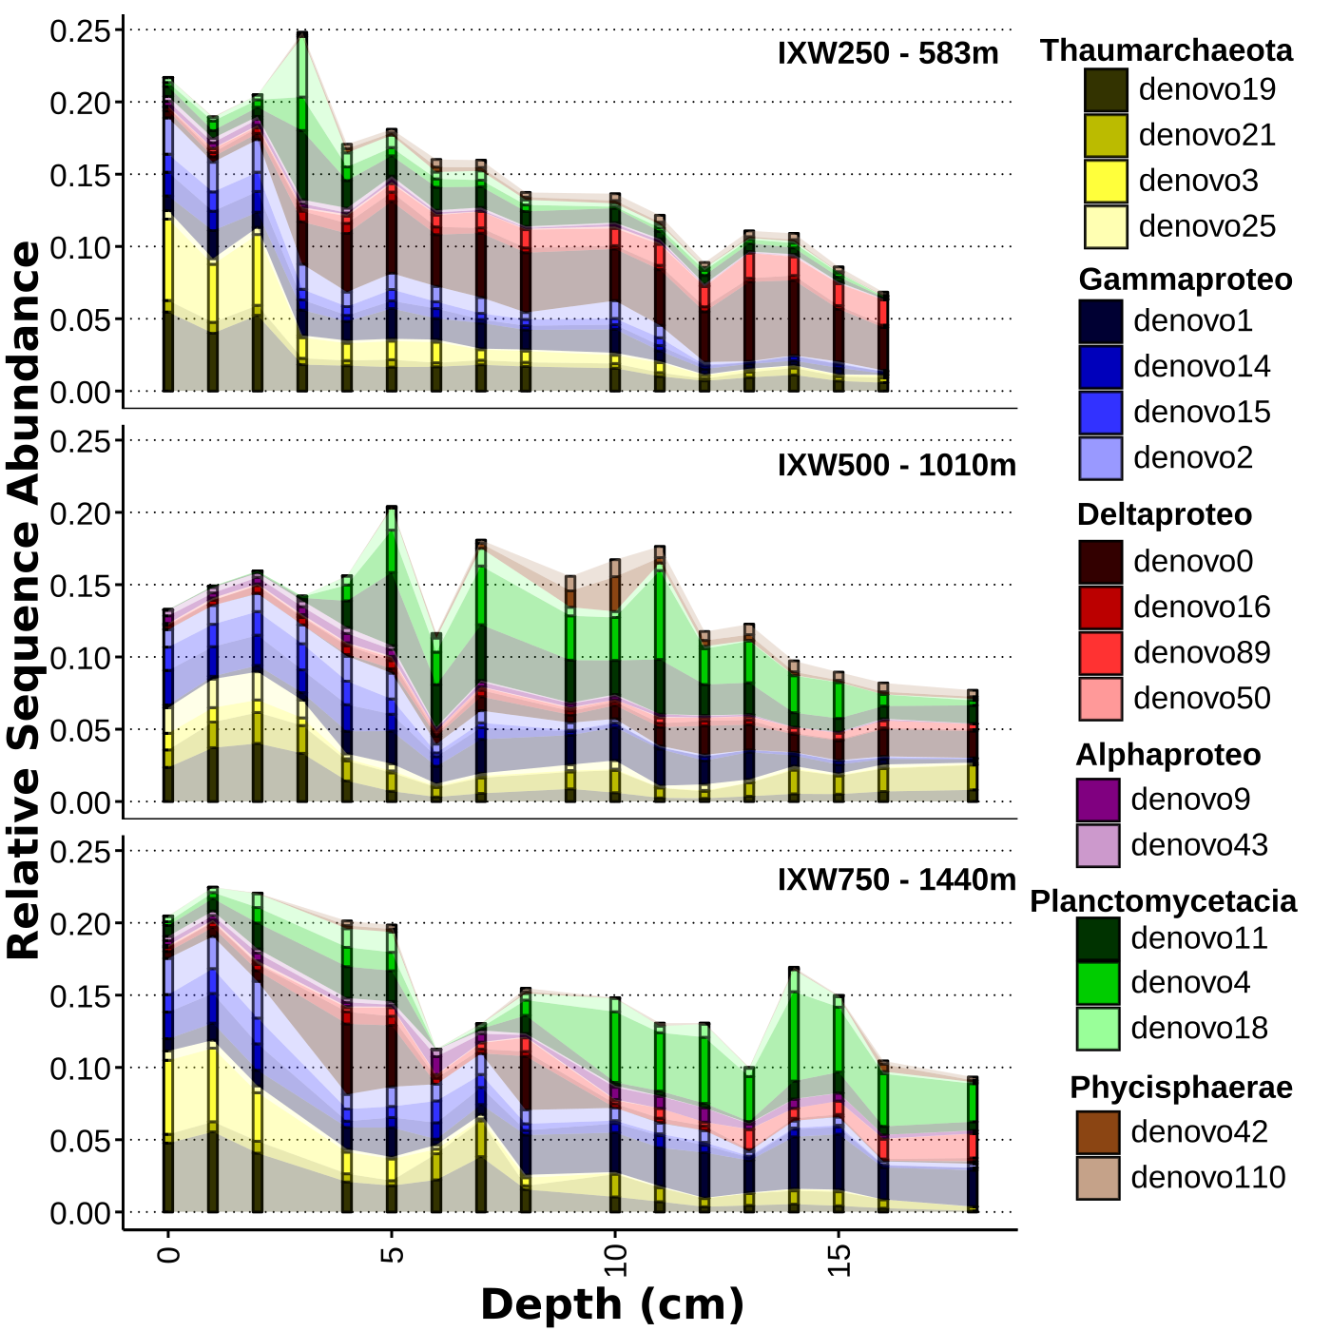

**Figure S5. Core profiles representing a depth transect in the Southern Gulf of Mexico showing population (OTU) level distributions.** Core profiles are arranged with increasing water depth.

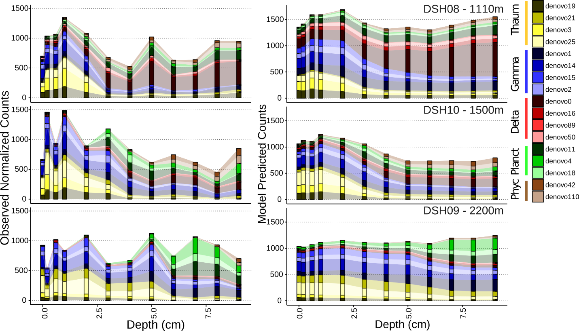

**Figure S6. A comparison of the model predictions for these abundant OTU relative to the observed values shown in Figure 6.** The observed OTU normalized counts from Figure 6 are reproduced in the left-hand plot while the values the predicted from each OTU-specific random forest regression model are presented on the right. As expected, the OTU-models simplify the observed variation, as can be seen in the much smoother OTU-distributions with increasing sediment and water depth. Core profiles are arranged with increasing water depth.

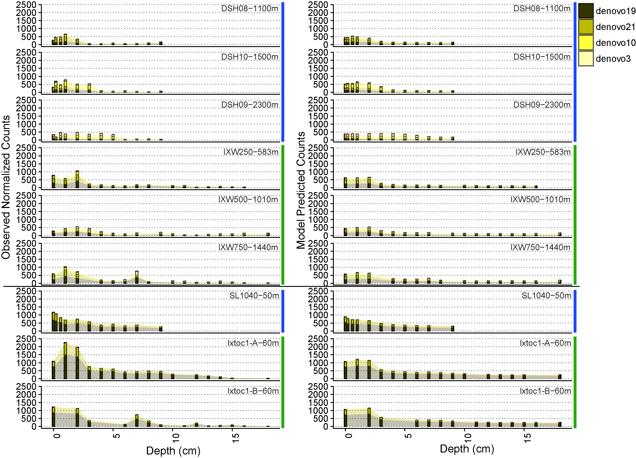

**Figure S7. Biogeography of the dominant Thaumarchaeota OTU.** The left side of the figure shows the observed counts for each of the OTU, while the right side shows the corresponding model predictions based on each of the OTU-specific random forest regression models created. Above the horizontal black line are deep water sites, while those below are shallow water sites. Blue horizontal bars to the right of the figures indicate samples collected in the northern Gulf of Mexico, while green horizontal bars indicate those from the southern Gulf of Mexico. The OTU SILVA identity and closest BLAST hit in the reference 16S database are as follows: denovo19 = MG-1 (SILVA), 97% *N. maritimus (*BLASTn *to* 16S ref; denovo21 = Nitrosopumilus, 99% N. maritimus; denovo10 = *Nitrosopumilus*, 95% *N. maritimus*; denovo3 = MG-1, 93% *N. maritimus.*

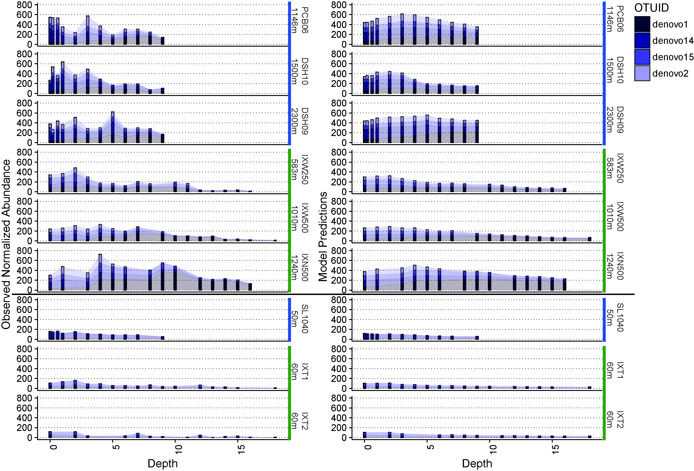

**Figure S8. Biogeography of the dominant Gammaproteobacteria OTU.** The left side of the figure shows the observed counts for each of the OTU, while the right side shows the corresponding model predictions based on each of the OTU-specific random forest regression models created. Above the horizontal black line are deep water sites, while those below are shallow water sites. Blue horizontal bars to the right of the figures indicate samples collected in the northern Gulf of Mexico, while green horizontal bars indicate those from the southern Gulf of Mexico. The OTU SILVA identity and closest BLAST hit in the reference 16S database are as follows: denovo1 = JTB255, 96% *Woeseia oceani;* denovo14 = JTB255, *Sulfuriflexus mobilis*; denovo15 = JTB255, 96% *Thioprofundum lithotrophicum*; denovo2 = Xanthomonadales, 94% *Thioprofundum hispidum*.

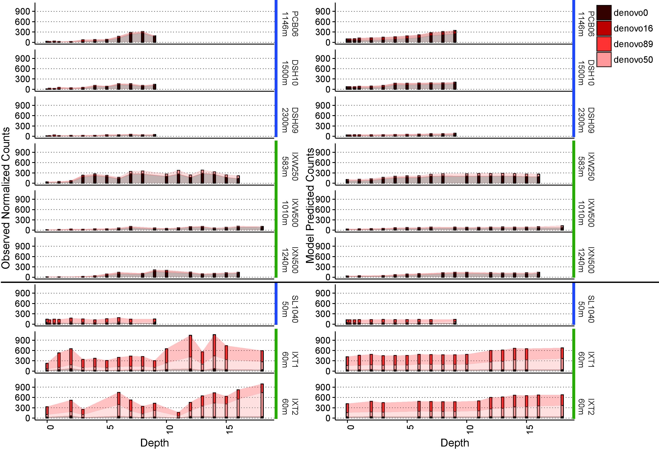

**Figure S9. Biogeography of the dominant Deltaproteobacteria OTU.** The left side of the figure shows the observed counts for each of the OTU, while the right side shows the corresponding model predictions based on each of the OTU-specific random forest regression models created. Above the horizontal black line are deep water sites, while those below are shallow water sites. Blue horizontal bars to the right of the figures indicate samples collected in the northern Gulf of Mexico, while green horizontal bars indicate those from the southern Gulf of Mexico. The OTU SILVA identity and closest BLAST hit in the reference 16S database are as follows: denovo0 = Syntrophobacteraceae, 91% *Syntrophobacter fumaroxidans*; denovo16 = Sh765-TzT-29, 91% *Deferrisoma camini*; denovo89 = Syntrophobacteraceae, 91% *Deferrisoma camini*; denovo50 = *Desulfatiglans*, 96% *Desulfatiglans aniline*.

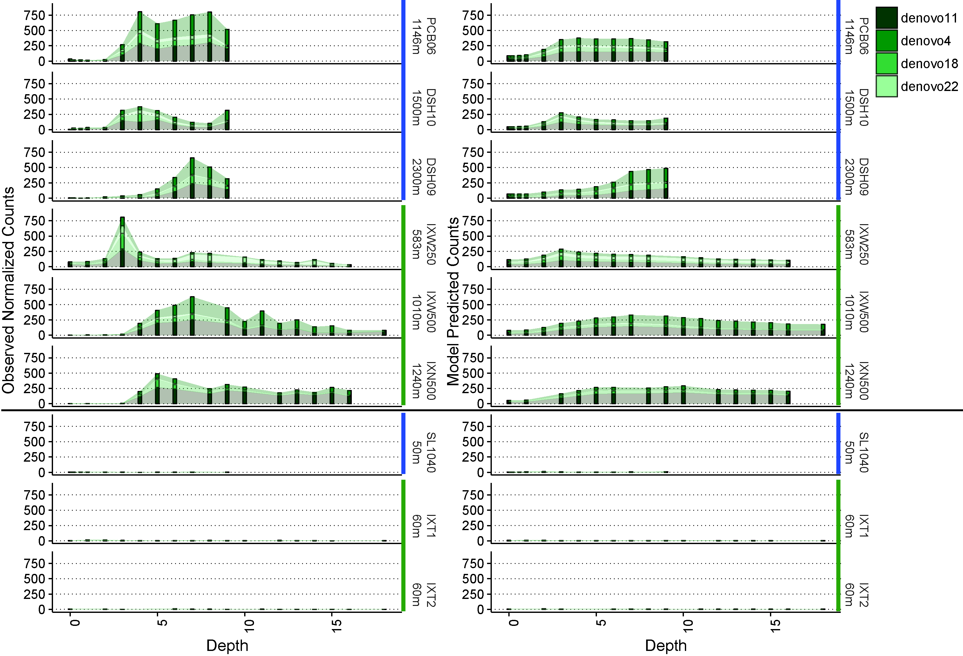

**Figure S10. Biogeography of the dominant Planctomycetes OTU.** The left side of the figure shows the observed counts for each of the OTU, while the right side shows the corresponding model predictions based on each of the OTU-specific random forest regression models created. Above the horizontal black line are deep water sites, while those below are shallow water sites. Blue horizontal bars to the right of the figures indicate samples collected in the northern Gulf of Mexico, while green horizontal bars indicate those from the southern Gulf of Mexico. All OTU shown here were 99-100% sequence similarity to *Candidatus Scalindua* sequences within blast NR and were all assigned to the *candidatus Scalindua* genus by RDP trained on SILVA.

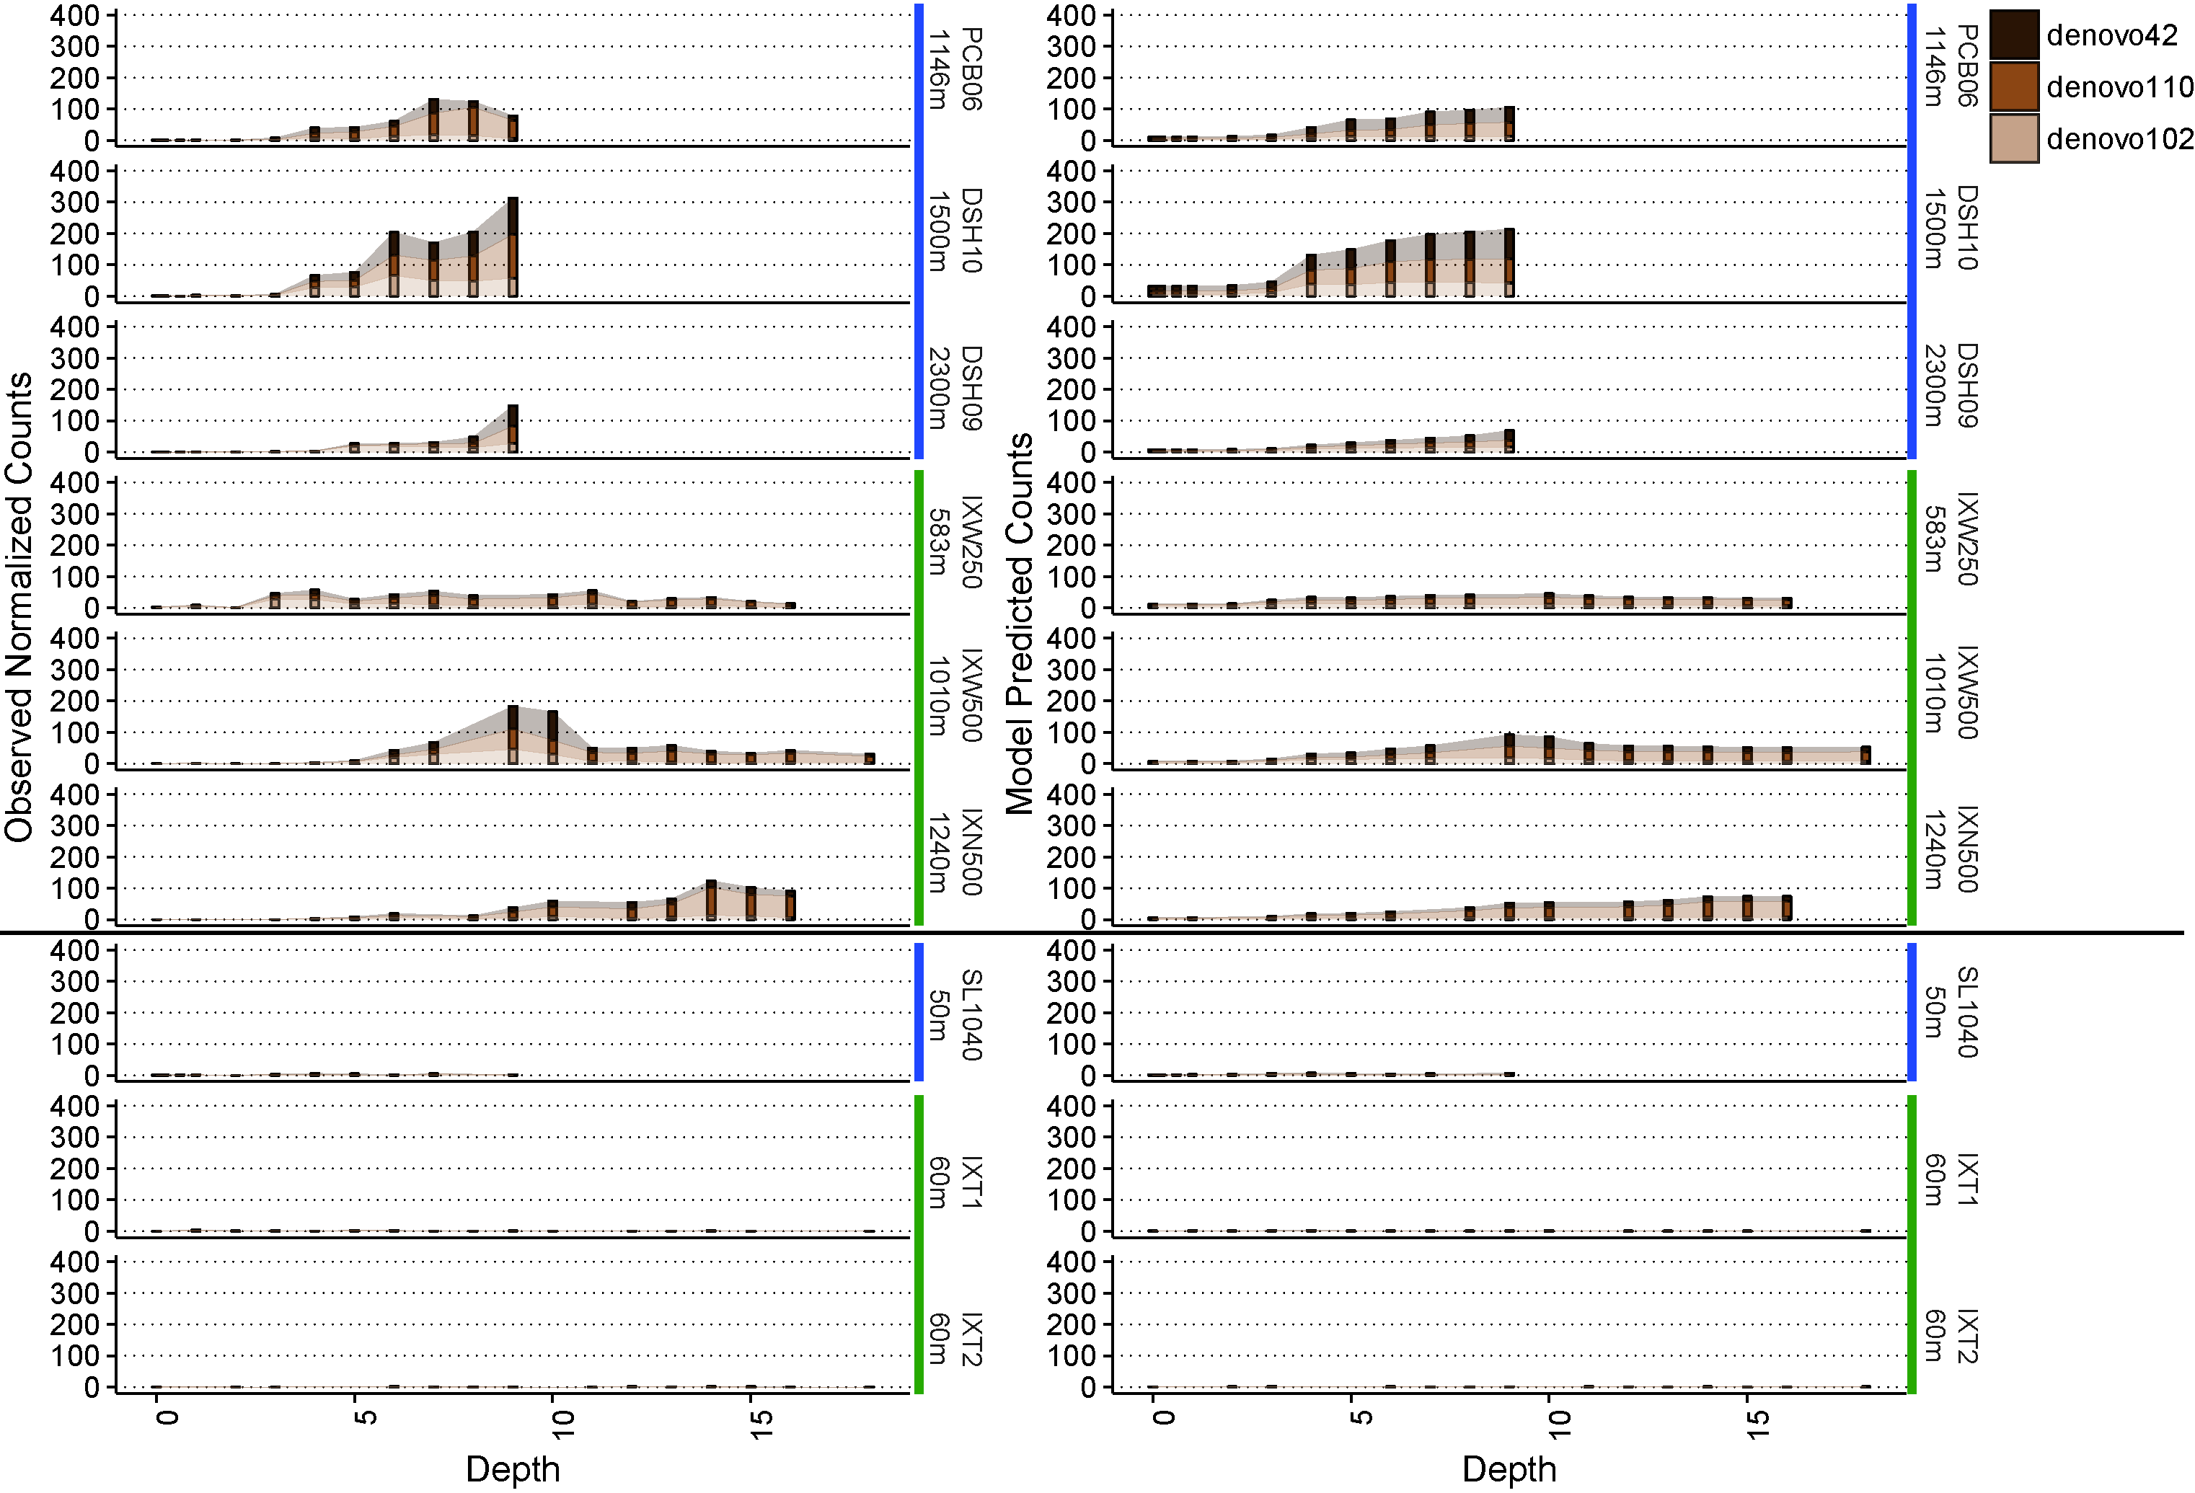

**Figure S11. Biogeography of the dominant Phycisphaerae OTU.** The left side of the figure shows the observed counts for each of the OTU, while the right side shows the corresponding model predictions based on each of the OTU-specific random forest regression models created. Above the horizontal black line are deep water sites, while those below are shallow water sites. Blue horizontal bars to the right of the figures indicate samples collected in the northern Gulf of Mexico, while green horizontal bars indicate those from the southern Gulf of Mexico. The OTU SILVA identity and closest BLAST hit in the reference 16S database are as follows: denovo42 = MSBL9, no hits >80%; denovo110 = ML-A-10, no hits >80%; denovo102 = MSBL9, no hits >80%.

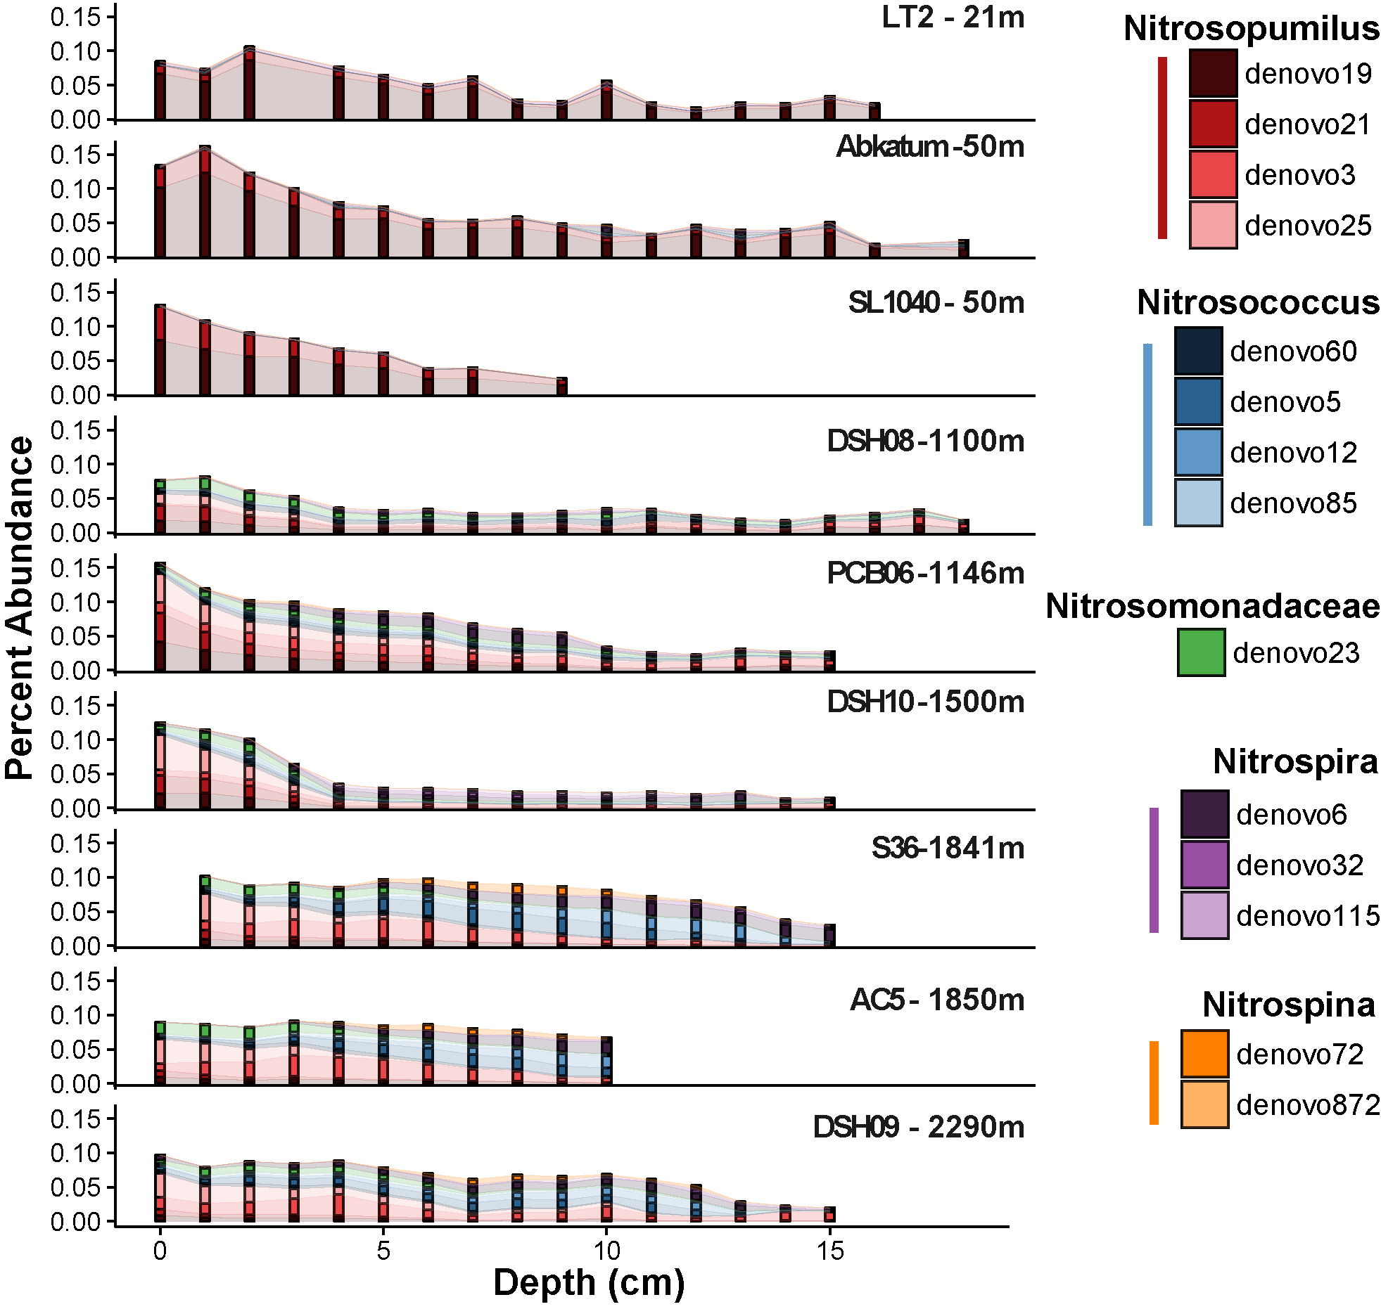

**Figure S12. Biogeographic patterns in putative nitrifying populations throughout the Gulf of Mexico.** All core profiles are organized from the shallowest site at the top to the deepest site at the bottom. *Nitrosopumilus*, *Nitrosococcus*, and the Nitrosomonadaceae family are considered as putative ammonium oxidizers, while *Nitrospira* and *Nitrospina* are considered here as putative nitrite oxidizers.