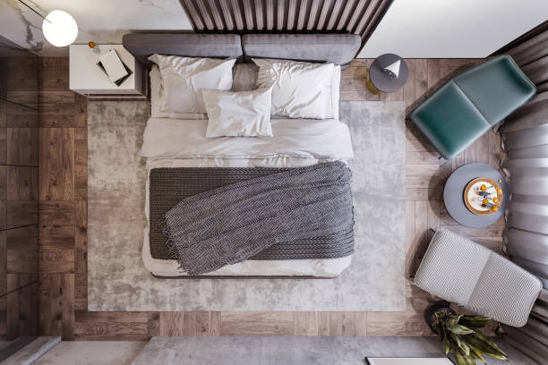

**A Camera sensor is placed on wall at a height 216 cm**

**A Camera sensor is placed on top of door at h = 194 cm**

**CAMERA 2**

**CAMERA 1**

**ROOM**

**BED**

**147cm**

**147cm**

**DOOR**

**215cm**

**295cm**

**180 x 90 x 43**