ME-735- CGPM 3/10/2016

**Midterm Project Report**

SOM Problem Solution & Vibration simulation

horizontal line

# Group Number: 3

# 13D100008 Saurabh Bajaj 13D100011 Nihar Mehta

13D100020 Mangesh Atpadikar 13D100037 Durgesh Ahirwar

horizontal line

# Introduction

· To build software that simulates the problems of strength of materials like bending of beams, torsion etc. and displays the graphical results.

· Show animated graphical output for oscillatory Loading in 2D and possibly 3D.

**Platform used**

C++ , OpenGL, WIn32, Codeblocks-Ep.

**Work done till now**

1. Made an GUI for Input parameters using WIN32 api.

User friendly Interface using buttons and textbox to get input values.

2.Modelled ‘Simply supported beam’ with ‘Point force’ in 2-D with buttons in OpenGl.

Graphical representation of beam along with location of force.

3.Wrote a function which draws beam deflection using Solved Differential equation.

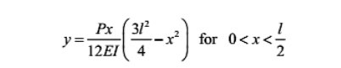 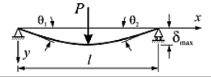

4.Made an animation of beam deflection for sinusoidal varying point force.

‘P’ in the above equation was a function of ‘sin(t)’ where ‘t’ is the time step of 25 ms.