**##WebShop DOC##**

**Kratki opis:**

* Kreiranje/Brisanje/Detalji Proizvoda, Kategorije, Korisnici, Uloge
* low CMS app
* N-Tier Arhitecture
* bez repository patterna

**User Home Page:**

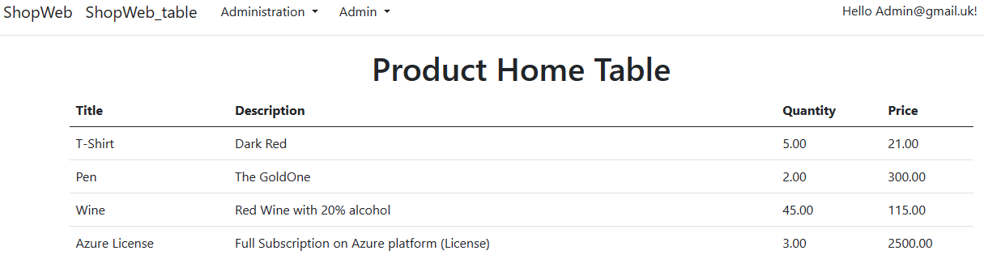

**Admin Navigation:**



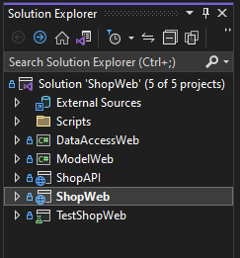**Tablice u Bazi:**

* __EFMigrationsHistory
* AspNetUsers
* Category
* Role
* Product
* UserClaims
* UserLogins
* UserTokens
* RoleClaims
* UserRoles
* ProductCategory

Aktivirati unutar ShowWeb.Scripts skriptu: **ScriptInsert.sql**

* dodavanje Usera, Categorija

LinkGithub:

<https://github.com/matpepe/ShopWeb_Repository>

<https://github.com/matpepe/ShopWeb_Repository.git>

|  |  |  |
| --- | --- | --- |
| Autor: | Verzija: | Godina: |
| Matko Popovic | 1.0. | 2023 |