UNIVERSIDAD ANÁHUAC MAYAB • DIVISION OF ENGINEERING
LABORATORY ACTIVITY 16: MULTI-MODEL REGRESSION
COMPARISON & DIAGNOSTICS BAKE-OFF
Predictive Modeling: OLS Fitting, Multi-Model Selection, & Residual Health Checks
Course & Period: | Data Mining & Modern AI Systems (IIND4417) — Academic Period: 202660
Class Session Alignment: | Session 19: Unit 5.2 Optimization & 5.3 Assumption Diagnostics
Instructor: | Dr. Víctor Cardoso
Team Assigned Database: | Team 4 — Biomedical ICU (regression_team4_biomedical.csv → cardiac_output_l_min)
Student Names & IDs: | 1. PIEKARZ Mathieu Xavier (00647375) 2. DE TALHOUET Théophile (00645543) 3. BARRAU Maxence (00645460)  4. YAÑEZ SANCHEZ Fabian Alberto 5. IRIGOYEN TORRES Danna Paula

🎯 THE MULTI-MODEL BAKE-OFF CHALLENGE: In real-world data science and AI engineering,
you never fit just one model and blindly trust it. Today, your team will configure 5 distinct regression models on your assigned industry database. You will evaluate their R², Adjusted R², MAE, and RMSE metrics, examine their residual diagnostic health checks, and defend which model represents the true 'Best Fit' for your client.

Objective & Engineering Mission
As we transition into predictive modeling for continuous numerical outcomes (regression), engineers must balance two competing forces: explanatory power versus model complexity. Adding more variables to a linear model will almost always increase the raw R² score—even if those variables are completely irrelevant noise! To prevent building overcomplicated models, engineers evaluate Adjusted R² (which penalizes useless predictors) and inspect residual health checks.

By the end of this laboratory activity, your team will:
- Ingest your team's assigned domain database and understand its continuous target variable.
- Configure 5 distinct candidate regression models with varying feature combinations.
- Train all 5 models using an identical 80/20 train/test split to guarantee fair, rigorous benchmarking.
- Log R², Adjusted R², MAE, and RMSE across all 5 models in a clean comparison table.
- Generate residual diagnostic plots (Fitted vs. Residuals and Q-Q plots) to verify regression health.
- Defend the single 'Best-Fit' model based on statistical evidence, physical interpretability, and client ROI.

Team Database Assignment Reference Table
To emulate specialized engineering squads and prevent cross-team code sharing, each team is assigned a completely distinct real-world telemetry dataset. Download your assigned CSV file from the course repository or Brightspace:
Team # & Domain |  | Assigned CSV File |  | Target Variable (y) | Predictor Pool (Features X)
Team 1: Solar Power regression_team1_solar.csv power_output_kw solar_irradiance_w_m2, (Kilowatt output) ambient_temp_c, wind_speed_m_s, panel_temp_c, sun_elevation_deg, dust_accumulation_pct
Team 2: Semiconductor | regression_team2_semiconduc  tor.csv | wafer_yield_pct  (Yield %) | rf_power_watts, chamber_pressure_torr, etching_time_sec,  gas_flow_sccm, wafer_temp_c, cleanroom_humidity_pct
Team 3: EV Battery | regression_team3_ev_battery.c sv | battery_cell_temp_c  (Cell temp °C) | discharge_current_a, ambient_temp_c, state_of_charge_pct, internal_resistance_mohm, coolant_flow_l_min, cell_voltage_v
Team 4: Biomedical ICU | regression_team4_biomedical. csv | cardiac_output_l_min  (Blood flow L/min) | heart_rate_bpm, stroke_volume_ml, systolic_bp_mmhg, mean_arterial_pressure_mmhg , systemic_vascular_resistance, blood_oxygen_pct
Team 5: Smart Grid regression_team5_smartgrid.cs active_power_load_mw industrial_consumption_mw,
v (Grid load MW) ambient_heat_index_c,
residential_meter_count, transformer_temp_c, reactive_power_mvar, grid_frequency_hz

The 5-Model Candidate Architecture
Your team must configure, fit, and evaluate the following 5 distinct candidate regression models on your assigned dataset. Notice how each model progressively expands in complexity:

- Model 1 (Simple Baseline — 1 Feature): Select the single feature you believe has the strongest physical impact on the target. This establishes your performance baseline floor.
- Model 2 (Primary Operational Pair — 2 Features): Add the second most important physical driver. Observe how much variance is explained by this core operational pair.
- Model 3 (Tri-Variate Core — 3 Features): Incorporate a third variable (such as an environmental or process control factor). Check if the addition produces a noticeable drop in RMSE.
- Model 4 (Operational Multi-Variable — 4 Features): Add a fourth auxiliary variable. Watch what happens to the gap between raw R² and Adjusted R².
- Model 5 (Full Engineering Model — 5 Features): Include all 5 primary continuous engineering predictors. Evaluate whether the added complexity is justified by a statistically meaningful improvement in test error.

Step-by-Step Laboratory Execution Guide
- Step 1: Feature Branching in VS Code GUI: Open VS Code and navigate to your team repository. In the bottom-left status bar, click on 'main' and select 'Create new branch'. Name your branch: feature/activity-16regression-models. Open the Source Control panel (Ctrl+Shift+G).
- Step 2: Ingest Assigned Dataset & Split (80/20): Load your team's assigned CSV file into pandas. Separate your feature matrix X and target vector y. Execute an 80/20 train/test split using train_test_split(X, y, test_size=0.20, random_state=42). Note: random_state=42 is mandatory so all 5 models are evaluated on the exact same test records!
- Step 3: Fit All 5 Regression Models: Using Scikit-Learn's LinearRegression(), fit each candidate model on X_train[selected_features] and y_train. Generate predictions on both the training set and the test set.
- Step 4: Compute Fit Statistics & Error Metrics: For every model, calculate: (1) Training R², (2) Testing R², (3) Adjusted R² (penalized for feature count), (4) Mean Absolute Error (MAE), and (5) Root Mean Squared Error (RMSE).
- Step 5: Visual Residual Diagnostics (Health Checks): For your top 2 candidate models, compute the test residuals (Residual = y_test - y_pred). Create a 2-panel diagnostic chart: (a) Fitted Values vs. Residuals scatter plot to check for homoscedasticity (equal variance) and linearity, and (b) Residual Histogram or Q-Q plot to verify normality.
- Step 6: Defend the Winning Model & Sync with GitHub: Compare your 5 models in the deliverable table. Write a 2-3 paragraph technical defense justifying your chosen 'Best-Fit' model. Stage your script, commit with message 'feat(regression): complete 5-model bake-off comparison', publish branch, open a GitHub PR, have a teammate review and approve, and merge into main.

Student Results Workspace & 5-Model Comparison Table
Log your team's empirical modeling results in the benchmark table below. Every team member must understand these numbers for in-class verification:
Model | Features Selected | Train R² | Test R² | Adjusted R² | MAE | RMSE
Model 1 Heart rate 0.569 0.595 0.592 1.077 1.264
Model 2 | HR + stroke vol. | 0.952 | 0.949 | 0.948 | 0.365 | 0.449
Model 3 | + SVR | 0.962 | 0.959 | 0.958 | 0.316 | 0.401
Model 4 | + MAP | 0.965 | 0.963 | 0.961 | 0.299 | 0.384
Model 5 + systolic BP 0.965 0.962 0.961 0.300 0.386

🏆 WINNING MODEL SELECTION & CLIENT DEFENSE
Which of the 5 models does your team designate as the 'Best Fit' for production deployment? Explain your reasoning in 2-3 paragraphs below. Address: (1) Why did this model beat the others? (2) Is the gain in Adjusted R² worth the cost of collecting and maintaining those additional sensor features? (3) Did the residual plots confirm that the model satisfies linearity and equal spread?

We chose Model 4 (heart rate, stroke volume, SVR and MAP). It has the best test results of the five: Test R² of 0.963, Adjusted R² of 0.961 and the lowest errors (MAE 0.299, RMSE 0.384 L/min). The biggest improvement comes when we add stroke volume to heart rate (Model 1 to Model 2): R² goes from about 0.59 to 0.95. That makes sense because cardiac output is basically heart rate times stroke volume. Adding SVR and MAP still helps a bit. Model 5 with systolic BP doesn't improve anything, the Adjusted R² even goes down slightly, probably because systolic BP gives the same information as MAP.
For the cost of the sensors, we think going up to 4 features is worth it. In an ICU these signals are already measured by the monitors, so it doesn't really cost more to use them, and the error drops compared to Model 2. But adding systolic BP is not worth it since it brings nothing. If we had to keep it really simple, Model 2 with only two features is already very good.
For the residual plots, the Q-Q plot follows the line well so the residuals look normal, and the spread is about the same everywhere, so equal variance looks ok. But the fitted vs residuals plot has a U shape, which means the relationship is not completely linear. We think it's because cardiac output = heart rate x stroke volume (a multiplication), and a linear model can't capture that perfectly. Adding an HR x SV feature could be a good improvement for a next version.

📈 RESIDUAL DIAGNOSTIC DASHBOARD (PASTE SCREENSHOTS)
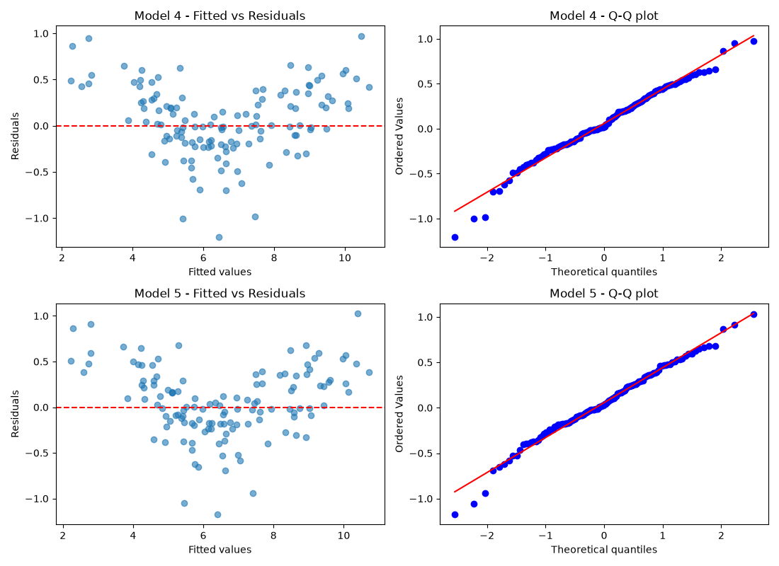

Responsible AI Pair-Programming & Troubleshooting Log
AI Tooling Utilized: | Claude
Verbatim Prompts Submitted: | 'Can you see activity 16 word document in my files? Can you make a simple script to make the regression models as instructed I will do the analysis myself after' ‘Can you correct my analysis. Tell me what you want to change if something is wrong, if it is correct, just reword the responses if needed so it is more understandable’ Claude also helped to do the commit description
AI Code Output & Suggestions: | for name, features in models.items():  model = LinearRegression()  model.fit(X_train[features], y_train)  pred_test = model.predict(X_test[features])  adj_r2 = 1 - (1 - r2_test) * (n - 1) / (n - p - 1)
Human Audit & Verification: | We checked that all 5 models use the same train/test split (random_state=42), that the column names match the CSV, and that the Adjusted R² formula is the one from class. We also ran the script ourselves to make sure we get the same numbers.
Limitations & Bugs Caught: | The code needed scikit-learn installed in a virtual environment before it would run. Also, the high R² made the models look perfect, but the residual plot showed they are not completely linear.
7. Activity Evaluation Rubric
Evaluation Pillar Excellent Developing Needs Improvement
1. 5-Model Configuration & Successfully configures, trains, Configures 3-4 models, or Fails to configure
Pipeline Implementation and tests all 5 regression models models are fitted on multiple models, script on identical 80/20 split. Features inconsistent splits, making crashes, or only fits a are logically grouped from comparison partially flawed. single baseline simple baseline to full regression. engineering model.
2. Metric Evaluation &  Comparison Table Accuracy | All metrics (Train R², Test R², Adjusted R², MAE, RMSE) are accurately computed and recorded in the comparison table with zero calculation errors. | Metrics are recorded, but 1-2 numbers are miscalculated (e.g., using train error instead of test, or omitting Adjusted R²). | Comparison table is incomplete, missing error metrics, or values are clearly fabricated without script execution.
3. Residual Diagnostics & Best  Model Defense | Generates clean Fitted vs.  Residuals and Q-Q plots. Identifies whether assumptions hold. Provides a compelling 2-3 paragraph defense of the winning model. | Residual plots generated but  lack clear labels or interpretation. Defense is brief or focuses only on raw R² without considering trade-offs. | No residual diagnostics provided, or team cannot articulate why their selected model was chosen.
4. Git Architecture &  Responsible AI Log | Clean feature branch in VS Code  GUI, atomic conventional commit (feat:), PR opened and approved by teammate, merged to main. AI log is thoroughly documented. | Code pushed to GitHub, but committed directly to main, generic commit message, or AI log lacks specific prompt auditing. | Code missing from remote GitHub repository, merge conflicts unresolved, or AI log is blank.

