

**NEO-M8**

**u-blox M8 concurrent GNSS modules**

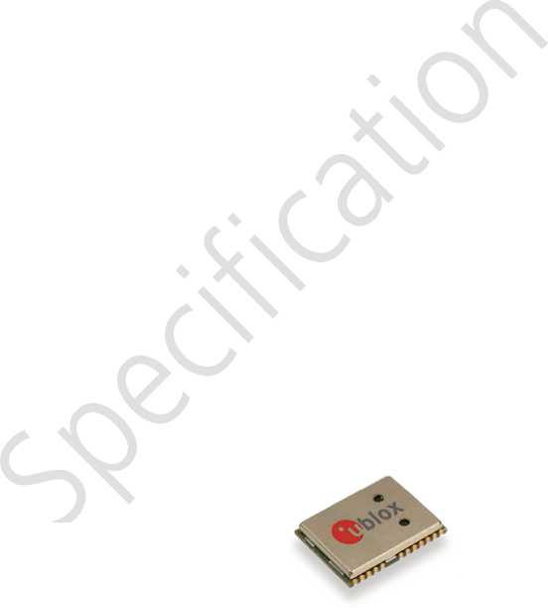**Data Sheet**

**Highlights:**

Concurrent GNSS engine for GPS, GLONASS, BeiDou and QZSS

Industry leading -167 dBm navigation sensitivity

Product variants to meet performance and cost requirements

Combines low power consumption and high sensitivity

Simple integration with u-blox wireless modules

Backward compatible with NEO-7, NEO-6 and NEO-5 families

[www.u-blox.com](http://www.u-blox.com)

UBX-13003366 - R02



**Document Information**

Title NEO-M8

Subtitle u-blox M8 concurrent GNSS modules

**Document type** Data Sheet

**Document number** UBX-13003366

**Revision and Date** R02 17-Dec-2013

Document status Objective Specification

**Document status explanation**

Objective Specification Document contains target values. Revised and supplementary data will be published later.

Advance Information Document contains data based on early testing. Revised and supplementary data will be published later.

Early Production Information Document contains data from product verification. Revised and supplementary data may be published later. Production Information Document contains the final product specification.

**This document applies to the following products:**

|  |  |  |  |  |
| --- | --- | --- | --- | --- |
| Name | Type number | ROM/FLASH version |  | PCN reference |
| NEO-M8N-0 | NEO-M8N-0-01 | Flash FW 2.01 |  | N/A |
| NEO-M8M-0 | NEO-M8M-0-00 | ROM 2.01 |  | N/A |
| NEO-M8Q-0 | NEO-M8Q-0-00 | ROM 2.01 |  | N/A |

This document and the use of any information contained therein, is subject to the acceptance of the u-blox terms and conditions. They can be downloaded from [www.u-blox.com.](http://www.u-blox.com/)

u-blox makes no warranties based on the accuracy or completeness of the contents of this document and reserves the right to make changes to specifications and product descriptions at any time without notice. Reproduction, use or disclosure to third parties without express permission is strictly prohibited. Copyright © 2013, u-blox AG.

u-blox® is a registered trademark of u-blox Holding AG in the EU and other countries. ARM® is the registered trademark of ARM Limited in the EU and other countries.

**ARM**

**Contents**

**Contents 3**

1. **Functional description 5**
   1. Overview 5
2. Product features 5
3. Performance 6

7

1. Block diagram.
2. GNSS

|  |  |
| --- | --- |
| 1.5.1 | GPS |
| 1.5.2 | GLONASS . |
| 1.5.3 | BeiDou |
| 1.5.4 | Galileo |
| 1.5.5 | QZSS |
| 6 Assisted GNSS 丨 | |
| 1.6.1 | AssistNow |
| 1.6.2 | AssistNow |
| 1.6.3 | AssistNow |

7

7

7

7

Galileo 8

QZSS 8

1. Assisted GNSS (A-GNSS) 8

Online 8

"■Offline 8

Autonomous 8

1. Augmentation Systems 9
2. Satellite-Based Augmentation System (SBAS) 9
3. Differential GPS (D-GPS) 9
4. Odometer 9
5. Data logging (NEO-M8N) 9
6. EXTINT: External interrupt 9
7. Pin Control 9
8. Aiding 10
9. TIMEPULSE 10
10. Protocols and interfaces 10
11. Interfaces 10
12. UART 10
13. USB 10
14. SPI 10
15. Display Data Channel (DDC) 11
16. Clock generation 11
17. Oscillators 11
18. Real-Time Clock (RTC) 11
19. Power management 11
20. DC/DC converter 11
21. Operating modes 11
22. Antenna 12
23. **Pin Definition 13**
    1. Pin assignment 13
24. **Configuration management 14**
    1. Interface Selection (D_SEL) 14
25. **Electrical specification 15**
    1. Absolute maximum rating 15
    2. Operating conditions 16
    3. Indicative current requirements 17
    4. SPI timing diagrams 18
       1. Timing recommendations 18
    5. DDC timing diagrams 18
26. **Mechanical specifications 19**
27. **Reliability tests and approvals 20**
    1. Reliability tests 20
    2. Approvals 20
28. **Product handling & soldering 21**
    1. Packaging 21
       1. Reels 21
       2. Tapes 21
    2. Shipment, storage and handling 22
       1. Moisture Sensitivity Levels 22
       2. Reflow soldering 22
       3. ESD handling precautions 22
29. **Default messages 23**
30. **Labeling and ordering information 24**
    1. Product labeling 24
    2. Explanation of codes 24
    3. Ordering codes 24

**Related documents 25**

**Revision history 25**

**Contact 26**

1. **Functional description**
   1. **Overview**

The NEO-M8 series of standalone concurrent GNSS modules is built on the exceptional performance of the u-blox M8 GNSS (GPS, GLONASS, Galileo, BeiDou, QZSS and SBAS) engine in the industry proven NEO form factor.

The NEO-M8 series provides high sensitivity and minimal acquisition times while maintaining low system power. The NEO-M8M is optimized for cost sensitive applications, while NEO-M8N provides best performance and easier RF integration. The NEO form factor allows easy migration from previous NEO generations. Sophisticated RF-architecture and interference suppression ensure maximum performance even in GNSS-hostile environments.

The NEO-M8 series combines a high level of robustness and integration capability with flexible connectivity options. The future-proof NEO-M8N includes an internal Flash that allows simple firmware upgrades for supporting additional GNSS systems. This makes NEO-M8 perfectly suited to industrial and automotive applications.

The DDC (l2C compatible) interface provides connectivity and enables synergies with the most of u-blox SARA, LEON and LISA wireless modules. For RF optimization the NEO-M8N/M8Q features an additional front-end LNA for easier antenna integration and a front-end SAW filter for inc「eased」amming immunity.

u-blox M8 modules use GNSS chips qualified according to AEC-Q100, are manufactured in ISO/TS 16949 certified sites, and fully tested on a system level. Qualification tests are performed as stipulated in the ISO16750 standard: “Road vehicles - Environmental conditions and testing for electrical and electronic equipment”.

u-blox' AssistNow Assistance supply aiding information, such as ephemeris, almanac, rough last position and time, reduce the time to first fix significantly and improve the acquisition sensitivity. AssistNow data are with u-blox M8 supporting both GPS and GLONASS constellation for faster acquisition than a GPS-only assistance. The extended validity of AssistNow Offline data (up to 35 days) and AssistNow Autonomous data (up to 6 days) provide faster acquisition after long off time.

See section 1.6 for more information concerning the NEO-M8 series related AssistNow Assistance.

* 1. **Product features**

dnaieM / JCLnJJBulleuJalxUJ Ins-no dsln&uuji

cld UOC33POJP

snvJj〕uajdo euu0lu< uocajlojd / uolpaiaip

snyp lJoqsn>uua;lu<

>.lddns puc山一u< Jsellpso leujajlul

lisSAJuula:

Ssa>l4snq0j pceqjno

alJna>l**—esloz

6.E660I eleQ {llselz) alqeEEeJ60Ja. (IduJSvouacl IdS sn

I

aa/〕9.JiodlsaMO_-l >vo.e->s9l >vorn—>r-..fN

6ucossotnuloJ asjDaJo.

6.Eu53aJQ:peaJG 6.E.gi noQag oai SSVN§

ssza/sa-9



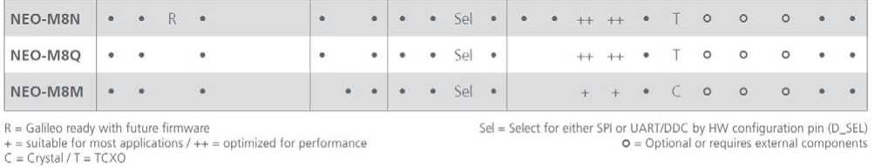

* 1. **Performance**

1

2

3

4

5

6

7 Assuming Airborne < 4 g platform

Ready to support GALILEO E1B/C when available (NEO-M8N) All satellites at -130 dBm

Dependent on aiding data connection speed and latency Demonstrated with a good external LNA

CEP, 50%, 24 hours static, -130 dBm, > 6 SVs 50% @ 30 m/s

|  |  |  |  |
| --- | --- | --- | --- |
| Parameter | Specification |  |  |
| Receiver type | 72 Channels GPS L1C/A SBAS L1C/A QZSS L1C/A GLONASS L1OF BeiDou B1 GALILEO E1B/C1 |  |  |
| 2  Time-To-First-Fix |  | NEO-M8N/Q | NEO-M8M |
|  | Cold Start | 26 s | 27 s |
|  | Hot Start | 1.5 s | ♦ 1.5s |
|  | 3  Aided Starts | 2 s | 4 s |
| 4  Sensitivity | Tracking & Navigation | NEO-M8N/Q -167 dBm | NEO-M8M -164 dBm |
|  | Reacquisition | -160 dBm | -159 dBm |
|  | Cold Start | -148 dBm | -147 dBm |
|  | Hot Start | -156 dBm | -156 dBm |
| 5  Horizontal position accuracy | Default mode (includes SBAS and QZSS) | 2.0 m |  |
| Accuracy of time pulse signal | RMS  99% | 30 ns 60 ns |  |
| Frequency of time pulse signal |  | 0.25 Hz ... 10 MHz (configurable) | |
| Max navigation update rate |  | NEO-M8N | NEO-M8M/Q |
|  | Single GNSS | 10 Hz | 18 Hz |
|  | Concurrent GNSS | 5 Hz | 10 Hz |
| Velocity accuracy6 |  | 0.05 m/s |  |
| Heading accuracy6 |  | 0.3 degrees |  |
| Operational limits7 | Dynamics | V < 4 g |  |
|  | Altitude | 50,000 m |  |
|  | Velocity | 500 m/s |  |

**Table 1: NEO-M8 performance in multi-GNSS mode (with concurrent reception of GPS and GLONASS)**

* 1. **Block diagram**

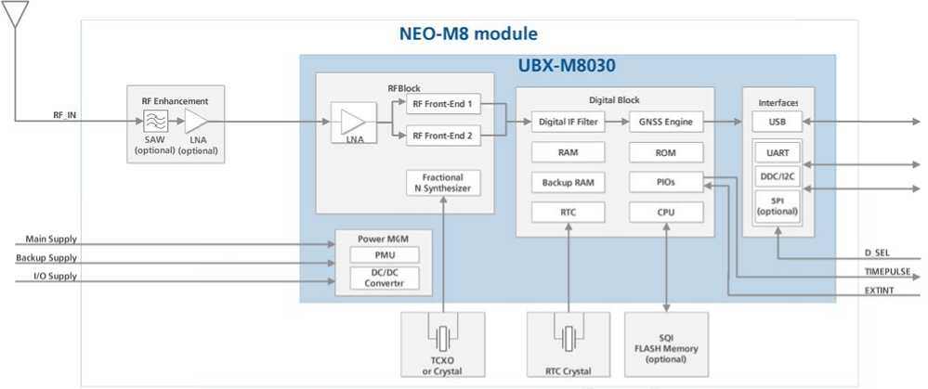

**Figure 1: NEO-M8 block diagram**

* 1. **GNSS**

The NEO-M8 GNSS modules are concurrent GNSS receivers and can receive and track multiple GNSS systems (e.g. GPS, GLONASS, GALILEO, BeiDou and QZSS signals). Because of the dual-frequency RF front-end architecture, two of the three signals (GPS L1C/A, GLONASS L1 OF and BeiDou B1) can be received and processed concurrently. By default the M8 receivers are configured for concurrent GPS (includes SBAS and QZSS) and GLONASS reception. If power consumption is a key factor, then the receiver should be configured for single GNSS operation using either GPS or GLOnAsS or BeiDou and disabling QZSS and SBAS.

Galileo, QZSS and SBAS share the same frequency band as GPS and can always be processed in conjunction with GPS.

* + 1. **GPS**

♦

The NEO-M8 positioning modules are designed to receive and track the L1C/A signals provided at 1575.42 MHz by the Global Positioning System (GPS). The NEO-M8 series can receive and process GPS concurrently with GLONASS or BeiDou.

* + 1. **GLONASS**

The NEO-M8 modules can receive and process GLONASS concurrently with GPS or BeiDou. The Russian GLONASS satellite system is an alternative system to the US-based Global Positioning System (GPS). u-blox NEO-M8 positioning modules are designed to receive and track the L1OF signals GLONASS provides at 1602 MHz + k*562.5 kHz, where k is the satellite's frequency channel number (k = —7,..., 5, 6). The ability to receive and track GLONASS L1OF satellite signals allows design of GLONASS receivers where required by regulations.

To take advantage of GPS and GLONASS, dedicated hardware preparation must be made during the design-in phase. See "ro-MSHaraWa厂e/nfeg厂af/on Manua/ [1] for u-blox design recommendations.

* + 1. **BeiDou**

The NEO-M8 modules can receive and process BeiDou concurrently with GPS or GLONASS, u-blox NEO-M8 positioning modules are designed to receive and track the B1 signals provided at 1561.098 MHz by the BeiDou Navigation Satellite System. The ability to receive and track BeiDou B1 satellite signals in conjunction with GPS results in higher coverage, improved reliability and better accuracy. By the end of 2013 BeiDou is not fully operational and provides regional coverage only. Global coverage is scheduled for 2020.

* + 1. **Galileo**

The NEO-M8N positioning module is ready to receive and track GPS and Galileo signals concurrently, enhancing accuracy and coverage. When Galileo ElB/C signals become available, u-blox NEO-M8N receiver equipped with an SQI flash memory device will be capable of receiving and processing them via a firmware update.

* + 1. **QZSS**

receive and track these signals concurrently with GPS signals, resulting in better availability esp signal conditions, e.g. in urban canyons. The L1-SAIF signal provided by QZSS is not supported.

The Quasi-Zenith Satellite System (QZSS) is a regional navigation satellite system that transmits additional GPS L1C/A signals for the Pacific region covering Japan and Australia. NEO-M8 series positioning modules are able to

ecially under bad

* 1. **Assisted GNSS (A-GNSS)**

Supply of aiding information, such as ephemeris, almanac, rough last position and time, will reduce the time to first fix significantly and improve the acquisition sensitivity. All u-blox M8 products support the u-blox AssistNow Online and AssistNow Offline A-GNSS services, support AssistNow Autonomous, and are OMA SUPL compliant.

* + 1. **AssistNow™ Online**

With AssistNow Online, an internet-connected GNSS device downloads assistance data from u-blox' AssistNow Online Service at system start-up. AssistNow Online is network-operator independent and globally available, u-blox only sends ephemeris data for those satellites currently visible to the device requesting the data, thus minimizing the amount of data transferred.

Supply of aiding information, such as ephemeris, almanac, rough last position and time, will reduce the time to first fix significantly and improve the acquisition sensitivity.

* + 1. **AssistNow™ Offline**

With AssistNow Offline, users download u-blox' long-term orbit data from the Internet at their convenience. The orbit data can be stored in the GNSS receiver's SQI flash memory (NEO-M8N) or must be stored in the memory of the application processor (NEO-M8M/M8Q). Thus the service requires no connectivity at system start-up, enabling a position fix within seconds, even when no network is available. AssistNow Offline offers augmentation for up to 35 days.

* + 1. **AssistNow™ Autonomous**

AssistNow Autonomous provides aiding information without the need for a host or external network connection. Based on previous broadcast satellite ephemeris data downloaded to and stored by the GNSS receiver, AssistNow Autonomous automatically generates accurate satellite orbital data (“AssistNow Autonomous data”）that is usable for future GNSS position fixes. The concept capitalizes on the periodic nature of GNSS satellites: their position in the sky is basically repeated every 24 hours. By capturing strategic ephemeris data at specific times of the day, the receiver can predict accurate satellite ephemeris for up to six days after initial reception. If using AssistNow Autonomous, the use of NEO-M8N (with SQI flash memory) is highly recommended.

u-blox' AssistNow Autonomous benefits are:

* Faster fix in situations where GNSS satellite signals are weak
* No connectivity required
* Compatible with AssistNow Online and Offline (can work stand-alone, or in tandem with these services)
* No integration effort; calculations are done in the background, transparent to the user.

For ROM-based NEO-M8M/M8Q receivers, AssistNow Autonomous can calculate GPS only orbit predictions for up to 6 days (3 days by defaults).

*For more details see the* ***u-b/ox M8 Receiver Description Including Protocol Specification V15****[2]*

* 1. **Augmentation Systems**
     1. **Satellite-Based Augmentation System (SBAS)**

The u-blox M8 positioning modules support SBAS. These systems supplement GPS data with additional regional or wide area GPS augmentation data. The system broadcasts augmentation data via satellite and this information can be used by GNSS receivers to improve the resulting precision. SBAS satellites can be used as additional satellites for ranging (navigation), further enhancing precision and availability. The following SBAS types are supported with u-blox M8: WAAS, EGNOS and MSAS.

*For more detaWs see the* ***u-blox M8 Receiver Description Including Protocol Specification***

* + 1. **Differential GPS (D-GPS)**

u-blox M8 receivers support Differential-GPS data according RTCM 10402.3: "RECOMMENDED STANDARDS FOR DIFFERENTIAL GNSS". The use of Differential-GPS data improves GPS position accuracy. RTCM cannot be used together with SBAS. The RTCM implementation supports the following RTCM 2.3 messages:

**Message Type  
1**

**Description**

Differential GPS Corrections

**2**

Delta Differential GPS Corrections

**3**

GPS Reference Station Parameters

**9**

GPS Partial Correction Set

**Table 2: Supported RTCM 2.3 messages**

*For more detaWs see the* ***u-blox M8 Receiver Description Including Protocol Specification V15****[2].*

* 1. **Odometer**

The odometer provides information on travelled ground distance (in meter) using solely the position and Doppler-based velocity of the navigation solution. For each computed travelled distance since the last odometer reset, the odometer estimates a 1-sigma accuracy value. The total cumulative ground distance is maintained and saved in the BBR memory.

The odometer feature is disabled by default. For more details see the u-blox M8 Receiver Descr/ption Including Protocol Specification V15 [2].

* 1. **Data logging (NEO-M8N)**

The u-blox NEO-M8N receiver can be used in data logging applications. The data logging feature enables continuous storage of position, velocity and time information to an onboard SQI flash memory (at least 16 MBit). It can also log the distance from the odometer. The information can be downloaded from the receiver later for further analysis or for conversion to a mapping tool. For more information see the u-blox M8 Receiver Description Including Protocol Specification V15 [2].

* 1. **EXTINT: External interrupt**

EXTINT is an external interrupt pin with fixed input voltage thresholds with respect to VCC_IO. It can be used for control of the receiver or for aiding.

For more information about how to implement and configure these features, see the ***u-blox M8 Receiver Description including Protocol Specification V15*** [2] and the ***NEO-M8 Hardware Integration Manual*** [1].

* + 1. **Pin Control**

The pin control feature allows overriding the automatic active/inactive cycle of Power Save Mode. The state of the receiver can be controlled through the EXTINT pin.

The receiver can also be forced OFF using EXTINT when Power Save Mode is not active.

* + 1. **Aiding**

The EXTINT pin can be used to supply time or frequency aiding data to the receiver.

For time aiding, hardware time synchronization can be achieved by connecting an accurate time pulse to the EXTINT pin.

Frequency aiding can be implemented by connecting a periodic rectangular signal with a frequency up to 500 kHz and arbitrary duty cycle (low/high phase duration must not be shorter than 50 ns) to the EXTINT pin. Provide the applied frequency value to the receiver using UBX messages.

* 1. **TIMEPULSE**

A configurable time pulse signal is available with all u-blox M8 modules.

The TIMEPULSE output generates pulse trains synchronized with GPS or UTC time grid with intervals configurable over a wide frequency range. Thus it may be used as a low frequency time synchronization pulse or as a high frequency reference signal.

By default the time pulse signal is configured to 1 pulse per second. For more information see the u-b/ox MS Receiver Description including Protocol Specification V15 [2].

* 1. **Protocols and interfaces**

**Protocol Type**

NMEA Input/output, ASCII, 0183, version 4.0

UBX Input/output, binary, u-blox proprietary

RTCM Input, 2.3

**Table 3: Available Protocols**

All protocols are available on UART, USB, DDC (l2C compliant) and SPI. For specification of the various protocols see the u-blox MS Receiver Description Including Protocol Specification V15 [2].

* 1. **Interfaces**

A number of interfaces are provided either for data communication or memory access. The embedded firmware uses these interfaces according to their respective protocol specifications.

* + 1. **UART**

The NEO-M8 series modules include one UART interface, which can be used for communication to a host. It supports configurable baud rates. For supported baud rates see the u-btox MS Receiver Descr/ption Including Protocol Specification V15 [2].

* + 1. **USB**

A USB version 2.0 FS compatible interface can be used for communication as an alternative to the UART. The pull-up resistor on pin USB_DP is integrated to signal a full-speed device to the host. The VDD_USB pin supplies the USB interface.

u-blox USB (CDC-ACM) driver supports Windows XP, Windows Vista and Windows 7 and Windows 8 operating systems.

* + 1. **SPI**

The SPI interface is designed to allow communication to a host CPU. The interface can be operated in slave mode only. The maximum transfer rate using SPI is 1 Mb/s and the maximum SPI clock frequency is 5.5 MHz. Note that SPI is not available in the default configuration, because its pins are shared with the UART and DDC interfaces. The SPI interface can be enabled by connecting D_SEL (Pin 2) to ground (see section 3.1).

* + 1. **Display Data Channel (DDC)**

An I2C compliant DDC interface is available for communication with an external host CPU or u-blox Wireless modules. The interface can be operated in slave mode only. The DDC protocol and electrical interface are fully compatible with Fast-Mode of the I2C industry standard. Since the maximum SCL clock frequency is 400 kHz, the maximum transfer rate is 400 kb/s.

* 1. **Clock generation**
     1. **Oscillators**

NEO-M8 GNSS modules are available in TCXO and crystal versions. The TCXO allows accelerated weak signal acquisition, enabling faster start and reacquisition times.

Oscillators used on NEO-M8 module are carefully selected and screened for stability and against frequency perturbations across the full operating range (_4〇0 to +850C).

The careful selection and qualification of critical parts, such as GNSS oscillators, has resulted in u-blox modules being the most reliable positioning modules in the industry, particularly in challenging conditions.

* + 1. **Real-Time Clock (RTC)**

The RTC is driven by a 32 kHz oscillator using an external RTC crystal. If the main supply voltage fails, and a battery is connected to V_BCKP, parts of the receiver switch off, but the RTC still runs providing a timing reference for the receiver. This operating mode is called Hardware Backup Mode, which enables all relevant data to be saved in the backup RAM to allow a hot or warm start later.

* 1. **Power management**

u-blox M8 technology offers a power-optimized architecture with built-in autonomous power saving functions to minimize power consumption at any given time. Furthermore, the receiver can be used in two operating modes: Continuous mode for best performance or Power Save Mode for optimized power consumption respectively. In addition, a high efficiency DC/DC converter is integrated to allow low power consumption even for higher main supply voltages.

* + 1. **DC/DC converter**

NEO-M8 series modules integrate a DC/DC converter, allowing reduced power consumption especially when using a main supply voltage above 2.5 V.

For more information see the Hardware /nfeg厂af/on Manua/ [1]

* + 1. **Operating modes**

u-blox M8 modules have two operating modes:

* Continuous Mode for best GNSS performance
* Power Save Mode to optimize power consumption

**1.15.2.1 Continuous Mode**

Continuous Mode uses the acquisition engine at full performance resulting in the shortest possible TTFF and the highest sensitivity. It searches for all possible satellites until the Almanac is completely downloaded. The receiver then switches to the tracking engine to lower power consumption.

Thus, a lower tracking current consumption level will be achieved when:

* A valid GNSS position is obtained
* The entire Almanac has been downloaded • The Ephemeris for each satellite in view is valid1.15.2.2 Power Save Mode

For power sensitive applications, u-blox M8 receivers provide a Power Save Mode for「educed power consumption.

|  |  |  |
| --- | --- | --- |
| Parameter | Specification |  |
| Antenna Type |  | Passive and active antenna |

Minimum gain

Active Antenna Recommendations Maximum gain

Maximum noise figure

15 dB (to compensate signal loss in RF cable)

509 dB / 3010 dB 1.5 dB

**Table 4: Antenna Specifications for all NEO-M8 modules**

Power Save Mode provides two dedicated methods, ON/OFF and Cyclic tracking, that reduce average current consumption in different ways to match the needs of the specific application. These operations can be set by using a specific UBX message.

For more information about power management strategies, see the u-blox M8 Receiver Description Including Protocol Specification V15 [2].

Power Save Mode is only available in GPS mode.

* 1. **Antenna**

NEO-M8 series modules are designed for use with passive and active[[1]](#bookmark0) [2] [3] antennas.



1. **Pin Definition**
   1. **Pin assignment**

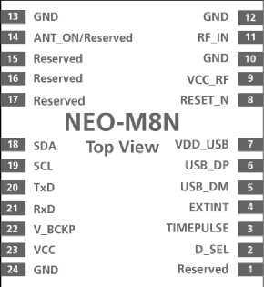

|  |  |  |  |  |  |  |  |
| --- | --- | --- | --- | --- | --- | --- | --- |
| Figure 2: Pin Assignment | | |  |  |  |  |  |
| No | Module | | Name |  |  | I/O | Description |
| 1 | A |  | Reserved |  |  | I | Reserved |
| 2 | A |  | D_SEL |  |  | I | Interface select |
| 3 | A |  | TIMEPULSE |  |  | O | Time pulse (1PPS) |
| 4 | A |  | EXTINT |  |  | I | External Interrupt Pin |
| 5 | A |  | USB_DM |  |  | I/O | USB Data |
| 6 | A |  | USB_DP |  |  | I/O | USB Data |
| 7 | A |  | VDD_USB |  |  | I | USB Supply |
| 8 | A |  | RESET_N |  |  | I | RESET—N |
| 9 | A |  | VCC—RF |  |  | O | Output Voltage RF section |
| 10 | A |  | GND |  |  | I | Ground |
| 11 | A |  | RF—IN |  |  | I | GNSS signal input |
| 12 | A |  | gnd |  |  | I | Ground |
| 13 | A |  |  |  |  | I | Ground |
|  | NEO-M8N | | ANT—ON |  |  | O | Antenna control |
| 14 | NEO-M8M | | Reserved |  |  | - | Reserved |
|  | NEO-M8Q | | ANT—ON |  |  | O | Antenna control |
| 15 | A |  | Reserved |  |  | - | Reserved |
| 16 | A |  | Reserved |  |  | - | Reserved |
| 17 | A |  | Reserved |  |  | - | Reserved |
| 18 | mA |  | SDA  SPI CS—N |  |  | I/O | DDC Data if D SEL =1 (or open) SPI Chip Select if D—SEL = 0 |
| 19 | A |  | SCL  SPI CLK |  |  | I/O | DDC Clock if D SEL =1(or open) SPI Clock if D—SEL = 0 |
| 20 |  |  | TxD  SPI MISO |  |  | O | Serial Port if D SEL =1(or open) SPI MISO if D—SEL = 0 |
| 21 | A |  | RxD  SPI MOSI |  |  | I | Serial Port if D SEL =1(or open) SPI MOSI if D—SEL = 0 |
| 22 | A |  | V—BCKP |  |  | I | Backup voltage supply |
| 23 | A |  | VCC |  |  | I | Supply voltage |
| 24 | A |  | GND |  |  | I | Ground |

**Table 5: Pinout**

Pins designated Reserved should not be used. For more information about Pinouts see the NEO-M8 Hardware Integration Manual [1].

1. **Configuration management**

Configuration settings can be modified with UBX configuration messages. The modified settings remain effective until power-down or reset. If these settings have been stored in battery-backup RAM, then the modified configuration will be retained, as long as the backup battery supply is not interrupted.

With the NEO-M8N, configuration settings modified with UBX configuration messages can be saved permanently. In this case, the modified settings remain effective even after power-down and do not require backup battery supply.

* 1. **Interface Selection (D_SEL)**

> set high or l

At startup Pin 2 (D_SEL) determines which data interfaces are used for communication. If D_SEL is set high or left open, UART and DDC become available. If D_SEL is set low, i.e. connected to ground, the NEO-M8 series module can communicate to a host via SPI.

|  |  |  |
| --- | --- | --- |
| PIN # | D_SEL=”1” (left open) | D_SEL =”0” (connected to GND) |
| 20 | UART TX | SPI MISO |
| 21 | UART RX | SPI MOSI |
| 19 | DDC SCL | SPI CLK |
| 18 | DDC SDA | SPI CS_N |

**Table 6: Data interface selection by D_SEL**



Configuration management Page 14 of 26

**Electrical specification**

The limiting values given are in accordance with the Absolute Maximum Rating System (IEC 134). Stress above one or more of the limiting values may cause permanent damage to the device. These are stress ratings only and operation of the device at these or at any other conditions above those given in the characteristics sections of the specification is not implied. Exposure to these limits for extended periods may affect device reliability.

**4**

Where application information is given, it is advisory only and does not form part of the specification. For more information see the WFO-M古 Ha厂d_re /nfeg厂af/on Manua/ [1].

1. **Absolute maximum rating**

|  |  |  |  |  |  |  |
| --- | --- | --- | --- | --- | --- | --- |
| Parameter | Symbol | Module | Condition | Min | Max | Units |
| Power supply voltage | VCC | All |  | -0.5 | 3.6 | V |
| Backup battery voltage | V_BCKP | All |  | -0.5 | 3.6 | V |
| USB supply voltage | VDD—USB | All |  | -0.5 | 3.6 | V |
| Input pin voltage | Vin | All |  | -0.5 | 3.6 | V |
|  | Vin—usb | All |  | -0.5 | VDD—USB | V |
| DC current trough any digital I/O pin | Ipin |  |  |  | 10 | mA |
| (except supplies) |  |  |  |  |  |  |
| VCC_RF output current | ICC—RF | All |  |  | 100 | mA |
| Input power at RF_IN | Prfin | All | source impedance |  | 15 | dBm |
|  |  |  | =50 Q, |  |  |  |
|  |  |  | continuous wave |  |  |  |
|  |  | NEO-M8M |  | -40 | 105 | °C |
| Storage temperature | Tstg | NEO-M8N/M8Q |  | -40 | 85 | °C |

**Table 7: Absolute maximum ratings**



**Stressing the device beyond the “Absolute Maximum Ratings” may cause permanent damage. These are stress ratings only. The product is not protected against overvoltage or reversed voltages. If necessary, voltage spikes exceeding the power supply voltage specification, given in table above, must be limited to values within the specified boundaries by using appropriate**

*A*

1. **Operating conditions**

11

All specifications are at an ambient temperature of 25°C. Extreme operating temperatures can significantly impact specification values. Applications operating near the temperature limits should be tested to ensure the specification.

|  |  |  |  |  |  |  |  |
| --- | --- | --- | --- | --- | --- | --- | --- |
| Parameter | Symbol | Module | Min | Typical | Max | Unit  s | Condition |
| Power supply voltage | VCC | NEO-M8M | 1.65 |  | 3.6 | V |  |
|  |  | NEO-M8N/Q | 2.7 | 3.0 | 3.6 | V |  |
| Supply voltage USB | VDDUSB | All | 3.0 | 3.3 | 3.6 | V |  |
| Backup battery voltage | V—BCKP | All | 1.4 |  | 3.6 ^i | 「V |  |
| Backup battery current | I—BCKP | All |  | 15 |  | pA | V BCKP = 1.8 V |
|  |  |  |  |  |  |  | VCC = 0 V |
| Input pin voltage range | Vin | All | 0 |  | VCC | V |  |
| Digital IO Pin Low level input voltage | Vil | All | 0 |  | 0.2*VCC | V |  |
| Digital IO Pin High level input voltage | Vih | All | 0.7*VCC |  | VCC | V |  |
| Digital IO Pin Low level output voltage | Vol | All |  |  | 0.4 | V | Iol = 4mA |
| Digital IO Pin High level output voltage | Voh | All | VCC-0.4 |  |  | V | Ioh = 4mA |
| USB_DM, USB_DP | VinU | All | Compatible with USB with 27 Q series resistance | | | | |
| VCC_RF voltage | VCC—RF | All |  | VCC-0.1 |  | V |  |
| VCC_RF output current | ICC—RF | All |  |  | 50 | mA |  |
| Receiver Chain Noise Figure[[4]](#bookmark102) | NFtot | NEO-M8M |  | 3.5 |  | dB |  |
|  |  | NEO-M8N/Q |  | _2.0 |  | dB |  |
| Operating temperature | Topr | All | -40 |  | 85 | °C |  |
| Table 8: Operating conditions |  |  |  |  |  |  |  |

Operation beyond the specified operating conditions can affect device reliability.

1. **Indicative current requirements**

Table 9 lists examples of the total system supply current for a possible application.

Values in Table 9 are provided for customer information only as an example of typical power requirements. Values are characterized on samples, actual power requirements can vary depending on FW version used, external circuitry, number of SVs tracked, signal strength, type of start as well as time, duration and conditions of test.

|  |  |  |  |  |  |  |
| --- | --- | --- | --- | --- | --- | --- |
| Parameter | Symbol | Module | Min Typ | Max | Units | Condition |
| Max. supply current[[5]](#bookmark3) [6] [7] | Iccp | All |  | 100 | mA |  |
|  | Icc Acquisition[[8]](#bookmark6) | NEO-M8N | 33.8 |  | mA |  |
|  | (GPS and GLONASS concurrently) | NEO-M8M | 26 |  | mA | Estimated at 3 V |
|  |  | NEO-M8Q | 28 |  | mA |  |
|  | 丨cc Tracking  (Continuous mode, | NEO-M8N | 34.4 |  | mA |  |
| Average supply current13, 14 | NEO-M8M | 21.2 |  | mA | Estimated at 3 V |
|  | GPS and GLONASS concurrently) | NEO-M8Q | 24 |  | mA |  |
|  | 丨cc Tracking  (Power Save mode / 1 Hz) | NEO-M8N | 11.5 |  | ^mA |  |
|  | NEO-M8M  NEO-M8Q | 4.8  ~~i 10.4 |  | mA  mA | Estimated at 3 V |
| Table 9: Indicative power requirements at 3.0 V | |  |  |  |  |  |

For more information about power requirements, see the WFO-MS Ha厂厂e /nfeg厂af/on Manua/ [1]

For GPS only operation current consumption can noticeably be reduced (see the Powe厂 Consumpf/on App//caf/on Note [4])

1. **SPI timing diagrams**

In order to avoid incorrect operation of the SPI, the user needs to comply with certain timing conditions. The following signals need to be considered for timing constraints:

**Symbol Description**

SPI CS_N (SS_N) Slave select signal

SPI CLK (SCK) Slave clock signal

**Table 10: Symbol description**

**INIT**

^^

SS_N



**Figure 3: SPI timing diagram**

1. **Timing recommendations**

The recommendations below are based on a firmware running from Flash memory. Parameter Description Recommendation

t,N,T Initialization Time 500

tDES Deselect Time

1 ms.

1 Mb/s

**Bit rate**

**Table 11: SPI timing recommendations**

The values in the abo few errors and disabli

ve table result from the requirement of an error-free transmission. By allowing」ust a ng the glitch filter, the bit rate can be increased considerably.

1. **DDC timing diagrams**

The DDC interface is I2C Fast Mode compliant. For timing parameters consult the I2C standard.

The maximum bit rate is 400 kb/s. The interface stretches the clock when slowed down when serving interrupts, so real bit rates may be slightly lower.

1. **Mechanical specifications**

**Symbol**

A

**Min, (mm)**

**Typ. (mm)**

**Max. (mm)**

15.9

16.0

16.6

12J

12.2

12.3

0.82

0.8

Weight

**Figure 4: Dimensions**

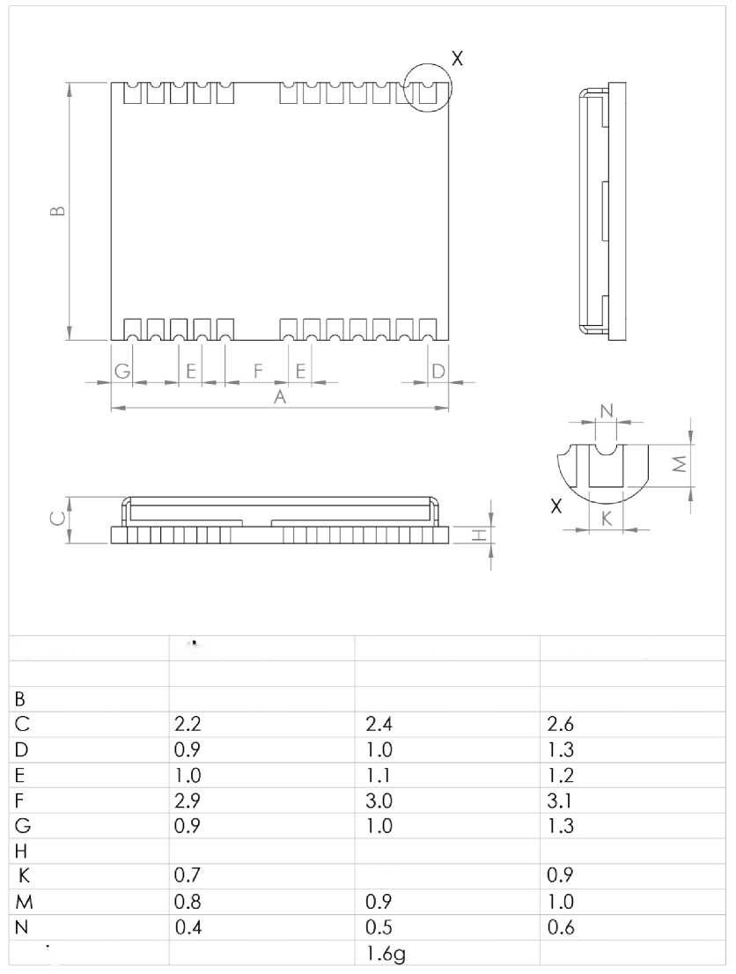For information regarding the Paste Mask and the Footprint see the NEO-M8 Hardware Integration Manual [1].

1. **Reliability tests and approvals**
   1. **Reliability tests**

All NEO-M8 series modules are based on AEC-Q100 qualified GNSS chips.

Tests for product family qualifications are according to ISO 16750 "Road vehicles - Environmental conditions and testing for electrical and electronic equipment”，and appropriate standards.

* 1. **Approvals**

Products marked with this lead-free symbol on the product label comply with the "Directive 2002/95/EC of the European Parliament and the Council on the Restriction of Use of certain Hazardous Substances in Electrical and Electronic Equipment" (RoHS).

**(Jb**

All u-blox M8 GNSS modules are RoHS compliant.



Reliability tests and approvals Page 20 of 26

1. **Product handling & soldering**
   1. **Packaging**

The NEO-M8 series GNSS modules are delivered as hermetically sealed, reeled tapes in order to enable efficient production, production lot set-up and tear-down. For more information see the u-b/ox Package /nfo厂maf/on Guide [3].

* + 1. **Reels**

The NEO-M8 series GNSS modules are deliverable in quantities of 250 pcs on a reel. The NEO-M8 receivers are shipped on Reel Type B, as specified in the u-b/^x Package /nformation Guide [3].

1. **Tapes**

The dimensions and orientations of the tapes for NEO-M8 modules are specified in Figure 5.

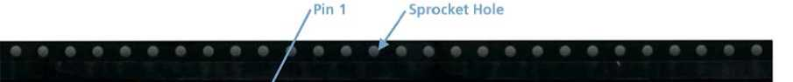

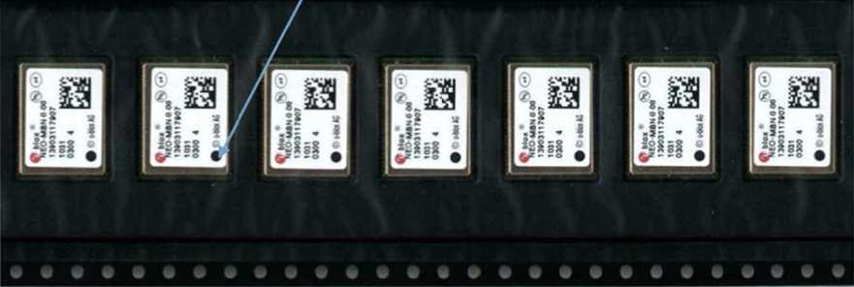

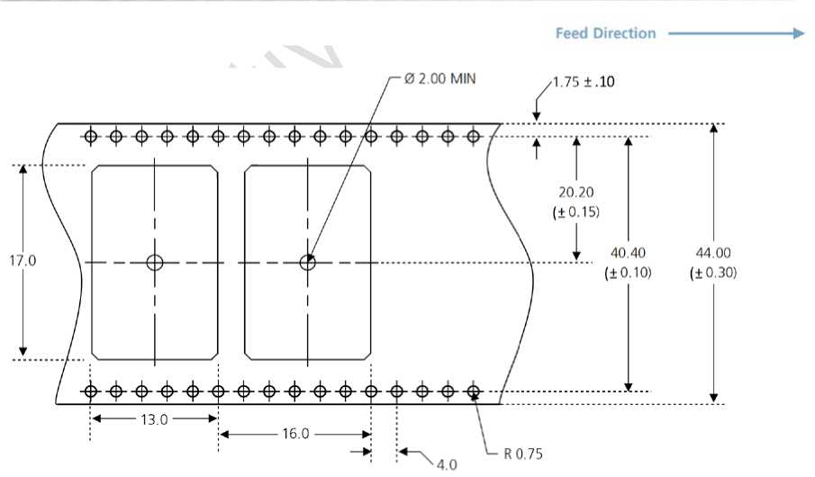

**Figure 5: Dimensions and orientation for NEO-M8 modules on tape**

* 1. **Shipment, storage and handling**

For important information regarding shipment, storage and handling see the u-b/ox Package /nfo厂maf/on Gu/de [3].

* + 1. **Moisture Sensitivity Levels**

The Moisture Sensitivity Level (MSL) relates to the packaging and handling precautions required. The NEO-M8 modules are rated at MSL level 4.

For MSL standard see IPC/JEDEC J-STD-020, which can be downloaded from [wwwjedec.org.](http://www.jedec.org/)

For more information regarding MSL see the u-b/ox Package/nfomaf/on Gu/de [3].

* + 1. **Reflow soldering**

一

***are Integration***

Reflow profiles are to be selected according u-blox recommendations (see N Manua/ [1]).

* + 1. **ESD handling precautions**

**NE0-M8 series modules are Electrostatic Sensitive Devices (ESD). Observe precautions for handling! Failure to observe these precautions can result in severe damage to the GNSS receiver!**

GNSS receivers are Electrostatic Sensitive Devices (ESD) and require special precautions when handling. Particular care must be exercised when handling patch antennas, due to the risk of electrostatic charges. In addition to standard ESD safety practices, the following measures should be taken into account whenever handling the receiver:

* 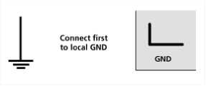Unless there is a galvanic coupling between the local GND (i.e. the work table) and the PCB GND, then the first point of contact when handling the PCB must always be between the local GND and PCB GND.
* Before mounting an antenna patch, connect ground of the device
* 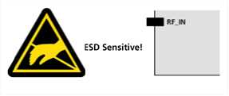When handling the RF pin, do not come into contact with any charged capacitors and be careful when contacting materials that can develop charges (e.g. patch antenna ~10pF, coax cable ~50-80pF/m, soldering iron, ...)
* To prevent electrostatic discharge through the RF input, do not touch any exposed antenna area. If there is any risk that such exposed antenna area is touched in non ESD protected work area, implement proper ESD protection measures in the design.
* When soldering RF connectors and patch antennas to the receiver's RF pin, make sure to use an ESD safe soldering iron (tip).

1. **Default messages**

**Interface Settings**

UART Output 9600 Baud, 8 bits, no parity bit, 1 stop bit

Configured to transmit both NMEA and UBX protocols, but only following NMEA and no UBX messages have been activated at start-up:

**GGA, GLL, GSA, GSV, RMC, TTG, TXT**

USB Output

UART Input

USB Input

DDC

SPI

TIMEPULSE (1Hz Nav)

Configured to transmit both NMEA and UBX protocols, but only following NMEA and no UBX messages have been activated at start-up:

**GGA, GLL, GSA, GSV, RMC, TTG, TXT**

USB Power Mode: Bus Powered

9600 Baud, 8 bits, no parity bit, 1 stop bit, Autobauding disabled Automatically accepts following protocols without need of explicit configuration:

UBX, NMEA, RTCM

The GNSS receiver supports interleaved UBX and NMEA messages.

Automatically accepts following protocols without need of explicit configuration:

UBX, NMEA

The GPS receiver supports interleaved UBX and NMEA messages.

USB Power Mode: Bus Powered Fully compatible with the I2C industry standard, available for communication with an external host CPU or u-blox Wireless modules, operated in slave mode only. Default messages activated.

NMEA and UBX are enabled as input messages, only NMEA as output messages.

Maximum bit rate 400 kb/s.

Allow communication to a host CPU, operated in slave mode only. Default messages activated. SPI is not available in the default configuration.

1 pulse per second, synchronized at rising edge, pulse length 100ms

**Table 12: Default messages**

Refer to the u-b/ox MS 尺ece/Ve厂 Deso^f/on /nc/ud/hg P厂ofoco/ 5pec/f/caf/on [2] for information about

further settings.

1. **Labeling and ordering information**

**9.1 Product labeling**

The labeling of u-blox M8 GNSS modules includes important product information. The location of the product type number is shown in Figure 6.

**©blox®** 物**(e4)**

**Product Type Number**

**PPP-TGV-T-XX —**

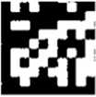5754400118 0652 0301 11

**Pin 1 Marking**

**© u-blox AG**

**Figure 6: Location of product type number on u-blox M8 module label**

1. **Explanation of codes**

Three different product code formats are used. The Product Name is used in documentation such as this data sheet and identifies all u-blox M8 products, independent of packaging and quality grade. The Ordering Code includes options and quality, while the Type Number includes the hardware and firmware versions. Table 13 below details these three different formats:

**Format**

**Structure**

PPP-TGV

PPP-TGV-T

PPP-TGV-T-XX

**Product Name Ordering Code Type Number**

**Table 13: Product Code Formats**

The parts of the product code are explained in Table 14.

|  |  |  |
| --- | --- | --- |
| Code | Meaning | Example |
| PPP | Product Family | NEO |
| TG | Platform | M8 = u-blox M8 |
| V | Variant | T = Timing, R = DR, etc. |
| T | Option / Quality Grade | Describes standardized functional element or quality grade such as Flash size, automotive grade etc. |
| XX | Product Detail | Describes product details or options such as hard- and software revision, cable length, etc. |

**Table 14: part identification code**

1. **Ordering codes**

**Ordering No. Product**

NEO-M8M-0 u-blox M8 Concurrent GNSS LCC Module, crystal, ROM, 12.2x16 mm, 250 pcs/reel

NEO-M8N-0 u-blox M8 Concurrent GNSS LCC Module, TCXO, flash, SAW, LNA, 12.2x16 mm, 250 pcs/reel

NEO-M8Q-0 u-blox M8 Concurrent GNSS LCC Module, TCXO, ROM, SAW, LNA, 12.2x16 mm, 250 pcs/reel

**Table 15: Product ordering codes for standard grade modules**

***Product changes affecting form, fit or function are documented by u-blox. For a list of Product Change Notifications ^PCNs) see our website.***

**Related documents**

NEO-M8 Hardware Integration Manual, Docu. No. UBX-13003557

u-blox M8 Receiver Description including Protocol Specification V15, Docu. No UBX-13002887 u-blox Package Information Guide, Docu. No. GPS-X-11004 PowerConsumption Application Note, Docu. No. UBX-13005162

2 3 4

For complete contact information visit us at [www.u-blox.com](http://www.u-blox.com/)



**Revision history**

**Revision**

1

R02

**Date**

28-Aug-2013

17-Dec-2013

**Name**

svin

julu

**Status / Comments**

Objective Specification.

Minor alignment with document structure. Updated ROM/Flash versions. Added NEO-M8Q product variant in the relevant sections. Updated section 1.1 and section 1.2 (Product features). Updated performance figures in Table 1. Updated section 1.4 (removed “optional” from RTC crystal), section 1.6.3 (AssistNow Autonomous) and section 1.9 (Added SQI flash memory size info). Added section 1.8 Odometer. Updated Table 3, Table 7 (e.g. Storage temperature) and Table 8. Updated power consumption figures in Table 9. Added Power Consumption Application Note reference in section 4.3. Added DDC and SPI interfaces in Table 12.

Related documents Page 25 of 26

**Contact**



**Headquarters**

**Europe, Middle East, Africa**

**u-blox AG**

Phone: +41 44 722 74 44

E-mail: [info@u-blox.com](mailto:info@u-blox.com)

Support: [support@u-blox.com](mailto:support@u-blox.com)

**u-blox Offices**

**North, Central and South America**

**u-blox America, Inc.**

Phone: +1 703 483 3180

E-mail: [info_us@u-blox.com](mailto:info_us@u-blox.com)

**Regional Office West Coast:**

Phone: +1 408 573 3640

E-mail: [info_us@u-blox.com](mailto:info_us@u-blox.com)

**Technical Support:**

Phone: +1 703 483 3185

E-mail: [support_us@u-blox.com](mailto:support_us@u-blox.com)

**Asia, Australia, Pacific**

**u-blox Singapore Pte. Ltd.**

Phone: +65 6734 3811

E-mail: [info_ap@u-blox.com](mailto:info_ap@u-blox.com)

Support: [support_ap@u-blox.com](mailto:support_ap@u-blox.com)

**Regional Office Australia:**

Phone: +61 2 8448 2016

E-mail: [info_anz@u-blox.com](mailto:info_anz@u-blox.com)

Support: [support_ap@u-blox.com](mailto:support_ap@u-blox.com)

**Regional Office China (Beijing):**

Phone: +86 10 68 133 545

E-mail: [info_cn@u-blox.com](mailto:info_cn@u-blox.com)

Support: [support_cn@u-blox.com](mailto:support_cn@u-blox.com)

**Regional Office China (Shenzhen):**

Phone: +86 755 8627 1083

E-mail: [info_cn@u-blox.com](mailto:info_cn@u-blox.com)

Support: [support_cn@u-blox.com](mailto:support_cn@u-blox.com)

**Regional Office India:**

Phone: +91 959 1302 450

E-mail: [info_in@u-blox.com](mailto:info_in@u-blox.com)

Support: [support_in@u-blox.com](mailto:support_in@u-blox.com)

**Regional Office Japan:**

Phone: +81 3 5775 3850

E-mail: [info_jp@u-blox.com](mailto:info_jp@u-blox.com)

Support: [support_jp@u-blox.com](mailto:support_jp@u-blox.com)

**Regional Office Korea:**

Phone: +82 2 542 0861

E-mail: [info_kr@u-blox.com](mailto:info_kr@u-blox.com)

Support: [support_kr@u-blox.com](mailto:support_kr@u-blox.com)

**Regional Office Taiwan:**

Phone: +886 2 2657 1090

E-mail: [info_tw@u-blox.com](mailto:info_tw@u-blox.com)

Support: [support_tw@u-blox.com](mailto:support_tw@u-blox.com)

1. For information on using active antennas with NEO-M8 modules, see the WEO-M8 Hardware Integration Manua/ [1].
2. NEO-M8M
3. NEO-M8N/M8Q
4. Only valid for the GPS band
5. Use this figure to dimension maximum current capability of power supply. Measurement of this parameter with 1 Hz bandwidth
6. Use this figure to determine required battery capacity.
7. Simulated GNSS constellation using power levels of -130 dBm. VCC = 3.0 V
8. Average current from start-up until the first fix.