**Assignment Project 1:**

**Part A**: Write script to implements the database design shown in Figure 1.

Create tables in ex_schema.

Create the sequences for the user_id, download_id, and product_id columns.

Include a PL/SQL script to drop the table or sequence if it already exists. Include any indexes necessary.

Figure 1

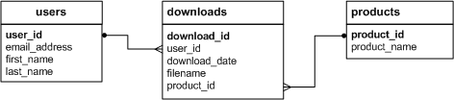

**Part B:** Write a script that adds rows to the database that created in part A.

Add two rows to the Users and Products tables.

Add three rows to the Downloads table: one row for user 1 and product 2; one row for user 2 and product 1; and one row for user 2 and product 2. Use the SYSDATE function to insert the current date into the download_date column.

Use the sequences created in the previous exercise to get the values for the user_id, download_id, and product_id columns.

Write a SELECT statement that joins the three tables and retrieves the data from these tables shown below:

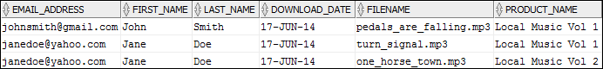

Sort the results by the email address in descending sequence and the product name in ascending sequence.

**Part C:** Write an ALTER TABLE statement that adds two new columns to the Products table created in Part A.

Add one column for product price that provides for three digits to the left of the decimal point and two to the right. This column should have a default value of 9.99.

Add one column for the date and time that the product was added to the database.

**Part D:** Write an ALTER TABLE statement that modifies the Users table created in Part A so the first_name column can store NULL values and can store a maximum of 20 characters.

Code an UPDATE statement that inserts a NULL value into this column. It should work since this column now allows NULL values.

Code another UPDATE statement that attempts to insert a first name that’s longer than 20 characters. It should fail due to the length of the column.

**Response to Assignment Project 1:**  Please see notepad++ file named as M_Chandok_SQL_Project1.sql file

**Assignment Project 2:** Using my Guitar database (mgs_schema)

**Part A:** Write a SELECT statement that returns three columns: email_address, order_id, and the order total for each customer. To do this, you can group the result set by the email_address and order_id columns. In addition, you must calculate the order total from the columns in the Order_Items table.

Write a second SELECT statement that uses the first SELECT statement in its FROM clause. The main query should return two columns: the customer’s email address and the largest order for that customer. To do this, you can group the result set by the email_address.

**Part B:** Write a SELECT statement that returns the name and discount percent of each product that has unique discount percent. In other words, don’t include products that have the same discount percent as another product.

Sort the results by the product_name column.

**Part C:** Use a correlated subquery to return one row per customer, representing the customer’s oldest order (the one with the earliest date). Each row should include these three columns: email_address, order_id, and order_date.

**Response to Assignment Project 2:** Please see notepad++ file named as M_Chandok_SQL_Project2.sql file

**Assignment Project 3:**

1. Draw a database diagram for a database that stores information about the downloads that users make. Each user must have an email address, first name, and last name.
2. Each user can have one or more downloads. Each download must have a filename and download date/time. Each product can be related to one or more downloads.
3. Each product must have a name.

**Response to Assignment Project 3:** Please see diagram below(3/11/15)

