UNIVERSITY OF TECHNOLOGY AND APPLIED SCIENCES
DESIGN AND IMPLEMENTATION OF STUDENT COMPLAINT SYSTEM FOR UTAS
A PROJECT REPORT
Submitted by
FATAWU DANIEL
ID: 20220404014
BACHELOR OF SCIENCE
in
COMPUTER SCIENCE
June, 2026

CHAPTER ONE
INTRODUCTION

1.0 Background of the Study
Digital technology has developed so much that it has revolutionised how things are done in many fields, such as education, commerce, and public administration. There has been a growing realization in educational institutions around the world of the need for a digital transformation that embraces the entire institution and is expected to modernize the processes that are traditionally performed by hand and to enhance service provision (Al-Emran & Shaalan, 2025). The digitalisation process increases organizational efficiency and allows stakeholders, especially the students and the heads of institutions to have better information access and better decision-making power.
As of the writing of this article, there are many possibilities of how digitalization can be applied, and one of the most effective applications of digital technology in education is a web-based system for collecting student complaints. This will assist students in tertiary institutions to get acquainted with the use of technology, which is still moving towards digitalization in the outside world. The system will also help students to file a complaint or grievance with the school administration and make sure it is addressed accordingly; this is the main objective of this project.
A tertiary institution student complaint system is a process that is well formulated and provides for the feedback of student complaints and steps to take to address the complaints. It aims to increase student satisfaction, foster a positive learning atmosphere and increase the accountability of the institution. Indeed, student complaints management systems have become an integral part of educational institutions to streamline the complaints handling process in modern educational institutions (Al-Emran, M., & Shaalan, K., 2025).
In tertiary institutions, managing student responses and complaints is of paramount importance for creating a conducive and inclusive educational environment. Most student grievances relate to existing issues in administration, academics, welfare, and service delivery, and any problem a student raises needs to be channelled quickly to the relevant administrators for a response and resolution.
In the past, the way students could file complaints or grievances was by using letters, the Student Representative Council (SRC) and verbally, which meant going to the offices of the relevant persons to voice their concerns about their academic lives in the institution. Students usually get to these offices only to discover that the people responsible are not there, wasting time and delaying complaints and obtaining solutions. The process of handling complaints filed by students in universities is either paper-based, informal, or bureaucratic, which has caused delay in the process, loss of information, and students’ dissatisfaction.
To create an integrated web-based platform wherein students can lodge complaints and school administrators can respond with the status of the complaints lodged will be required if a comprehensive complaint lodging by students and resolution by school administrators is required. In addition, it should be able to document all complaints that are filed by students to track complaints over time. This will aid the institution to know their pupils and the problems they are faced with, which will help them deal with the problems effectively to create a conducive environment for smooth institutional operations with pupils satisfied and their problems solved as soon as they are detected.
In response to these challenges and opportunities, this study primarily focuses on the design and implementation of a web-based student complaint system for University of Technology and Applied Sciences (UTAS). It will be a centralized system to record, track, and resolve students' issues ensuring the same are treated fairly, responded to in time and keeping a record of complaints filed by students of the institution for future reference.

1.1 Problem Statement
Despite the benefits that digitalisation can bring, UTAS still relies on manual, paper-based, and informal methods, including letters, the Student Representative Council (SRC), and face-to-face visits, for lodging and resolving student complaints. These manual operations are inefficient, ambiguous, and prone to critical data-integrity problems such as loss of records (Agyemang & Gyan, 2021). Similar research in Ghanaian tertiary institutions shows that limited adoption of digital solutions negatively affects institutional administration and grievance resolution (Alhassan & Agyapong, 2022). Students may also be less willing to report legitimate concerns where they fear face-to-face confrontation or see no consequence for inaction. This is corroborated by the questionnaire administered to students and staff during this study, in which [insert the percentage/finding from your questionnaire data here] of respondents reported dissatisfaction with how long complaints take to resolve under the current manual system.
Furthermore, institutional administrators lack immediate analytics to track complaint trends and recurring problems. Without an integrated complaint management system in place, the institution continues to experience:
• Delays in resolutions
• Insufficient documentation and tracking of grievances.
• Failure to be accountable and transparent
• Very little or no feedback given to students
• Inefficient reporting and decision-making tools

The aim of this research is therefore to provide a solution to these problems by designing and implementing a digital student complaint management system suited to the context of UTAS.
1.2 Objectives of the Study
1.2.1 Main Objective
The goal of the study is to create and develop a web-based student complaint management system for UTAS.

1.2.2 Specific Objectives
This study aims to:
- To analyse the current student complaint procedure to identify the functional and non-functional requirement
- To design and implement a web-based system that automates the manual procedure
- To provide complaint reports and summary information to support institutional decision making.

1.3 Significance of the Study
It is believed that introducing and incorporating a web-based student complaint system will significantly improve the above-mentioned challenges and errors in the manual system. It will enable pupils to speak aloud and clearly about their concerns and complaints.
A streamlined process to monitor and address problems will be given to administrators, which will support a productive and inclusive learning environment for administrators and students. Once again, policy makers in the institution will, via this mechanism, have an opportunity to receive feedback on the institution's weaknesses and shortfalls in its service, that is, those areas of the institution that have problems and could be addressed. This also is a case study of user-centred academic support system development for software developers.
The study is therefore important because it contributes to a conducive and inclusive learning environment for both institutional administrators and learners, and the system addresses many of the key problems and challenges encountered in lodging complaints with the authorities, even though, like any system, it cannot eliminate every administrative or human-factor challenge involved. This aligns with the global report from UNESCO (2021) on the importance of digital transformation in education for equity, transparency, and institutional accountability.

1.4 Scope of the Study
This study addresses the need for a web-based student complaint system specifically for UTAS as there is no digitalized and centralized medium for students of the university to file complaints or grievances. It will include on how to log-in as a student and administrator, how to submit a complaint as a student, how to know the status of a complaint, how to view complaints as an administrator, and how to resolve complaints. This system will be available only for students and administrators of UTAS and will not include third-party mediators or appeals.

1.5 Limitations of the Study
Like every research effort, this study is subject to a few limitations. Because of the limited time available for the project, the requirements-gathering process could not engage every department and complaint category at UTAS in equal depth, which may affect how broadly the system’s requirements generalise across the institution.
The system is also limited to the web platform and may not yet be available as a mobile application, although this could change in future. Furthermore, the project is targeted at internal use within the institution and may need to be adapted for wider adoption. It provides a basic level of security and privacy, but not necessarily at an Enterprise-grade compliance level (e.g., ISO 27001, GDPR).

1.6 Structure of Dissertation
This research work can be divided into five chapters. In Chapter One, the introduction of research study, Scope of study, significance of study, and the organization of research is discussed.
The literature review (both theoretical and empirical) is discussed in Chapter Two. The methodology of the study is explained in Chapter Three, the system analysis and design and a brief description of the tools used in the study. System results and discussions shown in chapter four, covering technology stack, system module analysis, and system requirements for implementation of the system. Chapter Five serves as a summary, recommendations, and conclusion of the entire work in the dissertation.

CHAPTER TWO
LITERATURE REVIEW

2.1 Introduction
This chapter reviews the existing literature on the design and implementation of student complaint systems in tertiary institutions, with a special focus on the context of the University of Technology and Applied Sciences (UTAS). The review of literature will be conducted in both chronological order and thematic order to give clarity and coherence to the literature, and to show the historical development or the focus of the topic. It is designed to provide answers to fundamental questions: What has been studied? Which frameworks and technologies are there? What gaps remain? This review is based on the studies in the foundation, digital transition, recent innovations, regional views, and real-life concerns to give a basis for this project's system design.

2.2 Foundational Perspective on Student Feedback and Complaints.
Students receive feedback and complaints through a variety of means during the course of their studies. Earlier research works provided a basis for the conceptualisation of the role and significance of student voice within tertiary institutions. Dolinsky (1994) and Coffield (1995) have stressed the importance of setting up student voice mechanisms within tertiary institutions and the need for traceable feedback systems as a way of improving the answerability of tertiary institutions and their students' satisfaction. They formed the connection between the effective complaint resolution and the institutional reputation and showed the connection between the prompt handling of complaints and the student retention rates.
Mann (2001) extended this discussion by exploring student engagement and resistance within educational contexts, arguing that complaint systems should not marginalise students but actively engage them. This principle directly informs the design of the system proposed in this study, which aims to give students a formal, structured pathway for raising concerns without fear of reprisal or bureaucratic inaction. Rolfe (2002) highlighted the importance of reflective practice within the institutional context and suggested that complaints should be used for ongoing improvement, not treated as one-off cases. Burke (2004) offered a critical perspective on the role of the university in governance, emphasising the need to connect complaint-resolution processes with democratic principles and public accountability.
These research works set out the ethical and conceptual framework on complaint systems, and present the view that complaint systems are not simply about resolving the individual logged complaint but are also tools that can be used for institutional learning and institutional improvement. The argument of their collective - with management, student feedback can raise the quality and accountability of tertiary education is directly informed by the design rationale of this study.

2.3 Evolution towards Digital and User-Centric Systems
As digital transformation has swept through higher education, complaint-handling systems have similarly begun shifting from purely manual, paper-based processes toward web-based, user-centric platforms.
With the introduction of digital technologies into higher education management, complaint systems went from manual/paper-based to web-based systems. Schoefer (2008) spoke about the foundation of service recovery in learning environments, in keeping with the main concept that if service complaints can be resolved effectively, it will enhance institutional trust and loyalty. This is especially important for UTAS, where there has been no formal mechanism to respond to student concerns and concerns, and consequently, students do not have confidence in the response process.
In the study on satisfaction metrics in academic support systems, Casado-Diaz (2009) studied the key metrics for measuring the success of any complaint platform. Jackson (2009) and Millward (2015) also added their own perspectives on the frameworks for implementing digital solutions and institutional preparedness for digital solutions, highlighting that technology implementation in academic environments is accompanied by training, stakeholder acceptance, and governance frameworks.
All these studies stress the importance of making complaint facilities available online that are easy to use, intuitive, and work seamlessly with institutional processes to improve efficiencies and responsiveness. This change mirrors the global landscape of higher education's expectations that web-based and mobile-first technologies will become significant changes in the field (Johnson, Becker, Cummins, & Estrada, 2016).

Sunyani Technical University in Ghana adopted a web-based student complaints system built with PHP and MySQL to enhance the reliability and efficiency of complaint handling (Mohammed, Solomon, & Nurideen, 2021). Similar digitisation efforts are emerging across other Ghanaian tertiary institutions as they explore more accessible channels for lodging and tracking student complaints. These local examples show that digital complaint management is both feasible and increasingly being adopted within Ghana’s tertiary education environment.

2.4 Recent Advances and Technological Innovations
Recent literature increasingly focuses on responsive, student-centred digital platforms, underscoring the importance for UTAS of adopting a web-based approach to complaint resolution. Scott (2018) highlighted the need for real-time communication and automation in complaint systems, which resonates with today’s students’ expectations of instant feedback, status tracking, and system responsiveness. These expectations directly shape the current system’s functional requirements, including the complaint-tracking module and real-time notification capabilities.
Furthermore, Yilmaz (2020) found that the usability and user experience of digital systems play a significant role in students’ acceptance and the long-term sustainability of the platform. This is directly relevant to the present project, which focuses on building a simple, easy-to-use system for reporting and tracking complaints: even a technically sound back-end will fail to meet institutional goals if the interface is difficult to navigate or slow to respond.
Taken together, these studies point to a common conclusion: emphasis should be placed on creating a web-based, standalone application that prioritises usability, speed of resolution, and ease of access. This approach is both realistic and accessible, and is well suited to UTAS’ current context, where there is no formal digital complaint process in place.

2.5 Contextual and Region-Specific Studies
Tshotlogo (2024) examined complaint-handling in rural colleges in Botswana and found that infrastructure limitations, low digital literacy, and cultural attitudes toward authority all shaped how willing students were to raise concerns through digital channels. These findings are directly relevant to UTAS, where similar factors, such as limited digital infrastructure and varying levels of digital confidence among students, may affect adoption of the proposed system. Similarly, Phratama (2024) studied mobile-first complaint solutions in Indonesian polytechnics and argued that such systems must be resource-aware and culturally sensitive to fit diverse user environments; this reinforces the need for the UTAS system to remain lightweight and accessible on low-end devices and limited bandwidth.
Kassem and Dahab (2018) reviewed several web-based grievance systems and found that real-time status tracking and feedback were often limited or absent altogether. This gap directly motivates the functional design of the current system, in which live status updates and administrator response notifications are treated as core features rather than optional add-ons.
In February 2021, the University of Ghana (UG) launched a Student Online Academic Complaint Platform, a joint initiative between the Office of the Pro Vice-Chancellor for Academic and Student Affairs, University of Ghana Computing Systems (UGCS), and the Academic Affairs Directorate, giving students a formal digital channel for academic complaints (University of Ghana, 2021). This practical example demonstrates that web-based complaint systems are both implementable and increasingly adopted in tertiary institutions across Ghana and the wider African region, lending weight to the feasibility of the system proposed for UTAS. However, Alhassan and Agyapong (2022) caution that digital-platform adoption in Ghana remains at an early stage, and many higher institutions continue to face access, scalability, and institutional-readiness challenges, issues that this project aims to help address within the context of UTAS.

2.5.1 Literature Mapping of Student Complaint Systems
A visual literature map was produced using Litmaps to help understand and reflect on the development of research on student complaint system. The image below shows some of the most important academic contributions in a chronological order (left to right) and by citation impact (bottom to top). The early buildings of student voice and complaint system theory are based on foundational work like Dolinsky (1994), Mann (2001), and Burke (2004). With its development, user and technology-oriented studies were produced, such as Schoefer (2008), Scott (2018) and recent context-oriented studies by Tshotlogo (2024).
Structured evolution, as presented in this review, is supported by this bibliometric overview and its contribution in situating the present study in the rapidly expanding literature on accountability, usability, and innovation in system development in tertiary education.
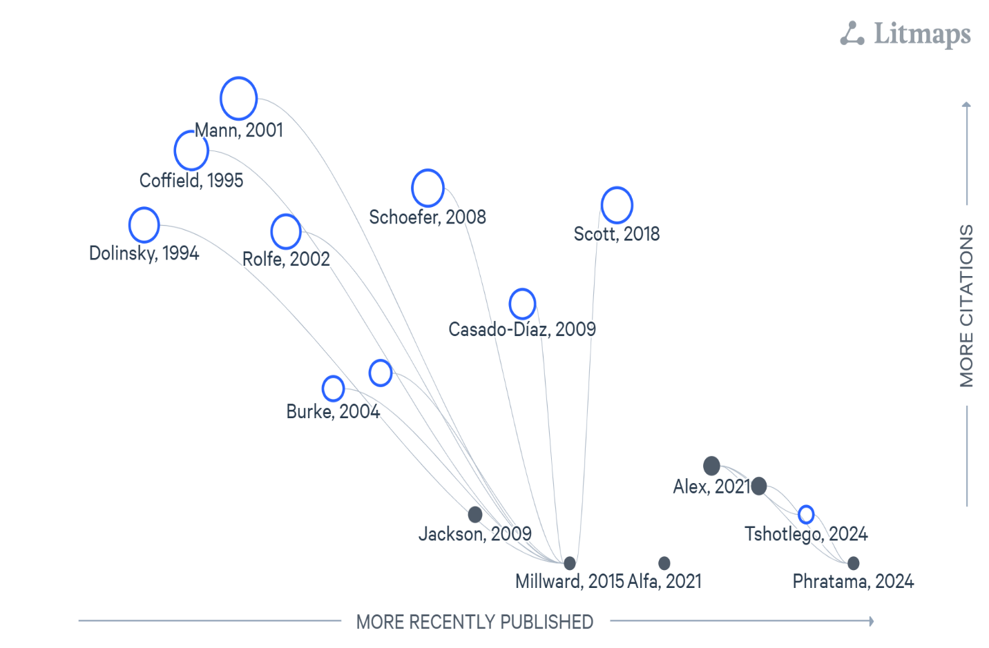
Figure 2.1 illustrates the evolution of Web-based complaint system.

2.6 Identified Gaps in the Literature
The literature reviewed in Sections 2.2 to 2.5 shows considerable progress in complaint-management theory, digital adoption, and regional context. However, much of it describes individual systems’ features in isolation rather than critically comparing the approaches, tools, and design choices behind them. Reading across these sections together, a number of areas remain insufficiently addressed:
Accessibility: The ability of the platforms to meet the needs of students with disabilities including those who may require assistive technologies and alternative input methods is not sufficiently covered.
However, there is considerable lack of long-term research on the effects of complaints on institutional policies, culture, and retention.
Existing systems do not provide real-time tracking and feedback systems in most cases as noted by Kassem and Dahab (2018) which hinders the effectiveness of the system in addressing students' expectations.
Local Context Adaptation: Many of these systems are developed in the institutional context of well-resourced institutions and aren't flexible enough to be used in developing country institutions where there may be infrastructure limitations.

These gaps directly influence the innovation objectives of this project, especially by providing a system that is inclusive, accessible, user-friendly and has the ability to inform institutional policy for the project using its complaints data analytics capabilities.

2.7 Implications of the Study
There is a clear roadmap to system development in the literature. Theories underpin the ethical and institutional rationale for a strong complaints process. Key design decisions in the digitalisation of complaint systems include web integration, access control and user experience. Finally, there is a need to remind designers of systems to consider context in developing contexts such as Ghana, so they can design systems suitable for the specific learning and cultural environments.
This project aims to address the gaps identified, by proposing a system for complaints that is geared towards the student, and will be accessible, transparent and make UTAS more responsive to complaints. The proposed system includes user authentication for role-based dashboards and a complaint tracking module to enhance efficiency in the process of handling complaints (Sommerville, 2016). These help establish the system as more than just a digital replacement for paper-based processes – it is a strategic institutional tool for continuous improvement.

2.8 Chapter Conclusion
The review of literature demonstrates how student complaints have evolved from a simple feedback mechanism into an intelligent, integrated system that forms part of an institution’s overall management and digitalisation strategy. The ethical and institutional foundations for this shift were established in Sections 2.2 and 2.3 (Dolinsky, 1994; Coffield, 1995; Mann, 2001; Rolfe, 2002; Burke, 2004), while Sections 2.4 and 2.5 traced the growing emphasis on real-time, user-centred, and context-sensitive design (Scott, 2018; Yilmaz, 2020; Tshotlogo, 2024; Phratama, 2024). Section 2.6 identified a number of gaps that remain in the current literature, particularly around real-time tracking, accessibility, and the long-term evaluation of complaint systems’ effects on institutional culture.
The aim of this study is to develop a practical, flexible and student-centred complaint management system for UTAS that will help the institution with its accountability, transparency and student welfare initiatives to bridge these gaps. This review is used to inform the methodology, system design and functional architecture as discussed in the following chapters.

CHAPTER THREE

METHODOLOGY

3.0 Introduction
This chapter outlines the methodologies and tools utilized in the design and development of the “Student Complaint System for UTAS”. It details the structured approach followed throughout the project, given justification for the selected tools and techniques. By these detailed procedures, it gives way for researchers and project developers to share their systematic approaches to achieve the stated project objectives.
As defined by Aleksandr Georgievich Spirkin, methodology is a system of principles for organizing and structuring both practical and theoretical activities, essentially forming the theory of the system (Moshaq A., 2013). This definition demonstrates the essence of methodology in ensuring that research and development efforts are coherent, well organized and effective.
The Software Development Life Cycle (SDLC) guides the project from initial conception through to deployment and maintenance. With the numerous SDLC approaches which include Waterfall model, Prototype model, and Spiral model, the Agile methodology was applied in this project due to its features such us adaptability and focus on user feedback as the system is been built.

3.1 The Agile Software Development Methodology
The Agile software methodology highlights iterative development, continuous delivery, flexibility, and collaboration. It simplifies the software project into small, manageable units call “sprints.” Typically lasting two to four weeks. Each sprints results in a functional component of the system, which is reviewed and improved upon in the next cycle of the system development.
Agile methodology has a continuous communication with stakeholders and end-users, making sure and being careful that final system meets user expectations and requirements and is able to adapt to changing environments. Agile encourages continuous improvement through regular retrospectives. Teams reflect on their processes and identify areas for improvement in each sprint. Agile also puts first delivering value to the customer which in this case is the students. Frequent customer (student) feedback and collaboration to help ensure the final product meets their needs and expectations. For such a system like a complaint management platform for students where user friendliness, responsiveness and student feedback are very critical Agile is ideal for the development.
Specifically, this project followed the Scrum framework, the most widely used implementation of Agile, in which work is organised into fixed-length sprints, each with a defined backlog of tasks and a review at the end of the sprint. Development was broken into four sprints: Sprint 1 covered user authentication and the student complaint-submission form; Sprint 2 covered the admin dashboard and complaint-routing logic; Sprint 3 covered status tracking and notifications; and Sprint 4 covered testing, bug fixes, and refinements based on feedback gathered from students and staff who reviewed the system during development. [Adjust this sprint breakdown if it does not match your actual development timeline.]
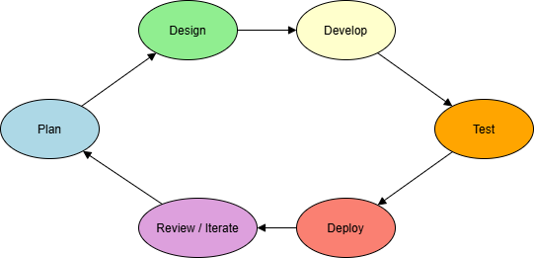
Figure 3.1 Agile methodology framework

3.2 Advantages of Agile Methodology
Agile methodology has advantages over the other methodologies, which makes it a better choice over the others for this system development. Some of these merits include;
- Encourages frequent user feedback
- Accommodates changing requirements during development
- Enables early delivery of functional components
- Enhanced collaboration and communication between developers and users
- Improves project transparency, visibility and tracking
- Higher overall project quality and user satisfaction

3.3 Justification for using Agile Methodology
- User – Centred Development: In Agile, there is frequent iteration cycles that makes sure student and admin feedback is swiftly incorporated, which is very important and necessary when it comes to a complaint system. This framework aligns with Yilmaz (2020), who elaborated that user-centered versions directly enhance the effectiveness and adoption of educational web platforms.
- Flexibility and Adaptability: Agile is highly adaptable and flexible thus supports mid – development changes, ideal for refining features based on stakeholder reviews.
- Risk Reduction/Control: With the continuous testing and reviews and each and every stage, Agile is able to reduce the likelihood of major failures late in the projects.
- Transparency: Stakeholders are involved in every sprint, improving trust and visibility.

3.4 Data Collection Methods
The collection of data in order to gather relevant user needs and system requirements, both primary and secondary data sources were utilized.
- Primary Data
- Digital Questionnaire (Students): Google Forms were created and distributed to students from various departments and levels at UTAS. These surveys gathered data on students’ experiences with the existing complaint channels and their expectations of a digital system.
- Questionnaire and Interviews (Staff): A parallel short questionnaire and informal interviews were conducted with administrative staff who currently handle student complaints, to capture their perspective on existing bottlenecks and the requirements needed from an automated system. [Insert the number of staff respondents/departments covered once finalised.]
- Observation: The researcher observed how administrative staff handled complaints lodged by students, noting how long it typically took for a complaint to reach the right office and receive a response under the current manual process.
- Secondary Data
- Academic Journals and Textbooks: They helped establish best practices in software development and complaint management systems.
- Online Technical Resources: These also assisted in understanding modern approaches and architectural models to some of these problems.

3.5 Brief Overview of the Existing System
Presently, complaints at UTAS are submitted through informal channels, including visiting the relevant office in person, submitting a written letter, or going through the SRC. These channels are inconsistent, untraceable, and often lack follow-up or resolution. Under the manual system, a student with a complaint must travel to the appropriate staff office, only to find the officer unavailable in some cases; where a complaint is submitted as a letter, it can be misplaced, further delaying resolution and forcing the student to return and follow up again. This is corroborated by the questionnaire administered to students and staff during this study, in which [insert the percentage/finding from your questionnaire data here] of respondents reported having to follow up more than once on a single complaint. The absence of a structured feedback and tracking mechanism leaves many students feeling discouraged from reporting issues at all.

3.6 Weakness in the Current Complaint System
These weaknesses are drawn directly from the informal channels described above and are corroborated by the questionnaire administered to students and staff during this study:
- Lack of a centralised or digital platform for complaint submission.
- Poor feedback and resolution mechanisms.
- No support for anonymity.
- High likelihood of information loss and delays.

3.7 Tools used for Development
In the development of the “Student Complaint System for UTAS” the following tools and techniques were employed in order to come up with the system.

- Visual Studio Code: This is a user-friendly Integrated Development Environment (IDE) used for writing and debugging codes for the application.
- XAMPP: This is also providing the local server environment used in running the program locally. It includes Apache, PHP, and MYSQL.
- HTML, CSS (Bootstrap), JavaScript: These are used for building the frontend interface.
- Draw.io: Used to draw architectural diagrams and entity-relationship models.
These tools were chosen over other available alternatives for practical reasons. Visual Studio Code was preferred over IDEs such as NetBeans or Sublime Text for its lightweight footprint, built-in Git integration, and wide extension support for PHP and JavaScript. XAMPP was chosen over WAMP or a cloud-hosted LAMP stack because it is free, cross-platform, and well suited to a local development environment without recurring hosting costs during development. Bootstrap was selected over plain CSS or frameworks such as Tailwind CSS for its shorter learning curve and ready-made responsive components, which sped up front-end development. Draw.io was used instead of paid tools such as Lucidchart or Microsoft Visio because it is free, browser-based, and fully sufficient for producing the architectural, ERD, and UML diagrams needed for this project.

3.8 Features of the proposed Agile system
The proposed new system is going to be a responsive, user – friendly web application that allows students to log complaints, monitor their status, and receive timely updates. Complaints are automatically routed to the appropriate administrative office, such as the IT Directorate, SRC, or departmental heads.
Key features include:
- Student registration and login
- Optional anonymous submission: a logged-in student may choose to submit a complaint anonymously, in which case their name and personal details are hidden from the reviewing administrator, while a session-linked reference is retained internally only to prevent abuse of the anonymous channel
- Category-based routing (IT Directorate, SRC, or departmental heads)
- Status tracking and resolution dashboard
- Admin account with response management tools
- Email notification to students on complaint status updates (chosen over SMS to avoid recurring SMS-gateway costs; SMS notification could be added later as a paid enhancement if budget allows)

3.9 Proposed Benefits of the New System
Below are some of the benefits that comes with a web-based student complaint system for UTAS.
- Transparent complaint tracking
- Faster response and resolution times
- Role based access control for admins
- Secure, centralized, and searchable records.
- Accessible on mobile and desktop platforms.

3.10 System Design Overview
The system design serves as the foundation for building the student complaint management system and ensures all functional and non-functional requirements are carefully mapped to technical components. It outlines how different modules of the system interact and ensures the system is efficient, secure and scalable.
The system is designed following a three-tier architecture, consisting of:
- Presentation Layer (Frontend)
- Application Layer (Server Logic)
- Database Layer (Using MySQL).
The system was designed to be modular, with each feature, registration, complaint submission, the admin dashboard, notifications, and reporting, built, tested, and improved as a separate unit within the Sprint 1 to Sprint 4 breakdown described in Section 3.1. This modular approach made it possible to complete and test one feature at a time within each sprint, and it also allows for easier future updates or integration with other institutional systems.

3.11 Architectural and Structural Design
The platform follows a three-tier architecture, chosen because it cleanly separates concerns and makes the system easier to develop, test, debug, and scale as new features are added:
- Client Layer: Built with HTML, Bootstrap, and JavaScript, this layer renders the user interface that students and administrators interact with. Bootstrap was chosen for this layer because its responsive grid ensures the interface works well both on desktop computers in staff offices and on the mobile phones most students use to access the system.
- Application Layer: Built with PHP running on Apache, this layer handles business logic, input validation, and request routing between the client and the database. PHP was chosen because it integrates natively with MySQL, is well documented, and is the language most widely taught and supported in the local development environment, which keeps the system easier to maintain after handover.
- Database Layer: Built with MySQL, this layer stores all system data, including users, complaints, roles, and logs. MySQL was chosen over alternatives such as PostgreSQL or MongoDB because it is free, integrates seamlessly with the XAMPP stack used for development, and is well suited to the clearly structured, relational data (students, admins, departments, complaints) that this system manages.
This architecture ensures that each layer can be developed and maintained independently. It also enhances scalability, performance, and system security.

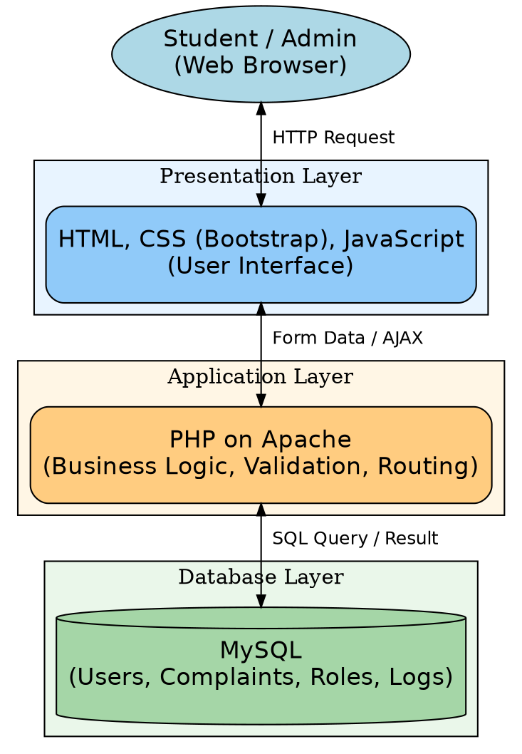
Figure 3.2 Diagram showing the architectural design of the proposed system.

3.12 Detailed System Design
Using Unified Modelling Language (UML), the system design includes;
- Use case Diagrams: showing different user roles (e.g., Student, Admin) and their interactions.
- Entity Relationship Diagram (ERD): Defining tables, fields, and relationships in the database.
- Activity Diagrams: Visualizing workflows like complaint submission and resolution.
These diagrams act as blueprints for the development team and help identify any inconsistencies before implementation.
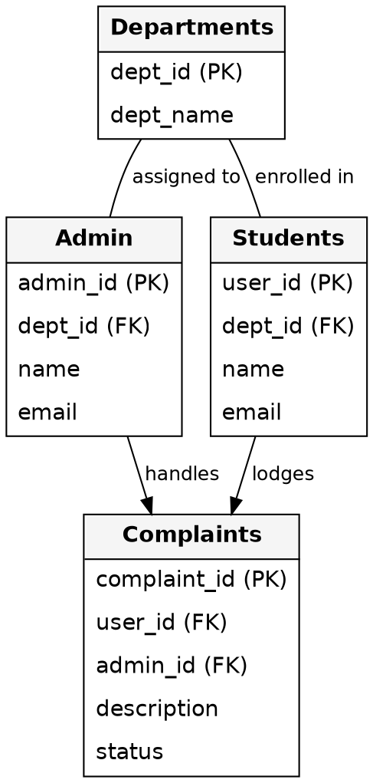
Figure 3.3a Entity Relationship Diagram (ERD) of the proposed system.

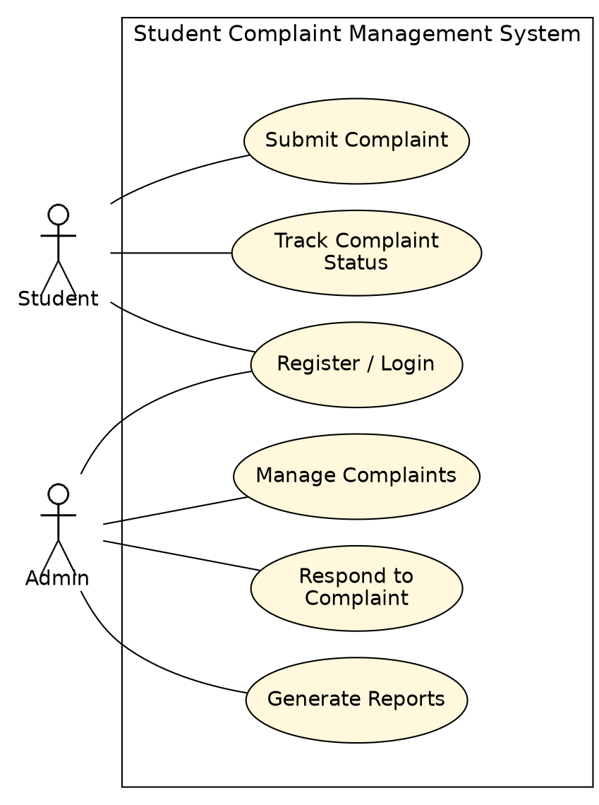
Figure 3.3b Use Case Diagram of the proposed system, showing the system boundary and actor interactions.

3.13 A Pseudocode for complaint submission and assignment.
This part of the chapter presents a logical flow regarding how student complaints are being submitted and how they are been directed or routed to the appropriate administrator based on the department selected. The Pseudocode clearly shows major steps, including form validation, database insertion, and admin assignment. Pseudocode representation allows developers to understand system logic before actual coding (Sommerville, I., 2016). It also provides a high-level abstraction of the
back-end processing for complaint handling.

Pseudocode: Complaint Submission and Assignment Algorithm.
BEGIN

DISPLAY Complaint Submission Form
INPUT: subject, description, school, department, optional attachment

IF form is submitted THEN

VALIDATE all required fields
IF any required field is empty THEN
DISPLAY error: "Please complete all required fields"
EXIT
ENDIF

SANITIZE input data
GET current_student_id from session

SELECT department_selected from form
FIND admin_id WHERE department = department_selected IN admin_table

IF admin_id is found THEN
INSERT INTO complaints_table:
(student_id, admin_id, subject, description, status = 'Pending', timestamp)
DISPLAY success message: "Complaint submitted successfully"
ELSE
DISPLAY error: "No administrator assigned to this department"
ENDIF

ENDIF

END
Flowchart Diagram: The process of submitting a complaint
The below diagrams visually explain the logic in complaint submission by the students in the system. It begins from the form interaction, validates data, checks admin assignment, and then confirms submission success.

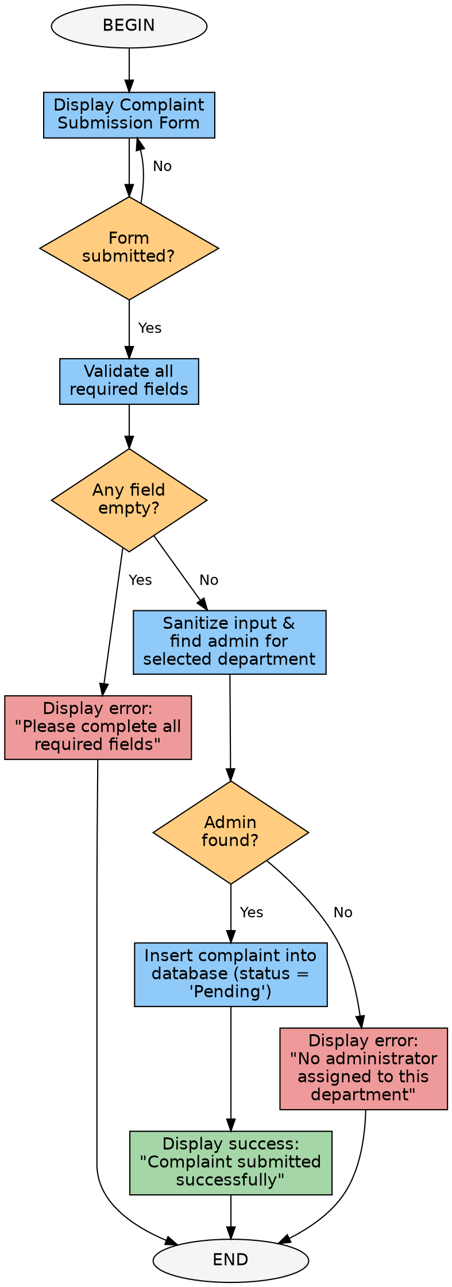
Figure 3.4: Flowchart showing the complaint submission and routing process.

REFERENCES
Agyemang, G., & Gyan, K. (2021). Comparative study between manual and automated grievance management in Educational Institutions. Sourced from the internet: http://ijiet.org/archive/26(3).html.Sourced from the internet: http://ijiet.org/archive/26(3).html.
Al-Emran, M., & Shaalan, K. (2025). Progress, challenges and opportunities in digital transformation in higher education. Educational Technology Research and Development 73(4): 845-862.
Alhassan S, Agyapong GK. (2022). Barriers and facilitators to the adoption of Information systems in tertiary institutions in Ghana. International Journal of Educational Management, Volume 36(5): 612-628.
UNESCO. (2021). The global report on the challenges, opportunities and trends of digital transformation in
Agyemang, G., & Gyan, K. (2021). The study of the grievance management process in educational institutions from the perspectives of manual and automated methods. Gaurang Raghavendra Butte, Casal J. E. B. T. & M. C. B. (2026), Education and Information Technologies, 26(3), 2845–2862.
Al-Emran, M., & Shaalan, K. (2025). The digital transformation in Higher Education – State of the art, problems, and opportunities. Educational technology research and development 73(4), 845-862.
Alhassan, S and Agyapong, G K. (2022). Barriers and facilitators of information systems adoption in the tertiary institutions in Ghana. International Journal of Educational Management, 36(5), 612 – 628.
Burke, P. J. (2004). Competing against the odds – women accessing education. London: Trentham Books.
Casado-Diaz, A. B. (2009). Academic support services' satisfaction with the users. International Journal of Educational Management 23(6), 510-521.
Coffield, F. (1995). Educational aspects of a learning society. A grinding foundry, the University of Durham, is located here.
Jackson, N. (2009). Supporting an environment for learning and professional development. Researching and developing student learning, in N. Jackson & R. Law (Eds.). 11–34). London: Routledge.
Kassem, R., & Dahab, M. (2018). Factors to consider when implementing Web-based grievance systems in Higher Education. The author(s) specifically refuse any liability for damages arising from access to, use of, or reliance on the information provided on or through this website and from any hyperlinked sites.
Mann, S. J. (2001). Alternate views of student experiences: Alienation, engagement. Studies in Higher Education, 26(1), 7–19.
Millward, P. (2015). Educational Institutions to be digitally ready. Journal of Higher Education Policy and Management, 37(4): 400-413.
Mohammed A., Solomon K., & Nurideen A. (2021). An online system for the student complaints for Sunyani Technical University. International Journal of Computer Applications, 183(12):1–9.
Phratama, R. (2024). The issue of complaints in polytechnics based on mobile-first: design and implementation problems. This can be published in the Asian Journal of Educational Technology, volume 6, issue 1, 22-35.
Rolfe, G. (2002). Tertiary education: Reflective practice. Journal of Advanced Nursing, 37(6), 578–585.
Schoefer, K. (2008). The student perspective on service recovery in Higher Education. International Journal of Educational Management (22,7) 2000, 617-631.
Scott, G. (2018). Immediate communication and automation of digital complaint processes. Computers & Education, 120, 74–86.
Sommerville, I. (2016). A. V. Aho and J. D. Ullman Software Engineering 10th Edition. Pearson Education Limited.
Tshotlego, M. (2024). Challenges and adaptations of digital complaint systems in Botswana tertiary colleges in the rural areas. African Journal of Information Systems 16(1) (2000): 1-18.
UNESCO. (2021). This is a global report on challenges, opportunities, and trends in digital transformation in education. UNESCO Publications.
Yilmaz, R. (2020). A systematic review on usability and user experience in HEDPs. Computers in Human Behavior, 108, 106347.

- Your page margins are wrong, follow the standard
- Your document has no page numbering, table of content
- Your heading numberings are not consistent

